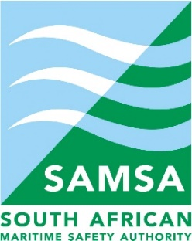

SOUTH AFRICAN MARITIME SAFETY AUTHORITY (SAMSA)

AWARDING OF TENDER

Name of institution | South African Maritime Safety Authority (SAMSA)
Contract description | SOUTH AFRICAN MARITIME SAFETY AUTHORITY (SAMSA) INVITE ALL INTERESTED PARTIES TO RESPOND TO THE REQUEST FOR PROPOSAL (RFP) TO APPOINT A PANEL OF SERVICE PROVIDERS FOR:  (1) THE PROVISION OF THE EMPLOYEE RISK SERVICES AND/OR  (2) THE PROVISION OF PSYCHROMETRIC FOR A PERIOD OF THREE YEARS
Contract number | SAMSA /038/2021/22
Date of award | 27 October 2022

Name of successful bidder | BIDDERS APPOINTED TO SERVE AS A PANEL OF SERVICE PROVIDERS FOR THE PROVISION OF THE EMPLOYEE RISK SERVICES  (1) Managed Integrity Evaluation (Pty) Ltd (MIE)  (2) Mabunha Trading (Pty)Ltd  (3) H & Labour Brokers cc  (4) Talent Profile  (5) SPLS Consultants (Pty)Ltd  (6) Signum  (7) Gijima Holdings (Pty) Ltd  (8) Abacas Financial Crime Advisory (pty)Ltd  BIDDERS APPOINTED TO SERVE AS A PANEL OF SERVICE PROVIDERS FOR THE PROVISION PSYCHROMETRIC ASSESSMENT  1) Managed Integrity Evaluation (Pty) Ltd (MIE)  (2) Duja  (3) H & Labour Brokers cc  (4) Talent Profile  (5) The Talent Hub  (6) Signum  (7) Gijima Holdings (Pty) Ltd
Period Cover | Three (3) Years

