To whom it may concern | Date | 01 December 2023
To whom it may concern | Enquiries | Fiona Manziya
To whom it may concern | E-mail address | manziyfd@eskom.co.za
Dear Sir/Madam
Request for Enquiry Number | WCTX1151FM
Description / Project Title | The Provision of Security Services in Western Grid Transmission Sites and National Key Point Site for a period of Thirty-Six (36) months.
Tender Questions Closing Date | 30 November 2023

Item | Questions | Answers | Clarity Published Dates
 | Discriminatory technical evaluation criteria_ The bidders expressed concern of the criteria, they feel that the requirements eliminate contractors who are specialist in the field and capable to provide the service per region. | As Eskom we have decided to appoint one supplier because we want a single point of contact when problem arise from specific site. Its easy for the management of the contract.  Sub-contracting is applicable, refer to SDL&I undertakings. | 30/11/2023
 | The bidders request Eskom to re-evaluate the appointment of one contractor. |  | 30/11/2023
 | Please advise if we can submit letters that have been signed of by the Director or CEO of companies? | Yes, we will accept letters that are submitted and signed off by Director/CEO or Security Manager of the company where they provided the service. | 30/11/2023
 | How may years of experience are bidders required to prove | There is no number of years of experience stipulated. | 30/11/2023
 | I would just like to know if subcontracting is a mandatory requirement? It appears in the SDL document but not in the Invitation to Tender or the Mandatory requirements.  And in the SDL requirements, it still is vague as to whether we are to subcontract.  The below states that Eskom must advertise the tender with a specific requirement of subcontracting – so I just require clarity so that we are in compliance.  1.3 Subcontracting  Mandatory subcontracting on contracts above R30 million as a condition for contract award  If feasible to subcontract for a contract above R30 million, Eskom:  a) must apply subcontracting to previously designated groups.  b) must advertise the tender with a specific condition for contract award that the successful  tenderer must subcontract a minimum of 30% of the value of the contract to: | Yes, it is mandatory as indicated in our documents and at clarification meeting.  Refer to page 9 of Invitation to Tender  3.10 Mandatory tender returnables  - A tenderer that does not submit mandatory documents/information required in mandatory documents by the required deadlines as stipulated in the Tender Returnable section of the respective Invitation to Tender; will be deemed non-responsive.  1. Technical mandatory requirement  2. SDL& I undertakings (sub-contracting) | 30/11/2023
 | - Should the vehicles be single cab or double cab?  - How many km’s will the vehicles be driving?  - Please can Eskom clarify what does the Transportation requirements are? | - Single or double cab. Must be able to carry 2 people.  - It will differ from month to month. It will depend on what the requirement is by the business during the month hence the request to tender a price per kilometre.  - Transportation requirement is to ensure that the guards are transported to and from the site before and after their shift.
  Transportation |  | 2 x transportation per shift
 | Technical Evaluation – Valid Letter from Insurance Company: We receive an annual confirmation letter from our insurance company stating that we are in good standing with our policy and due to the nature of our company being a part of a Group of other entities, it would be a challenge to obtain a letter from the current Insurance Company (based in London) as negotiations on the new policy for the period 01 March 2024 – 28 February 2025 is currently underway.  - In the interim, would it suffice if we state on our company letterhead that we will ensure immediate cover from the start of contract award and once we receive our updated policy confirmation letter for the new year, provide Eskom with this information during the adjudication process or upon award of contract if successful? | Yes, but pls ensure that you attach a signed letter with this explanation. | 30/11/2023
 | Desktop Evaluation – Certified Copy of PSIRA HR Listing: We have downloaded our PSIRA HR listing that consists of 320 pages. We would like Eskom to advise if you require all 320 pages to be certified or would it suffice if we provide Eskom with the certified PSIRA Letter of Good Standing together with the full HR Listing, however, only have the first and last page of the listing certified? | Only the letter of good standing needs to be certified as a true copy which certification is not older than 90 days | 30/11/2023
 | Substation GPS coordinates | Refer to BOQ & PRICE LIST Western Grid Security Services with SUB STATION GPS CO ORDINATES 29112023 | 30/11/2023
 | Please advise if we are to only submit a list of vehicles and their logbooks for the technical evaluation criteria?  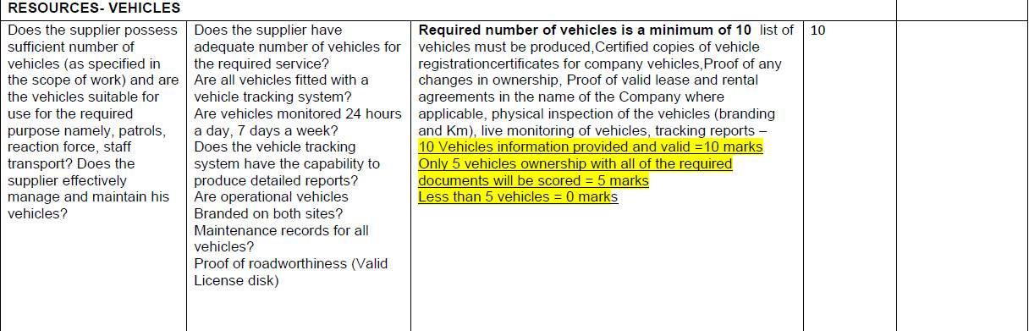 | Please produce the following:  - List of vehicles must be produced, (photo of vehicle with registration number)  - Certified copies of vehicle registration certificates for company vehicles,  - Proof of any changes in ownership,  - Proof of valid lease and rental agreements in the name of the Company where applicable,  - Physical inspection of the vehicles (branding and Km) (produce a photo)  - Live monitoring of vehicles and tracking reports (produce for the 10 vehicles on the list that is sent) | 30/11/2023
 | Please advise if we may fill in the BOQ electronically. | Fill the BOQ electronically and also submit their soft copy along with their tender file; bidders to note that although it is advised to fill the BOQ electronically, filling the BOQ manually will not lead to exclusion | 30/11/2023
 | There are no totals required on the BOQ, do we only fill in the rate? | Add a column on the BOQ next to the rate column for the amounts and include the totals; This is compulsory | 30/11/2023
 | Please clarify we can submit our reference letter signed by the Operations Manager of the Safety and Security Department? | Yes, that is fine. | 01/12/2023

