YOU ARE HEREBY INVITED TO BID FOR REQUIREMENTS OF THE (NAME OF DEPARTMENT/ PUBLIC ENTITY)
BID NUMBER: | KKDM 04/24 (RE-ADVERT) |  | CLOSING DATE: |  |  |  | 12/02/2025 |  |  |  |  |  | CLOSING TIME: |  |  |  |  | 11:00am
DESCRIPTION
THE SUCCESSFUL BIDDER WILL BE REQUIRED TO FILL IN AND SIGN A WRITTEN CONTRACT FORM (SBD7).
BID RESPONSE DOCUMENTS MAY BE DEPOSITED IN THE BID BOX SITUATED AT
CIVIC CENTRE
PATMORE ROAD
ORKNEY
2620
SUPPLIER INFORMATION
NAME OF BIDDER
POSTAL ADDRESS
STREET ADDRESS
TELEPHONE NUMBER |  |  |  | CODE |  |  |  |  |  |  | NUMBER
CELLPHONE NUMBER
FACSIMILE NUMBER |  |  |  | CODE |  |  |  |  |  |  | NUMBER
E-MAIL ADDRESS
VAT REGISTRATION NUMBER
 |  |  |  | TCS PIN: |  |  |  |  | OR |  |  | CSD No:
IF YES, WHO WAS THE CERTIFICATE ISSUED BY?
AN ACCOUNTING OFFICER AS CONTEMPLATED IN THE CLOSE CORPORATION ACT (CCA) AND NAME THE APPLICABLE IN THE TICK BOX |  |  |  |  | AN ACCOUNTING OFFICER AS CONTEMPLATED IN THE CLOSE CORPORATION ACT (CCA)
 |  |  |  |  | A VERIFICATION AGENCY ACCREDITED BY THE SOUTH AFRICAN ACCREDITATION SYSTEM (SANAS)
 |  |  |  |  | A REGISTERED AUDITOR
 |  |  |  |  | NAME:
ARE YOU THE ACCREDITED REPRESENTATIVE IN SOUTH AFRICA FOR THE GOODS /SERVICES /WORKS OFFERED? |  |  |  | Yes No  [IF YES ENCLOSE PROOF] |  |  |  |  |  | ARE YOU A FOREIGN BASED SUPPLIER FOR THE GOODS /SERVICES /WORKS OFFERED? |  |  |  |  |  |  | Yes No  [IF YES ANSWER PART B:3 BELOW ]
SIGNATURE OF BIDDER |  |  |  | ……………………………… |  |  |  |  |  | DATE

CAPACITY UNDER WHICH THIS BID IS SIGNED (Attach proof of authority to sign this bid; e.g. resolution of directors, etc.)
TOTAL NUMBER OF ITEMS OFFERED |  |  |  |  |  |  |  |  |  | TOTAL BID PRICE (ALL INCLUSIVE)
BIDDING PROCEDURE ENQUIRIES MAY BE DIRECTED TO: |  |  |  |  |  |  |  | TECHNICAL INFORMATION MAY BE DIRECTED TO:
DEPARTMENT/ PUBLIC ENTITY |  |  |  |  |  |  |  | CONTACT PERSON
CONTACT PERSON |  |  |  |  |  |  |  | TELEPHONE NUMBER
TELEPHONE NUMBER |  |  |  |  |  |  |  | FACSIMILE NUMBER
FACSIMILE NUMBER |  |  |  |  |  |  |  | E-MAIL ADDRESS
E-MAIL ADDRESS

PART B TERMS AND CONDITIONS FOR BIDDING

- BID SUBMISSION:
  - ALL BIDS MUST BE SUBMITTED ON THE OFFICIAL FORMS PROVIDED– (NOT TO BE RE-TYPED) OR ONLINE AND BE
DELIVERED BY THE STIPULATED TIME TO THE CORRECT ADDRESS. LATE BIDS WILL NOT BE ACCEPTED FOR CONSIDERATION.
  - BIDDERS MUST REGISTER ON THE CENTRAL SUPPLIER DATABASE (CSD). PROOF OF REGISTRATION WITH THE NATIONAL TREASURY CENTRAL SUPPLIER DATABASE (A BIDDER MUST ATTACH CSD REGISTRATION REPORT WITH SUPPLIER NO. AND UNIQUE CODE).
  - A VALID TAX CLEARANCE CERTIFICATE AND TAX COMPLIANCE STATUS DOCUMENT WITH PIN FROM SARS.
  - CERTIFIED COPIES OF COMPANY REGISTRATION DOCUMENTS AND ID COPIES OF COMPANY DIRECTORS
  - COMPLETED MBD FORMS.
  - A CURRENT MUNICIPAL ACCOUNT STATEMENT REFLECTING THE BIDDER IS NOT IN ARREARS FOR MORE THAN THREE (3) MONTHS (MUNICIPAL ACCOUNT OFTHE COMPANY’S BUSINESS ADDRESS AND ALSO OF THE DIRECTOR/S).
  - THIS BID IS SUBJECT TO THE PREFERENTIAL PROCUREMENT POLICY FRAMEWORK ACT 2000 AND THE PREFERENTIAL PROCUREMENT REGULATIONS, 2022, THE GENERAL CONDITIONS OF CONTRACT (GCC) AND, IF APPLICABLE, ANY OTHER LEGISLATION OR SPECIAL CONDITIONS OF CONTRACT.
- TAX COMPLIANCE REQUIREMENTS
- BIDDERS MUST ENSURE COMPLIANCE WITH THEIR TAX OBLIGATIONS.
- BIDDERS ARE REQUIRED TO SUBMIT THEIR UNIQUE PERSONAL IDENTIFICATION NUMBER (PIN) ISSUED BY SARS TO ENABLE THE ORGAN OF STATE TO VIEW THE TAXPAYER’S PROFILE AND TAX STATUS.
- APPLICATION FOR TAX COMPLIANCE STATUS (TCS) OR PIN MAY ALSO BE MADE VIA E-FILING. IN ORDER TO USE THIS PROVISION, TAXPAYERS WILL NEED TO REGISTER WITH SARS AS E-FILERS THROUGH THE WEBSITE WWW.SARS.GOV.ZA.
- BIDDERS MAY ALSO SUBMIT A PRINTED TCS TOGETHER WITH THE BID.
- IN BIDS WHERE CONSORTIA / JOINT VENTURES / SUB-CONTRACTORS ARE INVOLVED, EACH PARTY MUST SUBMIT A SEPARATE PROOF OF TCS / PIN / CSD NUMBER.
- WHERE NO TCS IS AVAILABLE BUT THE BIDDER IS REGISTERED ON THE CENTRAL SUPPLIER DATABASE (CSD), A CSD NUMBER MUST BE PROVIDED.

- QUESTIONNAIRE TO BIDDING FOREIGN SUPPLIERS
  - IS THE BIDDER A RESIDENT OF THE REPUBLIC OF SOUTH AFRICA (RSA)? ☐ YES ☐ NO
  - DOES THE BIDDER HAVE A BRANCH IN THE RSA? ☐ YES ☐ NO
  - DOES THE BIDDER HAVE A PERMANENT ESTABLISHMENT IN THE RSA? ☐ YES ☐ NO
  - DOES THE BIDDER HAVE ANY SOURCE OF INCOME IN THE RSA? ☐ YES ☐ NO

IF THE ANSWER IS “NO” TO ALL OF THE ABOVE, THEN, IT IS NOT A REQUIREMENT TO OBTAIN A TAX COMPLIANCE STATUS / TAX COMPLIANCE SYSTEM PIN CODE FROM THE SOUTH AFRICAN REVENUE SERVICE (SARS) AND IF NOT REGISTER AS PER 2.3 ABOVE.

NB: FAILURE TO PROVIDE ANY OF THE ABOVE PARTICULARS MAY RENDER THE BID INVALID.

SIGNATURE OF BIDDER:………………………………………………………………………………………

DATE:………………………………………

CAPACITY UNDER WHICH THIS BID IS SIGNED:…………………………………………………………

ANY ENQUIRIES REGARDING THE BIDDING PROCEDURE MAY BE DIRECTED TO:

DR Kenneth Kaunda District Municipality:

Contact Person: L. Veldschoen

Tel: 018 473 8000

Fax: 018 473 2523

ANY ENQUIRIES REGARDING TECHNICAL INFORMATION MAY BE DIRECTED TO:

Contact Person: Mr T Ngqobe

Tel: 018 473 8000

Fax: 018 473 2523

DESCRIPTION | PAGE
- Invitation to Bid Cover Page (MBD 1) | 1
- Certificate of Authority for Signatory | 25
- Declaration of Interest (MBD 4) | 28
- Certificate of Attendance at Compulsory Clarification | 31
- Declaration of Bidder’s Past Supply Chain Management Practices (MBD 8) | 33
- Certificate of Independent Bid Determination (MBD 9) | 35
- Preference Points Claim Form in terms of the Preferential Procurement Regulations 2011(MBD 6.1) | 37
- Original Tax Clearance Certificate | 43
- Proof of Payment of Municipal Account | 44
- Company Registration Certificate | 45
- Copies of Certified Identity Document of Partners or Directors | 46
- Functionality Portfolio of Evidence | 47
- IRMSA (Institute of Risk Management South Africa) certificate | 48
- Professional Indemnity Insurance | 49
- Fidelity Insurance | 50
- Letter of Good Standing (Dept of Labor) | 51
- FSCA (Financial Sector Conduct Authority) | 52
- Form of Offer | 54-56
- Pricing Schedule (MBD 3.1) | 63-89
Proof of Purchasing of this Document: Receipt from Supply Chain Unit To be attached at the back of the first page | -

CONTENTS

THE TENDER PAGE

Part T1 Tender Procedure 6

T1.1 Tender Notice and Invitation to Tender 7
T1.2 Tender Data 8-23

Part T2 Returnable Documents

T2.1 List of Returnable Documents 24
T2.2 Returnable Documents 42

THE CONTRACT

Part C1 Agreement and Contract Data 53

C1.1 Form of Offer and Acceptance 54-56
C1.2 Contract Data 58-61

Part C2 Pricing Data 62
C2.1 Pricing Instructions 62
C2.2 Pricing Schedule 63-89
Part C3 Scope of Works & Specifications 90-95

PART T.1

TENDERING PROCEDURES

Tender No:  23/01/2025 | Description | Non-Refundable Tender Deposit/Amount | Bid Docs to be availed from | Compulsory Site Meeting | Contact Person | Closing Date  &  Time
KKDM 04/24  (RE-ADVERT) | INVITATION FOR EXPERIENCED AND QUALIFIED SERVICE PROVIDERS FOR THE MANAGEMENT OF THE SHORT-TERM INSURANCE PORTFOLIO OF DR KENNETH KAUNDA DISTRICT MUNICIPALITY FOR A CONTRACT PERIOD OF THREE (3) YEARS | Tender documents available on the day of the briefing session from SCM @ R 500.00 non – refundable | Tender documents will be uploaded on E-Tender bidders who are unable to download the document can purchase the bid document at Dr Kenneth Kaunda District Municipality offices at Patmore Road, Orkney at a non-refundable tender amount | 29/01/2025 @ 11:00am  Address: Council Chamber, Patmore Road, Orkney (DrKKDM) | Mr T Ngqobe  018 473 8000  (Enquiries)  Ms L Veldschoen  (SCM Unit)  018 473 8000  018 473 8000 | 12/02/2025 @  11h00 am
Functionality: Minimum functionality to be deemed responsive: 75 points
80/20 Evaluation System;
80 points = Price;
Evaluation Criteria
The remaining 20 points will be allocated according to the Revised Preference Points (PPR - 2022) on the 80/20 Evaluation System according to the specific goals as required by the Dr Kenneth Kaunda District Municipality that includes:
The specific goals allocated points in terms of this tender | Number of points allocated
- Woman | 5
- Youth | 5
- Disability | 5
- Military Veteran | 5

SEALED TENDER DULY ENDORSED WITH THE BID NUMBER KKDM 04/24 (RE-ADVERT) AND DESCRIPTION MUST BE DEPOSITED INTO THE TENDER BOX IN THE FOYER OF DR. KENNETH KAUNDA DISTRICT MUNICIPALITY, ORKNEY, THE OLD MUNICIPAL BUILDING, PATMORE ROAD, ORKNEY.
CHECKED BY: SENIOR ACCOUNTANT-COMPLIANCE______________DATE_____________________

CHECKED BY: CHIEF SUPPLY CHAIN OFFICER _______________DATE____________

VERIFIED BY: DEPUTY CHIEF FINANCIAL OFFICER _______________________DATE:_______________

VERIFIED BY CHIEF FINANCIAL OFFICER ___________________DATE:_______________

APPROVED BY MUNICIPAL MANAGER: Mokgatlhe J. Ratlhogo _________________________DATE:____________________

T1.2 TENDER DATA

CONDITIONS OF TENDER

The Standard Conditions of Tender for Procurements make several references to the Tender Data for details that apply specifically to this tender. The Tender Data shall have precedence in the interpretation of any ambiguity or inconsistency between it and the standard conditions of tender.

Each item of data given below is cross-referenced to the clause in the Standard Conditions of Tender to which it mainly applies.

Clause number
CONDITIONS OF TENDER

The Standard Conditions of Tender for Procurements make several references to the Tender Data for details that apply specifically to this tender. The Tender Data shall have precedence in the interpretation of any ambiguity or inconsistency between it and the standard conditions of tender.

Each item of data given below is cross-referenced to the clause in the Standard Conditions of Tender to which it mainly applies.

F.1.1 | The employer is the Dr. Kenneth Kaunda District Municipality
F.1.2 | The tender documents issued by the employer comprise:  The Tender  Part T1 Tender Procedure  T1.1 Tender Notice and Invitation to Tender  T1.2 Tender Data  Part T2 Returnable Documents / Schedules  T2.1 Returnable Schedules  T2.2 List of Returnable Documents  The Contract  Part C1 Agreement and Contract Data  C1.1 Form of Offer and Acceptance  C1.2 Contract Data  Part C2 Pricing Data  C2.1 Pricing Instructions  C2.2 Pricing schedule  Part C3 Scope of Works  C3.1 Project data
F.1.4 | The employer’s agent is:  Name: MJ Ratlhogo  Address: Private Bag X 5017  Klerksdorp  2570  Tel: (018) 473 8000  Fax:(018) 473 2523  E-mail: admin@kaundadistrict.gov.za
F.1.6.2 | A competitive bid procedure will be followed in this tender.
F.1.6.3 | A single competitive bid procedure will be followed in this tender.
F.2.2 | The cost for tendering will be for the account of the tenderer.
F.2.12 | No alternative tender offers will be accepted.
F.2.13.3 | Parts of each tender offer communicated on paper shall be submitted as an original only.
F.2.13.5 | The employer’s address for delivery of tender offers and identification details to be shown on each tender offer package are:  Location of tender box: Foyer of the Municipal Office Building  Physical address: Patmore Road  Orkney  Identification details: TENDER NO: KKDM 04/24 (RE-ADVERT)  “(INVITATION FOR EXPERIENCED AND QUALIFIED SERVICE PROVIDERS FOR THE MANAGEMENT OF THE SHORT-TERM INSURANCE PORTFOLIO OF DR KENNETH KAUNDA DISTRICT MUNICIPALITY FOR A CONTRACT PERIOD OF THREE (3) YEARS).)”  Name and address of the tenderer.
F.2.13.6  F.3.5.1 | A two-envelope procedure will not be followed.
F.2.15.1 | The closing time for submission of tender offers is at 11:00am on 12/02/2025.
F.2.15.1 | Telephonic, telegraphic, telex, facsimile or e-mailed tender offers will not be accepted.
F.2.16 | The tender offer validity period is hundred and twenty (120) days.
F.2.23 | The tenderer is required to submit with his tender:
F.3.4.1 | The time and location for opening of the tender offers are:  Time: at 11:00 am on 12/02/2025.  Location: The Municipal Building  Patmore Road  Orkney
F 3.11.1 | The employer will reduce each responsive tender offer to a comparative offer and using the following method  to evaluate the responsive tender offers.  Tenders will be evaluated in terms of  - Functionality  - Price &  - Specific goals
F.3.11.3 | The procedure for the evaluation of responsive tenders is Method 4:  This is an 80/20 contract in terms of the Preferential Procurement Policy Framework (Act No.5 of 2000) as amended in 2023  Hundred (100) points will go towards quality (functionality) as pre-qualification criteria and any Bidder scoring less than seventy five (75) points will be rejected. Eighty (80) points will go towards price and twenty (20) points will be determined based on the Specific Goals
F.3.11.7 | Scoring Financial Offers  The score for financial offer is calculated using Formula 2 (option 1) where W₁ is the points allocated to financial offer and equals 80
F.3.11.8
  Criteria | Sub-criteria | Points | Max. Points
  Location of the business/company within the  Dr Kenneth Kaunda District.  Prospective service providers must attach municipal account/lease of their business. | • Within the District  • Within the Province  • Outside the Province | 20  15  5 | 20
  Experience /Similar Projects Executed with reference to this project in any sphere of government (Short-Term Insurance cover)  All letters must be on a letter head and  by the client.  The client must be contactable and the  contact details provided must include:  • Contact Person:  • Designation:  • Company name:  • Phone Number:  • e-mail address: and  • Landline and mobile number | • 10 or more satisfactory  reference letters  • 5 to 9 satisfactory references  letters  • 01 to 04 satisfactory reference  letter | 20  15  5 | 20
  Professional Indemnity Insurance (PII) | • Above minimum of  R20 million cover  for PII Cover  • Cover Value of PII  equal to minimum of  R20 million  • Cover Value of PII below of  R20 million | 30  15  0 | 30
  Fidelity Guarantee (FG). | • Above minimum of R20 million  Cover FG Covers  • Cover Value FG equal to  minimum of R20 million  • Cover Value of FG below of R20 million | 30  15  0 | 30
  Maximum possible score for Functionality = |  |  | 100
  Bidders who score less than 75 points on functionality will not be considered any further.
F.3.13.1 | Tender offers will only be accepted if:  - the tenderer has in his or her possession an original valid Tax Clearance Certificate issued by the South African Revenue Services  - the tenderer is not in arrears for more than 3 months with municipal rates and taxes and municipal service charges;  - the tenderer or any of its directors is not listed on the Register of Tender Defaulters in terms of the Prevention and Combating of Corrupt Activities Act of 2004 as a person prohibited from doing business with the public sector; and  - the tenderer has not:  - abused the Employer’s Supply Chain Management System; or  - failed to perform on any previous contract and has been given a written notice to this effect.  - it is considered that the performance of the services will not be compromised through any conflict of interest.
F3.18 | The number of paper copies of the signed contract to be provided by the employer is one (1)

TENDER CONDITIONS AND INFORMATION

- General and Special Conditions of Contract

The General Conditions of Contract (GCC) as well as Special Conditions of Contract (SCC) forming part of this set of documents will be applicable to this tender in addition to the conditions of tender. Where the GCC and SCC are in conflict with one another, the stipulations of the SCC will prevail.

- Acceptance of Rejection of a Tender

The Municipality reserves the right to withdraw any invitation to tender and/or to re- advertise or to reject any tender or to accept a part of it. The Municipality does not bind itself to accepting the lowest tender or the tender scoring the highest points.

- Validity Period

Bids shall remain valid for hundred and twenty (120) days after the tender closure date.

- Cost of Tender Documents

Payment for tender documents, if specified, must be paid in cash to the Dr. Kenneth Kaunda District Municipality. These costs are non-refundable.

- Registration on Accredited Supplier Database

It is expected of all prospective service providers who are not yet registered on the Municipality’s Accredited Supplier Database to register without delay on the prescribed forms. The Municipality reserves the right not to award tenders to prospective suppliers who are not registered on the Database.

- Completion of Tender Documents

- The original tender document must be completed fully in black ink and signed by the authorized signatory to validate the tender. Section 5: DECLARATION must be completed and signed by the authorized signatory and returned. Failure to do so will result in the disqualification of the tender.

- Tender documents may not be retyped. Retyped documents will result in the disqualification of the tender.

- The complete original tender document must be returned. Missing pages will result in the disqualification of the tender.

- No unauthorized alteration of this set of tender documents will be allowed. Any unauthorized alteration will disqualify the tender automatically. Any ambiguity has to be cleared with contact person for the tender before the tender closure

- Compulsory Documentation

  - Tax Clearance Certificate

- A valid original Tax Clearance Certificate must accompany the bid documents. If the South African Revenue Services (SARS) cannot provide a valid original Tax Clearance Certificate; the bidder must submit a letter from SARS on an original SARS letterhead that their tax matters are in order.

- In the case of a Consortium/Joint Venture every member must submit a separate Tax Clearance Certificate with the bid documents.

- If a bid is not supported by a valid original Tax Clearance Certificate, or a letter from SARS on an original SARS letterhead that states their tax matters are in order the bid will be disqualified.

- Other Documentation

  - Construction Industry Development Board (CIDB) (if applicable)

When applicable, the bidder’s CIDB registration number and certificate must be included with the tender. The Municipality will verify, if necessary, the bidder’s CIDB registration during the evaluation process.

  - Municipal Rates, Taxes and Charges

- A certified copy or an original of the bidder’s municipal accounts and the business account (for the Municipality where the bidder pays his account) for the month preceding the tender closure date must accompany the tender documents.

- If a bidder rents their premises, proof must be submitted that the rental includes their municipal rates and taxes or municipal charges and that their rent is not in arrears. Bidder must also attach the municipal accounts of directors
  - Authorized Signatory

- A copy of the recorded Resolution taken by the Board of Directors, members, partners or trustees authorizing the representative to submit this bid on the bidder’s behalf must be attached to the Bid Document on submission of same.

- A bid shall be eligible for consideration only if it bears the signature of the bidder or of some person duly and lawfully authorized to sign it for and on behalf of the bidder.

- If such a copy of the Resolution does not accompany the bid document of the successful bidder, the Municipality reserves the right to obtain such document after the closing date to verify that signatory is in order. If no such document can be obtained within a period as specified by the Municipality, the bid will be disqualified.

- Site /Information Meetings

- Site or information meetings, if specified, are compulsory. Bids will not be accepted from bidders who have not attended compulsory site or information meetings.

- Samples

Samples, if requested, are to be provided to the Municipality with the tender document or as stipulated.

- Quantities of Specific Items

If tenders are called for a specific number of items, the Municipality reserves the right to change the number of such items to be higher or lower. The successful bidder will then be given an opportunity to evaluate the new scenario and inform the Municipality if it is acceptable. If the successful bidder does not accept the new scenario, it will be offered to the second-placed bidder. The process will be continued to the Municipality’s satisfaction.

- Submission of Tender

- The tender must be place in a sealed envelope, or envelopes when the two-envelope system is specified, clearly marked with the tender number, title as well as closing date and time and placed in the tender box on the: Dr. Kenneth Kaunda District Municipality, Patmore Road, Orkney, 2619.

- Faxed, e-mailed and late tenders will not be accepted. Tenders may be delivered by hand, by courier at the bidder’s risk and must be received by the deadline specified above, irrespective of how they are sent or delivered.

- Expenses Incurred in Preparation of Tender.
The Municipality shall not be liable for any expenses incurred in the preparation and submission of the tender.

- Contact with Municipality after Tender Closure Date

Bidders shall not contact the Dr. Kenneth Kaunda District Municipality on any matter relating to their bid from the time of the opening of the bid to the time the contract is awarded. If a bidder wishes to bring additional information to the notice of the Dr. Kenneth Kaunda District Municipality, it should do so in writing to the Dr. Kenneth Kaunda District Municipality. Any effort by the firm to influence the Dr. Kenneth Kaunda District Municipality in the bid evaluation, bid comparison or contract award decisions may result in the rejection of the bid.

- Opening and Recording and Publications of Tenders Received

- Tenders will be opened on the closing date immediately after the closing time specified in the tender documents. If requested by any bidder present, the names of the bidders, and if practical, the total amount of each bid will be read out aloud in public.

- Details of tenders received in time will be recorded in a register which is open to public inspection.

- Faxed, e-mailed and late tenders will not be accepted.

- Evaluation of Tenders

Tenders will be evaluated in terms of their responsiveness to the tender specifications and requirements as well as such additional criteria as set out in this set of tender documents.

- Procurement Policy

Bids will be awarded in accordance with the Preferential Procurement Regulations, 2001 pertaining to the Preferential Procurement Policy Framework Act, No 5 of 2000 and its amendments as well as the Municipality’s Supply Chain Management Policy.

- Contract

- The successful bidder will be expected to sign the agreement in this bid document. The signing of the bid document from both parties signifies the conclusion of the contract. The Municipality, at its discretion, may request the signing of an additional Service Level Agreement which, together with the signed tender document, will constitute the full agreement between the Municipality and the successful bidder.

- Subcontracting

- The Contractor shall not subcontract the whole of the Contract.

- Except where otherwise provided by the Contract, the Contractor shall not subcontract any part of the Contract without the prior written consent of the Municipality, which consent shall not be unreasonably withheld.

- The contractual relationship between the Contractor and any subcontractors selected by the Contractor in consultation with the Municipality in accordance with the requirements of and a procedure contained within the Scope of Work, shall be the same as if the Contractor had appointed the subcontractor in terms of paragraph (b) above.

- Any consent granted in accordance with paragraph (b) or appointment of a subcontractor in accordance with paragraph (c) shall not imply a contract between the Municipality and the subcontractor, or a responsibility or liability on the part of the Municipality to the subcontractor and shall not relieve the Contractor from any liability or obligation under the Contract and he shall be liable for the acts, defaults and neglects of any subcontractor, his agent or employees as fully as if they were the acts, defaults or neglects of the Contractor, his agent or employees.

- The Contractor shall not be required to obtain such consent for –

- The provision of labour, or
- The purchase of materials which are in accordance with the Contract, or
- The purchase or hire of Construction Equipment.

- Language of Contract

The contract documents will be compiled in English and the English versions of all referred documents will be taken as applicable.

- Extension of Contract

The contract with the successful bidder may be extended should additional funds become available.

- Stamp and Other Duties

The successful bidder will be liable for all duties and costs on legal documents resulting in the establishment of a contract and for the surety and retentions.

- Wrong Information Furnished

Where a contract has been awarded on the strength of the information furnished by the bidder which, after the conclusion of the relevant agreement, is proved to have been incorrect, the Municipality may, in addition to any other legal remedy it may have, recover from the contractor all costs, losses or damages incurred or sustained by the Municipality as a result of the award of the contract.

- Past Practices

- The bid of any bidder may be rejected if that bidder or any of its directors have abused the municipality’s supply chain management system or committed any improper conduct in relation to such system.

- The bid of any bidder may be rejected if it is or has been found that the bidder or any of its directors influenced or tried to influence any official or councillor with this or any past tender.

- The bid of any bidder may be rejected if it is or has been found that the bidder or any of its directors offered, promised or granted any official or any of his/her close family members, partners or associates any reward, gift, favour, hospitality or any other benefit in any improper way, with this or any past tender

GENERAL CONDITIONS OF CONTRACT

- Definitions

The following terms shall be interpreted as indicated:

  - “Closing time” means the date and hour specified in the bidding documents for the receipt of bids.

  - “Contract” means the written agreement entered into between the purchaser and the supplier, as recorded in the contract form signed by the parties, including all attachments and appendices thereto and all documents incorporated by reference therein.

  - “Contract price” means the price payable to the supplier under the contract for the full and proper performance of his contractual obligations.

  - “Corrupt practice” means the offering, giving, receiving, or soliciting of anything of value to influence the action of a public official in the procurement process or in contract execution.

  - "Countervailing duties" are imposed in cases where an enterprise abroad is subsidized by its government and encouraged to market its products internationally.

  - “Country of origin” means the place where the goods were mined, grown or produced or from which the services are supplied. Goods are produced when, through manufacturing, processing or substantial and major assembly of components, a commercially recognized new product results that is substantially different in basic characteristics or in purpose or utility from its components.

  - “Day” means calendar day.

  - “Delivery” means delivery in compliance of the conditions of the contract or order.

  - “Delivery ex stock” means immediate delivery directly from stock actually on hand.

  - “Delivery into consignees store or to his site” means delivered and unloaded in the specified store or depot or on the specified site in compliance with the conditions of the contract or order, the supplier bearing all risks and charges involved until the supplies are so delivered and a valid receipt is obtained.

  - "Dumping" occurs when a private enterprise abroad market its goods on own initiative in the RSA at lower prices than that of the country of origin and which have the potential to harm the local industries in the RSA.

  - ”Force majeure” means an event beyond the control of the supplier and not involving the supplier’s fault or negligence and not foreseeable. Such events may include, but is not restricted to, acts of the purchaser in its sovereign capacity, wars or revolutions, fires, floods, epidemics, quarantine restrictions and freight embargoes.

  - “Fraudulent practice” means a misrepresentation of facts in order to influence a procurement process or the execution of a contract to the detriment of any bidder, and includes collusive practice among bidders (prior to or after bid submission) designed to establish bid prices at artificial non-competitive levels and to deprive the bidder of the benefits of free and open competition.

  - “GCC” means the General Conditions of Contract.

  - “Goods” means all of the equipment, machinery, and/or other materials that the supplier is required to supply to the purchaser under the contract.

  - “Imported content” means that portion of the bidding price represented by the cost of components, parts or materials which have been or are still to be imported (whether by the supplier or his subcontractors) and which costs are inclusive of the costs abroad, plus freight and other direct importation costs such as landing costs, dock dues, import duty, sales duty or other similar tax or duty at the South African place of entry as well as transportation and handling charges to the factory in the Republic where the supplies covered by the bid will be manufactured.

  - “Local content” means that portion of the bidding price which is not included in the imported content provided that local manufacture does take place.

  - “Manufacture” means the production of products in a factory using labour, materials, components and machinery and includes other related value-adding activities.

  - “Order” means an official written order issued for the supply of goods or works or the rendering of a service.

  - “Project site,” where applicable, means the place indicated in bidding documents.

  - “Purchaser” means the organization purchasing the goods.

  - “Republic” means the Republic of South Africa.

  - “SCC” means the Special Conditions of Contract.

  - “Services” means that functional services ancillary to the supply of the goods, such as transportation and any other incidental services, such as installation, commissioning, provision of technical assistance, training, catering, gardening, security, maintenance and other such obligations of the supplier covered under the contract.

  - “Written” or “in writing” means handwritten in ink or any form of electronic or mechanical writing.

- Application

  - These general conditions are applicable to all bids, contracts and orders including bids for functional and professional services, sales, hiring, letting and the granting or acquiring of rights, but excluding immovable property, unless otherwise indicated in the bidding documents.

  - Where applicable, special conditions of contract are also laid down to cover specific supplies, services or works.

  - Where such special conditions of contract are in conflict with these general conditions, the special conditions shall apply.

- General

  - Unless otherwise indicated in the bidding documents, the purchaser shall not be liable for any expense incurred in the preparation and submission of a bid. Where applicable a non-refundable fee for documents may be charged.

  - With certain exceptions, invitations to bid are only published in the Government Tender Bulletin. The Government Tender Bulletin may be obtained directly from the Government Printer, Private Bag X85, Pretoria 0001, or accessed electronically from www.treasury.gov.za

- Standards

  - The goods supplied shall conform to the standards mentioned in the bidding documents and specifications.

- Use of contract documents and information; inspection.

  - The supplier shall not, without the purchaser’s prior written consent disclose the contract, or any provision thereof, or any specification, plan, drawing, pattern, sample, or information furnished by or on behalf of the purchaser in connection therewith, to any person other than a person employed by the supplier in the performance of the contract. Disclosure to any such employed person shall be made in confidence and shall extend only so far as may be necessary for purposes of such performance.

  - The supplier shall not, without the purchaser’s prior written consent, make use of any document or information mentioned in GCC clause

  - Except for purposes of performing the contract.

  - Any document, other than the contract itself mentioned in GCC clause

  - Shall remain the property of the purchaser and shall be returned (all copies) to the purchaser on completion of the supplier’s performance under the contract if so required by the purchaser.

  - The supplier shall permit the purchaser to inspect the supplier’s records relating to the performance of the supplier and to have them audited by auditors appointed by the purchaser, if so required by the purchaser.

- Patent rights

The supplier shall indemnify the purchaser against all third-party claims of infringement of patent, trademark, or industrial design rights arising from use of the goods or any part thereof by the purchaser.

- Performance security
  - Within thirty (30) days of receipt of the notification of contract award, the successful bidder shall furnish to the purchaser the performance security of the amount specified in SCC.

  - The proceeds of the performance security shall be payable to the purchaser as compensation for any loss resulting from the supplier’s failure to complete his obligations under the contract.

  - The performance security shall be denominated in the currency of the contract, or in a freely convertible currency acceptable to the purchaser and shall be in one of the following forms:

    - a bank guarantee or an irrevocable letter of credit issued by a reputable bank located in the purchaser’s country or abroad, acceptable to the purchaser, in the form provided in the bidding documents or another form acceptable to the purchaser; or

    - a cashier’s or certified cheque

  - The performance security will be discharged by the purchaser and returned to the supplier not later than thirty (30) days following the date of completion of the supplier’s performance obligations under the contract, including any warranty obligations, unless otherwise specified in SCC.

- Inspections, tests and analyses

  - All pre-bidding testing will be for the account of the bidder.

  - If it is a bid condition that supplies to be produced or services to be rendered should at any stage during production or execution or on completion be subject to inspection, the premises of the bidder or contractor shall be open, at all reasonable hours, for inspection by a representative of the Department or an organization acting on behalf of the Department.

  - If there are no inspection requirements indicated in the bidding documents and no mention is made in the contract, but during the contract period it is decided that inspections shall be carried out, the purchaser shall itself make the necessary arrangements, including payment arrangements with the testing authority concerned.

  - If the inspections, tests and analyses referred to in clauses 8.2 and 8.3 show the supplies to be in accordance with the contract requirements, the cost of the inspections, tests and analyses shall be defrayed by the purchaser.

  - Where the supplies or services referred to in clauses 8.2 and 8.3 do not comply with the contract requirements, irrespective of whether such supplies or services are accepted or not, the cost in connection with these inspections, tests or analyses shall be defrayed by the supplier.

  - Supplies and services which are referred to in clauses 8.2 and 8.3 and which do not comply with the contract requirements may be rejected.

  - Any contract supplies may on or after delivery be inspected, tested or analysed and may be rejected if found not to comply with the requirements of the contract. Such rejected supplies shall be held at the cost and risk of the supplier who shall, when called upon, remove them immediately at his own cost and forthwith substitute them with supplies which do comply with the requirements of the contract. Failing such removal the rejected supplies shall be returned at the suppliers cost and risk. Should the supplier fail to provide the substitute supplies forthwith, the purchaser may, without giving the supplier further opportunity to substitute the rejected supplies, purchase such supplies as may be necessary at the expense of the supplier.

  - The provisions of clauses 8.4 to 8.7 shall not prejudice the right of the purchaser to cancel the contract on account of a breach of the conditions thereof, or to act in terms of Clause 23 of GCC.

- Packing

  - The supplier shall provide such packing of the goods as is required to prevent their damage or deterioration during transit to their final destination, as indicated in the contract. The packing shall be sufficient to withstand, without limitation, rough handling during transit and exposure to extreme temperatures, salt and precipitation during transit, and open storage. Packing, case size and weights shall take into consideration, where appropriate, the remoteness of the goods’ final destination and the absence of heavy handling facilities at all points in transit.

  - The packing, marking, and documentation within and outside the packages shall comply strictly with such special requirements as shall be expressly provided for in the contract, including additional requirements, if any, specified in SCC, and in any subsequent instructions ordered by the purchaser.

- Delivery and documents

  - Delivery of the goods shall be made by the supplier in accordance with the terms specified in the contract. The details of shipping and/or other documents to be furnished by the supplier are specified in SCC.

  - Documents to be submitted by the supplier are specified in SCC.

- Insurance

  - The goods supplied under the contract shall be fully insured in a freely convertible currency against loss or damage incidental to manufacture or acquisition, transportation, storage and delivery in the manner specified in the SCC.

- Transportation

  - Should a price other than an all-inclusive delivered price be required, this shall be specified in the SCC.

- Incidental services

  - The supplier may be required to provide any or all of the following services, including additional services, if any, specified in SCC:

    - performance or supervision of on-site assembly and/or commissioning of the supplied goods;

    - furnishing of tools required for assembly and/or maintenance of the supplied goods;

    - furnishing of a detailed operations and maintenance manual for each appropriate unit of the supplied goods;

    - performance or supervision or maintenance and/or repair of the supplied goods, for a period of time agreed by the parties, provided that this service shall not relieve the supplier of any warranty obligations under this contract; and

    - training of the purchaser’s personnel, at the supplier’s plant and/or on-site, in assembly, start- up, operation, maintenance, and/or repair of the supplied goods.

  - Prices charged by the supplier for incidental services, if not included in the contract price for the goods, shall be agreed upon in advance by the parties and shall not exceed the prevailing rates charged to other parties by the supplier for similar services.

- Spare parts

  - As specified in SCC, the supplier may be required to provide any or all of the following materials, notifications, and information pertaining to spare parts manufactured or distributed by the supplier:
(a) such spare parts as the purchaser may elect to purchase from the supplier, provided that this election shall not relieve the supplier of any warranty obligations under the contract; and
(b) in the event of termination of production of the spare parts:

(i) Advance notification to the purchaser of the pending termination, in sufficient time to permit the purchaser to procure needed requirements; and

(ii) Following such termination, furnishing at no cost to the purchaser, the blueprints, drawings, and specifications of the spare parts, if requested.

- Warranty

  - The supplier warrants that the goods supplied under the contract are new, unused, of the most recent or current models, and that they incorporate all recent improvements in design and materials unless provided otherwise in the contract. The supplier further warrants that all goods supplied under this contract shall have no defect, arising from design, materials, or workmanship (except when the design and/or material is required by the purchaser’s specifications) or from any act or omission of the supplier, that may develop under normal use of the supplied goods in the conditions prevailing in the country of final destination.

  - This warranty shall remain valid for twelve (12) months after the goods, or any portion thereof as the case may be, have been delivered to and accepted at the final destination indicated in the contract, or for eighteen (18) months after the date of shipment from the port or place of loading in the source country, whichever period concludes earlier, unless specified otherwise in SCC. The purchaser shall promptly notify the supplier in writing of any claims arising under this warranty.

  - Upon receipt of such notice, the supplier shall, within the period specified in SCC and with all reasonable speed, repair or replace the defective goods or parts thereof, without costs to the purchaser. If the supplier, having been notified, fails to remedy the defect(s) within the period specified in SCC, the purchaser may proceed to take such remedial action as may be necessary, at the supplier’s risk and expense and without prejudice to any other rights which the purchaser may have against the supplier under the contract.

- Payment

  - The method and conditions of payment to be made to the supplier under this contract shall be specified in SCC.

  - The supplier shall furnish the purchaser with an invoice accompanied by a copy of the delivery note and upon fulfilment of other obligations stipulated in the contract.

  - Payments shall be made promptly by the purchaser, but in no case later than thirty (30) days after submission of an invoice or claim by the supplier.

  - Payment will be made in Rand unless otherwise stipulated in SCC.

- Prices

  - Prices charged by the supplier for goods delivered and services performed under the contract shall not vary from the prices quoted by the supplier in his bid, with the exception of any price adjustments authorized in SCC or in the purchaser’s request for bid validity extension, as the case may be.

- Contract amendments

  - No variation in or modification of the terms of the contract shall be made except by written amendment signed by the parties concerned.

- Assignment

  - The supplier shall not assign, in whole or in part, its obligations to perform under the contract, except with the purchaser’s prior written consent.

- Subcontracts

  - The supplier shall notify the purchaser in writing of all subcontracts awarded under this contract if not already specified in the bid. Such notification, in the original bid or later, shall not relieve the supplier from any liability or obligation under the contract.

- Delays in the supplier’s performance

  - Delivery of the goods and performance of services shall be made by the supplier in accordance with the time schedule prescribed by the purchaser in the contract.

  - If at any time during performance of the contract, the supplier or its subcontractor(s) should encounter conditions impeding timely delivery of the goods and performance of services, the supplier shall promptly notify the purchaser in writing of the fact of the delay, its likely duration and its cause(s). As soon as practicable after receipt of the supplier’s notice, the purchaser shall evaluate the situation and may at his discretion extend the supplier’s time for performance, with or without the imposition of penalties, in which case the extension shall be ratified by the parties by amendment of contract.

  - No provision in a contract shall be deemed to prohibit the obtaining of supplies or services from a national department, provincial department, or a local authority.

  - The right is reserved to procure outside of the contract small quantities or to have minor essential services executed if an emergency arises, the supplier’s point of supply is not situated at or near the place where the supplies are required, or the supplier’s services are not readily available.

  - Except as provided under GCC Clause 25, a delay by the supplier in the performance of its delivery obligations shall render the supplier liable to the imposition of penalties, pursuant to GCC Clause 22, unless an extension of time is agreed upon pursuant to GCC Clause without the application of penalties.

  - Upon any delay beyond the delivery period in the case of a supplies contract, the purchaser shall, without cancelling the contract, be entitled to purchase supplies of a similar quality and up to the same quantity in substitution of the goods not supplied in conformity with the contract and to return any goods delivered later at the supplier’s expense and risk, or to cancel the contract and buy such goods as may be required to complete the contract and without prejudice to his other rights, be entitled to claim damages from the supplier.

- Penalties

  - Subject to GCC Clause 25, if the supplier fails to deliver any or all of the goods or to perform the services within the period(s) specified in the contract, the purchaser shall, without prejudice to its other remedies under the contract, deduct from the contract price, as a penalty, a sum calculated on the delivered price of the delayed goods or unperformed services using the current prime interest rate calculated for each day of the delay until actual delivery or performance. The purchaser may also consider termination of the contract pursuant to GCC Clause 23

- Termination for default

  - The purchaser, without prejudice to any other remedy for breach of contract, by written notice of default sent to the supplier, may terminate this contract in whole or in part:

    - if the supplier fails to deliver any or all of the goods within the period(s) specified in the contract, or within any extension thereof granted by the purchaser pursuant to GCC Clause 21.2;
    - if the Supplier fails to perform any other obligation(s) under the contract; or
    - if the supplier, in the judgment of the purchaser, has engaged in corrupt or fraudulent practices in competing for or in executing the contract.

  - In the event the purchaser terminates the contract in whole or in part, the purchaser may procure, upon such terms and in such manner as it deems appropriate, goods, works or services similar to those undelivered, and the supplier shall be liable to the purchaser for any excess costs for such similar goods, works or services. However, the supplier shall continue performance of the contract to the extent not terminated.

  - Where the purchaser terminates the contract in whole or in part, the purchaser may decide to impose a restriction penalty on the supplier by prohibiting such supplier from doing business with the public sector for a period not exceeding 10 years.

  - If a purchaser intends imposing a restriction on a supplier or any person associated with the supplier, the supplier will be allowed a time period of not more than fourteen (14) days to provide reasons why the envisaged restriction should not be imposed. Should the supplier fail to respond within the stipulated fourteen (14) days the purchaser may regard the intended penalty as not objected against and may impose it on the supplier.

  - Any restriction imposed on any person by the Accounting Officer / Authority will, at the discretion of the Accounting Officer / Authority, also be applicable to any other enterprise or any partner, manager, director or other person who wholly or partly exercises or exercised or may exercise control over the enterprise of the first-mentioned person, and with which enterprise or person the first-mentioned person, is or was in the opinion of the Accounting Officer / Authority actively associated.

  - If a restriction is imposed, the purchaser must, within five (5) working days of such imposition, furnish the National Treasury, with the following information:

(i) the name and address of the supplier and / or person restricted by the purchaser;
(ii) the date of commencement of the restriction
(iii) the period of restriction; and
(iv) the reasons for the restriction.

These details will be loaded in the National Treasury’s central database of suppliers or persons prohibited from doing business with the public sector.

  - If a court of law convicts a person of an offence as contemplated in sections 12 or 13 of the Prevention and Combating of Corrupt Activities Act, No. 12 of 2004, the court may also rule that such person’s name be endorsed on the Register for Tender Defaulters. When a person’s name has been endorsed on the Register, the person will be prohibited from doing business with the public sector for a period not less than five years and not more than 10 years. The National Treasury is empowered to determine the period of restriction and each case will be dealt with on its own merits. According to section 32 of the Act the Register must be open to the public. The Register can be perused on the National Treasury website.

- Anti-dumping and countervailing duties and rights

  - When, after the date of bid, provisional payments are required, or anti-dumping or countervailing duties are imposed, or the amount of a provisional payment or anti-dumping or countervailing right is increased in respect of any dumped or subsidized import, the State is not liable for any amount so required or imposed, or for the amount of any such increase. When, after the said date, such a provisional payment is no longer required or any such anti-dumping or countervailing right is abolished, or where the amount of such provisional payment or any such right is reduced, any such favourable difference shall on demand be paid forthwith by the contractor to the State or the State may deduct such amounts from moneys (if any) which may otherwise be due to the contractor in regard to supplies or services which he delivered or rendered, or is to deliver or render in terms of the contract or any other contract or any other amount which may be due to him

- Force Majeure

  - Notwithstanding the provisions of GCC Clauses 22 and 23, the supplier shall not be liable for forfeiture of its performance security, damages, or termination for default if and to the extent that his delay in performance or other failure to perform his obligations under the contract is the result of an event of force majeure.

  - If a force majeure situation arises, the supplier shall promptly notify the purchaser in writing of such condition and the cause thereof. Unless otherwise directed by the purchaser in writing, the supplier shall continue to perform its obligations under the contract as far as is reasonably practical, and shall seek all reasonable alternative means for performance not prevented by the force majeure event.

- Termination for insolvency

  - The purchaser may at any time terminate the contract by giving written notice to the supplier if the supplier becomes bankrupt or otherwise insolvent. In this event, termination will be without compensation to the supplier, provided that such termination will not prejudice or affect any right of action or remedy which has accrued or will accrue thereafter to the purchaser.

- Settlement of Disputes

  - If any dispute or difference of any kind whatsoever arises between the purchaser and the supplier in connection with or arising out of the contract, the parties shall make every effort to resolve amicably such dispute or difference by mutual consultation.

  - If, after thirty (30) days, the parties have failed to resolve their dispute or difference by such mutual consultation, then either the purchaser or the supplier may give notice to the other party of his intention to commence with mediation. No mediation in respect of this matter may be commenced unless such notice is given to the other party.

  - Should it not be possible to settle a dispute by means of mediation, it may be settled in a South African court of law.

  - Mediation proceedings shall be conducted in accordance with the rules of procedure specified in the SCC.

  - Notwithstanding any reference to mediation and/or court proceedings herein,

(a) The parties shall continue to perform their respective obligations under the contract unless they otherwise agree; and
(b) The purchaser shall pay the supplier any monies due the supplier.

- Limitation of liability

  - Except in cases of criminal negligence or wilful misconduct, and in the case of infringement pursuant to Clause 6;

(a) the supplier shall not be liable to the purchaser, whether in contract, tort, or otherwise, for any indirect or consequential loss or damage, loss of use, loss of production, or loss of profits or interest costs, provided that this exclusion shall not apply to any obligation of the supplier to pay penalties and/or damages to the purchaser; and

(b) The aggregate liability of the supplier to the purchaser, whether under the contract, in tort or otherwise, shall not exceed the total contract price, provided that this limitation shall not apply to the cost of repairing or replacing defective equipment.

- Governing language

  - The contract shall be written in English. All correspondence and other documents pertaining to the contract that is exchanged by the parties shall also be written in English.

- Applicable law

  - The contract shall be interpreted in accordance with South African laws, unless otherwise specified in SCC.

- Notices

  - Every written acceptance of a bid shall be posted to the supplier concerned by registered or certified mail and any other notice to him shall be posted by ordinary mail to the address furnished in his bid or to the address notified later by him in writing and such posting shall be deemed to be proper service of such notice

  - The time mentioned in the contract documents for performing any act after such aforesaid notice has been given, shall be reckoned from the date of posting of such notice.

- Taxes and duties

  - A foreign supplier shall be entirely responsible for all taxes, stamp duties, license fees, and other such levies imposed outside the purchaser’s country.

  - A local supplier shall be entirely responsible for all taxes, duties, license fees, etc., incurred until delivery of the contracted goods to the purchaser
  - No contract shall be concluded with any bidder whose tax matters are not in order. Prior to the award of a bid the Department must be in possession of a tax clearance certificate, submitted by the bidder. This certificate must be an original issued by the South African Revenue Services.

- National Industrial Participation (NIP) Programme

  - The NIP Programme administered by the Department of Trade and Industry shall be applicable to all contracts that are subject to the NIP obligation.

- Prohibition of Restrictive practices

  - In terms of section 4 (1) (b) (iii) of the Competition Act No. 89 of 1998, as amended, an agreement between, or concerted practice by, firms, or a decision by an association of firms, is prohibited if it is between parties in a horizontal relationship and if a bidder (s) is / are or a contractor(s) was / were involved in collusive bidding (or bid rigging).
PART T.2

RETURNABLE DOCUMENTS / SCHEDULEST2.1 LIST OF RETURNABLE DOCUMENTS

The tenderer must complete the following returnable documents:

- Returnable Schedules Required for Tender Evaluation Purposes
  - Certificate of Authority for Signatory
  - Compulsory Enterprise Questionnaire (include CIDB Registration Number)
  - Declaration of Tender’s Past Supply Chain Management Practices / Interest (MBD 4)
  - Certificate of Attendance at Compulsory Clarification Meeting
  - Record of Addenda to Tender Documents
  - Declaration of Bidder’s Past Supply Chain Management Practices (MBD 8)
  - Certificate of Independent Bid Determination (MBD 9)
  - Preference Points Claim Form in terms of the Preferential Procurement Regulations 2011 (MBD 6.1)
  - Pricing Schedule (MBD 3.1)
- Other documents required for tender evaluation purposes
  - Original Tax Clearance Certificate/ SARS Pin
  - Proof of payment of municipal account (Directors and Company)
  - Company registration certificate
  - Copies of Certified Identity document of Partners or Directors
  - Functionality Portfolio of Evidence
  - IRMSA (Institute of Risk Management South Africa) certificate
  - Professional Indemnity Insurance
  - Fidelity Insurance
  - Letter of Good Standing (Dept of Labor)
  - FSCA (FINANCIAL SECTOR CONDUCT AUTHORITY)
- Returnable Schedules that will be incorporated into the contract as bound in this document
- Other documents that will be incorporated into the contract
  - C1.1 Offer and Acceptance
  - C1.2 Contract Data
  - C2.1 Pricing Instructions
  - C2.2 Pricing Schedule
  - C3.1 Scope of Works

1.1 CERTIFICATE OF AUTHORITY OF SIGNATORY

SIGNING AUTHORITY:

State in cases where the Tenderer is a company, corporation or firm, by what authority the person signing does so, whether by Article of Association, Resolution, Power of Attorney or otherwise.

I,……………………………………………………………………………., the under-signed

(full names in block letters) am authorized to enter into the Contract on behalf of:

……………………………………………………………………………………………………….

By virtue of ………………………………………………………………………………………..

Dated …………………………………………

Name of authorized signatory…………………………………………………………………...

SIGNATURE ………………………………………………….

DATE …………………………………………

AS WITNESSES:

- ………………………………………………………..

- ………………………………………………………...

(In case of sole ownership Tenderer needs to indicate this by giving the reason for being able to sign the contract documents) attached letter of authority (on company’s Letterhead)

1.2 Compulsory Enterprise Questionnaire

The following particulars must be furnished. In the case of a joint venture, separate enterprise questionnaires in respect of each partner must be completed and submitted.
Section 1: Name of enterprise: . . . . . . . . . . . . . . . . . . . . . . . . . . . . . . . . . . . . . . . . . . . . . . . . . . . . . . . .
Section 2: VAT registration number, if any: . . . . . . . . . . . . . . . . . . . . . . . . . . . . . . . . . . . . . . . . . . . . . . . .
Section 3: CIDB registration number: not applicable
Section 4: Particulars of sole proprietors and partners in partnerships
Name* | Identity number* | Personal income tax number*
* Complete only if sole proprietor or partnership and attach separate page if more than 3 partners
Section 5: Particulars of companies and close corporations
Company registration number . . . . . . . . . . . . . . . . . . . . . . . . . . . . . . . . . . . . . . . . . . . . . . . . . . . . . . . . . . .
Close corporation number . . . . . . . . . . . . . . . . . . . . . . . . . . . . . . . . . . . . . . . . . . . . . . . . . . . . . . . . . . . . . .
Tax reference number . . . . . . . . . . . . . . . . . . . . . . . . . . . . . . . . . . . . . . . . . . . . . . . . . . . . . . . . . . . . . . . . .
Section 6: Record in the service of the state
Indicate by marking the relevant boxes with a cross, if any sole proprietor, partner in a partnership or director, manager, principal shareholder or stakeholder in a company or close corporation is currently or has been within the last 12 months in the service of any of the following:

- a member of any municipal council  - a member of any provincial legislature  - a member of the National Assembly or the National Council of Province  - a member of the board of directors of any municipal entity  - an official of any municipality or municipal entity | an employee of any provincial department, national or provincial public entity or constitutional institution within the meaning of the Public Finance Management Act, 1999 (Act 1 of 1999)  a member of an accounting authority of any national or provincial public entity  an employee of Parliament or a provincial legislature

If any of the above boxes are marked, disclose the following:

Name of sole proprietor, partner, director, manager, principal shareholder or stakeholder | Name of institution, public office, board or organ of state and position held | Status of service  (tick appropriate column)
 |  | Current | Within last 12 months
*insert separate page if necessary
Section 7: Record of spouses, children and parents in the service of the state
Indicate by marking the relevant boxes with a cross, if any spouse, child or parent of a sole proprietor, partner in a partnership or director, manager, principal shareholder or stakeholder in a company or close corporation is currently or has been within the last 12 months been in the service of any of the following:

- a member of any municipal council  - a member of any provincial legislature  - a member of the National Assembly or the National Council of Province  - a member of the board of directors of any municipal entity  - an official of any municipality or municipal entity | an employee of any provincial department, national or provincial public entity or constitutional institution within the meaning of the Public Finance Management Act, 1999 (Act 1 of 1999)  a member of an accounting authority of any national or provincial public entity  an employee of Parliament or a provincial legislature

Name of spouse, child or parent | Name of institution, public office, board or organ of state and position held | Status of service  (tick appropriate column)
Name of spouse, child or parent |  | Current | Within last 12 months
*insert separate page if necessary

The undersigned, who warrants that he / she is duly authorised to do so on behalf of the enterprise:
i) authorizes the Employer to obtain a tax clearance certificate from the South African Revenue Services that my / our tax matters are in order;
ii) confirms that the neither the name of the enterprise or the name of any partner, manager, director or other person, who wholly or partly exercises, or may exercise, control over the enterprise appears on the Register of Tender Defaulters established in terms of the Prevention and Combating of Corrupt Activities Act of 2004;
iii) confirms that no partner, member, director or other person, who wholly or partly exercises, or may exercise, control over the enterprise appears, has within the last five years been convicted of fraud or corruption;
iv) confirms that I / we are not associated, linked or involved with any other tendering entities submitting tender offers and have no other relationship with any of the tenderers or those responsible for compiling the scope of work that could cause or be interpreted as a conflict of interest; and
iv) confirms that the contents of this questionnaire are within my personal knowledge and are to the best of my belief both true and correct.
 | Signed |  | Date
 | Name Position

1.3 DECLARATION OF INTEREST

- No bid will be accepted from persons in the service of the state

- Any person, having a kinship with persons in the service of the state, including a blood relationship, may make an offer or offers in terms of this invitation to bid. In view of possible allegations of favouritism, should the resulting bid, or part thereof, be awarded to persons connected with or related to persons in service of the state, it is required that the bidder or their authorised representative declare their position in relation to the evaluating/adjudicating authority and/or take an oath declaring his/her interest.

- In order to give effect to the above, the following questionnaire must be completed and submitted with the bid.
  - Full Name: …………………………………………….
  - Identity Number: …………………………………………….
  - Company Registration Number:……………………………
  - Tax Reference Number: …………………………………………….
  - VAT Registration Number…………………………………………….
  - Are you presently in the service of the state YES / NO
If so, furnish particulars.
………………………………………………………………………………………
………………………………………………………………………………………

  - Have you been in the service of the state for the past twelve months? YES / NO
If so, furnish particulars.
………………………………………………………………………………………
………………………………………………………………………………………
  - Do you, have any relationship (family, friend, other) with persons in the service of the state and who may be involved with the evaluation and or adjudication of this bid. YES / NO
If so, furnish particulars.
……………………………………………………………………………………
………………………………………………………………………………………
    - Are you, aware of any relationship (family, friend, other) between a bidder and any persons in the service of the state who may be involved with the evaluation and or adjudication of this bid? YES / NO
If so, furnish particulars
……………………………………………………………………………………
……………………………………………………………………………………
    - Are any of the company’s directors, managers, principal shareholders or stakeholders in service of the state? YES / NO
If so, furnish particulars.
……………………………………………………………………………………
………………………………………………………………………………………

  - Are any spouse, child or parent of the company’s directors, managers, principal shareholders or stakeholders in service of the state? YES / NO

If so, furnish particulars.
……………………………………………………………………………………
……………………………………………………………………………………

CERTIFICATION

I, the undersigned (name) ……………………………………………………………......
Certify that the information furnished on this declaration form is correct.

I accept that the state may act against me should this declaration prove to be false.

……………………………………………... ............................................................
Signature Date
……………………………………… ............................................................
Position Name of Bidder

(If more than one director/shareholder, copies of MBD 4 declaration must be attached for all directors/shareholders)

1.4 CERTIFICATE OF ATTENDANCE AT COMPULSORY CLARIFICATION MEETING

This is to certify that I, ……………………………………………………………………

representative of (Tenderer)

Name: …………………………………………………………

Address: ………………………………………………………

………………………………………………………………….

…………………………………………………………………

Attended the official compulsory meeting on (date) : …………………………….

Tenderer’s representative:

………………………………. ……………………….
Signature Date

Employer’s representative:

…………………………. ……………………….
Signature Date

(Attach proof of purchased of this document for proof e.g receipt)

1.5 Record of Addenda to Tender Documents

We confirm that the following communications received from the Employer before the submission of this tender offer, amending the tender documents, have been taken into account in this tender offer:
 | Date |  | Title or Details
Attach additional pages if more space is required.
Signed |  |  |  | Date
Name |  |  |  | Position
Tenderer

1.6 DECLARATION OF BIDDER’S PAST SUPPLY CHAIN MANAGEMENT PRACTICES

- This Municipal Bidding Document must form part of all bids invited.

- It serves as a declaration to be used by municipalities and municipal entities in ensuring that when goods and services are being procured, all reasonable steps are taken to combat the abuse of the supply chain management system.

- The bid of any bidder may be rejected if that bidder, or any of its directors have:

  - abused the municipality’s / municipal entity’s supply chain management system or committed any improper conduct in relation to such system;
  - been convicted for fraud or corruption during the past five years;
  - wilfully neglected, reneged on or failed to comply with any government, municipal or other public sector contract during the past five years; or
  - been listed in the Register for Tender Defaulters in terms of section 29 of the Prevention and Combating of Corrupt Activities Act (No 12 of 2004).

- In order to give effect to the above, the following questionnaire must be completed and submitted with the bid.

Item | Question | Yes | No
4.1 | Is the bidder or any of its directors listed on the National Treasury’s Database of Restricted Suppliers as companies or persons prohibited from doing business with the public sector?  (Companies or persons who are listed on this Database were informed in writing of this restriction by the Accounting Officer/Authority of the institution that imposed the restriction after the audi alteram partem rule was applied).  The Database of Restricted Suppliers now resides on the National Treasury’s website(www.treasury.gov.za) and can be accessed by clicking on its link at the bottom of the home page. | Yes | No
4.1.1 | If so, furnish particulars:
4.2 | Is the bidder or any of its directors listed on the Register for Tender Defaulters in terms of section 29 of the Prevention and Combating of Corrupt Activities Act (No 12 of 2004)?  The Register for Tender Defaulters can be accessed on the National Treasury’s website (www.treasury.gov.za) by clicking on its link at the bottom of the home page. | Yes | No
4.2.1 | If so, furnish particulars:
4.3 | Was the bidder or any of its directors convicted by a court of law (including a court of law outside the Republic of South Africa) for fraud or corruption during the past five years? | Yes | No
4.3.1 | If so, furnish particulars:
Item | Question | Yes | No
4.4 | Does the bidder or any of its directors owe any municipal rates and taxes or municipal charges to the municipality / municipal entity, or to any other municipality / municipal entity, that is in arrears for more than three months? | Yes | No
4.4.1 | If so, furnish particulars:
4.5 | Was any contract between the bidder and the municipality / municipal entity or any other organ of state terminated during the past five years on account of failure to perform on or comply with the contract? | Yes | No
4.7.1 | If so, furnish particulars:

CERTIFICATION
I, the undersigned (full name) …………..……………………………..…… Certify that the information furnished on this declaration form true and correct.
I accept that, in addition to cancellation of a contract action may be taken against me should this declaration prove to be false.

………………………………………... …………………………..
Signature Date

………………………………………. …………………………..
Position Name of Bidder

1.7 CERTIFICATE OF INDEPENDENT BID DETERMINATION (MBD 9)

I, the undersigned, in submitting the accompanying bid:

TENDER NO: KKDM 04/24 (RE-ADVERT)
(INVITATION FOR EXPERIENCED AND QUALIFIED SERVICE PROVIDERS FOR THE MANAGEMENT OF THE SHORT-TERM INSURANCE PORTFOLIO OF DR KENNETH KAUNDA DISTRICT MUNICIPALITY FOR A CONTRACT PERIOD OF THREE (3) YEARS).)

in response to the invitation for the bid made by: Dr Kenneth Kaunda District Municipality.
do hereby make the following statements that I certify to be true and complete in every respect:
I certify, on behalf of:_______________________________________________________that:
(Name of Bidder)
- I have read and I understand the contents of this Certificate;
- I understand that the accompanying bid will be disqualified if this Certificate is found not to be true and complete in every respect;
- I am authorized by the bidder to sign this Certificate, and to submit the accompanying bid, on behalf of the bidder;
- Each person whose signature appears on the accompanying bid has been authorized by the bidder to determine the terms of, and to sign, the bid, on behalf of the bidder;
- For the purposes of this Certificate and the accompanying bid, I understand that the word “competitor” shall include any individual or organization, other than the bidder, whether or not affiliated with the bidder, who:
(a) has been requested to submit a bid in response to this bid invitation;
(b) could potentially submit a bid in response to this bid invitation, based on their qualifications, abilities or experience; and
(c) provides the same goods and services as the bidder and/or is in the same line of business as the bidder
- The bidder has arrived at the accompanying bid independently from, and without consultation, communication, agreement or arrangement with any competitor. However, communication between partners in a joint venture or consortium³ will not be construed as collusive bidding.
- In particular, without limiting the generality of paragraphs 6 above, there has been no consultation, communication, agreement or arrangement with any competitor regarding:
- prices;
- geographical area where product or service will be rendered (market allocation)
(c) methods, factors or formulas used to calculate prices;
(d) the intention or decision to submit or not to submit, a bid;
(e) the submission of a bid which does not meet the specifications and conditions of the bid; or
(f) bidding with the intention not to win the bid.

- In addition, there have been no consultations, communications, agreements or arrangements with any competitor regarding the quality, quantity, specifications and conditions or delivery particulars of the products or services to which this bid invitation relates.
- The terms of the accompanying bid have not been, and will not be, disclosed by the bidder, directly or indirectly, to any competitor, prior to the date and time of the official bid opening or of the awarding of the contract.
³ Joint venture or Consortium means an association of persons for the purpose of combining their expertise, property, capital, efforts, skill and knowledge in an activity for the execution of a contract.

- I am aware that, in addition and without prejudice to any other remedy provided to combat any restrictive practices related to bids and contracts, bids that are suspicious will be reported to the Competition Commission for investigation and possible imposition of administrative penalties in terms of section 59 of the Competition Act No 89 of 1998 and or may be reported to the National Prosecuting Authority (NPA) for criminal investigation and or may be restricted from conducting business with the public sector for a period not exceeding ten (10) years in terms of the Prevention and Combating of Corrupt Activities Act No 12 of 2004 or any other applicable legislation.

………………………………………………… …………………………………
Signature Date
…………………………………………………. …………………………………
Position
Name of Bidder

-

MBD 6.1

PREFERENCE POINTS CLAIM FORM IN TERMS OF THE PREFERENTIAL PROCUREMENT REGULATIONS 2022

This preference form must form part of all tenders invited. It contains general information and serves as a claim form for preference points for specific goals.

NB: BEFORE COMPLETING THIS FORM, TENDERERS MUST STUDY THE GENERAL CONDITIONS, DEFINITIONS AND DIRECTIVES APPLICABLE IN RESPECT OF THE TENDER AND PREFERENTIAL PROCUREMENT REGULATIONS, 2022

- GENERAL CONDITIONS
  - The following preference point systems are applicable to invitations to tender:
- the 80/20 system for requirements with a Rand value of up to R50 000 000 (all applicable taxes included); and
- the 90/10 system for requirements with a Rand value above R50 000 000 (all applicable taxes included).
  - To be completed by the organ of state
- The applicable preference point system for this tender is the 80/20 preference point system.

- The 80/20 preference point system will be applicable in this tender. The lowest/ highest acceptable tender will be used to determine the accurate system once tenders are received.

  - Points for this tender (even in the case of a tender for income-generating contracts) shall be awarded for:

- Price; and
- Specific Goals.
  - To be completed by the organ of state:
The maximum points for this tender are allocated as follows:
 | POINTS
PRICE | 80
SPECIFIC GOALS | 20
Total points for Price and SPECIFIC GOALS | 100

  - Failure on the part of a tenderer to submit proof or documentation required in terms of this tender to claim points for specific goals with the tender, will be interpreted to mean that preference points for specific goals are not claimed.
  - The organ of state reserves the right to require of a tenderer, either before a tender is adjudicated or at any time subsequently, to substantiate any claim in regard to preferences, in any manner required by the organ of state.
- DEFINITIONS
- “tender” means a written offer in the form determined by an organ of state in response to an invitation to provide goods or services through price quotations, competitive tendering process or any other method envisaged in legislation;
- “price” means an amount of money tendered for goods or services, and includes all applicable taxes less all unconditional discounts;
- “rand value” means the total estimated value of a contract in Rand, calculated at the time of bid invitation, and includes all applicable taxes;
- “tender for income-generating contracts” means a written offer in the form determined by an organ of state in response to an invitation for the origination of income-generating contracts through any method envisaged in legislation that will result in a legal agreement between the organ of state and a third party that produces revenue for the organ of state, and includes, but is not limited to, leasing and disposal of assets and concession contracts, excluding direct sales and disposal of assets through public auctions; and
- “the Act” means the Preferential Procurement Policy Framework Act, 2000 (Act No. 5 of 2000).

- FORMULAE FOR PROCUREMENT OF GOODS AND SERVICES

  - POINTS AWARDED FOR PRICE

3.1.1 THE 80/20 PREFERENCE POINT SYSTEMS
A maximum of 80 points is allocated for price on the following basis:

80/20

$Ps=80\left(1-\frac{Pt-P\min{}}{P\min{}}\right)$
Where
Ps = Points scored for price of tender under consideration
Pt = Price of tender under consideration
Pmin = Price of lowest acceptable tender

  - FORMULAE FOR DISPOSAL OR LEASING OF STATE ASSETS AND INCOME GENERATING PROCUREMENT

    - POINTS AWARDED FOR PRICE

A maximum of 80 points is allocated for price on the following basis:

80/20

$Ps=80\left(1+\frac{Pt-P\max{}}{P\max{}}\right)$

Where
Ps = Points scored for price of tender under consideration
Pt = Price of tender under consideration
Pmax = Price of highest acceptable tender

- POINTS AWARDED FOR SPECIFIC GOALS
  - In terms of Regulation 4(2); 5(2); 6(2) and 7(2) of the Preferential Procurement Regulations, preference points must be awarded for specific goals stated in the tender. For the purposes of this tender the tenderer will be allocated points based on the goals stated in table 1 below as may be supported by proof/ documentation stated in the conditions of this tender:
  - In cases where organs of state intend to use Regulation 3(2) of the Regulations, which states that, if it is unclear whether the 80/20 or 90/10 preference point system applies, an organ of state must, in the tender documents, stipulate in the case of—
- an invitation for tender for income-generating contracts, that either the 80/20 or 90/10 preference point system will apply and that the highest acceptable tender will be used to determine the applicable preference point system; or

- any other invitation for tender, that either the 80/20 or 90/10 preference point system will apply and that the lowest acceptable tender will be used to determine the applicable preference point system,
then the organ of state must indicate the points allocated for specific goals for both the 90/10 and 80/20 preference point system.

Table 1: Specific goals for the tender and points claimed are indicated per the table below.
(Note to organs of state: Where the 80/20 preference point system is applicable, corresponding points must also be indicated as such.
Note to tenderers: The tenderer must indicate how they claim points for each preference point system.)
The specific goals allocated points in terms of this tender | Number of points  allocated  (80/20 system)  (To be completed by the organ of state) | Number of points claimed (80/20 system)  (To be completed by the tenderer)
- Woman | 5
- Youth | 5
- Disability | 5
- Military Veteran | 5

DECLARATION WITH REGARD TO COMPANY/FIRM

  - Name of company/firm…………………………………………………………………….

  - Company registration number: …………………………………………………………...

  - TYPE OF COMPANY/ FIRM
Partnership/Joint Venture / Consortium
One-person business/sole propriety
Close corporation
Public Company
Personal Liability Company
(Pty) Limited
Non-Profit Company
State Owned Company
[Tick applicable box]

  - I, the undersigned, who is duly authorised to do so on behalf of the company/firm, certify that the points claimed, based on the specific goals as advised in the tender, qualifies the company/ firm for the preference(s) shown and I acknowledge that:
- The information furnished is true and correct;
- The preference points claimed are in accordance with the General Conditions as indicated in paragraph 1 of this form;
- In the event of a contract being awarded as a result of points claimed as shown in paragraphs 1.4 and 4.2, the contractor may be required to furnish documentary proof to the satisfaction of the organ of state that the claims are correct;
- If the specific goals have been claimed or obtained on a fraudulent basis or any of the conditions of contract have not been fulfilled, the organ of state may, in addition to any other remedy it may have –

  - disqualify the person from the tendering process;
  - recover costs, losses or damages it has incurred or suffered as a result of that person’s conduct;
  - cancel the contract and claim any damages which it has suffered as a result of having to make less favourable arrangements due to such cancellation;
  - recommend that the tenderer or contractor, its shareholders and directors, or only the shareholders and directors who acted on a fraudulent basis, be restricted from obtaining business from any organ of state for a period not exceeding 10 years, after the audi alteram partem (hear the other side) rule has been applied; and
  - forward the matter for criminal prosecution, if deemed necessary.

……………………………………….
SIGNATURE(S) OF TENDERER(S)

SURNAME AND NAME: ……………………………………………………..

DATE: ………………………………………………………

ADDRESS: ………………………………………………………

………………………………………………………

………………………………………………………

………………………………………………………

PLEASE ATTACH PORTFOLIO OF EVIDENCE FOR SPECIFIC GOALS CLAIM

T2.2 RETURNABLE DOCUMENTS

Attached the following documents to this page .

2.1 Tax Clearance Certificate

Notes:
It is a condition of bid that the taxes of the successful bidder must be in order, or that satisfactory arrangements have been made with South African Revenue Service (SARS) to meet the bidder’s tax obligations.

- In order to meet this requirement bidders are required to complete in full the attached form TCC 001 “Application for a Tax Clearance Certificate” and submit it to any SARS branch office nationally. The Tax Clearance Certificate Requirements are also applicable to foreign bidders / individuals who wish to submit bids.
- SARS will then furnish the bidder with a Tax Clearance Certificate that will be valid for a period of 1 (one) year from the date of approval.
- The original Tax Clearance Certificate/SARS Pin must be submitted together with the bid. Certified copies of the Tax Clearance Certificate will not be acceptable.
- In bids where Consortia / Joint Ventures / Sub-Contractors are involved; each party must submit a separate Tax Clearance Certificate/SARS PIN.
- Copies of the TCC 001 “Application for a Tax Clearance Certificate” form are available from any SARS branch office nationally or on the website www.sars.gov.za.
- Applications for the Tax Clearance Certificates may also be made via eFiling. In order to use this provision, taxpayers will need to register with SARS as eFilers through the website www.sars.gov.za.
- SARS PIN: ..............................................
- CSD REGISTRATION: MAAA...................................

2.2 Proof of Payment of Municipal Account

- A current municipal account statement reflecting the bidder is not in arrears for more than three (3) months (municipal account of the company’s business address and also of the director/s.

- Not more than three months old and it be in the name of the bidder, individual shareholders or directors etc. (attached account with age analyses)

- If a bidder rents their premises, proof must be submitted that the rental includes their municipal rates and taxes or municipal charges and that their rent is not in arrears. Bidder must also attach the municipal accounts of directors
- Business Municipal Account
- Bidders who are renting office space and are not responsible for payment of municipal services, attach a copy of the lease agreement.

2.3 COMPANY REGISTRATION CERTIFICATE

2.4 CERTIFIED COPIES OF IDENTITY DOCUMENT OF PARTNERS OR DIRECTORS

2.5 FUNCTIONALITY PORTFOLIO OF EVIDENCE

Portfolio of Evidence to include the following;

- Location of the business/company within the Dr Kenneth Kaunda District.
Prospective service providers must attach municipal account/lease of their business.

- Experience /Similar Projects Executed with reference to this project in any sphere of government (Short-Term Insurance cover)

All letters must be on a letter head and signed by the client.
The client must be contactable and the contact details provided must include:
• Contact Person:
• Designation:
• Company name:
• Phone Number:
• e-mail address: and
• Landline and mobile number

- Professional Indemnity Insurance (PII)

- Fidelity Guarantee (FG).

2.6. IRMSA (INSTITUTE OF RISK MANAGEMENT SOUTH AFRICA) CERTIFICATE

2.7. PROFESSIONAL INDEMNITY INSURANCE

2.8. FIDELITY INSURANCE

2.9. LETTER OF GOOD STANDING (DEPT OF LABOR)

2.10. FSCA (FINANCIAL SECTOR CONDUCT AUTHORITY)

PART C.1
AGREEMENT AND CONTRACT DATA

PART C1.1
FORM OF OFFER AND ACCEPTANCE

FORM OF OFFER

The employer, identified in the acceptance signature block, has solicited offers to enter into a contract for the procurement of: TENDER NO: KKDM 04/24 (RE-ADVERT)
INVITATION FOR EXPERIENCED AND QUALIFIED SERVICE PROVIDERS FOR THE MANAGEMENT OF THE SHORT-TERM INSURANCE PORTFOLIO OF DR KENNETH KAUNDA DISTRICT MUNICIPALITY FOR A CONTRACT PERIOD OF THREE (3) YEARS.
The tenderer, identified in the offer signature block, has examined the documents listed in the tender data and addenda thereto as listed in the returnable schedules, and by submitting this offer has accepted the conditions of tender.
By the representative of the tenderer, deemed to be duly authorized, signing this part of this form of offer and acceptance, the tenderer offers to perform all of the obligations and liabilities of the consultant under the contract including compliance with all its terms and conditions according to their true intent and meaning for an amount to be determined in accordance with the conditions of contract identified in the contract data.

THE OFFERED TOTAL OF THE PRICES EXCLUSIVE OF VALUE ADDED TAX IS (IF NOT REGISTERED FOR VAT)
………………………………………..…………………….....………………………..Rand (Amount) (in words);

R ……………………......………..(Amount) (in figures)

THE OFFERED TOTAL OF THE PRICES INCLUSIVE OF VALUE ADDED TAX IS (IF
REGISTERED FOR VAT). (VAT NUMBER: ...........................................................................)

………………………………………..…………………….....………………………..Rand (Amount) (in words);

R ……………………….......…….. (Amount) (in figures)

THIS OFFER MUST BE FOR THE (3) THREE YEARS PERIOD:

This offer may be accepted by the employer by signing the acceptance part of this form of offer and acceptance and returning one copy of this document to the tenderer before the end of the period of validity stated in the tender data, where upon the tenderer becomes the party named as the consultant in the conditions of contract identified in the contract data

Signature ……………………………….……………………………

Name ……………………………….……………………………

Capacity ……………………………….……………………………

for the tenderer: ……………………………….……………………………
(Name and address of organization)

……………………………….……………………………

……………………………….……………………………

Witness: ……………………………………….………………………………………………..
Signature Name

Date: ………………………………

ACCEPTANCE

By signing this part of this form of offer and acceptance, the employer identified below accepts the tenderer’s offer. In consideration thereof, the employer shall pay the contractor the amount due in accordance with the conditions of contract identified in the contract data. Acceptance of the tenderer’s offer shall form an agreement between the employer and the tenderer upon the terms and conditions contained in this agreement and in the contract that is the subject of this agreement.
The terms of the contract, are contained in:
Part C1 Agreements and contract data, (which includes this agreement)
Part C2 Pricing data
Part C3 Scope of work.
and drawings and documents or parts thereof, which may be incorporated by reference into Parts C1 to C4 above.
Deviations from and amendments to the documents listed in the tender data and any addenda thereto as listed in the tender schedules as well as any changes to the terms of the offer agreed by the tenderer and the employer during this process of offer and acceptance, are contained in the schedule of deviations attached to and forming part of this agreement. No amendments to or deviations from said documents are valid unless contained in this schedule.
The tenderer shall within two weeks after receiving a completed copy of this agreement, including the schedule of deviations (if any), contact the employer’s agent (whose details are given in the contract data) to arrange the delivery of any bonds, guarantees, proof of insurance and any other documentation to be provided in terms of the conditions of contract identified in the contract data. Failure to fulfil any of these obligations in accordance with those terms shall constitute a repudiation of this agreement.

Notwithstanding anything contained herein, this agreement comes into effect two working days after the submission by the employer of one fully completed original copy of this document including the schedule of deviations to the tenderer. Unless the tenderer (now consultant)) within seven working days of the date of such submission notifies the employer in writing of any reason why he cannot accept the contents of this agreement, this agreement shall constitute a binding contract between the parties.

Signature ……………………………………………………………………

Name MJ RATLHOGO

Capacity Municipal Manager
for the
Employer Dr. Kenneth Kaunda District Municipality
Private Bag X 5017
Klerksdorp
2570

Witness: ……………………………………….………………………………………………..
Signature Name

Date: ………………………………..

SCHEDULE OF DEVIATIONS

1 Subject _______________________________________________________________
Details

_______________________________________________________________________

2 Subject _______________________________________________________________
Details

_______________________________________________________________________

3 Subject _______________________________________________________________
Details

______________________________________________________________________

4 Subject _______________________________________________________________
Details

______________________________________________________________________

By the duly authorised representatives signing this agreement, the employer and the tenderer agree to and accept the foregoing schedule of deviations as the only deviations from and amendments to the documents listed in the tender data and addenda thereto as listed in the tender schedules, as well as any confirmation, clarification or changes to the terms of the offer agreed by the tenderer and the employer during this process of offer and acceptance.

It is expressly agreed that no other matter whether in writing, oral communication or implied during the period between the issue of the tender documents and the receipt by the tenderer of a completed signed copy of this Agreement shall have any meaning or effect in the contract between the parties arising from this agreement.

For the Employer:

Signature ……………………………………………………………………

Name MJ Ratlhogo

Capacity Municipal Manager

For the Tenderer:

Signature ……………………………….…………………………………

Name ………………………………………………………………...

Capacity ………………………………………………………………...

PART C1.2

CONTRACT DATA

C1.2 CONTRACT DATA

Conditions of Contract

Contract Specific Data

The following contract specific data are applicable to this contract. Each item of data given below is cross-referenced to the clause in the Conditions of Contract to which it mainly applies.

Part 1: Data provided by the Employer
Clause
C1.2.3 | The name of the Employer is the Dr. Kenneth Kaunda District Municipality DC 40
C1.2.3 | The Authorised and Designated representative of the Employer is:  Name: MJ RATLHOGO
C1.2.4 | The Employer’s address for receipt of communications is:  Physical address: Municipal Building  Patmore road  Orkney  Postal address: Private Bag X 5017  Klerksdorp  2570  Telephone: (018) 473-8000  Fax: (018) 473-2523  E-mail: mmsecretary@kaundadistrict.gov.za
1.6 & 38 | The non-working days are Sundays and public holidays
7 | Replace with the words with “Maximum duration from date of appointment is as indicated on Clause 49.4 below”.
10 | Replace with the words with ”The Contract / Supplier shall commence upon the issuing and acceptance of the appointment / Official Order by the Client”
35.1.3 | Replace the words, “The limit for indemnity for liability insurance is…” with not applicable for this contract.
42.1 | The work shall be completed within the agreed date of completion as provided by the Contractor in his/her programme. Replace the word “Contractor” with Supplier.
43.1 | Replace with the words with ”The penalty for failing to complete the may result in the automatic lapsing of the Contract between the Client and the Supplier and the Client will not be liable to compensate the Supplier financially”
49.1.5 | Replace the words “The percentage advance on materials not yet built into the permanent works is 75%”: with, will not be applicable on this contract.
49.3 | Replace the words “The percentage retention on the amounts due to the Contractor is 10%” with not applicable on this contract.
49.4 | Replace with the words with “The service provider will be paid the full tendered amount upon successful delivery of sewing equipment complying with the specifications in the quotation document”
49.5 | The start period not to exceed 4 (four) weeks from date of appointment, failure to deliver within this period will result in the automatic lapsing of your contract and no claim will be made against the Employer due to this delay.

Part 2: Data provided by the Contractor
Clause
1.8 | The legal name of the Contractor / Suppler is  ………………………………………………………………………………………………………………….
1.2.2 | The Contractor/ Supplier address is:  Physical address: ……………………………………………………………………  ……………………………………………………………………  ……………………………………………………………………  Postal address: ……………………………………………………………………  ……………………………………………………………………  ……………………………………………………………………  Telephone: ……………………………………………………………………  Fax: ……………………………………………………………………  E-mail: ……………………………………………………………………
Each item of data given below is cross-referenced to the clause in the Conditions of Contract to which
it mainly applies.

PART 2: DATA PROVIDED BY THE SERVICE PROVIDER

Clause
1 | The Service Provider is __________________________________  Physical address: ______________________________________  ______________________________________  ______________________________________  Postal address: ______________________________________  _____________________________________  _____________________________________  Telephone: ___________________________________________  Fax: __________________________________________  E-mail: _________________________________________
5.3 | The authorized and designated representative of the Service Provider is:  Name: _______________________________  The address for the receipt of communications is:  Postal address: ___________________________  ___________________________  ___________________________  Telephone: _________________________________  Fax: _________________________________  E-mail: _______________________________

PART C2
PRICING DATA

C2.1 PRICING INSTRUCTIONS

- Tenderer to indicate price per which must include the cost of service.

- For the purposes of this Bill of Quantities, the following words shall have the meanings hereby assigned to them:

Unit The unit of measurement for each item of work as defined in the Scope of Works and specifications

Quantity The number of units of work for each item

Rate The payment per unit of measurement at which the Tenderer tenders to do the work

Amount The product of the quantity and the rate tendered for an item

Sum An amount tendered for an item, the extent of which is described in the Bill of
Quantities or the Scope of Works and/or Specifications, but the quantity of which is not measured in any units in the schedule.

- The rates / price provided will be fixed for the duration of the contract.

- Errors of extension and addition will be corrected as per the Conditions of Tender, Clause F.3.9.

- Payment based on the rates tendered in this the Bill of Quantities shall cover all the services and incidentals included in the works covered by the contract and shall be made in accordance with the General Conditions of Contract, specifications and agreement pertaining to this contract.

- The tenderer must price each item in the Bill of Quantities in BLACK INK.

C2.2 PRICING SCHEDULE
OFFER TO BE VALID FOR 120 DAYS FROM THE CLOSING DATE OF BID.
All costs MUST be included in the bid price, for rendering of the service at the prescribed destination.
Documents MUST be completed in non-erasable ink.

1. MATERIAL DAMAGE
INSURANCE DETAILS | PREMIUM | EXCESS
Policy Loss Limit | R............................................. | R…....................................
Buildings (Standard Construction) | R............................................. | R…....................................
Buildings (non-standard Construction) | R............................................. | R…....................................
Contents (Standard Construction) | R............................................. | R…....................................
Contents (Non-Standard Construction) | R............................................. | R…....................................
Boreholes / Water pumping machinery | R............................................. | R…....................................
Private Dwellings, Residential Units Hostels | R............................................. | R…....................................
Contents of Private Dwellings | R............................................. | R…....................................
Private dwellings, residential units & etc, (Thatch) | R............................................. | R…....................................
Reservoirs and telemetry Systems | R............................................. | R…....................................
Sub-stations, mini sub-stations, transformers etc, | R............................................. | R…....................................
Plant & Machinery | R............................................. | R…....................................
Sport Stadiums | R............................................. | R…....................................
Swimming Pool/Pumps/Ablusion facilities | R............................................. | R…....................................
Debris Removal | R............................................. | R…....................................
Theft of Immovable Property | R............................................. | R…....................................
Sprinkler Leakage | R............................................. | R…....................................
Professional Fees | R............................................. | R…....................................
Malicious Damage caused by thieves | R............................................. | R…....................................
Water Infrastructures: Reticulation, Pumps,Pipes, Reservoirs | R............................................. | R…....................................
Sewerage Infrastructures: Reticulation, Pumps,Pipes, Reserviors | R............................................. | R…....................................
Parks and Resorts | R............................................. | R…....................................
Solid Waste (Landfill sites) | R............................................. | R…....................................
Reasonable Precautions | R............................................. | R…....................................
TSI: For All Single Locations Sums Insured in Excess of R50m | R............................................. | R…....................................
TSI: For All Single Locations Sum Insureds less than of R50m | R............................................. | R…....................................
TSI: Transfromers in Excess of Manufacturer Lifespan: Agreed Value Basis | R............................................. | R…....................................
Subtotal: | R….........................................
Miscellaneous Items
Description of Items
Air Conditioners | R......................................... | R…....................................
Backup Generators | R......................................... | R…....................................
Fencing | R......................................... | R…....................................
Parkhomes | R......................................... | R…....................................
Stock and Material in Trade | R......................................... | R…....................................
Subtotal: | R.........................................
ALL SUBSTATIONS & TRANSFORMERS
Brigade Charges | R......................................... | R.........................................
Other Extensions (Specify) | R......................................... | R.........................................
PROPERTY MORE SPECIFICASLLY INSURED
Pump Stations and Boreholes | R......................................... | R.........................................
Property in the Open | R......................................... | R.........................................
Motor Vehicle while Parked | R......................................... | R.........................................
Escalation | R......................................... | R.........................................
Claims Preparation Costs | R......................................... | R.........................................
Subtotal: | R…..........................................
Total: | R…..........................................

2. OFFICE CONTENTS
INSURANCE DETAILS | PREMIUM | EXCESS
General Contents | R…............................................. | R…...................................
Miscellaneous Items |  | R…...................................
Loss of Rent | R…............................................. | R…...................................
Theft Limit | R…............................................. | R…...................................
Loss of Documents | R…............................................. | R…...................................
Legal Liability | R…............................................. | R…...................................
Increase in Cost of Working | R…............................................. | R…...................................
Reasonable Costs | R…............................................. | R…...................................
Locks and Keys | R…............................................. | R…...................................
Claims Preparation Costs | R…............................................. | R…...................................
EXTENSIONS & CLAUSES
Subsidence and Landslip | R…............................................. | R…...................................
Malicious Damage | R…............................................. | R…...................................
Power Surge | R…............................................. | R…...................................
TOTAL: | R…............................................

4. BUSINESS ALL RISK
INSURANCE DETAILS | PREMIUM | EXCESS
Items | R….................................................... | R….............................
Specified Items
Description
Digital Cameras Camera | R….................................................... | R….............................
Laptops | R….................................................... | R….............................
Tablets | R….................................................... | R….............................
Subtotal: | R…....................................................
Employees personal effects whilst | R….................................................... | R….............................
on premises of the insured | R….................................................... | R….............................
Increase in Cost of Working | R…....................................................
Locks and Keys | R….................................................... | R….............................
Reasonable Costs | R….................................................... | R….............................
Claims Preparation Costs | R…....................................................
TOTAL: | R….....................................................

5. THEFT
INSURANCE DETAILS | PREMIUM | EXCESS
First Loss Limit Theft Cover subject to Forcible & Violent Entry / Exit | R…..................................... | R.............................
Property in the Open | R…..................................... | R.............................
Malicious damage to buildings | R…..................................... | R.............................
Personal Effects of Employees used for work | R…..................................... | R.............................
Reasonable Precautions | R…..................................... | R.............................
Locks and Keys | R…..................................... | R.............................
Claims Preparation Costs | R…..................................... | R.............................
TOTAL: | R…....................................

6. FIDELITY GUARANTEE
INSURANCE DETAILS | PREMIUM | EXCESS
FG iro Employees (Blanket Basis)
Limit any one period | R….................................... | R.............................
Computer Fraud | R….................................... | R.............................
Cost of Recovery | R….................................... | R.............................
Superseded Insurances | R….................................... | R.............................
Reinstatement Value | R….................................... | R.............................
Claims Preparation Costs | R….................................... | R.............................
TOTAL: | R…....................................

7. PERSONAL ACCIDENT COMMERCIAL
This schedule must be read in conjunction with the relevant section wording which is PUBLIC SECTOR (MAPS) (GROUP PERSONAL ACCIDENT SECTION) Version 02 Dated 2010-07-01 as well as the general section wording which is PUBLIC SECTOR (MAPS) (GENER EXCEPTIONS, CONDITIONS AND PROVISIONS) Version 08 Dated 2020-03-13.
INSURANCE DETAILS |  | PREMIUM |  | EXCESS
Councillors : 24 Hour Cover |  | R…........................................ |  | R.............................
- Number of councillors |  | R…........................................ |  | R.............................
Officials : 24 Hour Cover |  | R…........................................ |  | R.............................
Mayor |  | R…........................................ |  | R.............................
Speaker |  | R…........................................ |  | R.............................
Temporary Staff : (municipality activities only) |  | R…........................................ |  | R.............................
Insured Persons – Other |  | R…........................................ |  | R.............................
Death Limit |  | R…........................................ |  | R.............................
Permanent Disabilty Benefit |  | R…........................................ |  | R.............................
Temporary Total Disability |  | R…........................................ |  | R.............................
Medical Expenses |  | R…........................................ |  | R.............................
Additional Death Cover |  | R…........................................ |  | R.............................
Relocation Costs |  | R…........................................ |  | R.............................
Repatriation |  | R…........................................ |  | R.............................
Mobility |  | R…........................................ |  | R.............................
Maximum Limit any one life |  | R…........................................ |  | R.............................
Maximum Limit any one Event |  | R…........................................ |  | R.............................
Claims Preparation Costs |  | R…........................................ |  | R.............................
TOTAL: |  | R…........................................
8. STATED BENEFITS
INSURANCE DETAILS | PREMIUM |  | EXCESS
Salaries and Wages Roll (1 277 346,00) | R…......................................... |  | R….........................................
Death Benefit | R…......................................... |  | R….........................................
Number of times annual earnings 5 Years | R…......................................... |  | R….........................................
Permanent Total Disablement | R…......................................... |  | R….........................................
Temporary Total Disability | R…......................................... |  | R….........................................
Medical Expenses | R…......................................... |  | R….........................................
Additional Death Cover | R…......................................... |  | R….........................................
Repatriation | R…......................................... |  | R….........................................
Relocation Costs | R…......................................... |  | R….........................................
Mobility | R…......................................... |  | R….........................................
Maximum Limit any one life | R…......................................... |  | R….........................................
Maximum Limit any one Event | R…......................................... |  | R….........................................
Claims Preparation Costs | R…......................................... |  | R….........................................
TOTAL: | R….........................................

MOTOR COMMERCIAL
Insurance Cover Details
Item Reference | MOT0010 | Asset - Cost | Premium | EXCESS
VEHICLE DETAILS |  | Asset - Cost | Premium | EXCESS
Manufacturer | VW |  |  | R….........................
Model | 2.0 TIGUAN TDI HIGHLINE |  |  | R….........................
Year | 2023 |  |  | R….........................
Registration Number | KBB905NW |  |  | R….........................
Engine Number | Not advised |  |  | R….........................
Chassis Number | Not advised |  |  | R….........................
Registered Owner | Dr Kenneth Kaunda District Municipality |  |  | R….........................
COVER DETAILS |  |  |  | R….........................
Cover Type | Comprehensive |  |  | R….........................
Class of Use | Commercial |  |  | R….........................
No Claim Bonus | 0 |  |  | R….........................
Claim Free Group | 0 |  |  | R….........................
Sasria Cover | Yes |  |  | R….........................
Sasria Type | Category M1 - Motor(Private & Business) Ldvs(Private) |  |  | R….........................
VEHICLE SECURITY |  |  |  | R….........................
Gearlock | No |  |  | R….........................
Drivecam | No |  |  | R….........................
Data Dot | No |  |  | R….........................
Icab | No |  |  | R….........................
Alarm System | None |  |  | R….........................
Sub-Section A Loss or Damage |  | 658,891 | R….................................
CLAUSES AND EXTENSIONS
 | Taken First Amount Payable |  | R…................................. | R….................................
Car Hire for 30 days | No |  | R…................................. | R….................................
Claims Preparation Costs | No |  | R…................................. | R….................................
Wreckage Removal – Motor | No |  | R…................................. | R….................................
Fire Extinguishing Charges Motor | No |  | R…................................. | R….................................
Medical Expenses - per Occupant | No |  | R…................................. | R….................................
Loss of Keys (Motor) | No |  | R…................................. | R….................................
Theft or attempted theft of Radios / Sound Equipment | No |  | R…................................. | R….................................
Theft or attempted theft of Telephones (excluding cell phones) | No |  | R…................................. | R….................................
Third Party Liability Motor | Yes |  | R…................................. | R….................................
Passenger Liability : Fare Paying | No |  | R…................................. | R….................................
Passenger Liability : Other | No |  | R…................................. | R….................................
TOTAL |  |  | R….................................

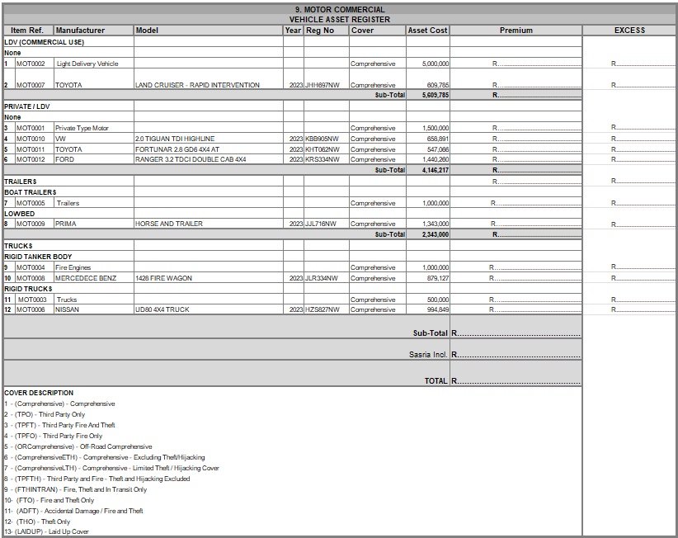

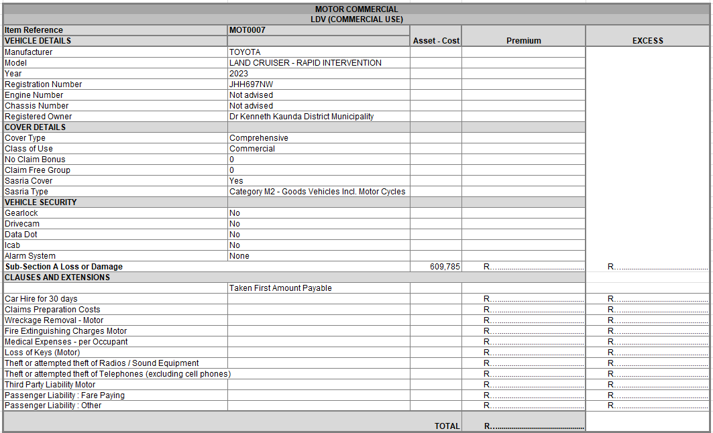
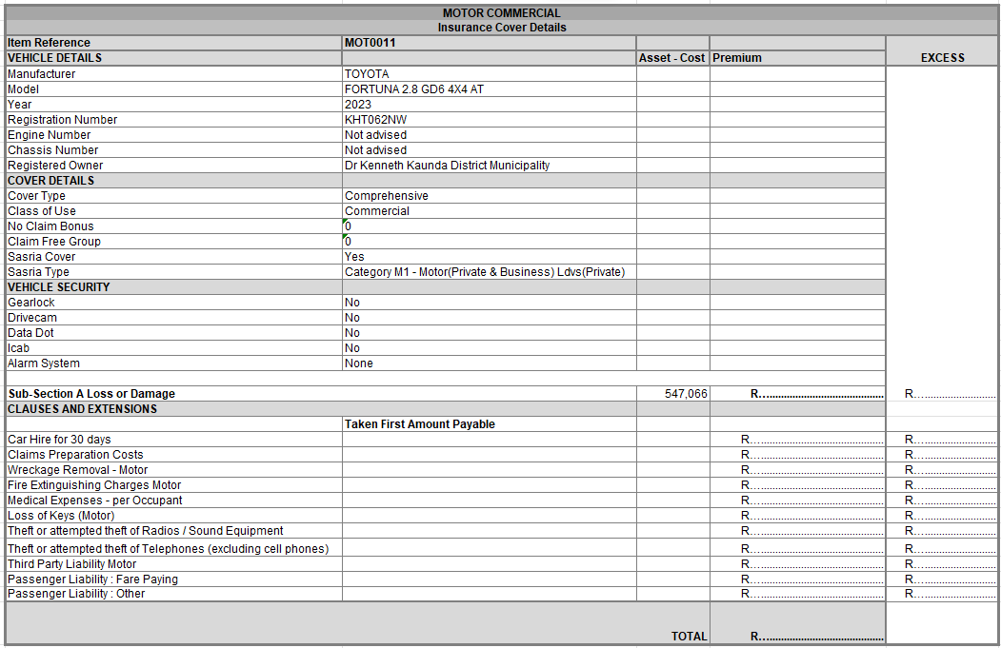
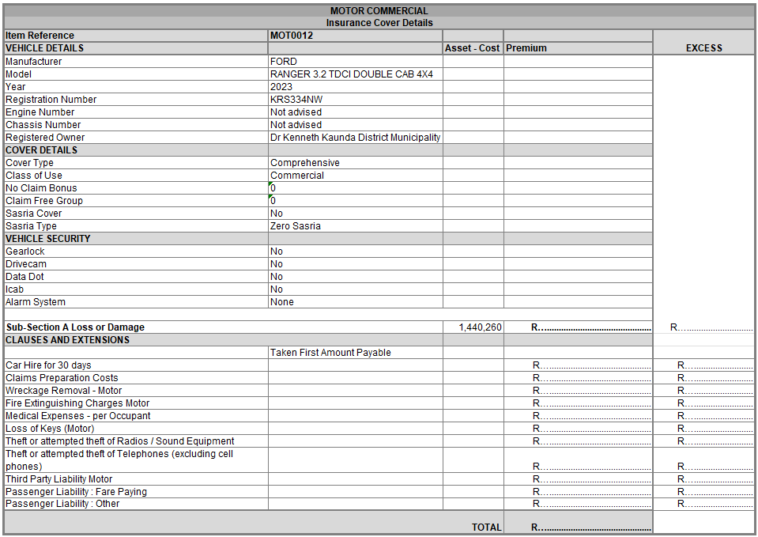
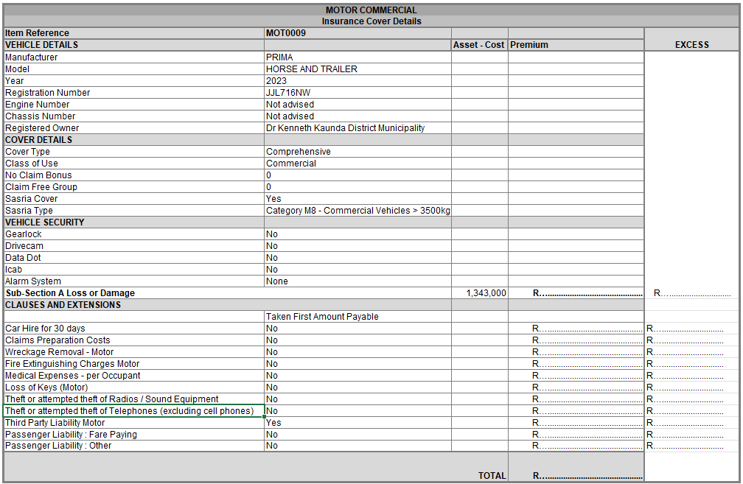
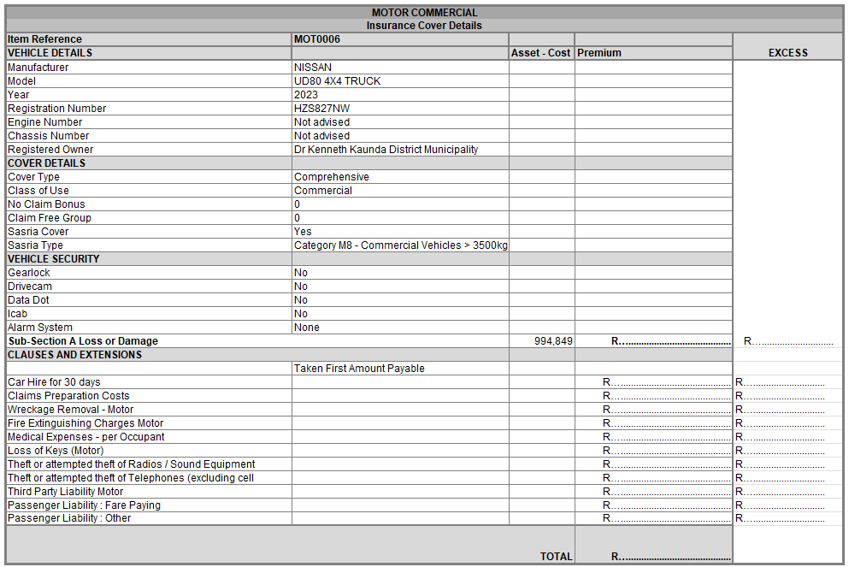
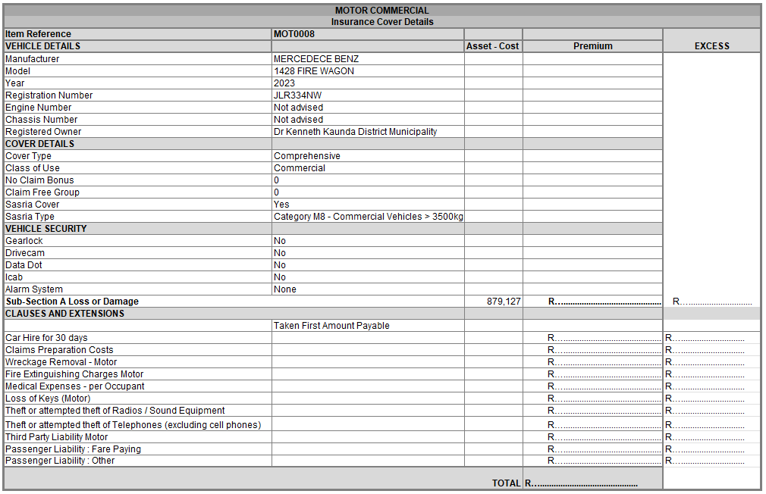
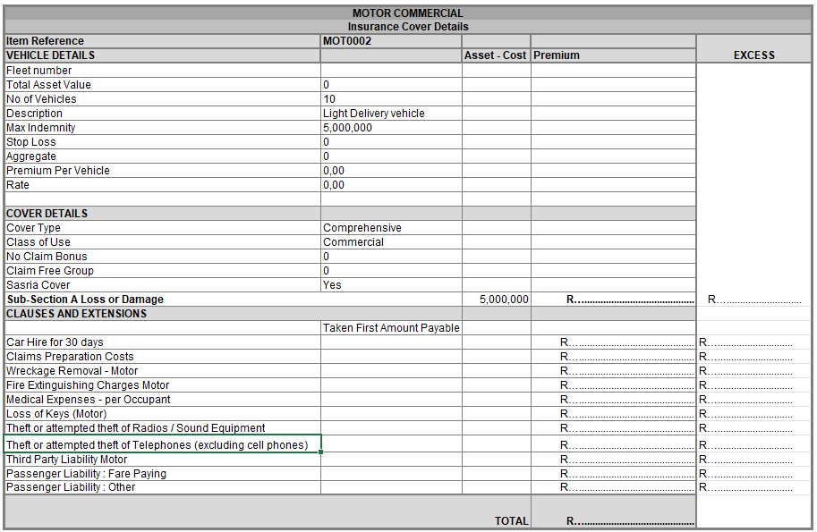
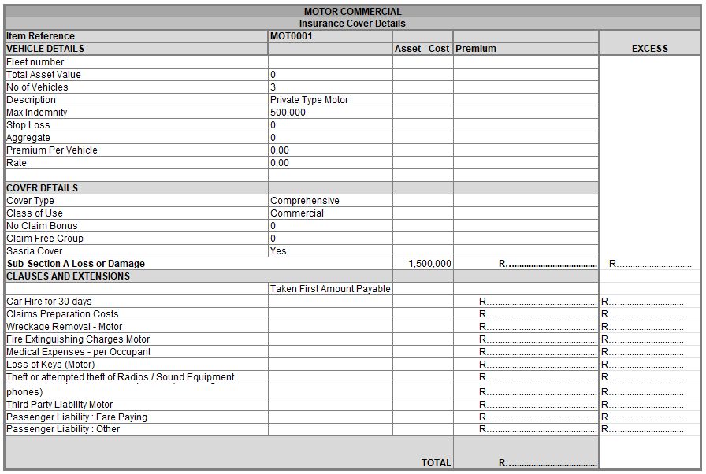
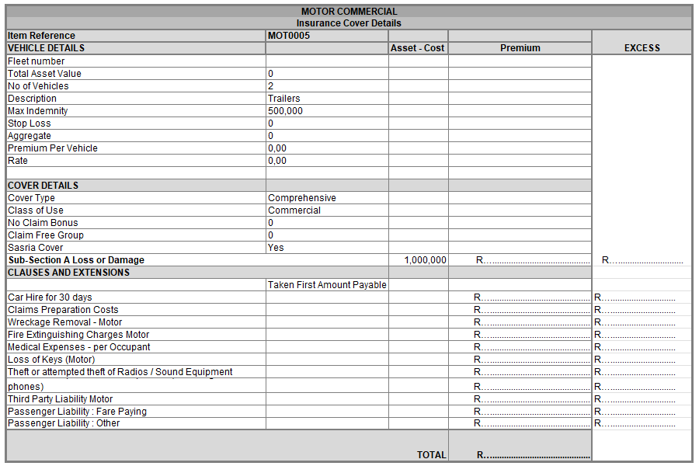
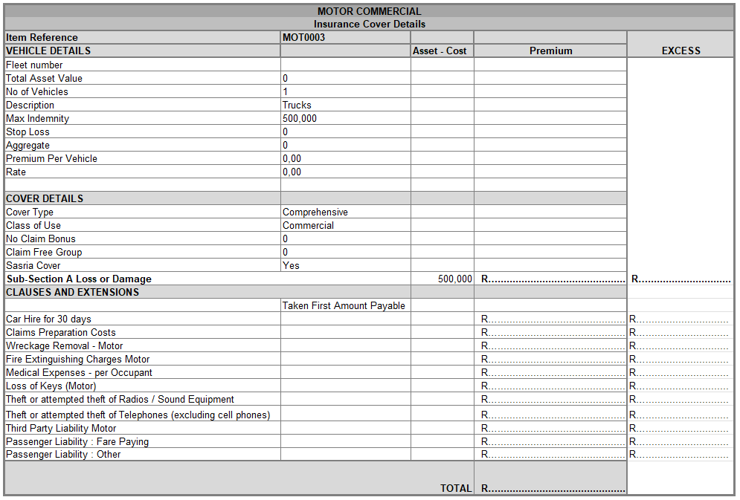
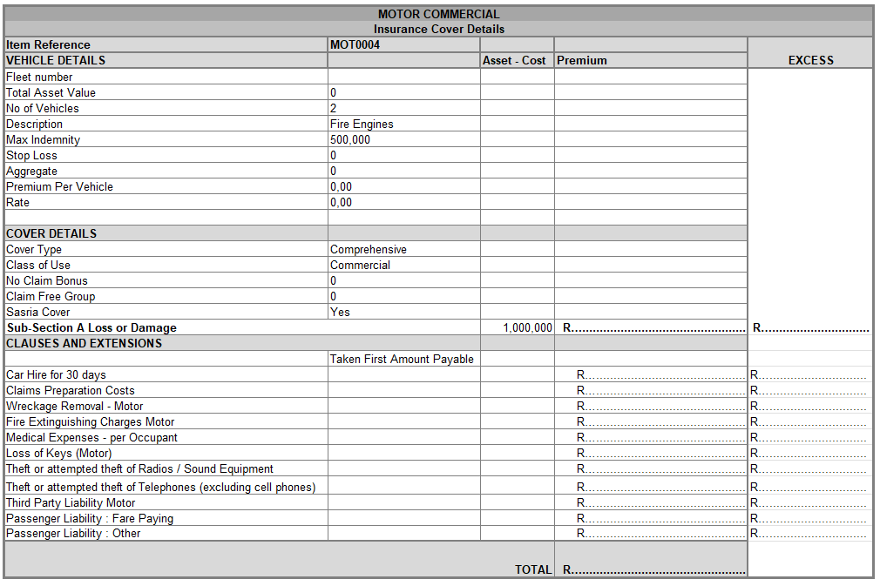
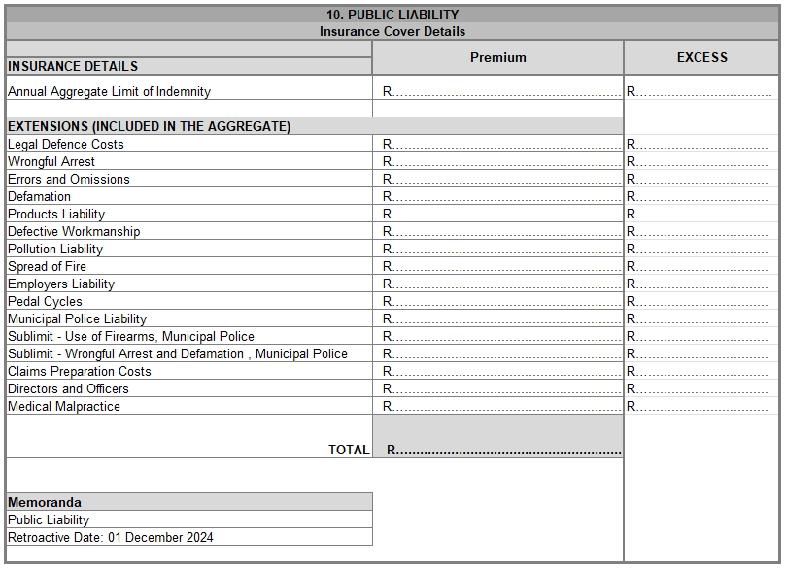
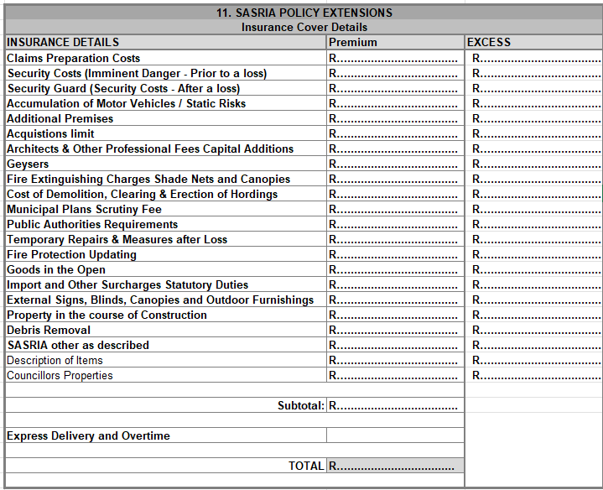
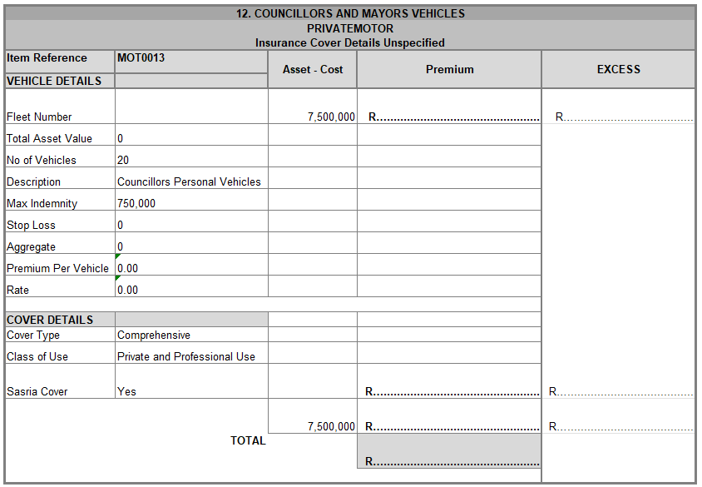
Summary
TYPE OF  POLICY | TOTAL INSURED  AMOUNT | TARIFF | PREMIUM |  | SASRIA |  | Excess | TOTAL ANNUAL  PREMIUM
1. Material Damage
2. Office Contents
3. Electronic Equipment
4. Business All Risk
5. Theft
6. Fidelity Guarantee
7. Personal Accident Commercial
8. Stated Benefits
9. Motor Commercial
10. Public Liability
11. SASRIA Policy Extensions
12. Councillors and Mayors vehicles
Year 2024-25 Total Premium =
VAT at 15% =
Total Premium (Inclusive of VAT) =
Total Bid Price (Inclusive of VAT) =
Year 2025-26 Total Premium =
VAT at 15% =
Total Premium (Inclusive of VAT) =
Total Bid Price (Inclusive of VAT) =
Year 2026-27 Total Premium =
VAT at 15% =
Total Premium (Inclusive of VAT) =
Total Bid Price (Inclusive of VAT) =
GRAND TOTAL (Inclusive of VAT) (YEAR 1, YEAR 2 AND YEAR 3) (TO BE TRANSFERRED TO THE FORM OF OFFER PAGE) |  |  |  |  |  |  | R……………………………………………………………..

Note: Estimated escalation in percentage for 2nd year: ..................% and 3rd year: % (LINKED TO CPIX)

PART C3
SCOPE OF WORK AND SPECIFICATIONS

BACKGROUND
The Dr Kenneth Kaunda District Municipality (DRKKDM) invites experienced and qualified service providers to tender for the management of the Short-Term Insurance Portfolio of Dr Kenneth Kaunda District Municipality for a contract period of three (3) years.

CURRENT STATE
The Municipality currently has a contract with a service provider, which will expire on the 28th of February 2025.

PROFILE OF THE DR KENNETH KAUNDA DISTRICT MUNICIPALITY
The DRKKDM is classified as a Category C District Municipality and was established on 5 December 2000.
The following Municipalities are within the DRKKDM jurisdiction:
-The City Council of Matlosana Local Municipality
-The Maquassi Hills Local Municipality (Environmental Health)
-The JB Marks Local Municipality (Ventersdorp and Potchefstroom) (Environmental Health)

PROJECT SCOPE
The tenderer will be responsible for the overall management of Dr Kenneth Kaunda District Municipality’s Short-Term Insurance Portfolio, which should include amongst other:
- Placement of the DRKKDM’s Insurance Portfolio and other Underwriting Administration processes.
- Claims administration.
- Review and renewal of the DRKKDM’s Insurance Portfolio over the term of the tender to ensure losses and/or liabilities are minimised.
- Risk assessments fees should be included in the final bidding price.
- Training of staff / capacity building/ skills transfer.
- The tenderer must submit a tender for Full Insurance Cover, as per the detailed schedules that are provided as part of the tender documents.
It should further be noted that the insurance data/values provided, are based on the DRKKDM’s Insurance Portfolio as of 01 July 2024, which will be used for pricing purposes.

PLACEMENT OF THE DRKKDM’S INSURANCE PORTFOLIO AND OTHER UNDERWRITING ADMINISTRATION PROCESSES.
- Assess the DRKKDM’s insurance requirements as reflected in the Tender Specifications.
- Negotiate with Insurance Underwriters on suitable insurance terms and premiums.
- Meet with the DRKKDM’s officials whenever required by either party to discuss or advice on the insurance cover.
- Place the DRKKDM’s insurance portfolio with insurance underwriters that are reputable, financially stable, meet all the relevant statutory requirements.
- Provide the DRKKDM with written confirmation thereof, together with the insurance cover placed.
- Any other processes required to successfully administer the underwriting Procedures.

CLAIMS ADMINISTRATION
The appointed service provider will be responsible to handle all aspects of the claims processes, as the DRKKDM will not communicate directly to any legal representatives of the service provider, third parties or the Underwriter where the insurance is placed.
The appointed service provider will be required to perform at least the following:
- Administer all the DRKKDM’s insurance claims, which fall under the various categories of the insurance policies.
- Administer all claims received by the DRKKDM from third parties’ claiming for personal injury or damage to their property.
- This includes liaising with the third parties on the DRKKDM’s behalf.
- Provide a motivation, based on substantive legal grounds, for all claims that were rejected by the insurance company. The DRKKDM reserve the right to reconsider any opinion received, to refer it back to the service provider for another opinion or recommendation.
- The DRKKDM will under no circumstance communicate directly with the underwriter regarding any aspects of a claim.
- Notifications in respect of:
  - claims registrations,
  - appointment of assessor and
  - authorization of repairs must be submitted to the DRKKDM.
- Confirmation of settlements paid to appointed service providers or the insured must be provided to the DRKKDM to ensure accuracy and completeness of insurance registers.
- Submit monthly reports in respect of all the DRKKDM’s claims submitted, indicating the status of each claim. The report must provide clear details that can identify the claim, indicating date of incident, date reported to the insurers and details of the progress with an indication of the outstanding information to finalise the claim.
- Reports must be provided to the DRKKDM on a monthly basis in respect of all claims measured against the total premiums paid.
- Regularly meet with the relevant DRKKDM municipal officials to discuss and advise on insurance claims.
- The appointed service provider will remain responsible for the administration and
finalisation of all outstanding claims/open claims as at the expiry of this tender (31 January 2028), including claims with a date of loss as of 31 January 2028.
- Public Liability claims are dealt with on a claims-made basis, therefore any such claims received up to the expiration of the current contract/tender (28 February 2025 to 31 January 2028), will be dealt with by the (newly appointed) current service provider.

REVIEW AND RENEWAL OF DRKKDM’S INSURANCE PORTFOLIO
- Annually, and prior to the renewal date, meet with the relevant DRKKDM municipal officials to discuss and advise on any additional insurance cover that may be required to ensure that the DRKKDM’s risk is minimised.
- Renew the DRKKDM’s insurance portfolio with the insurance underwriters at each renewal date, i.e. 01 December each year. Asset additions submitted to the insurer during the year must immediately be added onto the insurance portfolio and confirmed via a confirmation cover letter.
- The municipality will not be held accountable for uninsured assets should the portfolio not be updated accordingly by the service provider.
RISK ASSESSMENTS
Provide annual Risk Assessments to ensure that the DRKKDM has sufficient insurance
coverage and that all risks are minimised.

SKILLS CAPACITY BUILDING
- Provide skills transfer in the event where there are changes in claims procedures, changes in policy conditions, legislation and any changes deemed necessary by the appointed insurance provider;
- Provide guidance and support with general queries regarding the insurance policy conditions and wording as and when required.

GENERAL
- The DRKKDM is not bound to accept the lowest or any tender and reserve the right to accept any tender.
- It is accepted that, in the case of every type of policy tendered for, the tenderer will be willing to underwrite the individual policy type at the premium tendered amount, without any other policies being granted to.
- The tenderer must provide amounts payable per line item, in respect of Excess
- Payments for each asset, as per the applicable tender schedules.
- Liability for payment of Assessor Fees must be for the account of the tenderer.
- The submission of a tender signifies complete acceptance of the conditions contained in these instructions, the form of tender and the annexures.
- Tenders may only be submitted on the official tender document. The tender documents must be fully completed and signed.
- Tenderers must submit fully completed schedules of items for insurance cover together with each tender submitted, containing the detailed premium calculations for each class of insurance, over the tender period. These calculations must be submitted on a separate spread sheet in Microsoft Excel sheet format. Tenderers must ensure that the tender submission must include a printed version of any and all of these schedules, duly signed off.
- Any deviations, limitations or unfamiliar conditions must be clearly stipulated in respect of each policy type.
- All Brokers fees and any other administrative fees that will be payable, must be included in the insurance premiums.
- A detail description of the assets, amounts insured, et cetera, is furnished herewith, according to information currently available. However, the DRKKDM reserves the right to adjust details in respect of final number, description and value of individual items for insurance cover, if necessary, at the final placement of the insurance.
- The DRKKDM reserves the right to notify the tenderer of any adjustments, additions and or disposals during the period of the contract, for which the appropriate adjustments in premium payable / refund must be affected.
- All payments due by the DRKKDM in terms of claims and other related matters, including excess payments, will be paid over to the appointed service provider within 30 days. Any payments in respect of the insurer or any other creditor, will have to be transferred from the appointed service providers’ account.

SASRIA
- SASRIA rates must be included as a line item wherever applicable.
- In addition, Insurance cover need to be provided to all DR KKDM’s municipal councillors, for the loss of or damage to a councillor’s personal immoveable or moveable property and assets, as well as life and disability cover, for any loss or damage caused by riot, civil unrest, strike or public disorder, excluding property used by such councillor for business purposes.

APPOINTMENT OF ASSESSORS
- The Service provider will appoint an assessor as recommended by the Insurer within 5 (five) working days to investigate, evaluate, revise and authorize the quotations of vehicles involved in accidents or any other claim, as required by the insurer and/or the DR KKDM.
- The Service provider will provide to the appointed assessor the available information, documentation, declared value of the vehicle or any other claim and policy wording upon appointment.
- The Service provider will submit the assessors report and revised quotation within 5 (five) working days after the vehicle was assessed by the assessor or for any other claim to the employees of the Mechanical Maintenance Division and the relevant employee of the Insurance and Insurance Management Section.
- The assessor must recommend that the vehicle be either repaired by a Pannel beater approved by the assessor or written off as per the insurance policy wording.
- The Service provider must submit within 1 (one) working day after the assessor’s report was received with the recommendation that the vehicle must be written off as per the insurance policy wording a formal letter requesting that the vehicle be deregistered by DR Kenneth Kaunda District Municipality or the lease company.
- The Service provider will be responsible for the payment of Assessors to investigate, evaluate, revise and authorize the quotations of vehicles involved in accidents or any other incident which require the services of an Assessor.

EXCESS AMOUNTS
Excess amounts are to be shown clearly, otherwise the DR KKDM will assume that no deductible amount will apply, and this may not be rectified afterwards. The excess amounts tendered must remain firm.

PRICING REQUIREMENTS
- Tender prices must be in ZAR Currency (Rand).
- The premium tendered must remain firm for a period of 12 months and must include any broker fees. Tender rates must be submitted exclusive of Value-added-Tax of 15%, but the final bid price submitted must include VAT.
- Where extensions are granted free of charge, must be stated clearly.
- All costs must be included in the bid price.

COMPULSORY CONDITIONS/CRITERIA
- The bidder must be registered as an authorised financial service provider (Supply evidence)
- The bidder must have the relevant Professional Indemnity and relevant guarantees (Supply evidence)
- The bidder must provide the names of a minimum of 4 (four) municipalities in the Republic of South Africa that they serve as Insurer broker, included written reference letters as proof of satisfaction of work performed.
- The bidder must provide the following information of a minimum of 3 staff, including legal advisory support, dedicated to the municipality:
  - Name
  - Contact details
  - Qualifications
  - Years relevant experience
  - (The bidder must inform the municipality of any changes in advance)

COMPULSORY INSURANCE DOCUMENTATION TO BE SUBMITTED WITH THE TENDER BID:
- IRMSA (Institute of Risk Management South Africa) certificate
- Professional Indemnity Insurance
- Fidelity Insurance
- Letter of Good Standing (Dept of Labor)
- FSCA (Financial sector conduct authority)

CURRENT INSURANCE PORTFOLIO (attached) AND THREE (3) YEAR CLAIM HISTORY:

3 Year Claim History

