# | Question | Answer
1 | May you kindly provide clarity on the requirement relating to the provision of security for performance, as referenced on page 7 of the tender document (screenshot below).  Could you please confirm whether the performance security will be a pre-requisite at the tender submission stage, or whether this requirement will only apply post-award?  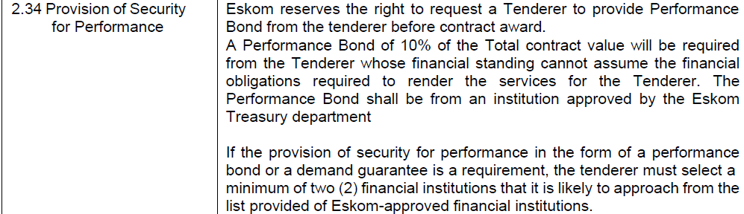 | This will be required at the award stage if the suppliers are not financially sound to be awarded a contract
2 | 240-12248652 List of Tender Returnables Rev7 (Quality)  Please advise whether the "Cover" Tab in this document needs to be completed by the Tenderer or whether it is for Internal Eskom us only for evaluation purposes | This document serves as a guide for suppliers to know what submit on quality.
3 | We humbly need your assistance with the issue of demo units for Eskom Tender : E3359CXMWP. We have approached the OEM’S who are not keen to issue demo units to every qualifying company for this tender. This being the case we need your guidance on how to approach this issue of the demo units. For example, what will happen if 10 or more companies pass to the next stage on a desktop for example? Does Eskom need 10 or more desktops of the same specs.?? The situation becomes a little fcomplex if notebooks are also included.  Please assist | Each Tenderer is required to supply their own Demo Units. The reason for this is transparency. If Tenderers for instance want the same Demo Unit/s to be evaluated for different Tenderers and the Demo Unit Fails for instance on Startup, All the Tenderers who are evaluated for that specific device will be disqualified. Each Tenderer should negotiate with the Distributors/OEM’S for the Demo Units. Alternatively, the Tenderers will have to Purchase each device that they would like to submit as a Demo Unit.

