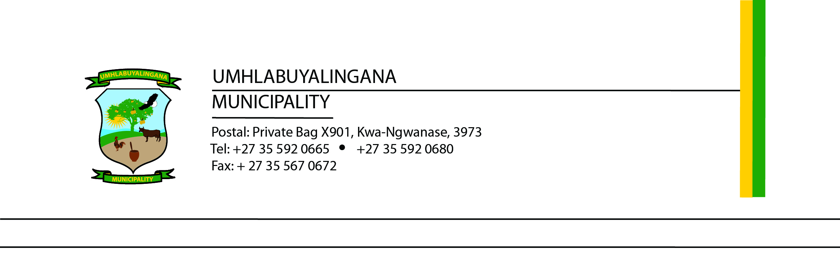

TENDER NOTICE
Bid Number: UMHL14/2025/2026
Procurement and Renewal of Microsoft 365 Business Standard Licenses for 160 Users
Umhlabuyalingana Local Municipality invites Microsoft-accredited service providers to submit proposals for the procurement and renewal of Microsoft 365 Business Standard licenses for 160 users over a 12-month period.

Scope of Work:
- Supply, renew, and activate licenses under the Municipality’s existing tenant
- Provide full technical support throughout the license term
- Enable user reassignment and editing flexibility during the year

Tender Documents:
Available electronically from Thursday, 20 November 2025 on:
- www.etender.gov.za
- www.umhlabuyalingana.gov.za

Submission Details:
- Closing Date: Thursday, 11 December 2025 at 12:00
- Submission Location: Tender Box at the Foyer, Umhlabuyalingana Local Municipality Offices, R22 Manguzi Main Road, KwaNgwanase, 3973
- Envelope Label: “TENDER NUMBER: UMHL 14/2025/2026: TENDER FOR PROCUREMENT AND RENEWAL OF MICROSOFT 365 BUSINESS STANDARD LICENSES”

Important Notes:
- No telephonic, email, or late submissions will be accepted
- Evaluation: 80 points for price, 20 points for specific goals (proof required)
- Mandatory documents include:
  - Valid Tax Compliance Status PIN
  - Microsoft Partner Accreditation Letter
  - National Treasury CSD Summary Report
  - Municipal Rate ( not older than 3 months)
  - All documents outlined in the bid specification
- Validity period: 90 days from closing date
- The Municipality reserves the right to accept any tender, in whole or part, and appoint multiple contractors

Inquiries:
All questions must be submitted in writing to:
- Procurement: bafanam@mhlabuyalingana.gov.za
- Technical: celumusak@mhlabuyalingana.gov.za, mxolisin@mhlabuyalingana.gov.za

Yours sincerely

………………….
Mr N.P.E. Myeni
Municipal Manager

