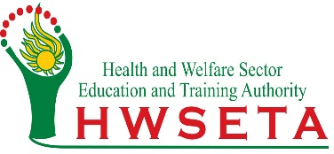
INVITATION TO TENDER

HWSETA Mission: The Health and Welfare Sector Education and Training Authority (HWSETA) endeavours to create an integrated approach to the development and provision of appropriately skilled health and social development workers, to render quality services comparable to world class standards.

HWSETA Vision: The creation of a skilled workforce for the health and social development needs of all South Africans.

Bid Description | Briefing Session Date and Closing Date
ADVERT  Appointment of supplier to provide internet lines for all HWSETA Offices.  Bid Ref No: HWSETA008-2025 | Briefing: 15 August 2025 @10h00  Closing date: 24 August 2025 @11h00

Specifications of the requirements for the above tenders may be viewed on the HWSETA website- at www.hwseta.org.za.
Alternatively, a copy of the specifications may be obtained via-email from: tenders@hwseta.org.za or the e-Tender portal.
Please note: The compulsory briefing sessions will be held via teams. Submissions fir the tenders close at 11h00 am on the dates outlined above
For more information and to confirm your attendance at the compulsory briefing session please contact Mrs N. Motloung at the Procurement Unit by emailing: tenders@ hwseta.org.za
All submissions must be placed in the tender box, HWSETA Head Office, 17 Bradford Road, Bedfordview, Gauteng, during office hours:9h00-15h00 Mondays to Fridays.

