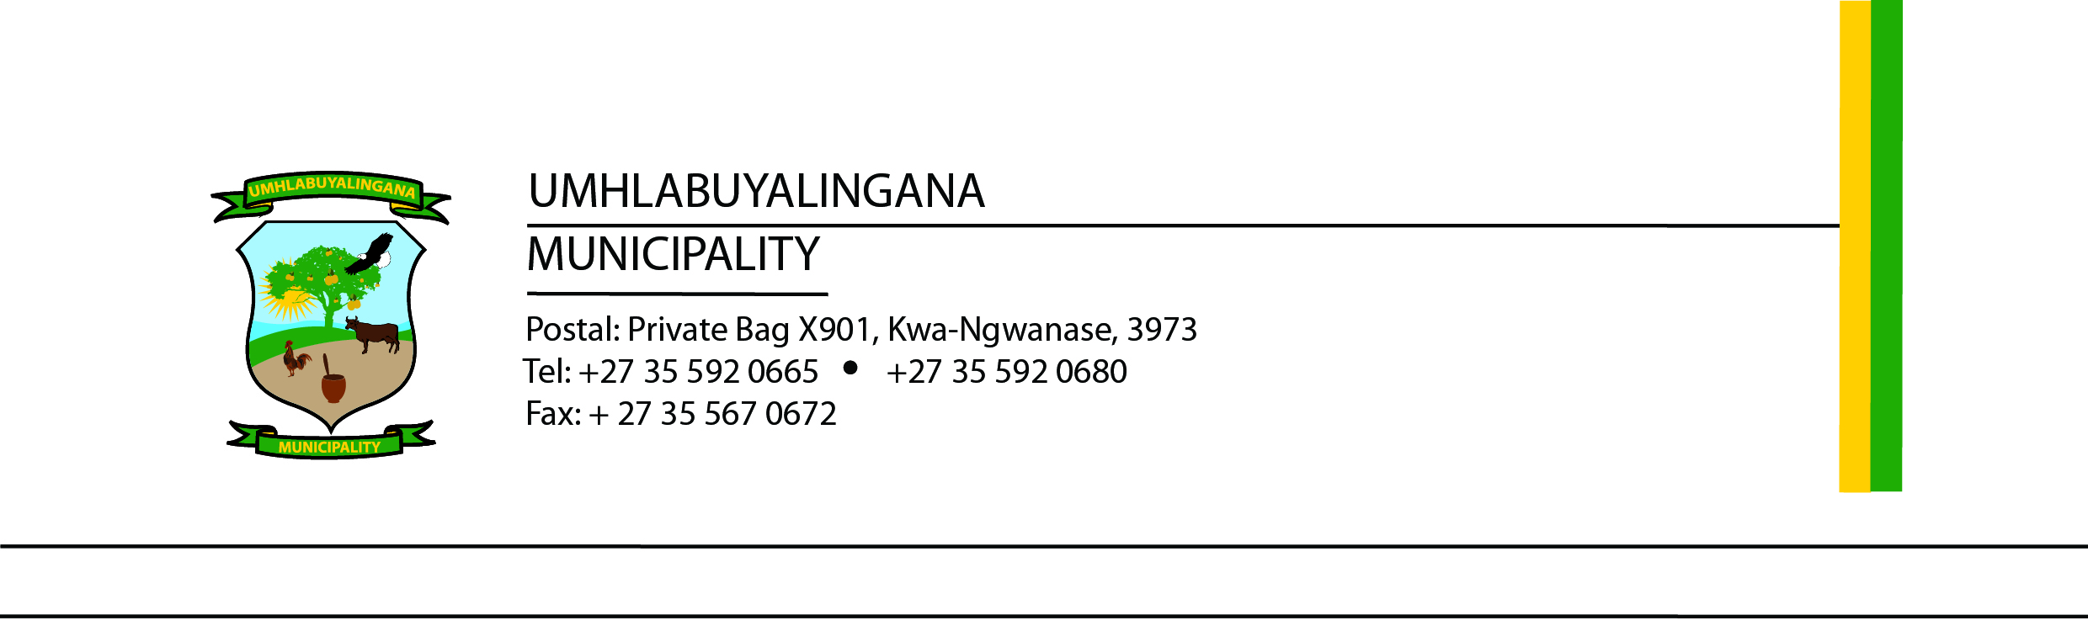

RENEWAL OF MBAZWANA & SKHEMELELE LANDFILL SITE WASTE MANAGEMENT LICENSE
TENDER NUMBER: UMHL34/2025/ 2026
The Municipality hereby invites suitably qualified and experienced service providers to submit bids for the Renewal of the Mbazwana Landfill Site Waste Management License and Closure of Sikhemelele Landfill Site in compliance with applicable environmental legislation and regulations.
The successful bidder will be required to provide professional environmental consulting services, including:
- Assessment of current landfill operations and compliance status;
- Compilation and submission of all required documentation;
- Conducting environmental studies and specialist assessments where required;
- Liaison with relevant authorities and stakeholders;
- Facilitation of public participation processes;
- Preparation and submission of the Waste Management license Renewal Application;
- Preparation and submission of closure documentation for Sikhemelele Landfill Site; and
- Assisting the Municipality until approval/finalisation of the License renewal and closure processes.
The project must comply with all applicable environmental legislation.
Bidders must submit the following:
- Company registration documents;
- Valid Tax Compliance Status PIN;
- CSD registration report;
- Relevant experience in landfill licensing and environmental compliance;
- MBDs; and
- Municipal Rates.
Bids will be evaluated in terms of the Municipality’s Supply Chain Management Policy and Preferential Procurement Regulations based on Functionality, Price and Specific Goals. Only bidders achieving the minimum functionality threshold of 60% will be considered for further evaluation.
Tender documents will be obtainable from the Municipality’s website www.umhlabuyalingana.gov.za or on eTenders portal www.etenders.gov.za .
A compulsory briefing session/site inspection will be held as follows:
Date: 20 May 2026, Time: 10h00 am, Venue: Umhlabuyalingana Municipality, Old Main Boardroom situated on R22 Manguzi Main Road, KwaNgwanase, 3973.
Completed tender documents clearly marked:

“RENEWAL OF MBAZWANA & SIKHEMELELE LANDFILL SITE WASTE MANAGEMENT LICENSE” TENDER NUMBER: UMHL34/2025/2026
must be placed in the tender box at the Municipal Offices no later than:
Closing Date: 05 June 2026, Time: 12h00 pm
Late, faxed or emailed bids will not be accepted.

Enquiries
Technical Enquiries can be directed to Director Community Services Mr W.S. Nhlenyama on williamn@mhlabuyalingana.gov.za
SCM Enquiries can be directed to SCM Manager Mr NM Mthembu on bafanam@mhlabuyalingana.gov.za
The Municipality reserves the right not to accept the lowest or any tender received.

Mr NPE Myeni
Municipal Manager

