Smart cane size 48 – Quantity 1

Ambutech Mobility Cane with Marshmallow tip– Adult

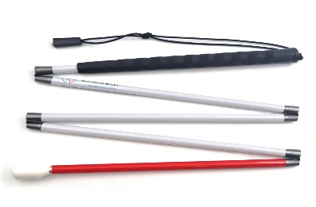

Smart cane size 46 – Quantity 1

Ambutech Mobility Cane with marshmallow tip– Adult

Additional information to the spec
- Tested for structural integrity and durability.
- height-adjustable, and properly weighted.
- Validated sensor accuracy for obstacles and falls detection.
Mandatory requirements:
- The supplier must be accredited by NCPD (National Council of and for Persons with Disabilities) and Disability Info South Africa (DISA) - Produce certification

