

APPOINTMENT OF A PROFESSIONAL AND EXPERIENCED SERVICE PROVIDER TO SUPPLY, DELIVER, ASSEMBLE, AND INSTALL OFFICE FURNITURE AT THE UGU DISTRICT MUNICIPALITY OFFICES, 96 MARINE DRIVE, OSLO BEACH

CONTRACT NO: UGU-05-1656-2024

NAME OF BIDDER:
CONTACT PERSON:
TELEPHONE Nº :
FAX Nº /EMAIL ADD.:
ADDRESS :

BID CLOSES: 12H00 ON FRIDAY, 23 FEBRUARY 2024

Note: This bid document must NOT be separated;
Annexures are to be attached to the back of the document.

Table of Contents
Bid Notice 3
UDM / MBD 1 5
UDM /SBD 4 8
UDM/ MBD 6.1 11
UDM/MBD 7.2 17
UDM/MBD 7.2 18
CERTIFICATE FOR PAYMENT OF MUNICIPAL SERVICES 19
COPY OF THE LATEST MUNICIPAL ACCOUNT OR AFFIDAVIT OR LEASE AGREEMENT 21
A. OFFER……………………………………………………………………………………………………………………………………….22
B. ACCEPTANCE 23
TERMS OF REFERENCE/SPECIFICATION 24
CK DOCUMENT/ID DOCUMENT ………………………………………………………………………………………………………..33
TAX REFERENCE NUMBER AND PIN ………………………………………………………………………………………………….34
JOINT VENTURE AGREEMENT (WHERE APPLICABLE)…………………………………………………………………………35
CERTIFIED VALID BBBEE CERTIFICATE………………………………………………………………………………………………..36
CENTRAL SUPPLIER DATABASE REGISTRATION………………………………………………………………………………....37
SPECIFIC GOALS SUPPORTING DOCUMENTS……………………………………………………………………………………..38
EXPERIENCE OF BIDDER…………………..…………………………………………………………………………………….………….39
EXPERIENCE OF PERSONNEL ….……………………………………………….……………………………………………………....40
TIMELINES……………………………………..…………………………………………..…………………………………………………….41
SAMPLES ASSESSMENT REPORT………………….…………………………..………………………………………………………..42
PRICING SCHEDULE…………………………………………………………………………………………………………………………..43



Bid Notice
APPOINTMENT OF A SERVICE PROVIDER TO SUPPLY, DELIVER, ASSEMBLE, AND INSTALL OFFICE FURNITURE AT THE UGU DISTRICT MUNICIPALITY OFFICES, 96 MARINE DRIVE, OSLO BEACH

CONTRACT NO: UGU-05-1656-2024

Bids are hereby invited from professional and experienced service providers to be appointed to Supply, Deliver, Assemble and Install Office Furniture at the Ugu District Municipality on 96 Marine Drive, Oslo Beach.
Bid documents are obtainable from the Ugu District Municipality office in Port Shepstone at No. 28 Connor Street as from Tuesday, 23 January 2024, at a non-refundable payment of R250.00 (No cheques will be accepted). The bid will also be advertised on the municipality’s website and e-Tender Portal where documents can be downloaded from the website, free of charge.
Bids completed in accordance with the conditions indicated in documents, must be sealed and endorsed with the relevant contract number and be deposited in the official tender box at the foyer of Ugu District Municipality on 96 Marine Drive, Phase 2 Building, Oslo Beach not later than 12h00 on Friday, 23 February 2024, at which time bids will be opened in public. Bids that are submitted late, incomplete, unsigned or by facsimile, electronically, or not completed in black ink will be rejected and not accepted for further evaluation. Bids submitted must be valid for a period of 90 days. The Municipality reserves the right to request bidders for the extension of the tender validity period.
A compulsory briefing will be held at the Ugu District Municipal Offices, at 96 Marine Drive, Phase 3 Building, on Wednesday, 31 January 2024 at 10h00. Bidders who fail to attend this compulsory meeting will not be considered for further evaluation. All bid enquiries are to be directed to the Registry and Auxiliary Officer, Ms Shivani Maharaj during office hours on (039) 688 5775/5795 or emailed to Shivani.Maharaj@ugu.gov.za
The bid will be evaluated on functionality, price and preference.
Minimum points of 60% must be obtained for eligibility. Bids scoring less than 60% will not be evaluated further. The following, will form criteria utilised for functionality assessment:
- Experience of Bidder
- Experience of Personnel
- Timelines
- Compliance to Quality Standards

Ugu District Municipality subscribes to the Preferential Procurement Regulations 2022, pertaining to the Preferential Procurement Policy Framework Act (PPPFA) principles whereby a bidder’s submission will be evaluated according to the sum of the award of points in respect of the tender value and Specific Goals.
Price and Preference will be used for evaluation. The 80/20 preferential point system will be applicable, with 80 points for price and 20 points for Specific Goals (See below table), in terms of revised Preferential Procurement Regulation in effect from 16 January 2023 Gazette Notice No. 47452 dated 04 November 2022.
Points to be allocated as follows:
 | Categories | 80|20
1 | Ownership | 12
2 | Reconstruction & Development Programme | 6
3 | Other Specific Goals- | 2
 |  | 20
# | Specific Goal(s) | 80|20 PP
 | Ownership Categories :
1 | Broad Based Black Economic Empowerment:
 | 1. BBBEE Level 1 | 12
 | 2.BBBEE Level 2 | 10
 | 3. BBBEE Level 3 to 8 | 6
2 | Promotion of Local Business(s)
 | 1. Enterprise Located within the District Municipality - Rural | 6
 | 2. Enterprise Located within the District Municipality - Urban | 4
 | 2. Enterprise Located within the Province | 3
3 | Other Specified Goals
 | 1. Enterprise 100% owned by Youth/Women/Disabled/ Military V | 2

The Council reserves the right not to accept the lowest bid or any bid and reserves the right to accept the whole or part of the bid, or to reject all bids and cancel the notice to tender.

Kindly note: Regulation 44 of Municipal Supply Chain Management Regulations states that the Municipality may not make any award to a person who is in the service of the state

VO MAZIBUKO
ACTING MUNICIPAL MANAGER
UGU DISTRICT MUNICIPALITY

PART A
INVITATION TO BID

YOU ARE HEREBY INVITED TO BID FOR REQUIREMENTS OF UGU DISTRICT MUNICIPALITY
BID NUMBER: | UGU-05-1656-2024 | CLOSING DATE: | 23 FEBRUARY 2024 | CLOSING TIME: | 12H00
DESCRIPTION | APPOINTMENT OF A SERVICE PROVIDER TO DELIVER, ASSEMBLE AND INSTALL OFFICE FURNITURE AT THE UGU DISTRICT MUNICIPALITY OFFICES ON 96 MARINE DRIVER, OSLO BEACH
THE SUCCESSFUL BIDDER WILL BE REQUIRED TO FILL IN AND SIGN A WRITTEN CONTRACT FORM (MBD7).

MBD 1

B
BID RESPONSE DOCUMENTS MAY BE DEPOSITED IN THE BID BOX
SITUATED AT (STREET ADDRESS _____
UGU DISTRICT MUNICIPALITY
93 MARINE DRIVE
PHASE 2 BUILDING
OSLO BEACH
- BRIEFING SESSION/SITE INSPECTION

SUPPLIER INFORMATION
NAME OF BIDDER
POSTAL ADDRESS
STREET ADDRESS
TELEPHONE NUMBER | CODE |  |  |  |  | NUMBER
CELLPHONE NUMBER
FACSIMILE NUMBER | CODE |  |  |  |  | NUMBER
E-MAIL ADDRESS
VAT REGISTRATION NUMBER
TAX COMPLIANCE STATUS | TCS PIN: |  |  | OR |  | CSD No:
B-BBEE STATUS LEVEL VERIFICATION CERTIFICATE  [TICK APPLICABLE BOX] | Yes  No |  |  | B-BBEE STATUS LEVEL SWORN AFFIDAVIT |  |  | Yes  No
ARE YOU THE ACCREDITED REPRESENTATIVE IN SOUTH AFRICA FOR THE GOODS ISERVICES IWORKS OFFERED? | Yes No  [IF YES ENCLOSE PROOF] |  |  |  | ARE YOU A FOREIGN  BASED SUPPLIER FOR THE GOODS ISERVICES IWORKS OFFERED? |  |  |  | Yes No  [IF YES, ANSWER PART B:3 ]
TOTAL NUMBER OF ITEMS OFFERED |  |  |  |  | TOTAL BID PRICE |  |  |  | As per the Pricing Schedule
SIGNATURE OF BIDDER | ……………………………… |  |  |  | DATE
CAPACITY UNDER WHICH THIS BID IS
SIGNED
BIDDING PROCEDURE ENQUIRIES MAY BE DIRECTED TO: |  |  | TECHNICAL INFORMATION MAY BE DIRECTED TO:
DEPARTMENT | SCM Unit |  | CONTACT PERSON |  |  |  |  | Ms S Maharaj
CONTACT PERSON | Ms N Mabaso |  | TELEPHONE NUMBER |  |  |  |  | 039-688 5775
TELEPHONE NUMBER | 039-688 5906 |  | FACSIMILE NUMBER |  |  |  |  | N/A
FACSIMILE NUMBER | N/A |  | E-MAIL ADDRESS |  |  |  |  | Shivani.Maharaj@ugu.gov.za
E-MAIL ADDRESS | Ntabiso.Mzotho@ugu.gov.za

PART B
TERMS AND CONDITIONS FOR BIDDING

1. BID SUBMISSION:
1.1. BIDS MUST BE DELIVERED BY THE STIPULATED TIME TO THE CORRECT ADDRESS. LATE BIDS WILL NOT BE
ACCEPTED FOR CONSIDERATION.

1.2. ALL BIDS MUST BE SUBMITTED ON THE OFFICIAL FORMS PROVIDED-(NOT TO BE RE-TYPED)

1.3. THIS BID IS SUBJECT TO THE PREFERENTIAL PROCUREMENT POLICY FRAMEWORK ACT AND THE PREFERENTIAL PROCUREMENT REGULATIONS, 2022, THE GENERAL CONDITIONS OF CONTRACT (GCC) AND, IF APPLICABLE, ANY OTHER SPECIAL CONDITIONS OF CONTRACT.
2. TAX COMPLIANCE REQUIREMENTS
2.1 BIDDERS MUST ENSURE COMPLIANCE WITH THEIR TAX OBLIGATIONS AND ARE REQUIRED TO SUBMIT VALID TAX
CLEARANCE CERTIFICATE.

2.2 IN BIDS WHERE CONSORTIA I JOINT VENTURES I SUB-CONTRACTORS ARE INVOLVED, EACH PARTY MUST SUBMIT A SEPARATE TCS CERTIFICATE / PIN / CSD NUMBER.

NB: FAILURE TO PROVIDE ANY OF THE ABOVE PARTICULARS MAY RENDER THE BID INVALID.
NO BIDS WILL BE CONSIDERED FROM PERSONS IN THE SERVICE OF THE STATE.

SIGNATURE OF BIDDER: …………………………………………… CAPACITY UNDER WHICH THIS BID IS SIGNED: …………………………………………… DATE: …………………………………………...

Please attach copies of the following documents. Failure to provide the following duly completed and up to date documents and certified where applicable will lead to automatic disqualification.

- Company registration documents.
- Tax Reference Number and Pin
- All Declarations Forms
- ID Document (for sole proprietors)
- Joint Venture Agreement (where applicable)
- Proof of payment for Municipal Services
- Central Supplier Database Registration
- Form of Offer
- Pricing Schedule

SBD 4

- BIDDER’S DISCLOSURE

- PURPOSE OF THE FORM
Any person (natural or juristic) may make an offer or offers in terms of this invitation to bid. In line with the principles of transparency, accountability, impartiality, and ethics as enshrined in the Constitution of the Republic of South Africa and further expressed in various pieces of legislation, it is required for the bidder to make this declaration in respect of the details required hereunder.

Where a person/s are listed in the Register for Tender Defaulters and / or the List of Restricted Suppliers, that person will automatically be disqualified from the bid process.

- Bidder’s declaration
  - Is the bidder, or any of its directors / trustees / shareholders / members / partners or any person having a controlling interest1 in the enterprise, employed by the state? YES/NO

    - If so, furnish particulars of the names, individual identity numbers, and, if applicable, state employee numbers of sole proprietor/ directors / trustees / shareholders / members/ partners or any person having a controlling interest in the enterprise, in table below.

Full Name | Identity Number | Name of State institution

  - Do you, or any person connected with the bidder, have a relationship

1 the power, by one person or a group of persons holding the majority of the equity of an enterprise, alternatively, the person/s having the deciding vote or power to influence or to direct the course and decisions of the enterprise.

with any person who is employed by the procuring institution? YES/NO

    - If so, furnish particulars:
……………………………………………………………………………………
……………………………………………………………………………………

  - Does the bidder or any of its directors / trustees / shareholders / members / partners or any person having a controlling interest in the enterprise have any interest in any other related enterprise whether or not they are bidding for this contract? YES/NO

    - If so, furnish particulars:
…………………………………………………………………………….
…………………………………………………………………………….

- DECLARATION

I, the undersigned, (name) in
submitting the accompanying bid, do hereby make the following statements that I certify to be true and complete in every respect:

  - I have read and I understand the contents of this disclosure;
  - I understand that the accompanying bid will be disqualified if this disclosure is found not to be true and complete in every respect;
  - The bidder has arrived at the accompanying bid independently from, and without consultation, communication, agreement or arrangement with any competitor. However, communication between partners in a joint venture or consortium2 will not be construed as collusive bidding.
  - In addition, there have been no consultations, communications, agreements or arrangements with any competitor regarding the quality, quantity, specifications, prices, including methods, factors or formulas used to calculate prices, market allocation, the intention or decision to submit or not to submit the bid, bidding with the intention not to win the bid and conditions or delivery particulars of the products or services to which this bid invitation relates.
  - The terms of the accompanying bid have not been, and will not be, disclosed by the bidder, directly or indirectly, to any competitor, prior to the date and time of the official bid opening or of the awarding of the contract.

  - There have been no consultations, communications, agreements or arrangements made by the bidder with any official of the procuring

2 Joint venture or Consortium means an association of persons for the purpose of combining their expertise, property, capital, efforts, skill and knowledge in an activity for the execution of a contract.

institution in relation to this procurement process prior to and during the bidding process except to provide clarification on the bid submitted where so required by the institution; and the bidder was not involved in the drafting of the specifications or terms of reference for this bid.

  - I am aware that, in addition and without prejudice to any other remedy provided to combat any restrictive practices related to bids and contracts, bids that are suspicious will be reported to the Competition Commission for investigation and possible imposition of administrative penalties in terms of section 59 of the Competition Act No 89 of 1998 and or may be reported to the National Prosecuting Authority (NPA) for criminal investigation and or may be restricted from conducting business with the public sector for a period not exceeding ten (10) years in terms of the Prevention and Combating of Corrupt Activities Act No 12 of 2004 or any other applicable legislation.

I CERTIFY THAT THE INFORMATION FURNISHED IN PARAGRAPHS 1, 2 and 3 ABOVE IS CORRECT.
I ACCEPT THAT THE STATE MAY REJECT THE BID OR ACT AGAINST ME IN TERMS OF PARAGRAPH 6 OF PFMA SCM INSTRUCTION 03 OF 2021/22 ON PREVENTING AND COMBATING ABUSE IN THE SUPPLY CHAIN MANAGEMENT SYSTEM SHOULD THIS DECLARATION PROVE TO BE FALSE.

…………………………………… ………………………………
Signature Date

…………………………………. ………………………………
Position Name of Bidder

MBD 6.1

PREFERENCE POINTS CLAIM FORM IN TERMS OF THE PREFERENTIAL PROCUREMENT REGULATIONS 2022

This preference form must form part of all tenders invited. It contains general information and serves as a claim form for preference points for specific goals.

NB: BEFORE COMPLETING THIS FORM, TENDERS MUST STUDY THE GENERAL CONDITIONS, DEFINITIONS AND DIRECTIVES APPLICABLE IN RESPECT OF THE TENDER AND PREFERENTIAL PROCUREMENT REGULATIONS,
2022.

- GENERAL CONDITIONS
  - The following preference point systems are applicable to invitations to tender:
- the 80/20 system for requirements with a Rand value of up to R50 000 000 (all applicable taxes included); and
- the 90/10 system for requirements with a Rand value above R50 000 000 (all applicable taxes included).

  - To be completed by the organ of state
(delete whichever is not applicable for this tender).
- The applicable preference point system for this tender is the 90/10 preference point system.

- The applicable preference point system for this tender is the 80/20 preference point system.

- Either the 90/10 or 80/20 preference point system will be applicable in this tender. The lowest/ highest acceptable tender will be used to determine the accurate system once tenders are received.

  - Points for this tender (even in the case of a tender for income-generating contracts) shall be awarded for:
- Price; and
- Specific Goals.

  - To be completed by the organ of state:
The maximum points for this tender are allocated as follows:
 | POINTS
PRICE | 80
SPECIFIC GOALS | 20
Total points for Price and SPECIFIC GOALS | 100

  - Failure on the part of a tenderer to submit proof or documentation required in terms of this tender to claim points for specific goals with the tender, will be interpreted to mean that preference points for specific goals are not claimed.

  - The organ of state reserves the right to require of a tenderer, either before a tender is adjudicated or at any time subsequently, to substantiate any claim in regard to preferences, in any manner required by the organ of state.

- DEFINITIONS
- “tender” means a written offer in the form determined by an organ of state in response to an invitation to provide goods or services through price quotations, competitive tendering process or any other method envisaged in legislation;
- “price” means an amount of money tendered for goods or services, and includes all applicable taxes less all unconditional discounts;
- “rand value” means the total estimated value of a contract in Rand, calculated at the time of bid invitation, and includes all applicable taxes;
- “tender for income-generating contracts” means a written offer in the form determined by an organ of state in response to an invitation for the origination of income-generating contracts through any method envisaged in legislation that will result in a legal agreement between the organ of state and a third party that produces revenue for the organ of state, and includes, but is not limited to, leasing and disposal of assets and concession contracts, excluding direct sales and disposal of assets through public auctions; and
- “the Act” means the Preferential Procurement Policy Framework Act, 2000 (Act No. 5 of 2000).

- FORMULAE FOR PROCUREMENT OF GOODS AND SERVICES

  - POINTS AWARDED FOR PRICE

3.1.1 THE 80/20 OR 90/10 PREFERENCE POINT SYSTEMS
A maximum of 80 or 90 points is allocated for price on the following basis:

80/20 or 90/10

$Ps=80\left(1-\frac{Pt-P\min{}}{P\min{}}\right)$ or $Ps=90\left(1-\frac{Pt-P\min{}}{P\min{}}\right)$
Where
Ps = Points scored for price of tender under consideration
Pt = Price of tender under consideration
Pmin = Price of lowest acceptable tender

  - FORMULAE FOR DISPOSAL OR LEASING OF STATE ASSETS AND INCOME GENERATING PROCUREMENT

    - POINTS AWARDED FOR PRICE

A maximum of 80 or 90 points is allocated for price on the following basis:

80/20 or 90/10

$Ps=80\left(1+\frac{Pt-P\max{}}{P\max{}}\right)$ or $Ps=90\left(1+\frac{Pt-P\max{}}{Pmax}\right)$

Where
Ps = Points scored for price of tender under consideration
Pt = Price of tender under consideration
Pmax = Price of highest acceptable tender

- POINTS AWARDED FOR SPECIFIC GOALS

  - In terms of Regulation 4(2); 5(2); 6(2) and 7(2) of the Preferential Procurement Regulations, preference points must be awarded for specific goals stated in the tender. For the purposes of this tender the tenderer will be allocated points based on the goals stated in table 1 below as may be supported by proof/ documentation stated in the conditions of this tender:
  - In cases where organs of state intend to use Regulation 3(2) of the Regulations, which states that, if it is unclear whether the 80/20 or 90/10 preference point system applies, an organ of state must, in the tender documents, stipulate in the case of—
- an invitation for tender for income-generating contracts, that either the 80/20 or 90/10 preference point system will apply and that the highest acceptable tender will be used to determine the applicable preference point system; or

- any other invitation for tender, that either the 80/20 or 90/10 preference point system will apply and that the lowest acceptable tender will be used to determine the applicable preference point system,
then the organ of state must indicate the points allocated for specific goals for both the 90/10 and 80/20 preference point system.

Table 1: Specific goals for the tender and points claimed are indicated per the table below.
(Note to organs of state: Where either the 90/10 or 80/20 preference point system is applicable, corresponding points must also be indicated as such.
Note to tenderers: The tenderer must indicate how they claim points for each preference point system.)
The specific goals allocated points in terms of this tender | Number of points  allocated  (90/10 system)  (To be completed by the organ of state)  PART A|B | Number of points  allocated  (80/20 system)  (To be completed by the organ of state)  PART A|B | Number of points claimed  (90/10 system)  (To be completed by the tenderer) | Number of points claimed (80/20 system)  (To be completed by the tenderer)
Ownership:
BBBEE Level 1 | 6 | 12
BBBEE Level 2 | 5 | 10
BBBEE Level 3-8 | 3 | 6
Empowerment
1. an EME or QSE which is at least 100% owned by black people;
2. an EME or QSE which is at least 51% owned by black people;
3. an EME or QSE which is at 25% - 50% owned by black people;
RDP
1. Enterprise Located within the District Municipality - Rural | 3 | 6
2. Enterprise Located within the District Municipality - Urban | 2 | 4
2. Enterprise Located within the Province | 1.5 | 3
Other Specific Goal
1. Enterprise 100% owned by Youth/Women/Disabled/ Military V | 1 | 2

DECLARATION WITH REGARD TO COMPANY/FIRM

  - Name of company/firm…………………………………………………………………….
  - Company registration number: …………………………………………………………...
  - TYPE OF COMPANY/ FIRM
Partnership/Joint Venture / Consortium
One-person business/sole propriety
Close corporation
Public Company
Personal Liability Company
(Pty) Limited
Non-Profit Company
State Owned Company
[Tick applicable box]

  - I, the undersigned, who is duly authorised to do so on behalf of the company/firm, certify that the points claimed, based on the specific goals as advised in the tender, qualifies the company/ firm for the preference(s) shown and I acknowledge that:
- The information furnished is true and correct;
- The preference points claimed are in accordance with the General Conditions as indicated in paragraph 1 of this form;
- In the event of a contract being awarded as a result of points claimed as shown in paragraphs 1.4 and 4.2, the contractor may be required to furnish documentary proof to the satisfaction of the organ of state that the claims are correct;
- If the specific goals have been claimed or obtained on a fraudulent basis or any of the conditions of contract have not been fulfilled, the organ of state may, in addition to any other remedy it may have –

  - disqualify the person from the tendering process;
  - recover costs, losses or damages it has incurred or suffered as a result of that person’s conduct;
  - cancel the contract and claim any damages which it has suffered as a result of having to make less favourable arrangements due to such cancellation;
  - recommend that the tenderer or contractor, its shareholders and directors, or only the shareholders and directors who acted on a fraudulent basis, be restricted from obtaining business from any organ of state for a period not exceeding 10 years, after the audi alteram partem (hear the other side) rule has been applied; and
  - forward the matter for criminal prosecution, if deemed necessary

……………………………………….
SIGNATURE(S) OF TENDERER(S)

SURNAME AND NAME: ……………………………………………………….
DATE: ………………………………………………………
ADDRESS: ………………………………………………………
………………………………………………………
………………………………………………………
………………………………………………………

(i)

MBD 7.2

CONTRACT FORM · RENDERING OF SERVICES

THIS FORM MUST BE FILLED IN DUPLICATE BY BOTH THE SERVICE PROVIDER (PART 1) AND THE PURCHASER (PART 2). BOTH FORMS MUST BE SIGNED IN THE ORIGINAL SO THAT THE SERVICE PROVIDER AND THE PURCHASER WOULD BE IN POSSESSION OF ORIGINALLY SIGNED CONTRACTS FOR THEIR RESPECTIVE RECORDS.
PART 1 (TO BE FILLED IN BY THE SERVICE PROVIDER)

1. I hereby undertake to render services described in the attached bidding documents to (name of the institution)............... in accordance with the requirements and task directives I proposals specifications stipulated in Bid Number.......... at the price/s quoted. My offer/s remain binding upon me and open for acceptance by the Purchaser during the validity period indicated and calculated from the closing date of the bid.

2. The following documents shall be deemed to form and be read and construed as part of this agreement:
(i) Bidding documents, viz
- Invitation to bid;
- Tax clearance certificate;
- Pricing schedule(s);
- Filled in task directiveIproposal;
- Preference claims for Specific Goal(s) Contribution in terms of the Preferential Procurement Regulations 2022;
- Declaration of interest;
- Declaration of Bidder's past SCM practices;
- Certificate of Independent Bid Determination;
- Special Conditions of Contract; (ii) General Conditions of Contract; and (iii) Other (specify)
3. I confirm that I have satisfied myself as to the correctness and validity of my bid; that the price(s) and rate(s) quoted cover all the services specified in the bidding documents; that the price(s) and rate(s) cover all my obligations and I accept that any mistakes regarding price(s) and rate(s) and calculations will be at my own risk.
4. I accept full responsibility for the proper execution and fulfilment of all obligations and conditions devolving on me under this agreement as the principal liable for the due fulfillment of this contract.
5. I declare that I have no participation in any collusive practices with any bidder or any other person regarding this or any other bid.
6. I confirm that I am duly authorized to sign this contract.

NAME (PRINT):............... CAPACITY: ................... SIGNATURE : ................ NAME OF FIRM: ................ DATE: ..................

WITNESSES

1 ...............

2 ...............

DATE:............

CONTRACT FORM · RENDERING OF SERVICES

PART 2 (TO BE FILLED IN BY THE PURCHASER)

- I..................in my capacity I in my capacity as

……………………………………accept your bid under reference number……………………………………………………………………………….

dated ................for the rendering of services indicated hereunder and/or further specified in the annexure(s).

2. An official order indicating service delivery instructions is forthcoming.

3. I undertake to make payment for the services rendered in accordance with the terms and conditions of the contract, within 30 (thirty) days after receipt of an invoice.

DESCRIPTION OF SERVICE | PRICE (ALL APPLICABLE TAXES INCLUDED) | COMPLETION DATE | SPECIFIC GOAL LEVEL OF CONTRIBUTION | MINIMUM  THRESHOLD FOR LOCAL PRODUCTION AND CONTENT (if applicable)

4. I confirm that I am duly authorized to sign this contract.

SIGNED AT ............... ON ..............

WITNESSES

1 ............
NAME (PRINT) | .................
SIGNATURE | ................
OFFICIAL STAMP

2 ...........

CERTIFICATE FOR PAYMENT OF MUNICIPAL SERVICES
DECLARATION IN TERMS OF CLAUSE 112(1) OF THE MUNICIPAL FINANCE MANAGEMENT ACT (NO.56
OF 2003) - (To be signed in the presence of a Commissioner of Oaths)
*FAILURE TO SUBMIT ANY PROOF AS REQUIRED, WILL INVALIDATE THE TENDER
I, _______________________________________, _________________ (full name and ID no.), hereby
acknowledge that according to SCM Regulation 38(1)(d)(i), the Municipality may reject the tender of the tenderer
if any municipal rates and taxes or municipal service charges owed by the Tenderer or any of its
directors/members/partners to Ugu District Municipality, or to any other municipality or municipal entity, are in
arrears for more than 3 (three) months.

I declare that I am duly authorised to act on behalf of __________________________________________ (name
of the firm) and hereby declare, that to the best of my personal knowledge, neither the firm nor any
director/member/partner of said firm is in arrears on any of its municipal accounts with any municipality in the
Republic of South Africa, for a period longer than 3 (three) months.

I further hereby certify that the information set out in this schedule and/or attachment(s) hereto is true and correct.

The Tenderer acknowledges that failure to properly and truthfully complete this schedule may result in the tender
being disqualified.

Director / Shareholder / partner.....................................................................................................................................................................................................

Physical /residential address of the Director /shareholder / partner..............................................................................................................................................

Municipal Account number(s)........................................................................................................................................................................................................

Director / Shareholder / partner.....................................................................................................................................................................................................

Physical /residential address of the Director /shareholder / partner..............................................................................................................................................

Municipal Account number(s)........................................................................................................................................................................................................

Physical address of the Business..................................................................................................................................................................................................

Municipal Account number(s)................................ ............................................. ............................................. ..................................................................

............................................. .......................................................... ........................
Signature Position Date

NB: Bidders who reside/whose businesses are situated in the rural area and are not liable for any Municipal Payment for Services MUST submit an Affidavit (SAPS) in confirmation of their declaration.

NB: Bidders who are tenants and are not liable for any Municipal Payment for Services MUST submit a valid Lease Agreement

NB: Bidders who reside/operating their businesses in a property situated in an urban/ township area that they do not own or rent MUST submit the Municipal Account for the owner and an Affidavit from the owner confirming same.

COMMISSIONER OF OATHS
Signed and sworn to before me at...................................................................., on this ..........day of ......................................2023
by the Deponent, who has acknowledged that he/she knows and understands the contents of this Affidavit, it is true and correct to the best of his/her knowledge and that he/she has no objection to taking the prescribed oath, and that the prescribed oath will be binding on his/her conscience.
COMMISSIONER OF OATHS STAMP

COMMISSIONER OF OATHS:-

Name & Surname........................................................................................

Signature.....................................................................................................

Position: ................................................................................

Address:..................................................................................

ATTACH COPY OF THE LATEST MUNICIPAL ACCOUNT OR AFFIDAVIT OR LEASE AGREEMENT

[Failure of a Bidder to submit this will invalidate the bid]

FORM OF OFFER AND ACCEPTANCE

A. OFFER
The Employer, identified in the Acceptance signature block, has solicited offers to enter into a contract in respect of the following works:

APPOINTMENT OF A SERVICE PROVIDER TO SUPPLY, DELIVER, ASSEMBLE, AND INSTALL OFFICE FURNITURE AT THE UGU DISTRICT MUNICIPALITY OFFICES, 96 MARINE DRIVE, OSLO BEACH.

Contract Number: UGU-05-1656-2024
The Bidder, identified in the Offer Signature block below, has examined the documents listed in the Specifications and addenda thereto as listed in the Tender Schedules, and by submitting this Offer has accepted the Conditions of Bid.
By the representative of the Bidder, deemed to be duly authorised, signing this part of this Form of Offer and Acceptance, the Bidder offers to perform all of the obligations and liabilities of the Contractor under the Contract including compliance with all its terms and conditions according to their true intent and meaning for an amount to be determined in accordance with the Conditions of Contract identified in the Contract Data.

The offered total of the prices inclusive of Value Added Tax is: (AS PER THE PRICING SCHEDULE)
This Offer may be accepted by the Employer by signing the Acceptance part of this Form of Offer and Acceptance and returning one copy of this document to the Tenderer before the end of the period of validity stated in the Tender Data, whereupon the Tenderer becomes the party named as the Contractor in the Conditions of Contract identified in the Contract Data.
Signature: (of person authorized to sign the bidder):…………………………………………………...........
Name: (of signatory in capitals):…………………………………………………………………………...................
Capacity: (of Signatory):…………………………………………………………………………………….....................
Name of Bidder: (organisation):……………………………………………………………………….................
Address: …………………………………………………………………………………………………................................
Telephone number: ……………………. Fax number: ………………………………................
Witness
Signature: …………………………………………………………………………………………………
Name: (in capitals):…………………………………………...…Date:……………………………………………
[Failure of a Bidder to fully complete and sign this form will invalidate the bid]

B. ACCEPTANCE
By signing this part of the Form of Offer and Acceptance, the Employer identified below accepts the Tenderer’s Offer. In consideration thereof, the Employer shall pay the Contractor the amount due in accordance with the Conditions of Contract identified in the Contract Data. Acceptance of the Tenderer’s Offer shall form an agreement between the Employer and the Tenderer upon the terms and conditions contained in this Agreement and in the Contract that is the subject of this Agreement.
The terms of the contract are contained in
Part 1 Agreement, and Specifications (Agreement to be finalised after award)
Part 2 Pricing Schedule
and the schedules, forms and documents or parts thereof, which may be incorporated by reference into Parts 1 to 4 above.
Deviations from and amendments to the documents listed in the Specifications and any addenda thereto listed in the Tender Schedules as well as any changes to the terms of the Offer agreed by the Tenderer and the Employer during this process of offer and acceptance, are contained in the Schedule of Deviations attached to and forming part of this Agreement. No amendments to or deviations from said documents are valid unless contained in this Schedule, which must be duly signed by the authorised representatives of both parties.
Notwithstanding anything contained herein, this Agreement comes into effect on the date when the Tenderer receives one fully completed original copy of this document, including the Schedule of Deviations (if any). Unless the Tenderer (now Service Provider) within five days of the date of such receipt notifies the Employer in writing of any reason why he cannot accept the contents of this Agreement, this Agreement shall constitute a binding contract between the parties.
Signature:..................................................................................................................................
Name: (in capitals).....................................................................................................................
Capacity: ................................................................................................................................
Name of Employer (organisation) ........................................................................................
Address: …………………………………………………………………………………………....................................
Witness:
Signature: .................................

Name: .............................................
Date: .............................................

TERMS OF REFERENCE

APPOINTMENT OF A PROFESSIONAL AND EXPERIENCED SERVICE PROVIDER TO SUPPLY, DELIVER, ASSEMBLE, AND INSTALL OFFICE FURNITURE AT THE UGU DISTRICT MUNICIPALITY OFFICES, 96 MARINE DRIVE, OSLO BEACH

- INTRODUCTION

The UGU District Municipality intends to appoint a qualified service provider for the supply, delivery, assemble and installation office furniture at the UGU DM offices – 96 Marine Drive, Oslo Beach, Port Shepstone, KwaZulu-Natal

- SCOPE OF THE WORK
STANDARD REQUIREMENTS

  - Supply, deliver, assemble, and install new office furniture at our new premises as per the attached Furniture Plan and Space Plan
  - All furniture indicated on Annexure A must be procured and needs to be ready to be assembled by 02 May 2024
  - Installation ang assembling of furniture at new premises from 06 May 2024 -10 May 2024
  - Bidders should pay attention to the m² for the Oslo Beach Phase 3 Offices for this tender:-
- Ground Floor 592m²
- First Floor 705m²
- Second Floor 439m²
- Overall Total 1 736m²

- FUNCTIONALITY EVALUATION CRITERIA = 100 POINTS

Criteria | Points
EXPERIENCE
Experience in supplying, delivering, and installing office furniture in the last (Five)  (5) years. Service providers to (a) provide profile detailing company experience, (b) client lists, (c) request for previous contract Award Letters with Award Value.  - NO experience : 0 points  - 1 – 3 Years experience : 5 points  - 4 – 6 Years experience : 10 points  - 7 years & above : 25 points | 25
Reference letters
Bidders must provide reference letters where supply, delivery and installation of office furniture in the last five years was done on office space greater than 2000m2. The reference letters must be on a letterhead of a client with contactable contact details, and it must be signed and certified.  - 5 reference letters on office space of greater than 2000m² - 40 points  - 4 reference letters on office space of greater than 2000m² - 30 points  - 3 reference letters on office space of greater than 2000m² - 25 points  - 2 reference letters on office space of greater than 2000m² - 20 points  - 1 reference letters on office space of greater than 2000m² - 10 points  - No reference letter- 0 points | 40
Furniture Installation Team
Bidders must submit proof of installation experience of the team leader(s). Proof must be demonstrated by CVs of not more than three (3) pages. | 10
1 - 2 years combined experience – 1 point
3 - 4 years combined experience – 5 points
5 years & above combined experience – 10
Timelines | 10
The service providers must provide clear timelines for the new office furniture's supply and installation in line with the indicated delivery and installation date of the furniture as specified above.
- Manufacturing/suppling of the furniture timeline – 5 points
- Installation of furniture timeline – 5 points

Compliance to Quality Standards | 15
Bidders are required to submit SABS Quality Certificates for each category of the items specified. Scoring is broken down as follows:

Bidders will be required to provide a guarantee from their Manufacturer that all the items being provided were SABS approved. If the bidder is a manufacturer, the bidder will provide same from him/herself as follows:

- 30 Individual SABS Quality Certificates/ A consolidated manufacturers guarantee for all 30 items = 15 points
- 20 – 29 Individual SABS Quality Certificates = 10 points
- 10 – 19 Individual SABS Quality Certificates = 5
- Non submission and or Less than 10 Individual SABS Quality Certificates = 0
Total | 100

ITEM | SPECIFICATION | SAMPLE PICTURE
BULK FILER | Bulk Filer 7 bay Bulk filer Tandom(14 bay) 5 x shelves per pay | 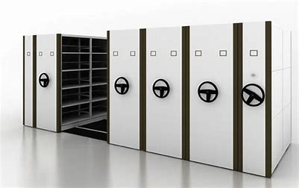
FREESTANDING DESK | 1500X750MM LAMINATE TOP STEEL FRAME 38X38MM TUBING MOBILE PEDESTAL | 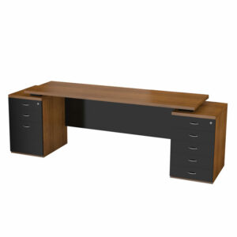
COUNTER | 1850 X 600mmD, Steel frame | 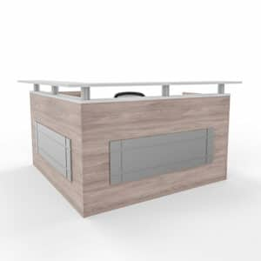
HIGH BACK CHAIR MANAGERS OFFICE/S | HIGH BACK CHAIR, FIXED HEADREST, BLACK NETTED BACK, ADJUSTABLE LUMBAR SUPPORT, HEIGHT ADJUSTABLE SUPPORT, HEIGHT ADJUSTABLE ARMS PU ARMPADS, ECONO SYNCHRON MECHANISM, VULCAN BLACK FABRIC, MIN 5 YEAR GUARANTEE ON CHAIR, GAS HEIGHT ADJUSTMENT, 125KG CAPACITY | 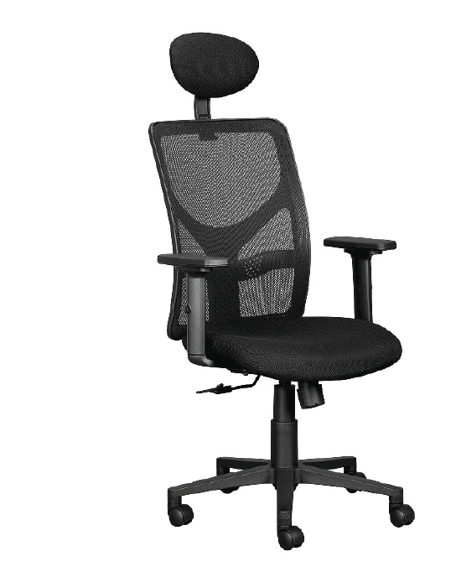
MAIN RECEPTION COUNTER | 3000X1800mm | 
Pedenza 1200mm 4 Drawers | 1200MM WITH 4 DRAWERS | 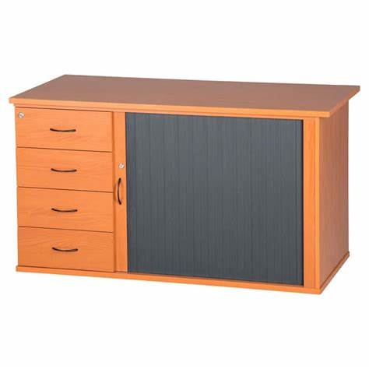
3 SEATER COUCH | 2190L X 88D X 800H (MM)WITH POLISHED ALUMINIUM LEGS, BUDGET 9.5M FABRIC | 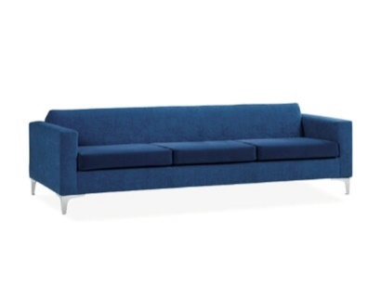
SIDE TABLE | SIMPLE SIDE TABLE | 
HINGE DOOR CABINET | 4 TIER WITH 3 ADJUSTABLE STEEL SHELVES, 900MM WIDE X 450MM DEEP X 1415MM HIGH | 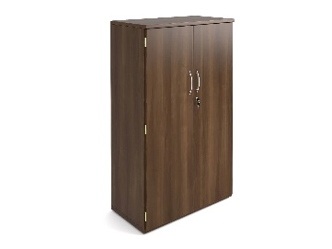
HR RECEPTION COUNTER | 3500X600MM WITH STEEL FRAME | 
EXECUTIVE WORK STATION | 2000 x 900mm | 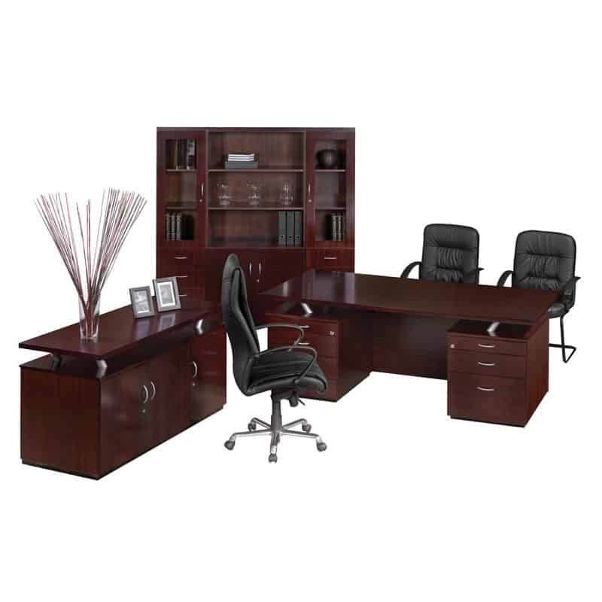
ROUND MEETING TABLE | 1000MM Diametre with steel frame | 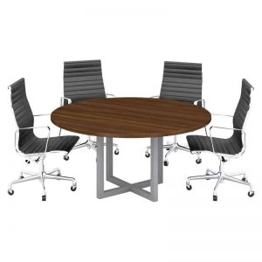
STEEL BENCH | 2.0mm Steel Cross Beam, with aluminium powder coating (2.0 x 80 x 40mm steel tube), Arms, legs and edges heavy duty 1.5mm stainless steel tubing. Seats 1.2mm brushed stainless steel (201) with stainless steel sides. 4 seater. 5 year warranty | 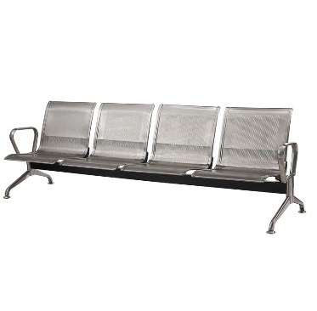
VISITORS CHAIRS | Arms: PU, Black Sleigh base frame. Black mesh fabric, weight limit 100kg | 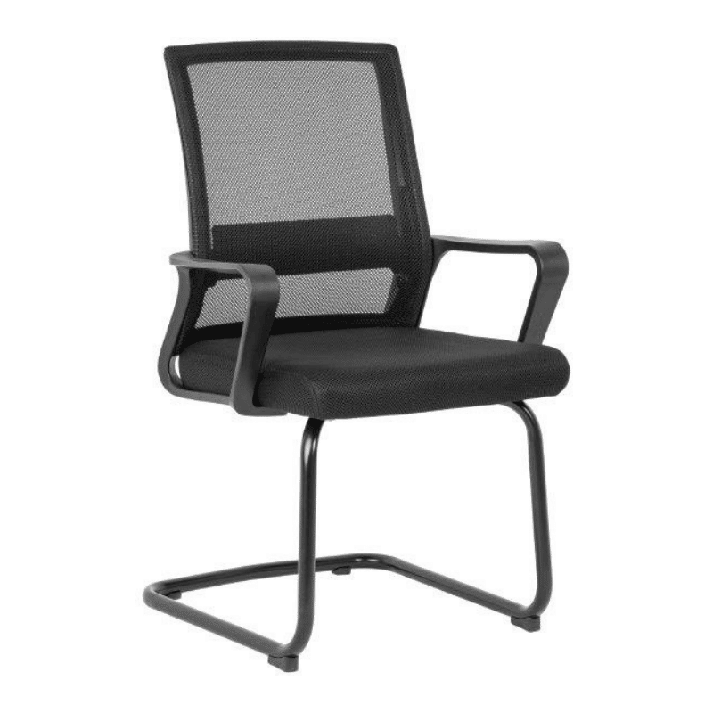
EXECUTIVE CHAIR | Swivel & tilt mechanism, black, gas height adjuster, 5-star wood base (700mmdiameter) combination of bonded leather on the front and PVC on the back | 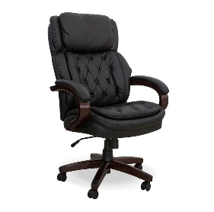
ERGONOMIC CHAIR | Lumbar support, armrest support, and tilt settings, ergonomic seating, 12-year warranty. Black. | 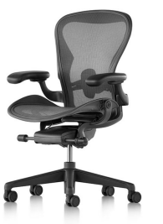
EXECUTIVE HIGH BACK CHAIR | Adjustable mesh backrest, adjustable lumbar support, upholstered seat with high-density automotive grade molded foam, seat depth adjustment (seat slider)from 440 to 490mm, height adjustable arm rest, synchronous mechanism with 4 locking positions | 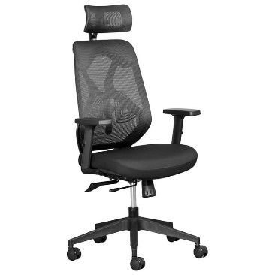
OFFICE DESK - PERSONAL ASISSTANT | L-Shaped desk with padenza 1800 x 800 | 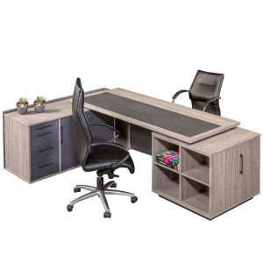
4 WAY CLUSTER DESKS WITH 3 DRAWER CREDENZA | 4-way cluster desks with 3 drawer credenzas. Modular desking system with power gap per user, laminate tops with power cutouts, leg and beam construction. Recessed intermediate legs for unimpeded movement, telescopic central beam for numerous workspace options, fully integrated cable management system. integrated power set (minimum 1x3 pin power, 1 x cat6 network port) per user | 
DESK WITH SIDE CABINET | 1500X750MM panel leg desk, fitted pedestal with 3 drawers, 900x 600mm sliding door cabinet | 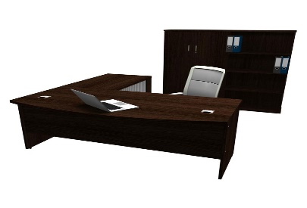
BOARDROOM TABLE | 22-Seater boardroom table | 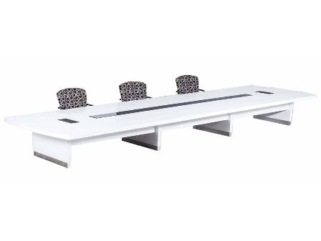
3 DOOR SERVER UNIT | 3 Door server unit 1700x600x960, to have 3 shelves and be lockable | 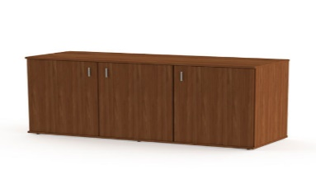
CHAIR BACK SUPPORT | Chair back support - mesh, mesh back support incorporating padded features for additional support, | 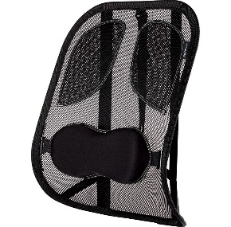
WASTE PAPER BINS |  | 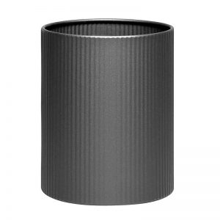
HIGH BACK CHAIR | High back chair, swivel and tilt mechanism with 1 position, lock gas height adjuster-PU arm rests, Black nylon base- FULL BLACK FABRIC UPHOLSTERY | 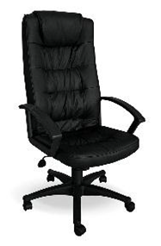
MID BACK CHAIR | Swivel & tilt mechanism with 1 position lock in upright position, executive gas height adjustment, standard full loop arm, tension adjustment, black fabric. | 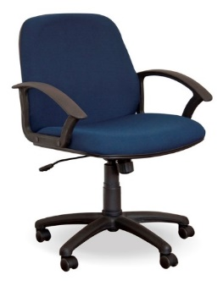
TOP RETRIEVAL FILING CABINETS-LEVER ARCH FILES | Top Retrieval filing cabinets that accommodate lever arch files | 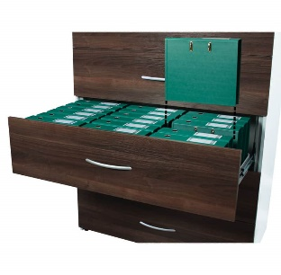
TOP RETRIEVAL FILING CABINETS-FOOLSCAP & A4 | Top Retrieval filing cabinets -Foolscap & A4 | 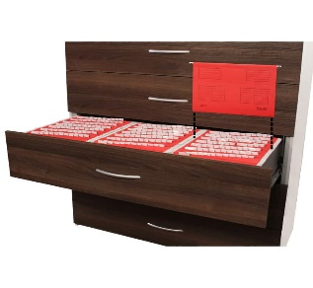
4 DRAWER LOCKABLE FILING CABINET | wooden, 4 drawer lockable filing cabinet | 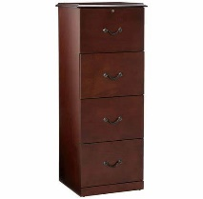
10 SEATER BOARDROOM TABLE | 10 seater boardroom table | 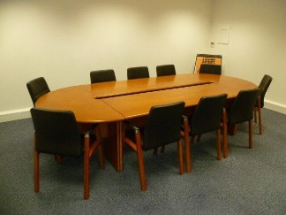

CERTIFIED CK DOCUMENT OR ID DOCUMENT (FOR SOLE PROPRIETORS)

[Failure of a Bidder to submit this will invalidate the bid]

TAX REFERENCE NUMBER AND PIN

[Failure of a Bidder to submit this will invalidate the bid]

JOINT VENTURE AGREEMENT (WHERE APPLICABLE)

[Failure of a JOINT VENTURE Bidder to submit this will invalidate the bid]

CERTIFIED VALID BBBEE CERTIFICATE

[Bidder that does not submit this will not be awarded BBBEE points]

CENTRAL SUPPLIER DATABASE REGISTRATION

[Failure of a Bidder to submit this will invalidate the bid]

SPECIFIC GOALS SUPPORTING DOCUMENTS

[Non-submission will result in no points being scored]

EXPERIENCE OF BIDDER (REFERENCE LETTERS)

[Non-submission will result in no points being scored]

EXPERIENCE OF PERSONNEL (CV’S)

[Non-submission will result in no points being scored]

TIMELINES (PROJECT PLAN)

[Non-submission will result in no points being scored]

SAMPLES ASSESSMENT REPORT

PRICING SCHEDULE

