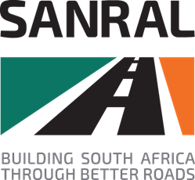
E-tender Portal
Description |  | Date Uploaded
Tender No: | CONTRACT SANRAL N.007-030-2022/1F | 28 MAY 2021
Tender Description: | CONSULTING ENGINEERING SERVICES FOR THE PERIODIC MAINTENANCE (RESURFACING) ON NATIONAL ROUTE 7 SECTION 3 FROM CEDERBERG INTERSECTION (KM 102.52) TO KRANSVLEIKLOOF (KM 120.88)
Closing Date: | 25 JUNE 2021
Tender Documents available from: | SANRAL website:  https://www.nra.co.za/service-provider-zone/tenders/open-tenders/.  Google (copy and paste the link)  https://www.nra.co.za/service-provider-zone/tenders/open-tenders/
No: of Addendum issued | TBC
Addenda available from | TBC

