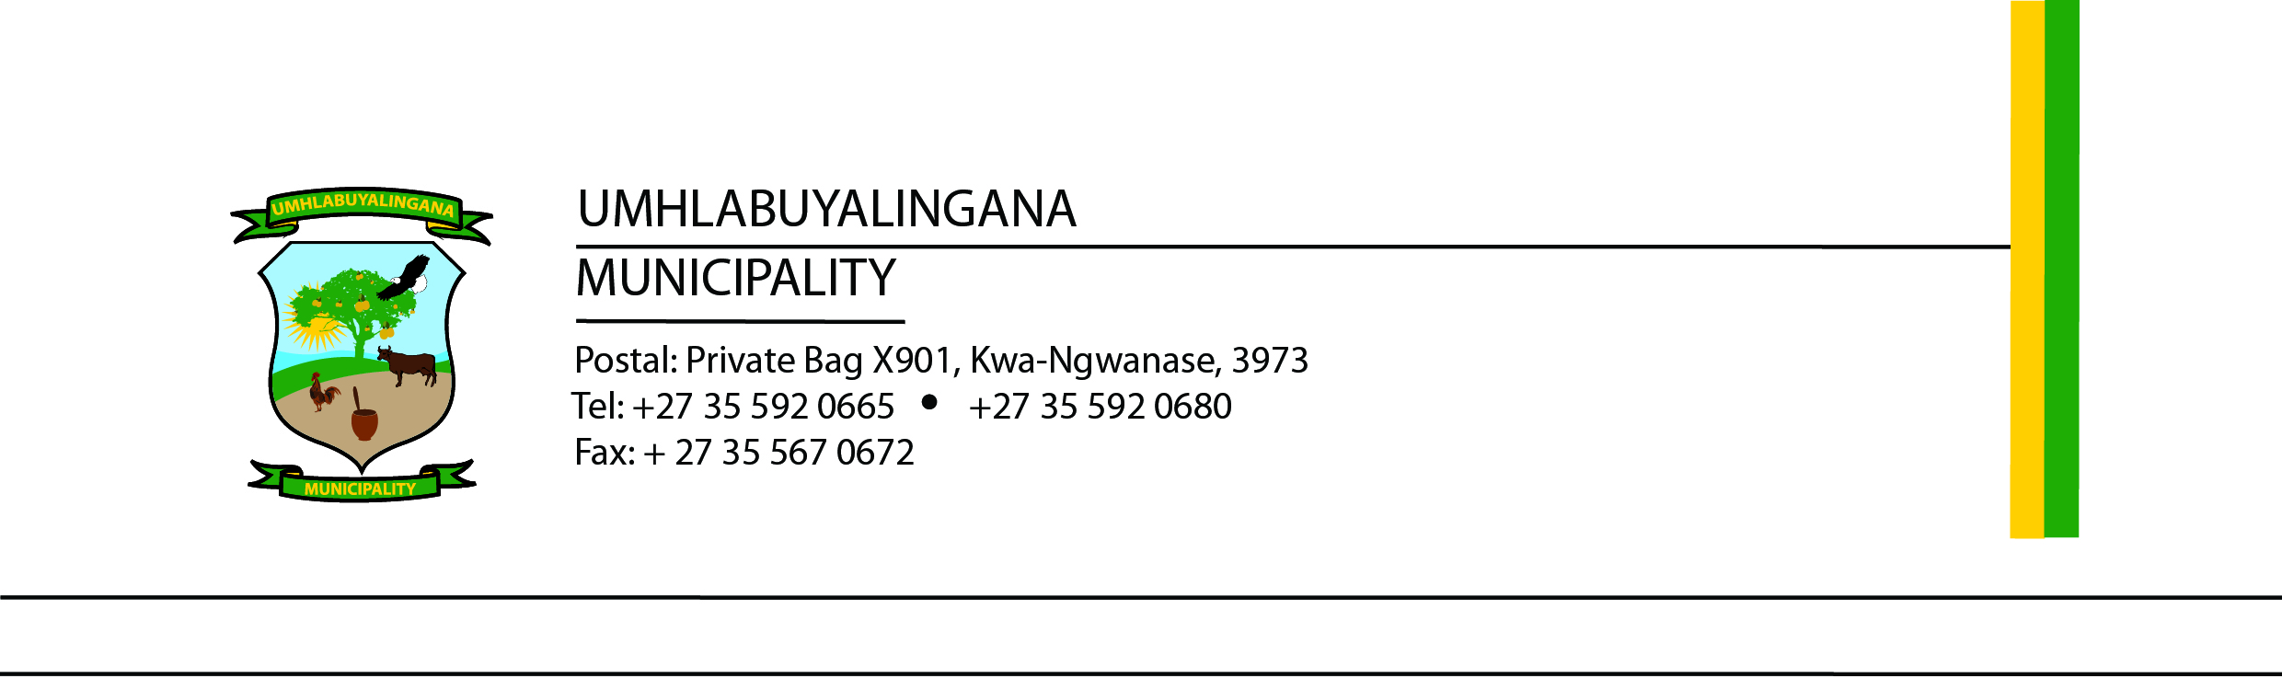

TENDER NOTICE – READVERTISEMENT
TENDER NO: UMHL10/2025/2026 PROVISION OF INTERNAL AUDIT SERVICES FOR A PERIOD OF 36 MONTHS
Umhlabuyalingana Local Municipality hereby invites proposals from suitably qualified and experienced organisations or consortia for the Provision of Internal Audit Services for a period of 36 months, in accordance with:
- Section 83 of the Municipal Systems Act, Act 32 of 2000 (as amended)
- Sections 110 and 112 of the Municipal Finance Management Act, Act 56 of 2003

Bid Documentation
Bid documents are available for download on the following platforms:
- www.umhlabuyalingana.gov.za
- www.etenders.co.za

Submission Details
Sealed proposals, clearly marked: “TENDER NO: UMHL10/2025/2026 – Provision of Internal Audit Services for a Period of 36 Months” must be deposited in the tender box located at:
Umhlabuyalingana Local Municipality R22 Manguzi Main Road KwaNgwanase, 3973
Closing Date and Time: 20 March 2026 at 12h00 (No late submissions will be accepted)

Mandatory Bid Requirements
- Proof of registration with the Central Supplier Database (CSD)
- Certified copies of qualifications for key personnel
- Proof of registration of company directors with applicable professional bodies (e.g. SAICA, IRBA, CFE, ICSA, ACCA, CIMA, SAIPA, SAIBA, IISA, SAITP)
- Proof of payment of municipal rates/taxes or valid lease agreement (not in arrears for more than 3 months)
- Company registration certificate
- Certified ID copies of all directors

Enquiries
- Technical: Mrs. NP Mkhabela – ziphom@mhlabuyalingana.gov.za
- Procurement: Mr. NM Mthembu – bafanam@mhlabuyalingana.gov.za (Office hours only)

Important Notes
- The Municipality will not be held liable for late delivery of proposals via courier or any other means not placed directly in the tender box before the closing date and time.
- Only proposals submitted on official tender documentation issued by the Municipality will be accepted.
- The Municipality reserves the right to accept any tender in whole or in part and is not bound to accept the lowest bid.
- Tender validity is 90 days from tender closing date.

Evaluation Criteria
Bids will be evaluated in accordance with the Umhlabuyalingana Local Municipality’s approved Supply Chain Management Policy.
- Only bidders who meet the mandatory returnable document requirements will be considered.
- Evaluation will be based on responsiveness.
- Bidders will be further evaluated on functionality, where a minimum score of 70% is required to proceed to the 80/20 preference point system:
  - 80 points – Price
  - 20 points – Specific goals (as detailed in the tender document)

Mr. NPE Myeni
Municipal Manager

