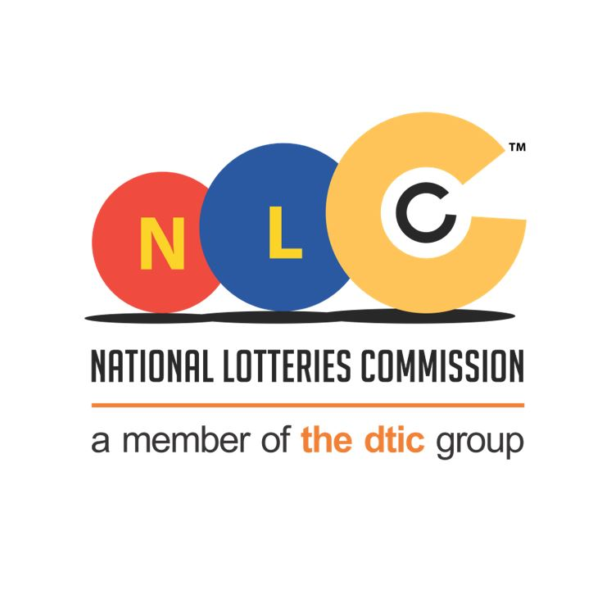
REQUEST FOR QOUTAIONS TO REPAIR TWO (2) XRAY MACHINES

CLOSING DATE: 04/10/2021
CLOSING TIME: 11:00
[Grab your reader’s attention with a great quote from the document or use this space to emphasize a key point. To place this text box anywhere on the page, just drag it.]

RFP/2021-

REQUEST FOR PROPOSAL FOR APPOINTMENT OF A CONTRACTOR FOR REPAIR OF TWO XRAY MACHINES
CLOSING DATE: 2021
CLOSING TIME: 11h00 (South African Standard Time)

NLC/2021 – 01

CLOSING DATE: 16 MARCH 2021
CLOSING TIME: 11H00 (South African Standard Time)

1. BACKGROUND AND DISCUSSION

The NLC has a footprint in all the nine (9) provinces and for security reasons the premises are equipped with security systems. The buildings are fitted with Xray machines and Metal detectors.

The purpose of this devices is to allow the operator to detect any dangerous and/or contraband items within luggage, parcels and/or cargo. After the X-rays pass through the item, they are picked up by a detector.

The National Lotteries Commission seeks the services of a suitably qualified service provider for repair and maintenance of two (2) X-ray machines in 2 provinces that has experienced components failure.

Contractors will ensure the following:

- General Maintenance of X-ray machines and Metal Detectors.

  - Corrective Maintenance
  - All serviceable parts

- Expenditure with the contractor will comply with legislative requirements.
- A formal Service Level Agreement will be in place.
- Contractors can be called upon at short notice, and
- Value for money.

In accordance with the National Lotteries Commission Current Procurement Policy, written quotes will be required.

- TECHNICAL SPECIFICATION FOR REPAIR AND MAINTENACE OF X-RAY MACHINES

  - General Scope of the Maintenance Works

Machine description

Office Location | QTY | Description | Required Service
Head Office - Pretoria | 1 | FISCAN CMEX-B6550A X-Ray Scanner | Service exchange generator  Service exchange x-ray controller
Mahikeng | 1 | FISCAN CMEX-B6550A X-Ray Scanner | Service exchange computer

2.2. Required Services

The services to be provided include:

- Corrective Maintenance (CM)

  - Service exchange generator
  - Service exchange x-ray controller
  - Service exchange computer

- Spare Parts

Service provider to provide all related spare parts and related items in cases where they are Corrective Maintenance.

The Contractor will liaise with the NLC on any proposed works and identify works where the Contractor:

- Does not have the required skills to undertake the works,
- Is required to be licensed or hold a qualification,
- Proposes to use a subcontractor, and or
- Has any other restriction or limitation in relation to the works?

Provincial Addresses where service will be rendered.

Office Name | Address
Gauteng and Head Office | 333 Grosvenor Street, Hatfield Gardens, Block D, Pretoria
North-West | 12 Visser Street, Mafikeng Industrial, Mafikeng

  - Limitations to be considered in relation to providing the service

    - Hours of Work

Generally, NLC buildings are open during standard business hours of operations 8:00 – 16:30, five days per week, 52 (fifty-two) weeks per year.

However, the Contractor is required to provide maintenance services and handyman services always, covering a 24 (twenty-four) hour span.

It is envisaged that most of the works will be undertaken in the period Monday to Friday from 8:00am to 16:00pm but after hours and weekend work may be required depending on the nature of the work to be done eg:

  - Excessive noise.
  - Malodorous materials.
  - Other forms of nuisance that might interfere with day-to-day operations of the NLC

Due to the nature of operations at the NLC which is corporate, and customer based, the Contractor may be required to undertake works after the hours of operation to avoid having an impact on NLC operational requirements.

    - Waste Removal

The Contractor will be required to manage all waste and by-products generated by the works as there are no facilities provided for recycling of waste on-site.

Similarly, there are no on-site facilities available for the disposal of oil wastes, chemical wastes or associated containers.

The Contractor will be responsible for the safe disposal of all oil, chemical and other hazardous waste in accordance with:
  - National Environment Management Act;
  - Occupational Health and Safety Act;
  - Municipal Bye-Laws.

    - Occupational Health and Safety

The Contractor will develop and implement an OHS Plan in accordance with the requirements of the OHS Act, 85 of 1993, in relation to all individual work to be performed.

    - Dress Code and Vehicle Presentation

The Contractor must provide all staff with work dress that is appropriate for both the functional and presentation requirements of the work.

The Contractor must provide identity badges for all staff. These identity badges must be displayed always when on site.

3. QUALITY CONTROL

- The NLC will have the right to conduct inspection at the supplier’s premises for quality and adherence to specification before delivery is made.
- The supplier must undertake and warrant that all goods shall, at the time of delivery, be according to specification, in good condition, order and ready for use.
- The supplier has the primary responsibility to ensure that quantity and quality are in accordance with the specification.

4. PAYMENT
- No payment will be made by the NLC before a service has been rendered.
- No payment will be made without an original invoice or certified copy.
- No payment will be processed before a full delivery is completed and accepted.
- Payment will be made within 30 days of receipt of the original or certified invoice from the supplier, provided that the NLC is satisfied with the quality and standard of the supplier’s performance.

5. EVALUATION CRITERIA

A two (2) phase evaluation criteria will be considered in evaluating the bid, being:

Phase 1: Administrative (Mandatory) Requirements

- Central Supplier Database (CSD) registration; and
- Signed standard bid documents (SBD Forms).
- As part of the pre-qualification criteria for preferential procurement, the following bidders may respond to this bid:
- ONLY Suppliers Registration with Department of Health
- Trade certificates (Relevant X-ray Machine Maintenance Qualifications)

5.1 Phase 2: The 80/20 Principle Point System based on Price and B-BBEE status level contributor.

Only bidders that have met the 80 point threshold in phase 1 will be evaluated in phase 2 for price and BBBEE. Price and BBBEE will be evaluated as follows:
In terms of regulation 6 of the Preferential Procurement Regulations pertaining to the Preferential Procurement Policy Framework Act, 2000 (Act 5 of 2000), responsive bids will be adjudicated on the 80/20-preference point system in terms of which points are awarded to bidders based on:
- The bid price (maximum 80 points)
- B-BBEE status level of contributor (maximum20 points)
- Stage 1 – Price Evaluation (80 Points)
Criteria | Points
Price Evaluation  Ps = 80 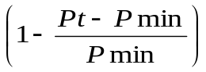 | 80

The following formula will be used to calculate the points for price:
Where
Ps = Points scored for comparative price of bid under consideration
Pt = Comparative price of bid under consideration
Pmin = Comparative price of lowest acceptable bid
- Stage 2 – BBBEE Evaluation (20 Points)
- BBBEE Points allocation
Points will be awarded to a bidder for attaining the B-BBEE status level of contributor in accordance with the table below:

B-BBEE Status Level of Contributor | Number of Points (80/20 system)
1 | 20
2 | 18
3 | 14
4 | 12
5 | 8
6 | 6
7 | 4
8 | 2
Non-Compliant contributor | 0

B-BBEE points may be allocated to bidders on submission of the following documentation or evidence:
- A duly completed Preference Point Claim Form: Standard Bidding Document (SBD 6.1); and
- B-BBEE Certificate.
- Joint Ventures, Consortiums and Trusts
A trust, consortium or joint venture, will qualify for points for their B-BBEE status level as a legal entity, provided that the entity submits their B-BBEE status level certificate.
A trust, consortium or joint venture will qualify for points for their B-BBEE status level as an unincorporated entity, provided that the entity submits their consolidated B-BBEE scorecard as if they were a group structure and that such a consolidated B-BBEE scorecard is prepared for every separate bid.
Bidders must submit concrete proof of the existence of joint ventures and/or consortium arrangements. NLC will accept signed agreements as acceptable proof of the existence of a joint venture and/or consortium arrangement.
The joint venture and/or consortium agreements must clearly set out the roles and responsibilities of the Lead Partner and the joint venture and/or consortium party. The agreement must also clearly identify the Lead Partner, who shall be given the power of attorney to bind the other party/parties in respect of matters pertaining to the joint venture and/or consortium arrangement.
6. TAX COMPLIANCE
No tender shall be awarded to a bidder who is not tax compliant. NLC reserves the right to withdraw an award made, or cancel a contract concluded with a successful bidder in the event that it is established that such bidder was in fact not tax compliant at the time of the award or has submitted a fraudulent Tax Clearance Certificate to NLC, or whose verification against the Central Supplier Database (CSD) proves non-compliant. NLC further reserves the right to cancel a contract with a successful bidder in the event that such bidder does not remain tax.

7. VALIDITY PERIOD
The validity period of the quotation requested must be 60 days.

8. COSTING
Costing of quotation must be VAT inclusive and quoted in South African Rand.

9. LATE QUOTATION
Quotations received late shall not be considered. A quote will be considered late if it arrived one second after 11:00 am or any time thereafter.
Closing Date: 04 October 2021

10. ENQUIRIES
Name and Surname: Penelope Soyingwa
E-mail: penelope@nlcsa.org.za
Tel: 012 432 1414

Enquiries received will be responded to within two (2) working days of receiving the enquiry.

THE NLC IS NOT OBLIGED TO ACCEPT THE LOWEST OR ANY BID AND RESERVES THE RIGHT TO ACCEPT ANY BID IN WHOLE OR PART.

