Technical Requirements.

  - Guarantee and Inherent Defects:

- Until such time that the instrument certifications have expired,12 months, the approved supplier shall be entirely responsible for repairing all defects occurring within this period.
- Supply, calibrate and certify in accordance to Prasa requirements and relevant standards.
- The approved supplier shall guarantee that when the instrument fails will be repaired and returned to service within 10 (ten) working days, from the date of being notified of the defect.

  - Document Management.

- Certificate of compliance, calibration and guarantee should be submitted during delivery.
- Test report and results should also accompany delivery

Specifications of the Work or Products or Services Required Definitions

- SANS – South African National Standard

EMU Maintenance Tools and Equipment Specification

TOOLS | DESCRIPTIONS
1. 3 1/2 Digit Digital Multimeter  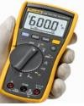 | - Digital multimeter includes an 80BK type K bead thermocouple probe with integral adaptor.  - The digital multimeter is suitable for a variety of measurement applications that comes with its own test leads; instruction manual; 9v alkaline batteries.  - This digital meter also features a display backlight for easier measurement reading.  - Features and Benefits • 6000 count LCD with 33 segment bar graph, True RMS (A.C.) measurement, EN61010-1 safety standard compliance to Cat IV 600V & Cat III 1000V, Resistance; continuity and diode measurement, Capacitance measurement up to 10000μF, Frequency measurement up to 100kHz, Min/Max/Average recording, Display and Auto Hold, Separate battery and fuses access without breaking the calibration seal  - Specification  - Multimeter Handheld;  - Absolute Maximum AC Current Measurement is 10A ac;  - Absolute Maximum DC Current Measurement is 10A dc;  - Absolute Maximum Resistance Measurement is 50GΩ;  - Absolute Maximum AC Voltage Measurement 1000V ac;  - Absolute Maximum DC Voltage Measurement 1000V dc;  - Absolute Maximum Temperature Measurement +400°C;  - Absolute Maximum Capacitance Measurement 9.999F;  - Functions Measured: AC Current; AC Voltage; Capacitance; Continuity; DC Current; DC Voltage; Diode; Frequency; Resistance; Temperature True RMS;  - Maximum Frequency 1kHz;  - LCD Display;  - AC Current Measurement Resolution 0.01mA;  - DC Current Measurement Resolution 0.01mA;  - DC Voltage Measurement Resolution 0.1mV dc;  - Resistance Measurement Resolution 100mΩ;  - AC Voltage Measurement Resolution 0.1mV ac;  - Capacitance Measurement Resolution 1nF;  - Temperature Measurement Resolution 0.1°C;  - Best Resistance Measurement Accuracy ±1.5% + 3 Digits;  - Safety Category Voltage 600 V; 1000 V;  - Maximum Operating Temperature +50°C;  - Battery Life 200 h;  - Best AC Voltage Accuracy ±1% + 3 Digits;  - Best Capacitance Measurement Accuracy ±10 %; Best DC  Voltage Accuracy ±0.1% + 2 Digits;

TOOLS | DESCRIPTIONS
 | - Best AC Current Accuracy ±1.5% + 3 Digits
2. Rigid Back Probe Pins  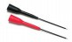 | - Slides onto test probes of the multimeter.  - Should be compatible with make of multimeter supplied. Sharp point allows for contact to electrical connectors and insulation protects from shorting .
3. Sure Grip Alligator Clips  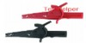 | - For use with the multimeter, thus should be compatible with the supplied multimeter. Red and black. One warranty. Multipurpose tooth grip for fine wire to 20mm bolt.
4. USB to Serial (RS232) port converter  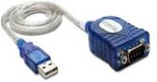 | - The USB to Serial Adapter provides the connection between USB and the traditional RS-232 serial port. The adapter is designed for connections to Cellular phones, PDA’s, digital cameras, modems, or ISDN terminal adapters through your USB port with over 230 kbps data transfer rate. Since the adapter uses no IRQs, it is perfect if you need many serial devices attached to your PC.  - The USB to Serial adaptor is Bus Powered and provides true Bi-Directional communication.  - Connector 1: USB 2.0 Type A Male Connector 2: DSUB 9 Pin Male 5m length
5. RJI CAB IP20/M12 4XAWG  22/7SCHL;1,5m (RJ45 TO M12 CABLE)  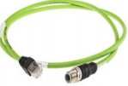 | - STX M12x1 Series, 4 Way, X Coded, patch cables are ideal for ethernet applications.  - The X-coded CAT.6A cable assemblies can transmit data rates of up to 10 GB/s, and with a M12 circular screw lock connector, they resistant to vibration and ideal for industrial environments. STX M12x1 series of 4 way patch cables can be used for many applications, such as security and video surveillance systems, production and manufacturing, renewable energy or use with railway vehicles data systems.  - Features and Benefits:  Dust poof and watertight, IP67 rated (RJ45 IP20 rated), Robust die cast housing, 360 degree shielding, Vibration protection, Full metal shield between pairs of wires, Connector A Straight M12, Connector B Straight RJ45, Length 5m, Connector A Number of Contacts 4, Connector B Number of Contacts 4 Sheath Colour Green, IP Rating IP67, Cross Sectional Area 0.14 mm²Connector A Housing Gender Plug, Shielding Shielded, Connector B Housing Gender Plug, Sheath Material Polyurethane PUR, American Wire Gauge 26
6. Tool Bag/Carry bag | - Tool Back Pack The best way of storing and transporting tools is by using specially designed backpacks that feature easy-

TOOLS | DESCRIPTIONS
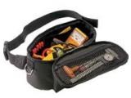 | access compartments in a variety of sizes and are made from extra-durable materials.  - Features & Benefits: Made from heavy-duty 600 x 600 denier fabric for long-lasting and extra durability 50 Pockets/tool holders for a wide variety of tools, including longer tools on the side such a level Removable dividers system with tool holders is easily detachable, with handle for easy carriage Padded back and shoulders - provide extra comfort when carrying heavier loads  - Hooks and nets give extra storing options Separate internal laptop compartment Dual Zipper mechanism allows for easy opening Waterproof, extra durable plastic bottom  - Large capacity: 28l
7. RS232 Gender Exchange (Female to Female)  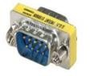 | - Serial Port Female to Female Coupler / DB9 RS232 Gender Changer This gender changer is to change a male connector to a female connector. Don’t buy another cable, just change its gender with this RS232 / Serial 9 pin F/F Gender Changer Adapter. RS232 / Serial 9pin Gender Changer F-F ● Typically used with RS232 serial 9pin cables ● Also helps make a longer extension to existing video cords
8. RJ45 to RJ45 Straight Ethernet Cable  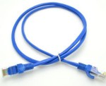 | - Cat6 Cabinet Line RJ45 to RJ45 angled patch cable assemblies with an IP20 RJ45 plug connector on either end.  - These Cabinet Line RJ45 to RJ45 patch cables have S/FTP shielding with a PE insulation and a grey LSZH sheath with a  5.9mm diameter.  - The operating temperature range for these Cabinet Line RJ45 to RJ45 patch cables is -20 to +60°C. These RJ45 to RJ45 angled patch cables must be 10m in lengths.  - Standards  - Halogen: to IEC 60754-2 Resistance to spread of flame: to IEC 60332-1/ UL 1581 FT2 Cable: ANSI / TIA / EIA-568- B.2-10, ISO / IEC 11801:2002, EN50173-1:2007  Connector: IEC 60603-7-51
9. RJ45 socket to M12 Female adapter  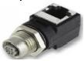 | - M12 Panel Mount RJ45 Adaptors The M12 female-RJ45 panel feed-through adaptors are Dcoded.  - With a hex-nut and seal included, a secure connection is assured and is protected to IP65 / IP67.  - A convenient and easy to install way of connecting conventional RJ45 devices to a more advanced and versatile M12 system.  - The D shaped cut out measures Ø16.3 mm with 15.4 mm flat.
10. RS232 cable (Male to Female) | - Assembled D-SUB cable, shielded, 9-pos., stranded (7-wire), cable color: RAL 7000 (gray), secured using 4-40 UNC thread,

ITEM | PARAMETER | UNIT MEASURE
 | Weight | 1 kg
 | Dimensions | 59 x 31 x 25 cm

TOOLS | DESCRIPTIONS
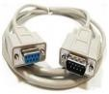 | IP20 protection, head 1 with socket shell 1 and straight cable outlet, head 2 with pin shell 1 and straight cable outlet.  - Connector A Male D-Sub,  - Connector B Female D-Sub  - Length 5m  - Number of Populated Ways 9,  - Series VS-09-DSUB-20-LI5.0, Voltage Rating 125 V, Current Rating 1 A, Outer Sheath Material PVC,  - Shielding Shielded, Standards Met EAC Approval
12. Ethernet Adapter  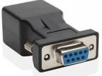 | - DB9 RS232 Female to RJ45 Female Adapter
13. Oil Draining Canister  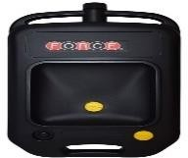 | The canister must be able to effectively catch oil being drained from the top with minimal spillages.

TOOLS | DESCRIPTIONS
14. Gurtech Grease gun  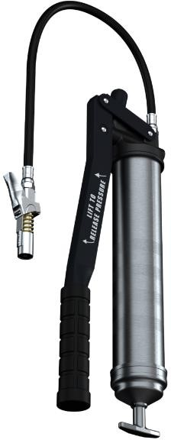 | 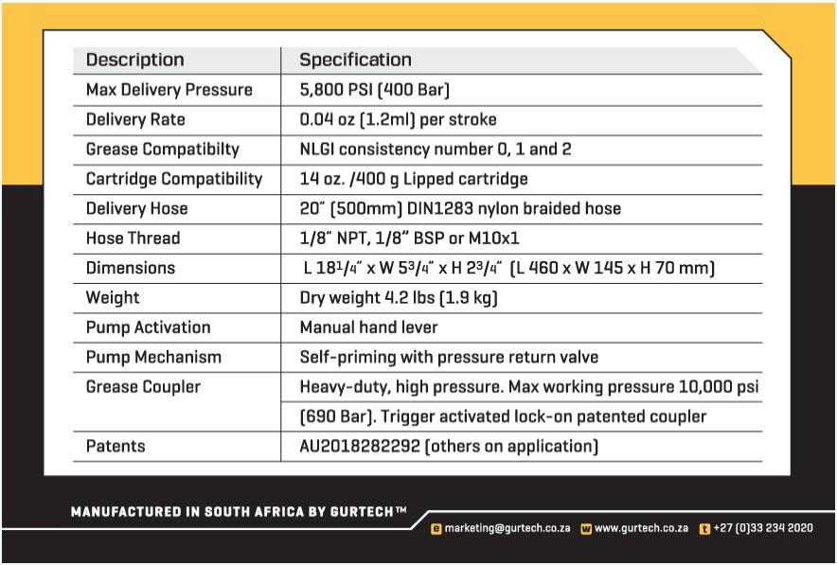
15. Grease gun fittings.  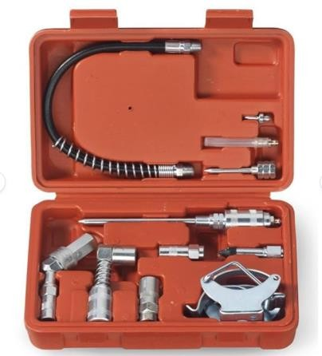 | - [ACCESSORIES]: Perfect for garages or automotive workshops and includes common lubing attachments that fit most grease gun couplers and guns.  - [VERSATILE]: All-in-one grease gun kit includes an easy-to-use connect design with a 90-degree swivel coupler and a 360-degree coupler for greasing at all angles.  - [CONVENIENT]: 12" flexible hose with spring fits in tight spaces and each kit includes grease injector needle and 1-1/2" needle nose adaptor.  - [VALUE]: Includes practically every zerk fitting at  half the price (4" needle nose adaptor, grease gun adaptor and coupler).

TOOLS | DESCRIPTIONS
 | - [INCLUDED]: 12" flexible hose w/spring, grease injector needle, 1-1/2" needle nose adapter (flat), standard coupler, heavy duty coupler, 90° swivel coupler, 360° swivel coupler, oil gun clamp, short grease gun adapter, and heavy duty case.
16. DPI 705 Digital pressure gauge  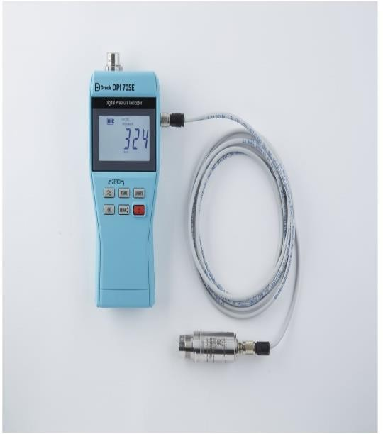 | Pressure Units  psi, inHg, inH2O (4°C, 20°C and 60°F), ftH2O (4°C, 20°C  and 60°F),  mmHg, mHg, mbar, bar, mH2O, Pa, hPa, KPa, MPa, Kgf/cm2  Calibration Units  mbar, bar, psi, kPa, mPa, hPa, Kgh/cm2  Leak Test  Standard 60 second leak test.  Zero  Zero pressure correction.  Tare  0 to 100% FS zero offset capability.  Filter  10 reading rolling average for unstable pressures.  Alarm  Adjustable high pressure alarm with visual and audible warning.  Ambient Temperature  °C and °F reading of local condition ±1.5°C (±3°F).  Calibration

TOOLS | DESCRIPTIONS
17. Fowler Digital inside caliper  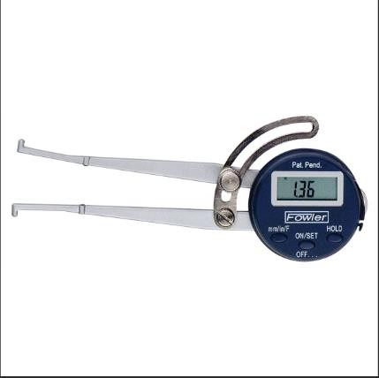 | - LCD Display: High-quality thickness caliper with a steel body; easy-to-read LCD display allows you to get precise results quickly and easily  - Measuring Capabilities: This digital caliper measures Inside dimensions for hole diameters and groove depths  - Accurate Measurements: The caliper measuring tool has an accuracy of 0.01" and a reading of 0.01"; perfect for machinists and household/DIY measurements  - Three-Unit Conversion: Quickly switch between inch, fraction, or metric units with a single click; allows you to set zero for taking intermediate or differential measurements; hold feature freezes display for later viewing  - Set Includes: Xtra-Value electronic caliper gage, CR2032 battery, manual, and a plastic case
18. Torque Wrench Set . Combination and Open End  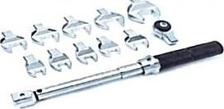 | - 10-50Nm  - Torque wrenches should be combination of hexagon standard set and open-end socket sets
19. Digital Venier – 150mm  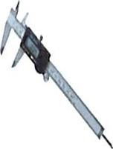 | - Easy-to-read LCD display. A useful conversion table is at the end.  - The perfect tool for a wide variety of industrial and automotive uses Range of measurement: O- 150 mm: accuracy: +0.02 mm."O.OOl in (100-150 mm).  - Resolution: 0.0005 in (0.1 1 mm).  - Repetition: 0.01 mm (0.0005 inches).  - I Ill's maximum reading speed

TOOLS | DESCRIPTIONS
21. Airflow Meter  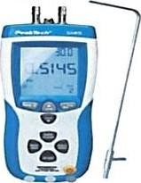 | - Air temperature: O c 50 ºc  - Anemometer functions: CFM (ft'/min), CMM (m³/min). Knots, ft/min, km/h, m/s, mph  - Display Type: LCD  - Pressure measurement: PA, PSI, inH20, mBar, mmH20 Measurement of air velocity and air flow  - Measurement of air temperature, barometric pressure and differential pressure  - Average, minimum and maximum value recording  - Switchable auto power off function  - Data hold and zero function  - Internal memory for 99 measurement readings  - PC software and USB 2.0 interface Accessories: case, USB-interface cable, pitot-tube, connection hose, software for Windows  - 20001XP/VlSTA/7, battery and manual
22. Vacuum Cleaner  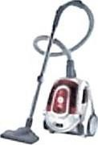 | - Hoover or equivalent Bagless Vacuum Cleaner (2000W)  - 220 Volts AC
23. Rechargeable Vacuum Cleaner  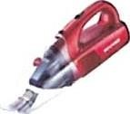 | - Handheld Vacuum Cleaner product  - Hoover Wet and Dry Handheld or equivalent  - Vacuum Cleaner 14.8V  Model: HHWD14
24. Angled Socket Wrench | - 9 Piece  - Metric 8 to 19mm  - 75.J9PB

TOOLS | DESCRIPTIONS
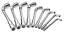
25. 12 Piece ratchet spanner set  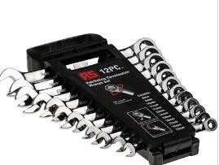 | - Size 8 to 19  - Chrome  - Metric  - Combination
26. 9 Piece Allen key set  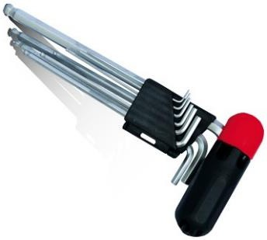 | - 9 piece  - Metric  - Ball type
27. 8 Piece tamper proof, Trox screwdriver set  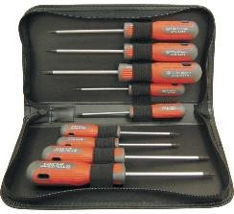 | - Magnetic  - Trox  - Dual grip, tri-angular handle
28. Padlock | - 4 piece  - 40mm  - Keyed Alike  - Waterproof Laminated Gate Door Padlock  - Pad Lock with Same Keys

TOOLS | DESCRIPTIONS
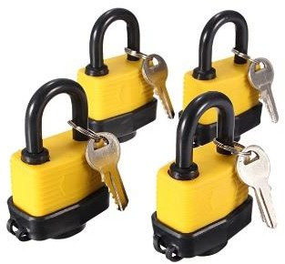
29. Wago tool  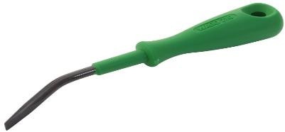 | - Tip Size: 0.5mm  - Blade Length: 3.5mm  - Suitable for 280 Series Actuator
30. 6 Piece Screwdriver set  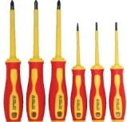 | - VDE 1000V  - Insulated  - Magnetic tips
31. 3 Step Ladder  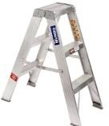 | - Aluminium  - 150 kg  - A frame
32. ¼” Drive socket set | - 33 piece  - With casing

TOOLS | DESCRIPTIONS
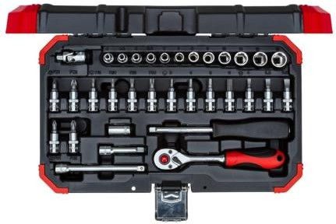
33. Safety harness and double lanyard  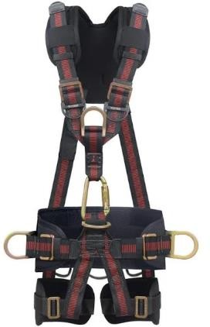  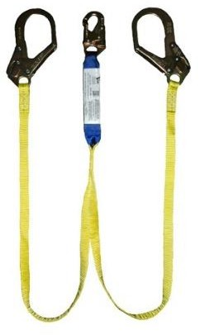 | - Safety harness and lanyard required are similar to the picture  - Full body harness with padding on both shoulder and leg straps, a kidney support and a double battery strap on waist belt  - 3 x attachment points - 1 back and 2 front  - D ring on chest strap for rescue  - Standing step - up strap in pouch on waist belt  - SANS 50354/ 50355/ 50361 certification for harness, energy absorber and lanyards to be submitted on delivery  - Detachable double leg lanyard, built-in shock absorber  - 1.75m lanyard length with 2 large scaffold steel hooks (53mm gate) and 1 steel snap hook  - Equipment to be serial numbered.  - To be supplied with carry bag

TOOLS | DESCRIPTIONS
34. VOLTAGE DETECTOR  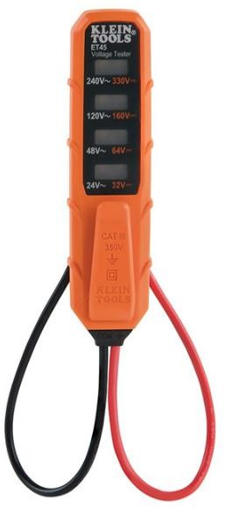 | VOLTAGE DETECTOR  Measures AC, DC Voltage 24VAC to 240VAC, 32VDC to 330VDC

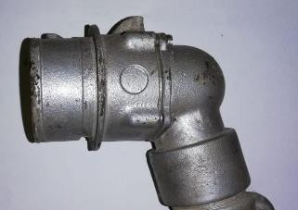
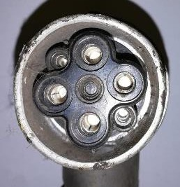
Railway Connector – Female

Railway Connector (female)
1. Housing Material | - Aluminium
2. Contact Material | - Silver Plated Brass
3. Insulator | - Thermosetting
4. Protection Index | - IP53 IK7
5. Contact Size | - Ph/Ph: 7mm  - Ph/T: 3mm
6. Contact Stem Size | - Ph/Ph: 7mm  - Ph/T: 3.3mm
7. Termination | - Soldering
8. Contact Type | - Sleeve
9. Max O.D. | - 30mm
10. Max Cross-Section | - Ph/Ph: 16mm²  - Ph/T: 6mm²
11. Max Ø Cable over  Insulation | - 11.5mm

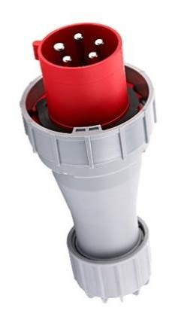
Industrial Plug and socket – Workshop Side
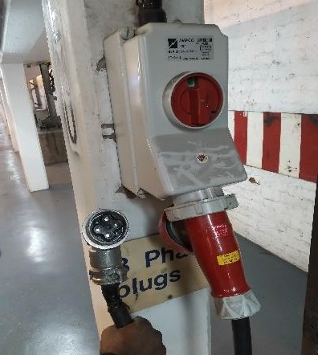

Industrial Plug (male) and Socket (female)
1. Number of Poles | - 3P+N+E
2. IP Grade | - IP67
3. Rated Current | - 63A
4. Rated Operating Voltage | - 220-380V AC

 |  | Wiring Diagram
 |  | Phase | Industrial Plug | Cable |  |  |  | Rail Connector
 |  | Phase | Pin Number | Colour |  |  |  | Pin Number
 |  | L1 | L1 | Brown |  |  |  | 1
 |  | L2 | L2 | Grey |  |  |  | 2
 |  | L3 | L3 | Blue |  |  |  | 3
 |  | N | N | Black |  |  |  | 4
 |  | E | E |  | Green/Yellow |  |  | NC
 |  |  |  |  |  | - 240-415V AC
 | 5. Rated Insulation Voltage |  |  |  |  | - 690V AC
 | 6. Rated Frequency |  |  |  |  | - 50/60Hz
 | 7. Earth Position |  |  |  |  | - 6H
 | 8. Standard |  |  |  |  | - IEC/EN 60309-1/2

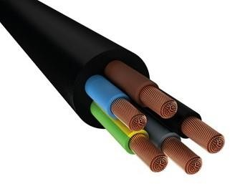
Cable

Cable
1. Insulation Type | - HO7RNF Heavy Duty Rubber
2. Insulation Colour | - Black
3. Outside diameter of  insulation | - 23.74mm
4. Insulation Thickness | - 4.56mm
5. Inside diameter of  insulation | - 17mm
6. Number of cores on the  cable | - 5 (3P+N+E)
7. Inside Diameter of Wire | - 5.96mm
8. Outside Diameter | - 6.69mm
9. Thickness of wire insulation | - 0.73mm
10. Area of wire (inside) | - 27.898mm²
11. Number of strands | - 43
12. Total cable length | - 14m

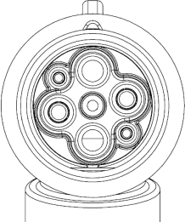
- Specifications of In-place Inclinometer System:

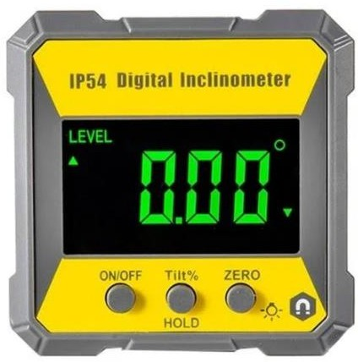

Sensor | Uniaxial or biaxial sensor
Accuracy | ± 0.1% fs
Resolution | ± 0.05 mm/m (8 arc seconds)
Output | SDI-12 serial output
Temperature Range | -20°C to 80°C

- DIGITAL SPIRIT LEVEL:

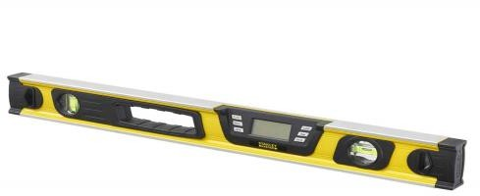

  - Digital accuracy: 0.10 at level and plumb, 0.20 at other angles

  - LCD screen means easy to read measurements

  - 360° readout flips in upside down position. Functional in all positions

  - HOLD function – make it easy to use even in low light condition

  - MODE function gives the degree/percentage/in-ft

  - MEMORY RECALL (9 measurements)

  - Buzzer at 0°, 45° and 90°

  - Low battery indicator

  - Waterproof bag included

- VIBRATION METER

Sensor | Piezoelectric Transducer
Measuring Range | Velocity: 0.01~400 mm/s 0.004~16.0 inch/s True RMS
Measuring Range | Displacement: 0.001~4.0 mm 0.04~160.0 mil Equivalent Peak-peak
Frequency Range | Acceleration: 10 Hz ~ 1k Hz 10 Hz ~ 10k Hz
Frequency Range | Velocity: 10 Hz ~ 1k Hz

- Mirror:
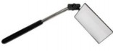 •

5 x 9.2cm Telescopic Inspection Mirror

- Features:

- The Duel Ball Joint positions the mirror at any angle for those hard to see places

Specifications: - Dimensions: 25 x 15 x 4cm - Weight: 0.25kg - Colour: silver & Black - Material: Steel & glass - Warranty: 12 Month

- Cable and Antenna analyzer:

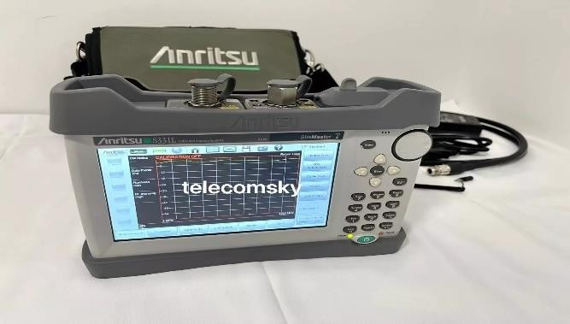
Condition > New, original Anritsu S331L Site Master, multi-languages ( including English) Brand > Anritsu
Frequency Range > 2 MHz to 4 GHz Installed Options > inst. calibration kit Soft bag > included
Size: > 800x480 7" TFT touch screen MPN
Battery > built-in

Frequency Resolution: > 1 kHz Touch pen > included
UPC

- SOCKET SET 1/2''

02330A 1/2 Impact Socket Set, 45 Piece Deep and Shallow Assortment, Metric Sizes 9mm to 32mm, Chrome Vanadium Steel, Extension Bars, Universal Joint and Adapter, 1/2" Drive Deep Well Socket Set
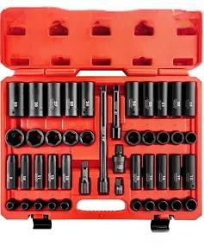
- BATTERY OPERATED CRIMPING KIT KITB1300-C-1
B1300 series portable crimping tool General features: LED light illuminating working area Li-Ion 18.0V 4.0Ah high power battery Crimping cycle data stored (up to 200.000 events) in memory for later transfer to PC Digital display indicating: crimp pressure, available battery life, service/maintenance information Supplied with plastic carrying case for tool, battery and charger and (included) die sets: ME 10-C, 14-C, 19-C, 24-C, 30-C, 37-C, 48-C/li/table SERIES B series TYPE OF TOOL Battery operated crimping tools DESCRIPTION Battery operated crimping tool FOR TERMINALS Die dependant CONDUCTOR Maximum 400 CRIMPING FORCE (kN) 132 kN
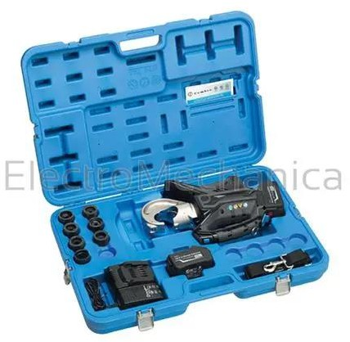

- Insulation testers insulation Resistance up to 10TΩ Short-Circuit Current up to 5mA
Wide Test Voltage from 250V to 5000V

Diagnostic Insulation Tests: IR, PI, DAR, DD, SV, RAMP.

Wireless communication by Bluetooth for transferring and showing real-time data to PC and Android device. Memory and Logging functions.
Filter function reduces noise interference.

Robust design for field use with IP65 (lid closed). Powered by rechargeable battery.
The K3127 is a 5kV High Voltage Digital Insulation Tester that is microprocessor controlled and is capable of performing tests from 250V up to 5000V, and will automatically discharge the circuit after the test has been completed. The meter is a battery powered instrument and operates on a simple and clear basis. Other features include Insulation Resistance 10TΩ, Short-Circuit Current 5mA, IR, PI, DAR, DD, SV, RAMP. The K3127 has the capabilities of being a diagnostic tool and is intended for testing insulation on Rotating Machines, Transformers, Cables, High Voltage Generators, Electrical Circuits and Surge Arresters. These readings are displayed on the large LCD display with a bargraph together with the actual output voltage thus making it easy for the user to read the results. Once the meter test is completed it will automatically discharge the apparatus under test and indicate the discharge voltage on the display while the meter is still on.

Dimensions: 208 x 225 x 130mm Weight: 8kg
Accessories:

Carrying Case

12V Lead-Acid Battery Test Leads
Instruction manual Charger
COC
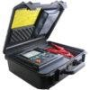

- 4 Pack 7 inch Snap Ring Pliers Set Heavy Duty Internal/External Circlip Green
Material: CRV Carbon Steel Length: 175mm/7''
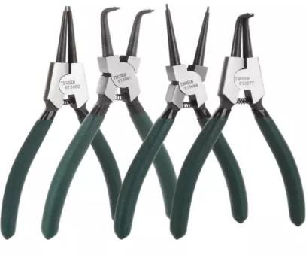
- . Cordless Impact Drill
Power source Battery Powered Maximum rotational speed 3250 RPM Voltage 18 Volts
Maximum chuck size 13 Millimeters Colour Black
Included components 1 x DeWalt 18V 2 x 5.Ah Li-on XR Compact Brushless Hammer Drill Drive Special feature customizing your speed and power
Product dimensions 6.7L x 20.3W x 19H centimetres MaterialMetal


- Cable cutter
Heavyduty,Industrial long-Arm wire Pliers Hand Tool ,24 inch

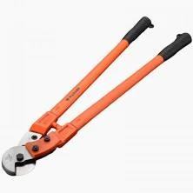

Trimming Knife
KNIFE TRIMMING STANLEY RETRACT 99E 210-099
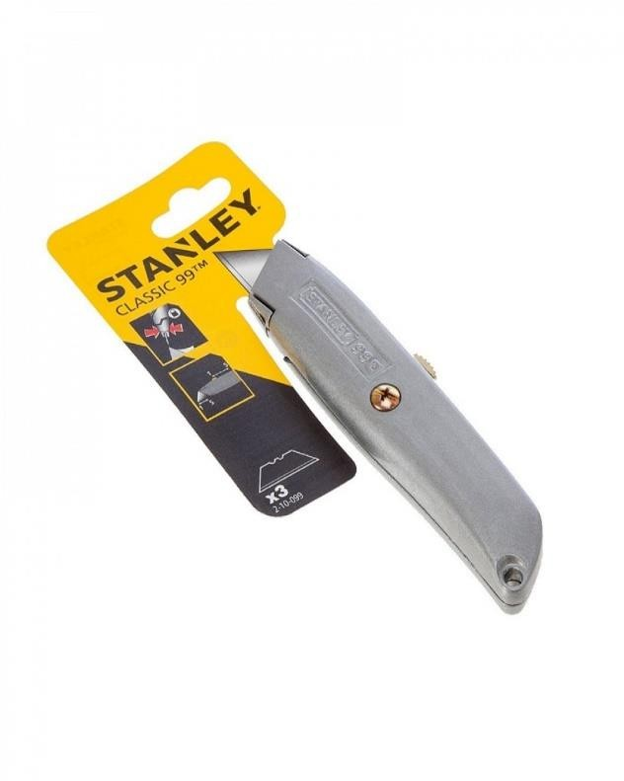

Extention cord/cable

RO-XT HEAVY DUTY 50M CABLE REEL - 4 SOCKET WITH SWITCH

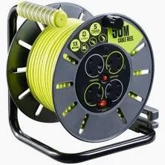

Staple gun
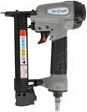

  - 12.7mm CRW X
  - 6-25MM
Cordless Rivet Gun
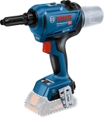
  - GRG 18V-16C

BENCH SAW

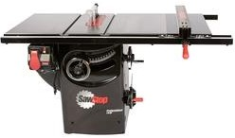

  - Cast-iron table and wings
  - Saw Stop Safety System stops on contact with skin
  - Integrated and Industrial mobile base options
  - Cabinet base, cabinet-mounted trunnion, interior motor
  - MAX 3.0HP Power, 203 kg (449 lbs) typical config weight
  - 1760 mm wide X 927 mm deep X 864 mm high

- 32 tooth saw blade
- Assembly tools
- Automatic safety return
- Blade brake
- Legstand

Flood light

2x50W LED FLOODLIGHT +STAND 2000x295MM 6400K DAYLIGHT

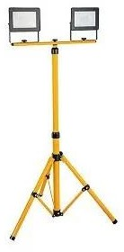

Cordless angle grinder
Cordless angle grinder 18V, BL1830B 3.0Ah Li-Ion battery and rapid charger

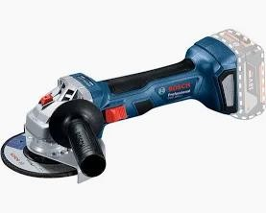

Impact machine
20V Battery operated impact machine


10-ton Hydraulic jack
10-ton Hydraulic jack ,10 Tonne Body repair

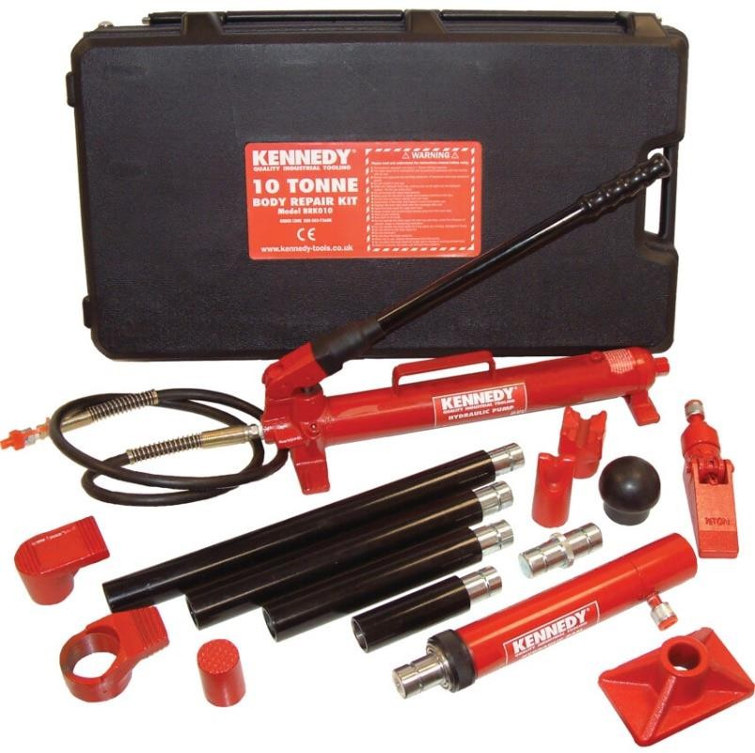
Ladder
Multipurpose, folding ladder, 3.5m A frame
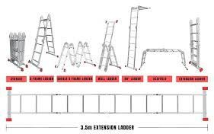

Portable gas complete
Oxyacetylene portable gas cutter

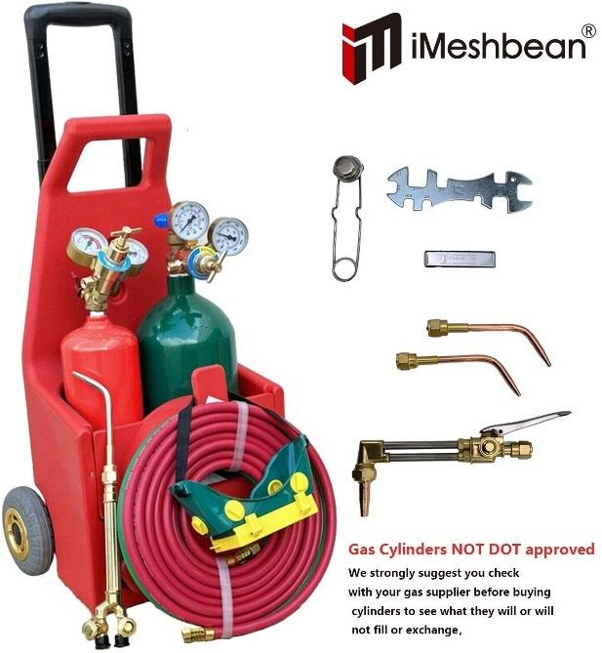

come along
Heavy duty come along

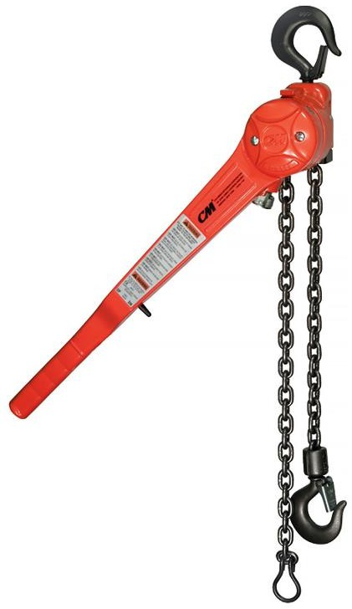

Generators
Heavy duty generators (Derailments)

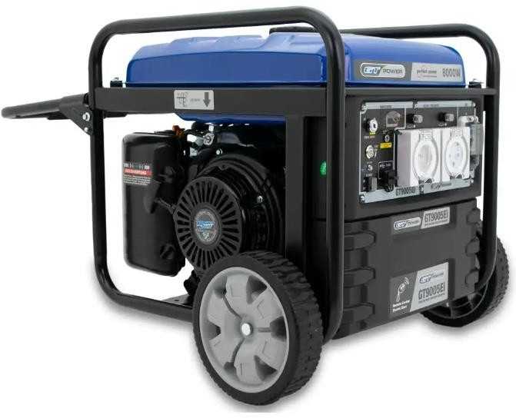

1000KPA Power washer
Power source Corded Electric Item weight 11.46 Kilograms Hose length 6 Meters
Product dimensions 32.9L x 90.1W x 36.9H centimetres Global Trade Identification Number 04054278907154

VGA Male- Female
PRODUCT SPECIFICATIONS
Brand Microworld
Item model number ADA014
Item type VGA Male to VGA Female 90 degree Angle Adaptor Color Black

Bill Of Quantity

NO | DESCRIPTION | UOM |  | UNIT | TOTAL
1. | 3 1/2 Digit Digital Multimeter | ea. | 25
2. | Rigid Back Probe Pins | ea. | 25
3. | Sure Grip Alligator Clips | ea. | 25
4. | USB to Serial (RS232) port converter cable | ea. | 25
5. | RJI CAB IP20/M12 4XAWG 22/7SCHL;1,5m (RJ45 TO  M12 CABLE) | ea. | 25
6. | Tool Bag/Carry bag | ea. | 25
7. | RS232 Gender Exchange (Female to Female) | ea. | 25
8. | RJ45 to RJ45 Straight Ethernet Cable | ea. | 25

9. | RJ45 socket to M12 Female adapter | ea. | 25
10. | RS232 cable (Male to Female) | ea. | 25
11. | Ethernet Adapter | ea. | 25
12. | Oil Draining Canister | ea. | 25
13. | Gurtech Grease gun | ea. | 2
14. | Grease gun fittings. | ea. | 5
15. | DPI 705 Digital pressure gauge | ea. | 25
16. | Fowler Digital inside caliper | ea. | 25
17. | Torque Wrench Set | ea. | 2
18. | Digital Venier – 150mm | ea. | 25
19. | Lazer Distance Meter | ea. | 25
20. | Airflow Meter | ea. | 25
21. | Vacuum Cleaner | ea. | 2
22. | Rechargeable Vacuum Cleaner | ea. | 2
23. | Angled Socket Wrench | ea. | 25
24. | 12 Piece ratchet spanner set - combination | ea. | 25
25. | 9 Piece Allen key set | ea. | 25
26. | 8 Piece tamper proof, Trox screwdriver set | ea. | 25
27. | Padlock | ea. | 25
28. | Wago tool | ea. | 25
29. | 6 Piece Screwdriver set | ea. | 25
30. | 3 Step Ladder | ea. | 5
31. | ¼” Drive socket set | ea. | 25
32. | VGA Male -female | ea. | 25
33. | Safety harness and double lanyard | ea. | 20

34. | Voltage detector | ea. | 5
35. | Inclinometer | ea. | 5
36. | Digital spirit level | ea. | 25
37. | Vibration Meter | ea. | 2
38. | Telescopic Inspection Mirror | ea. | 25
39. | Cable and Antenna analyzer | ea. | 2
40. | 1/2” Drive socket set | ea. | 25
41. | BATTERY OPERATED CRIMPING KIT KITB1300-C-1) | ea. | 2
42. | Insulation testers | ea. | 2
43. | Internal & External Circlip pliers | ea. | 25
44. | Cordless Impact Drill | ea. | 5
45. | Cable cutters | ea. | 2
46. | Trimming Knife | ea. | 25
47. | Extension cord/cable | ea. | 2
48. | Staple Gun | ea. | 2
49. | Cordless Rivet Gun | ea. | 5
50. | Bench Saw | ea. | 1
51. | Flood light | ea. | 10
52. | Cordless angle grinder | ea. | 10

53. | Battery operated impact machine | ea. | 10
54. | 10 ton Hydraulic jack Kennedy 10 Tonne Body repair | ea. | 2
55. | Multipurpose folding ladder 3.5m A frame | ea. | 2
56. | Oxyacetyle portable gas cutter | ea. | 1
57. | Heavy duty come along | ea. | 1
58. | Heavy duty generators (Derailments) | ea. | 1
59. | 1000KPA Power washer | ea. | 2
 | TOTAL

