Addendum D – Icon on Intranet home page
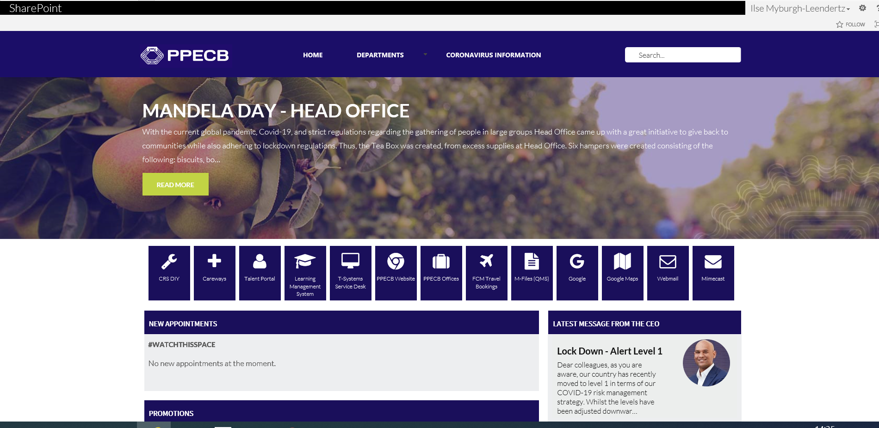
Icons for Quick links

