Questions | Answers
Good Day,  I hope this email finds you well. I am reaching out to request clarity on Protection IED stream under team composition. You provided 3 key personnel information, yet the tender states required number is 4 teams. Kindly advise on required certification and designation of the fourth team.  I hope I get a response this time.  Kind Regards,   | Yes , Three personnel per team , maximum of four teams.
Good Day Ndivhuwo  Please advise on the BID 2549GS Telecommunication Stream, Do you allow same person with different certificates that are required. Can we submit all four certificates required on this stream belonging to the same person?     | No, three different personnel per team
Good Day Ndivhuwo  Please clarify for me on the streams. Can I apply for only one stream or all the streams are compulsory on the BID 2549 GS? | You can select the stream you are applying for
Good morning, Mr/Mrs Maphanga.  I hope you are well.  Please provide the desired amperage for the battery in question, and also the desired charger ratings for the charger.  Kindly assist with RTU specifications as well.  We downloaded the CP_TSSPEC 151 and 160 but we cannot get it there either.  Kind regards, | Requirement is to complete the specification and ratings will be provided during execution.  RTU specifications Refer to spec 268 in the tender document
   | Thembelihle Khanyile  Solid Wedge Services, Unit 5 St James Commercial park  James Crescent, Halfway House, Midrand  Johannesburg, South Africa, 1685  Tel: +2711 314 5861 Cell: +27 67 705 0564  Email : salesza1@solid-wedge.com  Website: www.solid-wedge.com
Good morning, Ndivhumo.  I hope you are well.  On the bid document Bid No 2549GS, on RTU Stream.  Please advise on the where to find the speicifications 268.  Kindly advise.  Kind regards, | RTU specifications, Refer to spec 268 in the tender document
  Thembelihle Khanyile
  Solid Wedge Services, Unit 5 St James Commercial park
  James Crescent, Halfway House, Midrand
  Johannesburg, South Africa, 1685
  Tel: +2711 314 5861 Cell: +27 67 705 0564
  Email : salesza1@solid-wedge.com
  Website: www.solid-wedge.com
Regards  Good day , I hope this email finds you well  I am doing bid for battery and chargers. Now I am kindly asking what to write on the total bid price, and total number of items offered  Vhemma | Pricing will be required at Execution stage
Good day  Hope this finds you well.  Regarding the above-mentioned tender, is there a BOQ? If there is, please may you share it.  Regarding the key personnel, can bidders submit the same CV’s across the streams or do they have to be different personnel ? eg, Can bidders submit the same Technician in stream 1 & 2 ?  Please clarify the team compositions, where more than 1 team is needed, this means each team should consist of the personnel listed ? Eg, if 10 technicians are needed in a team and 4 teams are needed, bidders are to submit x40 technicians to score full points ?  Your urgent response would be highly appreciated  Kind Regards   | Pricing will be required at Execution stage  Yes same personnel in different streams  Yes
Regards  Good day to you. I hope I find you well.  I am having trouble with finding the BOQ for tender bid 2549GS.  Are we supposed to fill the price list . The document does have the BOQ.  Please advise  vhenna | Pricing will be required at Execution stage
Ndivhuwo  I hope this email finds you well.  May you please forward me BOQ on soft format.  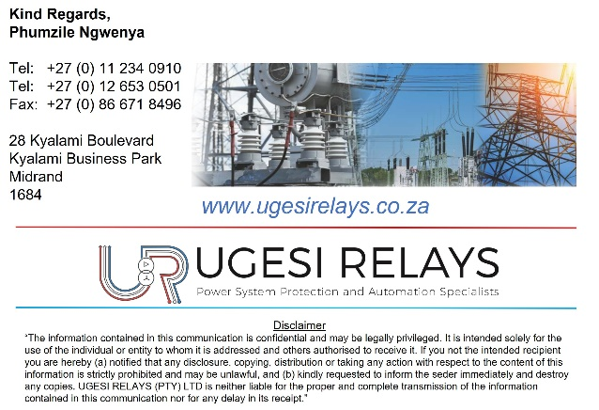 | Pricing will be required at Execution stage
Good Day Ndivhuwo,  I hope this email finds you well. I am reaching out to request for clarification on two items.  - The effect of acquiring 0% on Specific Goals, is 0% stands a ground of being kicked out without being evaluated on price?  - The list of documentation for each stream stated on specifications, are they required now or after the tender has been awarded? I have attached a screenshot for reference  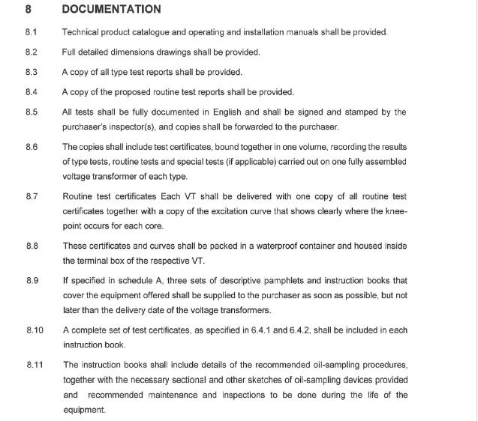   | Yes, it is possible of being kicked out by acquiring 0% on Specific Goals  It can be submitted any time
From: raymond@rmtsholdings.co.za <raymond@rmtsholdings.co.za>  Sent: Monday, 01 July 2024 09:30  To: 'nmamphaga@citypower.co.za' <nmamphaga@citypower.co.za>  Subject: Request for Bid_2549 GS  Good morning, Sir  Hope this email finds you well  I would like to find out if there is no BOQ document for this bid? I have not seen any  Regards | Pricing will be required at Execution stage
   | Raymond Mketi  Project Engineer  Tel : +27128093765 M : +27835641976  Web : https://www.rmtsholdings.co.za/  Email : raymond@rmtsholdings.co.za  Address: Unit 39/40 Block 3, Lombardy Business Park Graham Street, Silver lakes PTA East
Good morning, Sir  Hope this email finds you well  I would like to find out if there is no BOQ document for this bid? I have not seen any  Regards | Pricing will be required at Execution stage
  Raymond Mketi
  Project Engineer
  Tel : +27128093765 M : +27835641976
  Web : https://www.rmtsholdings.co.za/
  Email : raymond@rmtsholdings.co.za
  Address: Unit 39/40 Block 3, Lombardy Business Park Graham Street, Silver lakes PTA East
Good morning agreement on form data 3.1 page 26 do we write the amount the BOQ or contract sum by letters?  Regards  Dipuo Nkogatse | Pricing will be required at Execution stage
From: Garikai <garikai@pelesolutions.co.za>  Sent: Tuesday, June 18, 2024 3:30 PM  To: Ndivhuwo Mamphaga <nmamphaga@citypower.co.za>  Cc: tinashe@pelesolutions.co.za  Subject: Missing specification in Bid No 2549GS  Good day  May I know how we can be able to obtain the missing specification document for Bid No 2549GS. We were unable to obtain the following spec in the bid document:  CP_TSSTAN_111_REV 0 Standard for design, supply, installation, commissioning, and maintenance of multiplexers  Regards | Spec 111 is available on both City Powe Tender and e-tenders website
Good day Ndivhuwo,  Hope you are keeping warm.  Regarding the above mentioned tender – Integrated Security System Stream – is there a BOQ we are pricing or what determines the final Price Schedule?  I have downloaded the specifications as well and there is nothing in there.  If you could kindly offer some more clarity 😊  Kind regards,  Mariska van der Merwe | Pricing will be required at Execution stage

