SBD 3.1.A

PRICING SCHEDULE – FIRM PRICES
(PURCHASES)

NOTE: ONLY FIRM PRICES WILL BE ACCEPTED. NON-FIRM PRICES (INCLUDING PRICES SUBJECT TO RATES OF EXCHANGE VARIATIONS) WILL NOT BE CONSIDERED

IN CASES WHERE DIFFERENT DELIVERY POINTS INFLUENCE THE PRICING, A SEPARATE PRICING SCHEDULE MUST BE SUBMITTED FOR EACH DELIVERY POINT

Name of bidder…………………………………………………Bid number: DIRCO 01-2025/2026

Closing date 09/05/2025 Time 11:00am

OFFER TO BE VALID FOR 120 DAYS FROM THE CLOSING DATE OF BID.

__________________________________________________________________________

ITEM QUANTITY DESCRIPTION BID PRICE IN RSA CURRENCY
NO. (INCLUDING VAT)

- Required by: The Department of International Relations and Cooperation (DIRCO)
INVITATION FOR BIDDERS TO SUBMIT PROPOSALS TO PROVIDE AN ALL-INCLUSIVE EVENT MANAGEMENT SERVICE, FOR ADVERTISING, BRANDING MATERIAL, MEDIA-BUYING SERVICES, CONFERENCE PACKS, PROMOTIONAL MATERIAL, AND EVENT LOGISTICAL REQUIREMENTS (GOODS AND SERVICES), FOR THE G20 HEADS OF STATE AND GOVERNMENT SUMMIT UNDER THE SOUTH AFRICAN PRESIDENCY, SCHEDULED TO TAKE PLACE BETWEEN 22 TO 23 NOVEMBER 2025, IN GAUTENG

- CATEGORY A: BRANDING MATERIAL

Bidders are requested to quote us on branding material for the South Africa’s G20 Presidency as follows:

NO. | ITEM/SERVICE | DESCRIPTION | QUANTITY | PRICE OFFERED IN RANDS
 | AIRPORT BRANDING AT THE FOLLOWING AIRPORTS:  - O.R. Tambo  - Lanseria  - Waterkloof base  - Cape Town International  - King Shaka International  - Kimberley airport  - Polokwane Gateway Airport  - Pilanesberg International Airport  - Bhisho Airport  - Bram Fisher International  - Kruger Mpumalanga  - George  - Nelspruit | Branded Welcome desks (on rental)  - Design 45-degree curved desk with at least one shelf (internal) below countertop, and two highchairs (adjustable)  - Material Soft Wood (e.g. pine)  - Desk dimensions ±2m x 400mm  - Branding Full colour  - Finishing High Level Full Colour Print  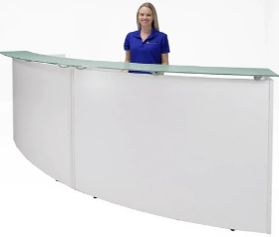  - Removal post-Summit | X15 Sets (one set per airport)
 |  | Media Backdrops  (to be placed behind each information desk)  - Dimensions 3000 x 2000mm  - Material Sublimated fabric (non- transparent)  - Aluminium Retractable construction  - Supplied with carry bag | X15 (1 per airport and 3 at OR Tambo
 |  | Media Backdrop Banners  (Protocol lounge etc.)  - Dimensions 8m(w) x 3m(h)  - Material Sublimated fabric (non- transparent)  - Finishing High Level Full Colour Print  - Branding Full colour  - Supplied with carry bag | X10 (allocation per airport to be advised)
 |  | Pull/Roll Up Banner  (State Protocol Lounges & dedicated Airport lanes)  - Dimensions 850mm(w) x 2 000mm(h)  - Branding Full Colour  - Finishing High Level Full colour Print  - Material Lay flat White PVC quality & resolution  - Wide Base Aluminium Alloy  - Branding Full colour  - Supplied with carry bag | X40 (allocation per airport to be advised)
 |  | Directional signage  (Floor decals at the O.R Tambo Airport for the duration of one week)  - Material Vinyl  - Size 30x20cm  Slip and scratch resistant | X200
 |  | Airport Fence Wrangler Wrap  (OR Tambo International Airport)  - Dimensions 2000m(w) x 5m(h)  - Material Sublimated fabric (non- transparent) finished with webbing  all around  - Additional Eyelets every 500mm apart  and hemmed for strength.  - Finishing High Level Full Colour Print  - Branding Full colour  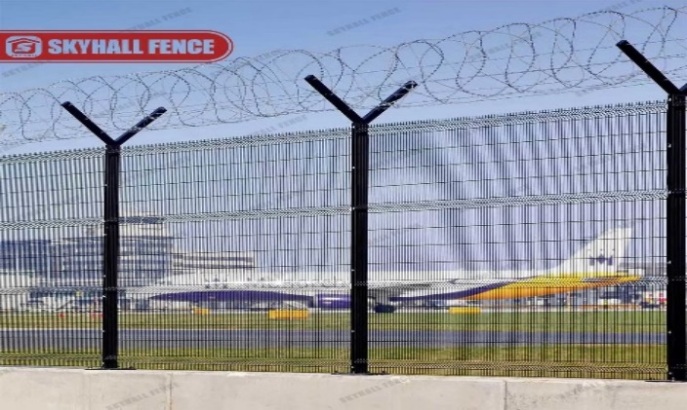  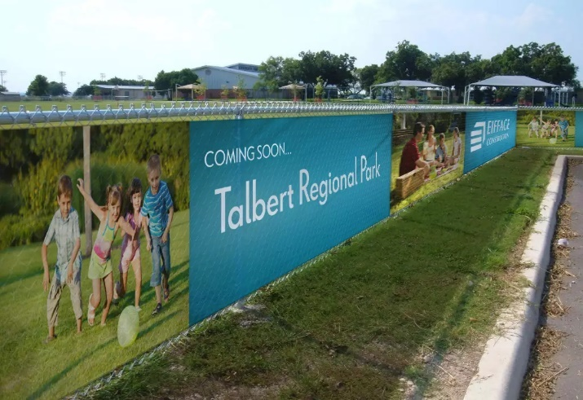 | X1
 |  | Bollard Wrapping: Arrivals and Departure Zones  O.R Tambo International Airport ONLY  Description 3-sided bollard cover  Material 3mm Correx  Size 36" x 4.5  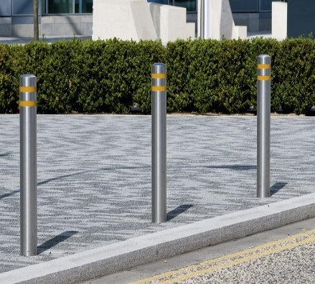  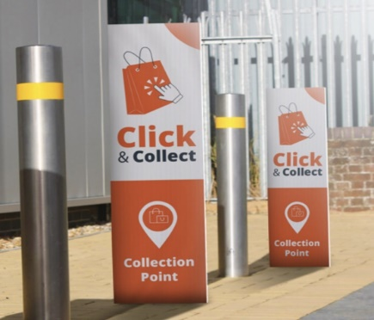 | X50
Total for Branding
VAT
Total Bid Price Offered

NAME OF THE SERVICE PROVIDER_________________________________

SIGNATURE AND INITIALS______________________________________

POSITION___________________________________________________

DATE ___________________________________________________

SBD 3.1(B)

PRICING SCHEDULE – FIRM PRICES
(PURCHASES)

NOTE: ONLY FIRM PRICES WILL BE ACCEPTED. NON-FIRM PRICES (INCLUDING PRICES SUBJECT TO RATES OF EXCHANGE VARIATIONS) WILL NOT BE CONSIDERED

IN CASES WHERE DIFFERENT DELIVERY POINTS INFLUENCE THE PRICING, A SEPARATE PRICING SCHEDULE MUST BE SUBMITTED FOR EACH DELIVERY POINT

Name of bidder…………………………………………………Bid number: DIRCO 01-2025/2026

Closing date 09/05/2025 Time 11:00am

OFFER TO BE VALID FOR 120 DAYS FROM THE CLOSING DATE OF BID.

__________________________________________________________________________

ITEM QUANTITY DESCRIPTION BID PRICE IN RSA CURRENCY
NO. (INCLUDING VAT)

- Required by: The Department of International Relations and Cooperation (DIRCO)

- CATEGORY B: MEDIA BUYING

Bidders are requested to quote the department on Media Buying services for South Africa’s G20 Presidency meetings and Summit as follows:
- Design services for all print media buying platforms stipulated under the category,
- Placement of radio advertisements,
- Placement of print advertisements, and
- Placement of billboards.

- .

NO. | ITEM/SERVICE | DESCRIPTION | QUANTITY | PRICE OFFERED IN RAND
 | Design Services | Bidders will be required to provide graphic design services on all print media in line with the provided G20 logo/brand guidelines and approved messaging. The design team from the bidding company will work closely with the G20 design team from DIRCO.  - Artwork will be signed off by DIRCO prior to production/application. | Across all areas.
 | Placement of:  Radio Advertisements | 27 Week National Campaign 2025  (01 June until 30 November 2025 Excluding weekend)  Service Providers are requested to assist with the placement of radio adverts on the following national and commercial stations.  - Power FM  - Lesedi FM  - Umhlobo Wenene FM  - Motsweding FM  - Thobela FM  - Metro FM  - SA FM  - 702  - Radio 2000  - Capricorn FM  - 947 (94.7)  - Ukhozi FM  - Phalaphala FM  - Munghana Lonene FM  - Ikwekwezi FM  ADVERT SPECIFICATIONS  - Number of Stations X15  - Segments X1 Morning show (per station)  X1 Afternoon show (per station)  - Length of Advert/s 30 seconds  - Duration X2 Bursts per day, per station for 27 weeks (1 June – 30 November 2025)  N.B.: Radio Adverts will be produced and provided by the Department (DIRCO) | X2 Bursts per Day, per Station X over 27 weeks (excluding weekends)  =4,500 Bursts per station (27-week campaign)
 | Placement of:  Print and online Advertisements | 27 Week Print and online Media Campaign  Service Providers are requested to assist with the placement of adverts in the following newspaper publications (print and/or online placements)  Weekends  - City Press  - Sunday World  - Sunday Times  Weekdays  - The Sowetan  - Business Day  - City Press  - Mail & Guardian  - Cape Times  - Daily Maverick  - The Star  ADVERT SPECIFICATIONS  - Size 90h X 205w mm  - Trim 95h X235w mm  - Bleed 100h X 245w m  - Finish Full colour  - Quantity X1 Burst per publication per week | X1 Placement per Publication per week  (1 June – 30 November 2025)
 | Billboard Advertising | Bidder/s are requested to assist with seventeen (17) Billboard applications for the duration of 27 weeks at the following sites:  - Billboard on R21 (Site number: 115040-01)  - Billboard on R21 (15077-01)  - Between Samrand and Allendale offramps North  - Between Samrand & Allendale offramps South  - Billboard on the freeway from OR Tambo International Airport to CBD  - Billboard on the freeway from CBD to OR Tambo International Airport  - Billboard on the N2 from Cape Town International Airport to CBD  - Billboard on the N2 from CBD to Cape Town International Airport  - Billboard on the freeway from King Shaka International Airport to CBD  - Billboard on the freeway from CBD to King Shaka International Airport  - Billboard situated between the N1 and the N2 Freeways.  - Billboard on the N1, from Polokwane to Pretoria,  - Billboard on the N1, from Pretoria to Polokwane,  - Billboard on the N4, from Pretoria to Nelspruit,  - Billboard on the N4, from Nelspruit to Pretoria,  - Billboard on the N14, to Lanseria Airport  - Billboard on the N14, from Lanseria Airport | X17 Billboards  (1 June – 30 November 2025)
Total cost for Media Buying
VAT
Total Bid Price Offered

NAME OF THE SERVICE PROVIDER_________________________________

SIGNATURE AND INITIALS______________________________________

POSITION___________________________________________________

DATE ___________________________________________________

SBD 3.1(C)

PRICING SCHEDULE – FIRM PRICES
(PURCHASES)

NOTE: ONLY FIRM PRICES WILL BE ACCEPTED. NON-FIRM PRICES (INCLUDING PRICES SUBJECT TO RATES OF EXCHANGE VARIATIONS) WILL NOT BE CONSIDERED

IN CASES WHERE DIFFERENT DELIVERY POINTS INFLUENCE THE PRICING, A SEPARATE PRICING SCHEDULE MUST BE SUBMITTED FOR EACH DELIVERY POINT

Name of bidder…………………………………………………Bid number: DIRCO 01-2025/2026

Closing date 09/05/2025 Time 11:00am

OFFER TO BE VALID FOR 120 DAYS FROM THE CLOSING DATE OF BID.

__________________________________________________________________________

ITEM QUANTITY DESCRIPTION BID PRICE IN RSA CURRENCY
NO. (INCLUDING VAT)

- Required by: The Department of International Relations and Cooperation (DIRCO)

- CATEGORY C: CONFERENCE PACKS
Bidders are requested to quote the department on conference packs for South Africa’s G20 Presidency meetings and Summit as follows:
- Design services for all artwork required for promotional material stipulated under the category,
- Conference bags,
- Notebook with folder sets,
- Branded Executive pens,
- Branded pens (Delegates, senior management and media)
- Coffee table books,
- Beaded lanyards,
- Lapel pins,
- Lanyards, and
- Gift bags.

NO. | ITEM/SERVICE | DESCRIPTION | QUANTITY | PRICE OFFERED IN RANDS
 | - DESIGN SERVICES | Bidders will be required to provide graphic design services on all branding material in line with the provided G20 logo/brand guidelines. The design team from the bidding company will work closely with the G20 design team from DIRCO.  - Artwork examples will be provided but will need to be adjusted according to specific products.  - Artwork will be signed off by DIRCO prior to production/application. | Across all areas.
 | HEADS OF STATE PACKS  (X110 pax) | Premium Leather briefcase  Equivalent to the following Quality:  - Material Premium full-grain genuine  leather  - Size Fits up to a 14-inch laptop  - Design Compact single-gusset  - Colour Dark brown  - Features Durable cotton lining  - Branding Foiling/ Debossing  Example:  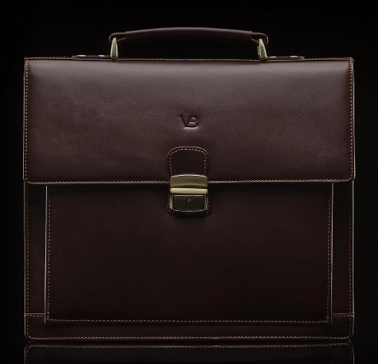 | X110
 | HEADS OF STATE PACKS  (X110 pax) | Branded A4 Notebook with Leather folder  - Folder quality Genuine Leather Zipped  - folder  - Size A4  - Pages Branded lined pages  - Colour Dark brown  - Branding Foiling/Debossing  Example:  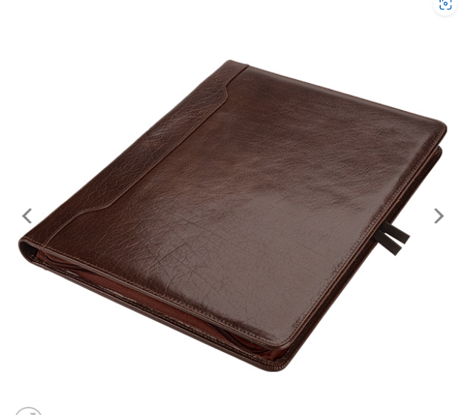 | X110
 | HEADS OF STATE PACKS  (X110 pax) | Branded Executive pen  - Description Executive fountain pen  - Branding Engraving  - Ink Black  Example:  - 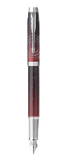 | X110
 | HEADS OF STATE PACKS  (X110 pax) | Coffee table book  Book Title: THE 21 ICONS BOOK  - Author Harriet Pratten  - Published by Quiver tree Publications  - Release date 2013  - Dimensions 350 x 280mm (L x W)  - Format Hard cover  - Pages 192  - ISBN-13 978-0-9922169-0-0  - 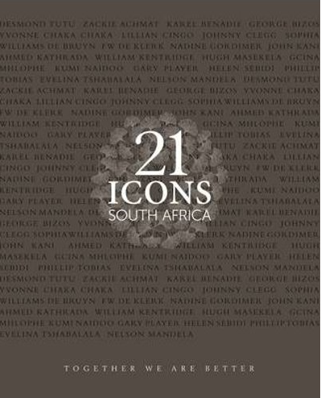 | X110
 | MINISTERS PACKS  (X500 pax) | Leather Messenger Bag  Equivalent to the following:  - Material 100% Genuine Leather  - Colour Desert  - Dimensions L-40cm x W-18cm x H-32cm  - Features 5 inner compartments  - Branding Full colour Screen Print/ Heat Press  Example:  - 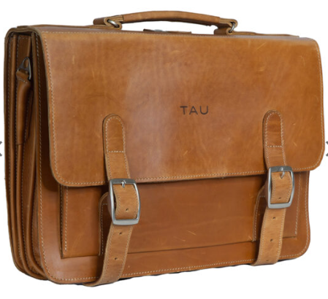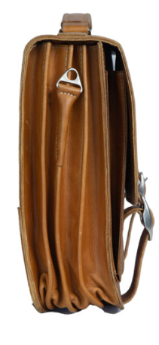 | X500
 | MINISTERS PACKS  (X500 pax) | Branded A4 Notebook with Leather folder  - Material Genuine leather  - Size A4  - Pages Branded lined pages  - Branding Foiling/ Laser embossing  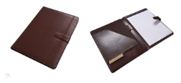 | X500
 | MINISTERS PACKS  (X500 pax) | Branded Executive pen  Equivalent to the following quality:  - High quality pen  - Fishing Chrome  - Branding Engraving  Example:  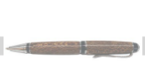 | X500
 | MINISTERS PACKS  (X500 pax) | Coffee table book  Book Title: THE 21 ICONS BOOK  - Author Harriet Pratten  - Published by Quivertree Publications  - Release date 2013  - Dimensions 350 x 280mm (L x W)  - Format Hard cover  - Pages 192  - ISBN-13 978-0-9922169-0-0 | X500
 | MINISTERS PACKS  (X500 pax) | Custom Lapel pin  - Pin type Two-piece Metal (brass), with magnetic back piece  - Size ±24mm  - Material Brass  - Branding 2025 G20 logo  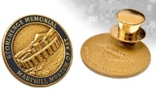 | X500
444  4 | DELEGATES PACKS  (X2000 pax) | Leather Briefcase  - Quality 100% Genuine Leather  - Material Genuine Leather  - (e.g. Cowhide)  - Lining Material Polyester  - Size 29cm x 40cm x 7cm  - Weight 1.1kg  - Branding Full colour Screen Print/ Heat Press  Example:  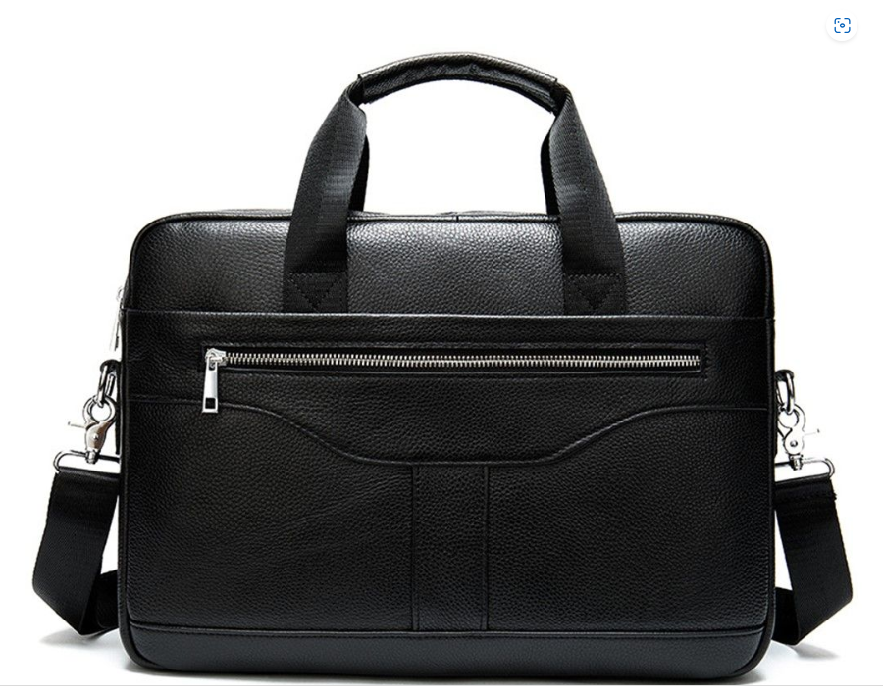 | X2000
444  4 | DELEGATES PACKS  (X2000 pax) | Branded A4 Notebook with folder  - Folder Material Synthetic leather  - Size 27.3 (l) X 20.5 (w) X 1.5 (h)  - Pages Branded lined pages  - Branding Foiling  Example:  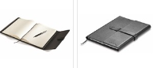 | X2000
 |  | Branded Executive Metal/ Aluminium pen  - Quality High quality  - Material Enamelling on Brass,  - Type Rollerball Pen Refill  - Ink Black  - Dimensions 138mm x 15mm x 7mm  - Branding Laser Engraving  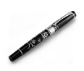 | X2000
 |  | Lapel pin  - Pin type Two-piece Metal (brass), with magnetic back piece  - Size ±24mm  - Material Brass  - Branding 2025 G20 logo   | X2000
 | MEDIA PACKS  (X3500) | Branded Backpack  - Quality Trolley Backpack  - Material Polyester 1680D  - Size 53.5 x 32 x 20cm  - Inner Volume 25 litres  - Weight 2,515g  - Features Combo backpack & trolley for  laptop, Airplane friendly:  - Protective padded laptop compartments,  - Aluminium double arm trolley with dedicated pocket, Back pocket to store the backpack shoulder straps  - Branding Print  Example:  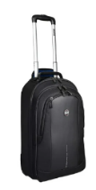
 | MEDIA PACKS  (X3500) | Branded A5 Notebook  - Quality Hard Cover Notebook  - Material PU leather  - Size 21.8(l) x 14.5(w) x 1.8(h) cm  - Pages Branded lined pages  - Branding Foiling  Example:  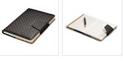
 | MEDIA PACKS  (X3500) | Branded pen  - Quality High quality  - Material Chrome Plated Copper & Stainless Steel  - Ink Black  - Branding Laser Engraving  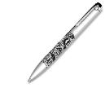
 | MEDIA PACKS  (X3500) | Power banks  - Quality High speed and quality 10000mAh  - Materia Aluminium & ABS Plastic  - Size 14cm (l) x 7cm (w) x 1.4cm (h)  - Capacity 10000mAh  - Branding Laser Engraving  Other features:  - Battery 10000mAh Lithium Polymer  - Input 5V/2A via both Type-C and Micro USB port  - Output 5V/2A  - Recharge Time 6 Hours  - Discharge Time 4 Hours  - A micro-USB port and a Type-C port  - LED Light Power Capacity Indicator  - 27cm Charging Cable  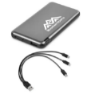
 | Senior Officials meetings  (5 000 pax) | A5 Notebook and pen set  - Description Prominence A5 Hard Cover Notebook  - Material PU  - Product Size 21(l) x14.3(w) x1.5cm (h)  - Capacity A5.  - Pages Branded Lined Pages  - Branding Screen Print  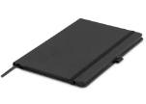 | X5000
 | Senior Officials meetings  (5 000 pax) | Branded ball pen  - Description High quality ball pen  - Material Metal  - Product Size 16.6 (l) x 6 (w) x 2.9cm (h)  - Branding Screen Print  - Colour black (with black ink)  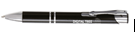 | X5000
 | Senior Officials meetings  (5 000 pax) | Lanyards  - Description Satin lanyards  - Material Satin & Metal  - Size 50cm x 2cm  - Branding Full colour Screen Print  - Colour Various | X5000
 | Senior Officials meetings  (5 000 pax) | Branded Paper bags  - Description Medium sized Gift bag  - Size A4 (255 X 120 X 300mm)  - Grammage 230gsm  - Colour Black  - Finishing Matte  - Branding Branded on both sides  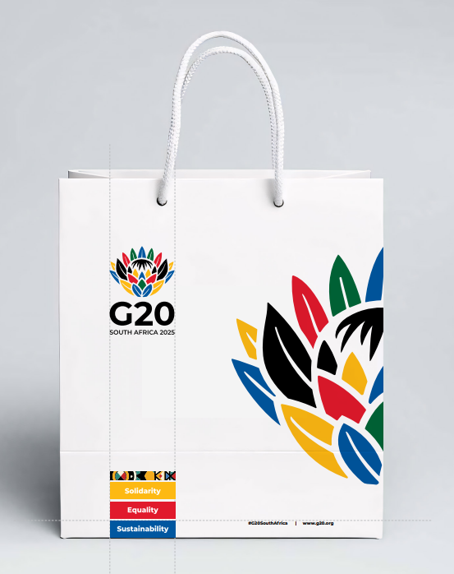 | X5000
Total Conference packs
VAT
Total Bid Price Offered

NAME OF THE SERVICE PROVIDER_________________________________

SIGNATURE AND INITIALS______________________________________

POSITION___________________________________________________

DATE ___________________________________________________

SBD 3.1(D)

PRICING SCHEDULE – FIRM PRICES
(PURCHASES)

NOTE: ONLY FIRM PRICES WILL BE ACCEPTED. NON-FIRM PRICES (INCLUDING PRICES SUBJECT TO RATES OF EXCHANGE VARIATIONS) WILL NOT BE CONSIDERED

IN CASES WHERE DIFFERENT DELIVERY POINTS INFLUENCE THE PRICING, A SEPARATE PRICING SCHEDULE MUST BE SUBMITTED FOR EACH DELIVERY POINT

Name of bidder…………………………………………………Bid number: DIRCO 01-2025/2026

Closing date 09/05/2025 Time 11:00am

OFFER TO BE VALID FOR 120 DAYS FROM THE CLOSING DATE OF BID.

__________________________________________________________________________

ITEM QUANTITY DESCRIPTION BID PRICE IN RSA CURRENCY
NO. (INCLUDING VAT)

- Required by: The Department of International Relations and Cooperation (DIRCO)

- CATEGORY D: PROMOTIONAL MATERIAL
Bidders are requested to quote the Department on branded promotional material for South Africa’s G20 Presidency as follows:

- Golf t-shirts,
- Sweatshirts,
- Thermal water bottles, and
- Golf umbrellas.

NO. | ITEM/SERVICE | DESCRIPTION | QUANTITY | PRICE OFFERED IN RANDS
 | PROMOTIONAL MATERIAL | Golf t-shirts (unisex)  Specifications  - Calgary golf shirt  - 200 g/m²  - 100% cotton piqué knit  - 1x1 rib knit collar and cuffs  - contrast colour neck tape  - two-button placket  - tone-on-tone logo buttons  - side slits with contrast inner tape  - heat transfer main label  - Colour: (assorted)  - Branding: Embroidery  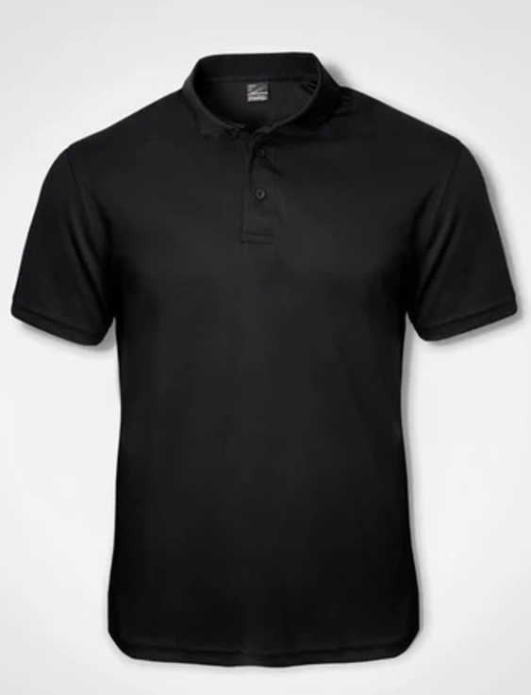 | X 1000
 |  | Long sleeve sweatshirts (unisex)  - Poly Spandex sweatshirt (unisex)  - 270 g/m²  - 100% mechanical stretch woven bonded to 100% polyester anti-pill treated micro fleece  - lining: 100% polyester brushed tricot knit  - concealed zip pocket  - full zip with branded zip puller  - wind placket  - hidden inner pockets  - adjustable Velcro cuffs  - standard fit  - thumb holes  - Colour: Black  - Branding: Embroidery  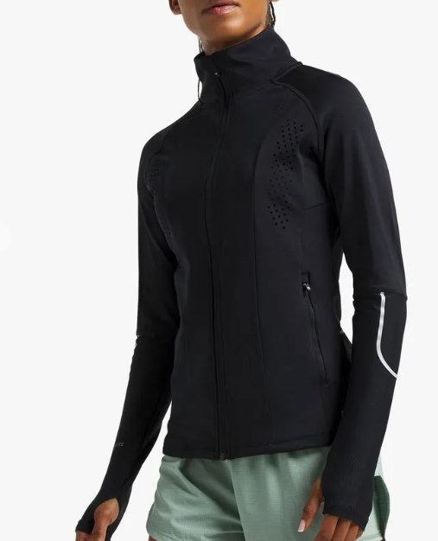 | X1000
 |  | THERMAL TRAVEL WATER BOTTLE  - Material Stainless steel, BPA-free  - Capacity 750ml  - Branding Full colour PU Print  - Branding: Full colour Screen Print  - Colour Black  Example:  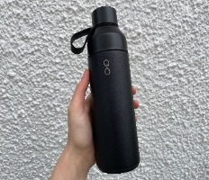 | X1000
 |  | Golf umbrella  - Auto-Open Golf Umbrella  - Material: 190T Pongee, PP & Fibreglass  - Size: 132cm (d)  - Capacity: 8 Panels  - Branding: Full colour Screen Print  - Colour: Black  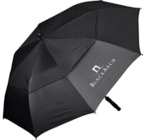 | X500

Total Promotional Material
VAT
Total Bid Price Offered

NAME OF THE SERVICE PROVIDER_________________________________

SIGNATURE AND INITIALS______________________________________

POSITION______________________________________________________

DATE ___________________________________________________

SBD 3.1(E)

PRICING SCHEDULE – FIRM PRICES
(PURCHASES)

NOTE: ONLY FIRM PRICES WILL BE ACCEPTED. NON-FIRM PRICES (INCLUDING PRICES SUBJECT TO RATES OF EXCHANGE VARIATIONS) WILL NOT BE CONSIDERED

IN CASES WHERE DIFFERENT DELIVERY POINTS INFLUENCE THE PRICING, A SEPARATE PRICING SCHEDULE MUST BE SUBMITTED FOR EACH DELIVERY POINT

Name of bidder…………………………………………………Bid number: DIRCO 01-2025/2026

Closing date 09/05/2025 Time 11:00am

OFFER TO BE VALID FOR 120 DAYS FROM THE CLOSING DATE OF BID.

__________________________________________________________________________

ITEM QUANTITY DESCRIPTION BID PRICE IN RSA CURRENCY
NO. (INCLUDING VAT)

- Required by: The Department of International Relations and Cooperation (DIRCO)

- CATEGORY E: Event logistics (G20 Live Broadcast Breakfast)

Bidders are requested to quote the Department on logistical requirements (goods and services) for the G20 Summit Live Broadcast Breakfast as follows:

NO. | ITEM/SERVICE | DESCRIPTION | QUANTITY | PRICE OFFERED IN RANDS
Catering requirements
(Live Broadcast Breakfast)
1. | DESIGN SERVICES | Bidders will be required to provide graphic design services on all branding material in line with the provided G20 logo/brand guidelines. The design team from the bidding company will work closely with the G20 design team from DIRCO.  - Artwork examples will be provided but will need to be adjusted according to specific products.  - Artwork will be signed off by DIRCO prior to production/application. | Across all areas.
2. | Catering | 96% Halaal on all food  10% vegetarian, and 4% plated kosher meals  ** The below menu is meant to serve as a guideline, suppliers are encouraged to provide alternative options.  On Arrival at 5am  (Coffee station)  - Assorted South Africa teas ( Rooibos tea, ceylon tea, etc)  - Fresh Coffee station (The coffee station should have a variety of hot beverages, filter coffee, cappuccinos, latte, etc…)  - Assorted 100% canned fruit juices  - Freshly baked assorted pastries  On each table  - Freshly baked scones served with fresh cream and an assortment of jams  - Cheeseboard – Assortment of cheeses  - Assortment of mini breads  - Fresh seasonal fruit  Plated Main  - Eggs Benedict with smoked salmon, hollandaise and mushroom skewers topped with fresh rocket  - Cheese and herb corn bread stacker topped with scrambled eggs and a drizzle of pesto topped with swirls of smoked salmon  Beverages  - Assorted South Africa teas (Rooibos tea, Ceylon, etc…)  - Fresh Coffee station (The station coffee should have a variety of hot beverages, filter coffee, cappuccinos, latte, etc…)  - Assorted 100% canned fruit juices  - 500ml Bottled Water (still and sparkling) | X500 Guests
3. | Waitrons | X 50 Waitrons (1:10) dressed in uniform, presentable and formal | X50
Decor requirements
(Live Broadcast Breakfast)
 | DÉCOR | Entrance to the Breakfast area  - X2 Plinths with large floral arrangements/displays on top (on either side of the entrance) (Floral arrangement should include: Proteas, Tulips, Hydrangeas, Lilies/ stargazers and other votives)  - X1 Red carpet at the main entrance to Delegates dining room (Size: 20m) | As per the décor requirements
 |  | Arrival Area  X2 Console tables with large floral arrangements/displays and Mirror against the wall (Floral arrangement should include: Proteas, Tulips, Hydrangeas, Lilies/ stargazers and other votives) | As per the décor requirements
 |  | On Stage  - X6 Wingback chairs (for Panel members)  - X5 Low wooden side tables, each with a low fresh floral centre piece (table positioned between chairs)  X1 Persian Rug (±6X2m) | X6  X5  X1
 |  | MAIN VENUE/ BALLROOM AREA – SEATING 500 guests  Décor requirements are as follows;  Table requirements  - X63 Round tables (each seating eight guests)  - Tufted/ dining chairs (Seating 500)  - Linen Tablecloths  - Satin overlays  - Satin napkins,  - Glass charger plates,  - Crystal glassware,  - Centre pieces – SA floral (i.e.: proteas, stargazer lily, tulips, orchids etc.)  - Presidential Cutlery (Stainless 18/10 grade)  - Presidential Crockery (Fine bone China)  - Table Numbers  Additional Room requirements  - X8 Plinths with floral arrangements  NOTE: The Successful bidder will be required to conduct a mock set-up for final approval a week prior to the event | X500 guests
 | Event Stationery | Menu/Programme cover:  - Size: 195mm-w/185mm-h  - Folded and scored in half (97mm-w/185)  - Gold foiling and full-colour printing.  - Paper: Saville Row  - Colour: Natural Ivory (280gsm)  Menu/Programme insert:  - Size: 195mm-w/ 185ww-h  - Folded and scored in half (97mm-w/185mm-h)  - Printing full colour only  - Paper: Saville Row  - Colour: Natural Ivory (120 gsm) | X500 Guests
Sound, Stage, Audio-Visual, and Technical Support
(Live Broadcast Breakfast)
 | Stage design | The successful service provider will be required to develop three (3) stage designs for the Department’s consideration, based on the below brief:  Concept: Multi-dimensional built set which incorporates the G20 logo (in 3-d), screens and other digital props.  Please see the below illustrative examples:  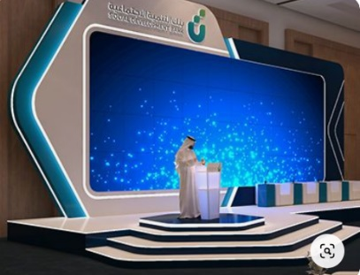  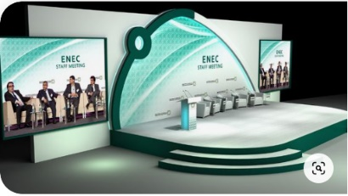  Dimensions  - Stage: 10m x 5m (0.6m high)  - Ramp: 1.2m x 6m (0.6m high)  - Must include; Steps & Cladding/ Skirting | X1
 | Digital Lectern | LCD Digital Lectern (Black) | X1
 | Camera risers | - X3 Camera riser (1.2m x 2.4m) | X3
 | PA System | - PA System (which also allows for background music)  - X7 Lapel Microphones (Programme director and panellists)  - X7 Microphones (backup solution for panellists)  - X3 Roving microphones (Q&A Session) | As per technical rider
 | AV Equipment | - X4 50” LED Screens on stands (for live feeding and branding)  - N.B.: Must provide 32 gb USB for each screen | X4
 | Lighting | - X1 Lighting Cabling and Multicores  - X2 Single Receiver  - X2 Single Transmitter  - X1 Ultralight - Complete  - X10 Washlight  - X24 Ledforce 18 RGBW  - X6 Colour Spot 700E  - X6 ETC SOURCE 4 Par 4 EA  - X1 12 Way Dimmer | As per requirements
TOTAL G20 EVENTS LOGISTICS
VAT
TOTAL BID PRICE

NAME OF THE SERVICE PROVIDER_________________________________

SIGNATURE AND INITIALS______________________________________

POSITION___________________________________________________

DATE ___________________________________________________

SBD 3.1(F)
CONSOLIDATION OF ALL CATEGORIES

PRICING SCHEDULE – FIRM PRICES
(PURCHASES)

NOTE: ONLY FIRM PRICES WILL BE ACCEPTED. NON-FIRM PRICES (INCLUDING PRICES SUBJECT TO RATES OF EXCHANGE VARIATIONS) WILL NOT BE CONSIDERED

IN CASES WHERE DIFFERENT DELIVERY POINTS INFLUENCE THE PRICING, A SEPARATE PRICING SCHEDULE MUST BE SUBMITTED FOR EACH DELIVERY POINT

Name of bidder…………………………………………………Bid number: DIRCO 01-2025/2026

Closing date 09/05/2025 Time 11:00am

OFFER TO BE VALID FOR 120 DAYS FROM THE CLOSING DATE OF BID.

No. | Item | PRICE OFFERED IN RANDS
1 | CATEGORY A: BRANDING MATERIAL
2 | CATEGORY B: MEDIA BUYING
3. | CATEGORY C: CONFERENCE PACKS
4. | CATEGORY D: PROMOTIONAL MATERIAL
5 | CATEGORY E: EVENT LOGISTICS (G20 LIVE BROADCAST BREAKFAST)
TOTAL COST (INCLUDING VAT)

NAME OF THE SERVICE PROVIDER_________________________________

SIGNATURE ___________________________________________________

POSITION______________________________________________________

DATE ___________________________________________________

