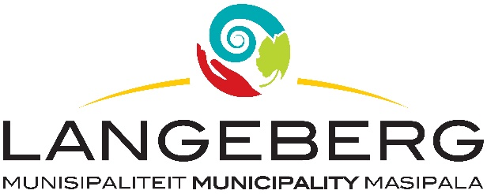

TENDER-23/2024

Tenders are hereby requested for the PROVISION OF BANKING SERVICE FOR A PERIOD OF FIVE (5) YEARS, WITH EFFECT FROM 01 JULY 2025 OR NEAREST DATE AS DETERMINED BY THE CHIEF FINANCIAL OFFICER as specified in the bid document.

Completed Bids, in sealed envelopes, clearly marked “TENDER-23/2024: PROVISION OF BANKING SERVICE FOR A PERIOD OF FIVE (5) YEARS, WITH EFFECT FROM 01 JULY 2025 OR NEAREST DATE AS DETERMINED BY THE CHIEF FINANCIAL OFFICER (CFO)” should be placed in the tender box, at the Langeberg Municipal Office, 28 Main Road, Ashton, not later than 12:00 on 08 NOVEMBER 2024 when the Bids will be opened in public. Late, faxed or e-mailed tenders will not be considered.

In terms of Section 7 and 85 of the Municipal Finance Management Act, 2003 (Act 56 of 2003) as wells regulation 30 of the Supply Chain Management Regulations, the Municipality must procure banking service through a competitive bidding process. Commercial banks registered in terms of the Banks Act, No. 94 of 1990, are hereby invited to submit tenders to provide banking services to Langeberg Municipality for a period of 5 years.
Only service providers who meet the eligibility criteria set out in the conditions of the tender are encouraged to participate in this tender.
Tenders that are not registered in terms of the Banks Act will be deemed non-responsive and will not be considered.
COMPULSORY CLARIFICATION MEETING:
A COMPULSORY CLARIFICATION MEETING WILL BE HELD ON THE 01 OCTOBER 2024, AT 11H00, AT COMMITTEE ROOM 3, THE ASHTON MUNICIPAL OFFICES, 28 MAIN ROAD, ASHTON, PERSONS ARRIVING LATER THAN 11H15 WILL NOT BE ALLOWED INTO THE MEETING.

Prospective tenderers shall meet in: COMMITTEE ROOM 3, Service providers who arrive 15 minutes later than the mentioned starting time will not be allowed into the meeting. Please note: The Municipality prefers that Senior Company Staff members or Contract Managers attend the compulsory clarification meeting as the Tender Specifications will be discussed in detail along with the Execution phase expectations and possible amendments. It remains the Bidder’s responsibility to familiarize themselves with and fully understand the tender specifications to be able to submit a responsive tender.
This will be a 2 Envelope Competitive bidding process, comprising of a Technical Evaluation process and Price Evaluation process. Two separate envelopes must be submitted, clearly marked “Technical Evaluation” and “Price Evaluation”; and should contain the documentation required for the respective evaluation process.
The municipality will at first, only open the envelope marked as “Technical Evaluation” and evaluate all the Technical Evaluation bid documentation received in terms of the Technical Evaluation Criteria. Bidders scoring less than 45-points out of 60- points in respective of “Technical Evaluation” will be regarded as submitting a non-responsive tender and will be disqualified.

The Price Evaluation documentation for all responsive tenders for bidders that scored 45-points or more for Technical Evaluation, will only be opened and evaluated in terms of the Price criteria.
Bidders may be required to demonstrate their banking solution through a practical demonstration in line with the technical requirements as stated should the Municipality require so.

PLEASE NOTE:

The official Bid document must be fully completed in black ink, all pages must be submitted and the document should preferably be bound. Supporting documents must be submitted separately and must be stapled or bound.

The lowest, or any tender, will not necessarily be accepted and council reserves the right to accept any tender. Tenders will be evaluated according to the Council’s Supply Chain Management Policy and the 80/20 Preference Point system. The Supply Chain Management Policy can be viewed at Municipal Offices or www.langeberg.gov.za

Tender documents are available from 30 AUGUST 2024, on the Langeberg Municipal website: www.langeberg.gov.za

Please refer written enquiries to MS L NOKAMA (lnokama@langeberg.gov.za).

DP LUBBE
MUNICIPAL MANAGER
Private Bag X2
Ashton,
6715

