

Invitation to submit Proposal

RFI Name: Supply and Deliver of Various Laboratory and Office Furniture
Number: RFI/LAB/OFFICEFURNITURE2024/25

Date of Issue | 24 October 2024
Closing Date & Time | 07 November 2024
RFI Enquiries | Portia Jonginyanga  E-mail: PortiaJ@ppecb.com  Tel: +27 21 930 1134
PPECB business hours | 08:15 – 16:45
Category | Laboratory Furniture

Invitation to Tender
Bidders are invited to submit Request for Information (FRI) for the supply and delivery of various office furniture.

Scope of Service

SPECIFICATION
Specification various office furniture for the laboratory and offices.

Quantity | Item
37 | Ergonomic Laboratory Chairs:  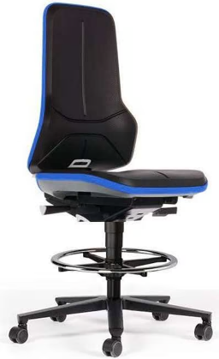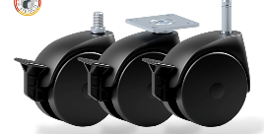  - Ergonomic  - Adjustable hight  - Adjustable back rest  - Footrest  - Swivel wheels with brake  - Material: fabric  - Colour: dark blue
3 | High Back Ergonomic Executive Chairs:  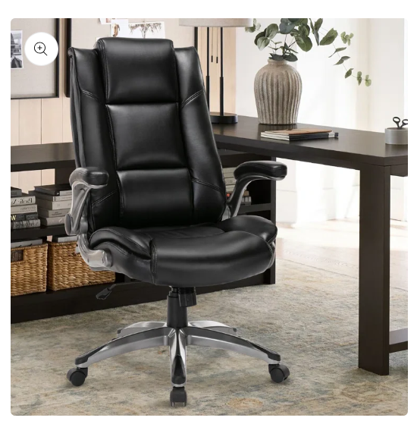  - Ergonomic: provides optimal neck and lumbar support, helps straighten the body, prevents hunching, and ensures the best sitting posture for computer users and students who spend long hours at their desks.  - Double-padded seat cushion  - High back chair on wheels  - Adjustable built-in lumbar support  - Adjustable flip up arms  - Adjustable tilt angle  - Soft high-density foam  - Material: leather  - Colour: Black  - Thicker and wider seat cushion  - 360° swivel chair  - Rolling casters  - Thick padded headrest  - Height adjustor
3  Only 1 book shelve | Executive tables:  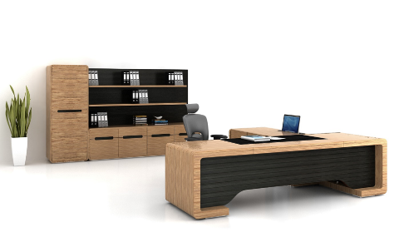  - L-shape  - 2 x 1.5 (estimate)  - Credenza  - Cupboard with drawers  - Colour – melamine maple  - Modesty panel  - With matching book shelve (as in picture)
1 | 6 Seater table with chairs:  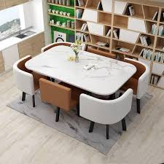  - Colour of table: maple melamine  - Colour of chairs: black
4 | 4 Seater round table with chairs:  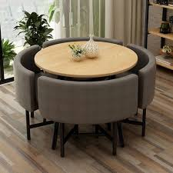  - Tabletop colour: Maple Melamine  - Padded seats colour: black
17 | Senior offices - Computer Desk Ergonomic Chairs:  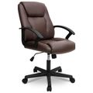  - Ergonomic: lumbar support  - Adjust rocking  - Adjust rocking tension  - Adjustable seat hight  - Material: leather  - Rolling casters  - Colour: black
12 | Senior offices – tables:  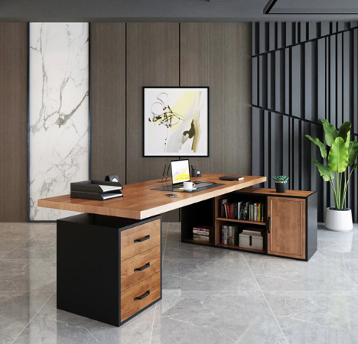  - Modesty panel  - Cupboard with drawers  - Credenza  - Colour: Melamine maple  - 2 x 1.5
11 | QMS office – glass door bookcases:  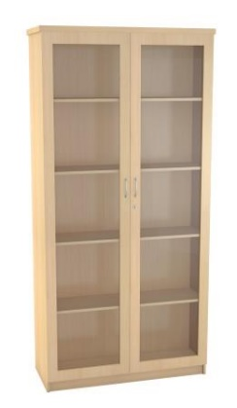  - Colour: melamine maple  - 5 Tier 1800H x 900W x 350D  - Adjustable shelves  - Lockable
2 | Wooden 4 drawer filing cabinet:  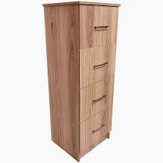  - Colour: maple melamine
32 | Lab and Senior Inspector - Office chairs:  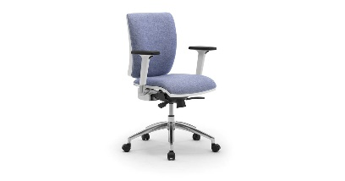  - Ergonomic: office chairs with lumbar support  - Adjustable flip up arms (padded)  - Adjustable seat hight  - Material: fabric  - Rolling casters  - Colour: dark blue
Seat up to 16  (6 x 4-seater) | Lab and Senior Inspectors - Cubicles:  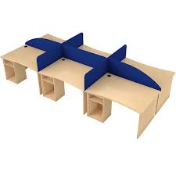  - Seats 4 people  - Colour: Maple melamine  - Screen colour: dark blue  - Screen size: half  - Modesty panels  - Cupboards
Seat up to 8 | Admin - Cubicles:  - Seats 4 people  - Colour: Maple melamine  - Screen colour: dark blue  - Screen size: half  - Modesty panels  - Cupboards
4 | Staff room furniture:  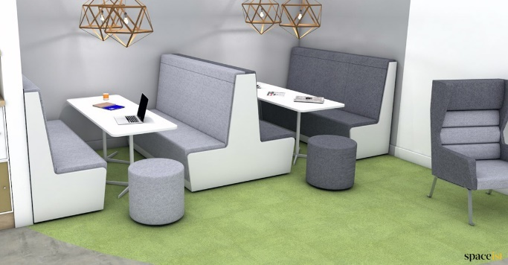  - Four Person Booth with Screen  - Material: fabric  - Table to include power and USB sockets.  - Seat colour: dark blue / light blue / green / grey  - End panel colour – white  - Table colour – white
4 | Ottoman:  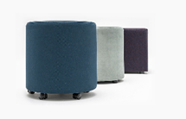  - Material – fabric  - Colour: dark blue / light blue / green / grey
2 | Sino Office + Lounge couches:  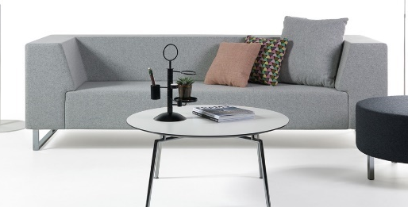  - 3-seater  - Material: Fabric  - Colour: dark blue
1 | Thabang’ office couch:  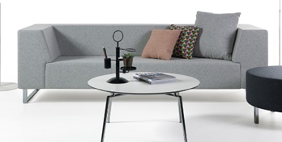  - 2-seater  - Material: Fabric  - Colour: dark blue
4  Option 2 | Round table with chairs for staff lounge:  - Tabletop colour: Maple Melamine  - Padded seats colour: dark blue / light blue / green / grey
1 | Reception desk:  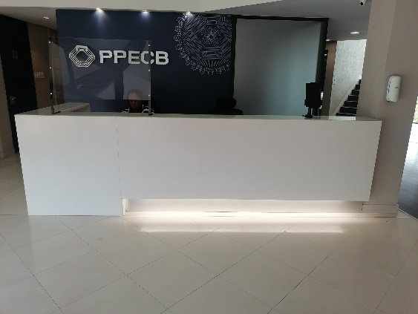  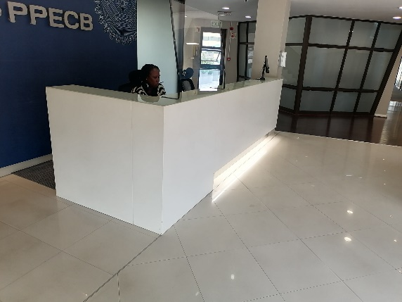  - Colour: White  - 4 drawers  - 1 door cabinet  - 2.3 x 1.0
2 | Sample reception:  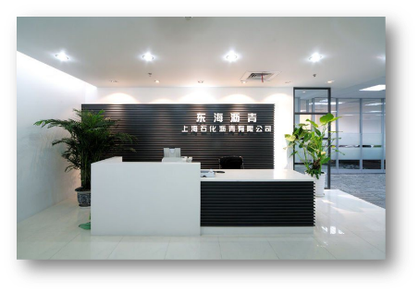  - Colour: Melamine Maple  - With cupboard and drawers  - Modesty panel
4 | Reception – visitor chairs:  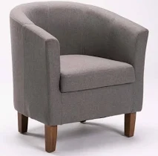  - Material: fabric  - Colour: dark blue
1 | Reception – coffee station:  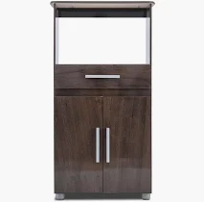  - Colour: maple melamine  - 1 drawer  - 2 doors
Must seat 40-50 people | Boardroom:  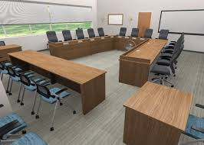  - U-shaped boardroom table to seat 40 people – maple melamine  - Boardroom chairs – black  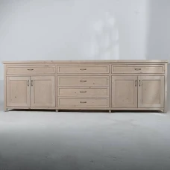  - Server with cupboard doors and drawers – maple melamine

Delivery address:
Centurion close
Block B, Unit 4
119 Gerhard Street, Centurion,
Gauteng, 0157
.
For any enquiries please contact:
Portia Jonginyanga @
PortiaJ@ppecb.com
021 930-1134

