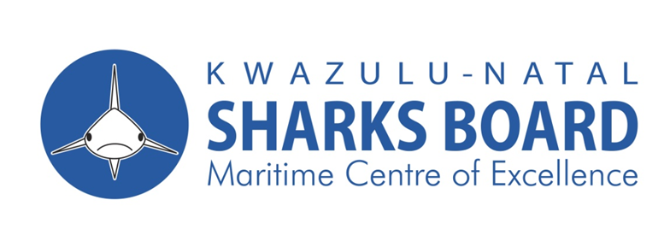
SUPPLY AND DELIVER NAVAL AND SAND (DURBAN) ANCHORS FOR THE KWAZULU-NATAL SHARKS BOARD MARITIME CENTRE OF EXCELLENCE FOR THE PERIOD OF 3 YEARS.
NOTIFICATION OF TENDER
The KwaZulu-Natal Sharks Board Maritime Centre of Excellence invites tenders for the following:
Description | Tender No. | Compulsory Briefing Date | Tender Closing Date | Tender Closing Time
Supply and deliver Naval and Sand (Durban) anchors for the Kwazulu-Natal Sharks Board Maritime Centre of Excellence for the period of 3 years.  Evaluation will be on mandatory requirement, and 80/20-point on specific goals system. | ZNT 2025/2026KZNSB03 | 15 July 2025 | 29 July 2025 | 11h00

- A compulsory briefing session with the representatives of the KwaZulu-Natal Sharks Board will take place at the Hall, 1a Herrwood Drive uMhlanga Rocks at 11:00 am.
- Tenders should provide the following:
- Valid BBBEE Certificate
- Proof of registration with the National Treasury Central Supplier Database (CSD): NB Proof to be printed from the National Treasury website
- Original or Certified copy of registration with Maritime or shipping authorities and Quality certification organizations (ISO).
- Proof of registration with Companies Intellectual Property Commission (CIPC)
- All Supply Chain Management inquiries must be addressed to Ms Nonkululeko Khumalo on 031 566 0400 E-mail: nonkululeko@shark.co.za and all Technical queries to Ms. Nomathamsanqa Bekwa on 031 566 0400 E-mail:nomathamsanqa@shark.co.za. and Grayson Love grayson@shark.co.za
- Telegraphic, telephonic, telex, facsimile and late tenders will not be accepted.

- Bids Documents Available at KwaZulu – Natal Sharks Board, 1a Herrwood Drive, Umhlanga.
- Submission of Bids: Sealed envelopes clearly marked with the relevant bid number, closing date and time and Bidders name must be deposited into the bid box at the Sharks Board premises at the Ground Floor, 1a Herrwood Drive Mhlanga, 4320.
- NB: A non – refundable deposit of R300.00 for the tender document is payable into KwaZulu – Natal Sharks Board bank account as mentioned below with reference “Tender”.
- The Banking details are as follows: Bank: ABSA, Account Number 1012341080, Account Holder: KZN Sharks Board, Branch: La Lucia Ridge.
- The tender document will be available 07 July 2025 – 14 July 2025 during working hours from 08H00 to 15H30. and may be collected upon producing proof of payment (deposit slip: no cash will be accepted).
- Tender documents will not be issued on the date of the briefing and after briefing session.
- An original valid Tax Clearance Certificate and valid B-BBEE Status Level Verification Certificate must accompany the bid.

