Annexure C4: Site Information PR10417336
Lightning and Earthing Protection at various Rand Water Booster station

Attention winning bidder-
*Successful supplier must submit a complete Safety File for Induction at Zwartkopjes Risk Department within 10 days of receiving official order number, for approval.
*Successful supplier must submit the Quality Control Plan as well as the programme within 2 weeks after the approval of the scope of work.
* Progress meetings will be required for duration of the project.
*Suppliers make use of their own equipment; no Rand Water equipment will be made available
Annexure C4: Site Information

SITE INFORMATION
1. SITE LOCATION- Mapleton Pumping station.
The Site of the work is situated at GPS coordinates 26°35’75.9’’S; 28°25’11.9’’E in Mapleton. This site is located on the East of Johannesburg not far from Vosloorus township.
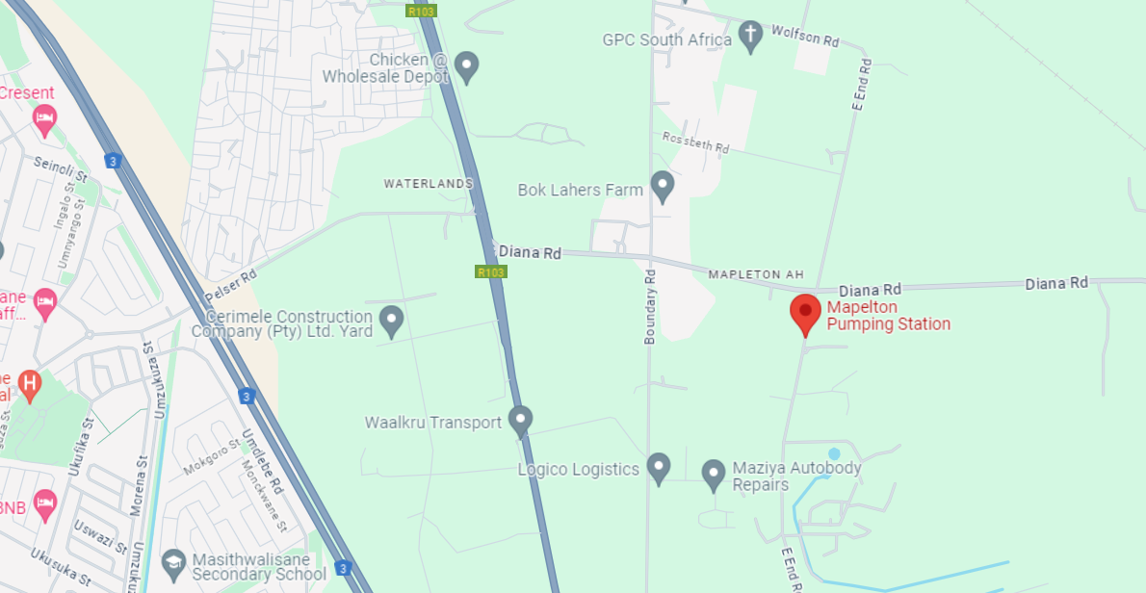

2. SITE LOCATION- Zwartkopjes Pumping station.
The Site of the work is situated GPS coordinates -26.353316244049388, 28.061408834861762 not far from the Mall of the South.

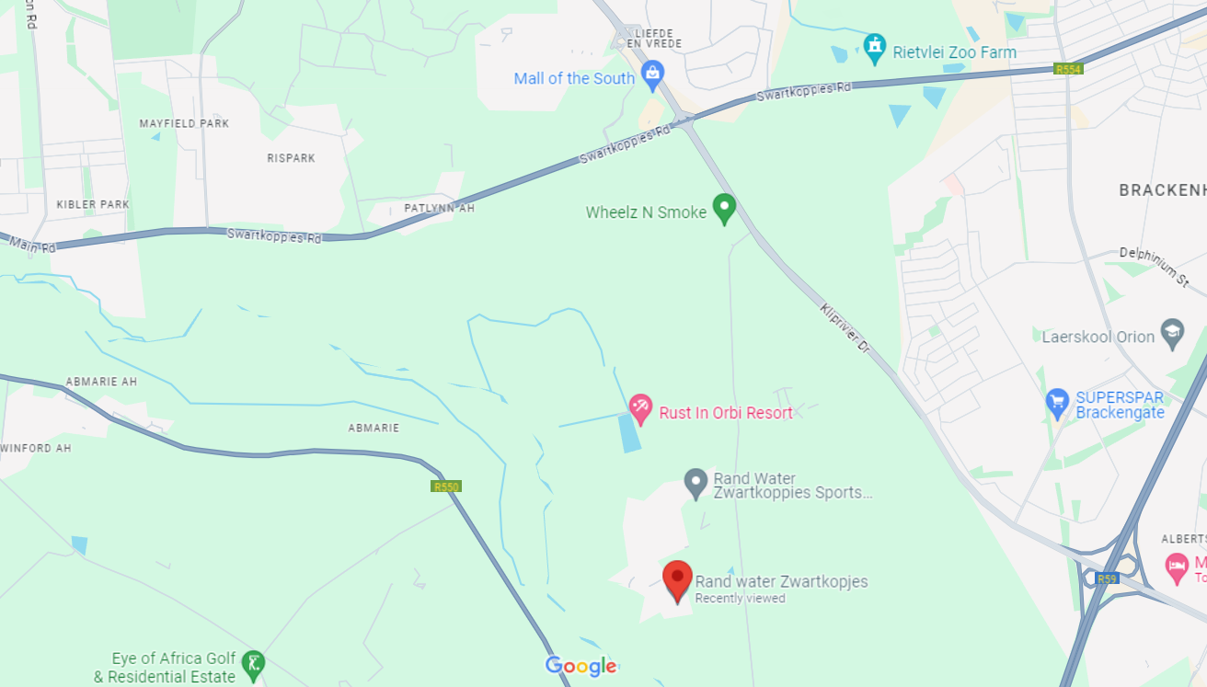

3. SITE LOCATION- Eikenhof Pumping station.
The Site of the work is situated GPS coordinates (-26.308665105288835) along R82 freeway, on the west of the Mall of the South
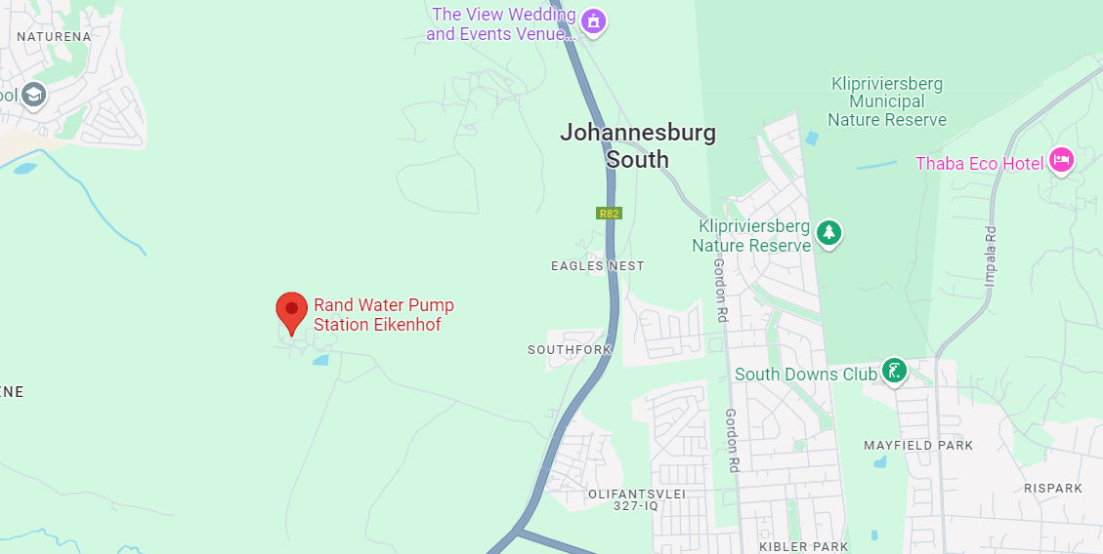

4. SITE LOCATION- Palmiet Pumping station.
The Site of the work is situated GPS coordinates (-26.305525063695637, 28.090309001999834) west of Mall of the south.
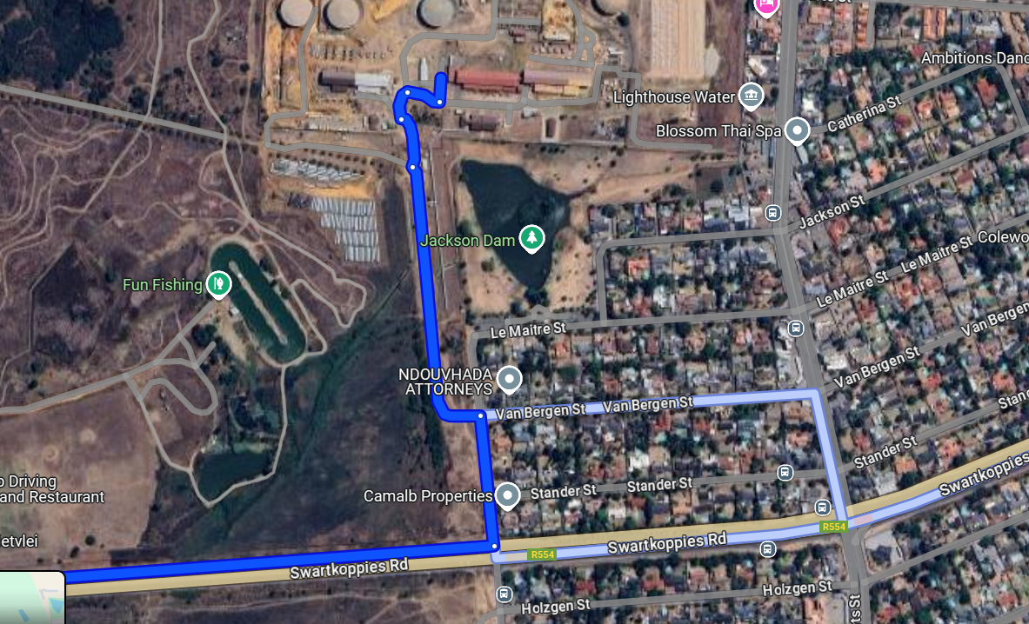

5. SAFETY. All people visiting the site during the briefing session shall wear safety shoes and ear protection.

