TABLE OF AUTOCLAVES: PHP CAMPUS list for service and pressure testing 2026
No | Autoclave or boiler | Serial no.
1 | Industrial Armsco autoclave (G6) | s/n V986
2 | Boiler (G6) | s/n A1627
Block D Bacterial Disease (BD)
3 | ALP Autoclave CL32L (C31) | s/n 811049
Block A Virology diagnostics
4 | Sturdy Industrial SA-300VL Washroom | s/n 220915001-010
Block L West Biological Nitrogen Fixation (BNF)
5 | Sturdy autoclave SA-300VL (L9) | s/n 150302011-007
6 | Huxley Autoclave HL-340 (L11) | s/n S0804007
7 | Sturdy autoclave HA 300MD (L9) | s/n 31117070154
Block L East Virology
8 | Sturdy autoclave SA-300VL (L30) | s/n 131119011-006
Biosystematics (across Moloto road)
9 | Lasec Autoclave ALP CL-32l (E3) | s/n 810202-23244
10 | Lasec Autoclave ALP CL-32l (E3) | s/n 810241-23269
11 | Nuve NC90M (E3) | N02.0809
Quarantine facility weeds
12 | JAB Autoclave | s/n J157
13 | JAB QF Boiler | s/n J156
14 | QSS Effluent plant decontamination plant | No plate
Quarantine facility Plant Pathogen
15 | HIRAYAMA HA-D3 | s/n 80055122
16 | Hospi Sterilizer JDSD 200 | s/n HS 1040
17 | Hospi boiler | s/n B1301

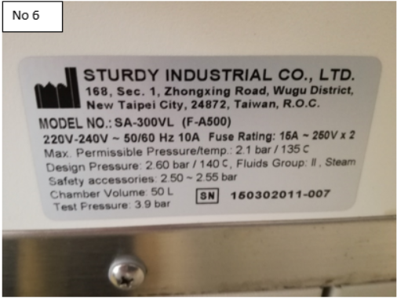
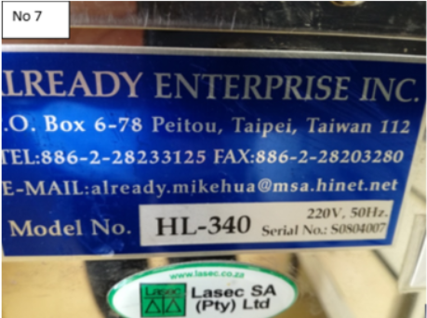
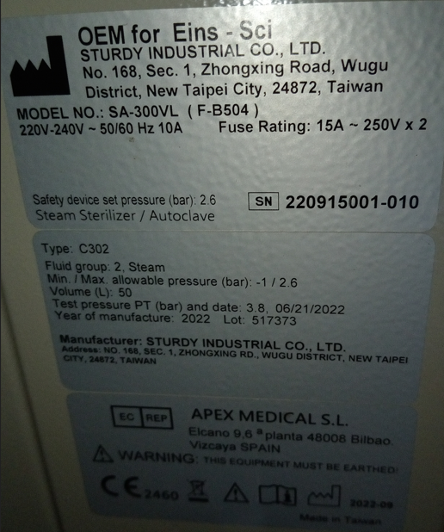
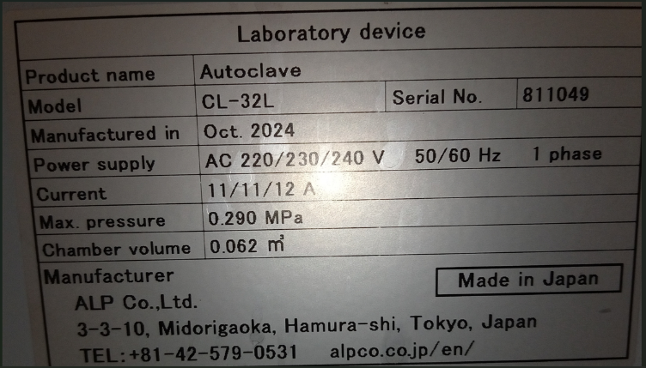
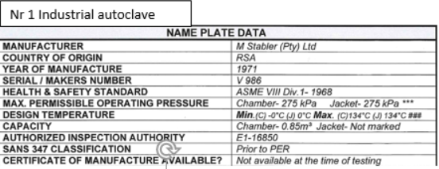
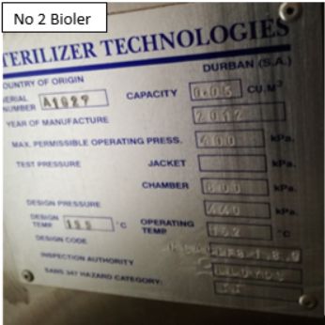
No 5
No 6
Nr 4
Nr 3

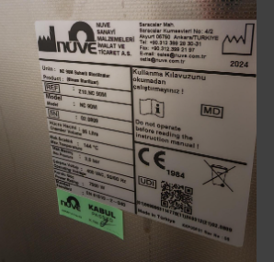
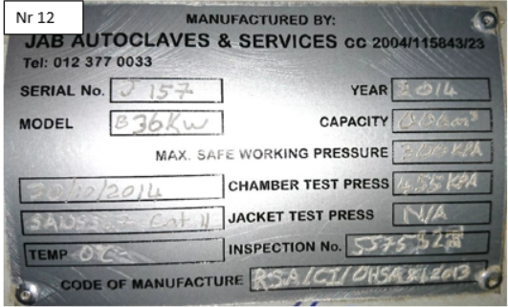
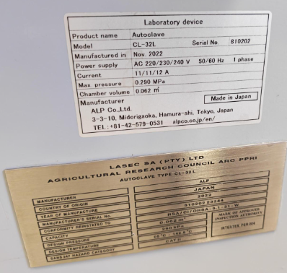
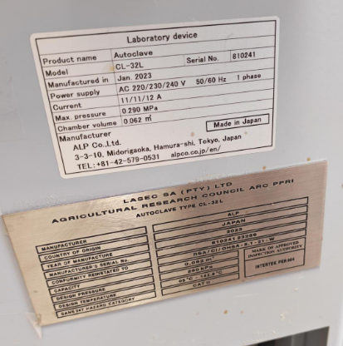
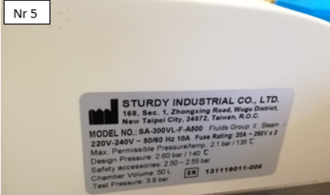
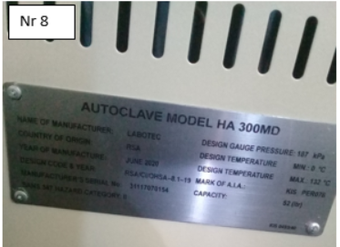
No 11
No 12
No 9
No 10
No 8
No 7
14 | Boiler weeds | No plate, in progress by QSS
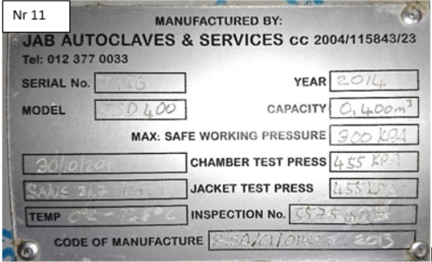
No 13

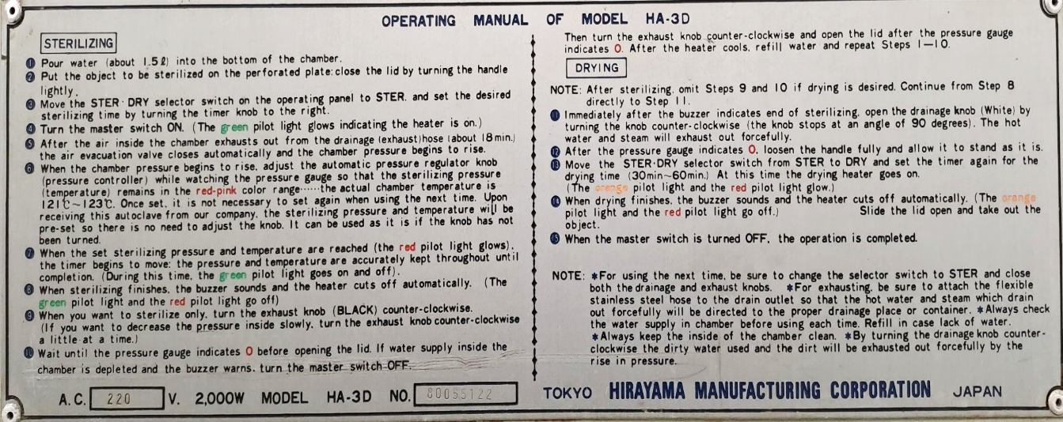
No. 15
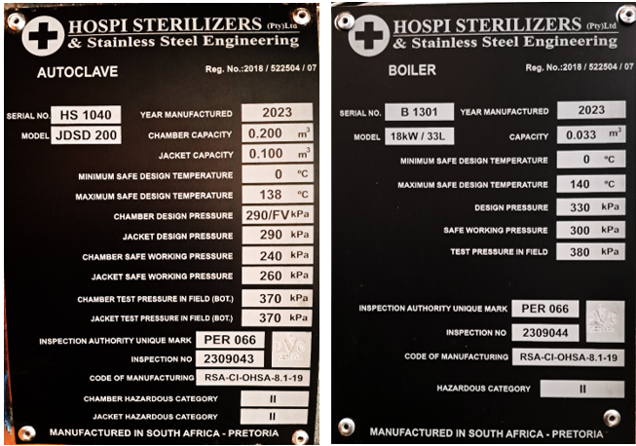
No 16
No 17

