
UPGRADE OF MASINGA TO ENTOKOZWENI BUS ROUTE PHASE 2

TENDER NUMBER: COM 13B/2023
TENDERER:
CLOSING DATE: 17 MARCH 2025 AT 11:00AM

CSD REG NUMBER: MAAA…………………………………………………
CLIENT | ENGINEER
  City of Mbombela  PO Box 45  Mbombela 1200  Tel: 013-759 2358  Christopher Nkambule  Supply Chain Management  E-mail: nomsan@mbombela.gov.za |   Nathoo Mbenyane Engineers  P.O. Box 4267  White River  1240  Tel: 013-750 3122  E-mail: info@nme.co.za

UPGRADE OF MASINGA TO ENTOKOZWENI BUS ROUTE PHASE 2
SUMMARY FOR TENDER OPENING PURPOSES
NAME OF TENDERER :_________________________________________________________________
ADDRESS :_________________________________________________________________

TELEPHONE NUMBER :_________________________________________________________________
FAX NUMBER :_________________________________________________________________
E-MAIL ADDRESS :_________________________________________________________________
CLOSING DATE :_________________________________________________________________
TENDERED AMOUNT :_________________________________________________________________
Signed by authorised representative of the TENDERER: ___________________________________________
DATE:
* Should any discrepancy occur between this figure and that stated in the Form of Offer and Acceptance, the latter shall take precedence and shall apply.

IMPORTANT INFORMATION

PLEASE READ CAREFULLY BEFORE COMPLETING DOCUMENT.

Notice to all tenderers.

Standards applied in this document.
1. NOTICE TO ALL TENDERERS

This is an original document:
- It may not be re-typed or altered in any way.
- It must be completed in black ink (non-erasable) – in an eligible handwriting. Mistakes are to be corrected by drawing a line through it and writing the correct information above it. Tenderer to sign next to the correction. The use of erasing fluid or strips is not allowed.
- It may not be taken apart.
- It is not available in electronic format except PDF.
- Bidders are required to attach returnable documents to the relative pages (where requested) and encouraged to use file fasteners and binding tape or any other similar method to ensure there are no loose pages. Any other form of presentation (loose pages or separate documents) will not be accepted.
2. STANDARDS APPLICABLE TO THIS DOCUMENT

Available from the S.A. Federation of Civil Engineering Contractors, the S.A. Institution of Civil Engineering and the S.A. Bureau of Standards, as applicable:

1. | CIDB | CIDB Standard for uniformity in Construction Procurement, 10 July 2015, as amended.
2. | SANS 10845-1 | Processes, methods and procedures.
3. | SANS 10845-2 | Formatting and compilation of procurement documentation.
4. | SANS 10845-3 |  | Standard conditions of tender.
5. | GCC |  | General Conditions of Contract for Construction Works, Third Edition (2015) issued by the South African institution of Civil Engineering.
6. | COTO |  | Standard Specifications for Road and Bridge Works for State Road Authorities (2020)
10. | This Document, as presented.

THE TENDER
CONTENTS
 | PAGE
COVER PAGE
Bid Summary for Tender Opening Purposes | i
Important Information | ii
Contents | iii
THE CONTRACT
SECTION | DESCRIPTION |  | PAGE
PART T1 | TENDERING PROCEDURES
T 1.1 | Tender Notice and Invitation to Tender | (white) | T1.1-1 to T1.1-1
T 1.2 | Tender Data | (pink) | T1.2-1 to T1.2-9
PART T2 | RETURNABLE DOCUMENTS  (See List of Documents) | (yellow) | T2.1-1 to T2.1-43

SECTION | DESCRIPTION |  | PAGE
PART C1 | AGREEMENT and CONTRACT DATA
C 1.1 | Form of Offer | (pink) | C1.1-1 to C1.1-1
C 1.2 | Form of Acceptance | (pink) | C1.2-1 to C1.2-1
C 1.3 | Schedule of Deviations | (pink) | C1.3-1 to C1.3-1
C 1.4 | Contract Data | (yellow) | C1.4-1 to C1.4-6
C 1.5 | Performance Guarantee | (yellow) | C1.5-1 to C1.5-4
C 1.6 | Agreement in Terms of the Occupational Health and  Safety Act, 1993 (Act No 85 Of 1993) | (yellow) | C1.6-1 to C1.6-3
C 1.7 | Certificate of Authority for Signatory to Agreement in Terms of Occupational Health and Safety Act, 1993 (Act No 85 Of 1993) | (yellow) | C1.7-1 to C1.7-2
PART C2 | PRICING DATA
C 2.1 | Pricing Instructions | (yellow) |  | C2.1-1 to C2.1-3
C 2.2 | Bill of Quantities | (yellow) |  | C2.2-2 to C2.2-28

SECTION | DESCRIPTION |  |  | PAGE
PART C3 | SCOPE of WORK
C 3.1 | Description of Works |  | (blue) | C3.1-1 to C3.1-2
C 3.2 | Engineering |  | (blue) | C3.2-1 to C3.2-2
C 3.3 | Procurement |  | (blue) | C3.3-1 to C3.3-1
C 3.4 | Construction |  | (blue) | C3.4-1 to C3.4-36
C 3.5 | Management |  | (blue) | C3.5-1 to C3.5-5
C 3.6 | Health and Safety |  | (blue) | C3.6-1 to C6.6-2
PART C4 |  | SITE INFORMATION
C 4.1 |  | Site Information | (green) | C4.1-1 to C4.1-4
ANNEXURES
Appendix A |  | Occupational Health and Safety Regulations | (white) | A1 to A15
Appendix B |  | Drawings for Tender Purposes | (white)

PART T1: TENDERING PROCEDURES
SECTION | DESCRIPTION | PAGE
T 1.1 | Tender Notice and Invitation to Tender | 9
T 1.2 | Tender Data | 10
PART T2: RETURNABLE DOCUMENTS
SECTION | DESCRIPTION | PAGE
T 2 | Returnable Documents | 15

PART T1 TENDERING PROCEDURES

T1.1 TENDER NOTICE AND INVITATION TO TENDER T1.1-1
T1.2 TENDER DATA T1.2-1

T1.1 TENDER NOTICE AND INVITATION FOR PROPOSALS
Bids are hereby invited from experienced services providers for Upgrade of Masinga To Entokozweni Bus Route Phase 2.
Tender No | Description | CIDB  Grading | Compulsory Meeting and Site Inspection Date | Closing Date
COM13B/2023 | UPGRADE OF MASINGA TO ENTOKOZWENI BUS ROUTE PHASE 2 | 7CE OR HIGHER | N/A | 17 MARCH 2025 AT 11:00

It is compulsory that service providers download a copy of the bid document that will ONLY be available as from 13 February 2025 on the municipal website: www.mbombela.gov.za on the tenders and notices folder and National e-Tender Portal: www.etenders.gov.za, free of charge.
Duly completed bid documents and supporting documents which are, COPY OF TAX COMPLIANCE STATUS, CERTIFIED COPY OF B-BBEE CERTIFICATE OR SWORN AFFIDAVIT FOR B-BBEE TO CLAIM B-BBEE POINTS, CURRENT MUNICIPAL RATES AND TAXES STATEMENT FROM RELEVANT LOCAL AUTHORITY OR PROOF OF RESIDENCE FROM A TRIBAL AUTHORITY OR LEASE AGREEMENT ACCOMPANIED WITH THE LESSOR’S UP-TO-DATE MUNICIPAL RATES AND TAXES STATEMENT FOR BOTH THE COMPANY AND ITS ACTIVE DIRECTORS INCLUDING CONSORTIUM/JV PARTNERS, CSD REGISTRATION FULL REPORT (Summary Report will not be considered) and a copy of the COMPANY REGISTRATION CERTIFICATE, together with the bid document must be sealed in an envelope clearly marked: “BID “BID NO.:COM 13B/2023, UPGRADE OF MASINGA TO ENTOKOZWENI BUS ROUTE PHASE 2”; CLOSING DATE” with the name of the bidder shall be placed in the bid box at MBOMBELA CIVIC CENTRE at 1 NEL STREET, MBOMBELA, before 11:00 on the closing date.
Bidders are advised not to commit fraudulent activities or forge documents. All abusers of the SCM system, including forging or faking of returnable documents, may be reported to SAPS and restricted from doing business with any Public Institutions for a period NOT exceeding 10 years which is in line with section 28 and 29 of the Prevention and Combating of Corrupt Activities Act 12 of 2004.
A preferential point system shall apply whereby this contract will be allocated to a bidder in accordance with the Preferential Procurement Policy Framework Act, No 5 of 2000 and as defined in the conditions of bid in the bid document, read in conjunction with the Preferential Procurement Regulations, 2022, where 90 points will be allocated in respect of price and 10 points in respect of Targeted Goals.
Procurement Enquiries : | Nomsa Ndukuya | (013) 759 9052
Technical Enquires : | Sakheleni Letau | (013) 759 2181
Employer : | City Manager, | Mr. Wiseman Khumalo
 | City of Mbombela
 | P. O. Box 45
 | 1200
 | Mbombela
VISIT OUR WEBSITE – www.mbombela.gov.za
NB: the results of this bid will be published on council’s website as prescribed on section 75(1)(g) of the MFMA and section 23(c) of the SCM Regulations

T1.2 TENDER DATA
The conditions of tender are the standard conditions of tender as contained in SANS 10845-3
Construction procurement, Part 3: Standard conditions of tender that apply specifically to this tender.

The Tender Data shall be read with the Standard Conditions of Tender in order to expand on the Tenderer’s obligations and the Employer’s undertakings in administering the tender process in respect of the project under construction.
The Tender Data hereafter shall have precedence in the interpretation of any ambiguity or inconsistency between it and the Standard Conditions of Tender.
Each item of data given below is cross-referenced to the clause in the standard conditions of tender to which it mainly applies.
Clause Number | Data
The conditions of tender are those contained in the latest edition of SANS 10845-3, Construction Procurement – Part 3: Standard conditions of tender.
SANS 10845-3 makes several references to the Tender Data for details that apply specifically to this tender. The Tender Data shall have precedence in the interpretation of any ambiguity or inconsistency between it and the provisions of SANS 10845-3.
Each item of data given below is cross-referenced to the clause in SANS 10845-3 to which it mainly applies.
3.1 | The Employer is: City of Mbombela, 1 Nel Street, Mbombela, 1200
The tender documents issued by the Employer comprise:
THE TENDER
Part T1 Tendering Procedures
Part T1.1 Tender Notice and Invitation to Tender (white)
Part T1.2 Tender Data (pink)
Part T1.3 Preferential Procurement Policy of City of Mbombela (pink)
Part T2 Returnable Documents
Part T2.1 List of Returnable Documents (yellow)
Part T2.2 Returnable Schedules to be completed by the Contractor (yellow)
Part T2.3 Returnable Schedules II (yellow)
THE CONTRACT
Part C1 Agreement and Contract Data
C1.1 Form of Offer and Acceptance (pink)
C1.2 Contract Data (yellow)
C1.3 Form of Guarantee (white)
C1.4 Agreement in terms of Occupational Health and Safety Act, 1993 (white)
C1.5 Authority for Signatory in Terms of OH&S Act, 1993 (white)
Part C2 Pricing Data
C2.1 Pricing Assumptions (yellow)
C2.2 Bill of Quantities and Information Sheets (yellow)

3.2 | Part C3 Scope of Works  C3.1 Scope of Works (blue)  C3.2 Engineering (blue)  C3.3 Procurement (blue)  C3.4 Construction (blue)  C3.5 Management (blue)  C3.6 Health and Safety (blue)  Part C4 Site Information  C4 Site Information (green)  Appendices  Annexure A Health and Safety Specification (white)  Annexure B Drawings for Tender Purposes (white)
3.4 | The Employer's Agent is:  Name: Nathoo Mbenyane Engineers (Pty) Ltd  Address: P.O. Box 4267  White River  1240  Tel: 013 750 3122  E-mail: info.mp@nme.co.za
3.5 | The language for communications is English.
3.6 | The competitive negotiation procedure shall not be applied.
4.1 | Only those tenderers who satisfy the following eligibility criteria and who provide the required evidence in their tender submissions are eligible to submit tenders and have their tenders evaluated:  a) CIDB registration  Only those tenderers who are registered with the CIDB, or are capable of being registered prior to the evaluation of submissions, in a contractor grading designation equal to or higher than a contractor grading designation determined in accordance with the sum tendered, or a value determined in accordance with Regulation 25 (1B) or 25 (7A) of the Construction Industry Development Regulations, for a 7CE or higher of construction work, are eligible to have their tenders evaluated.  Tenderers registered as potentially emerging enterprises but with a CIDB contractor grading designation lower than a contractor grading designation determined in accordance with the sum tendered, or a value determined in accordance with Regulation 25(1B) or 25(7A) of the Construction Industry Development Regulations, are not eligible to have their tenders evaluated.  For the sake of clarity and subject to satisfactory proof of a tenderer’s ability to perform the work specified at the tendered value, the Employer lists in the table below the margins it considers reasonable. However, in the event that the sum tendered exceeds the margins shown then such tender shall be deemed non-responsive.  Joint Ventures are eligible to submit bids provided that:  - every member of the joint venture is registered with the CIDB;  - the combined contractor grading designation calculated in accordance with the Construction Industry Development Regulations is equal to or higher than a contractor grading designation determined in accordance with the sum tendered for a 7CE or Higher class of construction work or a value determined in accordance with Regulation 25 (1B) or 25(7A) of the Construction Industry Development Regulations.
  Category of tender | Upper limits per CIDB Table 8 Regulation 17
  CE 5 | R10m
  CE 6 | R20m
  CE 7 | R60m
  CE 8 | R200m

- Key Personnel
In order to be considered for an appointment in terms of this tender, the tenderer must have in its permanent employment key personnel who will be the single point accountability and responsibility for the management of the construction works. Alternatively, a signed undertaking from an organization having the required personnel, stating that they will undertake the necessary work on behalf of the tenderer in terms of a sub-contractor agreement, will be acceptable. Such undertaking must be attached to Forms T of the Returnable Schedules.
Individuals must be identified for each of the key personnel listed under Forms T. Where the key personnel are no longer available to undertake the necessary work after the award of the tender, the contractor shall within a period of 14 working days replace the key personnel listed in Forms T with personnel with equivalent competencies and subject to approval by the Employer. Such approval shall not be unreasonably withheld.
The key person shall be a suitably qualified and experienced contracts manager who will be the single point accountability and responsibility for the management of the construction works, and who is registered with SACPCMP as Pr.CM or ECSA as Pr.Eng or Pr.Tech.Eng shall be required as a minimum.
Where the Contracts Manager will not be employed on the Works full time, his powers will be delegated to the approved construction manager.
Failure to comply with the requirements or to complete Form T may render the tender non- responsive.
4.6 | Bidders are encouraged to revisit the City’s website regularly prior the closing date particularly on this project folder to ensure that all addenda/ erratum that may be issued are adhered to.  Failure to apply instructions contained in addenda may render a tenderer’s offer non- responsive in terms of Condition of Tender 5.8.
4.7 | The arrangements for the compulsory clarification meeting are as stated in the tender notice and invitation to tender.  The onus rests with the tenderer to ensure that the person attending the clarification meeting on its behalf is appropriately qualified to understand all directives and clarifications given at that meeting.  The clarification meeting shall start strictly at the time advertised. Only then will the Employer’s Representative circulate the attendance register for completion by those present. During this time latecomers may complete the register. On completion by all present the Employer's Representative will:  - read out from the collected lists calling for confirmation that all have signed;  The signature on the attendance register and duly completed and signed Form A shall be considered proof that the tenderer attended the whole meeting and was available to hear all directives and clarifications given at the meeting.  Tenderers must sign the attendance list in the name of the tendering entity. Addenda will be issued to and tenders will be received only from those tendering entities appearing on the attendance list. The City will not take responsibility for incorrect information provided by the bidder on the attendance register.
4.8 | Request clarifications at least 7 working days before the closing time.
4.10 | Tenderers are required to state the rates and currencies in Rand.
An alternative tender offer will only be considered if a main tender offer, strictly in accordance with all the requirements of the tender documented is also submitted.
If the tenderer wishes to submit an alternative tender offer, the only criteria permitted for such alternative tender offer is that it demonstrate the Employer's standards and requirements, the details of which may be obtained from the Employer's Agent.

4.12 | Calculations, drawings and all other pertinent technical information and characteristics as well as modified or proposed Pricing Data must be submitted with the alternative tender offer to enable the Employer to evaluate the efficacy of the alternative and its principal elements, to take a view on the degree to which the alternative and to evaluate the acceptability of the pricing proposals. Calculations must be set out in a clear and logical sequence and must clearly reflect all design assumptions. Pricing Data must reflect all assumptions in the development of the pricing proposal.  Acceptance of an alternative tender offer will mean acceptance in principle of the offer. It will be an obligation of the contract for the tenderer, in the event that the alternative is accepted, to accept full responsibility and liability that the alternative offer complies in all respects with the Employer's standards and requirements.  The modified Tender Data must include an amount equal to 5% of the amount tendered for the alternative offer to cover the Employer's costs of confirming the acceptability of the detailed  design before it is constructed.
4.13.1 | Parts of each tender offer communicated on paper shall be submitted as an original, no copies are required.  The signed print-out shall be taken as the valid submission.
4.13  4.15 | The Employer’s address for delivery of tender offers and identification details to be shown on each tender offer package are:  Location of tender box: City of Mbombela  Physical address: 1 Nel Street, Mbombela 1200  Identification details: TENDER COM13B/2023, UPGRADE OF MASINGA TO ENTOKOZWENI BUS ROUTE PHASE 2  Tenders can be submitted 24 hours a day from Monday to Friday at the Employer’s address.  It is in the tenderer’s interest to ensure that the delivery of the tender offer is recorded in the Employer’s tenders received register.
4.13.4 | The tenderer is required to submit all certificates as listed in the Schedule of Tender Compliance (Form U).
4.13.5 | Place and seal the printed and completed tender document in an envelope clearly marked “TENDER” and bearing the Employer’s name, the contract number and description, the tenderer’s authorised representative’s name, the tenderer’s postal address and contact telephone numbers.
4.13.5 | A two-envelope procedure will not be followed.
4.13.6 | Telephonic, telegraphic, telex, facsimile or e-mailed tender offers will not be accepted.
4.15 | The closing time for submission of tender offer is as stated in the Tender Notice and Invitation to Tender.
4.16.1 | The tender offer validity period is 120 days.
4.16.2 | Where a tenderer, at any time after the opening of his tender offer but prior to entering into a contract based on his tender offer:  - withdraws his tender;  - gives notice of his inability to execute the contract in terms of his tender; or  - fails to comply with a request made in terms of 4.17, 4.18 or 5.9,  such tenderer shall be barred from tendering on any of the Employer’s future tenders for a period to be determined by the Employer, but not less than six (6) months, from the date of tender closure. The Employer may fully or partly exempt a tenderer from the provisions of this condition if he is of the opinion that the circumstances justify the exemption.
4.18 | Any additional information requested under this clause must be provided within 5 (five) working days of date of request.
4.20 | The tenderer is required to submit with his tender a letter of intent from an approved insurer undertaking to provide the Performance Bond to the format included in Part C1.8 of this  Procurement document.

5.1 | The employer shall respond to clarifications received up to 7 working days before tender closing time.
5.2 | The employer shall issue an addenda until 7 working days before tender closing time.
5.4 | All bid responses must be submitted before the Bid Closing date and time as stipulated on the tender invitation.
5.7 | In the event of disqualification, the Employer may, at its sole discretion, impose a specified period during which tender offers will not be accepted from the offending tenderer and report same to CIDB and National Treasury.
5.9 | Arithmetical errors, omissions, discrepancies and imbalanced unit rates  Check responsive tenders for discrepancies between amounts in words and amounts in figures. Where there is a discrepancy between the amounts in figures and the amount in words, the amount appearing in the summary to the Pricing Schedule shall govern.  Check responsive tender offers for:  - the gross misplacement of the decimal point in any unit rate;  - omissions made in completing the pricing schedule or bills of quantities; or  - arithmetic errors in:  - line item totals resulting from the product of a unit rate and a quantity in bills of quantities or schedules of prices; or  - the summation of the prices.  - imbalanced unit rates.  Notify shortlisted tenderers of all errors, omissions or imbalanced rates that are identified in their tender offers.  Where the tenderer elects to confirm the errors, omissions or re-balancing of imbalanced rates the tender offer shall be corrected as follows:  - If bills of quantities or pricing schedules apply and there is an error in the line item total resulting from the product of the unit rate and the quantity, the unit rate shall govern, and the line item total shall be corrected. Where there is an obviously gross misplacement of the decimal point in the unit rate, the line item total as quoted and the unit rate shall be corrected.  - Where there is an error in the total of the prices either as a result of other corrections required by this checking process or in the tenderer’s addition of prices, the total of the prices shall be corrected.  - Where the unit rates are imbalanced adjust such rates by increasing or decreasing them and selected others while retaining the total of the prices derived after any other corrections made under (a) and (b) above.  Where there is an omission of a line item, no correction is possible, and the offer may be declared non-responsive.  Declare as non-responsive and reject any offer from a tenderer who elects not to accept the corrections proposed and subject the tenderer to the sanction under 4.16.2.  The tenderer is required to submit balanced unit rates for rate only items in the pricing schedule. The rates submitted for these items will be taken into account in the evaluation of tenders.

5.10 | List of disqualifying factors of this tender are as follows:  A bid not complying with the requirements stated hereunder will be regarded as “Non Responsive”, and as such will be rejected/disqualified for further evaluation  - Submit company registration certificate  - Submit Tax Compliance Status issued by SARS  - Full CSD report NOT older than 30 days from the closing date , Summary report will NOT be considered  - Submit Joint venture agreement in case of JV. All parties are expected to attach their individual returnable documents except for consolidated B-BBEE certificate and combined CIDB grading.  - Submit original certified identity document of business directors  - Authority for Signatory, duly signed and dated original or certified copy on the Company(s) Letterhead. This condition will not apply to companies owned by one director / member / sole  - Submit copies of relevant Annual Financial Statements (last 3 Financial Years). For JV, relevant Annual Financial Statements from all parties are required (in line with the Companies ACT) Failure to provide for all the service Providers will results in disqualification.  - Submit copy of an active CIDB contractor grading designation of 7CE or higher. For JV, a combined CIDB grading is required.  - Tenderer must provide valid copy of municipal rates and taxes for both the company and for the active directors including JV/Consortium partners, Copies of latest municipal rates and taxes certificates from relevant local authority / proof of residential from tribal authority (if the business is operating or the directors are residing in rural areas) / lease agreement with the lessor’s up-to-date municipal rates and taxes for both the business and all business directors. Prospective bidders should ensure that the physical address details of the company and directors reflected on the CSD is similar to the one reflected on the company registration certificate. The municipality reserves the right to verify both the municipal rates and taxes of the company details reflected on the CSD and company registration certificates. The municipality further reserves the right to use ID numbers of the directors to verify if any municipal rates and taxes are not owned by each director. It is prudent and remains the responsibilities of the prospective bidders to ensure that each director, lessor and company rates are cleared with regards to the municipal rates and taxes. A bid will be rejected if any municipal rates and taxes owed by the bidder or any of its directors to the municipality, or to any other municipality or municipal entity, are in arrears for more than three months  - Letter of good standing for COIDA. The letter of good standing must reflect the relevant nature of business as prescribed on The Compensation for Occupational Injuries and Diseases Act 130 of 1993. Must also be in line with the required CIDB Grading.  - Proof of public liability Insurance / third party liability insurance for a minimum of R5 000 000.00. The letter must be issued by a registered insurance service provider. The letter should have the full contact details of the service provider and the underwriter.  - Letter of intent for performance guarantee from a registered Financial Service Provider (FSP). The letter should have the full contact details of the service provider and the FSP number.  - Fully completed and signed where applicable in the Returnable Schedules.  - Failure to apply instructions contained in addenda that may be issued.  - Submissions from bidders who did not attend a compulsory briefing session will not be acceptable.  - Prospective service providers may not make any alterations or additions to the Bid document, except to comply with instructions issued by the employer. The tender document must be furnished with non-erasable black ink and all corrections made by the service provider should be dated and signed by the authorized signatory. Erasures and the use of masking fluid, tippex, pencil or erasable ink are prohibited and failure to adhere to this condition will render your submission non responsive.

5.11 | The procedure for the evaluation of responsive tenders is Method 2: Functionality, price and preferences.  Method 2 Functionality, price and preferences is scored as follows:  - Score each tender in respect of the financial offer made and preferences claimed, if any.  - Calculate the total number of tender evaluation points (TEV) in accordance with the following formula: TEV = NFO + NP + NQ
5.11.5 | where: NFO is the number of tender evaluation points awarded for the financial offer made in accordance with F.3.11.7;  NP is the number of tender evaluation points awarded for preferences claimed in accordance with F.3.11.8.  NQ is the number of tender evaluation points awarded for quality claimed in accordance with F.3.11.9.  - Rank tender offers from the highest number of tender evaluation points to the lowest.  - Recommend the tenderer with the highest number of tender evaluation points for the award of the contract, unless there are compelling and justifiable reasons not to do so.  - Rescore and re-rank all tenderers should there be compelling and justifiable reasons not to recommend the tenderer with the highest number of tender evaluation points, and recommend the tenderer with the highest number of tender evaluation points, unless there are compelling and justifiable reasons not to do so and the process set out in this sub-clause is repeated.  - Compelling and justifiable reasons not to recommend a tenderer are inter alia tenderers who:  - do not meet the minimum requirements listed in Part T2.1, List of Returnable Documents and/or  - failed to complete the tender document comprehensively with all the required information.
5.11.7 | The financial offer will be scored using the following formula: NFO = W1 x A  Where:  NFO = the number of evaluation points awarded for the financial offer W1 = the maximum possible number of bid evaluation points awarded for the financial offer and will be:  - 90 where the financial value inclusive of VAT of all responsive tenders received have a value in excess of R 50,000,000; or  - 80 where the financial value inclusive of VAT of one or more responsive tender offers equals or is less than R 50,000,000.  A = the number calculated using Formula 2 (Option 1) Table 1: Formulae for calculating the value of Aa  a Pm is the comparative offer of the most favorable comparative offer.  P is the comparative offer of the tender offer under consideration.
  Formula | Comparison aimed at achieving | Option 1a | Option 2a
  1 | Highest price or discount | A = (1 + (P - Pm))  Pm | A = P / Pm
  2 | Lowest price or percentage commission /fee ' | A = (1 - (P- Pm )  Pm | A = Pm / P

 | Scoring preferences.
 | Up to 100 minus W1 tender evaluation points will be awarded to tenderers who submit
 | responsive tenders and who are found to be eligible for the preference claimed. Points are
 | based on a tenderer’s scorecard measured in terms of the Regulations (2022) to the Preferential Procurement Policy Framework Act (PPPFA, Act 5 of 2000).
 | Points awarded will be according to a tenderer’s specific goals summarised in the table below:
5.11.8
  Item No. | The specific goals allocated points in terms of this tender | Number of points  allocated  (80/20 system) | Number of points  allocated  (90/10 system)
   | 100% Black owned enterprises within the definition of the HDI | 2 | 1
   | At least 30% women owned enterprises | 2 | 1
   | At least 30% youth owned enterprises | 2 | 1
   | At least 30% enterprises people living with disabilities | 2 | 1
   | Enterprises regarded as EMEs located within the City of Mbombela | 2 | 1
   | Enterprise who will sub-contract minimum of 30% of the contract value to EME’s in the ward or local communities where the services to be rendered of works to be undertaken (Bidders shall list sub-contracting works or items) | 2 | 1
   | Corporate Social Investment (CSI) Plan. (see notes below) | 5 | 3
   | B-BBEE level 1 contribution (SANAS verified B-BBEE certificate for generic enterprise, and for EME and SME a sworn affidavit or CIPC issued certificate confirming annual turnover and level of Black Ownership | 3 | 1
  Total |  | 20 | 10
 | Eligibility for preference points will be determined as follows:
 | - Compliance with any other information requested to be attached to Returnable Schedule Form D.

.11.9 | Tender offers will only be considered responsive if the minimum quality requirement of 70 points is achieved.  Tenderers are required to demonstrate their ability to undertake the work and provide proof of previous experience, expertise and availability of plant and equipment to undertake a project of this nature. Tenderers are therefore required to meet a minimum Quality Score of 70% (70 points out of 100) based on the criteria listed below. A score of less than 70 out of 100 points for Quality will render the tender non-responsive. The onus rests with the Tenderer to supply sufficient information to allow for evaluation and award of points detailed below. If insufficient information is provided, zero points will be awarded for that particular item.  Note that Quality points are only used to determine responsiveness and will not be used further in the evaluation.  i). Plant and Equipment (Maximum 15 points)  Details of owned and hired plant and equipment are to be entered in Form R of the Returnable Schedules.  ii). Key Personnel (Maximum 25 points)  Details of key personnel and their experience and qualifications are to be entered in Form T of the Returnable Schedules.  iii). Company Experience (Maximum 50 points)  Details of paved surface roads related projects & supporting information in terms of the points to be claimed in terms of quality, must be entered in Form Q in the Returnable Schedule.  iv). Financial References (Maximum 10 points)  Details of financial references are to be entered in Form S of the Returnable Schedules.
  Description of quality criteria | Maximum number of points
  Plant and equipment | 15
  Key Personnel | 25
  Company Experience | 50
  Financial References | 10
  Total evaluation points for quality (Ms) | 100

5.13 | In addition to the requirements of the Condition of Tender, offers will only be accepted if:  - the tenderer is registered on the Central Supplier Database (CSD) for the South African government (see https://secure.csd.gov.za/). CSD is compulsory for any company to bid. The full report should be submitted, not the summary.  - the tenderer is in good standing with SARS according to the Central Supplier Database.  - the tenderer submits an Original letter of intent from an approved insurer undertaking to provide the Performance Bond to the format included in Form S of this procurement document.  - the tenderer is registered with the Construction Industry Development Board in an appropriate contractor grading designation.  - the tenderer or any of its directors/shareholders is not listed on the Register of Tender Defaulters in terms of the Prevention and Combating of Corrupt Activities Act of 2004 as a person prohibited from doing business with the public sector;  - the tenderer has not:  - abused the Employer’s Supply Chain Management System; or  - failed to perform on any previous contract and has been given a written notice to this effect;  - the tenderer has completed the Compulsory Declaration and there are no conflicts of interest which may impact on the tenderer’s ability to perform the contract in the best interests of the employer or potentially compromise the tender process;  - the tenderer is registered and in good standing with the compensation fund or with a licensed compensation insurer;  - the employer is reasonably satisfied that the tenderer has in terms of the Construction Regulations, 2003, issued in terms of the Occupational Health and Safety Act, 1993, the necessary competencies and resources to carry out the work safely.  - No Tippex has been used on the bid document.  - The tenderer has not used an erasable pen and completed the bid document with a pencil.
5.17 | The number of paper copies of the signed contract to be provided by the employer is One.
5.19 | All requests shall be in writing.

CHECKLIST FOR RETURNABLE DOCUMENTS STIPULATED UNDER SPECIAL CONDITIONS OF TENDER DOCUMENTS AS MANDATORY REQUIREMENTS. THIS DOCUMENT SHALL BE APPLICABLE TO ALL TENDER DOCUMENTS OF THE CITY.
Preamble
The objective of this checklist is aimed at ensuring that interpretation and application of the special conditions and other mandatory requirements at Bid Evaluation Committee (BEC) & Bid Adjudication Committee (BAC) are aligned as envisaged by the Bid Specification Committee (BSC). This will enhance consistency and uniformity in the entire bid committee system whilst promoting “user friendly” principles by simplifying tender requirements to all interested prospective bidders.
ITEM NO: | DESCRIPTION / RETURNABLE DOCUMENTS | NOTES | FOR OFFICE USE ONLY
ITEM NO: | DESCRIPTION / RETURNABLE DOCUMENTS | NOTES | CHECKLIST | YES or NO or N/A
 | Company Registration Certificate | - It’s a certificate issued by the Companies and Intellectual Property Commission in line with section 14 of the Companies Act 78 of 2008  - A Certificate issued by CIPRO in line with section 2 of the Close Corporation Act 69 of 1984  NB: The registration of Close Corporations (CCs) was replaced by introduction of the New Companies Act which came to effect in April 2011. CCs to be recognized as valid registration certificate will be up to 2010. | Has the bidders attached a valid company registration document in line with the applicable legislation?
 | Company Profile | - A Company Profile is a professional introduction of your Business that aims to inform Clients about its purpose, vision, trustworthiness, products and services, and experience of your Company. It is basically a “CV for your Business/Company” | Has the bidder attached a company profile and its experience is relevant to add value on this project?

 | Certification of documents to be submitted together with the tender document.  I.e. ID Copies of Key personnel, qualifications, Licenses and certificates, accreditation by professional bodies, proof of ownership document, appointment letters, completion certificates, etc. | - The certification of documents must be done by a commissioner of oath as prescribed in the Justice of the Peace and Commissioners of Oaths Act 16 of 1963 and its Regulations.  - Acceptable certified copies are copies originally certified from any police station, post office, Lawyers or notary public (who are members of a recognized professional body), Actuaries or accountants (who are members of a recognized professional body), Members of the judiciary, Directors, managers or company secretaries of a banks or regulated financial services business.  - Commissioner of Oaths stamps can be purchased at Stationary shops, but it can be custom made following the below example:  NB: All certified copies must NOT exceed three months and be originally certified. | Has the bidder certified all documents to be certified as per special conditions of bid?  Check validity on the date, check if the commissioner of oaths stamp is compliant as per example copied from the Regulations.
  CERTIFIED TRUE COPY OF THE ORIGINAL DOCUMENT. THERE ARE NO INDICATIONS THAT THE ORIGINAL DOCUMENT HAS BEEN ALTERED BY UNAUTHORISED PERSONS.
  Designation (rank) ………………………………………….ex officio: RSA
  Date: ……………………………… Place ……………………………………
  Business Address: ……………………………………………………………………………......... ……………………………………………………………………………………
  Commissioner of Oaths
  …………………………………………………………..………………………
  Signature Full Names
 | Central Supplier Database (CSD) Full report, (Summary report will NOT be acceptable).  N/B CSD Report date should not be more than 30 days before Bid closing date. | - The City requires that all prospective bidders should be registered on CSD. This is aimed at verification of email addresses, phone numbers, banking details, company registration numbers, tax status with SARS, state employees, etc. | Has the bidder attached a full CSD report, are tax matters in good order, are the directors not in the employment of any state and the CSD report is not older than 30 days from the closing date?

 | Tax Compliant Status (TCS) | - Prospective bidders are required to attach a valid TCS together with the tender document. | Has the bidder attached a valid (not expired) TCS?  The designated official should verify the bidder’s tax compliance status prior to finalization of the award of a bid or prize quotation. Where the recommended bidder is not tax compliant, the bidders should be notified of their non-compliant status and the bidder must be requested to submit to the City within 7 working days, written proof from SARS of their tax compliance status or proof from SARS that they have made arrangements to meet their outstanding tax obligations. The proof of tax compliance status submitted by the bidder to the City must be verified via the CSD report or e-Filing. The City should reject a bid submitted by the bidder if such a bidder fails to provide proof of tax compliance status within the timeframe stated above (See MFMA Circular No: 90).

 | Certified copy of B-BBEE Certificate / affidavit for B-BBEE status level of contributor (to claim points only). | - EMEs in terms of the B-BBEE Act 53 of 2003 may submit a sworn affidavit confirming annual total revenue and level of black ownership or Certified Copy of B-BBEE Certificate.  - Bidders other than EMEs and QSEs MUST submit their certified copies of valid B-BBEE status level verification certificate, substantiating their B-BBEE rating issued by a registered auditor approved by IRBA or a verification agency accredited by SANAS.  - A trust, consortium or joint venture will qualify for points for their B-BBEE status level as an unincorporated entity, provided that the entity submits their consolidated B-BBEE scorecard as if they were a group structure and that such a consolidated B-BBEE scorecard is prepared for every separate bid.  NB: There is NO consolidated affidavit for B-BBEE status level of contributor. Only consolidated B-BBEE certificate will be considered for JVs / Consortium & large companies that are making an annual turnover in access of R50 million including value added tax (VAT). This is not a disqualifying factor, non-adherence will lead to no allocation of B-BBEE points. | Is the copy B-BBEE Certificate valid?  Is the sworn affidavit for EME / QSE in line with the threshold for EME and EME and valid?  If the tendering entity is a JV / Consortium / Large company, has the bidder attached a certified copy of a valid and consolidated B-BBEE certificate in order to claim points as prescribed by the MSCM Regulations?  Is the copy of B-BEE certificate certified by the Commissioner of Oaths reflects as prescribe on the regulations of the Act?  Is the affidavit for B-BBEE stamped and signed by commissioner of oaths?  I.e. full names and signature, force/practice number, designation / rank, date and address.  Is the certification date not older than 3 months and original ink is clear on the document to confirm if it is originally certified? | Yes

 | Formal agreement must be attached in case of a joint venture (JV) or consortium. | - The JV/consortium must amongst others, reflect clear profit and loses sharing percentages. It is compulsory that the lead partner must have at least 51% majority shares in the JV/consortium. | If the tendering entity / bidder is a JV/Consortium, has the bidder attached a detailed JV/Consortium agreement with all critical information?
 | In bids where Consortia / Joint Ventures / Sub-contractors are involved, each party must submit separate required returnable documents. | - This will not be applicable to functionality and B-BBEE requirements. | If the tendering entity / bidder is a JV/Consortium, have the parties involved attached all individual required documents as per special condition of bid?
 | Latest municipal rates and taxes certificates from relevant local authority for the business and all business directors  OR  Proof of resident from tribal authority for the business and all business directors  OR  Lease agreement with the Lessor’s latest municipal rates and taxes certificates from relevant local authority.  NB: All accounts owing any municipality for more than 90 days will be disqualified as prescribed on the MSCM Regulations. | - If the business is operated and its director(s) are residing within a municipal area, bidders are expected to attach latest municipal rate and taxes certificates for the business and ALL its directors.  - If the business is operated and its director(s) are residing within a tribal authority. Bidders are expected to attach proof of resident for the business and ALL its directors.  - If the business directors are leasing a facility for residential purposes, they are required to attach individual lease agreement with lessor’s latest municipal rates and taxes for a facility is within a Municipal boundary and if the business is renting office / business facility, the bidders are required to attach lease agreement for the business with lessor’s latest municipal rates and taxes for a facility within a municipal boundary. If the facility leased is in a rural area, lease agreement will be accompanied with the lessor’s proof of residential from a tribal authority. | Has the bidder attached latest municipal rates and taxes from relevant local authority for the company / business and all company directors / owners?  In case of lease, has the bidders attached lease agreements and lessor’s proof of res from a tribal authority or latest municipal rates and taxes certificate?  Is the account not in areas for more than 90 days (3 months)?

NB: Domicilium citandi at executandi: Domicilium citandi et executandi is a Latin legal term meaning the address nominated by a bidder in a legal contract where legal notices may be sent.
Bidders are encouraged to update their addresses when they relocate their businesses and the preferred address on the CSD should be in line with the address on the Company Registration Document. It is the responsibility of the bidder to ensure that all physical addresses reflected either on the company registration document and CSD are not owing any municipal rates and taxes for more than three months including the Lessor’s municipal account in case of lease. The rationale behind this requirement is the enhance revenue in RSA municipalities as enshrined on the Municipal Systems Act 32, 2000. Failure to attach is an immediate disqualification but failure to align addresses will not be a disqualifying factor, however all addresses reflected on the both the CSD and company registration document will be subjected to this requirement.
 | Forging of documents/certificates  The City has noted that prospective bidders are allegedly submitting fraudulent and forged documents when bidding for tenders.  Bidders are advised not to commit fraudulent activities and forge documents. The City will ensure that this Act is adhered to by reporting all abusers of the SCM system to SAPS and enlist them on the Register of Tender Defaulters as prescribed on section 29 of the Prevention and Combating of Corrupt Activities Act 12 of 2004. | Section 34(1)(b) of the Prevention and Combating of Corrupt Activities Act 12 of 2004, stipulates that: “any person who holds a position of authority and who knows or ought reasonably to have known or suspected that any other person has committed the offence of theft, fraud, extortion, forgery or uttering a forged document involving an amount of R100 000 or more, must report such knowledge or suspicion or cause such knowledge or suspicion to be reported to any police official”.  Section 34(2) of the same Act stipulates that: “subject to the provision of section 37(2), any person who fails to comply with subsection (1), is guilty of an offence”. | Are there any suspicious / alleged fraudulent or forged documents?  If yes, has the matter been reported to the nearest SAPS following correct institutional protocol?  Has the matter been registered with the Registrar to enable due processes and per the Act?  NB: The minutes of the BEC / BAC should detail all the elements of alleged fraud and forged documents.

 | Abusers of the SCM system, amongst other penalties, may be restricted to do business with any Public Institutions for a period NOT exceeding 10 years (see section 28 of this Act).
 | Copy of Public Liability insurance. Only insurance covers from registered and authorized financial service providers will be accepted. | - Public liability insurance may vary from one project to another on the basis of the level of risk and complexity of the project. Minimum cover to be determined by the BSC prior consultation with the project manager if deemed necessary. | If applicable, is the bidder compliant with the minimum cover stipulated in the bid document?  Is the public liability insurance from a registered financial institution?
 | Recent audited / independently reviewed financial statements for three consecutive years.  NB: if a company provides any financial statements in terms of section 29 of the Companies Act, such statements must comply with the provision of the Act. | - Applicable to private companies that are not managed by its owners, if:  - It compiles its financial statement internally and its public interest score is less than 100.  - It has its financial statements compiled independently and its public interest score is between 100 and 349.  - the public interest score is 350 points or more, is required for an audit to be conducted. | Has the bidder furnished MBD 5 as mandatory for all projects estimated to be in excess of R10 million?  Has the bidder attached the relevant AFS as required by law and is it aligned with his/her declaration on MBD 5? False / mismatched / inconsistent declaration may lead to immediate disqualification.
 | Recent annual financial statement (AFS) for three consecutive years (unaudited AFS).  NB: if a company provides any financial statements in terms of section 29 of the Companies Act, such statements must comply with the provision of the Act. | - Applicable to private companies with a public interest score of less than 100.  - If, with respect to a particular company, every person who is a holder of, or has a beneficial interest in, any securities issued by that company is also a director of the company, that company is exempt from the requirements in this section to have its annual financial statements audited or independently reviewed. | Has the bidders furnished MBD 5 as mandatory?  Has the bidder attached the relevant AFS as required by law in line with his/her declaration on MBD 5?

 |  | NB: An independent review will suffice if the company has opted to have its financial statement audited or is required by its Memorandum of Incorporation (MOI) to do so.
 | Functionality / Quality for evaluation of complex projects | - Functionality test refers to evaluation of bidders on various aspects of the contract to establish if the bidders has the capabilities to execute the contract or not. The various aspect may include but not limited to: track record and experience on similar projects, human resource and their individual experience, financial capabilities, relevant technology, etc.  NB: Functionality will not be compulsory for all projects but for complex projects. Functionality criteria will vary from one project to another. | Has the bidder met the minimum threshold on functionality in order to qualify for further evaluation on price and B-BBEE?  Has the bidders been scored in line with the evaluation criteria set on the tender document?  All portfolio of evidence attached and certified as stated on the bid document?
 | The Compensation for Occupation Injuries and Diseases Act 130 of 1993 (COIDA) | - The COIDA provides for compensation for disablement caused by occupational injuries or diseases sustained or contracted by employees in the course of their employment, or for death resulting from such injuries or diseases, hence bidders are expected to attach COIDA certificates in line with their specialize area aligned to the type/nature of business. | If applicable, is the COIDA certification / letter of good standing attached, valid and reflects the nature of work in line with the scope of works?

PART T2 RETURNABLE DOCUMENTS

PART T2: RETURNABLE DOCUMENTS

- Failure to fully complete the compulsory returnable documents shall render such a tender offer unresponsive.
- Tenderers shall note that their signatures appended to each returnable form represents a declaration that they vouch for the accuracy and correctness of the information provided, including the information provided by candidates proposed for the specified key positions.
- Notwithstanding any check or audit conducted by or on behalf of the Employer, the information provided in the returnable documents is accepted in good faith and as justification for entering into a contract with a tenderer. If subsequently any information is found to be incorrect such discovery shall be taken as willful misrepresentation by that tenderer to induce the contract. In such event the Employer has the discretionary right under contract condition 9.2 to terminate the contract.
The Tenderer must complete the following returnable Schedules:

Returnable Schedules required for Tender evaluation purposes
COMPULSORY TENDER DOCUMENTS
FORM A | CERTIFICATE OF ATTENDANCE AT CLARIFICATION MEETING
FORM B | RECORD OF ADDENDA TO TENDER DOCUMENTS
FORM C | PROPOSED AMENDMENTS, QUALIFICATIONS AND ALTERNATIVES
FORM D | PREFERENCING SCHEDULE: BROAD BASED BLACK ECONOMIC EMPOWERMENT  STATUS
FORM E | COMPULSORY DECLARATION
FORM F | MUNICIPAL DECLARATION AND RETURNABLE DOCUMENTS
FORM G | CERTIFICATE OF INDEPENDENT TENDER
FORM H | DECLARATION OF GOOD STANDING REGARDING TAX
FORM I | DECLARATION OF TENDERER’S PAST SUPPLY CHAIN MANAGEMENT PRACTICES
FORM J | REGISTRATION ON NATIONAL TREASURY CENTRAL SUPPLIER DATABASE
FORM K | DECLARATION OF TENDERER’S LITIGATION HISTORY
FORM L | AUTHORITY OF SIGNATORY
FORM M | SCHEDULE OF SPECIALIST SUBCONTRACTORS
FORM N | PROOF OF GOOD STANDING WITH COMPENSATION COMMISSIONER
FORM O | SCHEDULE OF CURRENT COMMITMENTS
FORM P | REGISTRATION WITH CIDB
RETURNABLE FOR QUALITY CRITERIA
FORM Q | COMPANY EXPERIENCE IN RELATION TO SCOPE OF WORKS
FORM R | PLANT & EQUIPMENT
FORM S | FINANCIAL RESOURCES
FORM T | MANAGERIAL CAPACITY, EXPERIENCE AND QUALIFICATIONS
CERTIFICATE FOR TENDER COMPLIANCE
FORM W | SCHEDULE OF TENDER COMPLIANCE

COMPULSORY TENDER DOCUMENTS

FORM A: CERTIFICATE OF ATTENDANCE AT CLARIFICATION MEETING
Notes to Tenderer:
- Unless the attendee’s name, details and signature also appear on the attendance register this Certificate of Attendance shall not be accepted and the tenderer’s offer shall be deemed non- responsive.
This is to certify that I, ............................................................................................................................................
representative of (tenderer) ....................................................................................................................................
of (address) ............................................................................................................................................................
................................................................................................................................................................................
................................................................................................................................................................................
telephone number ..................................................................................................................................................
fax number ..............................................................................................................................................................
e-mail ......................................................................................................................................................................
attended the clarification meeting on (date) ...........................................................................................................
Signature of Representative:

Signature of Project Manager:

FORM B: RECORD OF ADDENDA TO TENDER DOCUMENTS (SIPDM)
We confirm that the following communications received from the Employer before the submission of this tender offer, amending the tender documents, have been taken into account in this tender offer:
 | Date | Title or Details
▪
▪
▪
▪
▪
▪
▪
▪
▪
Attach additional pages if more space is required.
Signed | Date
Name | Position

FORM C: PROPOSED AMENDMENTS, QUALIFICATIONS AND ALTERNATIVES (SIPDM)
The Tenderer should record any deviations or qualifications he may wish to make to the tender documents in this Returnable Schedule. Alternatively, a tenderer may state such deviations and qualifications in a covering letter to his tender and reference such letter in this schedule.
The Tenderer’s attention is drawn to clause 5.8 of SANS 10845-3 regarding the employer’s handling of material deviations and qualifications.

AMENDMENTS
Page, Clause or Item No | Proposed Amendment
Note: (1) Amendments to the General and Special Conditions of Contract are not acceptable.
    - The Tenderer must give full details of all the financial implications of the amendments and qualifications in a covering letter attached to his tender.
(This is not an invitation for alternatives but should the Tenderer desire to make any departures for the provisions of this contract he shall set out his proposals clearly hereunder.

ALTERNATIVES
Proposed Alternative | Description of Alternative
Note: (1) Individual alternative items that do not justify an alternative tender, and an alternative offer for time for completion should be listed here.
    - In the case of a major alternative to any part of the work, a separate Bill of Quantities, programme, etc. and a detailed statement setting out the salient features of the proposed alternatives must accompany the tender.
    - Alternative tenders involving technical modifications to the design of the works and methods of construction shall be treated separately from the main tender offer.

Signed | Date
Name | Position

FORM D: PREFERENTIAL PROCUREMENT REGULATIONS 2022

PREFERENCE POINTS CLAIM FORM IN TERMS OF THE PREFERENTIAL PROCUREMENT REGULATIONS 2022

This preference form must form part of all tenders invited. It contains general information and serves as a claim form for preference points for specific goals.

NB: BEFORE COMPLETING THIS FORM, TENDERERS MUST STUDY THE GENERAL CONDITIONS, DEFINITIONS AND DIRECTIVES APPLICABLE IN RESPECT OF THE TENDER AND PREFERENTIAL PROCUREMENT REGULATIONS, 2022

- GENERAL CONDITIONS
  - The following preference point systems are applicable to invitations to tender:
- the 80/20 system for requirements with a Rand value of up to R50 000 000 (all applicable taxes included); and
- the 90/10 system for requirements with a Rand value above R50 000 000 (all applicable taxes included).

  - To be completed by the organ of state

- The applicable preference point system for this tender is the 80/20 preference point system.

  - Points for this tender (even in the case of a tender for income-generating contracts) shall be awarded for:
- Price; and
- Specific Goals.
  - To be completed by the organ of state:
The maximum points for this tender are allocated as follows:
 | POINTS
PRICE | 80
SPECIFIC / TARGETED GOALS | 20
Total points for Price and SPECIFIC GOALS | 100

  - Failure on the part of a tenderer to submit proof or documentation required in terms of this tender to claim points for specific goals with the tender, will be interpreted to mean that preference points for specific goals are not claimed.
  - The organ of state reserves the right to require of a tenderer, either before a tender is adjudicated or at any time subsequently, to substantiate any claim in regard to preferences, in any manner required by the organ of state.
- DEFINITIONS
- “tender” means a written offer in the form determined by an organ of state in response to an invitation to provide goods or services through price quotations, competitive tendering process or any other method envisaged in legislation;
- “price” means an amount of money tendered for goods or services, and includes all applicable taxes less all unconditional discounts;
- “rand value” means the total estimated value of a contract in Rand, calculated at the time of bid invitation, and includes all applicable taxes;
- “tender for income-generating contracts” means a written offer in the form determined by an organ of state in response to an invitation for the origination of income-generating contracts through any method envisaged in legislation that will result in a legal agreement between the organ of state and a third party that produces revenue for the organ of state, and includes, but is not limited to, leasing and disposal of assets and concession contracts, excluding direct sales and disposal of assets through public auctions; and
- “the Act” means the Preferential Procurement Policy Framework Act, 2000 (Act No. 5 of 2000).

- FORMULAE FOR PROCUREMENT OF GOODS AND SERVICES

  - POINTS AWARDED FOR PRICE

3.1.1 THE 80/20 OR 90/10 PREFERENCE POINT SYSTEMS
A maximum of 80 or 90 points is allocated for price on the following basis:

80/20 or 90/10

$Ps=80\left(1-\frac{Pt-P\min{}}{P\min{}}\right)$ or $Ps=90\left(1-\frac{Pt-P\min{}}{P\min{}}\right)$
Where
Ps = Points scored for price of tender under consideration
Pt = Price of tender under consideration
Pmin = Price of lowest acceptable tender

  - FORMULAE FOR DISPOSAL OR LEASING OF STATE ASSETS AND INCOME GENERATING PROCUREMENT

    - POINTS AWARDED FOR PRICE

A maximum of 80 or 90 points is allocated for price on the following basis:

80/20 or 90/10

$Ps=80\left(1+\frac{Pt-P\max{}}{P\max{}}\right)$ or $Ps=90\left(1+\frac{Pt-P\max{}}{Pmax}\right)$

Where
Ps = Points scored for price of tender under consideration
Pt = Price of tender under consideration
Pmax = Price of highest acceptable tender

- POINTS AWARDED FOR SPECIFIC GOALS
  - In terms of Regulation 4(2); 5(2); 6(2) and 7(2) of the Preferential Procurement Regulations, preference points must be awarded for specific goals stated in the tender. For the purposes of this tender the tenderer will be allocated points based on the goals stated in table 1 below as may be supported by proof/ documentation stated in the conditions of this tender:
  - In cases where organs of state intend to use Regulation 3(2) of the Regulations, which states that, if it is unclear whether the 80/20 or 90/10 preference point system applies, an organ of state must, in the tender documents, stipulate in the case of—
- an invitation for tender for income-generating contracts, that either the 80/20 or 90/10 preference point system will apply and that the highest acceptable tender will be used to determine the applicable preference point system; or

- any other invitation for tender, that either the 80/20 or 90/10 preference point system will apply and that the lowest acceptable tender will be used to determine the applicable preference point system,
then the organ of state must indicate the points allocated for specific goals for both the 90/10 and 80/20 preference point system.
Table 1: Specific goals for the tender and points claimed are indicated per the table below.
(Note to organs of state: Where either the 90/10 or 80/20 preference point system is applicable, corresponding points must also be indicated as such.
Note to tenderers: The tenderer must indicate how they claim points for each preference point system.)
Item no. | The specific goals allocated points in terms of this tender | Number of points  allocated  (90/10 system) | Number of points claimed (90/10 system)  (To be completed by the tenderer)
1. | 100% Black owned enterprises within the definition of the HDI | 2
2. | At least 30% women owned enterprises | 2
3. | At least 30% youth owned enterprises | 2
4. | At least 30% enterprises people living with disabilities | 2
5. | Enterprises regarded as EMEs located within the City of Mbombela | 2
6 | Enterprise who will sub-contract minimum of 30% of the contract value to EME’s in the ward or local communities where the services to be rendered of works to be undertaken (Bidders shall list sub-contracting works or items) | 2
7 | Corporate Social Investment (CSI) Plan. (see notes below) | 5
8 | B-BBEE level 1 contribution (SANAS verified B-BBEE certificate for generic enterprise, and for EME and SME a sworn affidavit or CIPC issued certificate confirming annual turnover and level of Black Ownership | 3
The City will utilise the CSD report for the above-mentioned information
Corporate Social Investment (CSI)
NB: The minimum total value of the CSI should not be less than 2% of the total project value excluding vat and contingencies. The CSI project should be delivered concurrently with the project. The final product should be delivered prior to the issuing of completion certificate. The nature of the CSI project must benefit the community at large. (1 page, Arial font size 12) Prospective bidders will be expected to provide the City with a written explanation on how to implement the Corporate Service Investment on that particular ward, community or region. The investment must benefit the community at large. In order to claim points, a detailed one page report must be included in the list of returnable documents. The corporate social investment initiates must be implemented by the company/successful bidder. The final details of the CSI project will be finalized prior to the signing of the contract in consultations with relevant stakeholders.

DECLARATION WITH REGARD TO COMPANY/FIRM
  - Name of company/firm…………………………………………………………………….
  - Company registration number: …………………………………………………………...
  - TYPE OF COMPANY/ FIRM
Partnership/Joint Venture / Consortium
One-person business/sole propriety
Close corporation
Public Company
Personal Liability Company
(Pty) Limited
Non-Profit Company
State Owned Company
[Tick applicable box]
  - I, the undersigned, who is duly authorised to do so on behalf of the company/firm, certify that the points claimed, based on the specific goals as advised in the tender, qualifies the company/ firm for the preference(s) shown and I acknowledge that:
- The information furnished is true and correct;
- The preference points claimed are in accordance with the General Conditions as indicated in paragraph 1 of this form;
- In the event of a contract being awarded as a result of points claimed as shown in paragraphs 1.4 and 4.2, the contractor may be required to furnish documentary proof to the satisfaction of the organ of state that the claims are correct;
- If the specific goals have been claimed or obtained on a fraudulent basis or any of the conditions of contract have not been fulfilled, the organ of state may, in addition to any other remedy it may have
  - disqualify the person from the tendering process;
  - recover costs, losses or damages it has incurred or suffered as a result of that person’s conduct;
  - cancel the contract and claim any damages which it has suffered as a result of having to make less favourable arrangements due to such cancellation;
  - recommend that the tenderer or contractor, its shareholders and directors, or only the shareholders and directors who acted on a fraudulent basis, be restricted from obtaining business from any organ of state for a period not exceeding 10 years, after the audi alteram partem (hear the other side) rule has been applied; and
  - forward the matter for criminal prosecution, if deemed necessary.

5 Declaration
The tenderer declares that
- the tendering entity is a level contributor as stated in the submitted evidence of qualification as at the closing date for submissions
- the tendering entity has been measured in terms of the following code (tick applicable box)
□ Generic code of good practice
□ Other – specify .............................................................................................................................
- the contents of the declarations made in terms of a) and b) above are within my personal knowledge and are to the best of my belief both true and correct
The undersigned, who warrants that he / she is duly authorized to do so on behalf of the tenderer, confirms that he / she understands the conditions under which such preferences are granted and confirms that the tenderer satisfies the conditions pertaining to the granting of tender preferences.
Signature: ...............................................................................................................................………...
Name: .......................................................................................................................................……....
Duly authorised to sign on behalf of: ..............................................................................................…..
Telephone: ......................................................................
Fax: ....................................................................... Date: ....................................................................
Name of witness .................................................. Signature of witness ..................................
Note:
- Failure to complete the declaration will lead to the rejection of a claim for a preference.
- Supporting documentation of the abovementioned claim for a preference must be submitted with the tender submission to be eligible for a preference. (see Clause 5.11.8 in Tender Data)

……………………………………….
SIGNATURE(S) OF TENDERER(S)

SURNAME AND NAME: ……………………………………………………….
DATE: ………………………………………………………
ADDRESS: ………………………………………………………
………………………………………………………
………………………………………………………
………………………………………………………

FORM E: COMPULSORY DECLARATION
The following particulars must be furnished. In the case of a joint venture, separate declaration in respect of each partner must be completed and submitted.
Section 1: Enterprise Details
Name of Enterprise
Name of enterprise:
Contact person:
Email:
Telephone:
Cell no
Fax:
Physical address
Postal address

Section 2: Particulars of companies and close corporations Company / Close Corporation registration number.

Section 3: SARS Information
Tax reference number
VAT registration number | State Not registered if Not Registered for VAT

Section 5: National Treasury Central Supplier Database
Supplier number
Unique registration reference number

Section 6: Particulars of principals
principal: means a natural person who is a partner in a partnership, a sole proprietor, a director of a company established in terms of the Companies Act of 2008 (Act No. 71 of 2008) or a member of a close corporation registered in terms of the Close Corporation Act, 1984, (Act No. 69 of 1984).
Full name of principal | Identity number | Personal tax reference number
*insert separate page if necessary

Section 7: Record in the service of the state
Indicate by marking the relevant boxes with a cross, if any principal is currently or has been within the last 12 months in the service of any of the following:
- a member of any municipal council |  | an employee of any department, national or provincial public entity or constitutional institution within the meaning of the Public Finance Management Act of 1999 (Act No. 1 of 1999)
- a member of any provincial legislature
- a member of the National Assembly or the National Council of Province |  | member of an accounting authority of any national or provincial public entity
- a member of the board of directors of any municipal entity
- an official of any municipality or municipal entity |  | an employee of Parliament or an employee of Parliament or a provincial legislature

If any of the above boxes are marked, disclose the following:

Name of principal | Name of institution, public office, board or organ of state and position held | Status of service  (tick appropriate column)
Name of principal |  | Current | Within last 12 months
*insert separate page if necessary

Section 8: Record of family member in the service of the state
family member: a person’s spouse, whether in a marriage or in a customary union according to indigenous law, domestic partner in a civil union, or child, parent, brother, sister, whether such a relationship results from birth, marriage or adoption.
Indicate by marking the relevant boxes with a cross, if any family member of a principal as defined in section 5 is currently or has been within the last 12 months been in the service of any of the following:
- a member of any municipal council |  | an employee of any department, national or provincial public entity or constitutional institution within the meaning of the Public Finance Management Act of 1999 (Act No. 1 of 1999)
- a member of any provincial legislature
- a member of the National Assembly or the National Council of Province |  | member of an accounting authority of any national or provincial public entity
- a member of the board of directors of any municipal entity
- an official of any municipality or municipal entity |  | an employee of Parliament or an employee of Parliament or a provincial legislature

If any of the above boxes are marked, disclose the following:
Name of principal | Name of institution, public office, board or organ of state and position held | Status of service  (tick appropriate column)
Name of principal |  | Current | Within last 12 months
*insert separate page if necessary
Section 9: Record of termination of previous contracts with an organ of state
Was any contract between the tendering entity including any of its joint venture partners terminated during the past 5 years for reasons other than the employer no longer requiring such works or the employer failing to make payment in terms of the contract.
Yes No (Tick appropriate box)

If yes, provide particulars (insert separate page if necessary)
Section 10: Declaration
The undersigned, who warrants that he / she is duly authorised to do so on behalf of the tendering entity confirms that the contents of this Declaration are within my personal knowledge, and save where stated otherwise in an attachment hereto, are to the best of my belief both true and correct, and:
neither the name of the tendering entity or any of its principals appears on:
  - the Register of Tender Defaulters established in terms of the Prevention and Combating of Corrupt Activities Act of 2004 (Act No. 12 of 2004).
National Treasury’s Database of Restricted Suppliers (see www.treasury.gov.za)
- neither the tendering entity of any of its principals has within the last five years been convicted of fraud or corruption by a court of law (including a court outside of the Republic of South Africa);
- any principal who is presently employed by the state has the necessary permission to undertake remunerative work outside such employment (attach permission to this declaration);
- the tendering entity is not associated, linked or involved with any other tendering entities submitting tender offers
- has not engaged in any prohibited restrictive horizontal practices including consultation, communication, agreement, or arrangement with any competing or potential tendering entity regarding prices, geographical areas in which goods and services will be rendered, approaches to determining prices or pricing parameters, intentions to submit a tender or not, the content of the submission (specification, timing, conditions of contract etc.) or intention to not win a tender;
- has no other relationship with any of the tenderers or those responsible for compiling the scope of work that could cause or be interpreted as a conflict of interest;
- neither the tenderer or any of its principals owes municipal rates and taxes or municipal service charges to any municipality or a municipal entity and are not in arrears for more than 3 months;
SARS may, on an on-going basis during the term of the contract, disclose the tenderer’s tax compliance status to the Employer and when called upon to do so, obtain the written consent of any subcontractors who are subcontracted to execute a portion of the contract that is entered into in excess of the threshold prescribed by the National Treasury, for SARS to do likewise.
Signed: _____________________________ Date: _________________________

Name: ______________________________ Position: _________________________

NOTE 1 The Standard Conditions of Tender contained in SANS 10845-3 prohibits anticompetitive practices (clause 3.1) and requires that tenderers avoid conflicts of interest, only submit a tender offer if the tenderer or any of his principals is not under any restriction to do business with employer (4.1.1) and submit only one tender either as a single tendering entity or as a member in a joint venture (clause 4.13.1). Clause 5.7 also empowers the Employer to disqualify any tenderer who engages in fraudulent and corrupt practice. Clause 3.1 also requires tenderers to comply with all legal obligations.
NOTE 2: Section 30(1) of the Public Service Act, 1994, prohibits an employee (person who is employed in posts on the establishment of departments) from performing or engaging remunerative work outside his or her employment in the relevant department, except with the written permission of the executive authority of the department. When in operation, Section 8(2) of the Public Administration Management Act, 2014, will prohibit an employee of the public administration (i.e. organs of state and all national departments, national government components listed in Part A of Schedule 3 to the Public Service Act, provincial departments including the office of the premier listed in Schedule 1 of the Public Service Act and provincial departments listed in schedule 2 of the Public Service Act, and provincial government components listed in Part B of schedule 3 of the Public Service Act) or persons contracted to executive authorities in accordance with the provisions of section 12A of the Public Service Act of 1994 or persons performing similar functions in organs of state from conducting business with the State or to be a director of a public or private company conducting business with the State. The offence for doing so is a fine or imprisonment for a period not exceeding 5 years or both. It is also a serious misconduct which may result in the termination of employment by the employer.
NOTE 3: Regulation 44 of Supply Chain Management regulations issued in terms of the Municipal Finance Management Act of 2003 requires that organs of state and municipal entities not award a contract to a person who is the service of the state, a director, manager or principal shareholder in the service of the state or who has been in the service of the state in the previous twelve months.
NOTE: 4: Regulation 45 of Supply Chain Management regulations requires a municipality or municipal entity to disclose in the notes to the annual statements particulars of any award made to a close family member in the service of the state.
NOTE: 5 Corrupt activities which give rise to an offence in terms of the Prevention and Combating of Corrupt Activities Act of 2004) include improperly influencing in any way the procurement of any contract, the fixing of the price, consideration or other moneys stipulated or otherwise provided for in any contract and the manipulating by any means of the award of a tender.
NOTE: 6 Section 4 of the Competition Act of 1998 prohibits restrictive horizontal practice including agreements between parties in a horizontal relationship which have the effect of substantially preventing or lessening competition, directly or indirectly fixing prices or dividing markets or constitute collusive tendering. Section 5 also prohibits restrictive vertical practices. Any restrictive practices that are suspicious will be reported to the Competition Commission for investigation and possible imposition of administrative penalties.

ATTACH THE FOLLOWING DOCUMENTS TO THIS PAGE

For Closed Corporations
CK1 or CK2 as applicable (Founding Statement) Certified Shareholders Certificate

OR
  - For Companies
A copy of the Certificate of Incorporation, and Certified shareholders’ register

OR
  - For Joint Venture Agreements
  - Joint Venture Agreement between all the parties,
  - as well as the documents in (1) or (2) of each Joint Venture member.

OR
  - For Partnership
- Certified Copies of the ID’s of the partners

OR
  - One-person Business / Sole trader
- Certified Copy of ID

FORM F: MUNICIPAL DECLARATION AND RETURNABLE DOCUMENTS

The following particulars must be furnished in relation to tenders for municipalities and municipal entities where:
- contractors are required; and
- goods, services or a combination thereof where the estimated total of the prices exceeds R 10 million including VAT.
In the case of a joint venture, separate municipal declarations and returnable documents shall be submitted in respect of each partner.
Section 1: Enterprise Details / Name of enterprise:
Name of enterprise:
Contact person:
Email:
Telephone:
Cell no
Fax:
Physical address
Postal address

Section 2: Declaration for Contractor’s services:
The enterprise has been awarded the following contract services by an organ of state during the last five years.
Name of organ of state | Estimated value of contracts | Nature of service e.g. quantity surveying | Service number similar to required service  (yes / no)?
Attach separate page as necessary

Section 3: Goods, services or a combination thereof where the estimated total of the prices exceeds R 10 million including VAT
I / we certify that
- (tick one of the boxes):
□ the enterprise is not required by law to prepare annual financial statements for auditing.
□ the enterprise is required by law to have audited annual financial statements and attached the audited financial statements for the past three financial years, or since the establishment as the enterprise was established within the past three years.
- the enterprise and its directors has / have no undisputed commitments for municipal services towards a municipality or other service provider in respect of which payment is overdue for more than 30 days (i.e.: all municipal accounts are paid up to date) Attach Municipal Utility Account;
- source of goods and / or services:
(tick one of the boxes and insert percentages if applicable):
□ goods and / or services are sourced only from within the Republic of South Africa
□ % of the total cost of goods and / or services will be sourced from outside the Republic of South Africa and the percentage of payment from the municipality or municipal entity which is expected to be transferred out of the Republic is

%

I furthermore confirm that the following contracts were awarded to the enterprise by an organ of state during the last five years and attached particulars of any material non-compliance or dispute concerning the execution of such contracts:
Name of organ of state | Estimated number of contracts | Nature of contracts
*Attach separate page as necessary
I, the undersigned who warrants that I am duly authorized on behalf of the tendering entity, hereby declare that the contents of this Declaration are within my personal knowledge, and save where stated otherwise are to the best of my belief both true and correct.
Signed: _____________________________ Date: _________________________

Name: ______________________________ Position: _________________________

ATTACHED HERETO AN ORIGINAL OR CERTIFIED COPY OF THE LATEST MUNICIPAL UTILITY ACCOUNT

FORM G: CERTIFICATE OF INDEPENDENT TENDER (MBD 9)
Notes to tenderer:
- This certificate conforms to Treasury Regulation 16A9 and the requirement of section 4 (1) (b) (iii) of the Competition Act No. 89 of 1998, as amended, that prohibits an agreement between, or concerted practice by, firms, or a decision by an association of firms if it is between parties in a horizontal relationship and if it involves collusive tendering.
- Collusive tendering is a conspiracy between businesses that would normally be expected to compete, to agree not to compete, in a tender process.
- This certificate serves as a declaration by the tenderer that the tender submitted is free from any collusion with a competitor.

CERTIFICATE OF INDEPENDENT TENDER DETERMINATION
I, the undersigned, in submitting the accompanying tender:

(Tender Number and Description) in response to the invitation for the tender made by:

(Name of Municipality / Municipal Entity)
do hereby make the following statements that I certify to be true and complete in every respect:
I certify, on behalf of: that: (Name of Tenderer)
- I have read and I understand the contents of this Certificate;
- I understand that the accompanying tender will be disqualified if this Certificate is found not to be true and complete in every respect;
- I am authorized by the tenderer to sign this Certificate, and to submit the accompanying tender, on behalf of the tenderer;
- Each person whose signature appears on the accompanying tender has been authorized by the tenderer to determine the terms of, and to sign, the tender, on behalf of the tenderer;
- For the purposes of this Certificate and the accompanying tender, I understand that the word “competitor” shall include any individual or organization, other than the tenderer, whether or not affiliated with the tenderer, who:
  - has been requested to submit a tender in response to this tender invitation;
  - could potentially submit a tender in response to this tender invitation, based on their qualifications, abilities or experience; and
  - provides the same goods and services as the tenderer and/or is in the same line of business as the tenderer
- The tenderer has arrived at the accompanying tender independently from, and without consultation, communication, agreement or arrangement with any competitor. However, communication between partners in a joint venture or consortium³ will not be construed as collusive bidding.

- In particular, without limiting the generality of paragraphs 6 above, there has been no consultation, communication, agreement or arrangement with any competitor regarding:
- prices;
- geographical area where product or service will be rendered (market allocation)
- methods, factors or formulas used to calculate prices;
- the intention or decision to submit or not to submit, a tender;
- the submission of a tender which does not meet the specifications and conditions of the tender; or
- bidding with the intention not to win the tender.
- In addition, there have been no consultations, communications, agreements or arrangements with any competitor regarding the quality, quantity, specifications and conditions or delivery particulars of the products or services to which this tender invitation relates.
- The terms of the accompanying tender have not been, and will not be, disclosed by the tenderer, directly or indirectly, to any competitor, prior to the date and time of the official tender opening or of the awarding of the contract.
- I am aware that, in addition and without prejudice to any other remedy provided to combat any restrictive practices related to tenders and contracts, tenders that are suspicious will be reported to the Competition Commission for investigation and possible imposition of administrative penalties in terms of section 59 of the Competition Act No 89 of 1998 and or may be reported to the National Prosecuting Authority (NPA) for criminal investigation and or may be restricted from conducting business with the public sector for a period not exceeding ten (10) years in terms of the Prevention and Combating of Corrupt Activities Act No 12 of 2004 or any other applicable legislation.
Signature |  | Date
Capacity under which Tender is Signed |  | Name of Tenderer

FORM H: DECLARATION OF GOOD STANDING REGARDING TAX
ATTACH VALID TAX COMPLIANCE STATUS (TCS) PIN TO THIS PAGE
The Tax Compliance Status (TCS) PIN must be submitted together with the tender. Failure to submit the above-mentioned documentation will result in the invalidation of the tender.
In tenders where Consortia / Joint Ventures / Sub-contractors are involved, each party must submit a separate Tax Compliance Status (TCS) PIN.

FORM I: DECLARATION OF TENDERER’S PAST SUPPLY CHAIN MANAGEMENT PRACTICES (MBD 8)
Notes to tenderer:
- This tender document must form part of all tenders invited.
- This form serves as a declaration to be used by institutions in ensuring that when goods and services are being procured, all reasonable steps are taken to combat the abuse of the supply chain management system.
- The tender of any tenderer may be disregarded if that tenderer or any of its directors have;
  - abused the institution’s supply chain management system;
  - committed fraud or any other improper conduct in relation to such system;
  - failed to perform on any previous contract.
- In order to give effect to the above, the following questionnaire must be completed and submitted with this tender.
Item | Question | Yes | No
4.1 | Is the tenderer or any of its directors listed on the National Treasury’s Database of Restricted Suppliers as companies or persons prohibited from doing business with the public sector?  (Companies or persons who are listed on this Database were informed in writing of this restriction by the Accounting Officer/Authority of the institution that imposed the restriction after the audi alteram partem rule was applied).  The Database of Restricted Suppliers now resides on the National Treasury’s website(www.treasury.gov.za) and can be accessed by clicking on its link at the bottom of the home page. | Yes | No
4.1.1 | If so, furnish particulars:
4.2 | Is the tenderer or any of its directors listed on the Register for Tender Defaulters in terms of section 29 of the Prevention and Combating of Corrupt Activities Act (No 12 of 2004)?  for Tender Defaulters can be accessed on the National Treasury’s website (www.treasury.gov.za) by clicking on its link at the bottom of the home page. | Yes | No
4.2.1 | If so, furnish particulars:
4.3 | Was the tenderer or any of its directors convicted by a court of law (including a court of law outside the Republic of South Africa) for fraud or corruption during the past five years? | Yes | No
4.3.1 | If so, furnish particulars:

4.4 | Does the tenderer or any of its directors owe any municipal rates and taxes or municipal charges to the municipality / municipal entity, or to any other municipality / municipal entity, that is in arrears for more than three months? | Yes | No
4.4.1 | If so, furnish particulars:
4.5 | Was any contract between the tenderer and the municipality / municipal entity or any other organ of state terminated during the past five years on account of failure to perform on or comply with the contract? | Yes | No
4.7.1 | If so, furnish particulars:

CERTIFICATION
I, THE UNDERSIGNED (FULL NAME) …………………………………………………………………………
CERTIFY THAT THE INFORMATION FURNISHED ON THIS DECLARATION FORM IS TRUE AND CORRECT.
I ACCEPT THAT, IN ADDITION TO CANCELLATION OF A CONTRACT, ACTION MAY BE TAKEN AGAINST ME SHOULD THIS DECLARATION PROVE TO BE FALSE.

Signature |  | Date
Capacity under which Tender is Signed |  | Name of Tenderer

FORM J: REGISTRATION ON NATIONAL TREASURY CENTRAL SUPPLIER DATABASE
The tenderer shall provide a printed copy of the Active Supplier Listing on the National Treasury Central Supplier Database. (www.treasury.gov.za). Tenderers who are not registered on the Central Supplier Database should attach proof of their application for registration (refer to Tender Data Clause 4.1). In the case of a Joint Venture, a printed copy of the Active Supplier Listing must be provided for each member of the Joint Venture.
Name of Contractor:
......................................................................................................................................................................
Central Supplier Database Supplier Number:
..........................................................................................................................

Affix Proof of the National Treasury Central Supplier Database to this page

(Full CSD required, not summary)

FORM K: DECLARATION OF TENDERER’S LITIGATION HISTORY
Does the tenderer have any litigation with which tenderer (including its directors, shareholders or other senior members in previous companies) have been involved with any organ of state or state department within the last ten years?
NO
YES

If yes, furnish your details in table below.
NB: It is compulsory for all bidders to sign this form
The tenderer shall list below details of any litigation with which the tenderer (including its directors, shareholders or other senior members in previous companies) has been involved with any organ of state or state department within the last ten years. The details must include the year, the litigating parties, the subject matter of the dispute, the value of any award or estimated award if the litigation is current and in whose favour the award, if any, was made.
Client | Other Litigating Party | Dispute | Award Value | Date Resolved

Signature |  | Date
Capacity under which Tender is Signed |  | Name of Tenderer

FORM L: AUTHORITY OF SIGNATORY
Details of person responsible for tender process:
Name:
Contact number:
Office address:
Signatories for close corporations and companies shall confirm their authority by attaching to this form a duly signed and dated original or certified copy on the Company Letterhead of the relevant resolution of their members or their board of directors, as the case may be.

PRO-FORMA FOR COMPANIES AND CLOSE CORPORATIONS:
"By resolution of the board of directors passed on (date)
Mr……………………………………………………………………………………………………………………………
has been duly authorized to sign all documents in connection with the Tender for Contract Number/Name
………………………………………………………and any Contract which may arise there from on behalf of ………………………………………………………………………………………………………………………………
(BLOCK CAPITALS) SIGNED ON BEHALF OF THE COMPANY
IN HIS CAPACITY AS ......................................................................……………………………
DATE .......................................................................……………………………
FULL NAMES OF SIGNATORY ………………………………………………………………………
SIGNATURE .............................................................…………………………
AS WITNESSES: 1. NAME ………………………………… SIGNATURE …………………………
2. NAME ………………………………… SIGNATURE …………………………

PRO-FORMA FOR JOINT VENTURES:
Certificate of Authority for Joint Ventures
We, the undersigned, are submitting this tender offer in Joint Venture and hereby authorize……… Mr./Ms
…………………………………., authorized signatory of the company , acting in
the capacity of lead partner, to sign all documents in connection with the tender offer an any contract resulting from it on our behalf.
NAME OF FIRM | ADDRESS | DULY AUTHORISED  SIGNATORY
Signature: ……………………..
Name: ………………………….
Designation: …………………..
Signature: ……………………..
Name: ………………………….
Designation: …………………..
Signature: ……………………..
Name: ………………………….
Designation: …………………..
Signature: ……………………..
Name: ………………………….
Designation: …………………..

ATTACHED HERETO THE DULY SIGNED AND DATED ORIGINAL OR CERTIFIED COPY OF AUTHORITY OF SIGNATORY ON COMPANY LETTERHEAD

FORM M: SCHEDULE OF SPECIALIST SUBCONTRACTORS

Notes to tenderer:
- The tenderer shall list below the specialist items of work on this contract. Alternatives may be mentioned.
- The tenderer shall state whether he intends to carry out any specialised work himself.
Acceptance of this tender shall not be construed as approval of all or any of the listed specialist subcontractors. Should any or all of the specialist subcontractors not be approved subsequent to the acceptance of the tender, it shall in no way invalidate this tender, and the tendered unit rates for the various items of work shall remain final and binding, even in the event of a subcontractor not listed below being approved by the engineer.
SPECIALISED ITEM | INDICATE IF SUB-CONTRACTED  (Tick correct option)
SPECIALISED ITEM | YES | NO
In order to complete the Works under this Contract, I/we propose to employ the following sub-contractors to carry out the portion/type of work as detailed. Affix Original or Certified proof of 3 previous projects for each sub-contractor.
(Note: All proposed sub-contractors must be listed).
Sub-contractor:  Name, Address and Telephone No. | Portion/type of work to be undertaken
( ) |  | Previous value of work:
( ) |  | Previous Experience:
( ) |  | Previous value of work:
( ) |  | Previous Experience:

( ) |  | Previous value of work:
( ) |  | Previous Experience:
( ) |  | Previous value of work:
( ) |  | Previous Experience:

FORM N: PROOF OF GOOD STANDING WITH COMPENSATION COMMISSIONER
Notes to tenderer:
- Discovery that the tenderer has failed to make proper disclosure may result in the City of Mbombela terminating a contract that flows from this tender on the ground that it has been rendered invalid by the tenderer’s misrepresentation.
- The tenderer shall attach to this Form evidence that he is registered and in good standing with the compensation fund or with a licensed compensation insurer who is approved by Department of Labour in terms of section 80 of the Compensation for Injury and Disease Act 1993 (COID) (Act 130 of 1993).

Affix certified Proof of Good Standing with Compensation Commissioner to this page as per the required CIDB Grading

FORM O: SCHEDULE OF CURRENT COMMITMENTS
Notes to tenderer:
- The tenderer shall list below all contracts currently under construction or awarded and about to commence and tenders for which offers have been submitted but awards not yet made.
- In the event of a joint venture enterprise, details of all the members of the joint venture shall similarly be attached to this form.
- The lists must be restricted to not more than 5 contracts and 5 tenders. If a tenderer’s actual commitments or potential commitments are greater than 5 each, those listed should be in descending order of expected final contract value or sum tendered.
Contracts Awarded
Employer | Project | Expected Value of contract  (Inclusive of VAT) | Durations (Months) | Expected Completion Date

Tenders not Yet Awarded
Employer | Project | Tendered Amount (Inclusive of  VAT) | Tendered Durations (Months) | Expected Commencement Date

Signature |  | Date
Capacity under which Tender is Signed |  | Name of Tenderer

FORM P: REGISTRATION WITH CIDB
The tenderer shall provide a printed copy of the Active Contractor’s Listing off the CIDB website. (www.cidb.org.za). Tenderers whose CIDB registration expires within 21 days after close of tender should attach proof of their application for re-registration (refer to Tender Data Clause 4.1). In the case of a Joint Venture, a printed copy of the Active Contractor’s Listing must be provided for each member of the Joint Venture.
Name of Contractor: ..........................................................................................................................................
Contractor Grading Designation: ........................................................................................................................
CIDB Contractor Registration Number: .............................................................................................................
Expiry Date: .......................................................................................................................................................

RETURNABLES FOR QUALITY CRITERIA

FORM Q: COMPANY EXPERIENCE IN RELATION TO SCOPE OF WORKS

The Tenderer will receive a maximum of 50 points based on information provided in this schedule.
The following is a statement of work of similar (roads construction) nature and size recently successfully executed by myself/ ourselves:
- Points will be given for projects completed of similar nature and size.
- The tenderer scores 5 points per project with a value of more than R10 million but less than R20 million, completed in the last 5 years.
- The tenderer scores 8 points per project with a value of more than R20 million but less than R30 million completed in the last 5 years.
- The tenderer scores 10 points per project with a value of more than R30 million completed in the last 5 years.
- The tenderer may attach not more than 5 projects of similar nature and size.
- The maximum Quality points for each criterion are listed below.
- Points for appointment letters and completion certificates attached will be given for similar projects.
- Failure to submit all relevant information per project will result in the forfeiture of all points for that relevant project.
- The experience of the Tenderer or joint venture partners in a consortium will be evaluated based on experience in similar projects or similar areas and conditions in relation to the scope of work required for this project.
- Documents requested above must be certified and not older than 3 months. Failure to adhere to the directive zero points will be allocated.
NB: Similar project (construction of roads, excluding maintenance)
Certified Appointment letter as well as Completion Certificate (signed by client, contractor and engineer) of Relevant Work (to be attached – zero points if any is not attached) | Consulting Engineer: Contact Person and Telephone Number | Employer: Contact Person and Telephone Number | Value of Work (inclusive of VAT) | Date Completed (Attach Certified Completion Certificate)
*Attach additional pages if more space is required |  | Total Points

FORM R: PLANT & EQUIPMENT

The tenderer will receive a maximum of 15 points based on information provided in this schedule.
- The following are lists of major items of relevant equipment that I / we presently own or lease and will have available for this contract or will acquire or hire for this contract if my / our tender is accepted.
- The tenderer will receive Quality points for listing of plant available for this specific contract as follows:
  - Major plant for construction works if well identified and 100% is owned and available at start of contract maximum points will be as stated in allocated points if owned column.
  - 50% points will be allocated for hired plant as indicated in the Allocate points for hired plant column on the table below.
  - Points for the plant correctly identified and owned will be calculated according to the allocated points based on the quantities under the Quantities Required column.

- Proof of ownership to be submitted. Certified copies of motor vehicle license (MVLX) or motor vehicle license and license disc (MVL1) or certificate of registration (RC1) or any valid document issued by the department of transport (where applicable**). Invoices for equipment that are not traveling on the road will be accepted as proof of ownership (where applicable*). The invoice must be in the name of the bidding company or director(s).

Description, size, capacity, etc. | Allocate Points if  owned | Allocate points if hired |  |  | Quantity Required | Quantity owned | Quantity Hired | Points Scored
Motor grader (Cat 14H or Similar)** | 4.0 | 2.0 |  |  | 1
Excavator (20 ton)* | 2.0 | 1.0 |  |  | 1
Water Tanker (8000 Litres)** | 2.0 | 1.0 |  |  | 1
Smooth Drum Vibratory Roller (10 ton or above)* | 1.0 | 0.5 |  |  | 1
Tamping Foot Vibratory Roller (10 ton or above)* | 2.0 | 1.0 |  |  | 1
Tipper Truck (10 m3 or above)** | 2.0 | 1.0 |  |  | 4
TLB (48 kw Capacity)** | 2.0 | 1.0 |  |  | 1
Total | 15.0 | 7.5
Total Points Allocated
*Attach additional pages if more space is required.

FORM S: FINANCIAL RESOURCES BANKING INFORMATION

The tenderer will receive a maximum of 10 points based on information provided in this schedule.

Bank rating: A = 10 POINTS

B = 6 POINTS

C = 4 POINTS

NB: the bank rating must be based on the amount reflected on the form of offer. No points will be allocated on the rating below the tendered amount. The City reserves the right to verify the information with the Financial Service Provider. In case of a JV, Consortium or partnership only the details of the lead partner will be considered
DETAILS OF TENDERERS BANKING INFORMATION

Notes to tenderer:
- The tenderer shall attach to this form a letter of intent for 10% guarantee from a financial institution.
- In the event that the tenderer is a joint venture enterprise, the bank guarantee will be expected from the lead partner.
BANK NAME:
ACCOUNT NAME: (e.g. ABC Civil
Construction cc)
ACCOUNT TYPE: (e.g. Savings, Cheque etc.)
ACCOUNT NO:
ADDRESS OF BANK:
CONTACT PERSON:
TEL. NO. OF BANK / CONTACT:
BANK RATING
How long has this account been in existence:
How long has this account been in existence: |  | 0-6 months |  | (Tick which is appropriate)
How long has this account been in existence: |  | 7-12 months |  | (Tick which is appropriate)
How long has this account been in existence: |  | 13-24 months |  | (Tick which is appropriate)
How long has this account been in existence: |  | More than 24 months |  | (Tick which is appropriate)

FORM S: FINANCIAL RESOURCES DECLARATION OF PROCUREMENT ABOVE R 10 MILLION (GBD5)
For all procurement expected to exceed R10 million (all applicable taxes included), tenderer must complete the following questionnaire:
- Are you by law required to prepare annual financial statements for auditing?

YES / NO
- If yes, submit audited financial statements for the past three years or since the date of establishment if established during the past three years.
……………………………………………………………………………………………………………………..
……………………………………………………………………………………………………………………..
- Do you have any outstanding undisputed commitments for municipal services towards any municipal for more than three months or any other service provider in respect of which payments is overdue for more than 30 days?

YES / NO
………………………………………………………………………………………………………………………
………………………………………………………………………………………………………………………
  - If no, this serves to certify that the tenderer has no undisputed commitments for municipal services towards any municipality for more than three months or other service provider in respect of which payment is overdue for then 30 days?
……………………………..………..…………………………………………………………………………
……………………………………………………………………………………………………………..…
  - If yes, please provide particulars
….……………………………………………………………………………………………………………
……………………………………………………………………………………………………………….
  - Has any contract been awarded to you by an organ of state during the past five years, including particulars of any material non-compliance or dispute concerning the execution of such contract?

YES / NO
.........................................................................................................................................................
………………………………………………………………………………………………………………
a. If yes, furnish particulars
………………………………………………………………………………………………………………
………………………………………………………………………………………………………………

- Will any portion of goods or services be sourced from outside the Republic, and, if so, what portion of payment from the municipality / /municipal entity is expected to be transferred out of the Republic?

YES / NO
  - If yes, furnish particulars
….……………………………………………………………………………………………………………………………
………………………………………………………………………………………….……………………………………
CERTIFICATION

I, THE UNDERSIGNED (NAME) ……………………………………………………………………………...……..…
CERTIFY THAT THE INFORMATION FURNISHED ON THIS DECLARATION FORM IS CORRECT.
I ACCEPT THAT THE STE MAY ACT AGAINST ME SHOULD THIS DECLARATION PROVE TO BE FALSE
Signature |  | Date
Capacity under which Tender is Signed |  | Name of Tenderer

FORM S: FINANCIAL RESOURCES
DOCUMENTATION OF INTENT TO PROVIDE A PERFORMANCE GUARANTEE
The Tenderer must attach hereto an Original Letter from a financial institution with whom he has made the necessary arrangements, to the effect that the said financial institution will be prepared to provide the required performance guarantee when asked to do so. (Letter of Intent)

A Pro forma follows herewith for the tenderer to use.
PRO-FORMA FOR A PERFORMANCE GUARANTEE PERFORMANCE GUARANTEE
Employer
(Name and Address)

Contract No
Contract Title WHEREAS
(hereinafter referred to as “the Employer”) entered into, a Contract with:
(hereinafter called “the
Contractor”) on the day of 20 for the construction of (Contract Title)

at
AND WHEREAS it is provided by such Contract that the Contractor shall provide the Employer with security by way of a guarantee for the due and faithful fulfilment of such Contract by the Contractor;
AND WHEREAS  WE | (hereinafter referred to as the
Guarantor”) has/have at the request of the Contractor, agreed to give such guarantee;
NOW THEREFORE WE do hereby guarantee and bind ourselves jointly and severally as Guarantor and Co-Principal Debtor to the Employer under renunciation of the benefits of division and exclusion for the due and faithful performance by the Contractor of all the terms and conditions of the said Contract, subject to the following conditions:
- The Employer shall, without reference and/or notice to us, have complete liberty of action to act in any manner authorized and/or contemplated by the terms of the said Contract, and/or to agree to any modifications, variations, alterations, directions or extension of the Completion Data of the Works under the said Contract, and that its rights under this guarantee shall in no way be prejudiced nor or liability hereunder be affected by reason of any steps which the Employer may take under such Contract, or of any modification, variation, alterations of the Completion Date which the Employer may make, give, concede or agree to under the said Contract.
- This guarantee shall be limited to payment of a sum of money.
- The Employer shall be entitled, without reference to us, to release any guarantee held by it, and to give time to or compound or make any other arrangement with the Contractor.

However, upon receipt by us of an authenticated copy of the Certificate of Completion in terms of the Contract, the amount of liability shall be reduced by 50% which shall be in force until the issue of the Final Approval Certificate at expiry of the Defects Liability Period
This guarantee shall remain in full force and effect until the issue of the Certificate of Completion in terms of the Contract, unless we are advised in writing by the Employer before the issue of the said Certificate of Completion
- His intention to institute claims, and the particulars thereof, in which event this guarantee shall remain in full force and effect until all such claims have been paid of liquidated,
- Our total liability hereunder shall not exceed the sum of
(in words)
R | (in figures)
(10% of the tender sum) that amount I/we agree to hold at your disposal.
- The Guarantor reserves the right to withdraw from this guarantee by depositing the Guaranteed Sum with the beneficiary, whereupon the Guarantor’s liability hereunder shall cease.
I/We declare that I/we, on behalf of the Guarantor, waive the legal exceptions available to a guarantor and undertake to pay the said amount or such portion thereof as may be demanded, immediately on receipt of a written demand from you.
A certificate under your hand shall be sufficient and satisfactory evidence as to the amount of the Guarantor’s liability for the purpose of enabling provisional sentence or any similar relief to be obtained against the Guarantor.
This guarantee is neither negotiable nor transferable, and must be surrendered to the Guarantor in the event of the full amount of the Guarantee being paid to the Employer.
- I/We hereby choose our address for the serving of all notices for all purposes arising here from as

IN WITNESS WHERE OF this guarantee has been executed by us at
on the | day of | 20

As witness:
1. | Signature
2. | Signature

Duly authorized to sign on behalf of
(Guarantor)
Address

FORM T: KEY PERSONNEL EXPERIENCE AND QUALIFICATIONS

The Tenderer will receive a maximum of 25 points based on information provided in this Schedule
Notes to tenderer:
- The intention of this form is to demonstrate the tenderer’s project structure, as well as the lines of responsibility between members of the project team and the overall company structure. Attach own organogram to this form.
- State the city or town where the company’s head office is located. The locality of regional or satellite offices, regardless of degree of autonomy or size is not required. Only submit the number of offices other than the head office. Do not count offices outside RSA.
- For all foreign nationals must attach SAQA accreditation and certified proof of work permit

CONSTRUCTION PERSONNEL
  - Contracts Manager (5 Points)
Contract Manager is required to have a minimum of NQF Level 7 in Civil engineering or equivalent and a minimum of 07 years in roads construction, and who is registered with SACPCMP as Pr.CM/ Pr.CPM or ECSA as Pr.Eng or Pr.Tech.Eng shall be required as a minimum, as indicated below.:

YEARS (EXPERIENCE) | 7 | 8 | 9 | 10 | 11
POINTS | 1 | 2 | 3 | 4 | 5

  - Site Agent (10 Points)
Site Agent is required to have a N.D Civil engineering or above; or equivalent to a NQF 6 qualification and a minimum of 07 years in roads construction, as indicated below:
YEARS (EXPERIENCE) | 7 | 8 | 9 | 10 | 11
POINTS | 2 | 4 | 6 | 8 | 10

  - Site Foreman (5 Points)
Site Foreman on permanent/contract basis, with at least NQF 4 qualification or related qualification with experience in roads and bridges projects of not less than seven (7) years. Points will be allocated on a pro-rata basis for experience between 7 to 10 years, as indicated below:
YEARS (EXPERIENCE) | 7 | 8 | 9 | 10
POINTS | 2 | 3 | 4 | 5

  - Safety Officer (5 Points)
Safety officer on permanent/contract basis, to have a minimum qualification of Safety Management Training Course (SAMTRAC) or National Diploma in Safety Management or equivalent minimum NQF Level 5 qualification with a valid certificate issued by SACPCMP for registration as CHSO and with experience in road projects of not less than three (3) years. Points will be allocated on a pro-rata basis for experience between 3 to 5 years, as indicated below:
YEARS (EXPERIENCE) | 3 | 4 | 5
POINTS | 2 | 3 | 5

Experience | Points
Provide detailed CVs and certified qualifications for all Key Personnel for each category  stated above. | 25

N.B Points to be allocated based on the relevant experience provided on the CV’s provided. The appointed contractor is to provide such personnel as attached or one with equivalent qualifications and experience. Failure to do so will result to termination of contract.

Roads – Roads projects

Bridges – All Concrete structural Projects

ATTACH CV’S AND CERTIFIED QUALIFICATIONS OF KEY PERSONNEL TO THIS PAGE

Note: Only CV’s and Certified copies of Qualifications of Key personnel that were named and shown on the organogram to be attached.
COMPETENCE ACHIEVEMENT SCHEDULE (QUALITY)
 |  | MAXIMUM POINTS TO BE ALLOCATED | POINTS CLAIMED BY TENDERER | ALLOCATED POINTS
Company Experience: | Form Q | 50
Plant and Equipment: | Form R | 15
Financial References: | Form S | 10
Key Personnel: | Form T | 25
Sub- Total |  | 100
TOTAL |  | 100
Note:
Total allocated for Quality is 100 points. The minimum threshold required to qualify for the next stage of evaluation is 70 points. Only those tenders that achieve the minimum number will proceed to the price and preference evaluation stage.

SUPPLY CHAIN POLICY USING 80/20 SPECIFIC GOALS
 | MAXIMUM POINTS TO BE ALLOCATED
Price | 80
Specific Goals | 20
TOTAL | 100

FORM W: SCHEDULE OF TENDER COMPLIANCE
Note to tenderer:
This Table has been created as an aid to ensure a tenderer’s compliance with the completion of the returnable forms and schedules and subsequent placement in the correct envelope.
FORM NO  / GBD NO | FORM DESCRIPTION | TICK IF  COMPLETED
A | CERTIFICATE OF ATTENDANCE AT CLARIFICATION MEETING
B | RECORD OF ADDENDA TO TENDER DOCUMENTS
C | PROPOSED AMENDMENTS AND QUALIFICATIONS
D | PREFERENCING SCHEDULE: BROAD BASED BLACK ECONOMIC  EMPOWERMENT STATUS
E | COMPULSORY DECLARATION
F | MUNICIPAL DECLARATION AND RETURNABLE DOCUMENTS
G | CERTIFICATE OF INDEPENDENT TENDER
H | DECLARATION OF GOOD STANDING REGARDING TAX
I | DECLARATION OF TENDERER’S PAST SUPPLY CHAIN  MANAGEMENT PRACTICES
J | REGISTRATION ON NATIONAL TREASURY CENTRAL SUPPLIER  DATABASE
K | DECLARATION OF TENDERER’S LITIGATION HISTORY
L | AUTHORITY OF SIGNATORY
M | SCHEDULE OF SPECIALIST SUBCONTRACTORS
N | PROOF OF GOOD STANDING WITH COMPENSATION  COMMISSIONER
O | SCHEDULE OF CURRENT COMMITMENTS
P | REGISTRATION WITH CIDB
Q | COMPANY EXPERIENCE IN RELATION TO SCOPE OF WORKS
R | PLANT & EQUIPMENT
S | FINANCIAL RESOURCES
T | KEY PERSONNEL, EXPERIENCE AND QUALIFICATIONS

THE CONTRACT

PART C1 AGREEMENT AND CONTRACT DATA
PART C2 PRICING DATA
PART C3 SCOPE OF WORKS
PART C4 SITE INFORMATION

PART C1 AGREEMENT AND CONTRACT DATA

CONTENTS PAGE(S)
C1.1 | FORM OF OFFER .................................................................. | C1.1-1
C1.2 | FORM OF ACCEPTANCE ...................................................... | C1.2-1
C1.3 | SCHEDULE OF DEVIATIONS ................................................ | C1.3-1
C1.4 | CONTRACT DATA ...................................................………… | C1.4-1 to C1.4-6
C1.5 | PERFORMANCE GUARANTEE ............................................. | C1.5-1 to C1.5-4
C1.6 | AGREEMENT IN TERMS OF THE OCCUPATIONAL HEALTH AND SAFETY ACT, 1993 (ACT NO 85 OF 1993) ................... | C1.6-1 to C1.6-3
C1.7 | CERTIFICATE OF AUTHORITY FOR SIGNATORY TO  AGREEMENT IN TERMS OF OCCUPATIONAL HEALTH AND SAFETY ACT, 1993 (ACT NO 85 OF 1993) ................... | C1.7-1 to C1.7-2

C1.1 FORM OF OFFER
C1.2 FORM OF ACCEPTANCE
C1.3 SCHEDULE OF DEVIATIONS

C 1.1: FORM of OFFER

OFFER
The employer, identified in the acceptance signature block, has solicited offers to enter into a contract for the procurement of: UPGRADE OF MASINGA TO ENTOKOZWENI BUS ROUTE PHASE 2
The tenderer, identified in the offer signature block, has examined the documents listed in the tender data and addenda thereto as listed in the tender returnables and, by submitting this offer, has accepted the conditions of tender.
By the representative of the tenderer, deemed to be duly authorized, signing this part of this form of offer and acceptance, the tenderer offers to perform all of the obligations and liabilities of the contractor under the contract, including compliance with all its terms and conditions according to their true intent and meaning, for an amount to be determined in accordance with the conditions of contract identified in the contract data.
The offered total of the prices, inclusive of any value added tax or sales tax which the law requires the employer to pay, is ________________________________________________________________________
_______________________________________(in words) R___________________________(in figures)

This offer may be accepted by the employer by signing the acceptance part of this form of offer and acceptance and returning one copy of this document to the tenderer before the end of the period of validity stated in the tender data, whereupon the tenderer becomes the party named as the contractor in terms of the conditions of the contract identified in the contract data.
for the TENDERER
Signature:
Name:
Capacity:
Witness:
Name:
Signature:
Date:

C1.2: FORM of ACCEPTANCE
ACCEPTANCE
By signing this part of this form of offer and acceptance, the employer identified below accepts the tenderer’s offer. In consideration thereof, the employer shall pay the contractor the amount due in accordance with the conditions of contract identified in the contract data. Acceptance of the tenderer’s offer shall form an agreement between the employer and the tenderer upon the terms and conditions contained in this agreement and in the contract that is the subject of this agreement.
The terms of the contract, are contained in:
Part C 1: Agreements and contract data, (which includes this agreement) Part C 2: Pricing data
Part C 3: Scope of work.
Part C 4: Site information
and drawings and documents or parts thereof, which may be incorporated by reference into Parts C1 to C4 above.
Deviations from and amendments to the documents listed in the tender data and any addenda thereto as listed in the tender schedules, as well as any changes to the terms of the offer agreed by the tenderer and the employer during this process of offer and acceptance, are contained in the schedule of deviations attached to and forming part of this agreement. No amendments to or deviations from said documents are valid unless contained in this schedule.
The tenderer shall within two weeks after receiving a completed copy of this agreement, including the schedule of deviations (if any), contact the employer’s agent (whose details are given in the contract data) to arrange the delivery of any securities, bonds, guarantees, proof of insurance and any other documentation to be provided in terms of the conditions of contract identified in the contract data at, or just after, the date this agreement comes into effect. Failure to fulfil any of these obligations in accordance with those terms shall constitute a repudiation of this agreement.
Notwithstanding anything contained herein, this agreement comes into effect on the date when the tenderer receives one fully completed original copy of this document, including the schedule of deviations (if any). Unless the tenderer (now contractor) within five working days of the date of such receipt, notifies the employer in writing of any reason why he cannot accept the contents of this agreement, this agreement shall constitute a binding contract between the parties.
for the EMPLOYER
Signature: Date:
Name:
Capacity:
Witness:
Name:
Signature: Date:

C1.3: SCHEDULE of DEVIATIONS
1 Subject
Details
2 Subject
Details
3 Subject
Details
4 Subject
Details
By the duly authorized representatives signing this agreement, the employer and the tenderer agree to and accept the foregoing schedule of deviations as the only deviations from and amendments to the documents listed in the tender data and addenda thereto as listed in the returnable schedules, as well as any confirmation, clarification or changes to the terms of the offer agreed by the tenderer and the employer during this process of offer and acceptance.
It is expressly agreed that no other matter, whether in writing, oral communication or implied during the period between the issue of the tender documents and the receipt by the tenderer of a completed signed copy of this Agreement, shall have any meaning or effect in the contract between the parties arising from this agreement.
for the TENDERER
Signature:
Name:
Capacity:
for the EMPLOYER
Name:
Signature: Date:
Capacity:
Witness:
Name:
Signature: Date:

C1.4 CONTRACT DATA

C1.4: CONTRACT DATA

CONDITIONS OF CONTRACT
PART 1: DATA PROVIDED BY THE EMPLOYER
CONDITIONS OF CONTRACT
The General Conditions of Contract for Construction Works, Third Edition, 2015, published by the South African Institution of Civil Engineering, Private Bag X200, Halfway House, 1685, are applicable to this contract and is obtainable form www.saice.org.za.

CONTRACT SPECIFIC DATA
The following contract specific data, referring to the General Conditions of Contract for Construction Works, Third Edition, 2015, are applicable to this Contract.

PART 1: DATA PROVIDED BY THE EMPLOYER
The following contract specific data are applicable to this Contract:
Clause | Description
1.1.1.13 | The Defects Liability Period is 12 months
1.1.1.15 | The Name of the Employer is the City of Mbombela.
1.1.1.16 | The Name of the Employer’s Agent is NATHOO MBENYANE ENGINEERS (PTY) LTD
1.1.1.26 | The pricing strategy: Re-Measurement Contract
1.2.1.2 | The Employer’s address for receipt of communications is:  Physical address: Postal address:  1 Nel Street PO Box 45  MBOMBELA MBOMBELA  1200 1200  Telephone: 013 759 2181  Fax: 013 759 2070  E-mail: sakheleni.letau@mbombela.gov.za
1.2.1.2 | The address of the Employer’s Agent is:  Physical address: Postal address:  Telephone: 013 750 3122  E-mail: info.mp@nme.co.za
  Office G001 Potion 5 of Plot 173 | P O Box 4267
  The Ranch off Provincial Road R538 | White River
  White River  1240 | 1240
2.4 | Variations to the Conditions of Contract are:  Add the following at the end of sub clause 2.4.1:  - The several documents forming the Contract shall rank in the following order of precedence:  - Contract Agreement,  - Form of Offer and Acceptance,

Clause | Description
- Contract Data,
- Specification Data,
- Standardized Specifications,
- Drawings,
- Bill of Quantities,
- Statutory Regulations,
- Other standard specifications.
If the contents of any part of the documents contradict any other part, the document in the highest position on the above order of precedence shall have preference and apply.”
4.3.3 | Add the following at the end of sub clause 4.3.2:  "4.3.3 The Employer and the Contractor hereby agree, in terms of the provisions of Section 37(2) of the Occupational Health and Safety Amendment Act, 1993 (Act 85 of 1993), hereinafter referred to as 'the Act', that the following arrangements and procedures shall apply between them to ensure compliance by the Contractor with the provisions of the Act:  - The Contractor undertakes to acquaint the appropriate officials and employees of the Contractor with all relevant provisions of the Act and the Regulations promulgated in terms of the Act.  - The Contractor undertakes that all relevant duties, obligations and prohibitions imposed in terms of the Act and Regulations on the Contractor will be fully complied with.  - The Contractor accepts sole liability for such due compliance with the relevant duties, obligations and prohibitions imposed by the Act and Regulations and expressly absolves the Employer from himself being obliged to comply with any of the aforesaid duties, obligations and prohibitions, with the exception of such duties, obligations and prohibitions expressly assigned to the Employer in terms of the Act and its associated Regulations.  - The Contractor agrees that any duly authorized officials of the Employer shall be entitled, although not obliged, to take such steps as may be necessary to monitor that the Contractor has conformed to his undertakings as described in paragraphs (i) and (ii) above, which steps may include, but will not be limited to, the right to inspect any appropriate site or premises occupied by the Contractor, or any appropriate records or safety plans held by the Contractor.  - The Contractor shall be obliged to report forthwith to the Employer and Employer’s Agent any investigation, complaint or criminal charge which may arise as a consequence of the provisions of the Act and Regulations, pursuant to work performed in terms of this Contract, and shall, on written demand, provide full details in writing, to the Employer and Employer’s Agent, of such investigation, complaint or criminal charge.  The Contractor shall furthermore, in compliance with Constructional Regulations 2003 to the Act:  - Acquaint himself with the requirements of the Employer’s health and safety specification as laid down in regulation 5(1) of the Construction Regulation 2014 and prepare a suitably and sufficiently documented health and safety plan as contemplated in regulation 6(1) of the Construction Regulation 2014 for approval by the Employer or his assigned agent. The Contractor's health and safety plan and risk assessment shall be submitted to the Employer for approval within seven (7) days after acceptance of the bid. and shall be implemented and maintained from the Commencement of the Works.

Clause | Description
- The Employer, or his assigned agent, reserves the right to conduct periodic audits, as contemplated in the Construction Regulations 2003, to ensure that the Contractor is compliant in respect of his obligations. Failure by the Contractor to comply with the requirements of these Regulations shall entitle the Employer’s Agent, at the request of the Employer or his agent, to suspend all or any part of the Works, with no recourse whatsoever by the Contractor for any damages incurred as a result of such suspension, until such time that the Employer or his agents are satisfied that the issues in which the Contractor has been in default have been rectified."
The Employer and Contractor agree that the Contractor will comply with the provisions of “The Mine Health and Safety Act, (Act 29 0f 1996) as amended by the Mine Health and Safety Amendment Act (Act 72 of 1997).
The following arrangements and procedures will apply:
- The Contractor shall himself obtain the Mining Authorization for the sites.
- Contractor shall assume responsibility for the Environmental Management Programs (EMP) in respect of the sites and shall ensure that the sites are rehabilitated at the conclusion of the Contract.
- The Contractor shall comply with the provisions of the Act and the requirements of the Director: Mineral Development of the Department of Minerals and Energy in making the necessary financial provisions to mine optimally and safety and to rehabilitate the surface of the land concerned satisfactory and to carry out the EMP. All costs incurred in providing a guarantee or other financial provision shall be borne by the Contract.
- This Agreement shall hold good from the date on which the Mining Authorization is issued until the date on which a Closure Certificate is issued in terms of the Minerals Act, 1991.
- Nothing in this Agreement shall exonerate the Contractor from compliance with any requirements of the Employer’s Agent regarding the rehabilitation of sites prior to the issue of a Final Approval Certificate in terms of clause 5.16.2 of the General Conditions of Contract (2010).
- The Contractor shall undertake all the duties and accept all the responsibilities of the owner in compliance with the requirements of the Act as amended.
- The Contractor accepts responsibility for compliance with the Act, as amended, by all his sub-contractors whether or not selected and/or approved by the Employer.
5.3.1 | The documentation required before commencement with Works execution are:  - Health and Safety Plan (refer to clause 4.3.1)  - Initial programme (Refer to clause 5.6.1)  - Security (Refer to clause 6.2.1)  - Insurance (Refer to Clause 8.6.1)
5.3.2 | The time to submit the documentation required, before commencement with Works execution is 14 calendar days.
5.4.2 | The access and possession of site shall not be exclusive to the Contractor.

Clause | Description
5.8.1 | The non-working days are public holidays and Sundays. The special non-working days are:  The year-end break from 15 December 2025 to 02 January 2026 OR AS PER SAFCEC To Be Announced
5.13.1 | The penalty for failing to complete the Works is: 0.05 % of the Total Tender Sum per Calendar Day
5.14.1 | The requirements for achieving Practical Completion are as stated in General Conditions of Contract 2015. Practical completion is reached when:  - The Road has been fully constructed and paved, including junctions and bus-stops.  - Drainage structure completed.  - Pre-markings for road markings completed and vehicles can pass in a safe manner.  - All road signs in place.  - Erosion protective measures completed.  - Borrow pit and spoil sites rehabilitated.  The Contractor should be able to reach Completion within 30 days from receiving the certificate of practical completion.
5.16.3 | The latent defect period is 10 years after date of completion
6.5.1.2.3 | The percentage allowances to cover all charges for the Contractor's and subcontractor's profits, timekeeping, clerical work, insurance, establishment, superintendence and the use of hand tools is 15%.
6.8.2 | This contract does include for contract price adjustment
6.8.3 | Price adjustments for variations in the costs of special materials are allowed.
6.10.1.5 | The percentage advance on materials not yet built into the Permanent Works is 80%
6.10.3 | The limit of retention money is 10%
8.6.1.1.2 | Not required.
8.6.1.1.3 | The amount to cover professional fees for repairing damage and loss to be included in the insurance sum will be calculated at 12% of the claim value.
8.6.1.2 | A coupon policy for Special Risks Insurance issued by the South African Special Risks Insurances Association is required.
8.6.1.3 | The limit of indemnity for liability insurance is R 5 000 000.00 for any single liability claim
10.5.2 | Dispute resolution shall be ad-hoc adjudication.
10.5.3 | The number of Adjudication Board Members to be appointed is one.
10.7.1 | The determination of disputes shall be by arbitration.
10.7.2 | The value of payment certificates is to be adjusted in accordance with the Contract Price Adjustment Schedule, where  The value of “x” is 0,150  The values of the co-efficients are:  

CPA : Estimate more than R10 000 000.
New Road Construction Rehabilitation Labour Intensive
x = 0,150 … …
a = 0,25 0,26 0.42
b = 0,30 0,30 0.40
c = 0,37 0,37 0.13
d = 0,08 0,07 0.05
“L” is the “Labour Index” and shall be the “Consumer Price Index” for the urban area specified in the Contract, as published in the Statistical Release P0141.1 in table 21 of Statistics South Africa.
“P” is the “Plant Index” and shall be the “Civil Engineering Plant” index as published in the Statistical Release P0142.1 in table 16 of Statistics South Africa.
“M” is the “Materials Index” and shall be the price index for “Civil Engineering (Materials)” as published in the Statistical Release P0142.1 in table 15 of Statistics South Africa.
“F” is the “Fuel Index” and shall be the index for “Civil Engineering” as published in Statistical Release P0142.1 Table 16 of Statistics South Africa.
The suffix “o” denotes the basic indices applicable to the base month, which shall be the month prior to the month in which the closing date for the tender falls.
The suffix “t” denotes the current indices applicable to the month in which the last day of the period falls to which the relevant payment certificate relates.
If any index relevant to any particular certificate is not known at the time when the certificate is prepared, the Engineer shall estimate the value of such index. Any correction, which may be necessary when the correct indices become known, shall be made by the Engineer in subsequent payment certificates.
The urban area nearest the site is City of Mbombela.
The base month is January 2025

This contract will allow for contract price adjustment. The prices or rates shall be fixed for the first 12-month period determined from the tender base date and no change during this period will be allowed for escalation. On the 12-month anniversary date of the Contract base date the rates or sums shall be adjusted by the 12-month year on year CPI index (as published in the monthly bulletin PO141. of Statistics South Africa under table B) and fixed at this value for the following 12-month period. Subsequent 12-month periods shall be dealt with on the same basis.
10.7.3 | The Works shall be completed within 14 months as envisaged by the employer.
Special Clause | The Contractor’s CIDB grading must remain active at the same of higher level as at time of appointment, should the grading be suspended, downgraded and or expire the Contractor will only be allowed 21 days to remedy such and failure could result in termination of the Contract.
Special Clause | Thirty percent (30%) of the contract value shall be made NON-compulsory for subcontracting to local people/companies (CoM) irrespective of the domicilium et exicutandi of the contractor. However contractors will be a allocated points for the proposal of social responsibility/social development plan (Form V of returnables) within CITY OF MBOMBELA

PART 2: DATA PROVIDED BY THE CONTRACTOR
The Contractor is advised to read the General Conditions of Contract for Construction Works, Third Edition (2015) published by the South African Institution of Civil Engineering, in order to understand the implications of this Data which is required to be completed.
Each item of data given below is cross-referenced to the clause of Conditions of Contract to which it mainly applies.
Clause | Description
1.1.1.9  1.2.1.2 | The Contractor is ……………………………………………………………………………..  …………………………………………………………………………………………………..  The Contractor's address for receipt of communications is:  Physical address: Postal address:  ………………………………………………….. ……………………………………….  ………………………………………………….. ……………………………………….  ………………………………………………….. ………………………………………  ………………………………………………….. ……………………………………….  Telephone: ……………………………..………..……………  Fax: .……………………………. ………..………..  E-mail: …………………………….…………………...
1.1.1.14 | The time for achieving Practical Completion of the whole of the Works  is weeks after Commencement Date (site handover).
6.2.1 | The security to be provided by the Contractor shall be one of the following
  Type of Security | Contractor to choose: Indicate “ Yes” or “ No”
  Cash deposit of 10% of the contract sum
  Performance guarantee of 10% of the contract sum

C1.5 FORM OF GUARANTEE

PRO FORMA PERFORMANCE GUARANTEE

GUARANTOR DETAILS AND DEFINITIONS
"Guarantor" means: .......................................................................................................................................................
Physical address: ..........................................................................................................................................................
"Employer" means: ........................................................................................................................................................
"Contractor" means: .......................................................................................................................................................
"Employer’s Agent" means: .........................................................................................................................................
"Works" means: .............................................................................................................................................................
"Site" means: .................................................................................................................................................................
"Contract" means: The Agreement made in terms of the Form of Offer and Acceptance and such amendments or additions to the Contract as may be agreed in writing between the parties.
"Contract Sum" means: The accepted amount inclusive of tax of R ..........................................................................
Amount in words: ........................................................................................................................................................
"Guaranteed Sum" means: The maximum aggregate amount of R ...........................................................................
Amount in words.............................................................................................................................................................
"Expiry Date" means.......................................................................................................................................................

CONTRACT DETAILS
Employer’s Agent issues: Interim Payment Certificates, Final Payment Certificate and the Certificate Completion of the Works as defined in the Contract.

PERFORMANCE GUARANTEE
- The Guarantor's liability shall be limited to the amount of the Guaranteed Sum.
- The Guarantor's period of liability shall be from and including the date of issue of this Performance Guarantee and up to and including the Expiry Date or the date of issue by the Employer’s Agent of the Certificate of Completion of the Works or the date of payment in full of the Guaranteed Sum, whichever occurs first. The Employer’s Agent and/or the Employer shall advise the Guarantor in writing of the date on which the Certificate of Completion of the Works has been issued.
- The Guarantor hereby acknowledges that:
  - any reference in this Performance Guarantee to the Contract is made for the purpose of convenience and shall not be construed as any intention whatsoever to create an accessory obligation or any intention whatsoever to create a suretyship;
  - its obligation under this Performance Guarantee is restricted to the payment of money.
- Subject to the Guarantor's maximum liability referred to in 1, the Guarantor hereby undertakes to pay the Employer the sum certified upon receipt of the documents identified in 4.1 to 4.3:
  - A copy of a first written demand issued by the Employer to the Contractor stating that payment of a sum certified by the Employer’s Agent in an Interim or Final Payment Certificate has not been made in terms of the Contract and failing such payment within seven (7) calendar days, the Employer intends to call upon the Guarantor to make payment in terms of 4.2;

  - A first written demand issued by the Employer to the Guarantor at the Guarantor's physical address with a copy to the Contractor stating that a period of seven (7) days has elapsed since the first written demand in terms of 4.1 and the sum certified has still not been paid;
  - A copy of the aforesaid payment certificate which entitles the Employer to receive payment in terms of the Contract of the sum certified in 4.
- Subject to the Guarantor's maximum liability referred to in 1, the Guarantor undertakes to pay to the Employer the Guaranteed Sum or the full outstanding balance upon receipt of a first written demand from the Employer to the Guarantor at the Guarantor's physical address calling up this Performance Guarantee, such demand stating that:
  - the Contract has been terminated due to the Contractor's default and that this Performance Guarantee is called up in terms of 5; or
  - a provisional or final sequestration or liquidation court order has been granted against the Contractor and that the Performance Guarantee is called up in terms of 5; and
  - the aforesaid written demand is accompanied by a copy of the notice of termination and/or the provisional/final sequestration and/or the provisional liquidation court order.
- It is recorded that the aggregate amount of payments required to be made by the Guarantor in terms of 4 and 5 shall not exceed the Guarantor's maximum liability in terms of 1.
- Where the Guarantor has made payment in terms of 5, the Employer shall upon the date of issue of the Final Payment Certificate submit an expense account to the Guarantor showing how all monies received in terms of this Performance Guarantee have been expended and shall refund to the Guarantor any resulting surplus. All monies refunded to the Guarantor in terms of this Performance Guarantee shall bear interest at the prime overdraft rate of the Employer's bank compounded monthly and calculated from the date payment was made by the Guarantor to the Employer until the date of refund.
- Payment by the Guarantor in terms of 4 or 5 shall be made within seven (7) calendar days upon receipt of the first written demand to the Guarantor.
- Payment by the Guarantor in terms of 5 will only be made against the return of the original Performance Guarantee by the Employer.
- The Employer shall have the absolute right to arrange his affairs with the Contractor in any manner which the Employer may deem fit and the Guarantor shall not have the right to claim his release from this Performance Guarantee on account of any conduct alleged to be prejudicial to the Guarantor.
- The Guarantor chooses the physical address as stated above for the service of all notices for all purposes in connection herewith.
- This Performance Guarantee is neither negotiable nor transferable and shall expire in terms of 2, where after no claims will be considered by the Guarantor. The original of this Guarantee shall be returned to the Guarantor after it has expired.
- This Performance Guarantee, with the required demand notices in terms of 4 or 5, shall be regarded as a liquid document for the purposes of obtaining a court order.
- Where this Performance Guarantee is issued in the Republic of South Africa the Guarantor hereby consents in terms of Section 45 of the Magistrate's Courts Act No 32 of 1944, as amended, to the jurisdiction of the Magistrate's Court of any district having jurisdiction in terms of Section 28 of the said Act, notwithstanding that the amount of the claim may exceed the jurisdiction of the Magistrate's Court.

Signed .......................................................................................................
Date ……………………………………………………………………….
Guarantor's signatory (1) ..................................................................................................
Capacity ..................................................................................................
Guarantor's signatory (2) ..................................................................................................
Capacity ..................................................................................................
Witness signatory (1) ..................................................................................................
Witness signatory (2) ..................................................................................................

C1.6 AGREEMENT IN TERMS OF THE OCCUPATIONAL HEALTH AND SAFETY ACT, 1993 (ACT NO 85 OF 1993)

AGREEMENT IN TERMS OF THE OCCUPATIONAL HEALTH AND SAFETY ACT, 1993 (ACT NO 85 OF 1993)
THIS AGREEMENT made at ....................................................................................................................................
on this the ..................................................... day of ...................................................... in the year ……...............
between CITY OF MBOMBELA (hereinafter called "the Employer") of the one part, herein represented by
in his capacity as .........................................................................................................................................................
and ....................................................................................................................................................................
(hereinafter called "the Mandatory") of the other part, herein represented by ..........................................................
........................................................................................................................................................................................
in his capacity as ...........................................................................................................................................................
WHEREAS the Employer is desirous that certain works be constructed, viz Upgrage of Masinga to Ntokozweni Bus Route Phase 2 and has accepted a Tender by the Mandatory for the construction, completion and maintenance of such Works and whereas the Employer and the Mandatory have agreed to certain arrangements and procedures to be followed in order to ensure compliance by the Mandatory with the provisions of the Occupational Health and Safety Act, 1993 (Act 85 of 1993);
NOW THEREFORE THIS AGREEMENT WITNESSETH AS FOLLOWS:
- The Mandatory shall execute the work in accordance with the Contract Documents pertaining to this Contract.
- This Agreement shall hold good from its Commencement Date, which shall be the date of a written notice from the Employer or Employer’s Agent requiring him to commence the execution of the Works, to either
  - the date of the Final Approval Certificate issued in terms of Clause 52.1 of the General Conditions of Contract (hereinafter referred to as "the GCC"),
  - the date of termination of the Contract in terms of Clauses 54, 55 or 56 of the GCC.
- The Mandatory declares himself to be conversant with the following:
  - All the requirements, regulations and standards of the Occupational Health and Safety Act (Act 85 of 1993), hereinafter referred to as "The Act", together with its amendments and with special reference to the following Sections of The Act:
    - Section 8 : General duties of employers to their employees;
    - Section 9 : General duties of employers and self-employed persons to persons other than employees;
    - Section 37 : Acts or omissions by employees or Mandatory, and
    - Subsection 37(2) relating to the purpose and meaning of this Agreement.
  - The procedures and safety rules of the Employer as pertaining to the Mandatory and to all his subcontractors.
- In addition to the requirements of Clause 33 of the GCC and all relevant requirements of the above-mentioned Volume 3, the Mandatory agrees to execute all the Works forming part of this Contract and to operate and utilise all machinery, plant and equipment in accordance with the Act.

- The Mandatory is responsible for the compliance with the Act by all his subcontractors, whether or not selected and/or approved by the Employer.
The Mandatory warrants that all his and his subcontractors' workmen are covered in terms of the Compensation for Occupational Injuries and Diseases Act, 1993, which cover, shall remain in force whilst any such workmen are present on site. A letter of good standing from the Compensation Commissioner to this effect must be produced to the Employer upon signature of the agreement.
- The Mandatory undertakes to ensure that he and/or subcontractors and/or their respective employers will at all times comply with the following conditions:
  - The Mandatory shall assume the responsibility in terms of Section 16.1 of the Occupational Health and Safety Act. The Mandatory shall not delegate any duty in terms of Section 16.2 of this Act without the prior written approval of the Employer. If the Mandatory obtains such approval and delegates any duty in terms of section 16.2 a copy of such written delegation shall immediately be forwarded to the Employer.
  - All incidents referred to in the Occupational Health and Safety Act shall be reported by the Mandatory to the Department of Labour as well as to the Employer. The Employer will further be provided with copies of all written documentation relating to any incident.
  - The Employer hereby obtains an interest in the issue of any formal inquiry conducted in terms of section 32 of the Occupational Health and Safety Act into any incident involving the Mandatory and/or his employees and/or his subcontractors.
In witness thereof the parties hereto have set their signatures hereon in the presence of the subscribing witnesses:
SIGNED FOR AND ON BEHALF OF THE EMPLOYER:
WITNESS 1 2
NAME 1 2
(IN CAPITALS)
SIGNED FOR AND ON BEHALF OF THE MANDATORY:
WITNESS 1 2
NAME 1 2
(IN CAPITALS)

C1.7 CERTIFICATE OF AUTHORITY FOR SIGNATORY TO AGREEMENT IN TERMS OF OCCUPATIONAL HEALTH AND SAFETY ACT, 1993 (ACT NO 85 OF 1993)

CERTIFICATE OF AUTHORITY FOR SIGNATORY TO AGREEMENT IN TERMS OF OCCUPATIONAL HEALTH AND SAFETY ACT, 1993 (ACT NO 85 OF 1993)
The signatory for the company that is the Contractor in terms of the above-mentioned Contract and the Mandatory in terms of the above-mentioned Act shall confirm his or her authority thereto by attaching to this page a duly signed and dated copy of the relevant resolution of the Board of Directors.
An example is given below:
"By resolution of the Board of Directors passed at a meeting held on 20 ,
Mr/Ms whose signature appears below, has been duly authorised to sign the AGREEMENT in terms of THE OCCUPATIONAL HEALTH AND SAFETY ACT, 1993 (ACT 85 of 1993) on behalf of:

SIGNED ON BEHALF OF THE COMPANY:
IN HIS CAPACITY AS:
DATE:
SIGNATURE OF SIGNATORY:
WITNESS: 1. 2.
NAME (in capitals): 1. 2.

PART C2 PRICING DATA

C2.1 PRICING INSTRUCTIONS

C2.1: PRICING INSTRUCTIONS
- The Tender Data, the Contract Data, the Scope of Work, the Site Information and the Drawings shall be read in conjunction with the Schedule of Quantities.
- The Schedule comprises items covering the Contractor's profit and costs of general liabilities and of the construction of Temporary and Permanent Works.
Although the Tenderer is at liberty to insert a rate of his own choosing for each item in the Schedule, he should note the fact that the Contractor is entitled, under various circumstances, to payment for additional work carried out and that the Employer’s Agent is obliged to base his assessment of the rates to be paid for such additional work on the rates the Contractor inserted in the Schedule.
The measurement and payment clauses of each Specification, read together with the relevant clauses of the Specification Data, all set out which ancillary or associated activities are included in the rates for the specified operations.
- Descriptions in the Schedule of Quantities are abbreviated and may differ from those in the Standardized and Specification Data. No consideration will be given to any claim by the Contractor submitted on such a basis. The Schedule has been drawn up generally in accordance with the latest issue of Civil Engineering Quantities1. Should any requirement of the measurement and payment clause of the appropriate Standardized or Specification Data be contrary to the terms of the Schedule or, when relevant, to the Civil Engineering Quantities, the requirement of the appropriate Standardized Specification or Specification Data as the case may be, shall prevail.
- Unless stated to the contrary, items are measured and paid for net, in accordance with the Drawings, without any allowance having been made for waste.
- The amounts and rates to be inserted in the Schedule of Quantities shall be the full inclusive amounts to the Employer for the work described under the several items. Such amounts shall cover all the costs and expenses that may be required in and for the construction of the work described, and shall cover the costs of all general risks, profits, taxes (but excluding value-added tax), liabilities and obligations set forth or implied in the documents on which the Tender is based.
- An amount or rate shall be entered against each item in the Schedule of Quantities, whether or not quantities are stated. An item against which no amount or rate is entered will be considered to be covered by the other amounts or rates in the Schedule.
The Tenderer shall also fill in a rate against the items where the words "rate only" appears in the amount column. Although no work is foreseen under these items and no quantities are consequently given in the quantity column, the tender rates shall apply should work under these items actually be required.
Should the Tenderer group a number of items together and tender one sum for such group of items, the single tender sum shall apply to that group of items pro rata and not to each individual item, or should he indicate against any item that full compensation for such item has been included in another item, the rate for the item included in another item shall be deemed to be nil.
The tender rates, prices and sums shall, subject only to the provisions of the General Conditions of Contract, remain valid irrespective of any change in the quantities during the execution of the Contract.
- The quantities of work as measured and accepted and certified for payment in accordance with the General Conditions of Contract, and not the quantities stated in the Schedule of Quantities, will be used to determine payments to the Contractor. The validity of the Contract shall in no way be affected by any differences between the quantities in the Schedule of Quantities and the quantities certified for payment.
The ordering of materials shall not be based on the quantities in the Schedule of Quantities. Materials ordered from the Schedule of Quantities without prior confirmation by the Employer’s Agent shall be at the risk of the Contractor. No compensation shall be paid for materials ordered erroneously and all costs shall be borne by the Contractor.

- The standard system of measurement of civil engineering quantities published by the South African Institution of Civil Engineers.

- The quantities of work as measured and accepted and certified for payment in accordance with the General Conditions of Contract, and not the quantities stated in the Schedule of Quantities, will be used to determine payments to the Contractor. The validity of the Contract shall in no way be affected by any differences between the quantities in the Schedule of Quantities and the quantities certified for payment.
The ordering of materials shall not be based on the quantities in the Schedule of Quantities. Materials ordered from the Schedule of Quantities without prior confirmation by the Employer’s Agent shall be at the risk of the Contractor. No compensation shall be paid for materials ordered erroneously and all costs shall be borne by the Contractor.
- For the purposes of this Schedule of Quantities, the following words shall have the meanings hereby assigned to them:
Unit : The unit of measurement for each item of work as defined in the COTO Standardized Specification for Road and Bridge Works for State Authorities (2020 edition) or the Specification Data.
Quantity: The number of units of work for each item
Rate : The payment per unit of work at which the Tenderer tenders to do the work Amount : The quantity of an item multiplied by the tender rate of the (same) item Sum : An amount tender for an item, the extent of which is described in the
Schedule of Quantities, the Specifications or elsewhere, but of which the
quantity of work is not measured in units
- The units of measurement indicated in the Schedule of Quantities are metric units. The following abbreviations may appear in the Schedule of Quantities:
mm | = | millimetre
m | = | meter
km | = | kilometre
km-pass | = | kilometre-pass
m² | = | square metre
m²-pass | = | square meter-pass
ha | = | hectare
m³ | = | cubic meter
m³-km | = | cubic meter kilometre
kW | = | kilowatt
kN | = | kilo-Newton
kg | = | kilogram
l | = | litre
kl | = | kilolitre
Ml | = | mega litre
t | = | ton (1 000 kg)
% | = | per cent
MN | = | mega-Newton
MN-m | = | mega-Newton-meter
PC Sum | = | Prime Cost Sum
Prov Sum | = | Provisional Sum
Sum | = | Lump Sum

SCHEDULE OF QUANTITIES C2.2-2 to C2.2-35
C2.2: BILL OFQUANTITIES
SUMMARY OF SCHEDULE OF QUANTITIES C2.2-36 to C2.2-36

ITEM NO | DESCRIPTION | UNIT | LI | QTY | RATE | AMOUNT
C1.2 | GENERAL REQUIREMENTS AND PAYMENT
C1.2.1 | Environmental Management
C1.2.1.1 | Monitoring of compliance with and reporting on the EMP | month |  | 14
C1.2.4 | Stakeholder liaison (Community Liaison Officer (CLO)) | month |  | 14
C1.2.5 | Safety
C1.2.5.1 | Health and safety plan | Lump Sum |  | 1
C1.2.5.2 | Implementation of health and safety plan | month |  | 14
C1.2.8 | Dayworks
C1.2.8.1 | Personnel
(a) | Unskilled labourer | hour |  | 210
(b) | Semi-skilled labourer | hour |  | 80
(c) | Skilled labourer | hour |  | 30
(d) | Gang leader | hour |  | 20
(e) | Foreman | hour |  | 30
C1.2.8.2 | Construction Equipment (specify size and/or model number)
(a) | Motor grader | hour |  | 15
(b) | Vibratory roller | hour |  | 15
(c) | Pneumatic roller | hour |  |  |  | Rate Only
(f) | Compressor | hour |  | 15
(h) | Wacker compactor | hour |  | 15
(i) | Hand propelled vibratory roller (0.5 ton) | hour |  | 15
(j) | TLB (416 or similar) | hour |  | 15
(k) | Water truck (9 000 litres) | hour |  | 15
(l) | Trucks (6 m3) | hour |  | 15
C1.2 | TOTAL CARRIED FORWARD TO SUMMARY

ITEM NO | DESCRIPTION | UNIT | LI | QTY | RATE | AMOUNT
C1.3 | CONTRACTOR'S SITE ESTABLISHMENT AND GENERAL OBLIGATIONS
C1.3.1 | The Contractor's general obligations
C1.3.1.1 | Fixed obligations | Lump Sum |  | 1
C1.3.1.2 | Value-related obligations | Lump Sum |  | 1
C1.3.1.3 | Time-related obligations | month |  | 14
C1.3.2 | Contract sign boards | m² |  | 2.6
C1.3 | TOTAL CARRIED FORWARD TO SUMMARY

ITEM NO | DESCRIPTION | UNIT | LI | QTY | RATE | AMOUNT
C1.4 | FACILITIES FOR THE ENGINEER
C1.4.1 | Site accommodation
C1.4.1.1 | Offices and conference room | m² |  | 27
C1.4.1.2 | Laboratories | m² |  | 36
C1.4.1.3 | Open concrete working floors and verandas | m² |  | 50
C1.4.1.6 | Car ports | No |  | 2
C1.4.1.7 | Ablution unit (equipment as specified) | No |  | 2
C1.4.1.9 | Kithcen unit (equipment as specified) | No |  | 1
C1.4.1.13 | Rented housing paid for by the Contractor | Prov Sum |  | 1 | 150,000.00 | R 150,000.00
C1.4.1.14 | Contractor's handling costs, profit and all other charges in respect of item C1.4.1.13 | % |  | 150,000
C1.4.2.7 | Venetian blinds | m² |  | 8
C1.4.2.8 | Notice boards | m² |  | 8
C1.4.3 | Items measured by number
C1.4.3.1 | Office swivel chair | No |  | 1
C1.4.3.2 | Office chair | No |  | 2
C1.4.3.5 | Office desk with 3 drawers (at least one lockable drawer) | No |  | 1
C1.4.3.7 | Drawing table | No |  | 1
C1.4.3.8 | Conference table | No |  | 1
C1.4.3.10 | Filling cabinet | No |  | 1
C1.4.3.11 | General purpose steel cabinet with shelves | No |  | 1
C1.4.3.13 | 220/250 volt power outlet plug point | No |  | 2
C1.4.3.16 | Single 1 500 mm, 22 watt LED tube ceiling light | No |  | 1
C1.4 | TOTAL CARRIED FORWARD

ITEM NO | DESCRIPTION | UNIT | LI | QTY | RATE | AMOUNT
 | TOTAL BROUGHT FORWARD
C1.4.3.23 | Fire extinguisher 9,0 kg, dry powder type | No |  | 2
C1.4.3.24 | Air-conditioning unit | No |  | 1
C1.4.3.29 | A3 / A4 colour printer, copier, scanner | No |  | 1
C1.4.4 | Prime cost items
C1.4.4.3 | The provision of a direct independent telephone line for the Engineer, including the monthly rental charges and the cost of business calls | PC Sum |  | 1 | 50,000.00 | R 50,000.00
C1.4.4.4 | Handling cost and profit in respect of item C1.4.4.3 | % |  | 50,000.00
C1.4.4.5 | The provision of internet conectivity and WIFI data for Engineer's site staff | PC Sum |  | 1 | 10,000.00 | R 10,000.00
C1.4.4.6 | Handling cost and profit in respect of item C1.4.4.5 | % |  | 10,000.00
C1.4.4.7 | The provision of paper and ink for a combination colour printer/copier/scanner | PC Sum |  | 1 | 5,000.00 | R 5,000.00
C1.4.4.8 | Handling cost and profit in respect of item C1.4.4.7 | % |  | 5,000.00
C1.4.5 | Services at site offices, laboratories and site accommodation
C1.4.5.1 | Fixed Costs | Lump Sum |  | 1
C1.4.5.2 | Running costs | Month |  | 14
C1.4.7.2 | Travel on site | km |  | 1.7
C1.4.6.2 | Technical assistant | month |  | 14
C1.4 | TOTAL CARRIED FORWARD TO SUMMARY

ITEM NO | DESCRIPTION | UNIT | LI | QTY | RATE | AMOUNT
C1.5 | ACCOMMODATION OF TRAFFIC
C1.5.1 | Accommodation of pedestrian and non-motorised traffic
C1.5.1.1 | Accommodation of pedestrian and non-motorised traffic | month |  | 14
C1.5.2 | Accommodation of vehicular traffic | month |  | 14
C1.5.4 | Construction of temporary deviations
C1.5.5.10 | Watering of temporary deviations and existing roads used as detours | kl |  | 1,200
C1.5.5.11 | Other road maintenance work ordered by the Engineer | Prov Sum |  | 1 | 20,000.00 | R 20,000.00
C1.5.5.12 | Handling cost, profit and all other charges in respect of item C1.5.5.12 | % |  | 20,000
C1.5.7.1 | Delineators including mounting bases and ballast:
(a) | Single sided, reversible left or right | No |  | 160
(b) | Double sided, reversible left or right | No |  | 20
C1.5.7.2 | Traffic cones, minimum height 750 mm | No |  | 50
C1.5.7.3 | Flagmen | man-shift |  | 1000
(a.i) | 900 mm wide x 150mm high | No |  | 2
(c) | Illuminated road sign - R & TR series (1200 mm) | No |  | 38
(d) | Illuminated road sign - TW series | No |  | 16
C1.5.11 | Provision of safety equipment for visitors
C1.5.11.1 | Provision of reflective safety vests for visitors | No |  | 10
C1.5.11.2 | Provision of hard hats for visitors | No |  | 6
C1.5.12 | Additional traffic accommodation facilities ordered by the Engineer:
C1.5.12.1 | Provision of additional traffic accommodation facilities | Prov Sum |  | 1 | 20,000.00 | R 20,000.00
C1.5.12.2 | Handling cost, profit and all other charges in respect of item C1.5.12.1 | % |  | 20,000.00
C1.5 | TOTAL CARRIED FORWARD TO SUMMARY

ITEM NO | DESCRIPTION | UNIT | LI | QTY | RATE | AMOUNT
C1.6 | CLEARING AND GRUBBING
C1.6.1 | Clearing
C1.6.1.1 | Clearing with machines and some hand labour where necessary | ha |  | 2.5
C1.6.1.3 | Clearing for new fence lines (over a width of 2,0 m) | km |  | 1
C1.6.1.4 | Clearing for service trenches (over the agreed width required) | m² |  | 300
C1.6.2 | Grubbing
C1.6.2.1 | Clearing with machines and some hand labour where necessary | ha |  | 2.5
C1.6.2.2 | Clearing with hand labour only when labour enhanced work is specified or it is not practical to use a machine | ha |  | 1
C1.6.2.3 | Grubbing by hand for new fence lines (over a width of 2,0 m) | km |  | 1
C1.6.2.4 | Grubbing by hand for service trenches (over the agreed width required) | m² |  | 300
C1.6.3.1 | Removal and grubbing of large trees and tree stumps:
C1.6.3.1 | Girth equal to or exceeding 1,0 m up to and including 2,0 m | No |  | 3
C1.6.3.2 | Girth exceeding 2,0 m up to and including 3,0 m | No |  | 2
C1.6.3.3 | Girth exceeding 3,0 m | No |  | 1
C1.6.4.1 | (Identify type and location of each building or structure with a separate sub-item) | Lump Sum |  | 1 | 200,000.00 | R 200,000.00
C1.6.9 | Conservation of topsoil
C1.6.9.1 | Stockpilling topsoil | m³ |  | 1887
C1.6.9.2 | Windrowing topsoil | m³ |  | 1887
C1.6 | TOTAL CARRIED FORWARD TO SUMMARY

ITEM NO | DESCRIPTION | UNIT | LI | QTY | RATE | AMOUNT
C1.7 | LOADING AND HAULING
C1.7.1 | Loading
C1.7.1.1 | Loading from stockpile using machines and some hand loabour where necessary | m³ |  | 1,887
C1.7.1.2 | Loading from heaps or windrows using machines and/some hand labour where necessary | m³ |  | 1,887
C1.7.2.2 | Hauling material to spoil and off-loading it at a designated spoil or stockpile are:
(a) | Cleared and grubbed material (organic matter and all other unsuitable or waste material) | m³ - km |  | 800
(b) | Soil and gravel material | m³ - km |  | 3,774
(c) | Boulders, hard material and concrete | m³ - km |  | 1,400
C1.7 | TOTAL CARRIED FORWARD TO SUMMARY

ITEM NO | DESCRIPTION | UNIT | LI | QTY | RATE | AMOUNT
C2.1 | GENERAL REQUIREMENTS AND TRENCHING FOR SERVICES
C2.1.1 | Location, Identification and relocation of existing services
C2.1.1.2 | Permanent services relocation or protection work by others | PC Sum |  | 1 | 900,000.00 | R 900,000.00
C2.1.1.3 | Handling costs and profit in respect of item C2.1.1.2 above | % |  | 900,000
C2.1.1.4 | Permanent services relocation or protection work by Contractor | PC Sum |  | 1 | 30,000.00 | R 30,000.00
C2.1.2 | Existing services, detention and verification
C2.1.2.5 | Using hand excavation to locate, expose and verify services | m³ |  | 150
C2.1.6 | Trench excavation (in soft material)
C2.1.6.1 | Trenches up to 1.0m wide :
(a) | Up to 1.0m deep | m³ |  | 200
C2.1.7.1 | Hard material irrespective of depth | m³ |  | 50
C2.1.11 | Backfilling of trenches
C2.1.11.1 | Backfill compacted tp 93% (100% for sand) of MDD (areas subject to traffic loads) using material: | m³ |  | 170
C2.1.19 | Dealing with water during services work
C2.1.19.1 | Dealing with surface water | Lump Sum |  | 1
C2.1.19.2 | Dealing with subsurface water | Lump Sum |  | 1
C2.1.26 | Disposal of existing service materials:
C2.1.26.1 | State type and size of each service (110 mm) disposed of | m |  | 1,000
C2.1.27 | Demolition of existing manholes, access chambers and other service structures consisting of:
C2.1.27.1 | Unreinforced concrete | m³ |  | 20
C2.1.27.2 | Reinforced concrete | m³ |  | 20
C2.1.27.3 | Masonry | m³ |  | 10
C2.1 | TOTAL CARRIED FORWARD TO SUMMARY

ITEM NO | DESCRIPTION | UNIT | LI | QTY | RATE | AMOUNT
C2.2 | DRY SERVICES
C2.1.1 | Supply, lay and prove ducts
C2.2.1.1 | State for each duct the material type, class, joint type etc. (HDPE pliable type N450 with compression couplings)
(a) | State diameter (110 mm diameter (OD)) | m |  | 1,000
C2.2.1.2 | State for each duct the material type, class, joint type etc.
(a) | State diameter (110 mm diameter (OD)) | m |  | 20
C2.2.6 | Duct accessories (markers, marking, draw wires and end caps etc.)
C2.2.6.1 | Duct markers (200 mm diameter pipe) | No |  | 20
C2.2 | TOTAL CARRIED FORWARD TO SUMMARY

ITEM NO | DESCRIPTION | UNIT | LI | QTY | RATE | AMOUNT
C2.4 | ENERGY AND OTHER SERVICES
C2.4.1 | Bedding for electric power cables using material:
C2.2.1.1 | Selected from the excavated trench material | m³ |  | 500
C2.4.3.3 | Cable markers (200 mm diameter HDPE pliable type N450 ) | m |  | 20
C2.4 | TOTAL CARRIED FORWARD TO SUMMARY

ITEM NO | DESCRIPTION | UNIT | LI | QTY | RATE | AMOUNT
C3.1 | DRAINS
C3.1.1 | Excavation for open drains:
C3.1.1.1 | Excavating all material situated within the following depth ranges below the surface level using conventional methods :
(a) | 0m to 1.5m | m³ |  | 400
(b) | Exceeding 1.5m and up to 3.0m | m³ |  | 250
C3.1.1.2 | Extra over sub-item C3.1.1.1 for excavation in hard and boulder material, irrespective of depth | m³ |  | 40
C3.1.4 | Excavation and disposal of material for subsoil drainage systems
C3.1.4.1 | Excavating in all material situated within the following depth ranges below the surface :
(a) | 0m to 1.5m | m³ |  | 900
C3.1.4.2 | Excavating soft material situated within 0m to 1.5m below the surface level using labour enhanced construction methods | m³ |  | 180
C3.1.7.1 | Crushed stone obtained from approved sources on the site ( 20mm nominal size ) | m³ |  | 75
C3.1.8 | Natural permeable material in subsoil drainage system (approved natural sand)
C3.1.8.1 | Natural sand obtained from approved sources (meduim grade & commercial source )
C3.1.8.2 | Natural sand from commercial sources ( Medium Grade ) | m³ |  | 900
C3.1.9 | Pipes in subsoil drainage systems :
C3.1.9.1 | U-PVC pipes and fittings , normal duty, complete with coupling ( High-density type pipe poluethylene pressure pipes and fittings, complete with couplings (110mmØ slotted)) | m |  | 1,000
C3.1.11. | Geotextile (Synthetic -fibre filter fabric, Grade 2) | m² |  | 1,500
C3.1 | TOTAL CARRIED FORWARD

ITEM NO | DESCRIPTION | UNIT | LI | QTY | RATE | AMOUNT
 | TOTAL BROUGHT FORWARD
C3.1.13 | Concrete outlet structures, manhole boxes, junction boxes and cleaning eyes for subsoil drainage systems:
C3.1.13.1 | Outlet structures | No |  | 4
C3.1.13.3 | Junction boxes | No |  | 16
C3.1.14 | Caps for subsoil drain pipe :
C3.1.14.1 | Concrete caps | No |  | 10
C3.1.17 | Backfilling existing eroded side drains | m³
C3.1.18 | Backfilling of drains with selected material compacted to 93 % of MDD prior to construction of concrete lining and/or stone pitched lining | m³ |  | 80
C3.1.22 | Test flushing of subsoil drain pipe systems | No |  | 1
C3.1.23 | Subsoil drain outlet marker (type or drawing specified) | No |  | 20
C3.1.24 | Submission of as built drawings by the Contractor | Prov sum |  | 1
C3.1 | TOTAL CARRIED FORWARD TO SUMMARY

ITEM NO | DESCRIPTION | UNIT | LI | QTY | RATE | AMOUNT
C3.3 | CONCRETE KERBING AND CHANNELING, ASPHALT BERMS, CHUTES, DOWNPIPES, AS WELL AS CONCRETE, STONE PITCHED AND GABION LININGS FOR OPEN DRAINS
C3.3.1 | Concrete kerbing:
C3.3.1.1 | Prefabricated kerbing (class 30/20 concrete to SANS 927:2007)
(a) | Figure 8b mountable kerb and concrete bedding with reference to drawing C22001-DET-LC-D01 | m |  | 3,400
(b) | Figure 12 kerb | m |  | 1,700
C3.3.2.2 | Cast in situ kerbing-channeling (with class 30/20 concrete and Class U2 finish)
(a) | Figure 8b mountable kerb and channel combination | m |  | 50
C3.3.3 | Extra over items C3.3.1 and C3.3.2 for concrete kerbing or concrete kerbing and channeling on curves
C3.3.3.1 | On curves of radii more than or equal to 5,0 m but less than 20 m | m |  | 20
C3.3.4 | Extra over item C3.3.2 for drop kerbs at pedestrian crossings and driveways | m |  | 50
C3.3.7 | Cast in situ concrete chutes (measured by components):
C3.3.7.1 | Concrete (class 30/20 concrete) | m³ |  | 10
C3.3.7.2 | Formwork (Class U2 surface finish) | m² |  | 60
C3.3.8 | Linings for open drains:
C3.3.8.1 | Cast in situ concrete lining (Cast in situ concrete lining class 30/20 concrete:) | m³ |  | 330
C3.3.8.2 | ClassU2 surface finish to cast in situ concrete (type of open drain indicated) | m² |  | 2650
C3.3.9 | Formwork to cast in situ concrete lining for open drains (Class F2 surface finish):
C3.3.9.2 | To sides with formwork on both internal and external faces (each face measured) | m² |  | 530
C3.3 | TOTAL CARRIED FORWARD

ITEM NO | DESCRIPTION | UNIT | LI | QTY | RATE | AMOUNT
 | TOTAL BROUGHT FORWARD
C3.3.9.3 | To ends of slabs | m² |  | 20
C3.3.10 | Sealed joints in concrete and stone pitched linings of open drains (description of each type with reference to drawing) | m |  | 540
C3.3.12 | Reinforcement:
C3.3.12.3 | Welded steel fabric (Ref. no 193) | kg |  | 4,550
C3.3.15 | Energy dissipaters in outlet structures
C3.3.15.1 | Precast concrete blocks in outlet structures | No |  | 40
C3.3.15.2 | Stones set in outlet structures | m² |  | 20
C3.3.16 | Demolition and removal of existing kerbs and/or channel | m³ |  | 20
C3.3 | TOTAL CARRIED FORWARD TO SUMMARY

ITEM NO | DESCRIPTION | UNIT | LI | QTY | RATE | AMOUNT
C4.2 | CUT MATERIALS
C4.2.3 | Excavating of materials in cuttings, material obtained from
C4.2.3.1 | Soft excavation | m³ |  | 2,000
C4.2.3.2 | Boulder excavation class A | m³ |  | 2,600
C4.2.3.3 | Boulder excavation class B | m³ |  | 1,800
C4.2.3.5 | Hard excavation (by blasting) | m³ |  | 3,000
C4.2.11 | Breaking down oversize material | m³ |  | 3,000
C4.2 | TOTAL CARRIED FORWARD TO SUMMARY

ITEM NO | DESCRIPTION | UNIT | LI | QTY | RATE | AMOUNT
C5.1 | ROADBED
C5.1.1 | Roadbed construction and compaction
C5.1.1.2 | Compaction of in-situ material to 93% of MDD | m³ |  | 1,720
C5.1.6.3 | Smooth drum vibratory rollers | m² |  | 2,000
C5.1 | TOTAL CARRIED FORWARD TO SUMMARY

ITEM NO | DESCRIPTION | UNIT | LI | QTY | RATE | AMOUNT
C5.2 | FILL
C5.2.2 | Fill construction
C5.2.2.1 | Normal fill material in compacted layer thicknesses of 200 mm and less:
(b) | Compacted to 93% MDD | m³ |  | 3,300
(c) | Roller-pass compaction | m² |  | 2,800
C5.2.11 | Finishing off fill slopes, medians and interchange areas
C5.2.11.1 | Fill slopes | m² |  | 6,500
C5.2 | TOTAL CARRIED FORWARD TO SUMMARY

ITEM NO | DESCRIPTION | UNIT | LI | QTY | RATE | AMOUNT
C5.3 | ROAD PAVEMENT LAYERS
C5.3.2 | Construction of pavement layers
C5.3.2.1 | Construction of layers using conventional construction methods:
(a) | Lower selected subgrade layer (l150 mm thick G7 laye) compacted to 93% of MDD | m³ |  | 1,900
(l) | Upper subbase gravel layer (chemically stabilised) (l150 mm thick C4 layer) compacted to 95% of MDD | m³ |  | 1,900
C5.3 | TOTAL CARRIED FORWARD TO SUMMARY

ITEM NO | DESCRIPTION | UNIT | LI | QTY | RATE | AMOUNT
C5.4 | STABILISATION
C5.4.2 | Chemical stabilisation
C5.4.2.1 | Chemical stabilisation (150 mm) of pavement layers (Gravel subbase layer) | m³ |  | 1,900
C5.4.5 | Cementitious stabilisation agents for pavement layers
C5.4.5.1 | Addition of cementitious stabilisation agents (Ordinary portland cement) for pavement layers
(a) | Cement (Gravel subbase layer) | t |  | 160
C5.4 | TOTAL CARRIED FORWARD TO SUMMARY

ITEM NO | DESCRIPTION | UNIT | LI | QTY | RATE | AMOUNT
C6.2 | SEGMENTAL BLOCK PAVING LAYERS
C6.2.1 | Segmental block paving
C6.2.1.1 | Concrete block paving 80mm type S-A segmented paving blocks (herringbone bond), with 20mm bedding sand) | m² |  | 12,700
C6.2.2 | Cast in-situ concrete edge and intermediate beams
C6.2.3.1 | Provision of materials | PC sum |  | 1 | 25,000.00 | R25,000.00
C6.2.3.2 | Contractor’s charges and profit added to the prime cost sum | % |  | 25,000
C6.2.4 | Re-sanding of joints in segmental block paving
C6.2.4.1 | Concrete block paving (80mm type S-A segmented paving blocks) | m² |  | 12,700
C6.2 | TOTAL CARRIED FORWARD TO SUMMARY

ITEM NO | DESCRIPTION | UNIT | LI | QTY | RATE | AMOUNT
C11.1 | PITCHING, STONEWORK, CAST IN SITU CONCRETE FOR PROTECTION AGAINST EROSION
C11.1.2.2 | Grouted stone pitching with mortar | m² |  | 200
C11.1.6 | Concrete edge beams (30/20) | m³ |  | 22
C11.1.7 | Provision of approved herbicide and ant poison:
C11.1.7.1 | Provision of materials | Prime Cost |  | 1 | 12,000.00 | R 12,000.00
C11.1.7.2 | Contractor’s charges and profit added to the prime cost sum | % |  | 12,000
BC11.2 | PATENTED EARTH RETAINING SYSTEMS
 | Patented Earth Retaining Systems:
BC11.2.1 | (d) Flora Wall system | m² |  | 2,000
 | Excavation for concrete baees for earth retaining system
BC11.2.2 | (a) in Soft material | m² |  | 105
 | Concrete basis for earth retaining systems - Class 20/20 )
BC11.2.3 | (a) in Soft material | m² |  | 90
BC11.3 | Construction of Speedhumps, complete as per drawing | No |  | 4
C11.1 | TOTAL CARRIED FORWARD TO SUMMAR

ITEM NO | DESCRIPTION | UNIT | LI | QTY | RATE | AMOUNT
C11.2 | NON-STRUCTURAL GABIONS
C11.2.1 | Foundation trench excavation:
C11.2.1.1 | Excavating all material situated within the following depth ranges below the surface level
(a) | 0 m to 1,5 m | m³ |  | 250
C11.2.1.2 | Extra over sub-item C11.2.1.1 for excavation in hard material, irrespective of depth | m³ |  | 150
C11.2.1.4 | Excavating intermediate material within 1,5 m below the surface level using labour enhanced construction methods:
C11.2.2 | Surface preparation for bedding the gabion boxes and mattresses | m² |  | 250
C11.2.3 | Gabion boxes and mattresses:
C11.2.3.1 | Galvanized gabion boxes (Length 2 m, depth 1 m, width 1 m and nominal diameter of mesh wire 2.7 mm, mesh size 80 mm x 100 mm) | m³ |  | 175
C11.2.3.3 | Galvanized gabion mattresses (0,3 mm deep, width 2 m, length 6 m, and mesh size 80 mm x 100 mm nominal diameter of mesh size 2,5 mm, and 1 m diaphragm spacing ) | m³ |  | 75
C11.2.4 | Geotextile (Filter fabric (grade 2) | m² |  | 300
C11.2 | TOTAL CARRIED FORWARD TO SUMMARY

ITEM NO | DESCRIPTION | UNIT | LI | QTY | RATE | AMOUNT
C11.4 | ROAD RESTRAINT SYSTEMS
C11.4.1 | Erecting of guardrails at 3,81 m spacing
C11.4.1.1 | Complete galvanized system compliant to SANS 1350:
(a) | On timber posts | m |  | 350
C11.4.1.2 | Terminal sections for 3,81 guardrails comprising of:
(e) | End treatments where double guardrail sections are specified | No |  | 8
C11.4.5 | Additional guardrail posts for 3,81 m systems:
C11.4.5.1 | Timber | No |  | 22
C11.4 | TOTAL CARRIED FORWARD TO SUMMARY

ITEM NO | DESCRIPTION | UNIT | LI | QTY | RATE | AMOUNT
C11.5 | FENCING
C11.5.1 | Supply and erect new fencing material for new fences and for supplementing material in existing fences which are being repaired or removed:
C11.5.1.3 | Diamond mesh | m² |  | 2,880
C11.5.2 | New gates (Vehicular Gates) | No |  | 12
C11.5.4 | Dismantling existing fences and gates:
C11.5.4.1 | Fences:
(a) | Stock-proof fences | km |  | 0.8
C11.5.4.2 | Gates | No |  | 6
C11.5 | TOTAL CARRIED FORWARD TO SUMMARY

ITEM NO | DESCRIPTION | UNIT | LI | QUANTITY | RATE | AMOUNT
C11.6 | ROAD SIGNS
C11.6.1 | Road signboards with painted or coloured semi-matt background. Symbols, lettering and borders in semi- matt black or in Class I retro-reflective material, where the sign board is constructed from:
C11.6.1.1 | Aluminium sheet (2,0 mm thick):
(b) | Area exceeding 0,5 m² but not 2,0 m² | m² |  | 5
C11.6.1.7 | Regulatory signs, permanent
(c) | 1200 mm diameter (signboard material, background and symbol retro-reflective Class 1) | No |  | 18
C11.6.2.2 | Lettering, symbols, numbers, arrows, emblems and borders of retro-reflective material:
(a) | Class III | m² |  | 9
C11.6 | TOTAL CARRIED FORWARD TO SUMMARY

ITEM NO | DESCRIPTION | UNIT | LI | QTY | RATE | AMOUNT
C11.7 | ROAD MARKINGS AND ROAD STUDS
C11.7.1 | Road marking:
C11.7.1.1 | White lines broken or unbroken (paint type and width of line indicated) | km |  | 1.7
C11.7.2 | Retro-reflective road marking:
C11.7.2.1 | White lines broken or unbroken (100 mm, 150 mm, 300 mm) | km |  | 2.4
C11.7.2.4 | White lettering and symbols | m² |  | 20
C11.7.4.4 | Transverse lines, painted island and arrestor bed markings (any colour) | m² |  | 50
C11.7.5 | Variations in rate of application:
C11.7.5.1 | White paint | l |  | 20
C11.7.5.2 | Yellow paint | l |  | 20
C11.7.8 | Setting out and premarking the lines (excluding traffic island markings, lettering and symbols) | km |  | 2.4
C11.7 | TOTAL CARRIED FORWARD TO SUMMARY

ITEM NO | DESCRIPTION | UNIT | LI | QTY | RATE | AMOUNT
C11.8 | LANDSCAPING AND PLANTING PLANTS
C11.8.1 | Trimming:
C11.8.1.1 | Machine trimming | m² |  | 300
C11.8.1.2 | Hand trimming | m² |  | 20,000
C11.8.3.3 | Topsoiling within the road reserve where the following materials are used:
(a) | Topsoil obtained from within the road reserve or borrow areas (free haul 1,0 km) | m³ |  | 50
(b) | Topsoil obtained from commercial sources by the Contractor (including all haul) | m³ |  | 950
C11.8.4.2 | Sodding by using the following types of sods:
(a) | Nursery sods | m² |  | 20,000
C11.8.4.3 | Hydroseeding:
(a) | Providing an approved seed mixture for hydroseeding | kg |  | 45
C11.8.5 | Watering the grass when established by topsoiling only | kℓ |  | 3
C11.8 | TOTAL CARRIED FORWARD TO SUMMARY

ITEM NO | DESCRIPTION | UNIT | LI | TY | RATE | AMOUNT
C11.9 | FINISHING THE ROAD AND ROAD RESERVE AND TREATING OLD ROADS
C11.9.1 | Finishing the road and road reserve:
C11.9.1.2 | Single carriageway road | km |  | 1.7
C11.9.2 | Treatment of old roads and temporary deviations:
C11.9.2.1 | Conventional construction methods | km |  | 2
C11.9 | TOTAL CARRIED FORWARD TO SUMMARY

ITEM NO | DESCRIPTION | UNIT | LI | QTY | RATE | AMOUNT
C20.1 | TESTING MATERIALS AND JUDGEMENT OF WORKMANSHIP
(a) | Additional Tests requested by the Engineer | Prime Cost |  | 1 | 100,000.00 | R100,000.00
(a.i) | Handling costs and profit in respect of item C20.1.2.2(a) | % |  | 100,000.00
C20.1 | TOTAL CARRIED FORWARD TO SUMMARY

ITEM NO | DESCRIPTION | UNIT | LI | QTY | RATE | AMOUNT
F1 | EXPANDED PUBLIC WORKS PROGRAMME (EPWP)
F5.02 | Training of learners employed by main contractor:
(a) | Generic Skills:
(a.i) | Training costs | Prov Sum |  | 1 | 160,000.00 | R 160,000.00
(a.ii) | Handling costs and profit in respect of subitem F5.02(a)(i) above. | % |  | 160,000.00
(c) | Construction skills:
(c.i) | Training costs | Prov Sum |  | 1 | 160,000.00 | R 160,000.00
(c.ii) | Handling costs and profit in respect of subitem F5.02(c)(i) above. | % |  | 160,000.00
(d) | Transportation & accommodation costs of selected leaners, while receiving off-site training:
(d.i) | Training costs | Prov Sum |  | 1 | 5,000.00 | R 5,000.00
(d.ii) | Handling costs and profit in respect of subitem F5.02(d)(i) above. | % |  | 5,000
F1 | TOTAL CARRIED FORWARD TO SUMMARY

SCHEDULE A - SUMMARY OF SCHEDULE OF QUANTITIES

CHAPTER | DESCRIPTION |  |  | AMOUNT
C1.2 | GENERAL REQUIREMENTS AND PAYMENT
C1.3 | CONTRACTOR'S SITE ESTABLISHMENT AND GENERAL OBLIGATIONS
C1.4 | FACILITIES FOR THE ENGINEER
C1.5 | ACCOMMODATION OF TRAFFIC
C1.6 | CLEARING AND GRUBBING
C1.7 | LOADING AND HAULING
C2.1 | GENERAL REQUIREMENTS AND TRENCHING FOR SERVICES
C2.2 | DRY SERVICES
C2.4 | ENERGY AND OTHER SERVICES
C3.1 | DRAINS
C3.3 | CONCRETE KERBING AND CHANNELING, ASPHALT BERMS, CHUTES, DOWNPIPES, AS WELL AS CONCRETE, STONE PITCHED AND GABION LININGS FOR OPEN DRAINS
C4.2 | CUT MATERIALS
C5.1 | ROADBED
C5.2 | FILL
C5.3 | ROAD PAVEMENT LAYERS
C5.4 | STABILISATION
C6.2 | SEGMENTAL BLOCK PAVING LAYERS
C11.1 | PITCHING, STONEWORK, CAST IN SITU CONCRETE FOR PROTECTION AGAINST EROSION
C11.2 | NON-STRUCTURAL GABIONS
C11.4 | ROAD RESTRAINT SYSTEMS
C11.5 | FENCING
C11.6 | ROAD SIGNS
C11.7 | ROAD MARKINGS AND ROAD STUDS
C11.8 | LANDSCAPING AND PLANTING PLANTS
C11.9 | FINISHING THE ROAD AND ROAD RESERVE AND TREATING OLD ROADS
C20.1 | TESTING MATERIALS AND JUDGEMENT OF WORKMANSHIP
F1 | EXPANDED PUBLIC WORKS PROGRAMME (EPWP)
TOTAL SCHEDULE A: ROADWORKS

TENDER SUMMARY

SCHEDULE |  |  |  | AMOUNT
SCHEDULE A : ROAD CONSTRUCTION - SUMMARY
SUBTOTAL 1
CONTINGENCIES (10% of Subtotal 1)
SUBTOTAL 2
CONTRACT PRICE ADJUSTMENT (10% of Subtotal 2)
SUBTOTAL 3
VAT (15% of Subtotal 3)
TOTAL CARRIED FORWARD TO FORM OF OFFER
Signed on behalf of the Tenderer: ……………………………………………………. (Signature)
Date: …………………………………………………..
Tenderer’s Name: ………………………………………………………………. (Company Name)
DISCLAIMER
Kindly note that the responsibility lies with Tenderer to check the tender document and the tender addenda (if issued) to verify that all the information is correct, and all changes have been incorporated as no claims will be entertained in this regard afterwards. Accordingly, we confirm that the hard copies of the original tender document and the tender addenda are to be regarded to contain the correct items and quantities.

PART C3 SCOPE OF WORKS

PART C3: SCOPE of WORK
CONTENTS | PAGES
C3.1 DESCRIPTION OF WORKS.......................................................................... | C3.1-1
C3.1.1 Employer's Objectives ......................................................................... | C3.1-1
C3.1.2 Overview of the Works......................................................................... | C3.1-1
C3.1.3 Extent of Works.................................................................................... | C3.1-1
C3.1.4 Location of the Works .......................................................................... | C3.1-2
C3.1.5 Temporary Works ................................................................................ | C3.1-2
C3.2 ENGINEERING .............................................................................................. | C3.2-1
C3.2.1 Design .................................................................................................. | C3.2-1
C3.2.2 Employer's Design ............................................................................... | C3.2-1
C3.2.3 Contractor's Design ............................................................................. | C3.2-1
C3.2.4 Drawings .............................................................................................. | C3.2-1
C3.2.5 Design Procedure ................................................................................ | C3.2-2
C3.3 PROCUREMENT ........................................................................................... | C3.3-1
C3.3.1 Preferential Procurement ..................................................................... | C3.3-1
C3.3.2 Subcontracting ..................................................................................... | C3.3-1
C3.4 CONSTRUCTION .......................................................................................... | C3.4-1
C3.4.1 Works Specifications............................................................................ | C3.4-1
C3.4.2 Project Specifications Relating to Standard Specifications ................. | C3.4-24
C3.5 MANAGEMENT ............................................................................................. | C3.5-1
C3.5.1 Management of the Works................................................................... | C3.5-1
C3.6 HEALTH AND SAFETY................................................................................. | C3.6-1
C3.6.1 Health and Safety Requirements and Procedures .............................. | C3.6-1
C3.6.2 Protection of the Public ........................................................................ | C3.6-1
C3.6.3 Barricades and Lighting ....................................................................... | C3.6-1
C3.6.4 Traffic Control on Roads ...................................................................... | C3.6-2
C3.6.5 Measures Against Disease and Epidemics ......................................... | C3.6-2
C3.6.6 Aids Awareness ................................................................................... | C3.6-2

C3.1: DESCRIPTION of WORKS

C3.1 DESCRIPTION OF THE WORKS
C3.1.1 EMPLOYER'S OBJECTIVES

The employer’s objectives are to deliver public infrastructure using labour-intensive methods with the aim of services delivery, job creation and poverty alleviation.

The Employer requires the Upgrade of Masinga to Entokozweni Bus Route Phase 2 from gravel to a formal block paved road. As part of the construction of the new road, job creation will occur through the employment of local labourers, and/or local subcontractors.
The Employer desires that the work required be of a high standard and be completed in the shortest practical time whilst creating jobs for local labourers and contractors.
C3.1.2 OVERVIEW OF THE WORKS
The contract entails the Upgrade of Masinga to Entokozweni Bus Route Phase 2. The roadway consists of a gravel surface, with certain segments resembling tracks that are inaccessible to vehicles. This necessitated the upgrading from gravel to surfaced road using the paving brick.

Upgrade of Masinga to Entokozweni Bus Route Phase 2 is approximately 1.7 km long. The road requires upgrading of the gravel road to a paving surface road. This will be a link road of Masinga and Likazi communities on completion. Upgrade of Masinga to Entokozweni Bus Route Phase 2 is faced with challenges of limited road reserve and rock crop which will require blasting to reduce the steep grades. The terrain is regarded as rolling, with grades on average of 5%.
C3.1.3 EXTENT OF WORKS
The approximate length of the road to be upgraded is 1.7 km. The road is a single carriageway within a built-up area where there are a number of encroachments by household yards. The lane width will be 3m from beginning to end of road.
The pavement design includes the Roadbed 150mm layer, 150mm G7 sub-base layer, 150mm C4 base layer and the 80mm paving brick as a surface layer.
The Works to be carried out by the Contractor under this Contract comprise mainly the following:

- Contractor’s establishment on site
- Compliance with EMP requirements
- Compliance with OHS act requirements
- Provisions of temporary workforce (ABE)
- Training of temporary workforce
- Housing, offices and laboratories for the engineer’s personnel
- Maintenance of the road reserve including daily dust control
- Identifying and relocating of existing services (Electricity poles and water mains)
- Setting out of the works
- Clearing and grubbing of the site
- Bulk earthworks to achieve the required design levels
- Construction of layerworks, roadbed selected, subbase and base layers
- Construction of concrete kerbing and concrete edge beams
- Surfacing of roads with Concrete Block Paving.
- Construction of bellmouths
- Painting of road markings
- Erection of signage
- Finishing of the road reserve
This description of the Works is not necessarily complete and shall not limit the work to be carried out by the Contractor under this Contract.
Approximate quantities of each type of work are given in the Schedule of Quantities.
C3.1.4 LOCATION OF THE WORKS
The project is located in eBhodla, a township in the Masinga area within the City of Mbombela under the jurisdiction of the Ehlanzeni region of the Mpumalanga Province. The existing road under investigation is a local street linking Masinga and Likazi townships. The road falls within ward 22. The road is approximately 25Km away from Nelspruit heading in an Easterly direction.
Figure 1: LOCATION OF THE WORKS
Project Name | Start | End | District  Municipality | Local  Municipality
UPGRADE OF MASINGA TO ENTOKOZWENI BUS ROUTE PHASE 2 | Lat: 25°25'58.45"S  Long:  31° 9'37.39"E | Lat: 25°26'24.67"S  Long: 31°10'1.40"E. | Ehlanzeni | City of Mbombela

C3.1.5 TEMPORARY WORKS
The Contractor shall, as relevant,
- provide temporary drainage works, temporary pumps and other equipment as might be necessary for the protection, draining and dewatering of the works; and
- Construct and maintain haulage, temporary access and construction roads, subject to the approval of the Employer, and permit the Employer, other Contractors, statutory bodies or any other person who might require legitimate access to or through the site for the purpose of executing legitimate business, free and unhindered usage of such roads.
- Temporary water connections, Contractor’s offices, storage sheds, latrines, barricading of Works shall be located in an approved position and subject to the approval of all authorities concerned.
- Safety and Security of the Contractors’ temporary works shall be at the Contractors’ discretion.
- The camp shall be adequately guarded during or outside working hours.

PS.2 DESCRIPTION OF THE SITE AND ACCESS

PS.2.2 Access to Site

Access to site is per normal vehicle.

PS.2.3 Nature of the Ground and Subsoil Conditions

A multi-disciplinary geotechnical centreline and materials investigation was conducted for the UPGRADE OF MASINGA TO ENTOKOZWENI BUS ROUTE. The investigation was undertaken in order to assess the engineering geological character of the area, focusing on the geotechnical properties which will affect the construction of the proposed new road.

The findings of this investigation are elucidated in their report, the summary of which is available from the Employer’s Agent at request. All of the relevant material testing data is included in the report.

PS.2.4 Construction in Confined Areas

It will be necessary for the Contractor to work in confined areas. No additional payment will be made for work in "restricted areas", except in the case of structures as described in Sub clause 6108(d) of the Standard Specifications. In certain areas the width of the fill material and pavement layers may reduce to zero and the working space may be confined. The method of construction in these confined areas depends on the Contractor's Constructional Plant. However, the Contractor must note that measurement and payment will be in accordance with the specified cross-sections and dimensions, irrespective of the methods used to achieve these cross-sections and dimensions, and that the rates and amounts tendered will be deemed to include full compensation for any special equipment or construction methods or for any difficulty encountered in working in confined areas and narrow widths, and at or around obstructions, and that no extra payment will be made nor will any claim for payment be considered on account of these difficulties.
PS.3.2 Labour-Optimising Construction Activities

(a) General

The portions of the Works listed in Subclause (b) below shall, unless otherwise instructed by the Engineer, be constructed under this Contract using labour-optimising construction methods only. Payment for works identified in Subclause (b) below shall be made in accordance with the pay items provided in the bill of quantities.

In respect of those portions of the Works which are not listed in Subclause (b), the construction methods adopted and Plant used shall be at the discretion of the Contractor, provided always that the construction methods adopted and Plant used by the Contractor are appropriate in respect of the nature of the Works to be executed and the standards to be achieved in terms of the Contract.

(b) Operations to be executed using labour-optimising construction methods

The following portions of the Works shall be executed using labour-optimising construction methods:

i. Clearing and grubbing at inlets and outlets of hydraulic structures
ii. Cleaning of hydraulic structures
iii. Excavating for all open drains, culverts, inlet and outlet structures, fence posts, road sign posts and guardrail posts
iv. Constructing culvert inlet and outlet structures as well as cast in situ slabs, including all masonry work and minor precast work. All concrete shall be mixed by hand or by hand-driven mixing machines
v. Removing oversize material
vi. Block paving

PS.3.3 Restrictions on the Use of Personnel in the Permanent Employ of the Contractor

(a) The Contractor shall limit the use on the Contract Works of his permanently employed personnel to that of key personnel only (as defined in Part C of the Project Specifications) and shall, subject to the further provisions of the following parts of the Project Specifications

(i) Part C - Provision of the temporary workforce

execute and complete the Works using a temporary workforce employed directly by the Contractor and/or by Subcontractors.

(b) The Engineer may at his discretion, upon receipt of a written and fully motivated application from the Contractor and where he deems the circumstances to warrant, authorise in writing that the Contractor may use in the execution of the Works, workers not being his key personnel but who are in his permanent employ. Without limiting the generality of application of this subclause, circumstances which may be considered by the Engineer to warrant the authorization of the use of the Contractor's permanent employees not being key personnel, include:
(i) The unavailability of sufficient numbers of temporary workers and/or Subcontractors to execute the Works, provided always that the Contractor has proven that he has exercised his best endeavours and taken all reasonable actions to recruit sufficient numbers of temporary workers and Subcontractors and has exhausted all reasonable recruitment options
(ii) The unavailability within the temporary worker pool and/or subcontractor sources available to the Contractor in terms of the Contract, of sufficient of the required knowledge and skills necessary for the execution of the Works or specific portions thereof, in cases where the time for completion allowed in the Contract is insufficient to facilitate the creation of the necessary skills through the provision of training as contemplated in this Contract
(iii) Any other circumstances which the Engineer may deem as constituting a warrant.

PS.3.4 Community Liaison and Community Relations

In all dealings with the various communities and workers employed from within the communities, the Contractor shall take due cognisance of the character, culture and circumstances of the communities involved and shall at all times use his best endeavours to avoid the development of disputes and to foster a spirit of co-operation and harmony towards the Contract.

The Contractor shall at all times keep the Engineer fully informed on all matters affecting the Contract and the communities and shall attend all meetings of the Project Co-ordinating Committee as may be reasonably required by the Engineer. All matters concerning the communities shall be discussed and where possible, resolved at such meetings.

Where any resolution of the Project Co-ordinating Committee shall be contrary to the terms and provisions of the Contract, the Contractor shall not give effect to them without a prior written instruction from the Engineer. Where the Contractor is of the opinion that any instruction of the Engineer issued in terms of this clause will result in him incurring additional costs which were not provided for in his tendered rates and prices, and/or that a delay in the progress of the Works will result, he will be entitled to submit a claim in terms of Clause 51 of the Conditions of Contract, provided always that the period of twenty-eight (28) days referred to in Clause 51 shall be reduced to three (3) normal working days in respect of all claims submitted in terms of this clause.

PS.3.13 Construction Programme

(a) Preliminary Programme

The Contractor shall include with his tender a preliminary programme on the prescribed form. to be completed by all Tenderers. The programme shall be in the form of a simplified bar chart with sufficient details to show clearly how the works will be performed within the time for completion as stated in the Contract Data.

The Contractor shall be deemed to have allowed fully in his tendered rates and prices as well as in his programme for all possible delays due to normal adverse weather conditions and special non-working days as specified in the Special Conditions of Contract, in the Project Specifications and in the Contract Data.

(b) Programme in terms of Clause 5.6 of the General Conditions of Contract

It is essential that the construction programme, which shall conform in all respects to Clause 5.6 of the General Conditions of Contract, be furnished within the time stated in the Contract Data. The preliminary programme to be submitted with the tender shall be used as the basis for this programme

C3.2: ENGINEERING

C3.2 ENGINEERING
C3.2.1 DESIGN
- The Employer is responsible for the design of the permanent Works as reflected in the Contract Documents unless otherwise stated.
- The Contractor is responsible for the design of the temporary Works (if applicable) and their compatibility with the permanent Works.
- The Contractor shall supply all details necessary to assist the Engineer in the compilation of the record drawings.
C3.2.2 EMPLOYER'S DESIGN
The Employer’s Design is contained in the Tender Documentation and Drawings. Amendments to the design, if necessary, will be issued during the construction phase.
C3.2.3 CONTRACTOR'S DESIGN
Where the Contractor is to supply the design of designated parts of the permanent Works or temporary Works, he shall supply full working drawings supported by a professional engineer's design certificate.
C3.2.4 DRAWINGS
The Contractor shall use only the dimensions stated in figures on the Drawings in setting out the Works, and dimensions shall not be scaled from the Drawings, unless required by the Employer’s Agent. The Employer’s Agent will, on the request of the Contractor in accordance with the provisions of the Conditions of Contract, provide such dimensions as may have been omitted from the Drawings.
The Contractor shall ensure that accurate as-built records are kept of all infrastructure installed or relocated during the contract. The position of pipe bends, junction boxes, duct ends, and all other underground infrastructure shall be given by either co-ordinates or stake value and offset. Where necessary, levels shall also be given. A marked-up set of drawings shall also be kept and updated by the Contractor. This information shall be supplied to the Employer’s Agent's Representative on a regular basis.
All information in possession of the Contractor, required by the Employer’s Agent and/or the Employer’s Agent’s Representative to complete the as-built/record drawings, must be submitted to the Employer’s Agent's Representative before a Certificate of Completion will be issued.
The Drawings prepared by the Employer for the permanent Works are listed below and are bound in a separate document or is attached at the back of this volume. The Employer reserves the right to issue and/or amended additional drawings during the Contract.

DRAWING NUMBERS | DRAWING DESCRIPTION
GEOMETRIC LAYOUT PLANS OF ROADS
C22001-C01 | PLAN LAYOUT CH 0+00 – CH 0+800 (SHEET 1 OF 2)
C22001-C02 | PLAN LAYOUT CH 0+00 – CH 1+1680 (SHEET 2 OF 2)
LONGITUDINAL SECTION OF ROADS
C22001-LS01 | LONGITUDINAL SECTION CH 0+00 – CH 0+970 (SHEET 1 OF 2)
C22001-LS02 | LONGITUDINAL SECTION CH 0+970 – CH 1+680 (SHEET 2 OF 2)
DETAILS
C22001-D02 | STORMWATER DETAILS
C22001-D01 | DETAILS

C3.2.5 DESIGN PROCEDURES

Not applicable.

C3.3: PROCUREMENT

C3.3 PROCUREMENT

C3.3.1 PREFERENTIAL PROCUREMENT

C3.3.1.1 Requirements
Tenders will be evaluated in terms of the City of Mbombela Preferential Procurement Policy. Points will be awarded for price and specific contract participation goals as contained in the Tender Data.

C3.3.1.2 Resource standard pertaining to targeted procurement
The Preferential Procurement Policy (PPP) of the City of Mbombela is applicable to this project. Refer to the Tender Data.

C3.3.2 SUBCONTRACTING

C3.3.2.1 Preferred subcontractors/suppliers
Where possible, local subcontractors should be considered for subcontract work provided they are capable.

C3.3.2.2 Scope of subcontracted works for LI items (Labour Rates)
- Paving - R55/m²- R60/m²
- Kerbing - R45/m - R50/m
- V – Drains - R80/m³ - R90/m³
- Gabions – R150/m³ - R180/m³
- Backfilling Waterlines – R35/m³ to R40/m³
- Erect diamond fences – R60/m
- Brickwall – R60/m - R80/m
- Plastering – R70/m² - R80/ m²
- Guard Rails – R420/m
- Speed humps – R2,650/ Speed hump
- Hiring of Mobile toilets – R2500/month – R3000/m
However, local subcontractors should be considered provided they are capable.
The contractor is solely responsible for negotiating with local subcontractors.

C3.3.2.3 Attendance on subcontractors
Not applicable.

C3.3.2.4 Subcontracting procedures
The contractor is solely responsible for negotiating with local subcontractors.

C3.4: CONSTRUCTION

C3.4 CONSTRUCTION

C3.4.1 WORKS SPECIFICATIONS
The following specifications shall apply for the construction of the Works.

C3.4.1.1 Standard Specifications
The COTO Standard Specifications for Road and Bridge Works for State Road Authorities (2020 Edition) shall apply for the construction of the Works.
The term "project specification" must be replaced by "scope of works" wherever it appears in these standardised specifications.
The term “Engineer” must be replaced by “Employer’s Agent” wherever it appears in these standardized specifications.

C3.4.1.2 National and International Standards
The SANS or BS Specifications and Codes of Practice shall apply for the construction of the Works.
Wherever any reference is made to the South African National Standards (SANS) and the British Standards Specification (BSS) in either these Bill of Quantities or the Specification of Materials and Methods to be used (OOG-001E), this reference shall be deemed to read “SANS or equivalent standard” and BS or equivalent standard” respectively.

C3.4.1.3 Particular Specifications
The following particular specifications shall apply for the construction of the Works.
Various other specifications specified in the COTO Standard Specifications or the Project Specifications.
Latest Sabita Manual, Manual 25 entitled “Quality Management in the Handling and Transport of Bituminous Binders”.
TG2 Second Edition May 2009, “Technical Guideline for Bitumen Stabilised Materials (BSM)” issued by the Asphalt Academy.

C3.4.1.3 Amendments to the COTO 2020 Edition Standardized Specifications

There are no amendments to the Standard Specifications as issued by the Committee of Land Transport Officials (COLO).

C3.5: MANAGEMENT

C3.5 MANAGEMENT
C3.5.1 MANAGEMENT OF THE WORKS
C3.5.1.1 Applicable SANS and SABS Standards
The SANS 1200 Civil Engineering Standardized Specifications listed in C3.4.1.1 are applicable.

C3.5.1.2 Particular/Generic Specifications
Not applicable.

C3.5.1.3 Methods and Procedures
  - Maintenance of access and streets
The operation of construction vehicles on existing roads or streets, or streets that have been completed to the level of subbase, base or surfaced treatment, shall be limited to the traffic with an axle load not exceeding that allowed by the Road Traffic Ordinance of the authority concerned, or any amendment thereof. Hauling is strictly forbidden on sections of road or streets that have been completed as described above. The Contractor shall make use of a temporary haul road, or where not practically possible, program his work in such a manner that the haulage materials shall be restricted to that required for the particular section of street. No additional payment shall be made for the use of temporary haul roads and all relevant costs shall be deemed covered by the appropriate rates.
No additional payment will be made for the construction of temporary access roads to the construction site, borrow areas or the spoil sites, except for payment made under payment item 15.01 in the Bill of Quantities.
Should the Contractor make use of existing roads or streets for haulage, he shall be held responsible to clear the road or street of any spillage caused by his activities within one (1) day after such spillage occurred. No additional payment will be made for the cleaning of the spillage.
  - Blasting operation
All blasting shall be carried out by a competent, registered blaster. The blaster shall furnish to the Engineer copies of all the permits required to purchase, transport, use and dispose of unused blasting material. The Contractor shall inform the commander of the local SAPS at least 1 day prior to the date and time blasting is about to take place.
No blasting operations shall take place on weekends or holidays or weekdays after 17h00.
The Contractor shall ensure that sufficient suitable material, to the satisfaction of the blaster, is available and in place before the blast is initiated.
  - Normal working hours
Normal working hours shall be from 07h00 until 17h00 on weekdays from Monday to Friday. It shall be from 07h00 until 13h00 on Saturdays.
Work on other days will only be allowed after written approval has been granted by the Engineer.
  - Interference with municipal staff and operations
The Contractor shall ensure that none of his staff interfere in any way with any municipal staff member or their functions.
Any person ignoring this shall be removed permanently from site, all at the expense of the Contractor.
  - Access for other contractors
The Contractor shall provide reasonable access to other Contractors carrying out work on the site from time to time, as and when such access is required. The Contractor is entitled to request reasonable notification of at least 24 hours before access by others is required.
The contractual responsibilities of the Contractor shall remain in full force in spite of the other Contractors having access to the site.
  - Giving notice of work to be covered up
The Contractor shall give the Engineer at least 24 hours’ notice prior to a request for examination of materials or work to be covered up. This request must be made in the request book on site.
Should such a request be made and upon inspection the Engineer found that the works or materials are not yet ready for inspection, the Contractor shall reimburse the Engineer within 30 days of invoice for all expenses incurred as a result.
  - Sequence of the works
The Contractor shall execute the Works in accordance with the approved programme.

C3.5.1.4 Quality plans and control (Testing)
Refer to Section C3.4.2.5(b).

C3.5.1.5 Environmental Management Plan (EMP)
- Demarcation of the site
For the purpose of the EMP, the site shall be demarcated into two distinct areas, viz.;
  - The construction camp comprising all buildings, hostels, offices, lay down yards, vehicle wash areas, fuel and material storage area, batching areas and other infrastructure that is required for the running of the job.
  - The working area in which construction activities are permitted to take place. No infrastructure, permanent lay down or storage areas shall be established in this working are unless specified in the project specification or prior approval is obtained from the Engineer.

Construction camp
The Contractor shall provide the Engineer with a plan showing the positions of all buildings, yards, vehicle wash areas, batching areas and other infrastructure for approval by the Engineer at least ten (10) days prior to the commencement date.

Fencing of site
If a temporary fence is required, the Contractor shall erect and maintain such a fence (demarcating the boundary of the working area, construction camp and access roads) to the satisfaction of the Engineer.
This fence shall be erected before the commencement of any other work on site. The fence shall be removed after completion of the project and the site reinstated to its original state.

Workshops
All workshops shall be located inside the demarcated construction camp area as approved by the Engineer prior to establishment. The workshop shall have a smooth impermeable concrete floor sloped to one side where oil is trapped in an oil trap or sump to contain any spillages of substances such as oil.

Waste material shall be disposed of in accordance with the national, regional and local by-laws regulations and by-laws. The waste shall be regularly removed and disposed of at an approved site.

Eating areas
The Contractor’s employees shall eat in a designated eating area indicated on the drawing approved by the Engineer. The Contractor shall provide adequate shade and provide scavenger proof and waterproof refuse bins. Cooking will only take place in this area on well-maintained gas cookers with fire extinguishers present. Open fires other than the gas cookers shall not be allowed.

Watchmen
The Contractor shall have a watchman present on site during non-working hours and on holidays to ensure the safety of plant and materials on site.

Ablution facilities
The exact location of toilets shall be approved by the Engineer. The Contractor shall provide the toilets and maintain and service it on a daily basis. The toilets shall be kept clean. Regular inspections shall be conducted by the Engineer. Burial of waste on site is strictly forbidden. Leaking or broken toilets shall be removed and replaced immediately by the Contractor.

Solid waste
“Solid waste” refers to construction debris, chemical waste, tins, cans, paper, wrappers, excess concrete, waste timber, etc.
The Contractor shall establish a waste control and removal system. He shall submit a method statement to the Engineer for approval prior to commencement.
Appropriate solid waste containers shall be provided for the storage of waste. The containers shall be water proof. The waste shall be removed on a regular basis to prevent the accumulation of waste on site and disposed of at an approved waste site.

Wastewater
Water shall be used sparingly on site. Where possible, wastewater shall be recycled. A wastewater management plan shall be submitted to the Engineer for approval 10 days prior to the commencement date.
The management plan shall detail the expected extent of the contamination of each wastewater stream and how the Contractor plans to deal with it.
Wastewater shall be prevented from flowing into the Olifants River.

Fuel storage area
Fuel shall be stored on site in a depot at a location as agreed with the Engineer. The Contractor shall ensure that liquid fuels are stored in tanks with lids. The tanks shall be placed on a sloped smooth concrete surface with an oil trap on the lower end to collect any spillage.
Fuel shall be kept under lock at all times.

Concrete batching area
Cement and concrete is hazardous to the environment due to the high pH of the material and the chemicals it contains.
The Contractor shall furnish to the Engineer for approval a method statement for the mixing of concrete. Concrete shall not be mixed directly on the ground. Care must be taken to ensure that wastewater and contaminated material is collected and disposed of correctly.

Equipment maintenance and storage
All equipment and vehicles shall be kept in good working order and serviced regularly. Leaking equipment shall be repaired immediately or removed from site. Where possible, maintenance and service shall take place only in the workshop. Permission must be obtained from the Engineer if the aforementioned cannot be adhered to.
The Contractor shall demarcate an area in which the equipment and vehicles may be stored. The location shall be approved by the Engineer.

Materials handling, use and storage
The Contractor is responsible to ensure that all material suppliers are aware of the EMP’s restrictions and conditions. The Contractor shall be held responsible should deliveries not comply with the EMP requirements.
The Contractor shall comply with all relevant national, regional and local legislation with regard to the transport, use and disposal of hazardous material.
The Contractor shall furnish to the Engineer a list of all hazardous materials to be used on site, together with the handling, storage and disposal procedures of the materials. This information shall be available to all personnel on site.
The location of the hazardous material store shall be within the demarcated construction camp area. The location shall be approved by the Engineer.
Where possible, the Contractor shall ensure that the refueling of vehicles takes place only at the fuel storage area in the construction camp. If this is not possible, the Contractor shall obtain permission from the Engineer to refuel at any other place. Contaminated material and water at the refueling area shall be contained and disposed of correctly.

Emergency procedures
The Contractor shall ensure that emergency procedures for the following situations are submitted for approval to the Engineer;
Fire – the Contractor shall inform the relevant authority immediately as soon as a fire starts. The Contractor shall ensure that his staff and subcontractors are fully aware of the procedures to be followed in the event of a fire.
Spillages – the Contractor shall ensure that his staff and subcontractors are fully aware of the procedures to be followed in the event of a spillage. The Engineer must be informed immediately about a spill. The Contractor shall ensure that the necessary materials and equipment is on site to deal with spills and leaks. The cleanup of spills and leaks shall be for the account of the Contractor.

Care of surrounding areas
The Contractor shall ensure that no contamination of or damage to the surrounding areas or watercourses shall occur as a result of any of his activities during construction.

C3.5.1.6 Planning and programming
The programme to be furnished by the Contractor to the Engineer for approval shall be in the form of a Gantt chart. The critical path shall be indicated in red.

C3.5.1.7 Other Contractors on site
No other water treatment contractors will be on site during the implementation of the project.

C3.5.1.8 Recording of weather
The Contractor shall record the weather conditions on a daily basis in the site diary. Rainfall figures and strong wind which could delay the Works shall be noted and recorded.

C3.5.1.9 Format of communications
All communication regarding the Contract shall be channelled through the Engineer or his representative.

C3.5.1.10 Planning and programming
Management meeting shall be held monthly on site for the duration of the project on dates to be agreed upon.

C3.5.1.11 Daily records
Daily records of plant, personnel, materials, etc., shall be kept daily by the Contractor and noted in the site diary to be supplied by the Contractor before commencement date of the project.

C3.6: HEALTH AND SAFETY

C3.6 HEALTH AND SAFETY
C3.6.1 HEALTH AND SAFETY REQUIREMENTS AND PROCEDURES
Before starting work on site, the Contractor shall present to the Engineer his Health and Safety Plan which includes the COVID-19 plan for approval. He shall also appoint a health and Safety Officer in writing and give a copy of the letter of appointment to the Engineer.
The Health and Safety Specification is attached as Appendix B and must be referred to when compiling the Health and Safety Plan.

Construction Regulations, 2003
The Contractor shall be required to comply with the Occupational Health and Safety Act, 1993: Construction Regulations, 2003 (the regulations) as promulgated in Government Gazette No 25207 and Regulation Gazette No 7721 of 18 July 2003 Non-compliance with these regulations, in any way whatsoever, will be adequate reason for suspending the Works.
The proposed type of work, materials to be used and potential hazards likely to be encountered on this Contract are detailed in the Project Specifications, Schedule of Quantity and Drawings, as well as in the Employers' Health and Safety Specifications (regulation 4(1)) of the Construction Regulations 2003.
The Contractor shall in terms of regulation 5(1) provide a comprehensive health and safety plan detailing his proposed compliance with the regulations, for approval by the Employer.
The Contractor shall at all times be responsible for full compliance with the approved plan as well as the Construction Regulations and no extension of time will be considered for delays due to non-compliance with the abovementioned plan or regulations.
Payment items are included in the Schedule of Quantities to cover the Contractor's cost for compliance with the OHS Act and the abovementioned regulations.
C3.6.2 PROTECTION OF THE PUBLIC
The site is accessible to the general public. The Contractor shall ensure that all personnel entering the construction site is fully informed about the dangers, dos and don’ts on the site. The Contractor shall ensure that non-construction personnel are protected within the guidelines of the OH&S Regulations.
C3.6.3 BARRICADES AND LIGHTING
All excavations, into which a person may fall, shall be securely barricaded at all times in accordance with the requirements of the applicable OH&S Regulations.

C3.6.4 TRAFFIC CONTROL ON ROADS
The Safety Officer shall take full responsibility for the traffic control in and around the site. The personnel on site shall be fully informed and trained by the Safety Officer regarding the construction traffic and general traffic control.

C3.6.5 MEASURES AGAINST DISEASE AND EPIDEMICS
Necessary measures must be adopted and implement occupational health and safety measures to reduce and eliminate the escalations of infections in workplaces against disease, epidemics and pandemics on site as and when directed by the Department of Labour.

C3.6.6 AIDS AWARENESS
All construction personnel shall be given an Aids Awareness briefing session by the Safety Officer.

PART C4 SITE INFORMATION

PART C4: SITE INFORMATION
GENERAL
This section describes the site at the time of tender to enable the tenderer to price his tender and to decide upon his method of working and programming and risks.
CONTENTS

SI1 Site location
SI2 Climatic Condition
SI3 Geotechnical Investigation
SI4 Photographs of existing information

SI 1 project Location
  - Site Location
The project is located in eBhodla, a township in the Masinga area within the City of Mbombela under the jurisdiction of the Ehlanzeni region of the Mpumalanga Province. The existing road under investigation is a local street linking Masinga and Likazi townships. The road falls within ward 22. The road is approximately 25Km away from Nelspruit heading in an Easterly direction.
The start of the road is at Lat: 25°25'58.45"S Long: 31° 9'37.39"E and ends at Lat: 25°26'24.67"S Long: 31°10'1.40"E. The approximate length of the road is 1.7 km.

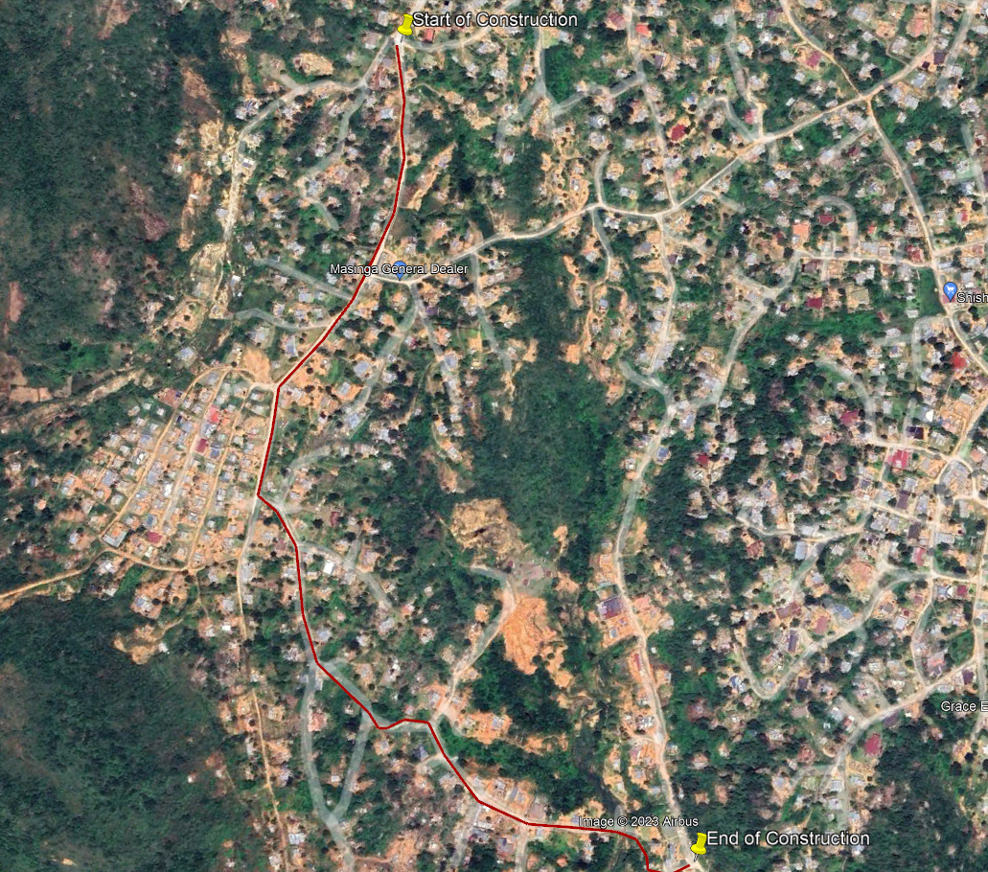Figure 1: Locality Plan of the Project Area

SI 2 Climatic Condition

The climate of the project area is Savana Biome climate characterized by seasonal precipitation and sub-tropical thermal regimes with no frost. The mean daily maximum temperatures for summer months are between 260 C and 32 0C. In winter, the daily minimum temperatures remain above IOO C. The area receives the lowest rainfall (2mm) in June and the highest (119mm) in December.
According to the Weinert, 1980, the area has a climatic "N" value of 2.2 which is associated with humid warm area and a surplus of water, where chemical decomposition is the predominant rock weathering mode.
Soils derived from the decomposition of bedrock of the area are associated with the following engineering properties:
- High permeability
- Uneven bedrock
- Hight erodibility
- Unstable slopes
- Semi-pervious to pervious soils
- Good compaction and workability

SI 3 Geotechnical Investigation

The published geological map series, 2530, Barberton at a scale of 1:250 000 shows that the site is covered by Nelspruit Granite suite overlain by Mpageni Granite. The site is dominated by Grey to white, coarse-grained biotite granite; weakly to very strongly porphyritic; veined by granodiorite; bimodal porphyritic granite veined by granodiorite with large phenocrysts. The site is also intersected by dolerite dyke.
The geological map for the area is presented below.
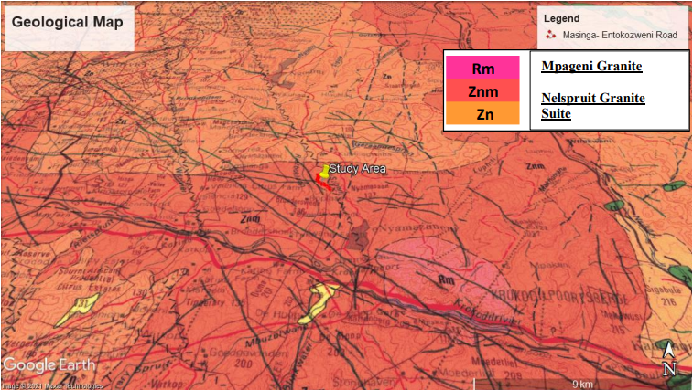

- Materials Descriptions
Below are the different soil profiles encountered on site:
- Topsoil intersected in the majority of the test pits. This horizon comprises light brown to reddish brown conglomerates material of sandy gravel, with pebbles and boulders of rock materials extending down to an average of 0.3m below the surface.
- Residual soil Residual soils, derived from the in situ weathering of granite bedrock. They consist generally of light brownish/reddish gravel extending to between 0.30m and 1.0m in majority of the test pits.
- Highly to moderately weathered Granite bedrock described as yellowish brown/orange, highly to moderately weathered, soft to medium hard rock grading into moderately weathered closely to medium jointed medium hard rock which finally becomes slightly weathered medium jointed hard rock with depth.

- Groundwater seepage and surface Run-off
No ground water permeability was encountered in any of the inspection pits dug on site. However, wet
conditions were encountered throughout the site

SI 4 METHODS OF INVESTIGATION

  - Field Work
The field work phase of the investigation was conducted on 30th August 2021.
A total of seven (7) inspection pits designated TP1 to TP7 were excavated using a Track loader
backhoe (TLB) machine advanced to depths ranging from 0.80m to 1.20m below natural ground level (mbgl). Approximately 250m interval was used in positioning the inspection pits along the length of the proposed route.

All inspection pits were profiled immediately after excavation by an Engineering Geologist in
accordance with the method of Jennings et al., (1973) and are attached in Appendix B of this report.

  - In Situ and Laboratory Soil Testing
A total of 4 DCP test were carried out from 0m – 2m below natural ground level (mbgl). The DCP
tests were carried out to assess the bearing capacity of the in-situ material below 1m. The number of DCP tests conducted were limited due to presence of rock outcrops along the proposed route.

Representative disturbed samples of the material recovered were taken for laboratory testing to
determine the properties of the material and their suitability for use as road construction materials.

The soil samples were taken for Road Indicator tests, Moisture/Density tests and CBR tests. These
tests evaluate the compaction characteristics of the site soils and permit an evaluation of their
suitability for use as construction materials

SI 5 RESULTS OF THE INVESTIGATION

  - Laboratory Test Results
In order to assess more accurately the engineering properties of the various materials encountered on site and to assess the suitability of the in situ materials for the use as bedding and fill, the following material classification tests were carried out on selected samples during the investigation:

- Grading Analyses,
- Atterberg Limit Determinations and Linear Shrinkage Determinations,
- Moisture Density Relationship (MOD AASTHO),
- California Bearing Ratio (CBR)

Table 1: Summary of indicator test results
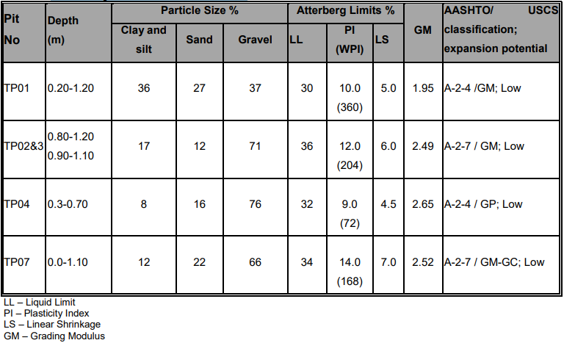

The results above represent the properties of clay gravel to sandy gravel material sampled on site. The lower percentage of fines accounts for the low potential expansion.

However; in the case of coarse grained soils the use of plasticity index can lead to incorrect materials classification (Look, 2016). The plasticity index is determined only for the material passing the 0.0425mm sieve and does not account for the coarser fractions. The use of the weighted PI (WPI), which is the product of the PI times the percentage passing the 0.425mm, is intended to report the percentage used and give the correct movement potential classification.

Table 2 below shows the range of WPI values and associated classifications.
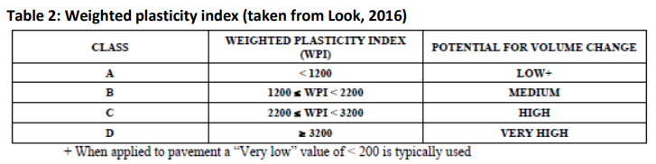

The WPI for clayey sand gravel material ranges from 72 to 360 (WPI) falling to Class A, that is, low potential for volume change. Compaction tests were also conducted on the same material and the results are given below.

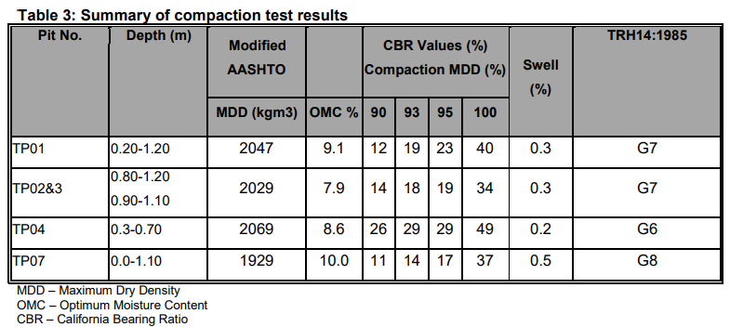

The results indicate that the material has a maximum dry density ranging from 1925 to 2228kg/m3 and an optimum moisture content ranging from 7.0 to 9.7%. The CBR swell is low medium. The material classifies as G6 to G8.The material can be used as general fill (Appendix C).

  - DCP Test Results
A total of four (4) DCP tests were carried out across the site. DCP tests were done from 0 – 1 mbgl. The DCP tests were carried out to assess the bearing capacity of the in-situ material below 1m. The penetration resistance is expressed as millimeters per blow as shown in table 4 below

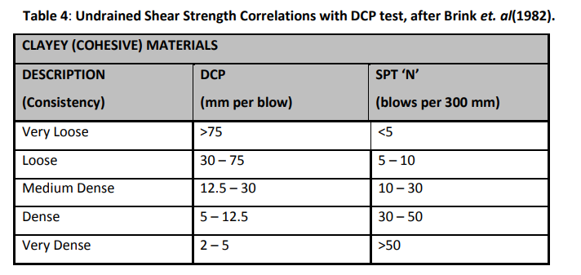
The results show an average of 4.8 (mm/blow) with a bearing capacity of between 60 – >200kPa. From DCP results, it was noted that the material consistency was Medium Dense to Very Dense for the. The DCP test results are attached in Appendix D.

  - Material Classification, Usage and Subgrade Treatment
The results of the laboratory tests, together with the dynamic penetrometer tests and the visual assessment conducted on site have been used to provide an indication of the suitability for use of the materials on site for the construction of the road. See table 5 below

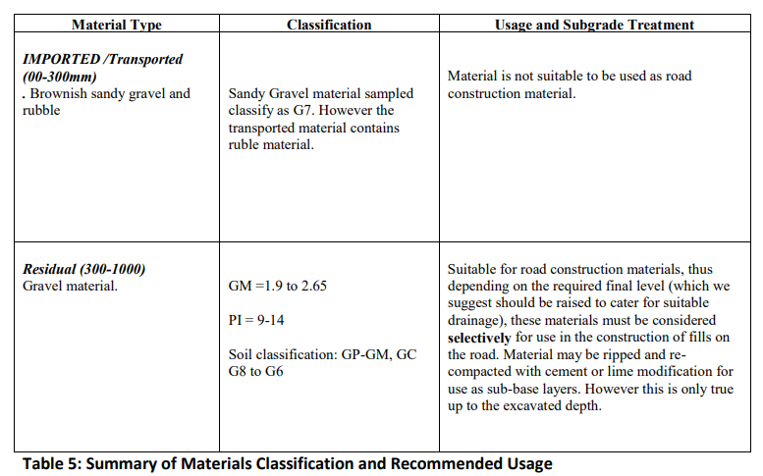

The material making up the residual gravel is considered suitable for use in selected layers, if these are considered in the design. Care must be taken during excavation and stockpiling to ensure that unsuitable material is spoiled and not mixed with these materials. It must be noted that this qualification given in this report is based on assessments made in test pits and limited testing, it is thus recommended that continuous testing (prior to and during construction) be carried out to ensure material quality

SI 6 GEOTECHNICAL EVALUATION AND RECOMMENDATIONS

Various stages of the development are discussed below with comments, guidelines, and recommendations given to assist in making the project a success.

Bulk Earthworks

The field tests show that excavation using light conventional earth moving equipment can be used to excavate to an average depth of 1.5m throughout the site. However, it is advisable to consider a heavy plant with 30 tonne to 40 tonne capacity for the entire site and the level of slightly weathered granite bedrock may vary at position not exposed during the geotechnical investigation.

The steep sloping terrain of the site is likely to warrant excessive cuts and fills in some part of the road taking into account that cuts and fills should be determined by the required final elevation of the road. It is recommended that all earthworks be carried out in accordance with SABS 1200 or equivalent SANS standards and/or COTO of 2020.

All fill should be placed and compacted within an allowable error of ±2% of the materials Optimum Moisture Content. Subgrade fill should be compacted to at least 93% of the materials Standard Maximum Dry Density (MDD) value.

Road structure fill, including the Crushed Stone Base Course and the Select Granular Sub-base should be placed and compacted to at least 95% of the material’s MDD value Both during and after construction, the site should be well graded to permit water to drain readily away and to prevent ponding of water anywhere on the ground surface. All terraces and earthworks in general should be sloped to a gradient of not less than 1 vertical in 50 horizontal to prevent ponding and ingress of water into the subsoil’s. Surface drainage should be directed away from the crests of fill embankments to prevent over-topping and erosion of fill slopes.

  - Subgrade Treatment

Subgrade treatment shall comprise the normal rip/scarify and re-compact procedure. Any subgrade material deemed unsuitable from the design considerations shall be removed to such widths and depths as maybe required and disposed of accordingly. The excavated areas shall be backfilled with approved materials and compacted to the required density.

No design CBR or pavement designs were provided prior to this investigation as such no specific depths or widths of excavation can be specified in this report. However if the assumption is that current levels of the existing roads will be maintained, the subgrade treatment should then follow the excavation (and spoil or stockpile) of the fill layers.

  - Subsoil Drainage

Due to site terrains, it is evident that surface water is a concern which may thus raise the water table
and give problems with groundwater inflow during excavations, especially during periods of heavy
rainfall. Even though all excavations were water free, it is good practice to place subsoil drains at such
fairly level sites. Noting that the water table may vary with climatic seasons thus, subsoil drains must
be placed at the following positions, if any, to intercept groundwater and divert it around structures.

- Retaining walls
- At the toe of cuts
- Below the structural layers of roads and paved area

  - Excavation requirements

Excavation conditions across the majority of the site can be described as “Soft to Intermediate to
hard Excavation” in accordance with SANS 1200D -Earthworks

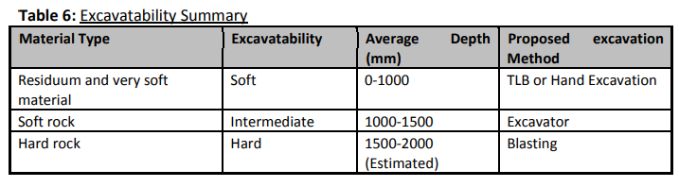
Material of “Intermediate Excavation Class” and possibly “Hard or Boulder Excavation Class” can be
anticipated with depth below 1.5m due to the underlying slightly weathered granite bedrock.

However, in places where the bedrock is shallow and hard, a 30 tonne track mounted excavator may
be required to get to the specific depth below existing ground level. This is however expected to be
localized along TP4 to TP7 where granite outcrops are visible on the surface.

Provision for hard excavation (Blasting) will need to be made over the site for box cut on the
exposed granitic rock outcrops.

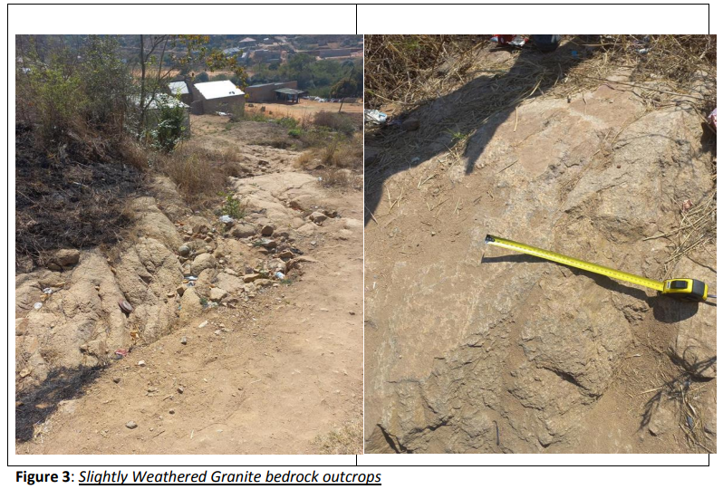

SI 7 CONCLUSIONS

This report presents the results of a detailed centre-line geotechnical investigation undertaken for the proposed upgrading of Masinga - Entokozweni internal roads pavement top standards within the Mbombela Local Municipality of the Mpumalanga province.

The investigation undertaken has concluded that the site is suitable for the proposed services, provided that the recommendations provided in this report are adhered to.

Finally, it should be noted that the subsoil conditions contained in this report relate to the information obtained from the inspection pits put down for investigation. It is possible that variances to the anticipated subsoil conditions will be encountered along during construction. It is therefore important that when such variances occur, they are reported to Lekhuleni Geotechnical Services, for timeous assessment and recommendations for the necessary adjustments to construction procedure can be made

Appendix B – Pictures and Soil Profile

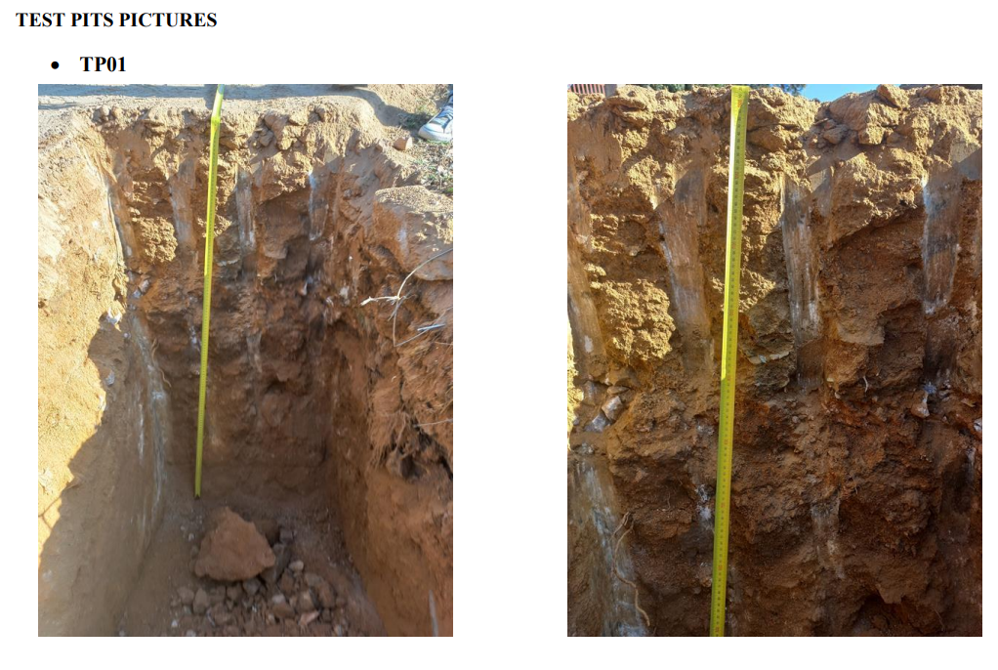
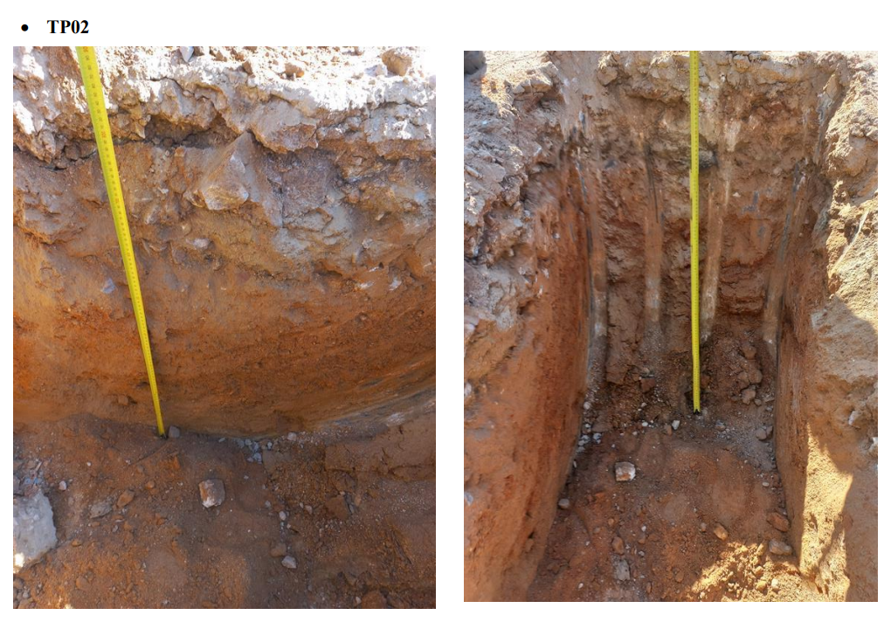

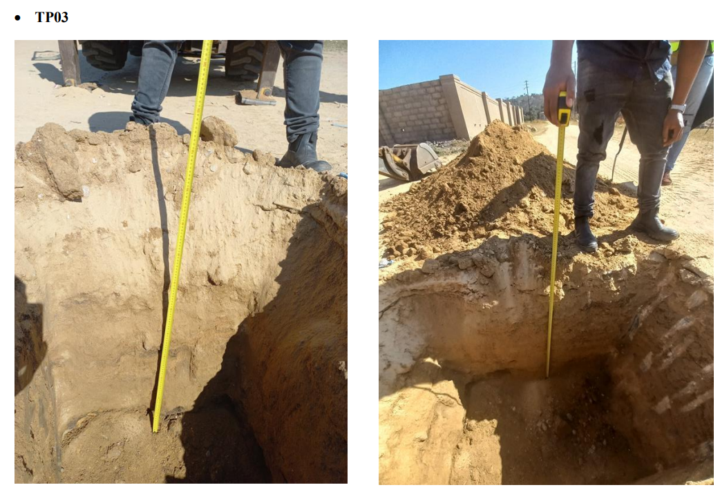

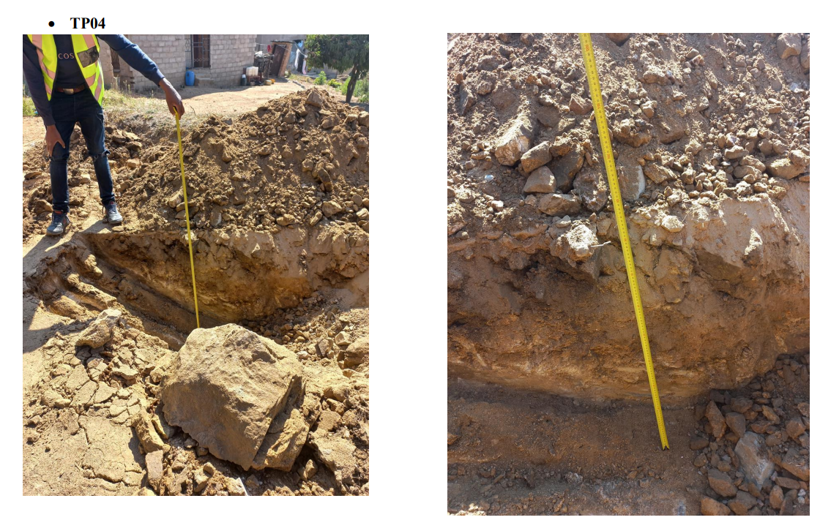

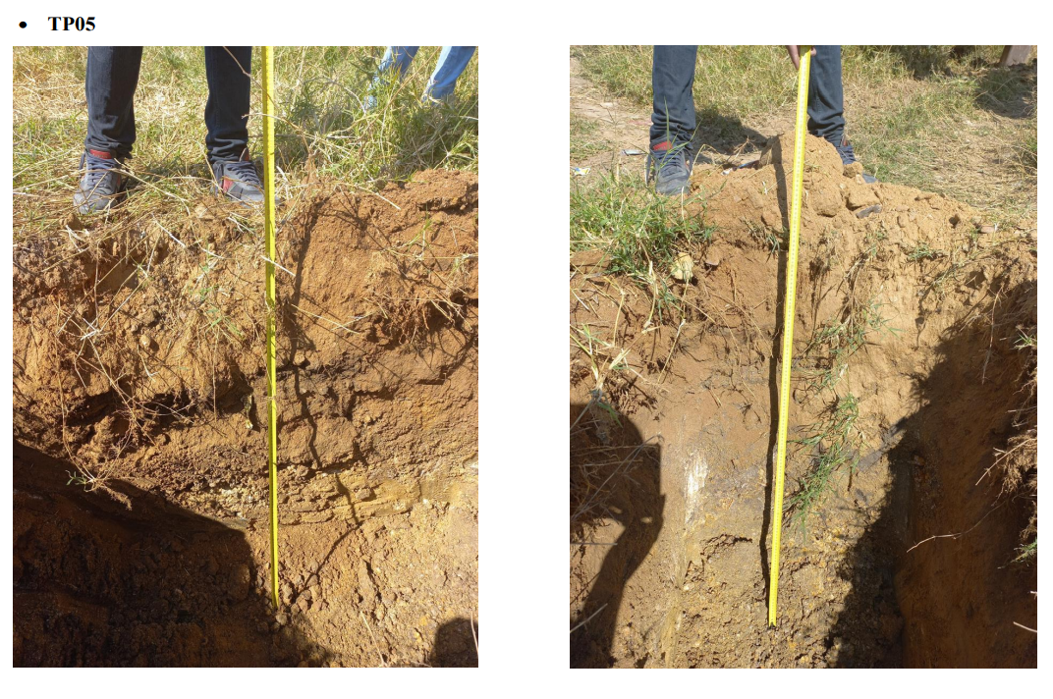
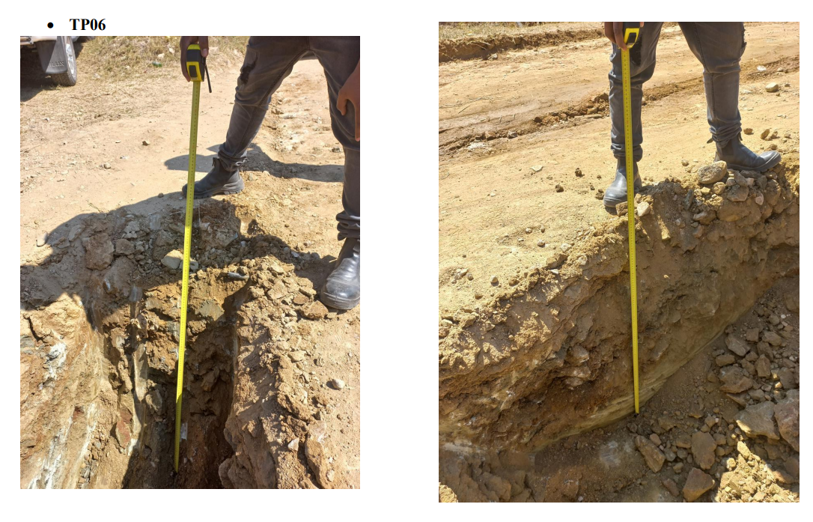

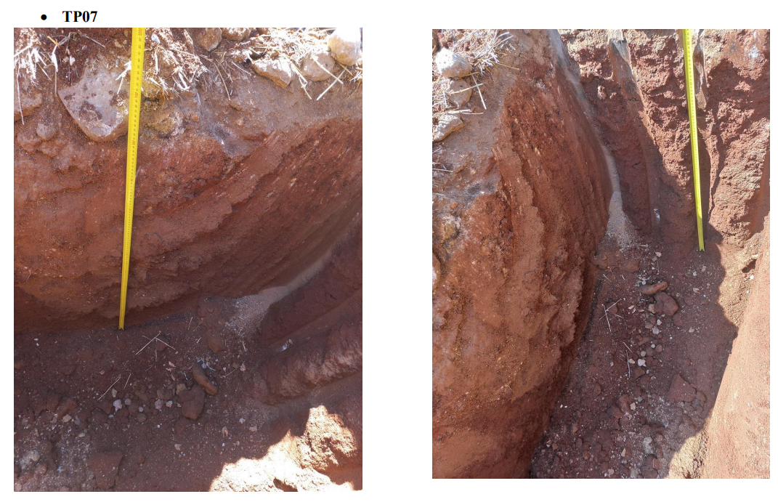

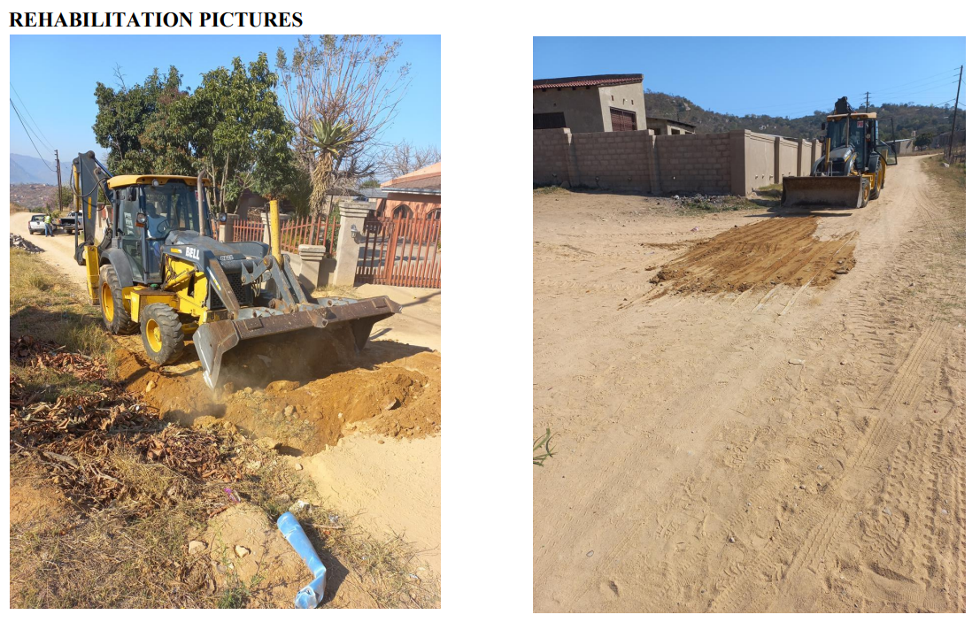

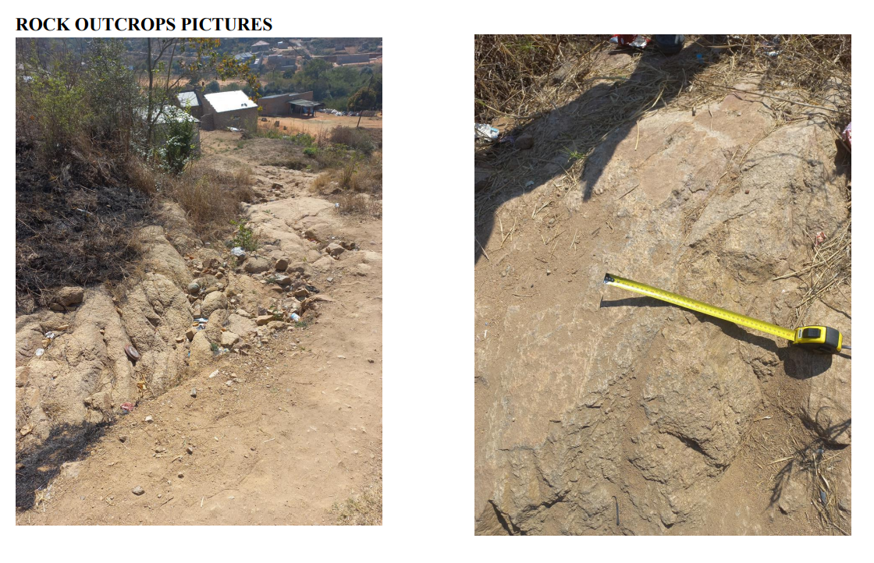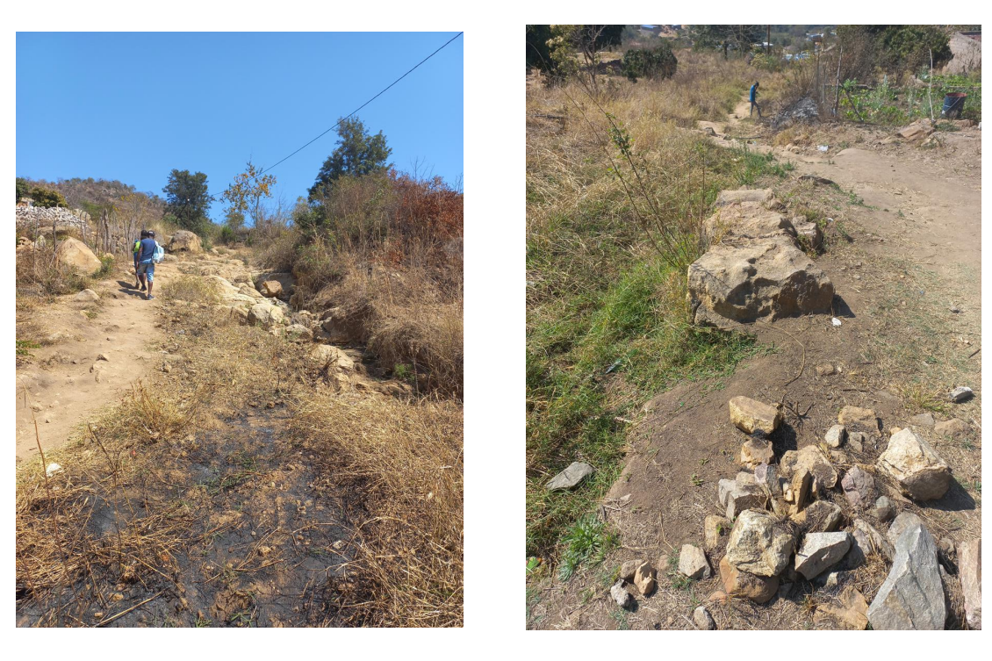

OCCUPATIONAL HEALTH AND SAFETY SPECIFICATIONS
CONTENTS

PARTICULAR SPECIFICATIONS A-1
AGREEMENT OCCUPATIONAL HEALTH AND SAFET……………………………A-11

CONTRACTOR'S HEALTH AND SAFETY DECLARATION ................................ A-13

PRO FORMA NOTIFICATION A-16

PARTICULAR SPECIFICATIONS
SECTION OHS: OHSA 1993: HEALTH AND SAFETY SPECIFICATION

OHS 1 SCOPE
This specification covers the health and safety requirements to be met by the Contractor to ensure a continued safe and healthy environment for all workers, employees and subcontractors under his control and for all other persons entering the site of works.
This specification shall be read with the Occupational Health and Safety Act (Act No 85 and amendment Act No 181) 1993, and the corresponding Construction Regulations 2014, and all other safety codes and specifications referred to in the said Construction.
In terms of the OHSA Agreement in Section (C1.4) of the Contract document, the status of the Contractor as mandatory to the Employer (client) is that of an employer in his own right, responsible to comply with all provisions of OHSA 1993, the Construction Regulations 2014.
This safety specification and the Contractor’s own Safety Plan, the Construction Regulations 2014, shall be displayed on site or made available for inspection by all workers, employees, inspectors and any other persons entering the site of works.
The following are possible risks associated with this project:
- Please insert the risks associated with the project here
Additional risks may arise from specific methods of construction selected by the Contractor which are not necessary covered in the above.

OHS 2 DEFINITIONS
For the purpose of this contract the following shall apply:
Employer” where used in the contract documents and in this specification, means the Employer as defined in the General Conditions of Contract and it shall have the exact same meaning as “client” as defined in the Construction Regulations 2014. “Employer” and “client” is therefore interchangeable and shall be read in the context of the relevant document.
- “Contractor” wherever used in the contract documents and in this specification, shall have the same meaning as “Contractor” as defined in the General Conditions of Contract.
In this specification the terms “principal contractor” and “contractor” are replaced with “Contractor” and “subcontractor” respectively.
For the purpose of this contract the Contractor will, in terms of OHSA 1993, be the mandatory, without derogating from his status as an employer in his own right.
- “Engineer” where used in this specification, means the Engineer as defined in the General Conditions of Contract. In terms of the Construction Regulations the Engineer may act as agent on behalf of the Employer (the client as defined in the Construction Regulations).

OHS 3 TENDERS
The Contractor shall submit the following with his tender:
- a documented Health and Safety Plan as stipulated in Regulation 7 of the Construction Regulations. The Safety Plan must be based on the Construction Regulations 2014 and COVID-19(C19 OHS), 2020 and will be subject to approval by the Employer;
- a declaration to the effect that he has the competence and necessary resources to carry out the work safely in compliance with the Construction Regulations 2014;
- a declaration to the effect that he made provision in his tender for the cost of the health and safety measures envisaged in the Construction Regulations.
- Failure to submit the foregoing with his tender, will lead to the conclusion that the Contractor will not be able to carry out the work under the contract safely in accordance with the Construction Regulations.

OHS 4 NOTIFICATION OF COMMENCEMENT OF CONSTRUCTION WORK
After award of the contract, but before commencement of construction work, the Contractor shall, in terms of Regulation 3, notify the Provincial Director of the Department of Labour in writing if the following work is involved:
- the demolition of structures and dismantling of fixed plant of height of 3,0m or more;
- the use of explosives;
- construction work that will exceed 30 days or 300 person-days;
- excavation work deeper than 1,0m; or
- working at a height greater than 3,0m above ground or landings.
The notification must be done in the form of the pro forma included under Section T2 (Forms to be Completed by Tenderer) of the tender document.
A copy of the notification form must be kept on site, available for inspection by inspectors, Employer, Engineer, employees and persons on site.

OHS 5 RISK ASSESSMENT
Before commencement of any construction work during the construction period, the Contractor shall have a risk assessment performed and recorded in writing by a competent person. (Refer Regulation 9 of the Construction Regulations 2014).
The risk assessment shall identify and evaluate the risks and hazards that may be expected during the execution of the work under the contract, and it shall include a documented plan of safe work procedures to mitigate, reduce or control the risks and hazards identified.
The risk assessment shall be available on site for inspection by inspectors, Employer, Engineer, subcontractors, employees, trade unions and health and safety committee members, and must be monitored and reviewed periodically by the Contractor.

OHS 6 APPOINTMENT OF EMPLOYEES AND SUBCONTRACTORS
  - Health and Safety plan
The Contractor shall appoint his employees and any subcontractors to be employed on the contract, in writing, and he shall provide them with a copy of his documented Health and Safety Plan, or relevant sections thereof. The Contractor shall ensure that all subcontractors and employees are committed to the implementation of his Safety Plan.

Health and safety induction training
The Contractor shall ensure that all employees under his control, including subcontractors and their employees, undergo a health and safety induction training course by a competent person before commencement of construction work. No visitor or other person shall be allowed or permitted to enter the site of the works unless such person has undergone health and safety training pertaining to hazards prevalent on site.
The Contractor shall ensure that every employee on site shall at all times be in possession of proof of the health and safety induction training issued by a competent person prior to commencement of construction work.

OHS 7 APPOINTMENT OF SAFETY PERSONNEL
  - Construction Supervisor
The Contractor shall appoint a full-time Construction Supervisor with the duty of supervising the performance of the construction work.
He may also have to appoint one or more competent employees to assist the construction supervisor where justified by the scope and complexity of the works.

Construction safety officer
Taking into consideration the size of the project and the hazards or dangers that can be expected, the Contractor shall appoint in writing a full-time or part-time Construction Safety Officer if so decided by the client. The Safety Officer shall have the necessary competence and resources to perform his duties diligently.
Provision shall be made by the Contractor in his rates, to cover the cost of this dedicated construction safety officer appointed after award of the contract.

Health and safety representatives
In terms of Section 17 and 18 of the Act (OHSA 1993) the Contractor, being the employer in terms of the Act for the execution of the contract, shall appoint a health and safety representative whenever he has more than 20 employees in his employment on the site of the works. The health and safety representative must be selected from employees who are employed in a full-time capacity at a specific workplace.
The number of health and safety representatives for a workplace shall be at least one for every 100 employees.
The function of health and safety representative(s) will be to review the effectiveness of health and safety measures, to identify potential hazards and major incidents, to examine causes of incidents (in collaboration with his employer, the Contractor), to investigate complaints by employees relating to health and safety at work, to make representations to the employer (Contractor) or inspector on general matters affecting the health and safety of employees, to inspect the workplace, plant, machinery etc. on a regular base, to participate in consultations with inspectors and to attend meetings of the health and safety committee.

Health and safety committee
In terms of Sections 17 and 18 of the Act (OHSA 1993) the Contractor (as employer), shall establish one or more health and safety committee(s) where there are two or more health and safety representatives at a workplace. The persons selected by the Contractor to serve on the committee shall be designated in writing.

The function of the health and safety committee shall be to hold meetings at regular intervals, but at least once every three months, to review the health and safety measures on the contract, to discuss incidents related to health and safety with the Contractor and the inspector, and to make recommendations regarding health and safety to the Contractor and to keep record of recommendations and reports made by the committee.

Competent persons
In accordance with the Construction Regulations the Contractor has to appoint in writing competent persons responsible for supervising construction work on each of the following work situations that may be expected on the site of the works.
    - Risk assessment and induction training as described in Regulation 9 of the Construction Regulations;
    - Fall protection as described in Regulation 10;
    - Structures described in Regulation 11;
    - Temporary works described in Regulation 12;
    - Excavation described in Regulation 13;
    - Demolition work described in Regulation 14;
    - Tunneling as described in Regulation 15;
    - Scaffolding as described in Regulation 16;
    - Suspended platforms as described in Regulation 17;
    - Rope Access Work as described in Regulation 18;
    - Material hoists as described in Regulation 19;
    - Bulk mixing plant as described in Regulation 20;
    - Explosive actuated fastening device as described in Regulation 21;
    - Cranes as described in Regulation 22;
    - Construction vehicle and mobile as described in Regulation 23;
    - Electrical installations and machinery of construction sites as described in Regulation 24;
    - Use and temporary storage of flammable liquids on construction sites as described in Regulation 25;
    - Water environments as described in Regulation 26;
    - Housekeeping and general safeguarding on construction sites as described in Regulation 27;
    - Stacking and storage on construction sites as described in Regulation 28;
    - Fire precautions on construction sites as described in Regulation 29, and
(s) Construction employees’ facilities as described in Regulation 30.
A competent person may be appointed for more than one part of the construction work with the understanding that the person must be suitably qualified and able to supervise at the same time the construction work on all the work situations for which he has been appointed.

The appointment of competent persons to supervise parts of the construction work does not relieve the Contractor from any of his responsibilities to comply with all requirements of the Construction Regulations.

OHS 8 RECORDS AND REGISTERS
In accordance with the Construction Regulations the Contractor is bound to keep records and registers related to health and safety on site for periodic inspection by inspectors, the Engineer, the Employer, trade union officials and subcontractors and employees. The following records and registers must be kept on site and shall be available for inspection at all times.
- A copy of the OHSA 1993 Construction Regulations 2014;
- A copy of this Health and Safety Specification;
- A copy of the Contractor’s Health and Safety Plan (Regulation 7);
- A copy of the Notification of Construction Work (Regulation 4);
- A health and safety file in terms of Regulation 5(1)(b) with inputs by the Construction Safety Officer (Regulation 7(1));
- A copy of the risk assessment described in Regulation 9;
- A full protection plan and the corresponding records of evaluation and training of employees working from elevated positions as described in Regulation 10;
- Drawings pertaining to the design of structures (Regulation 11(1)(c)) and formwork and support work structures (Regulation 12) must be kept on site;
- Pronouncement of the safety of excavations must be recorded in a register to be kept on site (Regulation 13);
- A copy of the certificate of the system design for suspended platforms (Regulation 17(2)(b));
- A notice must be affixed around the base towers of material hoists to indicate the maximum mass load, which may be carried at any one time by material hoists (Regulation 19(5));
- Maintenance records of material hoists and inspection results must be kept in a record book to be kept on site (Regulation 19(8));
- A record of any repairs to or maintenance of a batch plant must be kept on site (Regulations 20(8));
- A warning notice must be displayed in a conspicuous manner when and wherever an explosive powered tool is used (Regulation 19(2));
- A register for recording of findings by the competent person appointed to inspect construction vehicles and mobile plant (Regulation 23(1)(k)).

OHS 9 CONTRACTORS RESPONSIBILITIES
For this contract the Contractor will be the mandatory of the Employer (Client), as defined in the Act (OHSA 1993), which means that the Contractor has the status of employer in his own right in respect of the contract. The Contractor is therefore responsible for all the duties and obligations of an employer as set out in the Act (OHSA 1993) and the Construction Regulations 2014.
Before commencement of work under the contract, the Contractor shall enter into an agreement with the Employer (Client) to confirm his status as mandatory (employer) for the contract under consideration.
The Contractor’s duties and responsibilities are clearly set out in the Construction Regulations 2014 and are not repeated in detail but some important aspects are highlighted hereafter, without relieving the Contractor of any of his duties and responsibilities in terms of the Construction Regulations.

- Contractor’s position in relation to the Employer (Client) (Regulation 5)
In accordance with Section 4 of the Regulations, the Contractor shall liaise closely with the Employer or the Engineer on behalf of the Employer, to ensure that all requirements of the Act and the Regulations are met and complied with.
- The Principal Contractor and Contractor (Regulation 7)
The Contractor is in terms of the definition in Regulation 1 the equivalent of Principle Contractor as defined in the Construction Regulations, and he shall comply with all the provisions of Regulation 7.
Any subcontractors employed by the Contractor must be appointed in writing, setting out the terms of the appointment in respect of health and safety. An independent subcontractor shall however provide and demonstrate to the Contractor a suitable, acceptable and sufficiently documented health and safety plan before commencement of the subcontract. In the absence of such a health and safety plan the subcontractor shall undertake in writing that he will comply with the Contractor’s safety plan, the health and safety specifications of the Employer and the Construction Regulations 2014.
- Supervision of construction work (Regulation 8)
The Contractor shall appoint the safety and other personnel and employees as required in terms of Regulation 7 and as set out in OHS 7 above. Appointment of those personnel and employees does not relieve the Contractor from any of the obligations under Regulation 7.
- Risk assessment (Regulation 9)
The Contractor shall have the risk assessment made as set out in paragraph 7 above before commencement of the work and it must be available on site for inspection at all times. The Contractor shall consult with the health and safety committee or health and safety representative(s) etc. on a regular basis to ensure that all employees, including subcontractors under his control, are informed and trained by a competent person regarding health hazards and related work procedures.
No subcontractor, employee or visitor shall be allowed to enter the site of works without prior health and safety induction training, all as specified in Regulation 7.
- Fall protection (Regulation 10)
Fall protection, if applicable to this contract shall comply in all respects with Regulation 8 of the Construction Regulations.
- Structures (Regulation 11)
The Contractor will be liable for all claims arising from collapse or failure of structures if he failed to comply with all the specifications, project specifications and drawings related to the structures, unless it can be proved that such collapse or failure can be attributed to faulty design or insufficient design standards on which the specifications and the drawings are based.
In addition, the Contractor shall comply with all aspects of Regulation 11 of the Construction Regulations.
- Temporary works (Regulation 12)
The Contractor will be responsible for the adequate design of all formwork and support structures by a competent person.
All drawings pertaining to formwork shall be kept on site and all equipment and materials used in formwork, shall be carefully examined and checked for suitability by a competent person.
The provisions of Regulation 12 of the Construction Regulations shall be followed in every detail.

- Excavation work (Regulation 13)
It is essential that the Contractor shall follow the instructions and precautions in the Standard Specifications and Project Specifications as well as the provisions of the Construction Regulations to the letter as unsafe excavations can be a major hazard on any construction site. The Contractor shall therefore ensure that all excavation work is carried out under the supervision of a competent person, that inspections are carried out by a Professional Engineer or Technologist, and that all work is done in such a manner that no hazards are created by unsafe excavations and working conditions.
Supervision by a competent person will not relieve the Contractor from any of his duties and responsibilities under Regulation 13 of the Construction Regulations.
- Demolition work (Regulation 14)
Whenever demolition work is included in a contract, the Contractor shall comply with all the requirements of Regulation 14 of the Construction Regulations. The fact that a competent person has to be appointed by the Contractor does not relieve the Contractor from any of his responsibilities in respect of safety of demolition work.
- Tunneling (Regulation 15)
The Contractor shall comply with Regulation 15 wherever tunneling of any kind is involved.
- Scaffolding (Regulation 16)
The Contractor shall ensure that all the provisions of Regulation 16 of the Construction Regulations are complied with. [Note: Reference in the Regulations to “Section 44 of the Act” should read “Section 43 of the Act”].
- Suspended platforms (Regulation 17)
Wherever suspended platforms will be necessary on any contract, the Contractor shall ensure that copies of the system design issued by a Professional Engineer are submitted to the Engineer for inspection and approval. The Contractor shall appoint competent persons as supervisors and competent scaffold erectors, operators and inspectors and ensure that all work related to suspended platforms are done in accordance with Regulation 17 of the Construction Regulations.
- Rope Access Work (Regulation 18)
Where rope access work is required on the construction site, the Contractor shall comply with Regulation 18.
- Material Hoists (Regulation 19)
Wherever applicable, the Contractor shall comply with the provisions of Regulation 19 to the letter.
- Batch plants (Regulation 20)
Wherever applicable, the Contractor shall ensure that all lifting machines, lifting tackle, conveyors, etc. used in the operation of a batch plant shall comply with, and that all operators, supervisors and employees are strictly held to the provisions of Regulation
20. The Contractor shall ensure that the General Safety Regulations (2003), the Driven Machinery Regulations (Government Notice R295 of 26/2/1988) and the Electrical Installation Regulations (Government Notice R2271 of 11/10/1995) are adhered to by all involved.
In terms of the Regulations, records of repairs and maintenance shall be kept on site.

- Explosive powered tools (Regulation 21)
The Contractor shall ensure that, wherever explosive-powered tools are required to be used, all safety provisions of Regulation 21 are complied with.
It is especially important that warning notices are displayed and that the issue and return of cartridges and spent cartridges be recorded in a register to be kept on site.
- Cranes (Regulation 22)
Wherever the use of tower cranes becomes necessary, the provisions of Regulation 20 shall be complied with.
- Construction vehicles and mobile plant (Regulation 23)
The Contractor shall ensure that all construction vehicles and plant are in good working condition and safe for use, and that they are used in accordance with their design and intended use. The vehicles and plant shall only be operated by workers or operators who have received appropriate training, all in accordance with all the requirements of Regulation 23.
All vehicles and plant must be inspected on a daily basis, prior to use, by a competent person and the findings must be recorded in a register to be kept on site.
- Electrical installation and machinery on construction sites (Regulation 24)
The Contractor shall comply with the Electrical Installation Regulations (Government Notice R2920 of 23 October 1992) and the Electrical Machinery Regulations (Government Notice R1953 of 12 August 1993). Before commencement of construction, the Contractor shall take adequate steps to ascertain the presence of, and guard against dangers and hazards due to electrical cables and apparatus under, over or on the site.
All temporary electrical installations on the site shall be under the control of a competent person, without relieving the Contractor of his responsibility for the health and safety of all workers and persons on site in terms of Regulation 24.
- Use of temporary storage of flammable liquids on construction sites (Regulation 25)
The Contractor shall comply with the provisions of the General Safety Regulations (2003) and all the provisions of Regulation 25 of the Construction Regulations to ensure a safe and hazard-free environment to all workers and other persons on site.
- Water environments (Regulation 26)
Where construction work is done over or in close proximity to water, the provisions of Regulation 26 shall apply.
- Housekeeping on Construction sites (Regulation 27)
Housekeeping on all construction sites shall be in accordance with the provisions of the environment Regulations for workplaces (Government Notice R2281 of 16 October 1987) and all the provisions of Regulation 27 of the Construction Regulations.
- Stacking and storage on construction sites (Regulation 28)
The provisions for the stacking of articles contained in the General Safety Regulations (2003) as well as all the provisions Regulation 28 of the Construction Regulations shall apply.

- Fire precautions on construction sites (Regulation 29)
The provisions of the Environmental Regulations for Workplaces (Government Notice R2281 of 16 October 1987) shall apply.
In addition, the necessary precautions shall be taken to prevent the incidence of fires, to provide adequate and sufficient fire protection equipment, sirens, escape routes etc. all in accordance with Regulation 29 of the Construction Regulations.
- Construction employees’ facilities (Regulation 30)
The Contractor shall comply with the construction site provisions as in the Facilities Regulations (2004), the provisions of Regulation 30 of the Construction Regulations.

OHS 10 MEASUREMENT AND PAYMENT
  - Principles
It is a condition of this contract that Contractors, who submit tenders for this contract, shall make provision in their tenders for the cost of all health and safety measures during the construction process. All associated activities and expenditure are deemed to be included in the Contractor’s tendered rates and prices.

Safety personnel
The Construction Supervisor, the Construction Safety Officer, Health and Safety Representatives, Health and Safety Committee and Competent Persons referred to in clauses 7.1 to 7.5 shall be members of the Contractor’s personnel, and no additional payment will be made for the appointment of such safety personnel.

Records and Registers
The keeping of health and safety-related records and registers as described in paragraph 8 is regarded as a normal duty of the Contractor for which no additional payment will be considered, and which is deemed to be included in the Contractor’s tendered rates and prices.

AGREEMENT IN TERMS OF SECTION 37(2) OF THE OCCUPATIONAL HEALTH AND SAFETY ACT NO 85 OF 1993
THIS AGREEMENT is made between.................................................................
(hereinafter called the EMPLOYER of the one part, herein represented by:
…………………………………………………………………………………………………………………………
…………………………………………………………………………………………………………………………
…………………………………………………………………………………………………………………………
………………………………………………………………………………………………………………
in his capacity as:
……………………………………………………………………………………………………………………..
AND:
(hereinafter called the CONTRACTOR) of the other part, herein represented by
…………………………………………………………………………………………………………………………
…………………………………………………………………………………………………………………………
…………………………………………………………………………………………………………………………
………………………………………………………………………………………………………………
in his capacity as:
…………………………………………………………………………………………………………………….. duly authorised to sign on behalf of the Contractor.
WHEREAS the CONTRACTOR is the Mandatory of the EMPLOYER in consequence of an agreement between the CONTRACTOR and the EMPLOYER in respect of
CONTRACT:.............................................................................................................................................
AND WHEREAS the EMPLOYER and the CONTRACTOR have agreed to enter into an agreement in terms of the provisions of Section 37(2) of the Occupational Health and Safety Act No 85 of 1993, as amended by OHSA Amendment Act No 181/1993 (hereinafter referred to as the ACT);
NOW THEREFORE the parties agree as follows:

The CONTRACTOR undertakes to acquaint the appropriate officials and employees of the CONTRACTOR with all relevant provisions of the ACT and the regulations promulgated in terms thereof.
- The CONTRACTOR undertakes to fully comply with all relevant duties, obligations and prohibitions imposed in terms of the ACT and Regulations: Provided that should the EMPLOYER have prescribed certain arrangements and procedures that same shall be observed and adhered to by the CONTRACTOR, his officials and employees. The CONTRACTOR shall bear the onus of acquainting himself/herself/itself with such arrangements and procedures.
- The CONTRACTOR hereby accepts sole liability for such due compliance with the relevant duties, obligations, prohibitions, arrangements and procedures, if any, imposed by the ACT and Regulations, and the CONTRACTOR expressly absolves the EMPLOYER and the Employer’s CONSULTING ENGINEERS from being obliged to comply with any of the aforesaid duties, obligations, prohibitions, arrangements and procedures in respect of the work included in the contract.

- The CONTRACTOR agrees that any duly authorised officials of the EMPLOYER shall be entitled, although not obliged, to take such steps as may be necessary to ensure that the CONTRACTOR has complied with his undertakings as more fully set out in paragraphs 1 and 2 above, which steps may include, but shall not be limited to, the right to inspect any appropriate site or premises occupied by the CONTRACTOR, or to take such steps it may deem necessary to remedy the default of the CONTRACTOR at the cost of the CONTRACTOR.
- The CONTRACTOR shall be obliged to report forthwith to the EMPLOYER any investigation, complaint or criminal charge which may arise as a consequence of the provisions of the ACT and Regulations, pursuant to work performed in terms of this agreement, and shall, on written demand, provide full details in writing of such investigation, complaint or criminal charge.
Thus signed at for and on behalf of the CONTRACTOR
on this the ……………… day of ……......………..……… 20………
SIGNATURE: .........................................................................................................................................
NAME AND SURNAME: ...........................................................................................................................
CAPACITY: ...........................................................................................................................................
WITNESSES: 1. ..............................................................................................................................
2. ................................................................................................................................
Thus signed at for and on behalf of the EMPLOYER on this
the …………………………... day of ……………..……… 20………
SIGNATURE: .............................................................................................................................................
NAME AND SURNAME: ...............................................................................................................................
CAPACITY: ...............................................................................................................................................
WITNESSES: 1. ..............................................................................................................................
2. ................................................................................................................................

CONTRACTOR'S HEALTH AND SAFETY DECLARATION
In terms of Clause 4(4) of the OHSA 1993 Construction Regulations 2014 (referred to as "the Regulations" hereafter), a Contractor may only be appointed to perform construction work if the Employer is satisfied that the Contractor has the necessary competencies and resources to carry out the work safely in accordance with the Occupational Health and Safety Act No 85 of 1993 and the OHSA 1993 Construction Regulations 2014.
To that effect a person duly authorised by the tenderer must complete and sign the declaration hereafter in detail.

Declaration by Tenderer
- I the undersigned hereby declare and confirm that I am fully conversant with the Occupational Health and Safety Act No 85 of 1993 (as amended by the Occupational Health and Safety Amendment Act No 181 of 1993), and the OHSA 1993 Construction Regulations 2014.
- I hereby declare that my company has the competence and the necessary resources to safely carry out the construction work under this contract in compliance with the Construction Regulations and the Employer's Health and Safety Specifications.
- I propose to achieve compliance with the Regulations by one of the following:
- From my own competent resources as detailed in 4(a) hereafter: *Yes / No
- From my own resources still to be appointed or trained until competency is
achieved, as detailed in 4(b) hereafter: *Yes / No
- From outside sources by appointment of competent specialist subcontractors
as detailed in 4(c) hereafter: *Yes / No
(* = delete whatever is not applicable)
- Details of resources I propose:
(Note: Competent resources shall include safety personnel such as a construction supervisor and construction safety officer as defined in Regulation 8, and competent persons as defined in Regulations 9-29, (all or individual regulations) as applicable to this contract)
- Details of the competent and qualified key persons from my company's own resources, who will form part of the contract team:
NAMES OF COMPETENT PERSONS | POSITIONS TO BE FILLED BY COMPETENT PERSONS

- Details of training of persons from my company's own resources (or to be hired) who still have to be trained to achieve the necessary competency:
(i) By whom will training be provided? ....................................................................................
(ii) When will training be undertaken? .....................................................................................
(iii) List the positions to be filled by persons to be trained or hired: ....................................................
............................................................................................................................................
............................................................................................................................................
- Details of competent resources to be appointed as subcontractors if competent persons cannot be supplied from own company:
Name of proposed subcontractor: ................................................................................................
Qualifications or details of competency of the subcontractor: ......................................................
- I hereby undertake, if my tender is accepted, to provide, before commencement of the works under the contract, a suitable and sufficiently documented Health and Safety Plan in accordance with Regulation 7(1) of the Construction Regulations, which plan shall be subject to approval by the Employer.
- I confirm that copies of my company's approved Health and Safety Plan, the Employer's Safety Specifications as well as the OHSA 1993 Construction Regulations 2014 will be provided on site and will at all times be available for inspection by the Contractor's personnel, the Employer's personnel, the Engineer, visitors, and officials and inspectors of the Department of Labour.
- I hereby confirm that adequate provision has been made in my tendered rates and prices in the schedule of quantities to cover the cost of all resources, actions, training and all health and safety measures envisaged in the OHSA 1993 Construction Regulations 2014, and that I will be liable for any penalties that may be applied by the Employer in terms of the said Regulations (Regulation 33) for failure on the Contractor's part to comply with the provisions of the Act and the Regulations.
- I agree that my failure to complete and execute this declaration to the satisfaction of the Employer will mean that I am unable to comply with the requirements of the OHSA 1993 Construction Regulations 2014, and accept that my tender will be prejudiced and may be rejected at the discretion of the Employer.
SIGNATURE: .................................................................. DATE: .....…….....................
(of person authorised to sign on behalf of the Tenderer)

PRO FORMA NOTIFICATION FORM IN TERMS OF THE OCCUPATIONAL HEALTH AND SAFETY ACT 1993, CONSTRUCTION REGULATIONS 2014
[This form must be completed and forwarded, prior to commencement of work on site, by all Contractors that qualify in terms of Regulation 3 of the Construction Regulations 2014, to the office of the Department of Labour]

NOTIFICATION OF CONSTRUCTION WORK
- (a) Name and postal address of principal contractor.
---------------------------------------------------------------------------------------------------------------------------------
(b) Name and tel. pf principal contractor’s contact person:
---------------------------------------------------------------------------------------------------------------------------------
- Principal contactor’s compensation registration number:
---------------------------------------------------------------------------------------------------------------------------------
- (a) Name and postal address of client :
---------------------------------------------------------------------------------------------------------------------------------
(b) Name and tel. no of clients contact person or agent:
---------------------------------------------------------------------------------------------------------------------------------
4 (a) Name and postal address of designer (s) for the project:
---------------------------------------------------------------------------------------------------------------------------------------
(b) --------------------------------------------------------------------------------------------------------------------------
- Name and telephone number of principal contractor’s sub- ordinate supervisor on site appointed in terms of Regulation 8 (1).
-----------------------------------------------------------------------------------------------------------------------------------------
- Name /s of principal contractor’s sub- ordinate supervisor on sire appointed in terms of Regulation 8 (2)
---------------------------------------------------------------------------------------------------------------------------------
- Exact physical address of the construction site or site office:
---------------------------------------------------------------------------------------------------------------------------------

- Nature of the construction work:
---------------------------------------------------------------------------------------------------------------------------------
---------------------------------------------------------------------------------------------------------------------------------
---------------------------------------------------------------------------------------------------------------------------------
- Expected commencement date:
---------------------------------------------------------------------------------------------------------------------------------
- Expected completion date:
---------------------------------------------------------------------------------------------------------------------------------
- Estimated maximum number of persons on the construction site.
Total: Male: Female
- Planned number of contractors on the construction:
---------------------------------------------------------------------------------------------------------------------------------

- Name (s) of contractors already selected.
---------------------------------------------------------------------------------------------------------------------------------------
---------------------------------------------------------------------------------------------------------------------------------------
---------------------------------------------------------------------------------------------------------------------------------------
Principal Contractor |  | Date
Client’s Agent (where applicable) |  | Date
Client |  | Date

ANNEXURE B: DRAWINGS FOR TENDER PURPOSES

