Specification – General Maintenance Tools

1 x cordless impact drill (with all the drill bits) -18 V – can be any decent model – best if it comes in a decent case

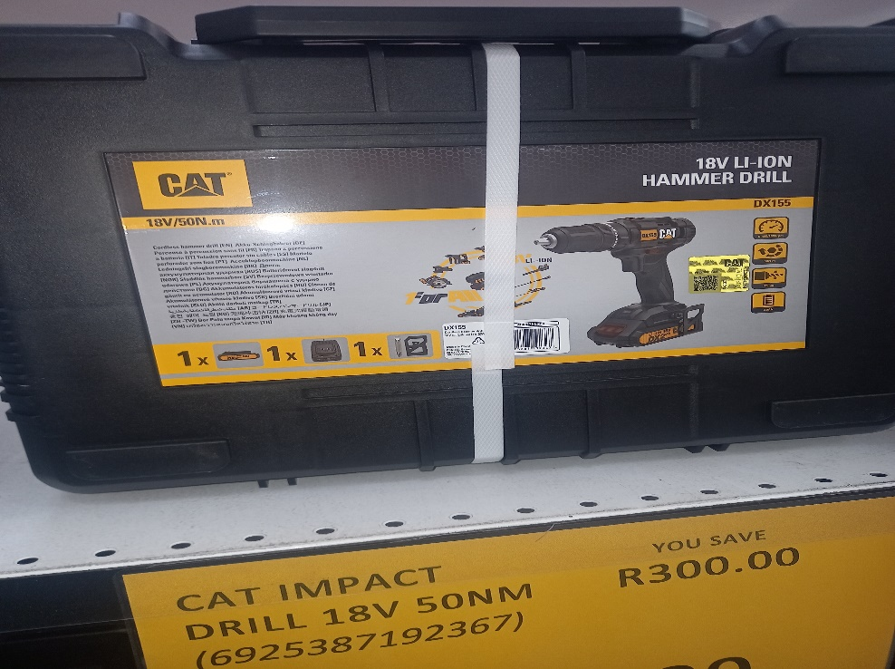

1 x circular saw (standard set that sits on a workbench)

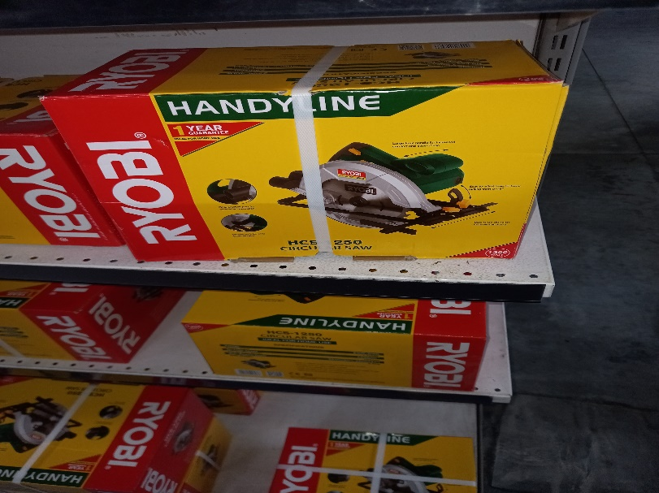

1 x spanner set (a full set of spanners – normally 18 - can be more – better if it is in a decent case)

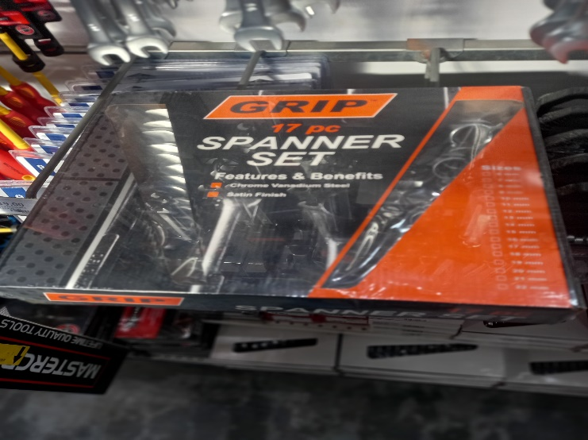

1 x screwdriver set (full set of screwdrivers – also normally 18 or more – again better if it is in a decent case)

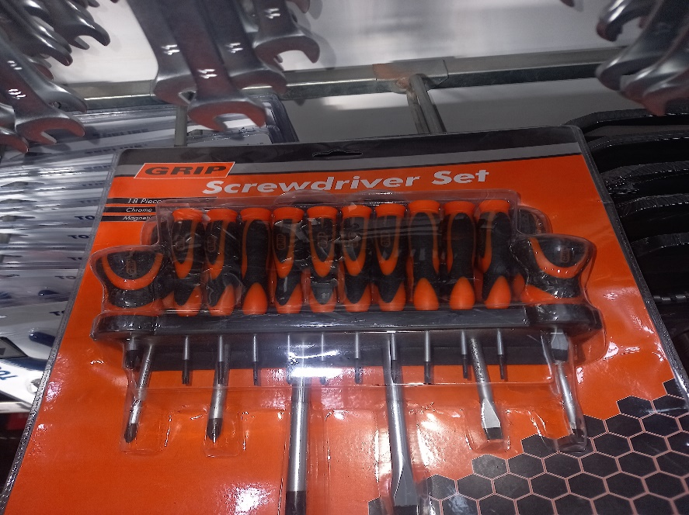

1 x Standard 6V/12V Battery charger – best not to get the smallest and cheapest one – but they are standard.

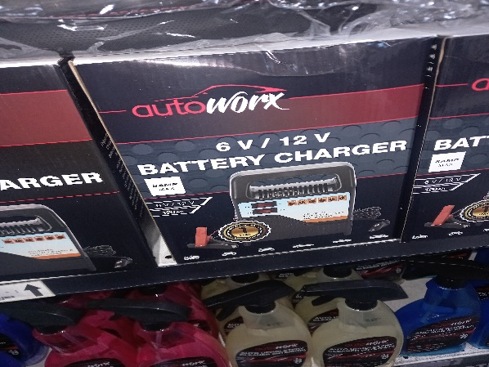

2 x standard 11 Fin Oil heaters – 1100A - (any standard make)

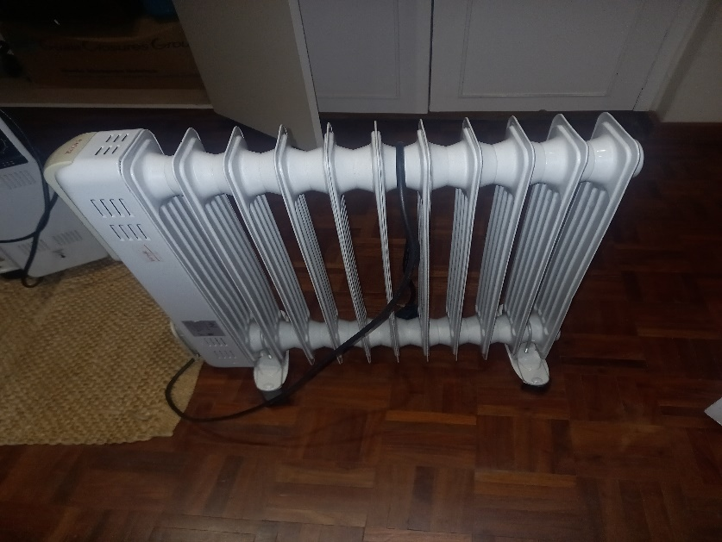

2 x standard desk-top fans – any make

