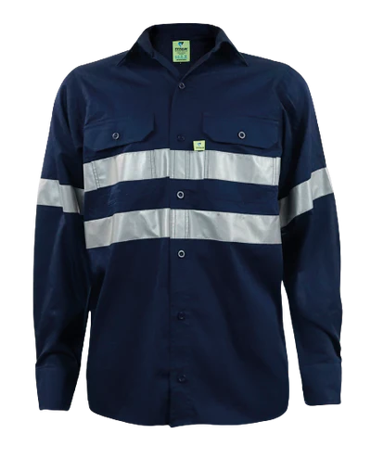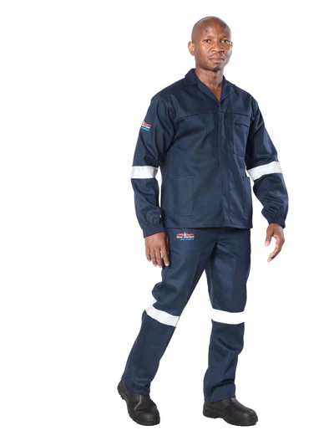
WORK SUIT

- 0mm silver flame retardant double needle topstitched reflective tape on arms & legs
- YKK concealed brass zip on jackets and pants
- Mitred laid on jacket pockets, mitred breast pocket with flap, mitred hip pocket and tool pocket on pants
- 1 back hip pocket
- Fully triple stitched garment
- Elasticated cuffs and side slits on jacket
- The natural fibres add comfort and breathability
- Protection in the event of a Flash Fire, Accidental Chemical Spillage
- 100% Cotton, 300/320gsm fabric
- A flame retardant and coated acid resistant fabric

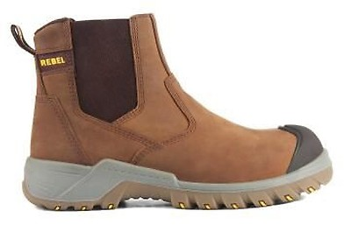

SAFETY SHOES

- Must offer maximum protection and style with a 200J Steel toe cap
- Toe bumper for added scuff protection
- Heat resistance up to 300° Celsius
- Steel midsole for anti-penetration and a high quality full grain leather upper.
- Foam platinum foot bed.
- ISO 20345, SABS and NRCS approved.

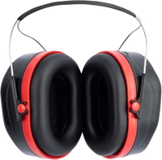

EAR MUFFS *4
- Low profile design for uninterrupted cheek weld. 24db NRR.
- Comfort padded headband.
- Soft comfortable ear cushions.
- Compact folding design.

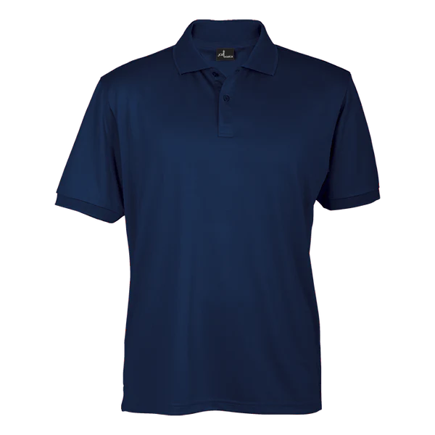
GOLF T-SHIRT/ NAVY BLUE

- 165g 100% COTTON
- Knitted rib collar and sleeve cuffs
Set in sleeves
- shoulder seams

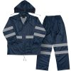
RAIN COAT
The colour must be navy blue
JACKET
  - Stow away hood with draw cord
  - Ventilated mesh back and underarm eyelets for breathability
  - Raglan sleeves
  - Concealed elasticised storm cuffs
  - Stud fastening storm front with concealed Vislon zip
  - Lower patch pockets with flaps
- Tipped draw cord with adjustable toggles at waist

TROUSERS
- Fully elasticated waist
- Ankle poppers on the trouser hem
- Polyester PVC
- 180 g/m²

Embroidery-HSRC Logo on the left Name only on the Right (jacket only)
HSRC Logo on GOLF Shirt

Name | 4 X Golf shirt | 2X Jacket | 2X Trouser | 5 Pairs Socks | Leather belts | Rain coat | 1 Pair Shoes
1.Frank Ragedi | 2Xl | XL | 38 | Size 12 | 38 | 2XL | 12
2. Thomas Ngwenya | XL | XXL | 36 | Size 10 | 36 | XL | 10
3. Jan Moela | L | L | 38 | Size 7 | 38 | L | 7
4. Obed Sengoaneng | L | L | 34 | Size 9 | 34 | L | 9
5. Sello Molatji | S | M | 30 | Size 8 | 30 | M | 8

