

DEPARTMENT OF WATER AND SANITATION

DUE AT 11:00 ON

CLOSING DATE: 29 AUGUST 2024

DWS12-0724 WTE

DISMANTLING, HANDLING, TRANSPORTATION AND DISPOSAL OF ASBESTOS SHEETS AND MISCELLANEOUS MATERIAL FROM UITKEER; INCLUDING CLEARING ALL SITES FROM BUILDING MATERIAL AND BUILDING RUBBLE: UITKEER RESIDENTIAL AREA - ONLY BIDDERS WITH CIDB CONTRACTOR GRADING DESIGNATION OF CIDB 3GB OR HIGHER ARE ELIGIBLE TO BID.

SUBMIT BID DOCUMENTS TO:

POSTAL ADDRESS: OR TO BE DEPOSITED IN:
DIRECTOR-GENERAL: THE BID BOX AT THE ENTRANCE
WATER AND SANITATION OF ZWAMADAKA BUILDING
PRIVATE BAG X313 157 FRANCIS BAARD STREET
PRETORIA, 0001 PRETORIA, 0001

Compulsory Briefing Session
Date: 07 August 2024
Time: 10:00am
Venue: Uitkeer Fish-Sundays River GWS (Government Water Scheme), Uitkeer Offices Boardroom, 1 Rooi Els Avenue, Uitkeer. Closer to Somerset East, on the R63 between Somerset East & Cookhouse (west of the N10)
GPS Coordinates: Latitude: 32°46'0.04"S
Longitude: 25°40'3.88"E

BIDDER: (Company Address OR Stamp)

COMPILED BY:
DEPARTMENT OF WATER AND SANITATION: OPERATIONS SOUTHERN

DEPARTMENT OF WATER AND SANITATION

DWS12-0724 WTE

DISMANTLING, HANDLING, TRANSPORTATION AND DISPOSAL OF ASBESTOS SHEETS AND MISCELLANEOUS MATERIAL FROM UITKEER; INCLUDING CLEARING ALL SITES FROM BUILDING MATERIAL AND BUILDING RUBBLE: UITKEER RESIDENTIAL AREA - ONLY BIDDERS WITH CIDB CONTRACTOR GRADING DESIGNATION OF CIDB 3GB OR HIGHER ARE ELIGIBLE TO BID

Tender document compiled date: June 2023
Issued by:
Department of Water and Sanitation
Zwamadaka building
157 Francis Baard Street
Pretoria
0001

Prepared by:
Uitkeer (Somerset East)
Asbestos Removal Project
Operations Southern
Department of Water and Sanitation

DEPARTMENT OF WATER AND SANITATION

DWS12-0724 WTE

CONTENT OF DOCUMENT (as presented)
COVER PAGE
Contact information
THE TENDER
Part T1: Tendering procedures
T1.1 Tender notice and invitation to tender
T1.2 Tender data
Part T2: Returnable documents and schedules
T2.1 List of Returnable documents and schedules
T2.2 Returnable documents and schedules
THE CONTRACT
Part C1: Contract data
C1.1 Pro-forma Form of offer and acceptance
C1.2 Contract data
C1.3 Pro-forma Performance guarantee
Part C2: Pricing data
C2.1 Pricing Instructions
C2.2 Bill of Quantities
Part C3: Scope of work
C3.1 Standard Specifications
C3.2 Project Specifications
C3.3 Particular Specifications
Part C4: Site Information
C4.1 Description of the Project
C4.2 The Site Conditions
C4.3 Facilities Provided by DWS to Contractor
C4.4 Facilities Provided by Contractor for Works
C4.5 Climatic Conditions
C4.6 Tender Drawings

DEPARTMENT OF WATER AND SANITATION

DWS12-0724 WTE

DISMANTLING, HANDLING, TRANSPORTATION AND DISPOSAL OF ASBESTOS SHEETS AND MISCELLANEOUS MATERIAL FROM UITKEER; INCLUDING CLEARING ALL SITES FROM BUILDING MATERIAL AND BUILDING RUBBLE: UITKEER RESIDENTIAL AREA - ONLY BIDDERS WITH CIDB CONTRACTOR GRADING DESIGNATION OF CIDB 3GB OR HIGHER ARE ELIGIBLE TO BID.

T1.1 TENDER NOTICE AND INVITATION TO TENDER

It is estimated that Tenderers should have a CIDB Contractor grading designation of CIDB 3GB or higher.
Documents may be downloaded from Department of Water and Sanitation website at www.dws.gov.za/Tenders and from National Treasury e-Tender Portal at www.etenders.gov.za.

Queries relating to the issue of these documents may be addressed in writing to e-mail address: bidenquirieswte@.gov.za and Retiefp@dws.gov.za

A compulsory site clarification meeting with representatives of the Employer will take place at Uitkeer (Somerset East) at - Uitkeer Fish-Sundays River GWS (Government Water Scheme), Uitkeer Offices Boardroom, 1 Rooi Els Avenue, Uitkeer. Closer to Somerset East, on the R63 between Somerset East & Cookhouse (west of the N10).

The closing time for receipt of tenders is 11:00 hrs on 29 August 2024. Telegraphic, telephonic, telex, facsimile, e-mail and late tenders will not be accepted.

Tenders may only be submitted on the tender documentation that is issued.

Requirements for sealing, addressing, delivery, opening and assessment of tenders are stated in the Tender Data.

DEPARTMENT OF WATER AND SANITATION

DWS12-0724 WTE

Dismantling, Handling, Transportation and Disposal of Asbestos sheets and miscellaneous material from Uitkeer; including clearing all sites from building material and building rubble: Uitkeer residential area - only bidders with CIDB contractor grading designation of CIDB 3GB or higher are eligible to bid.

T1.2 TENDER DATA

IMPORTANT INFORMATION
PLEASE READ CAREFULLY THROUGH THE ENTIRE TENDER DOCUMENT BEFORE COMPLETING THE DOCUMENT.

TENDER AND CONTRACT STANDARDS CONDITIONS APPLICABLE TO THIS DOCUMENT
SANS ISO 10845-1: 2015 Ed 1 Processes, methods, and procedures.
SANS ISO 10845-2: 2015 Ed 1 Formatting and compilation of procurement documentation.
SANS ISO 10845-3: 2015 Ed 1 Standard conditions of tender.
GCC 2015 Ed 3 The General Conditions of Contract for Construction Works, 3rd Edition (2015), published by the South African Institution of Civil Engineering.

INSTRUCTIONS TO BIDDERS
All recipients of these bid documents, whether they submit a Bid or not, shall treat the details of the documents as PRIVATE AND CONFIDENTIAL.

T1.2 TENDER SPECIFIC DATA
The conditions of tender are those contained in the latest edition of SANS ISO 10845-2 2015 Ed 1,
Construction Procurement – Part 3: Standard conditions of tender.
SANS ISO 10845-2:2015 Ed 1 makes several references to the Tender Data for details that apply specifically to this tender. The Tender Data shall have precedence in the interpretation of any ambiguity or inconsistency between it and the provisions of SANS ISO 10845-2: 2015 Ed 1.
Each item of data given below is cross-referenced to the clause in SANS ISO 10845-2:2015 Ed 1 to which it mainly applies.
Clause number | TENDER DATA
2 | TERMS AND DEFINITIONS
2.5 | Wherever reference is made in the documentation to Bill of Quantities it shall also mean Pricing Schedule or Schedule of Quantities.
2.33 | Whenever reference is made in the documentation to Bidder or Tenderer it shall mean is the person or organization that submits a tender offer. (The successful Bidder will be appointed as Contractor as per GCC 2015- Clause 1.1.1.9)
4.3.2 | Only those tenderers who are registered with the CIDB, or are capable of being so prior to the evaluation of submissions, in a contractor grading designation equal to or higher than a contractor grading designation determined in accordance with the sum tendered, or a value determined in accordance with Regulation 25 (1B) or 25(7A) of the Construction Industry Development Regulations, for a CIDB 3GB or higher class of construction work, are eligible to have their tenders evaluated.  Joint ventures are eligible to submit tenders provided that:  - every member of the joint venture is registered with the CIDB;  - the lead partner has a contractor grading designation in the CIDB 2GB or higher class of construction work; and  the combined contractor grading designation calculated in accordance with the Construction Industry Development Regulations is equal to or higher than a contractor grading designation determined in accordance with the sum tendered for a CIDB 3GB or higher class of construction work or a value determined in accordance with Regulation 25 (1B) or 25(7A) of the Construction Industry Development Regulations.
4.4.4 | The arrangements for a compulsory site clarification meeting are as stated in the Tender Notice and Invitation to Tender. (Site clarification meeting is also referred to as site briefing session.)  The residential site is at Uitkeer 9km from Somerset East and 14 km from Cookhouse on the R63 and accessed through a manned security gate in Eastern Cape province.  Asbestos removal related Personal Protective Equipment (PPE) such as safety boots will be required before entering the site to examine some aspects of the works.  A full-time employee of the bidder who is involved in the preparation of submissions shall sign the attendance list in the name of the bidder. Addenda will be issued to, and bidders will be evaluated from only those bidders appearing on the attendance list.
4.3.2 | No alterations, omissions or additions shall be made to this document, but should it be deemed necessary to do so, the Bidder is at liberty to qualify his bid.  Bidders shall be deemed to have waived, renounced and abandoned any conditions printed or written upon any stationery used by them for the purpose of or in connection with the submission of bids which are in conflict with the conditions laid down in this document.  Bidders shall not make any alterations or additions to the bid documents, except to comply with instructions issued by the Department, or necessary to correct errors made by the Bidder. All signatories to the bid offer shall initial all such alterations. Erasures and the use of masking fluid are prohibited.
4.3.2 | No alternative tender offers will be considered.
4.3.2 | Parts of each tender offer communicated on paper shall be submitted as an original, plus one (1) copy.
4.2.3 | An Entity is not eligible to submit a bid if the bid offer is not signed by a person authorized to sign on behalf of the Bidder. Each page of the completed document that will be submitted should be initialled by the Bidder at the bottom of the page.  State clearly in Form D under T2.2 returnable documents and schedules, the authorised signatories that are liable on the behalf of the Tenderer, with proof from the employer and or company.  If the bid is submitted by joint venture of more than one person and/or Companies and/or firms it shall be accompanied by the following:  - The original or a notarial certified copy of the original document under which such joint venture was constituted which must define precisely inter alia the conditions under which the joint venture will function, its period of duration and the participation of the several constituent persons and/or companies and/or firms.  A certificate signed by or on behalf of each participating person and/or company and/or firm authorising the person who signed the bid to do so.
4.3.1 | The ORIGINAL printed, completed tender document together with a cover letter and all supporting documents needs to be placed and sealed in an envelope. The envelope needs to be clearly marked as below indicated.  The details and address for delivery of tender offers and identification details that are to be shown on the envelope:  - Tender Identical details:  Tender reference number: DWS12-0724 WTE  Title of Tender: Dismantling, Handling, Transportation and Disposal of Asbestos sheets and miscellaneous material from Uitkeer; including clearing all sites from building material and building rubble: Uitkeer residential area - only bidders with CIDB contractor grading designation of CIDB 3GB or higher are eligible to bid  – CIDB CONTRACTOR GRADING DESIGNATION OF CIDB 3 GB OR HIGHER  - The details and address for delivery of tender offers and closing time are:  Location of tender box: THE BID BOX AT THE ENTRANCE  Physical address: ZWAMADAKA BUILDING  157 FRANCIS BAARD STREET, PRETORIA, 0001  Closing date & time: 29 August 2024 at 11:00 hrs.  - Name of the Bidder (shall be clearly shown)
4.3.3 | The “ORIGINAL” and “COPY” are to be submitted as separate packages.
4.3.2 | Telephonic, telegraphic, telex, facsimile or e-mailed tender offers shall NOT be accepted.
4.3.2 | The closing time for submission of tender offers is as stated in the Tender Notice and Invitation to Tender.
4.4.4.1 | The tender offer validity period is for 120 days.
4.4.41 | Provide, on request by the employer, any other material that has bearing on the tender offer within 5 working days of request.
4.4.1.2 | The Tenderer is required to submit with his tender a letter of intent from an approved insurer undertaking to provide the Performance Guarantee to the format included in Part C1.3 of this procurement document.  (See also GCC 2015: Clause 6.2 – Security.)
6 | EMPLOYER’S UNDERTAKINGS
6.1 | The Employer will respond to requests for clarification received up to seven (7) working days before the tender closing time.
6.2 | The employer shall issue addenda until four (4) working days before tender closing time.
4.3.2e | Feedback will be provided in writing by Supply Chain Management
4.3.1 | Tenders will be opened immediately after the closing time for tenders at 11:00 hrs.
4.3.2c | The financial offer will be reduced to a comparative basis using the Tender Assessment Schedule.
4.3.2c | TEST FOR RESPONSIVENESS:  Bids will be evaluated in accordance with the new Preferential Procurement Regulations, 2022, using 80/20 preference points system as prescribed in the Preferential Procurement Policy Framework Act (PPPFA, Act 5 of 2000. The lowest acceptable bid will score 80 points for price and a maximum of 20 points will be awarded for the specific goals.  Bids received will be evaluated on the five (5) phases namely:  - Mandatory Requirements,  - Administrative Compliance,  - Functionality Compliance  - Price & Preference (5.11.7 & 5.11.8), &  - Evaluation Method 4 (6.11.5).
4.3.2c | - PHASE 1: MANDATORY REQUIREMENTS:  Failure to submit any of the documents listed below will render your bid non-responsive and the bid will be disqualified.  - CIDB registration in terms of Construction Industry Development Board (CIDB) grade. (As per clause 4.1)  - Certificate of attendance at the compulsory site briefing session and or sign on the attendance register.  - Type 3 Registered Asbestos Removal contractor certificate from Department of Labour  - Registration with the professional body SACPCMP is required.
4.3.2c | - PHASE 2: ADMINISTRATIVE COMPLIANCE  Bidders are required to comply with the following listed below:
  No | Criteria | Yes | No
  1 | Companies must be registered with National Treasury’s Central Supplier Database must submit CSD report. Provide MAAA number on SBD1
  2 | Tax compliant with SARS (to be verified through CSD and SARS). Attach Tax Compliance status PIN page
  3 | Active registration with Company Intellectual Property Commission (to be verified through CSD and CIPC). Attach copy of Bidder’s CIPC / CIPRO certificate.
  4 | A valid copy of B-BBEE Status Level Verification Certificate or a valid original sworn affidavit (failure to submit, the Bidder will forfeit the relevant points allocated for B-BBEE under specific goals)
  5 | A valid letter of Good Standing with the Compensation Commissioner in terms of the Compensation for Occupational Injuries and Diseases Act No 130 of 1993 and or third parties’ insurance registered with Financial Service Board (COIDA).
  6 | Letter of appointment of duly authorized person to sign bid. Proof of such authority must be submitted with the bid.  If by an individual, must be signed by that individual or by someone on his behalf duly authorised thereto and proof of such authority must be produced.  If the bid is by a Company, it must be signed by a person duly authorised thereto by a Resolution of a Board of Directors a copy of which Resolution, duly certified by the Chairman of the Company is to be submitted with the bid.
  7 | Complete, sign, submit SBD1, SBD3.1, SBD4, SBD6.1
4.3.2c | - PHASE 3: FUNCTIONALITY COMPLIANCE  As explained in Annexure G.  The Bidder must score a minimum of 70 points out of 100 to allow them to proceed to the next phase of evaluation.
4.3.2c | - PHASE 4: PRICE AND PREFERENCE  As explained in 6.11.7 & 6.11.8.
4.3.2c | Preference Score:  Preferential Procurement Regulations, 2022, Act no. 5 of 2000 will be used to evaluate this proposal as per the applicable threshold value.  Bid proposals will be evaluated based on the 80/20 preference points system in accordance with the PPPFA Act (Act no. 5 of 2000). Where a maximum of 80 points will be awarded in respect of price and a maximum of 20 points will be awarded for specific goals.  N_{p} shall be calculated to a maximum of 20 points, as claimed in Table 1 below in accordance with Preferential Procurement Regulations, 2022 and described below.  Points claimed will be according to a bidder’s specific goals claimed as indicated in Table 1 below.  In terms of Regulation 4(2) and 5(2) of the Preferential Procurement Regulations, preference points must be awarded for specific goals stated in the tender. For the purposes of this tender the tenderer will be allocated points based on the tenderer’s goals claimed as per Table 1 below. The tenderer goal claimed must be supported by proof / documentation as per Table 2 and the special conditions of this tender where applicable.  Table 1: Specific goals for the tender and points claimed  “Specific goals” means specific goals as contemplated in section 2(1)(d) of the PPPFA Act which may include contracting with persons, or categories of persons, historically disadvantaged by unfair discrimination on the basis of race, gender and disability including the implementation of programmes of the Reconstruction of Development Programme as published in Government Gazette No. 16085 date 23 November 1994.  “Ownership” means the percentage ownership and control, exercised by individuals within an enterprise.  "Disability" means, in respect of a person, a permanent impairment of a physical, intellectual, or sensory function, which results in restricted, or lack of, ability to perform an activity in the manner, or within the range, considered normal for a human being.  - A blind person (in terms of the Blind Persons Act, 1968 (Act no.26 of 1968);  - A deaf person, whose hearing is impaired to such an extent that he/she cannot use it as a primary means of communication;  - A person who, as a result of permanent disability, requires a wheelchair, caliper or crutch to assist him/her to move from one place or another;  - A person who requires an artificial limb; or  - A person who suffers from a mental illness (in terms of the Mental Health Act, 1973 (Act no. 18 of 1973).  "Youth" means, in respect of a person younger than 35 years of age.  "Location of enterprise” Local equals province. Where a project cuts across more than on province, the bidder may be located in anu of the relevant provinces to obtain the points.  Women, disability, and youth will be measured by calculating the pro-rata percentage of ownership of the bidding company which meets the criterion. E.g., Company A has five shareholders each of whom own 20% of the company. Three of the five shareholders meet the criterion, i.e., they are women/disability/youth. Therefore, this bidder will obtain 60% of the points allowable for this goal.  Documents/ information listed on the below Table 2 must be submitted to support and verify points claimed as per Table 1 above.  Table 2: Documents required for verification of Tenderer claimed points  Failure on the part of a bidder to submit proof of documentation required in terms of this tender to claim for specific goals with the bid, will be interpreted to mean that preference points for specific goals are not claimed and will not be allocated.
  The specific goals allocated points in terms of this tender | Number of points allocated  (80/20 system)  (To be completed by the organ of state) | Number of points claimed  (80/20 system) (To be completed by the tender)
  Women Ownership | 5
  Disability Ownership | 5
  Youth Ownership (35 and below) | 5
  Location of enterprise (local equals province): Eastern Cape | 2
  B-BBEE status level contribution from level 1 to 2 which are QSE or EME | 3
  TOTAL SCORED POINTS | 20
  Specific Goal | Requires Proof Documents
  Women Ownership | Full CSD Report
  Disability Ownership | Full CSD Report
  Youth Ownership | Full CSD Report
  Location of enterprise | Full CSD Report
  B-BBEE status level contribution  from level 1 to 2  which are QSE or EME | - Valid B-BBEE certificate/sworn affidavit  - Consolidated B-BBEE certificate in cases of Joint Ventures  - Full CSD Report
4.3.2c | Functionality (Quality) Score:  The score obtained in Annexure G (functionality compliance) will be used for the following formula:  $$N_{Q}=100 x \frac{S_{0}}{M_{s}}$$  Where  N_{Q} is the number of tender evaluation points awarded for functionality offered;  S_{O} is the score for functionality compliance (Annexure G) allocated to the submission under consideration; and  M_{S} is the maximum possible score for functionality compliance (100).  Functionality is the terminology used to define the technical ability of the Tenderer, based on experience, to deliver the required product in accordance with the specialised quality, reliability and functionality.  Points allocated for functionality shall be evaluated in accordance with the criteria as listed below table. An overall minimum threshold of 70 (M_{s}) points out of total 100 (M_{s}) must be achieved for the tender to be eligible.  See T2 returnable annexure (as indicated below) for applicable documents with detail on point allocation for the sub-criteria’s.  The quality criteria and maximum score in respect of each of the criteria are as follows:  Quality shall be scored by not less than three evaluators in accordance with the following schedules:  - Annexure G: Ability & Capability  The minimum number of evaluation points for functionality (quality) is 70
  Functionality criteria |  | Maximum number of points
  1 | Company Experience | 30
  2 | Method Statement | 40
  3 | Personnel Experience | 30
  Maximum possible score for quality (M_{s}) |  | 100
4.3.2c | SCORING OF FUNCTIONALITY:  The prompts for judgment and the associated scores used in the evaluation of quality shall be as follows:  Each evaluation criteria will be assessed in terms of five indicators – no response, poor, satisfactory, good and very good. Scores of 0, 40, 70, 90 or 100 will be allocated to no response, poor, satisfactory, good and very good, respectively.  TABLE: (SANS ISO 10854-3:2008 Ed2 Table A4) Scoring system that shall be used to score this criterion  The scores of each of the evaluators will be averaged, weighted and then totalled to obtain the final score for quality.  EXAMPLE OF EVALUATION:
  Score | Rating | Qualitative indicator or prompt for judgement
  Score | Rating | Example 1  (Proposed Organization and staffing) | Example 2  (Approach paper) | Example 3  (Knowledge of issues pertinent to the project)
  0 | No response | Failed to provide information. | Failed to provide information. | Failed to provide information.
  40 | Poor | The organization chart is sketchy, the staffing plan is weak in important areas. There is no clarity in allocation of tasks and responsibilities. | The technical approach and/or methodology is poor/is unlikely to satisfy project objectives or requirements. The tenderer has misunderstood certain aspects of the scope of work and does not deal with the critical aspects of the project. | Key staff have limited experience of issues pertinent to the project
  70 | Satisfactory | The organizational chart is complete and detailed, the technical level and composition of the staffing arrangements are adequate. | The approach is generic and not tailored to address the specific project objectives and methodology. The approach does not adequately deal with the critical characteristics of the project. The quality plan, manner in which risk is to be managed, etc. is too generic. | Key staff have reasonable experience of issues pertinent to the project.
  90 | Good | Besides attaining the “satisfactory” rating, staff are well-balanced, i.e. they show good co-ordination, complimentary skills, clear and defined duties and responsibilities. Some members of the project team have worked together before on limited occasions. | The approach is specifically tailored to address the specific project objectives and methodology and is sufficiently flexible to accommodate changes that might occur during execution. The quality plan and approach to managing risk, etc. is specifically tailored to the critical characteristics of the project. | Key staff have extensive experience of issues pertinent to the project.
  100 | Very good | Besides attaining the “good” rating, the proposed team is well-integrated, and several members have worked together extensively in the past. | Besides attaining the “good” rating, the important issues are approached in an innovative and efficient way, indicating that the tenderer has outstanding knowledge of state-of-the-art approaches.  The approach paper details ways to improve the project outcomes and the quality of the outputs. | Key staff have outstanding experience of issues pertinent to the project.
  Criteria | SCORE (out of 0% - 100%) | WEIGHT (POINTS) | TOTAL  (A% score x 5 points)
  Sub-Criteria | Score according to SANS ISO 10845-3:2022 ed2 Table A.4 | Max allowed points for a (per) sub-criteria.
  Example 1 | 70 score (=70%): Satisfactory | 5 | = 5 * 70% = 3.5
  Example 2 | 90 score (=90%): Good | 20 | = 20 * 90% = 18
4.3.2c | Tender offers will only be accepted if:  - the Tenderer is registered on the Central Supplier Database (CSD) for the South African government (see https://secure.csd.gov.za/) unless it is a foreign supplier with no local registered entity;  - the Tenderer is in good standing with SARS according to the Central Supplier Database.  - the Tenderer submits a letter of intent from an approved insurer undertaking to provide the Performance guarantee to the format included in Part C1.3 of this procurement document.  - the Tenderer is registered with the Construction Industry Development Board (CIDB) in an appropriate Contractor grading designation.  - the Tenderer or any of its directors/shareholders is not listed on the Register of Tender Defaulters in terms of the Prevention and Combating of Corrupt Activities Act of 2004 as a person prohibited from doing business with the public sector.  - the Tenderer has not:  i) abused the Employer’s Supply Chain Management System; or  ii) failed to perform on any previous contract and has been given a written notice to this effect.  g) the Tenderer has completed the Compulsory Declaration and there are no conflicts of interest which may impact on the Tenderer’s ability to perform the contract in the best interests of the employer or potentially compromise the tender process.  h) the Tenderer is registered and in good standing with the compensation fund or with a licensed compensation insurer.  i) the employer is reasonably satisfied that the Tenderer has in terms of the Construction Regulations, 2003, issued in terms of the Occupational Health and Safety Act, 1993, the necessary competencies and resources to carry out the work safely.
4.3.2c | The number of paper copies of the signed contract to be provided by the employer to the successful Bidder is One (1).



DEPARTMENT OF WATER AND SANITATION

DWS12-0524 WTE

DISMANTLING, HANDLING, TRANSPORTATION AND DISPOSAL OF ASBESTOS SHEETS AND MISCELLANEOUS MATERIAL FROM UITKEER; INCLUDING CLEARING ALL SITES FROM BUILDING MATERIAL AND BUILDING RUBBLE: UITKEER RESIDENTIAL AREA - ONLY BIDDERS WITH CIDB CONTRACTOR GRADING DESIGNATION OF CIDB 3GB OR HIGHER ARE ELIGIBLE TO BID.

T2: RETURNABLE DOCUMENTS AND SCHEDULES

CONTENTS

T2.1: LIST OF RETURNABLE DOCUMENTS AND SCHEDULES
T2.2 RETURNABLE DOCUMENTS AND SCHEDULES

T2.1 LIST OF RETURNABLE DOCUMENTS AND SCHEDULES

THE TENDER DOCUMENT MUST BE SUBMITTED AS A WHOLE i.e. All volumes (including the fully priced and extended Provisional Bills of Quantities) as is bound together in one single document herein. All forms must be properly completed in black ink as required, and the document shall not be taken apart or altered in any way whatsoever.

Note: Should any of the below-mentioned documents and/or the entire Tender Enquiry Document not be submitted the tender submission may be viewed as NON-RESPONSIVE.

The tendered must complete the following returnable document/schedules:

RETURNABLE SCHEDULES REQUIRED FOR TENDER EVALUATION PURPOSES THAT WILL BE INCORPORATED INTO THE CONTRACT
Doc. Ref. Nr. | Document/ Schedule | Completed (Tick)
SBD 1 | SBD 1: Invitation to Bid
SBD 3.1 | SBD 3.1: Bill of Quantities –Firm Price  (Priced and extended Provisional Bill of Quantities - Part C2.2)
SBD 4 | SBD 4: Declaration of Interest
SBD 6.1 | SBD 6.1: Preference Points Claim Form: General Conditions and Definitions
FORM A | Certificate of Attendance at Compulsory Clarification Site Meeting
FORM B | Record of Addenda to Tender Documents
FORM C | Compulsory Declaration
FORM D | Certificate Authority of Signatory
FORM F | Pro Forma Form of Offer and Acceptance (Part C1.1)
FORM G | Contract Data (Part C1.2)
FORM H | Pro Forma Performance Guarantee (Part C1.3)
FORM I | Contractor's health and safety declaration
FORM J | Health and Safety Act agreement
FORM K | Verification Documentation
ANNEXURE A | Preferencing Schedule for Broad Based Black Economic Empowerment Status (together with original or certified copy of B-BBEE certificate)
ANNEXURE B | A certified copy of Certificate of Contractor Registration issued by the Construction Industry Development Board (CIDB)
ANNEXURE C | Tax compliant with SARS (to be verified through CSD and SARS). Attach Tax Compliance status PIN page.
ANNEXURE D | Central Supplier Database (CSD) proof of registration containing MAAA number.
ANNEXURE E | Originally certified copies of Bidder’s CIPC company registration documents listing all members with percentages
ANNEXURE F | Letter of good standing from COIDA (Compensation for Occupational Injuries & Diseases Act)
ANNEXURE G | Functionality Compliance

NOTE: Failure to provide all these listed documents may result in the tender not being evaluated

PART A

INVITATION TO BID
YOU ARE HEREBY INVITED TO BID FOR REQUIREMENTS OF THE (NAME OF DEPARTMENT/ PUBLIC ENTITY)
BID NUMBER: | DWS12-0724 WTE |  |  | CLOSING DATE: |  | 29 AUGUST 2024 |  |  |  | CLOSING TIME: |  | 11:00AM
DESCRIPTION | Dismantling, Handling, Transportation and Disposal of Asbestos sheets and miscellaneous material from Uitkeer; including clearing all sites from building material and building rubble: Uitkeer residential area - only bidders with CIDB contractor grading designation of CIDB 3GB or higher are eligible to bid
BID RESPONSE DOCUMENTS MAY BE DEPOSITED IN THE BID BOX SITUATED AT (STREET ADDRESS)
BIDDING PROCEDURE ENQUIRIES MAY BE DIRECTED TO |  |  |  |  | TECHNICAL ENQUIRIES MAY BE DIRECTED TO:
CONTACT PERSON |  |  | Department of Water and Sanitation |  | CONTACT PERSON |  |  | Mr P. Retief
TELEPHONE NUMBER |  |  | 012 336 6562 / 7780 / 8151 |  | TELEPHONE NUMBER |  |  | 071 861 5348
FACSIMILE NUMBER |  |  |  |  | FACSIMILE NUMBER
E-MAIL ADDRESS |  |  | bidenquirieswte@dws.gov.za |  | E-MAIL ADDRESS |  |  | Retiefp@dws.gov.za
SUPPLIER INFORMA.TION
NAME OF BIDDER
POSTAL ADDRESS
STREET ADDRESS
TELEPHONE NUMBER |  | CODE |  |  |  | NUMBER
CELLPHONE NUMBER
FACSIMILE NUMBER |  | CODE |  |  |  | NUMBER
E-MAIL ADDRESS
VAT REGISTRATION NUMBER
SUPPLIER COMPLIANCE STATUS |  | TAX COMPLIANCE SYSTEM PIN: |  |  | OR |  | CENTRAL SUPPLIER DATABASE No: |  | MAAA
B-BBEE STATUS LEVEL VERIFICATION CERTIFICATE |  | TICK APPLICABLE BOX]  Yes No |  |  | B-BBEE STATUS LEVEL SWORN AFFIDAVIT |  |  |  |  |  | [TICK APPLICABLE BOX]  Yes No
[A B-BBEE STATUS LEVEL VERIFICATION CERTIFICATE/ SWORN AFFIDAVIT (FOR EMES & QSEs) MUST BE SUBMITTED IN ORDER TO QUALIFY FOR PREFERENCE POINTS FOR B-BBEE]
ARE YOU THE ACCREDITED REPRESENTATIVE IN SOUTH AFRICA FOR THE GOODS /SERVICES /WORKS OFFERED? |  | Yes No  [IF YES ENCLOSE PROOF] |  |  | ARE YOU A FOREIGN BASED SUPPLIER FOR THE GOODS /SERVICES /WORKS OFFERED? |  |  |  |  |  | Yes No  [IF YES, ANSWER THE QUESTIONNAIRE BELOW]
QUESTIONNAIRE TO BIDDING FOREIGN SUPPLIERS
IS THE ENTITY A RESIDENT OF THE REPUBLIC OF SOUTH AFRICA (RSA)? YES NO
DOES THE ENTITY HAVE A BRANCH IN THE RSA? YES NO
DOES THE ENTITY HAVE A PERMANENT ESTABLISHMENT IN THE RSA? YES NO
DOES THE ENTITY HAVE ANY SOURCE OF INCOME IN THE RSA? YES NO
IS THE ENTITY LIABLE IN THE RSA FOR ANY FORM OF TAXATION? YES NO
IF THE ANSWER IS “NO” TO ALL OF THE ABOVE, THEN IT IS NOT A REQUIREMENT TO REGISTER FOR A TAX COMPLIANCE STATUS SYSTEM PIN CODE FROM THE SOUTH AFRICAN REVENUE SERVICE (SARS) AND IF NOT REGISTER AS PER 2.3 BELOW.

PART B

TERMS AND CONDITIONS FOR BIDDING

- BID SUBMISSION:
  - BIDS MUST BE DELIVERED BY THE STIPULATED TIME TO THE CORRECT ADDRESS. LATE BIDS WILL NOT BE ACCEPTED FOR CONSIDERATION.
  - ALL BIDS MUST BE SUBMITTED ON THE OFFICIAL FORMS PROVIDED–(NOT TO BE RE-TYPED) OR IN THE MANNER PRESCRIBED IN THE BID DOCUMENT.
  - THIS BID IS SUBJECT TO THE PREFERENTIAL PROCUREMENT POLICY FRAMEWORK ACT, 2000 AND THE PREFERENTIAL PROCUREMENT REGULATIONS, 2022, THE GENERAL CONDITIONS OF CONTRACT (GCC) AND, IF APPLICABLE, ANY OTHER SPECIAL CONDITIONS OF CONTRACT.
  - THE SUCCESSFUL BIDDER WILL BE REQUIRED TO FILL IN AND SIGN A WRITTEN CONTRACT FORM (SBD7).

- TAX COMPLIANCE REQUIREMENTS
- BIDDERS MUST ENSURE COMPLIANCE WITH THEIR TAX OBLIGATIONS.
- BIDDERS ARE REQUIRED TO SUBMIT THEIR UNIQUE PERSONAL IDENTIFICATION NUMBER (PIN) ISSUED BY SARS TO ENABLE THE ORGAN OF STATE TO VERIFY THE TAXPAYER’S PROFILE AND TAX STATUS.
- APPLICATION FOR TAX COMPLIANCE STATUS (TCS) PIN MAY BE MADE VIA E-FILING THROUGH THE SARS WEBSITE WWW.SARS.GOV.ZA.
- BIDDERS MAY ALSO SUBMIT A PRINTED TCS CERTIFICATE TOGETHER WITH THE BID.
- IN BIDS WHERE CONSORTIA / JOINT VENTURES / SUB-CONTRACTORS ARE INVOLVED; EACH PARTY MUST SUBMIT A SEPARATE TCS CERTIFICATE / PIN / CSD NUMBER.
- WHERE NO TCS PIN IS AVAILABLE BUT THE BIDDER IS REGISTERED ON THE CENTRAL SUPPLIER DATABASE (CSD), A CSD NUMBER MUST BE PROVIDED.
- NO BIDS WILL BE CONSIDERED FROM PERSONS IN THE SERVICE OF THE STATE, COMPANIES WITH DIRECTORS WHO ARE PERSONS IN THE SERVICE OF THE STATE, OR CLOSE CORPORATIONS WITH MEMBERS PERSONS IN THE SERVICE OF THE STATE.”

NB: FAILURE TO PROVIDE / OR COMPLY WITH ANY OF THE ABOVE PARTICULARS MAY RENDER THE BID INVALID.

SIGNATURE OF BIDDER: ……………………………………………

CAPACITY UNDER WHICH THIS BID IS SIGNED: ……………………………………………
(Proof of authority must be submitted e.g. company resolution)

DATE: ………

SBD 3.1 PRICING SCHEDULE

PRICING SCHEDULE –FIRM PRICES
(PURCHASES)

SBD 3.1 is in section – Contract C2, under C2.2

Complete this document and place back into bid at C2.2

BIDDER’S DISCLOSURE
- PURPOSE OF THE FORM
Any person (natural or juristic) may make an offer or offers in terms of this invitation to bid. In line with the principles of transparency, accountability, impartiality, and ethics as enshrined in the Constitution of the Republic of South Africa and further expressed in various pieces of legislation, it is required for the Bidder to make this declaration in respect of the details required hereunder.

Where a person/s are listed in the Register for Tender Defaulters and / or the List of Restricted Suppliers, that person will automatically be disqualified from the bid process.
- Bidder’s declaration
2.1 Is the Bidder, or any of its directors / trustees / shareholders / members / partners or any person having a controlling interest in the enterprise, employed by the state? YES/NO
2.1.1 If so, furnish particulars of the names, individual identity numbers, and, if applicable, state employee numbers of sole proprietor/ directors / trustees / shareholders / members/ partners or any person having a controlling interest in the enterprise, in table below.
Full Name | Identity Number | Name of State institution

2.2 Do you, or any person connected with the Bidder, have a relationship with any person who is employed by the procuring institution? YES/NO
2.2.1 If so, furnish particulars:
…………………………………………………………………………………….………
………………………………………………………………………………………….…
2.3 Does the Bidder or any of its directors / trustees / shareholders / members / partners or any person having a controlling interest in the enterprise have any interest in any other related enterprise whether or not they are bidding for this contract? YES/NO
    - If so, furnish particulars:
………………………………………………………………………..………………….
………………………………………………………………………………..………….
- DECLARATION
I, the undersigned, (name)……………………………………………………………. in submitting the accompanying bid, do hereby make the following statements that I certify to be true and complete in every respect:

3.1 I have read and I understand the contents of this disclosure;
3.2 I understand that the accompanying bid will be disqualified if this disclosure is found not to be true and complete in every respect.
3.3 The Bidder has arrived at the accompanying bid independently from, and without consultation, communication, agreement or arrangement with any competitor. However, communication between partners in a joint venture or consortium will not be construed as collusive bidding.
3.4 In addition, there have been no consultations, communications, agreements or arrangements with any competitor regarding the quality, quantity, specifications, prices, including methods, factors or formulas used to calculate prices, market allocation, the intention or decision to submit or not to submit the bid, bidding with the intention not to win the bid and conditions or delivery particulars of the products or services to which this bid invitation relates.
3.4 The terms of the accompanying bid have not been, and will not be, disclosed by the Bidder, directly or indirectly, to any competitor, prior to the date and time of the official bid opening or of the awarding of the contract.
3.5 There have been no consultations, communications, agreements or arrangements made by the Bidder with any official of the procuring institution in relation to this procurement process prior to and during the bidding process except to provide clarification on the bid submitted where so required by the institution; and the Bidder was not involved in the drafting of the specifications or terms of reference for this bid.
  - I am aware that, in addition and without prejudice to any other remedy provided to combat any restrictive practices related to bids and contracts, bids that are suspicious will be reported to the Competition Commission for investigation and possible imposition of administrative penalties in terms of section 59 of the Competition Act No 89 of 1998 and or may be reported to the National Prosecuting Authority (NPA) for criminal investigation and or may be restricted from conducting business with the public sector for a period not exceeding ten (10) years in terms of the Prevention and Combating of Corrupt Activities Act No 12 of 2004 or any other applicable legislation.

I CERTIFY THAT THE INFORMATION FURNISHED IN PARAGRAPHS 1, 2 and 3 ABOVE IS CORRECT.
I ACCEPT THAT THE STATE MAY REJECT THE BID OR ACT AGAINST ME IN TERMS OF PARAGRAPH 6 OF PFMA SCM INSTRUCTION 03 OF 2021/22 ON PREVENTING AND COMBATING ABUSE IN THE SUPPLY CHAIN MANAGEMENT SYSTEM SHOULD THIS DECLARATION PROVE TO BE FALSE.

……………………………………….….… ………………………….………
Signature Date

…………………………………………….. ..…………………………………
Position Name of Bidder

PREFERENCE POINTS CLAIM FORM IN TERMS OF THE PREFERENTIAL PROCUREMENT REGULATIONS 2022

This preference form must form part of all tenders invited. It contains general information and serves as a claim form for preference points for specific goals.

NB: BEFORE COMPLETING THIS FORM, TENDERERS MUST STUDY THE GENERAL CONDITIONS, DEFINITIONS AND DIRECTIVES APPLICABLE IN RESPECT OF THE TENDER AND PREFERENTIAL PROCUREMENT REGULATIONS, 2022

- GENERAL CONDITIONS
  - The following preference point systems are applicable to invitations to tender:
- the 80/20 system for requirements with a Rand value of up to R50 000 000 (all applicable taxes included); and
- the 90/10 system for requirements with a Rand value above R50 000 000 (all applicable taxes included).

  - To be completed by the organ of state
- The applicable preference point system for this tender is the 80/20 preference point system.

  - Points for this tender (even in the case of a tender for income-generating contracts) shall be awarded for:
- Price; and
- Specific Goals.

  - To be completed by the organ of state:
The maximum points for this tender are allocated as follows:
 | POINTS
PRICE | 80
SPECIFIC GOALS | 20
Total points for Price and SPECIFIC GOALS | 100

  - Failure on the part of a tenderer to submit proof or documentation required in terms of this tender to claim points for specific goals with the tender, will be interpreted to mean that preference points for specific goals are not claimed.

  - The organ of state reserves the right to require of a tenderer, either before a tender is adjudicated or at any time subsequently, to substantiate any claim in regard to preferences, in any manner required by the organ of state.

- DEFINITIONS
- “tender” means a written offer in the form determined by an organ of state in response to an invitation to provide goods or services through price quotations, competitive tendering process or any other method envisaged in legislation;
- “price” means an amount of money tendered for goods or services, and includes all applicable taxes less all unconditional discounts;
- “rand value” means the total estimated value of a contract in Rand, calculated at the time of bid invitation, and includes all applicable taxes;
- “tender for income-generating contracts” means a written offer in the form determined by an organ of state in response to an invitation for the origination of income-generating contracts through any method envisaged in legislation that will result in a legal agreement between the organ of state and a third party that produces revenue for the organ of state, and includes, but is not limited to, leasing and disposal of assets and concession contracts, excluding direct sales and disposal of assets through public auctions; and
- “the Act” means the Preferential Procurement Policy Framework Act, 2000 (Act No. 5 of 2000).

- FORMULAE FOR PROCUREMENT OF GOODS AND SERVICES

  - POINTS AWARDED FOR PRICE

3.1.1 THE 80/20 OR 90/10 PREFERENCE POINT SYSTEMS
A maximum of 80 or 90 points is allocated for price on the following basis:

80/20 or 90/10

$Ps=80\left(1-\frac{Pt-P\min{}}{P\min{}}\right)$ or $Ps=90\left(1-\frac{Pt-P\min{}}{P\min{}}\right)$
Where
Ps = Points scored for price of tender under consideration
Pt = Price of tender under consideration
Pmin = Price of lowest acceptable tender

  - FORMULAE FOR DISPOSAL OR LEASING OF STATE ASSETS AND INCOME GENERATING PROCUREMENT

    - POINTS AWARDED FOR PRICE

A maximum of 80 or 90 points is allocated for price on the following basis:

80/20 or 90/10

$Ps=80\left(1+\frac{Pt-P\max{}}{P\max{}}\right)$ or $Ps=90\left(1+\frac{Pt-P\max{}}{Pmax}\right)$

Where
Ps = Points scored for price of tender under consideration
Pt = Price of tender under consideration
Pmax = Price of highest acceptable tender

- POINTS AWARDED FOR SPECIFIC GOALS

  - In terms of Regulation 4(2); 5(2); 6(2) and 7(2) of the Preferential Procurement Regulations, preference points must be awarded for specific goals stated in the tender. For the purposes of this tender the tenderer will be allocated points based on the goals stated in table 1 below as may be supported by proof/ documentation stated in the conditions of this tender:
  - In cases where organs of state intend to use Regulation 3(2) of the Regulations, which states that, if it is unclear whether the 80/20 or 90/10 preference point system applies, an organ of state must, in the tender documents, stipulate in the case of—
- an invitation for tender for income-generating contracts, that either the 80/20 or 90/10 preference point system will apply and that the highest acceptable tender will be used to determine the applicable preference point system; or

- any other invitation for tender, that either the 80/20 or 90/10 preference point system will apply and that the lowest acceptable tender will be used to determine the applicable preference point system,
then the organ of state must indicate the points allocated for specific goals for both the 90/10 and 80/20 preference point system.

Table 1: Specific goals for the tender and points claimed are indicated per the table below.
(Note to organs of state: Where either the 90/10 or 80/20 preference point system is applicable, corresponding points must also be indicated as such.
Note to tenderers: The tenderer must indicate how they claim points for each preference point system.)

The specific goals allocated points in terms of this tender | Number of points  allocated  (80/20 system)  (To be completed by the organ of state) | Number of points claimed  (80/20 system)  (To be completed by the tenderer)
Women Ownership | 5
Disability Ownership | 5
Youth Ownership (35 and below) | 5
Location of enterprise  (local equals province)  Eastern Cape | 2
B-BBEE status level contribution from level 1 to 2 which are QSE or EME | 3

DECLARATION WITH REGARD TO COMPANY/FIRM

  - Name of company/firm…………………………………………………………………….
  - Company registration number: …………………………………………………………...
  - TYPE OF COMPANY/ FIRM
Partnership/Joint Venture / Consortium
One-person business/sole propriety
Close corporation
Public Company
Personal Liability Company
(Pty) Limited
Non-Profit Company
State Owned Company
[Tick applicable box]

  - I, the undersigned, who is duly authorised to do so on behalf of the company/firm, certify that the points claimed, based on the specific goals as advised in the tender, qualifies the company/ firm for the preference(s) shown and I acknowledge that:
- The information furnished is true and correct;
- The preference points claimed are in accordance with the General Conditions as indicated in paragraph 1 of this form;
- In the event of a contract being awarded as a result of points claimed as shown in paragraphs 1.4 and 4.2, the contractor may be required to furnish documentary proof to the satisfaction of the organ of state that the claims are correct;
- If the specific goals have been claimed or obtained on a fraudulent basis or any of the conditions of contract have not been fulfilled, the organ of state may, in addition to any other remedy it may have –

  - disqualify the person from the tendering process;
  - recover costs, losses or damages it has incurred or suffered as a result of that person’s conduct;
  - cancel the contract and claim any damages which it has suffered as a result of having to make less favourable arrangements due to such cancellation;
  - recommend that the tenderer or contractor, its shareholders and directors, or only the shareholders and directors who acted on a fraudulent basis, be restricted from obtaining business from any organ of state for a period not exceeding 10 years, after the audi alteram partem (hear the other side) rule has been applied; and
  - forward the matter for criminal prosecution, if deemed necessary.

……………………………………….
SIGNATURE(S) OF TENDERER(S)

SURNAME AND NAME: ……………………………………………………….
DATE: ………………………………………………………
ADDRESS: ………………………………………………………
………………………………………………………
………………………………………………………
………………………………………………………

FORM A CERTIFICATE OF ATTENDANCE AT COMPULSORY CLARIFICATION SITE MEETING

This is to certify that (Tenderer) I,

was represented by the person of (Bidder)

of(address)

Telephone number

named below at the compulsory meeting held for all Tenderers at (location)

on(date)..................................................... starting at (time)
I acknowledge that the purpose of the meeting was to acquaint myself with the site of the works and / or matters incidental to doing the work specified in the tender documents in order for me to take account of everything necessary when compiling our rates and prices included in the tender.
Having previously studied the documents, I carefully examined the site and equipment. I have made myself familiar with all the equipment likely to influence the work and the cost thereof.
I further certify that I am satisfied with the description of the work and the explanations given by the Department of Water and Sanitation Representative, and I understand perfectly the work to be done, as specified and implied, in the execution of this Contract.

Particulars of person attending the meeting: (Signed on behalf of Bidder) PRINT NAME & SIGNATURE

Name: Signature:

Capacity:

Attendance of the above person at the meeting is confirmed by the Employer's representative, namely:
(PRINTED NAME & SIGNATURE)

Name: Signature:

Capacity: Date and Time:

FORM B RECORD OF ADDENDA TO TENDER DOCUMENTS

We confirm that the following communications received from the Employer before the submission of this tender offer, amending the tender documents, have been taken into account in this tender offer:
 | Date |  | Title or Details
Attach additional pages if more space is required.
Signed |  |  |  | Date
Name |  |  |  | Position
Tenderer

FORM C COMPULSORY DECLARATION

The following particulars must be furnished. In the case of a joint venture, separate declaration in respect of each partner must be completed and submitted.
Section 1: Enterprise Details

Name of enterprise:
Contact person:
Email:
Telephone:
Cell no
Fax:
Physical address
Postal address

Section 2: Particulars of companies and close corporations

Company / Close Corporation registration number

Section 3: SARS Information

Tax reference number
VAT registration number: | State Not Registered if not registered for VAT

Section 4: CIDB registration number

CIDB Registration number (if applicable)

Section 5: National Treasury Central Supplier Database

Supplier number
Unique registration reference number

Section 6: Particulars of principals
principal: means a natural person who is a partner in a partnership, a sole proprietor, a director of a company established in terms of the Companies Act of 2008 (Act No. 71 of 2008) or a member of a close corporation registered in terms of the Close Corporation Act, 1984, (Act No. 69 of 1984).

Full name of principal | Identity number | Personal tax reference number
Attach separate page if necessary

Section 7: Record in the service of the state
Indicate by marking the relevant boxes with a cross, if any principal is currently or has been within the last 12 months in the service of any of the following:
- a member of any municipal council  - a member of any provincial legislature  - a member of the National Assembly or the National Council of Province  - a member of the board of directors of any municipal entity  - an official of any municipality or municipal entity | an employee of any department, national or provincial public entity or constitutional institution within the meaning of the Public Finance Management Act of 1999 (Act No. 1 of 1999)  a member of an accounting authority of any national or provincial public entity  an employee of Parliament or a provincial legislature
If any of the above boxes are marked, disclose the following:
Name of principal | Name of institution, public office, board or organ of state and position held | Status of service  (tick appropriate column)
Name of principal |  | Current | Within last 12 months
*insert separate page if necessary
Section 8: Record of family member in the service of the state
family member: a person’s spouse, whether in a marriage or in a customary union according to indigenous law, domestic partner in a civil union, or child, parent, brother, sister, whether such a relationship results from birth, marriage or adoption

Indicate by marking the relevant boxes with a cross, if any family member of a principal as defined in section 5 is currently or has been within the last 12 months been in the service of any of the following:
- a member of any municipal council  - a member of any provincial legislature  - a member of the National Assembly or the National Council of Province  - a member of the board of directors of any municipal entity  - an official of any municipality or municipal entity | an employee of any provincial department, national or provincial public entity or constitutional institution within the meaning of the Public Finance Management Act, 1999 (Act 1 of 1999)  a member of an accounting authority of any national or provincial public entity  an employee of Parliament or a provincial legislature

Name of family member | Name of institution, public office, board or organ of state and position held | Status of service  (tick appropriate column)
Name of family member |  | Current | Within last 12 months
*insert separate page if necessary
Section 9: Record of termination of previous contracts with an organ of state
Was any contract between the tendering entity including any of its joint venture partners terminated during the past 5 years for reasons other than the employer no longer requiring such works or the employer failing to make payment in terms of the contract.
Yes No (Tick appropriate box)
If yes, provide particulars (interest separate page if necessary)
Section 10: Declaration
The undersigned, who warrants that he / she is duly authorised to do so on behalf of the tendering entity confirms that the contents of this Declaration are within my personal knowledge, and save where stated otherwise in an attachment hereto, are to the best of my belief both true and correct, and:
i) neither the name of the tendering entity or any of its principals appears on:
a) the Register of Tender Defaulters established in terms of the Prevention and Combating of Corrupt Activities Act of 2004 (Act No. 12 of 2004)
b) National Treasury’s Database of Restricted Suppliers (see www.treasury.gov.za)
ii) neither the tendering entity of any of its principals has within the last five years been convicted of fraud or corruption by a court of law (including a court outside of the Republic of South Africa);
iii) any principal who is presently employed by the state has the necessary permission to undertake remunerative work outside such employment (attach permission to this declaration);
iv) the tendering entity is not associated, linked or involved with any other tendering entities submitting tender offers
v) has not engaged in any prohibited restrictive horizontal practices including consultation, communication, agreement, or arrangement with any competing or potential tendering entity regarding prices, geographical areas in which goods and services will be rendered, approaches to determining prices or pricing parameters, intentions to submit a tender or not, the content of the submission (specification, timing, conditions of contract etc) or intention to not win a tender;
vi) has no other relationship with any of the Tenderers or those responsible for compiling the scope of work that could cause or be interpreted as a conflict of interest;
vii) neither the Tenderer or any of its principals owes municipal rates and taxes or municipal service charges to any municipality or a municipal entity and are not in arrears for more than 3 months;
viii) SARS may, on an on-going basis during the term of the contract, disclose the Tenderer’s tax compliance status to the Employer and when called upon to do so, obtain the written consent of any subcontractors who are subcontracted to execute a portion of the contract that is entered into in excess of the threshold prescribed by the National Treasury, for SARS to do likewise.

NOTE 1 The Standard Conditions of Tender contained in SANS 10845-3 prohibits anticompetitive practices (clause 3.1) and requires that Tenderers avoid conflicts of interest, only submit a tender offer if the Tenderer or any of his principals is not under any restriction to do business with employer (4.1.1) and submit only one tender either as a single tendering entity or as a member in a joint venture (clause 4.13.1). Clause 5.7 also empowers the Employer to disqualify any Tenderer who engages in fraudulent and corrupt practice. Clause 3.1 also requires Tenderers to comply with all legal obligations.
NOTE 2: Section 30(1) of the Public Service Act, 1994, prohibits an employee (person who is employed in posts on the establishment of departments) from performing or engaging remunerative work outside his or her employment in the relevant department, except with the written permission of the executive authority of the department. When in operation, Section 8(2) of the Public Administration Management Act, 2014, will prohibit an employee of the public administration (i.e. organs of state and all national departments, national government components listed in Part A of Schedule 3 to the Public Service Act, provincial departments including the office of the premier listed in Schedule 1 of the Public Service Act and provincial departments listed in schedule 2 of the Public Service Act, and provincial government components listed in Part B of schedule 3 of the Public Service Act) or persons contracted to executive authorities in accordance with the provisions of section 12A of the Public Service Act of 1994 or persons performing similar functions in organs of state from conducting business with the State or to be a director of a public or private company conducting business with the State. The offence for doing so is a fine or imprisonment for a period not exceeding 5 years or both. It is also a serious misconduct which may result in the termination of employment by the employer.

NOTE 3: Regulation 44 of Supply Chain Management regulations issued in terms of the Municipal Finance Management Act of 2003 requires that organs of state and municipal entities not award a contract to a person who is the service of the state, a director, manager or principal shareholder in the service of the state or who has been in the service of the state in the previous twelve months.

NOTE: 4: Regulation 45 of Supply Chain Management regulations requires a municipality or municipal entity to disclose in the notes to the annual statements particulars of any award made to a close family member in the service of the state.

NOTE: 5 Corrupt activities which give rise to an offence in terms of the Prevention and Combating of Corrupt Activities Act of 2004) include improperly influencing in any way the procurement of any contract, the fixing of the price, consideration or other moneys stipulated or otherwise provided for in any contract and the manipulating by any means of the award of a tender.
NOTE: 6 Section 4 of the Competition Act of 1998 prohibits restrictive horizontal practice including agreements between parties in a horizontal relationship which have the effect of substantially preventing or lessening competition, directly or indirectly fixing prices or dividing markets or constitute collusive tendering. Section 5 also prohibits restrictive vertical practices. Any restrictive practices that are suspicious will be reported to the Competition Commission for investigation and possible imposition of administrative penalties.

Signed |  | Date
Name |  | Position
Tenderer

FORM D CERTIFICATE AUTHORITY OF SIGNATORY

Indicate the status of the Tenderer by ticking the appropriate box hereunder. The Tenderer must complete the certificate set out below for the relevant category. Delete whichever is inapplicable.

A  Company | B  Partnership | C  Joint Venture | D  Sole Proprietor | E  Close Corporation

A. CERTIFICATE FOR COMPANY

I, …………………………………………..……………………………….…, chairperson of the board of directors of ……..……………………………………………………………………………..…………………………………..…, hereby confirm that by resolution of the board taken on ………………………………….…… 20………….…...
Mr/Ms………..……………………….…………………………………………………………, acting in the capacity of …………………………………………, was authorised to sign all documents in connection with this tender for Contract reference number ………………………………………………….…. and any contract resulting from it on behalf of the company.

As witnesses:-

- …………………………………………… ………………………………………………
Witness Chairman

- …………………………………………… ………………………………………………
Witness Date

B. CERTIFICATE FOR PARTNERSHIP

We, the undersigned, being the key partners in the business trading as
………………………………………………………………….……………………….…………………………………
hereby authorise Mr/Ms ………………………………………………………………………………………………, acting in the capacity of ………………………………………………………………………………………… to sign all documents in connection with the tender for Contract reference number …………………………..…..……….. and any contract resulting from it on our behalf.

NAME | ADDRESS | SIGNATURE | DATE

NOTE: This certificate is to be completed and signed by all of the key partners upon whom rests the direction of the affairs of the Partnership as a whole.

C. CERTIFICATE FOR JOINT VENTURE

We, the undersigned, are submitting this tender offer in Joint Venture and hereby authorise Mr/Ms …………………………………………………………………..……………………, authorised signatory of the company ……………………………………………………………………………………………………….…, acting in the capacity of lead partner, to sign all documents in connection with the tender offer for Contract reference number………………………..……..……………………………… and any contract resulting from it on our behalf.
This authorisation is evidenced by the attached power of attorney signed by legally authorised signatories of all the partners to the Joint Venture.
NAME OF FIRM | ADDRESS | AUTHORIZING SIGNATURE, NAME & CAPACITY

Lead Partner

Partner 1

Partner 2

Partner 3

Partner 4

D. CERTIFICATE FOR SOLE PROPRIETOR.

I, ……………………………………………………………….………… hereby confirm that I am the sole owner of the business trading as …………………………………………………………………………………………………

As witnesses:-

- …………………………………………… ………………………………………………
Witness Signature: Sole owner

- …………………………………………… ………………………………………………
Witness Date

E. CERTIFICATE FOR CLOSE CORPORATION

We, the undersigned, being the key partners in the business trading as
…………………………………………………………………..……………………….…………………………………
………………………………………………………………..………………………….…………………………………
hereby authorise Mr/Ms …………………………………………………………………………………………………, acting in the capacity of ………………………………………………………………………………………… to sign all documents in connection with the tender for Contract reference number …………………………..…..……….. and any contract resulting from it on our behalf.
NAME | ADDRESS | SIGNATURE | DATE

NOTE: This certificate is to be completed and signed by all of the key members upon whom rests the direction of the affairs of the Close Corporation as a whole.

FORM F PRO FORMA FORM OF OFFER AND ACCEPTANCE

Pro Forma Form of Offer and Acceptance is in section – Contract C1, under C1.1

Complete this document and place back into bid at C1.1

FORM G CONTRACT DATA

Contract data is in section – Contract C1, under C1.2

Complete this document and place back into bid at C1.2

FORM H PRO FORMA PERFORMANCE GUARANTEE

Pro Forma Performance Guarantee is in section – Contract C1, under C1.3

Complete this document and place back into bid at C1.3

FORM I CONTRACTOR’S HEALTH AND SAFETY DECLARATION

In terms of Clause 4(4) of the OHSA 1993 Construction Regulations 2003 (referred to as "the Regulations" hereafter), a Contractor may only be appointed to perform construction work if the Employer is satisfied that the Contractor has the necessary competencies and resources to carry out the work safely in accordance with the Occupational Health and Safety Act No 85 of 1993 and the OHSA 1993 Construction Regulations 2003.

To that effect a person duly authorised by the Tenderer must complete and sign the declaration hereafter in detail.

Declaration by Tenderer

1. I the undersigned hereby declare and confirm that I am fully conversant with the Occupational Health and Safety Act No 85 of 1993 (as amended by the Occupational Health and Safety Amendment Act No 181 of 1993), and the OHSA 1993 Construction Regulations 2003.
2. I hereby declare that my company / enterprise has the competence and the necessary resources to safely carry out the construction work under this contract in compliance with the Construction Regulations and the Employer's Health and Safety Specifications.
3. I hereby undertake, if my tender is accepted, to provide a sufficiently documented Health and Safety Plan in accordance with Regulation 5(1) of the Construction Regulations, approved by the Employer or his representative, before I will be allowed to commence with construction work under the contract. I hereby agree that my company/enterprise will not have a claim for compensation for delay or extension of time because of my failure to obtain the necessary approval for the said safety plan.

4. I confirm that copies of my company's approved Health and Safety Plan, the Employer's Safety Specifications as well as the OHSA 1993 Construction Regulations 2003 will be provided on site and will at all times be available for inspection by the Contractor's personnel, the Employer's personnel, visitors, and officials and inspectors of the Department of Labour.

5. I hereby confirm that adequate provision has been made in my tendered rates and prices in the bill of quantities to cover the cost of all resources, actions, training and all health and safety measures envisaged in the OHSA 1993 Construction Regulations 2003, including the cost for specific items that may be scheduled in the bill of quantities.

6. I hereby confirm that I will be liable for any penalties that may be applied by the Employer in terms of the said Regulations for failure on my part to comply with the provisions of the Act and the Regulations as set out in Regulation 30 of the Regulations.

7. I agree that my failure to complete and execute this declaration to the satisfaction of the Employer will mean that I am unable to comply with the requirements of the OHSA 1993 Construction Regulations 2003, and accept that my tender will be prejudiced and may be rejected at the discretion of the Employer.

8. I am aware of the fact that, should I be awarded the contract, I must submit the notification required in terms of Regulation 3 of the OHSA 1993 Construction Regulations 2003 before I will be allowed to proceed with any work under the contract.

SIGNATURE: .................................................................. DATE: .............…….....................
(of person authorised to sign on behalf of the Tenderer)

FORM J HEALTH AND SAFETY ACT AGREEMENT

AGREEMENT IN TERMS OF SECTION 37(2) OF THE OCCUPATIONAL HEALTH AND SAFETY ACT, NO. 85 OF 1993

The Employer and the Contractor hereby agree, in terms of the provisions of Section 37(2) of the Occupational Health and Safety, Act No. 85 of 1993, hereinafter referred to as 'the Act', that the Contractor as an employer in its own right and in its capacity as Contractor for the execution of the works, shall have certain obligations and that the following arrangements shall apply between them to ensure compliance by the Contractor with the provisions of the Act, namely:-

i) The Contractor undertakes to acquaint the appropriate officials and the employees of the Contractor with all relevant provisions of the Act, and the regulations promulgated in terms of the Act, and

ii) The Contractor undertake that all relevant duties, obligations and prohibitions imposed in terms of the Act and regulations will be fully complied with, and

iii) The Contractor hereby accepts sole liability for such due compliance with the relevant duties, obligations and prohibitions imposed by the Act and regulations and expressly absolves the Employer from being obliged to comply with any of the aforesaid duties, obligations and prohibitions.

iv) The Contractor shall be obliged to report forthwith to the Employer any investigation, complaint, or criminal charge which may arise as a consequence of the provisions of the Act and regulations pursuant to work performed on behalf of the Employer, and shall, on written demand, provide full details in writing of such investigation, complaint or criminal charge.

SIGNED at ………….……….…………………. On this ……….. day of …………………………… 20……...

For and on behalf of the Contractor: Name: ____________________________________________

Company Name: _______________________________________________________________

AS WITNESSES:

1. _______________________

2. _______________________

for and on behalf of the Employer:

AS WITNESSES:

1. _______________________

2. _______________________

NOTE: As and when required; the Contractor will be required to sign project specific agreements in terms of section 37(2) of the Occupational Health and Safety Act no 85 of 1993.

FORM K VERIFICATION DOCUMENTATION

VERIFICATION DOCUMENTATION

The Tenderer shall attach the following documentation in support of the specification of this bid:

A valid copy of B-BBEE Status Level Verification Certificate or a valid original sworn affidavit , issued by accredited Verification Agency/s by SANAS, together with their bid to substantiate their B-BBEE rating claims.

A trust, consortium or joint venture (including unincorporated consortia and joint ventures) must submit a consolidated B-BBEE Status Level Verification certificate to substantiate their B-BBEE rating claims.

An EME is required to submit a sworn affidavit confirming their annual total revenue of R10 million or less and level of black ownership to substantiate their EME rating claims.

An EME that is regarded as a Specialized Enterprise is required to submit a sworn affidavit confirming their annual turnover/allocated budget/ gross receipt of R10 million or less and level of percentage of black beneficiaries to substantiate their EME rating claims.

A QSE is required to submit a sworn affidavit confirming their annual total revenue of between R10 million and R50 million and level of black ownership or a B-BBEE level verification certificate to substantiate their QSE rating claims.

NOTE: It is a requirement of this contract that the verification documentation of the names of proposed Sub-contractors for the work must be provided with the Tender.

SIGNATURE: ..............................................…………....……... DATE: ……....................................
(of person authorised to sign on behalf of the Tenderer)

ANNEXURE A B – BBEE STATUS VERIFICATION CERTIFICATE

Preferencing schedule: Broad Based Black Economic Empowerment Status
Preamble

Section 10(b) of the Broad-Based Black Economic Empowerment Act of 2003 (Act No. 53 of 2003) states that “Every organ of state and public entity must take into account and. as far as is reasonably possible. apply any relevant code of good practice issued in terms of this Act in developing and implementing a preferential procurement policy:”
A number of codes of good practice have been issued in terms of Section 9(1) of the B-BBEE Act of 2003 including a generic code of good practice and various sector codes. The sector codes vary the metrics, weightings and targets used in the generic code of good practice to establish the overall performance of an entity and its B-BBBEE status. The B-BBEE status needs to be assessed in accordance with the applicable code.

1 Conditions associated with the granting of preferences
Tenderers who claim a preference shall provide sufficient evidence of their B-BBEE Status in accordance with the requirements of section 2 in respect of the applicable code as at the closing time for submissions, failing which their claims for preferences will be rejected.

2 Sufficient evidence of qualification
2.1 Exempted micro enterprises
Sufficient evidence of qualification as an Exempted Micro-Enterprise is a :
a) a sworn affidavit - B-BBEE Exempted Micro Enterprise (see www.thedti.gov.za/gazzettes/Affidavit_EME.pdf

2.2 Enterprises other than micro exempted enterprises
Sufficient evidence of B-BBEE Status is:
- an original or certified copy of the certificate issued by a verification agency accredited by the South African National Accreditation System (SANAS); or
- a sworn affidavit – B-BBEE Qualifying Small Enterprise (see www.thedti.gov.za/gazzettes/BBEE_QUALIFYING_SMALL_ENTERPRISE.pdf)

3 Declaration

The Tenderer declares that
a) the tendering entity is a level contributor as stated in the submitted evidence of qualification as at the closing date for submissions
b) the tendering entity has been measured in terms of the following code (tick applicable box)
□ Generic code of good practice
□ Other – specify . . . . . . . . . . . . . . . . . . . . . . . . . . . . . . . . . . . . . . . . . . . . . . . . . . . . . . . .
c) the contents of the declarations made in terms of a) and b) above are within my personal knowledge and are to the best of my belief both true and correct

The undersigned, who warrants that he / she is duly authorised to do so on behalf of the Tenderer confirms that he / she understands the conditions under which such preferences are granted and confirms that the Tenderer satisfies the conditions pertaining to the granting of tender preferences.

Signature : ...............................................................................................................................……….

Name : .......................................................................................................................................………

Duly authorised to sign on behalf of : ............................................................................................………

Telephone : ......................................................................

Fax: ....................................................................... Date : .......................................................................

Name of witness . . . . . . . . . . . . . . . . . . . . . . . . . . . . . . Signature of witness . . . . . . . . . . . . . . . . . . . . . . . . . . . . . .
Note: 1) Failure to complete the declaration will lead to the rejection of a claim for a preference
2) Supporting documentation of the abovementioned claim for a preference must be submitted with the tender submission to be eligible for a preference

NOTE: ATTACHED TOGETHER WITH PREFERENCING SCHEDULE THE FOLLOWING:
Attached B-BBEE Status level in original or certified copy of B-BBEE certificate issued in accordance with the revised Notice of Clarification published in the Notice 44 of 2015 published in Government Gazette 38799 on 15 May 2015 by the Department of Trade and Industry.

Attached hereto this page is my / our B-BBEE Status Level verification Certificate/s. My failure to submit the certificate/s with my / our tender document may result in the award of 0 (zero) points for specific goals.

SIGNATURE: ..............................................…………....……... DATE: ……....................................
(of person authorised to sign on behalf of the Tenderer)

ANNEXURE B CIDB CERTIFICATE

CONTRACTOR'S CERTIFICATE OF REGISTRATION WITH CIDB

Attached to this page: certified copy of Certificate of Contractor Registration issued by the Construction Industry Development Board (CIDB).

Note: Only certificates for the specified category 3GB or higher are acceptable. Applications, or acknowledgement of applications by CIDB, will only be acceptable if it is certain that the application will be successful and a certificate will be issued before award of the contract.

Attached hereto this page is my / our Certificate of Registration with CIDB. My failure to submit the certificate with my / our tender document will lead to the conclusion that I am / we are not registered with the CIDB and therefore will not be eligible to tender.

SIGNATURE: ..............................................…………....……... DATE: …….........................................
(of person authorised to sign on behalf of the Tenderer)

ANNEXURE C TAX COMPLIANCE STATUS PIN PAGE

CONTRACTOR'S TAX COMPLIANCE STATUS PIN PAGE

Attached to this page: A copy of valid Tax Compliance Status pin page ( to be confirmed/verified through SARS).

Attached hereto this page is my / our copy of valid Tax compliance status pin page. My / our failure to submit the tax compliance status pin page with my / our tender document may lead to the conclusion that I am / we are not Tax compliant and therefore maybe not eligible to tender.

SIGNATURE: ..............................................…………....……... DATE: …….........................................
(of person authorised to sign on behalf of the Tenderer)

ANNEXURE D CENTRAL SUPPLIER DATABASE

CONTRACTOR'S CENTRAL SUPPLIER DATABASE (CSD) PROOF OF REGISTRATION

Attached to this page: Central Supplier Database (CSD) proof of registration containing MAAA number.

Attached hereto this page is my / our Proof of Registration with National Treasury’s Central Supplier Database (CSD).

SIGNATURE: ..............................................…………....……... DATE: …….........................................
(of person authorised to sign on behalf of the Tenderer)

ANNEXURE E COMPANY INTELLECTUAL PROPERTY COMMISSION CERTIFICATE

CONTRACTOR'S COMPANY INTELLECTUAL PROPERTY COMMISSION (CIPC/CIPRO) PROOF OF REGISTRATION

Attached to this page: Originally certified copies of Bidder’s CIPC / CIPRO company registration documents listing all members with percentages.

Attached hereto this page is my / our Proof of CIPC/CIPRO active registration certificate.

SIGNATURE: ..............................................…………....……... DATE: ……..........................................
(of person authorised to sign on behalf of the Tenderer)

ANNEXURE F LETTER OF GOOD STANDING FROM COIDA

CONTRACTOR'S LETTER OF GOOD STANDING FROM COIDA

Attached to this page: A valid letter of Good Standing with the Compensation Commissioner in terms of the Compensation for Occupational Injuries and Diseases Act No 130 of 1993 and or third parties insurance registered with Financial Service Board

Attached hereto this page is my / our Letter of Good Standing from COIDA.

SIGNATURE: ..............................................…………....……... DATE: …….........................................
(of person authorised to sign on behalf of the Tenderer)

ANNEXURE G FUNCTIONALITY COMPLIANCE

[MAX POINT 100]

COMPANY EXPERIENCE [MAX 30 POINTS]

Attached to this page proof of at least a minimum of 3 client references:
- All signed completion certificates together with 3 client reference letters for similar works projects completed.

The client reference should have the following:
- Description of the project / title of project,
- Scope of work completed,
- Period of the contract / time frame,
- Contract amount/value of work done,
- Client Name, &
- Client contact details (Telephone number, Cell phone number and E-mail Address),
- Reference letter to be sign by client/employer

METHOD STATEMENT DISMANTLING, HANDLING, TRANSPORTATION AND DISPOSAL OF ASBESTOS SHEETS AND MISCELLANEOUS MATERIAL FROM UITKEER; INCLUDING CLEARING ALL SITES FROM BUILDING MATERIAL AND BUILDING RUBBLE: UITKEER RESIDENTIAL AREA.

[MAX 40 POINTS]

The tenderer must acquaint themself with the scope of work (Section C3) before writing the preliminary method statement.

It is a requirement that the Contractor will submit a preliminary Method Statement that adequately details all activities, durations, equipment and materials and any associated risks in terms of operations envisaged on this contract, with full details will be required for the following but not limited to:
- Project Program
- Environmental
- Health & Safety
- Methodology
- Preliminary Site Layout
The following should also be addressed in the method statement:
- Indicated the quality management system intent to use, and provide sample record sheets
- Indicate H&S system to be used and file structure of documents
- Baseline Health, safety and environmental Risk assessment
- Adequately details all activities to be conducted, durations of activities, equipment and materials to be used
Max 10-20 pages recommended.
This scoring system as indicated in Table G.2 shall be used to score these criteria.

PERSONNEL EXPERIENCE: [MAX 30 POINTS]

The Bidder shall attach his proposed management organogram, key personnel structure, and human resource plan for the execution of the works.

- CV’s (inclusive certified certificates of qualifications) of key personnel showing applicable experience.
- Proof of qualifications, and accreditation / affiliations for experience key personnel / staff.

With the following identified key project team members (but not limited to) required proof of experience, qualifications/training, and where applicable registration:

Project Manager Must have:
Project Manager: NQF 6
Proof that Project Manager has more than 9 years of relevant work experience.
Proof that Project Manager has 6 years or more but less than 9 years of relevant work experience.
Proof that Project Manager has more than 3 years but less than 6 years of relevant work experience.
If the Project manager has less than 3 years will mean that the Bidder is non-responsive.

Foreman Must have:

Proof that Foreman has more than 9 years of relevant work experience. Proof that Foreman has 6 years or more but less than 9 years of relevant work experience. Proof that Foreman has 3 years or more but less than 6 years of relevant work experience.
If Foreman has less than 3 years will mean that the bidder is non-responsive. This scoring system as indicated in Table G.3 shall be used to score these criteria.

NO. | CRITERIA | DELIVERABLES | MAXIMUM POINTS
1 | Company Experience | Experience in Dismantling, handling, transporting and disposal of asbestos including certificate from Approved Asbestos Inspection Authority (AAIA) from Department of labour  Providing of at least 3 x client reference letters (as per above requirements) together with the relevant signed completion certificates for 9 or more projects signed completion certificates for similar work completed (as described above). [30 points]  Providing of at least 3 x client reference letters (as per above requirements) together with the relevant signed completion certificates for 6 or more but less than 9 projects signed completion certificates for similar work completed (as described above). [20 points]  Providing of at least 3 x client reference letters (as per above requirements) together with the relevant signed completion certificates for 3 or more but less than 6 projects signed completion certificates for similar work completed (as described above). [15 points]  Less than 3 project [0 points]  If less than 3 completed projects to the above requirements is submitted, it will mean that the bidder is non-responsive. | 30
2 | Method Statement | It is a requirement that the Tenderer shall attach a preliminary Method Statement, that adequately details all activities, and any associated risks in terms of operations envisaged on this contract in line with the requirements as described in Section C3 and in Annexure G. This method statement should cover Health and Safety, Environmental and quality management system aspects.  Project Program [MAX: 10 points]  Environmental [MAX: 10 points]  Health & Safety [MAX: 5 points]  Methodology [MAX: 10 points]  Preliminary Site Layout [MAX: 5 points]  Score as per SANS ISO 10854-3:2022 Ed2 Table A4 | 40

3 | Personnel Experience | Demonstrated skills and experience for this project by submission of organization and staffing proposals (Organogram) with resume (CV) of each key project team member; CV to include experience, accreditation / affiliation. Proof of qualifications and registration is required.  Project Manager: NQF 6 Civil Engineering/ Project Management and registration with a professional body – SACPCMP  Proof that Project Manager has more than 9 years of Asbestos removal and Handling experience. [20 points]  Proof that Project Manager has 6 years or more but less than 9 years of relevant work experience. [10 points]  Proof that Project Manager has more than 3 years but less than 6 years of relevant work experience. [5points]  If the Project manager has less than 3 years will mean that the Bidder is non-responsive. [0 points]  COMPLETE ANNEXURE J & J-1 AND ATTACHED CV’S (proven relevant asbestos work experience & building or civil engineering (structures) qualifications)  Foreman:  Proof that Foreman has more than 9 years of relevant work experience. [10 points]  Proof that Foreman has 6 years or more but less than 9 years of relevant work experience. [5 points]  Proof that Foreman has 3 years or more but less than 6 years of relevant work experience. [3 points]  If Foreman has less than 3 years will mean that the bidder is non-responsive. [0 points]  COMPLETE ANNEXURE J & J-1 AND ATTACHED CV’S (proven relevant asbestos work experience & building or civil engineering (structures) qualifications). | 30
 | TOTAL |  | MAX 100  MIN 70

Attached hereto this page is my / our documents as listed above.

SIGNATURE: ..............................................…………....……... DATE: ….........................................
(of person authorised to sign on behalf of the Tenderer)

DEPARTMENT OF WATER AND SANITATION

DWS12-0724 WTE

DISMANTLING, HANDLING, TRANSPORTATION AND DISPOSAL OF ASBESTOS SHEETS AND MISCELLANEOUS MATERIAL FROM UITKEER; INCLUDING CLEARING ALL SITES FROM BUILDING MATERIAL AND BUILDING RUBBLE: UITKEER RESIDENTIAL AREA - ONLY BIDDERS WITH CIDB CONTRACTOR GRADING DESIGNATION OF CIDB 3GB OR HIGHER ARE ELIGIBLE TO BID.

C1: AGREEMENT AND CONTRACT DATA

CONTENTS

C1.1 PRO FORMA FORM OF OFFER AND ACCEPTANCE
C.1.2 CONTRACT DATA
C 1.2.1 GENERAL CONDITIONS OF CONTRACT
C 1.2.2 SPECIAL CONDITIONS OF CONTRACT
C 1.2.3 CONTRACT SPECIFIC DATA
C1.3 PRO FORMA FORM OF GUARANTEE

FORM F – PRO FORMA FORM OF OFFER AND ACCEPTANCE

C1.1 PRO FORMA FORM OF OFFER AND ACCEPTANCE - RENDERING OF SERVICES (as per GCC 2015)

OFFER
The Employer, identified in the acceptance signature block, has solicited offers to enter into a contract in respect of the following works:
Dismantling, Handling, Transportation and Disposal of Asbestos sheets and miscellaneous material from Uitkeer; including clearing all sites from building material and building rubble: Uitkeer residential area.
The Tenderer, identified in the Offer signature block below, has examined the documents listed in the Tender Data and addenda thereto as listed in the Tender Schedules, and by submitting this Offer has accepted the Conditions of Tender.

By the representative of the Tenderer, deemed to be duly authorised, signing this part of this Form of Offer and Acceptance, the Tenderer offers to perform all of the obligations and liabilities of the Contractor under the Contract including compliance with all its terms and conditions according to their true intent and meaning for an amount to be determined in accordance with the Conditions of Contract identified in the Contract Data.

THE OFFERED TOTAL OF THE PRICES INCLUSIVE OF VALUE ADDED TAX IS

Rand (in words); R (in figures)
This Offer may be accepted by the Employer by signing the Acceptance part of this Form of Offer and Acceptance and returning one copy of this document to the Tenderer before the end of the period of validity stated in the Tender Data, whereupon the Tenderer becomes the party named as the Contractor in the Conditions of Contract identified in the Contract Data.
For the Tenderer:
Signature(s): ____________________________________________________________
Name(s): ____________________________________________________________
Capacity: ____________________________________________________________
Date: ____________________________________________________________

Name and address of organisation:
_______________________________________________________
_______________________________________________________
_______________________________________________________
_______________________________________________________

Signature and names of witness:
Signature(s): ____________________________________________________________
Name(s): ____________________________________________________________
Capacity: ____________________________________________________________
Date: ____________________________________________________________

ACCEPTANCE
By signing this part of this Form of Offer and Acceptance, the Employer identified below accepts the Tenderer’s offer. In consideration thereof, the Employer shall pay the Contractor the amount due in accordance with the Conditions of Contract identified in the Contract Data. Acceptance of the Tenderer’s offer shall form an agreement, between the Employer and the Tenderer upon the terms and conditions contained in this Agreement and in the Contract that is the subject of this Agreement.

The terms of the contract, are contained in
Part T1: Tender Data
Part T2: Returnable Schedules and Documents
Part C1: Contract Data
Part C2: Pricing Data
Part C3: Scope of Work
Part C4: Site Information
and drawings and documents or parts thereof, which may be incorporated by reference into Part T1 to Part C4 above.
Deviations from and amendments to the documents listed in the Tender Data and any addenda thereto listed in the Tender Schedules as well as any changes to the terms of the Offer agreed by the Tenderer and the Employer during this process of offer and acceptance, are contained in the Schedule of Deviations attached to and forming part of this Agreement. No amendments to or deviations from said documents are valid unless contained in this Schedule, which must be duly signed by the authorised representative(s) of both parties.
The Tenderer shall within two weeks after receiving a completed copy of this Agreement, including the schedule of deviations (if any), contact the Employer’s agent (whose details are given in the Contract Data) to arrange the delivery of any bonds, guarantees, proof of insurance and any other documentation to be provided in terms of the Conditions of Contract identified in the Contract Data at, or just after, the date this Agreement comes into effect. Failure to fulfil any of these obligations in accordance with those terms shall constitute a repudiation of this Agreement.
Notwithstanding anything contained herein, this Agreement comes into effect on the date when the Tenderer receives one fully completed original copy of this document, including the schedule of deviations (if any). Unless the Tenderer (now Contractor) within five days of the date of such receipt notifies the Employer in writing of any reason why he cannot accept the contents of this Agreement, this agreement shall constitute a binding contract between the parties.
For the Employer:
Signature(s): ____________________________________________________________
Name(s): ____________________________________________________________
Capacity: ____________________________________________________________
Date: ____________________________________________________________

Name and address of organisation:
_______________________________________________________
_______________________________________________________
_______________________________________________________
_______________________________________________________

Signature and names of witness:
Signature(s): ____________________________________________________________
Name(s): ____________________________________________________________
Capacity: ____________________________________________________________
Date: ____________________________________________________________

SCHEDULE OF DEVIATIONS

Notes:

1. The extent of deviations from the tender documents issued by the Employer prior to the tender closing date is limited to those permitted in terms of the Conditions of Tender;
2. A Tenderer’s covering letter shall not be included in the final contract document.
Should any matter in such letter, which constitutes a deviation as aforesaid become the subject of agreements reached during the process of, offer and acceptance, the outcome of such agreement shall be recorded here;
3. Any other matter arising from the process of offer and acceptance either as a confirmation, clarification or change to the tender documents and which it is agreed by the Parties becomes an obligation of the contract shall also be recorded here;
4. Any change or addition to the tender documents arising from the above agreements and recorded here, shall also be incorporated into the final draft of the Contract.

1. Subject: __________________________________________________________________
Details __________________________________________________________________

2. Subject: __________________________________________________________________
Details ___________________________________________________________________

By the duly authorised representatives signing this Agreement, the Employer and the Tenderer agree to and accept the foregoing schedule of deviations as the only deviations from and amendments to the documents listed in the Tender Data and addenda thereto as listed in the Tender schedules, as well as any confirmation, clarification or change to the terms of the offer agreed by the Tenderer and the Employer during this process of offer and acceptance.
It is expressly agreed that no other matter whether in writing, oral communication or implied during the period between the issue of the tender documents and the receipt by the Tenderer of a completed signed copy of this Agreement shall have any meaning or effect in the contract between the parties arising from this Agreement.

FOR THE TENDERER: FOR THE EMPLOYER

_________________________________ Signature(s) _____________________________

_________________________________ Name(s) _____________________________

_________________________________ Capacity _____________________________

Name and address of organisation Name and address of organisation

_________________________________ _____________________________

_________________________________ _____________________________

_________________________________ _____________________________

_________________________________ Witness signature _____________________________

_________________________________ Witness Name _____________________________

_________________________________ Date _____________________________

C1.2 CONTRACT DATA

C1.2.1 GENERAL CONDITIONS OF CONTRACT

The Contract shall be governed by the “General Conditions of Contract for Construction works, Third Edition, 2015, published by the South African Institution of Civil Engineering, Private Bag X200, Halfway House, 1685 and is obtainable from www.saice.org.za Leave Contact data

C1.2 CONTRACT SPECIFIC DATA

The General Conditions of Contract for Construction Works, Third Edition, 2015 published by the South African Institution of Civil Engineering, Private Bag X200, Halfway House, 1685, is applicable to this Contract and copies of these Conditions of Contract may be obtained from the South African Institution of Civil Engineering (Tel 011 805 5947), www.saice.org.za.

The General Conditions of Contract make several references to the Contract Data for specific data, which together with these conditions collectively describe the risks, liabilities and obligations of the contracting parties and the procedures for the administration of the Contract. The Contract Data shall have precedence in the interpretation of any ambiguity or inconsistency between it and the General Conditions of Contract.

The following contract specific data, referring to the General Conditions of Contract for Construction Works Third Edition (2015), are applicable to this Contract:

PART 1 COMPULSORY DATA PROVIDED BY THE EMPLOYER

Clause | Description | Information
1.1.1.13 | Defects and liability period | N/A
1.1.1.14 | The time for practical Completion | 3 Months from commencement date
1.1.1.15 | The name of Employer | Department of Water and Sanitation: Operations Southern
1.2.1.2 | The address of the Employer | Department of Water and Sanitation  Operations Southern  50 Heugh Road  Lion Roars Office Park Building  Walmer  6070
1.1.1.26 | The Pricing Strategy | Fixed contract
3.2.3 | Specific approval of the Employer required | 5.7.3 Acceleration  5.12.3 Extension of Time  6.3.1 Variations  9.1 Termination of Contract  9.2 Termination by Employer  10 Claims and Disputes
5.1.1.1 | Special non-working days | 1. Statutory holidays as declared by National Government.  2. Three weeks annual Builders holiday December to January (dates to be confirmed)
5.8.1 | The non-working days | Sundays
5.3.1 | The documentation required before commencement with works execution: | Health and Safety plan (Clause 4.3)  Initial programme (Clause 5.6)  Insurance (Clause 8.6)  Method Statements (as required by the applicable Specifications)  Environmental Plan  Other documents as specified in C3
5.3.2 | The time to submit the documentation required before commencement with Works execution | 14 days
5.4.2 | The access and possession of the Site | Shall not be exclusive to the Contractor but as set out in the Site Information
5.14.1 | Requirements for practical completion | AAIA Certificate
5.16.3 | The latent defect period | Three months
6.10.3 | The limit of retention money | 20% of the Contract Value
10.7.1 | The determination of disputes | Legal Process

FORM G CONTRACT DATA
C1.2 CONTRACT DATA
PART 2: DATA PROVIDED BY THE CONTRACTOR
Clause | Description | Information
4.4.1.2 | The name of the Contractor
4.4.1.2 | The address of the Contractor | Physical address:  Postal address:  E-mail address:
4.4.1.2 | The security to be provided by the Contractor | Performance guarantee of 0% of Contract sum.

(End of Section C1)

FORM H PRO FORMA PERFORMANCE GUARANTEE
C1.3 PRO FORMA PERFORMANCE GUARANTEE
Tender Reference No: DWS12-0724 WTE
General Conditions of Contract for Construction Works, Third Edition (2015)
PRO FORMA
PERFORMANCE GUARANTEE
For use with the General Conditions of Contract for Construction Works, Third Edition (2015).
GUARANTOR DETAILS AND DEFINITIONS
"Guarantor" means: .…...........................................................................................................................
Physical address: ....................................................................................................................................
"Employer" means: ….............................................................................................................................
"Contractor" means: ...............................................................................................................................
"Employer's Agent" means: ...……………………………………………………………………………….….
"Works" means: .....................................................................................................................................
"Site" means: ..........................................................................................................................................
"Contract" means: The Agreement made in terms of the Form of Offer and Acceptance and such amendments or additions to the Contract as may be agreed in writing between the parties.
"Contract Sum" means: The accepted amount inclusive of tax of R 0
Amount in words:
"Guaranteed Sum" means: The maximum aggregate amount of R ........................................................
Amount in words: ....................................................................................................................................
Type of Performance Guarantee: …………………………………………………(Insert Variable or Fixed)
"Expiry Date" means: ……………………………..…………(Give date) or any other later date set by the
Contractor and/or Employer provided such instruction is received prior to the Expiry Date as indicated here.

CONTRACT DETAILS

Employer's Agent issues: Interim Payment Certificates, Final Payment Certificate and the Certificate of Completion of the Works as defined in the Contract.

- C 1.4 appointment of adjudicators to be included, consult the original document VARIABLE PERFORMANCE GUARANTEE
1.1 Where a Variable Performance Guarantee has been selected, the Guarantor's liability shall be limited during the following periods to diminishing amounts of the Guaranteed Sum as follows:
1.1.1 From and including the date of signing the Performance Guarantee up to and including the date of the interim payment certificate certifying, for the first time, more than 50% of the Contract Sum:
R..........................................(Amount in words………………………………………………………………..)
1.1.2 From the day following the date of the said interim payment certificate up to and including the Expiry Date, or the date of issue by the Employer's Agent of the Certificate of Completion of the Works, whichever occurs first:
R..........................................(Amount in words………………………………………………………………..)
1.2 The Employer's Agent and/or the Employer shall advise the Guarantor in writing of the date on which the interim payment certificate certifying, for the first time, more than 50% of the Contract Sum, has been issued and the date on which the Certificate of Completion of the Works has been issued.
- FIXED PERFORMANCE GUARANTEE
2.1 Where a Fixed Performance Guarantee has been selected, the Guarantor's liability shall be limited to the amount of the Guaranteed Sum.
2.2 The Guarantor's period of liability shall be from and including the date on which the Performance Guarantee is signed, up to and including the Expiry Date, or the date of issue by the Employer's Agent of the Certificate of Completion of the Works, or the date of payment in full of the Guaranteed Sum, whichever occurs first.
2.3 The Employer's Agent and/or the Employer shall advise the Guarantor in writing of the date on which the Certificate of Completion of the Works has been issued.
- CONDITIONS APPLICABLE TO VARIABLE AND FIXED PERFORMANCE GUARANTEES
3.1 The Guarantor hereby acknowledges that:
3.1.1 Any reference in this Performance Guarantee to the Contract is made for the purpose of convenience and shall not be construed as any intention whatsoever to create an accessory obligation or any intention whatsoever to create a suretyship.
3.1.2 Its obligation under this Performance Guarantee is restricted to the payment of money.
3.2 Subject to the Guarantor's maximum liability referred to in 1.1 or 2.1, the Guarantor hereby undertakes to pay the Employer the sum certified upon receipt of the documents identified in 3.2.1 to 3.2.3:
3.2.1 A copy of a first written demand issued by the Employer to the Contractor stating that payment of a sum certified by the Employer's Agent in an Interim or Final Payment Certificate has not been made in terms of the Contract and failing such payment within seven (7) calendar days, the Employer intends to call upon the Guarantor to make payment in terms of 3.2.2;
3.2.2 A first written demand issued by the Employer to the Guarantor at the Guarantor's physical address with a copy to the Contractor stating that a period of seven (7) days has elapsed since the first written demand in terms of 3.2.1 and the sum certified has still not been paid;
3.2.3 A copy of the aforesaid payment certificate which entitles the Employer to receive payment in terms of the Contract of the sum certified in 3.2.
3.3 Subject to the Guarantor's maximum liability referred to in 1.1 or 2.1, the Guarantor undertakes to pay to the Employer the Guaranteed Sum or the full outstanding balance upon receipt of a first written demand from the Employer to the Guarantor at the Guarantor's physical address calling up this Performance Guarantee, such demand stating that:
3.3.1 the Contract has been terminated due to the Contractor's default and that this Performance Guarantee is called up in terms of 3.3; or
3.3.2 a provisional or final sequestration or liquidation court order has been granted against the Contractor and that the Performance Guarantee is called up in terms of 3.3; and
3.3.3 the aforesaid written demand is accompanied by a copy of the notice of termination and/or the provisional/final sequestration and/or the provisional liquidation court order.
3.4 It is recorded that the aggregate amount of payments. required to be made by the Guarantor in terms of 3.2 and 3.3 shall not exceed the Guarantor's maximum liability in terms of 1.1 or 2.1.
3.5 Where the Guarantor has made payment in terms of 3.3, the Employer shall upon the date of issue of the Final Payment Certificate submit an expense account to the Guarantor showing how all monies received in terms of this Performance Guarantee have been expended and shall refund to the Guarantor any resulting surplus. All monies refunded to the Guarantor in terms of this Performance Guarantee shall bear interest at the prime overdraft rate of the Employer's bank compounded monthly and calculated from the date payment was made by the Guarantor to the Employer until the date of refund.
3.6 Payment by the Guarantor in terms of 3.2 or 3.3 shall be made within seven (7) calendar days upon receipt of the first written demand to the Guarantor.
3.7 Payment by the Guarantor in terms of 3.3 will only be made against the return of the original Performance Guarantee by the Employer.
3.8 The Employer shall have the absolute right to arrange his affairs with the Contractor in any manner which the Employer may consider fit and the Guarantor shall not have the right to claim his release from this Performance Guarantee on account of any conduct alleged to be prejudicial to the Guarantor.
3.9 The Guarantor chooses the physical address as stated above for the service of all notices for all purposes in connection herewith.
3.10 This Performance Guarantee is neither negotiable nor transferable and shall expire in terms of 1.1.2 or 2.2, where after no claims will be considered by the Guarantor. The original of this Guarantee shall be returned to the Guarantor after it has expired.
3.11 This Performance Guarantee, with the required demand notices in terms of 3.2 or 3.3, shall be regarded as a liquid document for the purposes of obtaining a court order.
3.12 Where this Performance Guarantee is issued in the Republic of South Africa the Guarantor hereby consents in terms of Section 45 of the Magistrates' Courts Act No 32 of 1944, as amended, to the jurisdiction of the Magistrate's Court of any district having jurisdiction in terms of Section 28 of the said Act, notwithstanding that the amount of the claim may exceed the jurisdiction of the Magistrate's Court.

Signed at: …………………......................................................................................................................
Date: ……………………...........................................................................................................................
Guarantor's signatory (1): ………………...............................................................................................
Capacity: ................................................................................................................................................
Guarantor's signatory (2): ....................................................................................................................
Capacity: ................................................................................................................................................
Witness signatory (1): ...........................................................................................................................
Witness signatory (2): ...........................................................................................................................

DEPARTMENT OF WATER AND SANITATION

DWS12-0724 WTE

DISMANTLING, HANDLING, TRANSPORTATION AND DISPOSAL OF ASBESTOS SHEETS AND MISCELLANEOUS MATERIAL FROM UITKEER; INCLUDING CLEARING ALL SITES FROM BUILDING MATERIAL AND BUILDING RUBBLE: UITKEER RESIDENTIAL AREA - ONLY BIDDERS WITH CIDB CONTRACTOR GRADING DESIGNATION OF CIDB 3GB OR HIGHER ARE ELIGIBLE TO BID

C2 PRICING DATA

CONTENTS

C2.1 PRICING INSTRUCTIONS
C2.2 BILL OF QUANTITIES

C2.1 PRICING INSTRUCTIONS

1. GENERAL
The Bill of Quantities forms part of the Contract Documents and must be read and priced in conjunction with all the other documents comprising the Tender Documents which include the Conditions of Tender, Conditions of Contract, the Specifications (including the Project Specification), and the Drawings.

2. DESCRIPTION OF ITEMS IN THE SCHEDULE
The short descriptions of the items in the Bill of Quantities are for identification purposes only and the measurement and payment clause of the Standardised Specifications and each Particular Specification, read together with the relevant clauses of the Project Specification and directives on the drawings, set out what ancillary or associated work and activities are included in the rates for the operations specified.

3. QUANTITIES REFLECTED IN THE SCHEDULE
The quantities given in the Bill of Quantities are estimated quantities only and will be subject to re-measuring during the execution of the work. Where quantities or sums are indicated as "Provisional, the Employer reserves the right to adjust the quantity or sum upwards or downwards as necessary, or the item can be omitted altogether. The Contractor shall obtain the Employers Agent's detailed instructions for all work before ordering any materials or executing work or making arrangements for it.
The Works as finally completed in accordance with the Contract shall be measured and paid for as specified in the Bill of Quantities, and the contract price for the completed contract shall be computed at the relevant unit rates and prices, all in accordance with the General and Special Conditions of Contract, the Specifications and Project Specifications, and the Drawings, et.. Unless otherwise stated, items are measured net in accordance with the Drawings, and no allowance has been made for waste.
The validity of the contract will in no way be affected by differences between the quantities in the Bill of Quantities and the quantities finally certified for payment.

4. PRICING OF THE SCHEDULE
The prices and rates to be inserted by the Tenderer in the Bill of Quantities shall be the full inclusive prices to be paid by the Employer for the work described under the several items, and shall include full compensation for all costs and expenses that may be required in and for the completion and maintenance during the defects liability period of all the work described and as shown on the drawings as well as all overheads, profits, incidentals and the cost of all general risks, liabilities, and obligations set forth or implied in the documents on which the Tender is based. Reasonable unit rates and prices shall be entered in the Bill of Quantities as these will be used for the assessment of payment for any additional work that may have to be carried out.
Each item shall be priced and extended to the "Total" column by the Tenderer, with the exception of the items for which “rate only” is required or items which already have Prime Cost or Provisional Sums affixed thereto. If the Contractor omits to price any items in the Bill of Quantities, then these items will be considered to have a nil rate or price.
All items for which terminology such as "inclusive" or "not applicable" have been added by the Tenderer will be regarded as having a nil rate which shall be valid irrespective of any change in quantities during the execution of the Contract.
All rates and amounts quoted in the Bill of Quantities shall be in Rand and shall include all levies and taxes (other than VAT). VAT will be added in the summary of the Bill of Quantities.
5. CORRECTION OF ENTRIES
Incorrect entries shall not be erased or obliterated with correction fluid but must be crossed out neatly. The correct figures must be entered above or adjacent to the deleted entry, and the alteration must be initialled by the Tenderer.

6. MONTHLY PAYMENTS
Unless otherwise specified in the Specifications and Project Specifications, progress payments in Interim Certificates, referred to in Clause 6.10 of the General Conditions of Contract 2015 (Third edition), in respect of "sum" items in the Schedule of Quantities shall be by means of interim progress instalments assessed by the Employers Agent and based on the measure in which the work actually carried out relates to the extent of the work to be done by the Contractor.

7. UNITS OF MEASUREMENT
The units of measurement described in the Bill of Quantities are metric units for which standard international abbreviations are used. Abbreviations used in the Bill of Quantities, including some non-standard abbreviations, are as follows:
Non-Standard Abbreviations
% | percent
No. | number
Prov sum | Provisional sum
R/only | Rate only
Sum | lump sum
Standard Abbreviations
kPa | kilopascal
M | metre
m² | square metre
m³ | cubic metre
MN | meganewton
MN.m | meganewton-metre
MPa | megapascal
T | ton (1000 kg)

For the purpose of this Bill of Quantities, the following words shall have the meanings hereby assigned to them:

Unit: The unit of measurement for each item of work

Quantity: The number of units of work for each item.

Rate: The agreed payment per unit of measurement.

Amount: The product of the quantity and the agreed rate for an item.

Lump-sum: An agreed amount for an item, the extent of which is described in the Bills of Quantities but the quantity of work of which is not measured in any units.

8. ARITHMETICAL ERRORS
Where there is a discrepancy between the amounts in figures and in words, the amount in words shall govern.
If a bill of quantities (or schedule of quantities or schedule of rates) applies and there is a discrepancy between the unit rate and the line-item total resulting from multiplying the unit rate by the quantity, the line item total shall govern and the rate shall be corrected. However, in exceptional cases where, in the opinion of the Employer, there is an obviously gross misplacement of the decimal point in either the unit rate or line total, or where the error was obviously not a result of incorrect arithmetic but rather the result of a writing error, the Employer reserves the right to correct either the tendered rate or the line total as the case may be, subject to clarification in terms of SANS 10845 -3 Clause 4.10.
Where there is an error in the total of the prices, either as a result of other corrections required by this checking process or in the Tenderer's addition of prices, the total of the prices shall be adjusted to obtain the correct tender value.

DEPARTMENT OF WATER AND SANITATION

DWS12-0724 WTE

DISMANTLING, HANDLING, TRANSPORTATION AND DISPOSAL OF ASBESTOS SHEETS AND MISCELLANEOUS MATERIAL FROM UITKEER; INCLUDING CLEARING ALL SITES FROM BUILDING MATERIAL AND BUILDING RUBBLE: UITKEER RESIDENTIAL AREA - ONLY BIDDERS WITH CIDB CONTRACTOR GRADING DESIGNATION OF CIDB 3GB OR HIGHER ARE ELIGIBLE TO BID

C2.2 BILL OF QUANTITIES

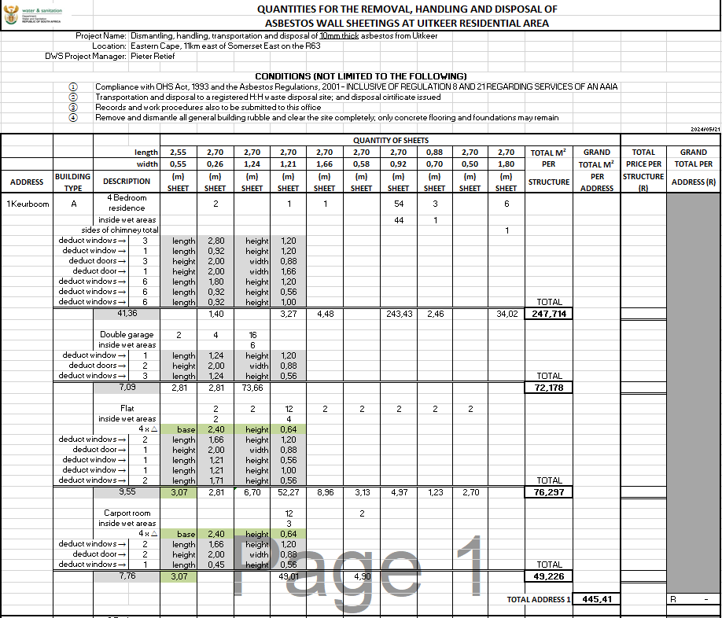

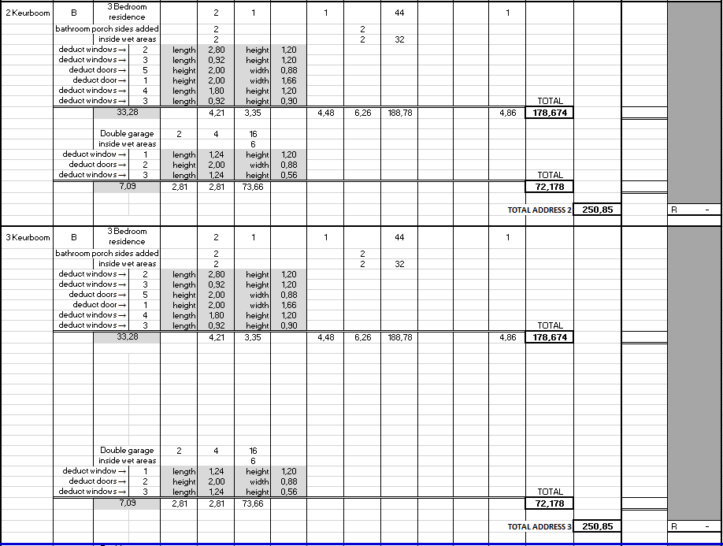

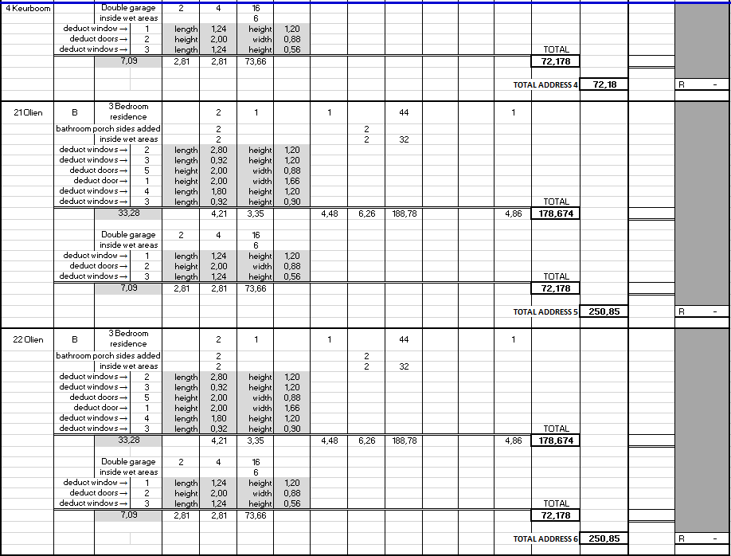

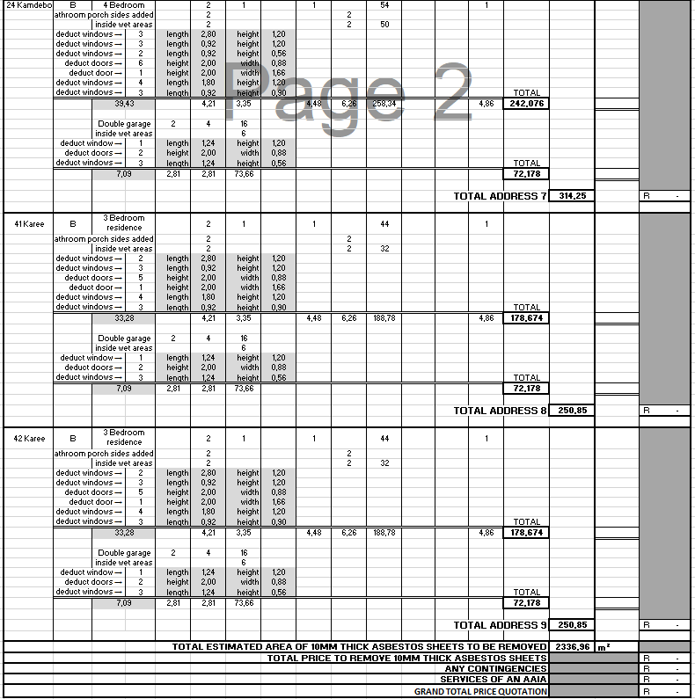

SBD 3.1

PRICING SCHEDULE – FIRM PRICES
(PURCHASES)
NOTE: ONLY FIRM PRICES WILL BE ACCEPTED. NON-FIRM PRICES (INCLUDING PRICES SUBJECT TO RATES OF EXCHANGE VARIATIONS) WILL NOT BE CONSIDERED
IN CASES WHERE DIFFERENT DELIVERY POINTS INFLUENCE THE PRICING, A SEPARATE PRICING SCHEDULE MUST BE SUBMITTED FOR EACH DELIVERY POINT
Name of bidder…………………………………… Bid number…………………....................

Closing Time 11:00 Closing date……………………………………

OFFER TO BE VALID FOR 120 DAYS FROM THE CLOSING DATE OF BID.
_____________________________________________________________________
ITEM QUANTITY DESCRIPTION BID PRICE IN RSA CURRENCY
NO. ** (ALL APPLICABLE TAXES INCLUDED)

ITEM | QTY | DESCRIPTION | UNIT PRICE | BID PRICE
1. |  | Dismantling, Handling, Transportation and Disposal of Asbestos sheets and miscellaneous material from Uitkeer; including clearing all sites from building material and building rubble: Uitkeer residential area - only bidders with CIDB contractor grading designation of CIDB 3GB or higher are eligible to bid
1.1 |  | Site establishment
1.2 | 2336,96 m² | 10mm thick asbestos sheets
1.3 | 1 | AAIA certificate to be issued to DWS
1.4 | 1 | Safe disposal certificate to be issued to DWS: following disposal at a registered hazardous (H:H) Waste Disposal Site  Asbestos Abatement Regulations, 2020 published under Government Notice R1196 in GG 43893 of 10 November 2020  Asbestos Regulations: Regulation 21a to be implemented; documents and plans submitted
 |  |  | 15% VAT | R………………………
 |  |  | TOTAL BID PRICE | R………………………

- Required by: ………………………………….

- At: ………………………………….

…………………………………

- Brand and model ………………………………….

- Country of origin ………………………………….

- Does the offer comply with the specification(s)? *YES/NO

- If not to specification, indicate deviation(s) ………………………………….

- Period required for delivery ………………………………….
*Delivery: Firm/not firm

- Delivery basis ……………………………………

Note: All delivery costs must be included in the bid price, for delivery at the prescribed destination.

** “all applicable taxes” includes value- added tax, pay as you earn, income tax, unemployment insurance fund contributions and skills development levies.

*Delete if not applicable

DEPARTMENT OF WATER AND SANITATION

DWS12-0724 WTE

DISMANTLING, HANDLING, TRANSPORTATION AND DISPOSAL OF ASBESTOS SHEETS AND MISCELLANEOUS MATERIAL FROM UITKEER; INCLUDING CLEARING ALL SITES FROM BUILDING MATERIAL AND BUILDING RUBBLE: UITKEER RESIDENTIAL AREA - ONLY BIDDERS WITH CIDB CONTRACTOR GRADING DESIGNATION OF CIDB 3GB OR HIGHER ARE ELIGIBLE TO BID.

C3: SCOPE OF WORK

CONTENT

C3.1 STANDARD SPECIFICATION

- STANDARD SPECIFICATION

3.1.1 APPLICABLE STANDARD SPECIFICATIONS
The scope of this bid shall be executed as per the Standard Specification for General Conditions of Contract 2015 (Third edition), Any reference in the Standard Specification to the Engineer shall be interpreted as the Employers Agent as defined under sub clause 1.1.1.16 of the General Conditions of Contract.
This bid specification is for the DISMANTLING, HANDLING, TRANSPORTATION AND DISPOSAL OF ASBESTOS SHEETS AND MISCELLANEOUS MATERIAL FROM UITKEER; INCLUDING CLEARING ALL SITES FROM BUILDING MATERIAL AND BUILDING RUBBLE: UITKEER RESIDENTIAL AREA - ONLY BIDDERS WITH CIDB CONTRACTOR GRADING DESIGNATION OF CIDB 3GB OR HIGHER ARE ELIGIBLE TO BID

Compliance requirements:
  - Full compliance to the requirements by indicating compliance or non-compliance on the specification table requirements. Bidders must indicate compliance by means of a (Tick “√”: on Comply) and non-compliance by means of a (Cross “X”: on Not Comply).

  - A bidder who fails to comply with the specifications requirements will be disqualified and not considered for further evaluation.

SPECIFICATION

Item no. | Description of services | Quantity | Comply | Not Comply
1. | Dismantling, Handling, Transportation and Disposal of Asbestos sheets and miscellaneous material from Uitkeer; including clearing all sites from building material and building rubble: Uitkeer residential area.
1.1 | Site Establishment
1.2 | 10mm thick asbestos sheets | 2336,96 m²
1.3 | AAIA certificate to be issued to DWS
1.4 | Safe disposal certificate to be issued to DWS: following  disposal at a registered hazardous (H:H) Waste Disposal Site  Asbestos Abatement Regulations, 2020 published under Government Notice R1196 in GG 43893 of 10 November 2020  Asbestos Regulations: Regulation 21a to be implemented; documents and plans submitted

SECTIONS:
B1200: GENERAL REQUIREMENTS AND PROVISION

B1300: CONTRACTOR'S ESTABLISHMENT ON SITE AND GENERAL OBLIGATIONS

- The following restricted working conditions will
- Work at night will not be permitted.

B1209 PAYMENT

(a) Rates to be VAT inclusive

SECTION B1300: CONTRACTOR'S ESTABLISHMENT ON SITE AND GENERAL OBLIGATIONS

B1303 PAYMENT

Item Unit

B13.01 The contractor's general obligations

Add the following pay sub-item:

“(d) Health and safety obligation………………………………………………………month”

DEPARTMENT OF WATER AND SANITATION

DWS12-0724 WTE

DISMANTLING, HANDLING, TRANSPORTATION AND DISPOSAL OF ASBESTOS SHEETS AND MISCELLANEOUS MATERIAL FROM UITKEER; INCLUDING CLEARING ALL SITES FROM BUILDING MATERIAL AND BUILDING RUBBLE: UITKEER RESIDENTIAL AREA - ONLY BIDDERS WITH CIDB CONTRACTOR GRADING DESIGNATION OF CIDB 3GB OR HIGHER ARE ELIGIBLE TO BID

C4: Site Information

CONTENTS

C4.1 Description of the Project
C4.2 The Site Conditions

LIST OF IMAGES AND ADDRESSES FOR UITKEER HOUSES

DISCRIPTION OF BUILDING PHOTOS TITLE/ADDRESS
- 4 bedrooms + Double Garage+ flat + carport 1 Keurboom, Uitkeer
- 3 bedrooms + Double Garage 2 Keurboom, Uitkeer
- 3 bedrooms + Double Garage 3 Keurboom, Uitkeer
- Double Garage 4 Keurboom, Uitkeer
- 3 bedrooms + Double Garage 21 Olien, Uitkeer
- 3 bedrooms + Double Garage 22 Olien, Uitkeer
- 4 bedrooms + Double Garage 24 Kamdeboo, Uitkeer
- 3 bedrooms + Double Garage 41 Karee, Uitkeer
- 3 bedrooms + Double Garage 42 Karee, Uitkeer
GOOGLE EARTH IMAGE

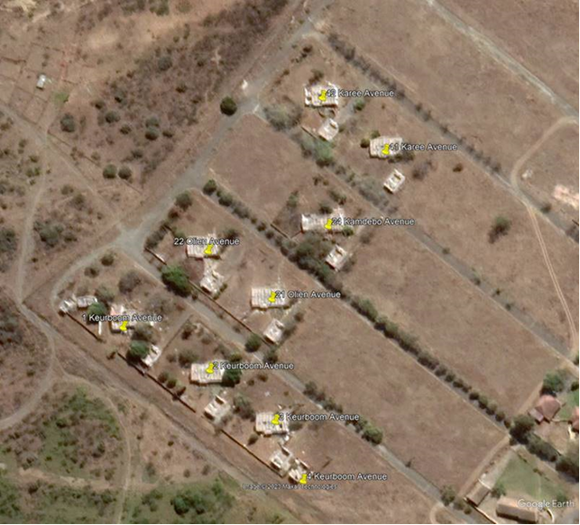

1 Keurboom Avenue, Uitkeer (4 structures)
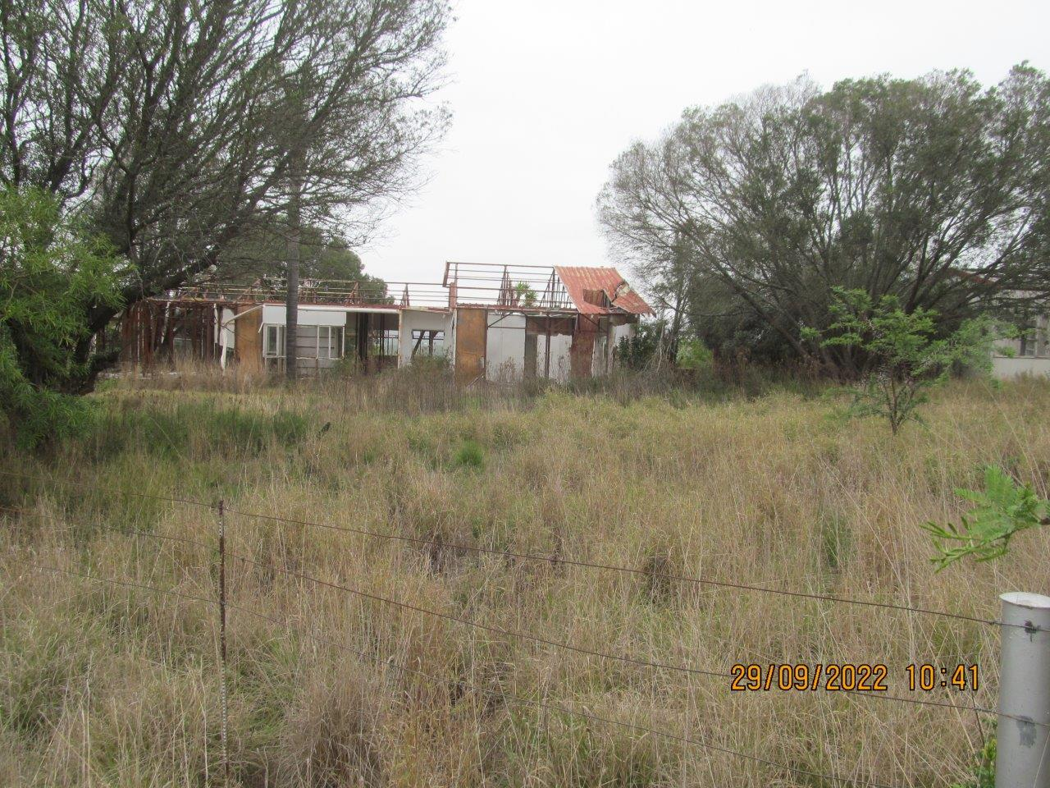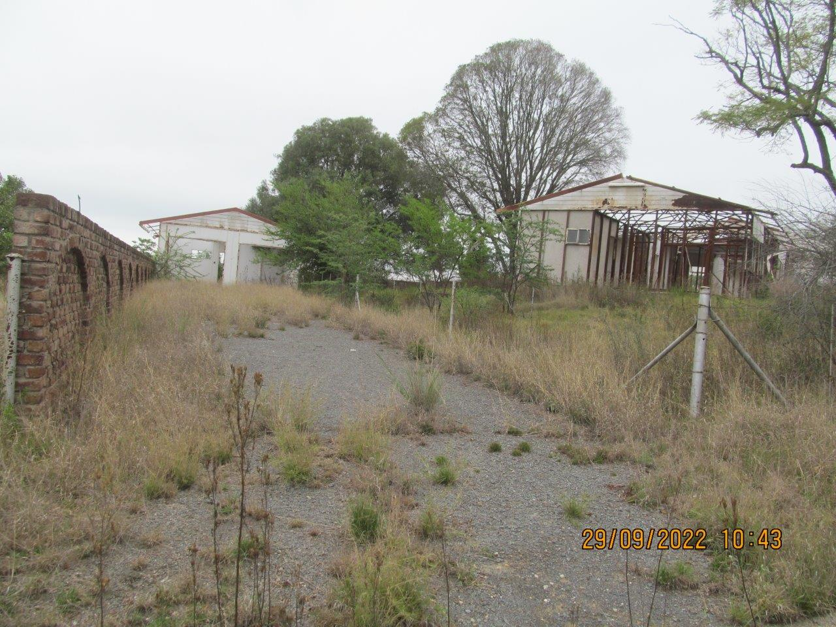
            - 4 Bedroom House 2. Double Garage

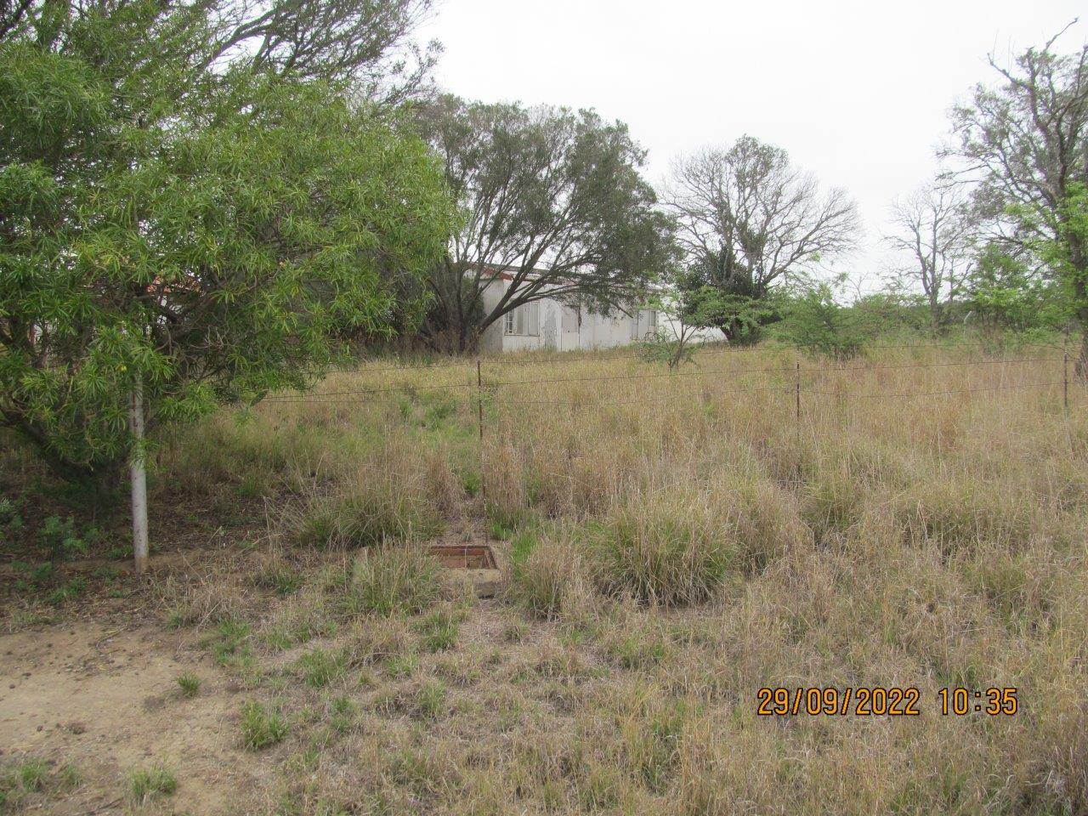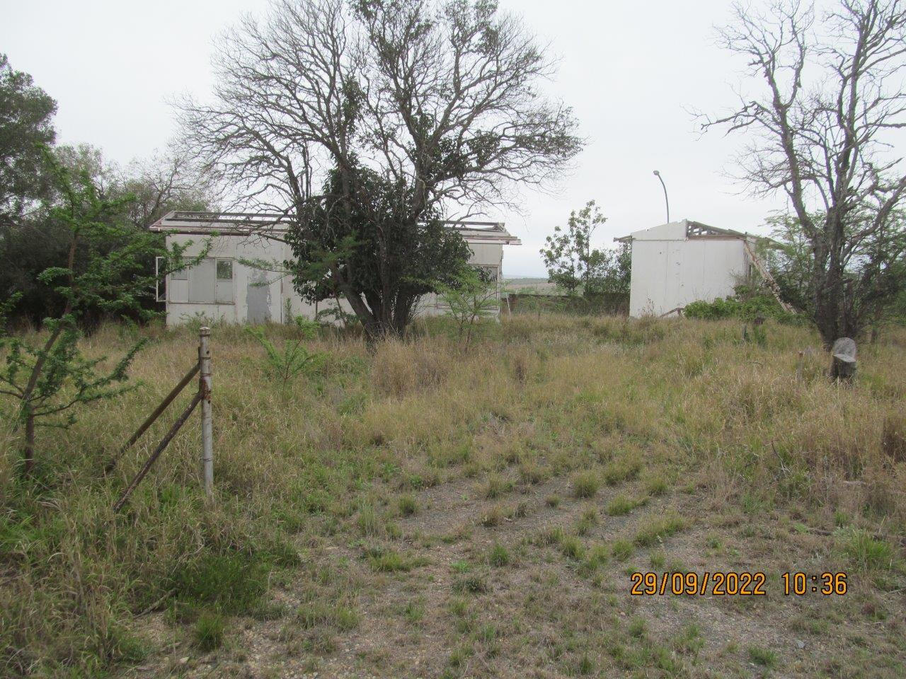
3. Flat 4. Carport

2 Keurboom Avenue, Uitkeer (2 structures)
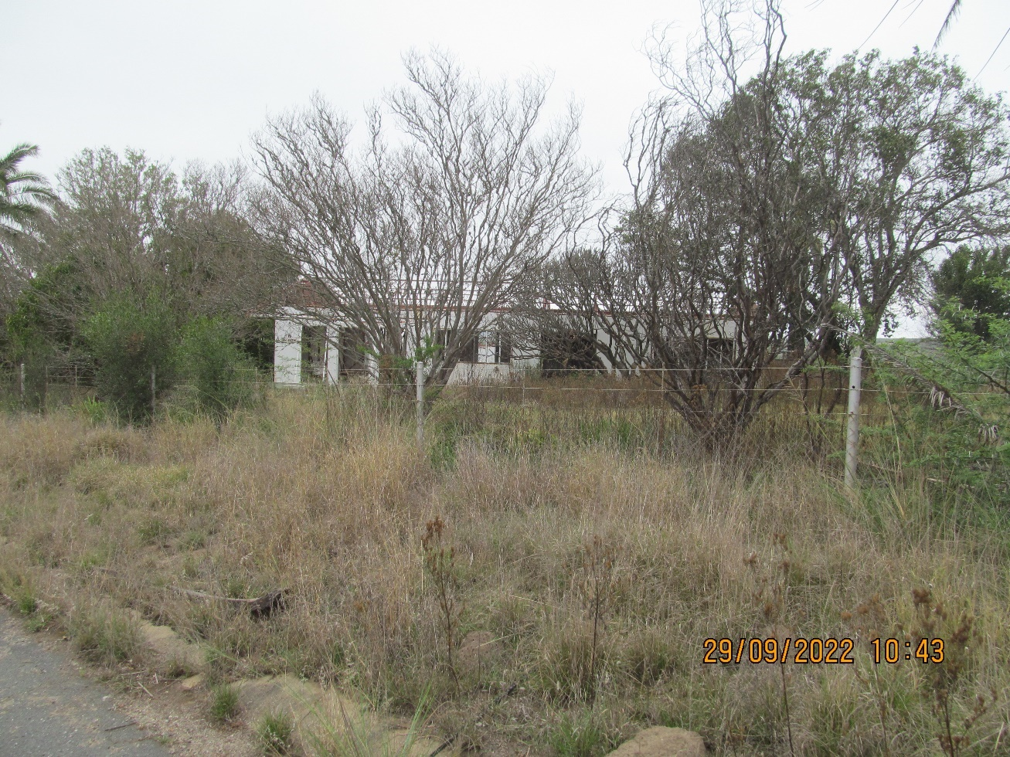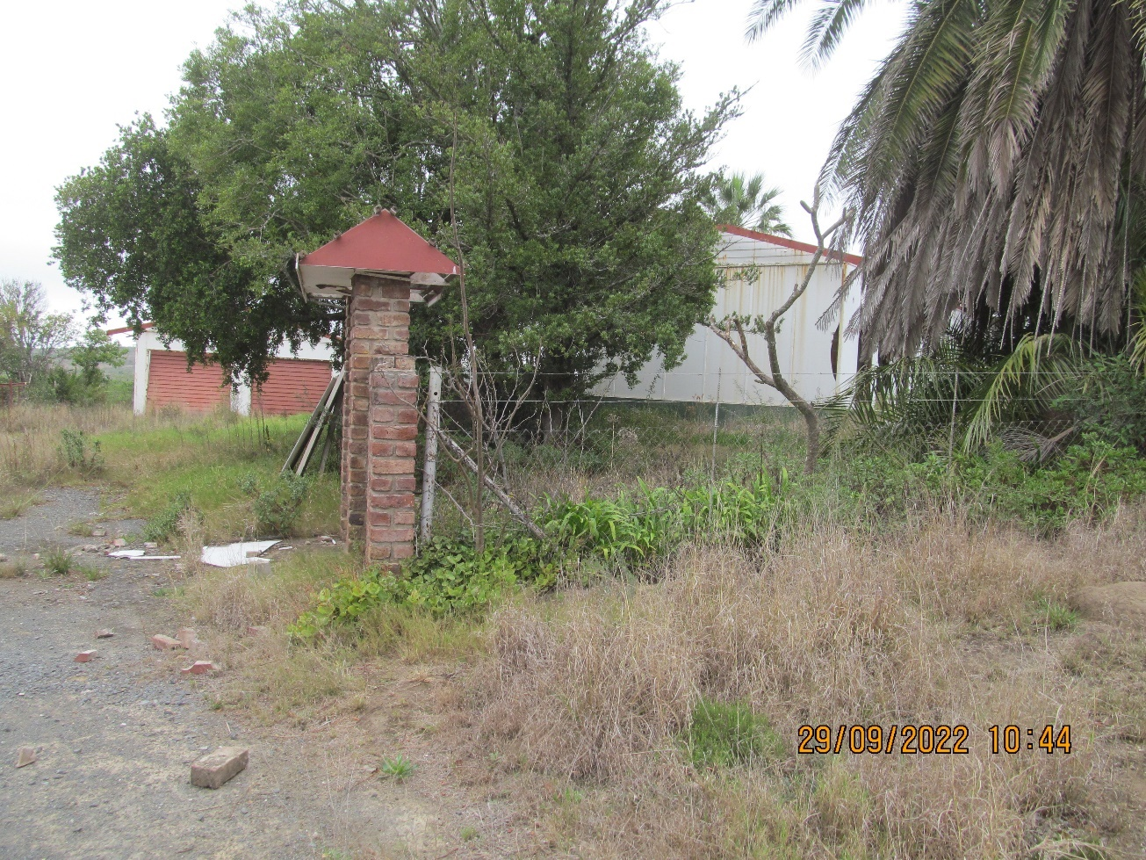
5. 3 Bedroom House 6. Double Garage

3 Keurboom Avenue, Uitkeer (2 structures)

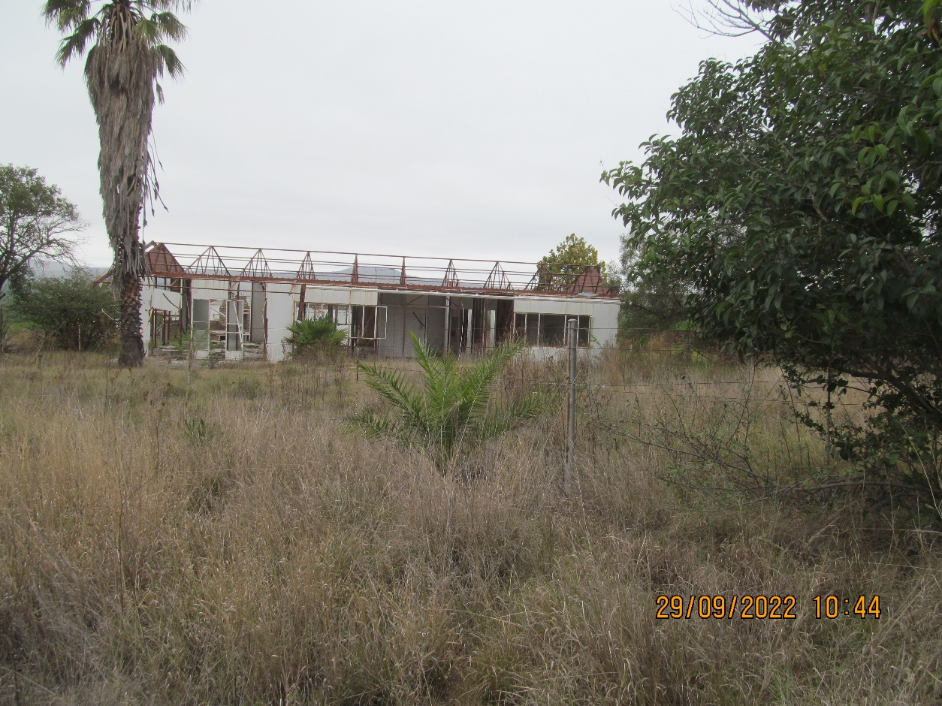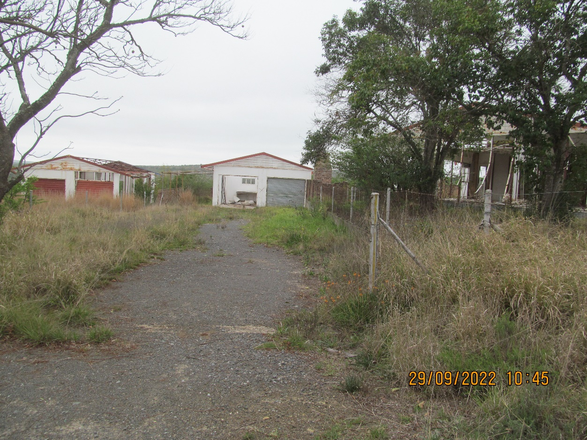
7. 3 Bedroom House 8. Double Garage

4 Keurboom Avenue , Uitkeer (1 structure)
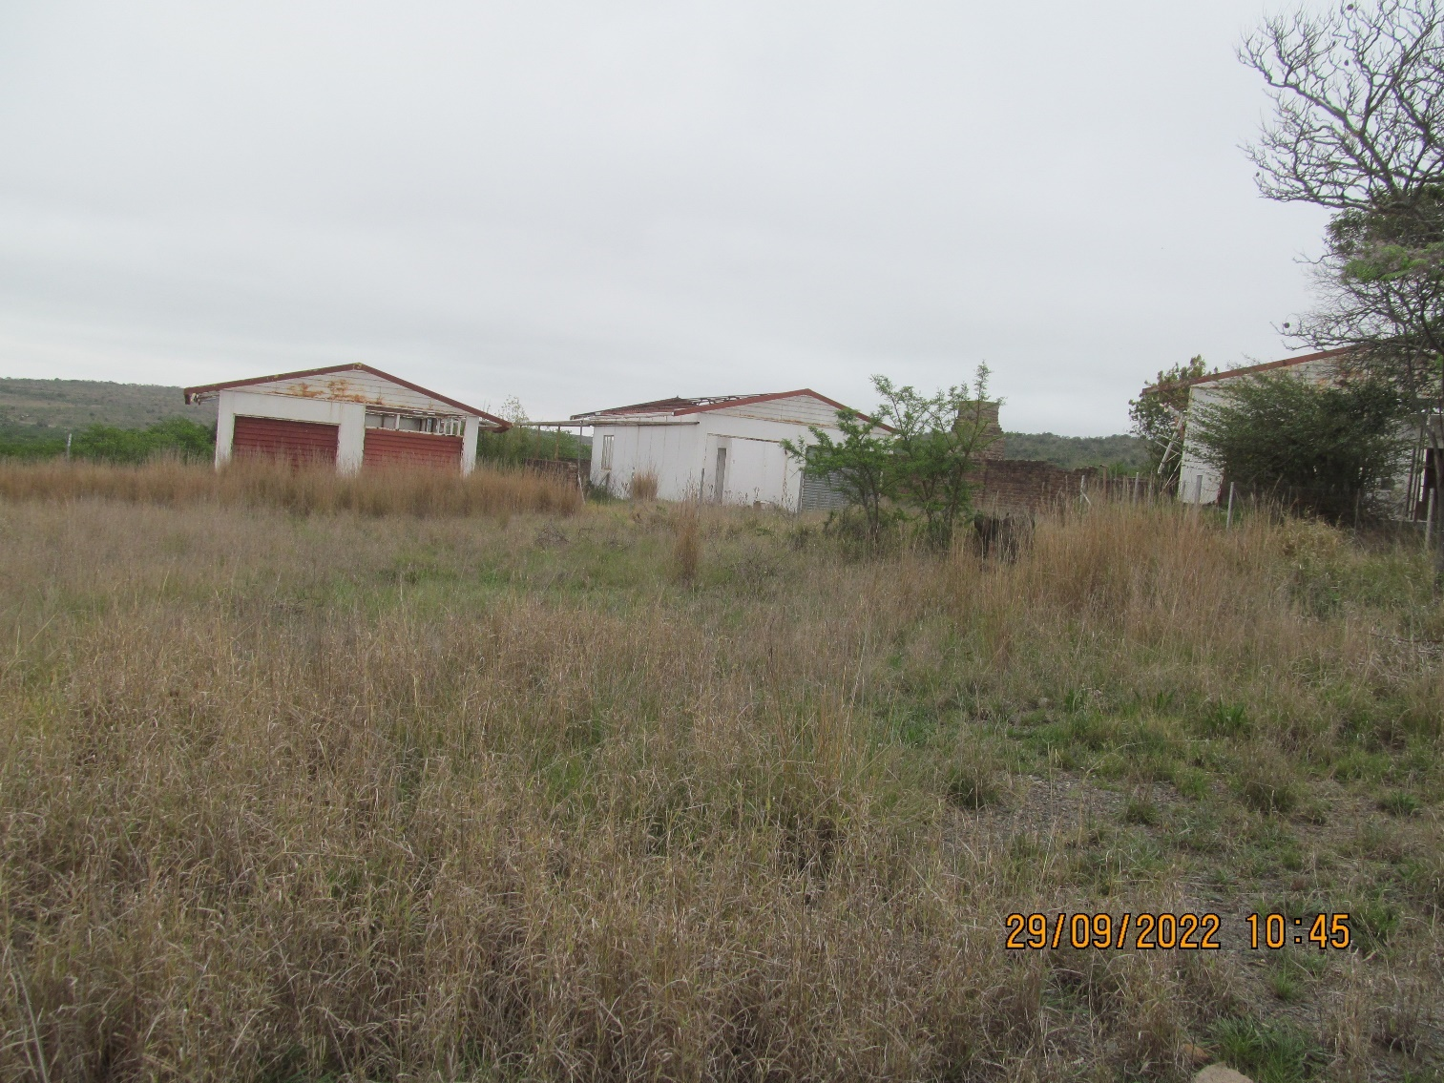
9. Double Garage

21 Olien Avenue, Uitkeer (2 structures)
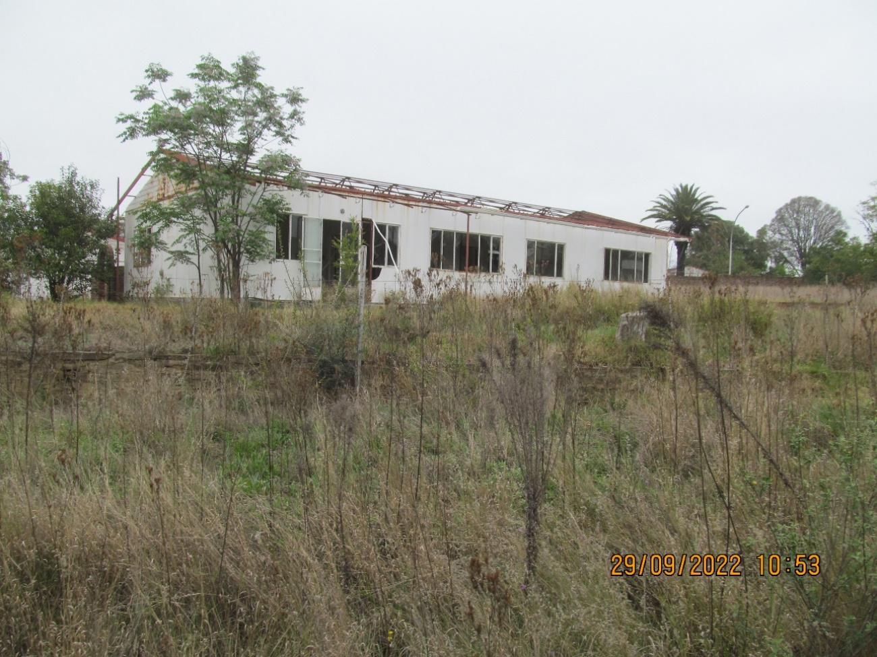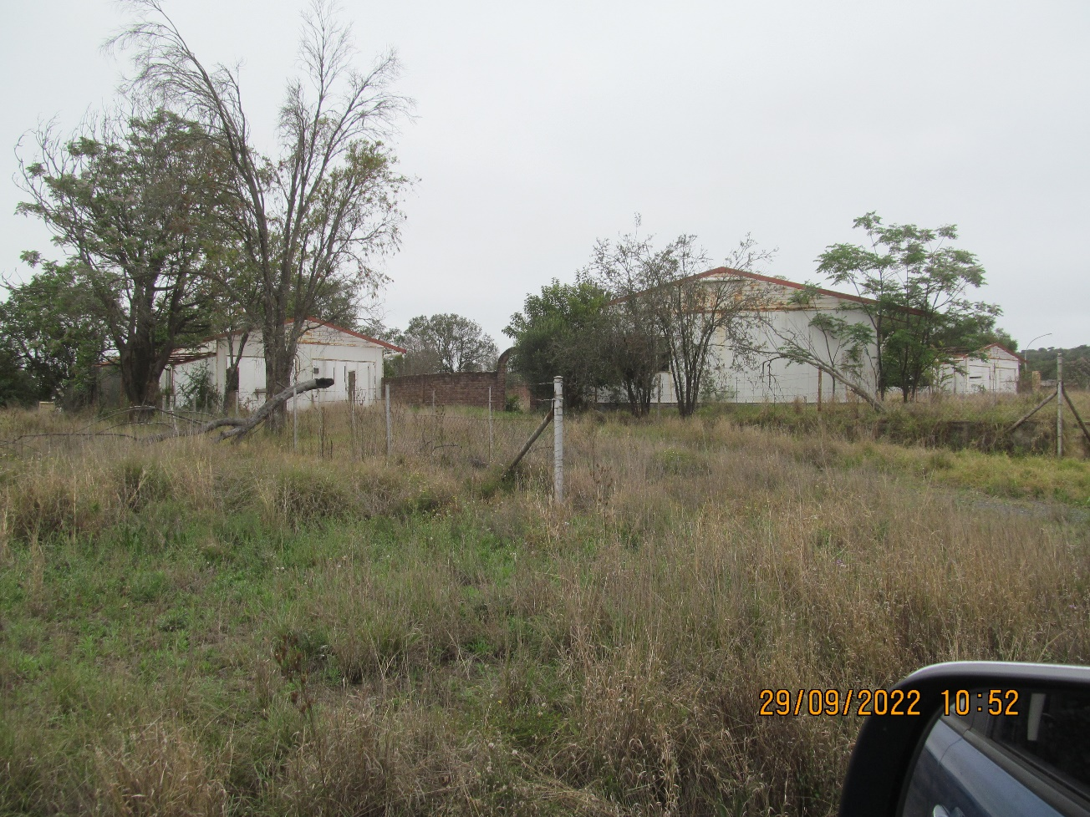
10. 3 Bedroom House 11. Double Garage

22 Olien Avenue, Uitkeer (2 structures)
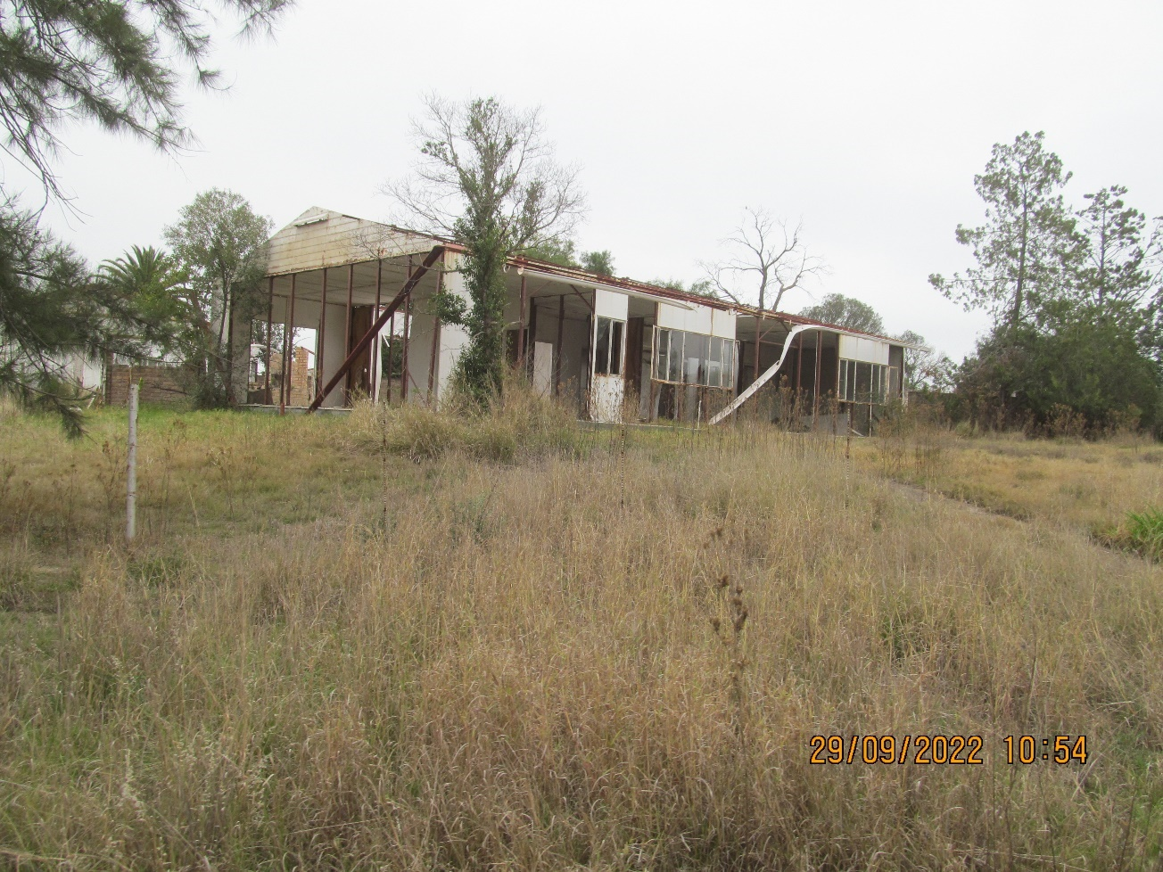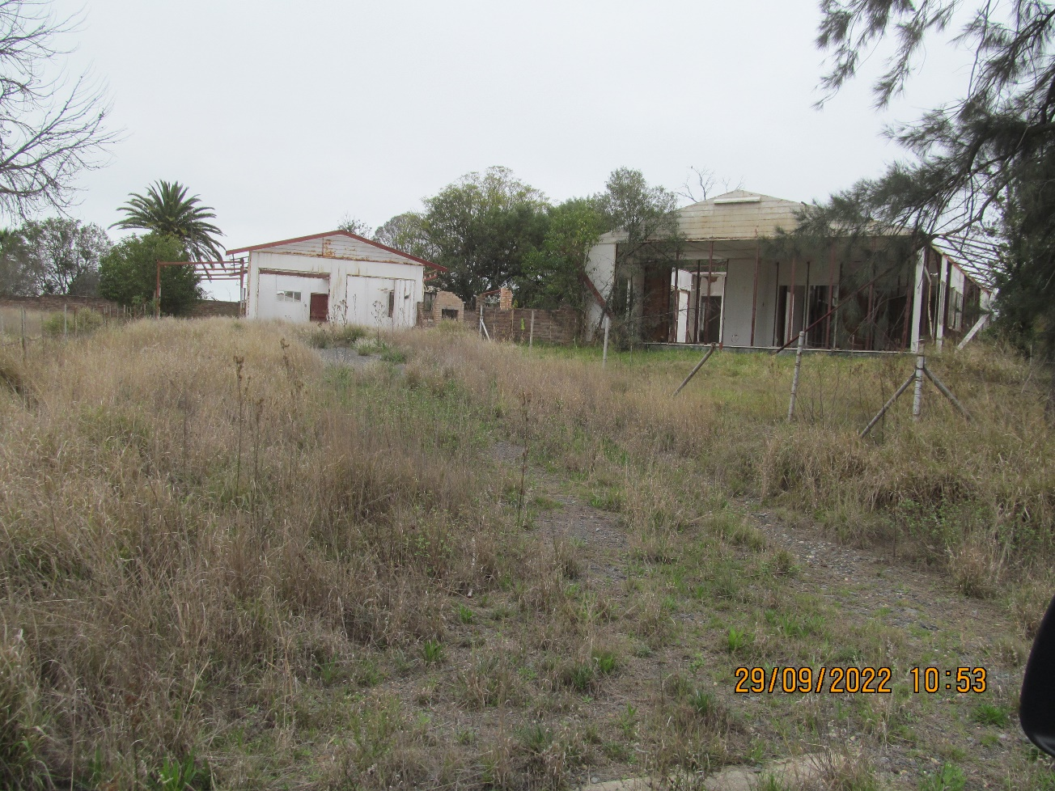
12. 3 Bedroom House 13. Double Garage

24 Kamdebo Avenue, Uitkeer (2 structures)
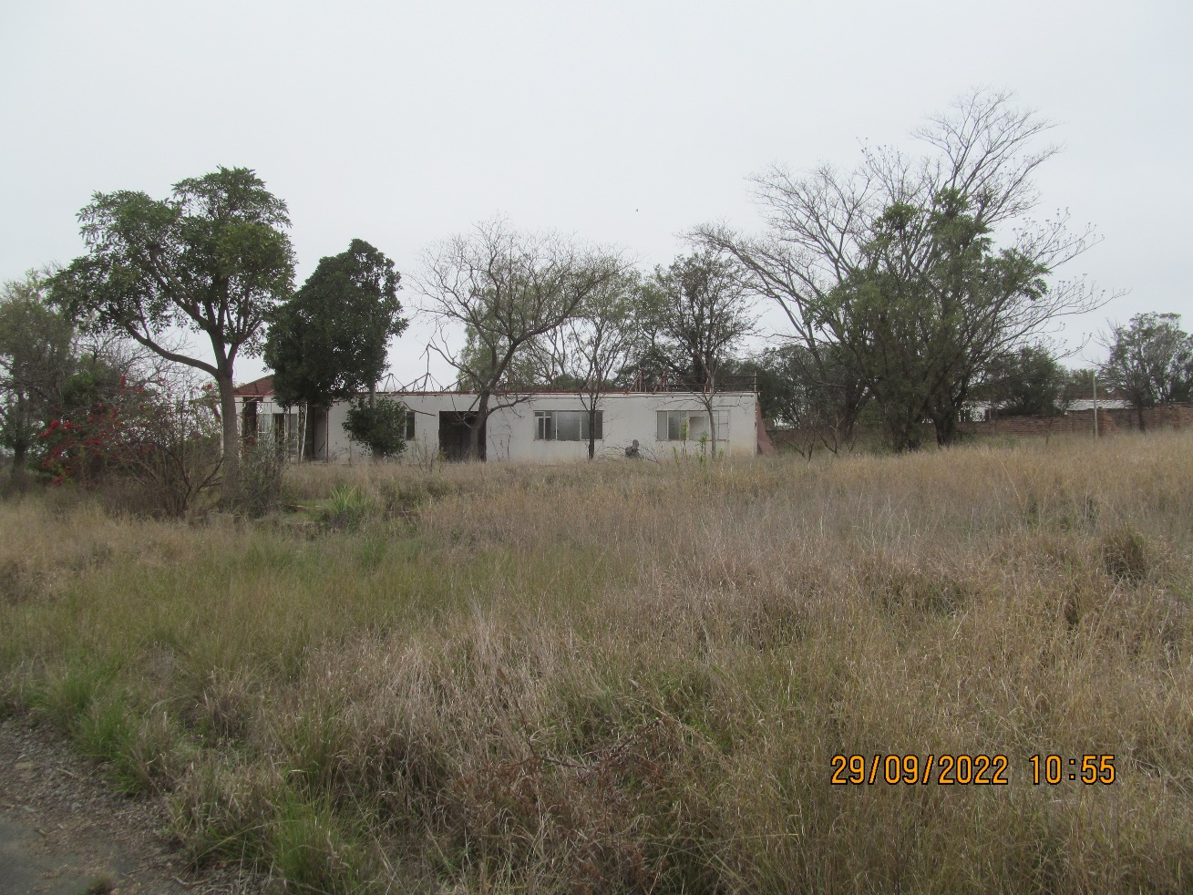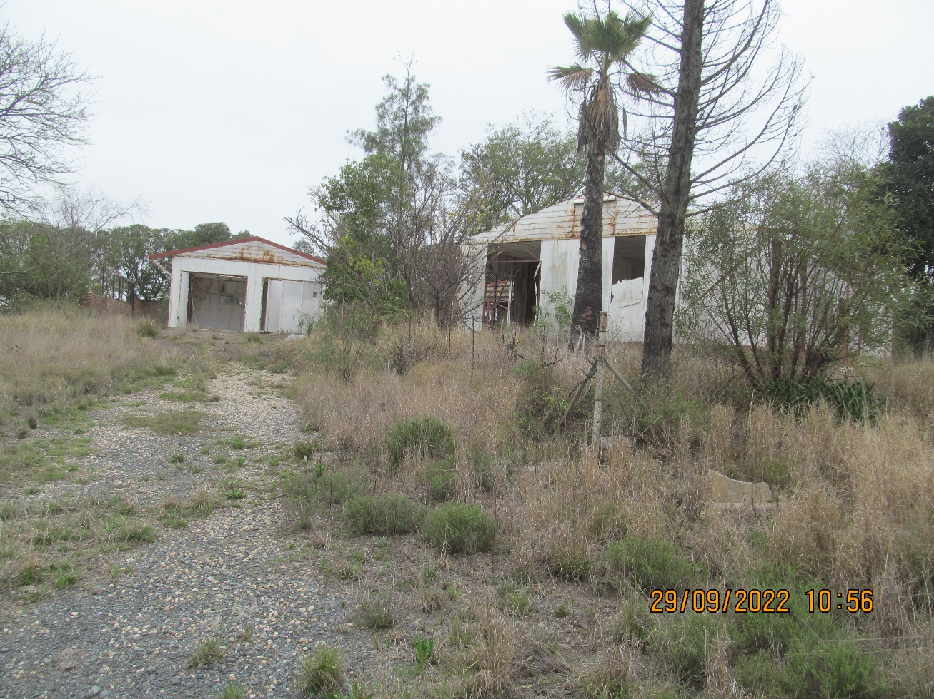
14. 4 Bedroom House 15. Double Garage

41 Karee Avenue, Uitkeer (2 structures)
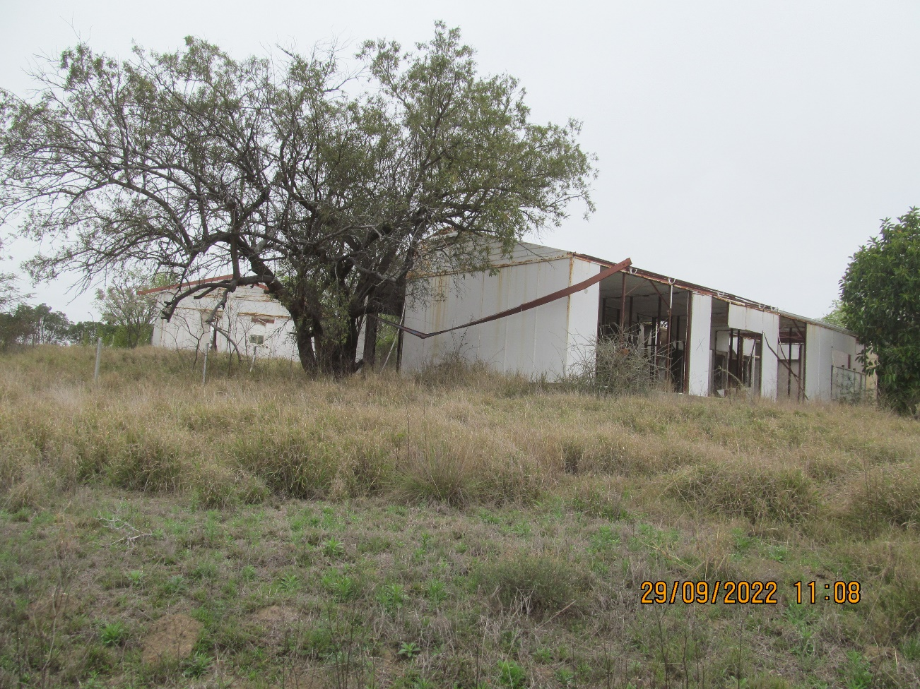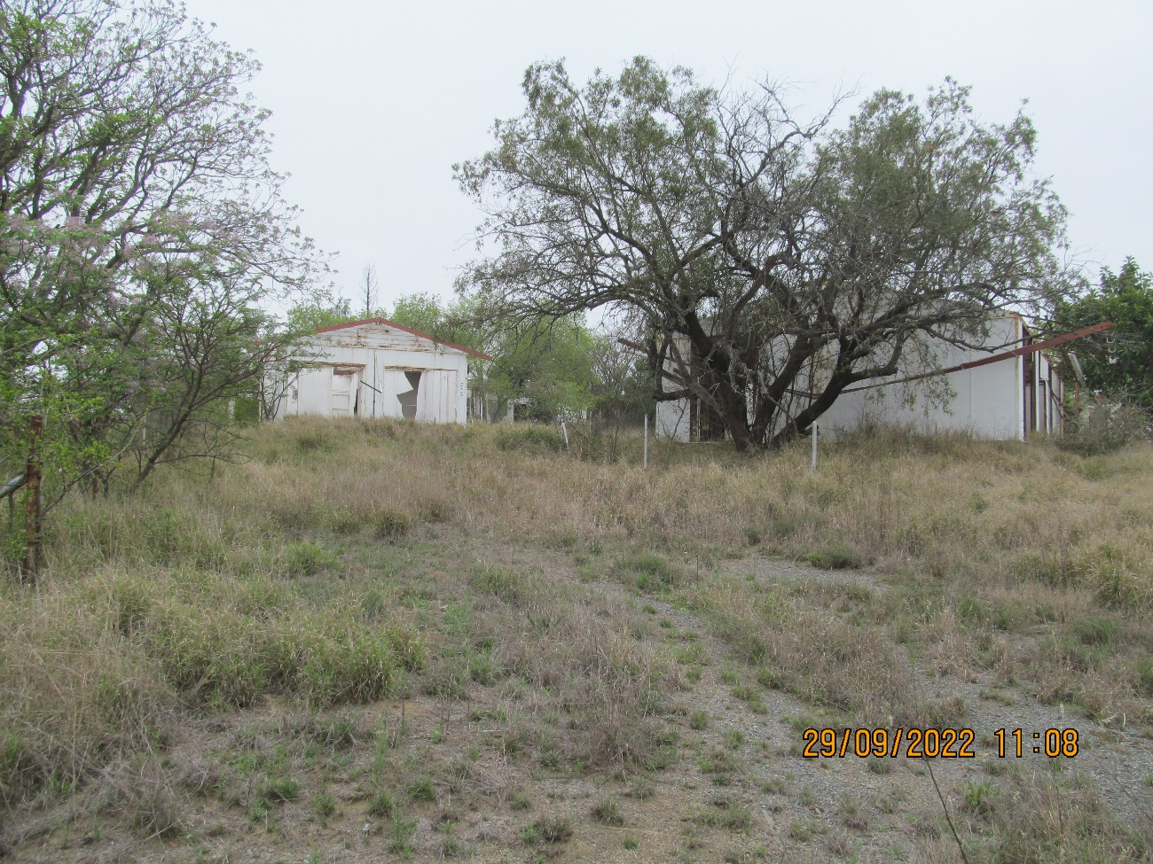
16. 3 Bedroom House 17. Double Garage

42 Karee Avenue, Uitkeer (2 structures)
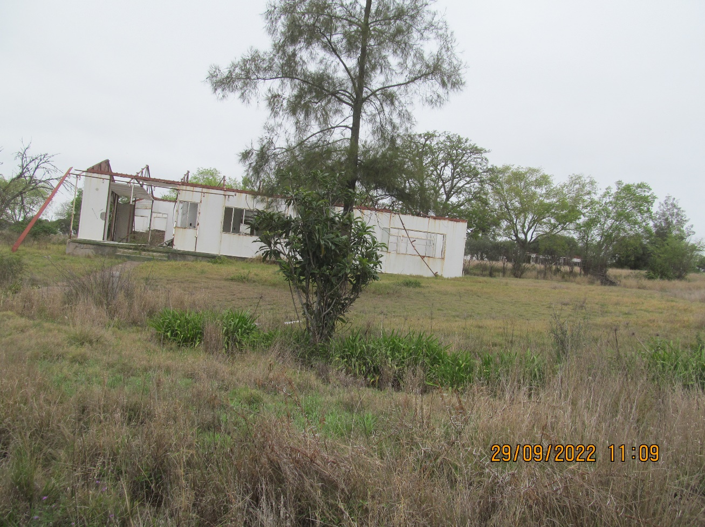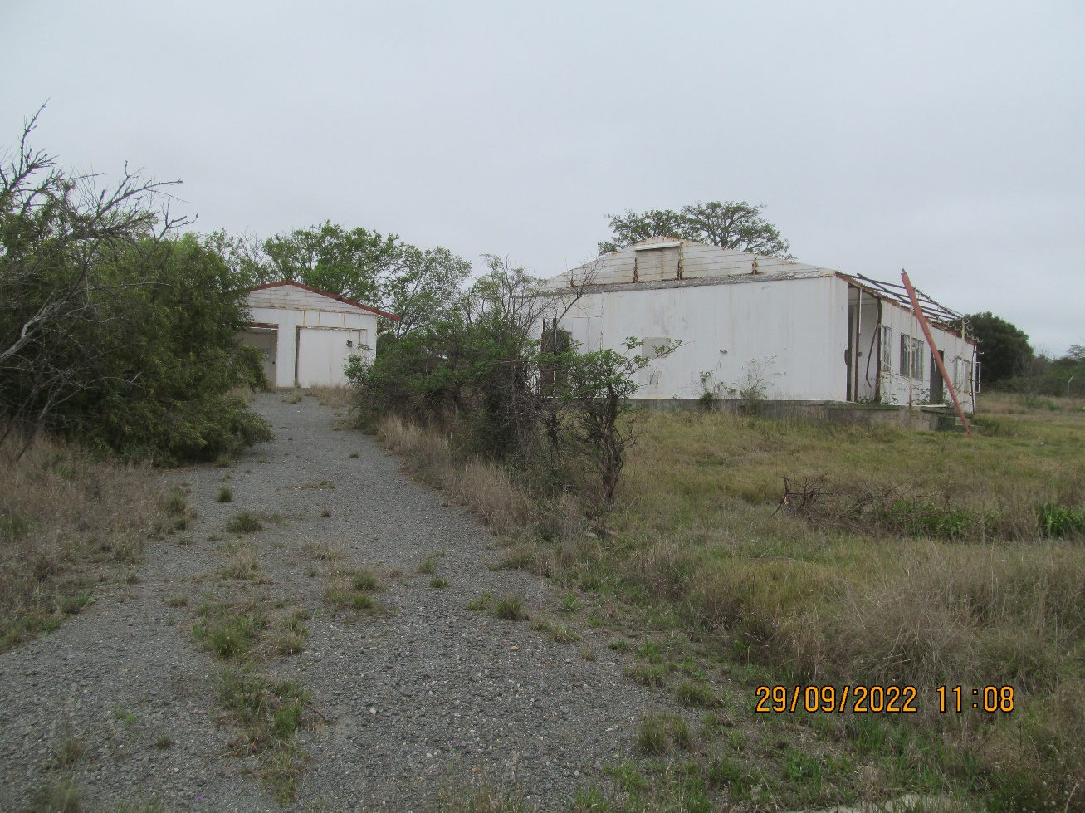
18. 3 Bedroom House 19. Double Garage

the power, by one person or a group of persons holding the majority of the equity of an enterprise, alternatively, the person/s having the deciding vote or power to influence or to direct the course and decisions of the enterprise.
Joint venture or Consortium means an association of persons for the purpose of combining their expertise, property, capital, efforts, skill and knowledge in an activity for the execution of a contract.

