- 

AIRPORTS COMPANY SOUTH AFRICA SOC LIMITED | I
 | I
TITLE OF SERVICE: FAULT FINDING, SERVICING, REPAIR AND TESTING OF CIVIL EQUIPMENT,  SUPPLY AND DELIVERY OF MECHANICAL SPARES AT BRAAM FISCHER INTERNATIONAL AIRPORT FOR A  PERIOD OF FIVE (5) YEARS | II

NEC 3: TERM SERVICE CONTRACT (TSC)

Between | AIRPORTS COMPANY SOUTH AFRICA SOC LIMITED  Applicable at BRAM FISHER INTERNATIONAL AIRPORT  (Registration Number: 1993/004149/30)
and | (Registration Number:)
for | FAULT FINDING, SERVICING, REPAIR AND TESTING OF CIVIL EQUIPMENT, SUPPLY AND DELIVERY OF MECHANICAL SPARES AT BRAAM FISCHER INTERNATIONAL AIRPORT FOR A  PERIOD OF FIVE (5) YEARS
Contents: |  | No of pages
Part C1 | Agreements & Contract Data | 1 to 35
Part C2 | Pricing Data | 1 to 3
Part C3 | Employer Service Information | 1 to 29
Part C4 | Site Information | 1 to 16

PART C1: AGREEMENT AND CONTRACT DATA

C1.1 Form of Offer and Acceptance

Offer
The employer, identified in the acceptance signature block, has solicited offers to enter into a contract for the procurement of Fault Finding, Serving, repair and Testing of Civil Equipment, supply and delivery of mechanical spares at Bram Fischer International Airport for a Period of Five (5) Years. This form of Contract is “on an as and when basis”
The tenderer, identified in the offer signature block, has examined this document and addenda hereto as listed in the schedules, and by submitting this offer has accepted the conditions of tender.

By the representative of the contractor, deemed to be duly authorised, signing this part of this form of offer and acceptance, the contractor offers to perform all of the obligations and liabilities of the Contractor under the contract including compliance with all its terms and conditions according to their true intent and meaning for an amount to be determined in accordance with the Conditions of Contract identified in the Contract Data.

The offered total of the prices (INCLUSIVE OF VAT) is:

(in words) …………………………………………………………………………………………………………. ………………………………………………………………………………………………………………………………. Rand;

R…………………………………… (in figures)

for the contractor

Signature . . . . . . . . . . . . . . . . . . . . . . . . . . . . . .. Date . . . . . . . . . . . . . . . . . . . . ..
Name . . . . . . . . . . . . . . . . . . . . . . . . . . . . . .. Capacity . . . . . . . . . . . . . . . . . . . . . . . .

(Name and . . . . . . . . . . . . . . . . . . . . . . . . . . . . . . . . . . . . . . . . . . . . . . . . . . . . . . . . . . . . . . . . . ..
address of
organisation) . . . . . . . . . . . . . . . . . . . . . . . . . . . . . . . . . . . . . . . . . . . . . . . . . . . . . . . . . . . . . . . . . . . .

. . . . . . . . . . . . . . . . . . . . . . . . . . . . . . . . . . . . . . . . . . . . . . . . . . . . . . . . . . . . . . . . . . . .
Name and
signature
of witness . . . . . . . . . . . . . . . . . . . . . . . . . . . . . . . . . . . . . . . . . . . . . . . . . . . . . . . . . . . .

This offer may be accepted by the employer by signing the acceptance part of this form of offer and acceptance and returning one copy of this document to the tenderer before the end of the period of validity stated in the tender data, whereupon the tenderer becomes the party named as the contractor in the conditions of contract identified in the contract data.

Acceptance

By signing this part of this form of offer and acceptance, the employer identified below accepts the tenderers offer. In consideration thereof, the employer shall pay the contractor the amount due in accordance with the conditions of contract identified in the contract data or the Pricing Data. Acceptance of the contractor’s offer shall form an agreement between the employer and the contractor upon the terms and conditions contained in this agreement and in the contract that is the subject of this agreement.
The terms of the contract, are contained in:

Part C1: Agreements and contract data, (which includes this Form of Offer and Acceptance)

Part C2: Pricing data

Part C3: Service information

Part C4: Site information

Deviations from and amendments to the documents listed in the tender data and any addenda thereto as listed in the tender schedules as well as any changes to the terms of the offer agreed by the tenderer and the employer during this process of offer and acceptance, are contained in the schedule of deviations attached to and forming part of this agreement. No amendments to or deviations from said documents are valid unless contained in this schedule.

The tenderer shall within two weeks after receiving a completed copy of this agreement, including the schedule of deviations (if any), contact the Service manager (to be confirmed) to arrange the delivery of any bonds, guarantees, proof of insurance and any other documentation to be provided in terms of the conditions of contract identified in the contract data. Failure to fulfil any of these obligations in accordance with those terms shall constitute a repudiation of this agreement.

Unless the tenderer (now contractor) within five working days of the date of such receipt notifies the employer in writing of any reason why he cannot accept the contents of this agreement, this agreement shall constitute a binding contract between the parties.

for the Employer

Signature . . . . . . . . . . . . . . . . . . . . . . . . . . . . . Date . . . . . . . . .. . . . . . . . . . . . . . . . . . .
Name . . . . . . . . . . . . . . . . . . . . . . . . . . . . . Capacity . . . . . . . . . . . . . . . . . . . . . . . . . . .
Airports Company South Africa SOC Limited
Bram Fischer International Airport,
N8 Thaba Nchu Road,
Bloemfontein, 9300
Name and
signature
of witness . . . . . . . . . . . . . . . . . . . . . . . . . . . . . . Date . . . . . . . . . . . . . . . . . . . . . . . . . . . . . .

Schedule of Deviations

1 Subject . . . . . . . . . . . . . . . . . . . . . . . . . . . . . . . . . . . . . . . . . . . . . . . . . . . . . . . . . . . . . . . . . . . . . . . . . . .
Details . . . . . . . . . . . . . . . . . . . . . . . . . . . . . . . . . . . . . . . . . . . . . . . . . . . . . . . . . . . . . . . . . . . . . . . . . . .
. . . . . . . . . . . . . . . . . . . . . . . . . . . . . . . . . . . . . . . . . . . . . . . . . . . . . . . . . . . . . . . . . . . . . . . . . . .
. . . . . . . . . . . . . . . . . . . . . . . . . . . . . . . . . . . . . . . . . . . . . . . . . . . . . . . . . . . . . . . . . . . . . . . . . . .
. . . . . . . . . . . . . . . . . . . . . . . . . . . . . . . . . . . . . . . . . . . . . . . . . . . . . . . . . . . . . . . . . . . . . . . . . . .
2 Subject . . . . . . . . . . . . . . . . . . . . . . . . . . . . . . . . . . . . . . . . . . . . . . . . . . . . . . . . . . . . . . . . . . . . . . . . . . .
Details . . . . . . . . . . . . . . . . . . . . . . . . . . . . . . . . . . . . . . . . . . . . . . . . . . . . . . . . . . . . . . . . . . . . . . . . . . .
. . . . . . . . . . . . . . . . . . . . . . . . . . . . . . . . . . . . . . . . . . . . . . . . . . . . . . . . . . . . . . . . . . . . . . . . . . .
. . . . . . . . . . . . . . . . . . . . . . . . . . . . . . . . . . . . . . . . . . . . . . . . . . . . . . . . . . . . . . . . . . . . . . . . . . .
. . . . . . . . . . . . . . . . . . . . . . . . . . . . . . . . . . . . . . . . . . . . . . . . . . . . . . . . . . . . . . . . . . . . . . . . . . .
3 Subject . . . . . . . . . . . . . . . . . . . . . . . . . . . . . . . . . . . . . . . . . . . . . . . . . . . . . . . . . . . . . . . . . . . . . . . . . . .
Details . . . . . . . . . . . . . . . . . . . . . . . . . . . . . . . . . . . . . . . . . . . . . . . . . . . . . . . . . . . . . . . . . . . . . . . . . . .
. . . . . . . . . . . . . . . . . . . . . . . . . . . . . . . . . . . . . . . . . . . . . . . . . . . . . . . . . . . . . . . . . . . . . . . . . . .
. . . . . . . . . . . . . . . . . . . . . . . . . . . . . . . . . . . . . . . . . . . . . . . . . . . . . . . . . . . . . . . . . . . . . . . . . . .
. . . . . . . . . . . . . . . . . . . . . . . . . . . . . . . . . . . . . . . . . . . . . . . . . . . . . . . . . . . . . . . . . . . . . . . . . . .
4 Subject . . . . . . . . . . . . . . . . . . . . . . . . . . . . . . . . . . . . . . . . . . . . . . . . . . . . . . . . . . . . . . . . . . . . . . . . . . .
Details . . . . . . . . . . . . . . . . . . . . . . . . . . . . . . . . . . . . . . . . . . . . . . . . . . . . . . . . . . . . . . . . . . . . . . . . . . .
. . . . . . . . . . . . . . . . . . . . . . . . . . . . . . . . . . . . . . . . . . . . . . . . . . . . . . . . . . . . . . . . . . . . . . . . . . .
. . . . . . . . . . . . . . . . . . . . . . . . . . . . . . . . . . . . . . . . . . . . . . . . . . . . . . . . . . . . . . . . . . . . . . . . . . .
. . . . . . . . . . . . . . . . . . . . . . . . . . . . . . . . . . . . . . . . . . . . . . . . . . . . . . . . . . . . . . . . . . . . . . . . . . .
5 Subject . . . . . . . . . . . . . . . . . . . . . . . . . . . . . . . . . . . . . . . . . . . . . . . . . . . . . . . . . . . . . . . . . . . . . . . . . . .
Details . . . . . . . . . . . . . . . . . . . . . . . . . . . . . . . . . . . . . . . . . . . . . . . . . . . . . . . . . . . . . . . . . . . . . . . . . . .
. . . . . . . . . . . . . . . . . . . . . . . . . . . . . . . . . . . . . . . . . . . . . . . . . . . . . . . . . . . . . . . . . . . . . . . . . . .
. . . . . . . . . . . . . . . . . . . . . . . . . . . . . . . . . . . . . . . . . . . . . . . . . . . . . . . . . . . . . . . . . . . . . . . . . . .
. . . . . . . . . . . . . . . . . . . . . . . . . . . . . . . . . . . . . . . . . . . . . . . . . . . . . . . . . . . . . . . . . . . . . . . . . . .

By the duly authorised representatives signing this agreement, the employer and the contractor agree to and accept the foregoing schedule of deviations as the only deviations from and amendments to the documents listed in the tender data and addenda thereto as listed in the tender schedules, as well as any confirmation, clarification, or changes to the terms of the offer agreed by the tenderer and the employer during this process of offer and acceptance.

It is expressly agreed that no other matter whether in writing, oral communication or implied during the period between the issue of the tender documents and the receipt by the tenderer of a completed signed copy of this Agreement shall have any meaning or effect in the contract between the parties arising from this agreement.

Signature(s)

Name(s)
Capacity

for the Employer | Airports Company South Africa SOC Limited  Bram Fischer International Airport,  N8 Thaba Nchu Road,  Bloemfontein, 9300
Name & signature of witness |  |  | Date

Signature(s)

Name(s)

Capacity

For the tenderer:

Name & signature of witness | (Insert name and address of organisation) |  | Date

C1.2a Contract Data

Part one - Data provided by the Employer
Clause | Statement | Data
1 | General
 | The conditions of contract are the core clauses and the clauses for main Option:
 |  | A: Priced contract with price list
 | dispute resolution Option: | W1: Dispute resolution procedure
 | and secondary Options:
 |  | X17 Low Service Damages
 |  | X18: Limitation of Liability (as amended inOption Z)
X19: Task Order
X20: Key Performance Indicators
 |  | Z: Additional conditions of contract
 | of the NEC3 Term Service Contract (April 2013)
10.1 | The Employer is (Name): | Airports Company South Africa SOC Limited
10.1 | Address | Bram Fischer International Airport,  N8 Thaba Nchu Road,  Bloemfontein, 9300
10.1 | The Service Manager is:
11.2(1) | The Accepted Plan is | Included in Part C3 of this document, including Annexes thereto as submitted by the Contractor and accepted by the Service Manager.
11.2(2) | The Affected Property is | Bram Fisher International Airport as set out in Part C4 Site Information
11.2(13) | The Service is | Landscaping at Airside and Landside at Braam Fischer International Airport for a Period of Five (5) years
11.2(14) | The following matters will be included in the Risk Register | Service Level Performance  Adherence & Compliance to requirements  The method statements,  OHS Act,  ACSA policy & procedure  Legislation and regulation
11.2(15) | The Service Information is in | The section titled Service Information included as Part C3 of this document.
12.2 | The law of the contract is the law of | The Republic of South Africa
13.1 | The language of this contract is | English
13.3 | The period for reply is | 7 calendar days
21.1 | The period within which the Contractor provides the Contractor’s Plan | 14 calendar days from Contract Date
_________________________________________________________________________________
2 |  | The Contractor's main responsibilities |  |  |  | Detailed in Part C3 (Service Information)
3 |  | Time
30.1 |  | The starting date is |  |  |  | Upon signing of the contract by ACSA
30.2 |  | The Service Period is |  |  |  | (5) years from the starting date
4 |  | Testing and Defects |  |  |  | No data is required for this section of the conditions of contract
5 |  | Payment
50.1 |  | The assessment interval is on the |  |  |  | Every 4 weeks (Monthly)
51.1 |  | The currency of this contract is the |  |  |  | South African Rand (ZAR)
51.2 |  | The period within which payments are made is |  |  |  | 30 days from receipt of a valid tax invoice
6 |  | Compensation events |  |  |  | No data is required for this section of the conditions of contract.
7 |  | Use of Equipment Plant and Materials |  |  |  | No data is required for this section of the conditions of contract.
8 |  | Risks and insurance |  |  |  | Refer to Part C1.4
83.2 |  | The minimum amounts of cover or minimum limits of indemnity required for the insurance table |  |  |  | Refer to Part C1.4
9 |  | Termination |  |  |  | No data is required for this section of the conditions of contract.
10 |  | Data for main Option clause
A |  | Priced contract with price list (bills of quantities) |  |  |  | Refer to Part C2
11 |  | Data for Option W1
W1.1 | The Adjudicator is |  |  | The person appointed jointly by the parties from the list of adjudicators contained below
W1.2 | The Adjudicator nominating body is |  |  | The current Chairman of Johannesburg Advocate’s Bar Council
W1.4 | The tribunal is |  |  | Arbitration
W1.4 | If the tribunal is arbitration, the arbitration procedure is |  |  | The arbitration procedure is set out in The Rules for the Conduct of Arbitrations 2013 Edition, 7th Edition, published by The Association of Arbitrators, (Southern Africa)
W1.4 | The place where arbitration is to be held is |  |  | Johannesburg, South Africa.
W1.4 | The person or organization who will choose an arbitrator |  |  | The Arbitrator is the person selected by the Parties as and when a dispute arises in terms of the relevant Z Clause, from the Panel of Arbitrators provided under the relevant Z clause if the arbitration procedure does not state who selects an arbitrator. The Arbitrator nominating body is the Chairman of the Johannesburg Advocates Bar Council.
12 |  | Data for secondary Option
X17 |  | Low Service Damages |  |  | No additional data is required for this secondary option – Also refer to the Low Service Damages Table.
X18 |  | Limitation of liability
X18.1 |  | The Contractor’s liability to the Employer for indirect or consequential loss is limited to |  |  | Nil - Neither Party is liable to the other for any consequential or indirect loss, including but not limited to loss of profit, loss of income or loss of revenue
X18.2 |  | For any one event, the Contractor’s liability to the Employer for loss of or damage to the Employer’s property is limited to |  |  | Total of the losses incurred and/or repairs to the damages caused
X18.3 |  | The Contractor’s total liability to the  Employer for defects due to his design  which are not listed on the Defects Certificate is limited to |  |  | Total of the losses incurred and/or repairs to the damages caused
X18.4 |  | The Contractor’s total liability to the Employer for all matters arising under or in connection with this contract, other than excluded matters, is limited to |  |  | The Contractor’s total direct liability to the Employer for all matters arising under or in connection with this contract, other than the excluded matters, is limited to the total of the losses incurred and/or repairs to the damages caused, and applies in contract, tort or delict and otherwise to the extent allowed under the law of the contract.  The excluded matters are amounts payable by the Contractor as stated in this contract for:  - Loss of or damage to the Employer’s property,  - Defects liability,  - Insurance liability to the extent of the Contractor’s risks  - death of or injury to a person;  - infringement of an intellectual property right
X19 |  | Task Order |  |  | No additional data is required for this secondary option
X20 |  | Key Performance Indicators
X20.1 |  | The incentive schedule for Key Performance Indicators is in |  |  | Refer to part C3
X20.2 |  | A report of performance against each Key Performance Indicator is provided at intervals of |  |  | Refer to part C3
Z | The Additional conditions of contract are |  | Z1 – Z19
 | Amendments to the Core Clauses
Z1 | Interpretation of the law
Z1.1 | Add to core clause 12.3:  Any extension, concession, waiver or relaxation of any action stated in this contract by the Parties, the Service Manager, the Supervisor, or the Adjudicator does not constitute a waiver of rights and does not give rise to an estoppel unless the Parties agree otherwise and confirm such agreement in writing.
Z2 | Providing the Service:
Z2.1 | Delete core clause 20.1 and replace with the following:  The Contractor provides the Service in accordance with the Service Information and warrants that the results of the Service, when complete, shall be fit for their intended purpose.
Z5 | Termination
Z5.1 | Add the following to core clause 91.1, at the second main bullet, fifth sub-bullet point, after the words “assets or”: “business rescue proceedings are initiated, or steps are taken to initiate business rescue proceedings”.
 | Amendment to the Secondary Option Clauses
Z7 | Limitation of liability:
Z7.1 | Insert the following new clause as Option X18.6:  The Employer's liability to the Contractor for the Contractor's indirect or consequential loss is limited to R0.00
Z7.2 | Notwithstanding any other clause in this contract, any proceeds received from any insurances or any proceeds which would have been received from any insurances but for the conduct of the Contractor shall be excluded from the calculation of the limitations of liability listed in the contract
 | Additional Z Clauses
Z8 | Cession, delegation and assignment
Z8.1 | The Contractor shall not cede, delegate or assign any of its rights or obligations to any person without the written consent of the Employer, which consent shall not be unreasonably withheld. This clause shall be binding on the liquidator/business rescue practitioner /trustee (whether provisional or not) of the Contractor
Z8.2 | The Employer may cede and delegate its rights and obligations under this contract to any person or entity
Z9 | Joint and several liability
Z9.1 | If the Contractor constitutes a joint venture, consortium or other unincorporated grouping of two or more persons, these persons are deemed to be jointly and severally liable to the Employer for the performance of the Contract.
Z9.2 | The Contractor shall, within 1 week of the Contract Date, notify the Service Manager and the Employer of the key person who has the authority to bind the Contractor on their behalf.
Z9.3 | The Contractor does not materially alter the composition of the joint venture, consortium or other unincorporated grouping of two or more persons without prior written consent of the Employer.
Z10 | Ethics
Z10.1 | The Contractor undertakes:
Z10.1.1 | not to give any offer, payment, consideration, or benefit of any kind, which constitutes or could be construed as an illegal or corrupt practice, either directly or indirectly, as an inducement or reward for the award or in execution of this contract;
Z10.1.2 | to comply with all laws, regulations or policies relating to the prevention and combating of bribery, corruption and money laundering to which it or the Employer is subject, including but not limited to the Prevention and Combating of Corrupt Activities Act, 12 of 2004.
Z10.2 | The Contractor’s breach of this clause constitutes grounds for terminating the Contractor’s obligation to Provide the Works or taking any other action as appropriate against the Contractor (including civil or criminal action). However, lawful inducements and rewards shall not constitute grounds for termination.
Z10.3 | If the Contractor is found guilty by a competent court, administrative or regulatory body of participating in illegal or corrupt practices, including but not limited to the making of offers (directly or indirectly), payments, gifts, gratuity, commission or benefits of any kind, which are in any way whatsoever in connection with the contract with the Employer, the Employer shall be entitled to terminate the contract in accordance with the procedures stated in core clause 92.2. the amount due on termination is A1.
Z11 | Confidentiality
Z11.1 | All information obtained in terms of this contract or arising from the implementation of this contract shall be treated as confidential by the Contractor and shall not be used or divulged or published to any person not being a party to this contract, without the prior written consent of the Service Manager or the Employer, which consent shall not be unreasonably withheld.
Z11.2 | If the Contractor is uncertain about whether any such information is confidential, it is to be regarded as such until otherwise notified by the Service Manager.
Z11.3 | This undertaking shall not apply to –
Z11.3.1 | Information disclosed to the employees of the Contractor for the purposes of the implementation of this agreement. The Contractor undertakes to procure that its employees are aware of the confidential nature of the information so disclosed and that they comply with the provisions of this clause;
Z11.3.2 | Information which the Contractor is required by law to disclose, provided that the Contractor notifies the Employer prior to disclosure so as to enable the Employer to take the appropriate action to protect such information. The Contractor may disclose such information only to the extent required by law and shall use reasonable efforts to obtain assurances that confidential treatment will be afforded to the information so disclosed;
Z11.3.3 | Information which at the time of disclosure or thereafter, without default on the part of the Contractor, enters the public domain or to information which was already in the possession of the Contractor at the time of disclosure (evidenced by written records in existence at that time);
Z11.4 | The taking of images (whether photographs, video footage or otherwise) of the works or any portion thereof, in the course of Providing the Works and after Completion, requires the prior written consent of the Service Manager. All rights in and to all such images vests exclusively in the Employer
Z11.5 | The Contractor ensures that all his Subcontractors abide by the undertakings in this clause.
Z12 | Employer’s Step-in rights
Z12.1 | If the Contractor defaults by failing to comply with his obligations and fails to remedy such default within 2 weeks of the notification of the default by the Service Manager, the Employer, without prejudice to his other rights, powers and remedies under the contract, may remedy the default either himself or procure a third party (including any subcontractor or supplier of the Contractor) to do so on his behalf. The reasonable costs of such remedial works shall be borne by the Contractor
Z12.2 | The Contractor co-operates with the Employer and facilitates and permits the use of all required information, materials and other matter (including but not limited to documents and all other drawings, CAD materials, data, software, models, plans, designs, programs, diagrams, evaluations, materials, specifications, schedules, reports, calculations, manuals or other documents or recorded information (electronic or otherwise) which have been or are at any time prepared by or on behalf of the Contractor under the contract or otherwise for and/or in connection with the works) and generally does all things required by the Service Manager to achieve this end.
Z13 | Liens and Encumbrances
Z13.1 | The Contractor always keeps the Equipment used to Provide the Services free of all liens and other encumbrances. The Contractor, vis-a-vis the Employer, waives all and any liens which he may from time to time have, or become entitled to over such Equipment and any part thereof and procures that his Subcontractors similarly, vis-a-vis the Employer, waive all liens they may have or become entitled to over such Equipment from time to time
Z14 | Intellectual Property
Z14.1 | Intellectual Property (“IP”) rights means all rights in and to any patent, design, copyright, trade mark, trade name, trade secret or other intellectual or industrial property right relating to the Works.
Z14.2 | IP rights remain vested in the originator and shall not be used for any reason whatsoever other than carrying out the works.
Z14.3 | The Contractor gives the Employer an irrevocable, transferrable, non-exclusive, royalty free licence to use and copy all IP related to the works for the purposes of constructing, repairing, demolishing, operating and maintaining the works
Z14.4 | The written approval of the Contractor is to be obtained before the Contractor's IP made available to any third party which approval will not be unreasonably withheld or delayed. Prior to making any Contractor's IP available to any third party the Employer shall obtain a written confidentiality undertaking from any such third party on terms no less onerous than the terms the Employer would use to protect its IP
Z14.5 | The Contractor shall indemnify and hold the Employer harmless against and from any claim alleging an infringement of IP rights (“the claim”), which arises out of or in relation to:
Z14.5.1 | the Contractor’s design, manufacture, construction or execution of the Works
Z14.5.2 | the use of the Contractor’s Equipment, or
Z14.5.3 | the proper use of the Works.
Z14.6 | The Employer shall, at the request and cost of the Contractor, assist in contesting the claim and the Contractor may (at its cost) conduct negotiations for the settlement of the claim, and any litigation or arbitration which may arise from it.
Z15 | Dispute resolution:
Z15.1 | Appointment of the Adjudicator
 | An Adjudicator is appointed when a dispute arises, from the Panel of Adjudicators below. The referring party nominates an Adjudicator, which nomination is either accepted or rejected by the other party. In the instance of a rejection of the nominated Adjudicator, the referring Party refers the appointment deadlock to the Chairman of the Johannesburg Bar Council, who appoints an Adjudicator listed in the Panel of Adjudicators below  The Parties appoint the Adjudicator under the NEC3 Adjudicator’s Contract, April 2013 |  | Panel of Adjudicators
  Name | Location | Contact details  (phone & e mail)
  Adv. Ghandi Badela | Gauteng | +27 11 282 3700  ghandi@badela.co.za
  Mr. Errol Tate Pr. Eng. | Durban | +27 11 262 4001  Errol.tate@mweb.co.za
  Adv. Saleem Ebrahim | Gauteng | +27 11 535-1800  salimebrahim@mweb.co.za
  Mr. Sebe Msutwana Pr. Eng. | Gauteng | +27 11 442 8555  sebe@civilprojects.co.za
  Mr. Sam Amod | Gauteng | sam@samamod.com
  Adv. Sias Ryneke SC | Gauteng | 083 653 2281  reyneke@duma.nokwe.co.za
  Mr. Emeka Ogbugo  (Quantity Surveyor) | Pretoria | +27 12 349 2027  emeka@gosiame.co.za
Z15.2 | Appointment of the Arbitrator
 | An Arbitrator is appointed when a dispute arises from the Panel of Arbitrators below. The referring party nominates an Arbitrator, which nomination is either accepted or rejected by the other party. In the instance of a rejection of the nominated Arbitrator, the referring Party refers the appointment deadlock to the Chairman of the Johannesburg Bar Council, who appoints an Arbitrator listed in the Panel of Arbitrators below |  | Panel of Arbitrators
  Name | Location | Contact details  (phone & e mail)
  Adv. Ghandi Badela | Gauteng | +27 11 282 3700  ghandi@badela.co.za
  Mr. Errol Tate Pr. Eng. | Durban | +27 11 262 4001  Errol.tate@mweb.co.za
  Adv. Saleem Ebrahim | Gauteng | +27 11 535-1800  salimebrahim@mweb.co.za
  Mr. Sebe Msutwana Pr. Eng. | Gauteng | +27 11 442 8555  sebe@civilprojects.co.za
  Mr. Sam Amod | Gauteng | sam@samamod.com
  Adv. Sias Ryneke SC | Gauteng | 083 653 2281  reyneke@duma.nokwe.co.za
  Mr. Emeka Ogbugo  (Quantity Surveyor) | Pretoria | +27 12 349 2027  emeka@gosiame.co.za
Z16 | Notification of a compensation event
Z16.1 | Delete “eight weeks” in clause 61.3 and replace with “four weeks”. Delete the words “unless the event arises from the Service Manager or the Supervisor giving an instruction, issuing a certificate, changing an earlier decision or correcting an assumption.
Z17 | BBBEE and Tax Clearance Certificates
Z17.1 | The Contractor shall be expected to annually present a compliant BEE Certificate and a Tax Clearance Certificate. Failure to adhere to these requirements shall be considered a material breach of the conditions of this Contract, the sanction for which may be a cancellation of this Contract.

Z18 | Communication
Z18.1 | Add a new Core Clause 14.5 and 14.6 to read as follows:  The Service Manager requires the written consent of the Employer if an action will result in a change to the design, scope, and Service information
Z18.2 | The Service Manager requires the written consent of the Employer if an action will result in the Completion Date being extended by more than 30 days.
Z19 | Delegation
 | As stipulated by Section 37(2) of the Occupational Health and Safety Act No. 85 of 1993 as amended the Contractor agrees to the following:
Z19.1 | As part of this contract the Contractor acknowledge that it (mandatory) is an employer in its own right with duties as prescribed in the Occupational Health and Safety Act No 85 of 1993 as amended and agree to ensure that all work being performed, or Equipment, Plant and Materials being used, are in accordance with the provisions of the said Act, and in particular with regard to the Construction Regulations.

PART C1.2b CONTRACT DATA

PART TWO – DATA PROVIDED BY THE CONTRACTOR
Clause | Statement |  | Data
10.1 | The Contractor is (Name):  Address:  Telephone No.  Fax No.
11.2 | The working areas are |  | See C3 ‘Service Information’
11.2 | The following matters will be included in the Risk Register |  | Contractor to populate

PART C1: AGREEMENTS AND CONTRACT DATA
C1.3: OCCUPATIONAL HEALTH AND SAFETY AGREEMENT

AGREEMENT IN TERMS OF SECTION 37(2) OF THE OCCUPATIONAL HEALTH & SAFETY ACT (ACT 85 Of 1993), AS AMENDED & CONSTRUCTION REGULATION 5.1(k)

OBJECTIVES

To assist Airport Company South Africa SOC Limited in order to comply with the requirements of:
- The Occupational Health & Safety (Act 85 of 1993), as amended and its regulations and
- The Compensation for Occupational Injuries & Diseases Act (Act 130 of 1993) also known as the (COID Act).
- Construction Regulations 2014

To this end an Agreement must be concluded before any contractor/ subcontracted work may commence

The parties to this Agreement are:

Name of Organisation:

AIRPORTS COMPANY SOUTH AFRICA SOC LIMITED

Physical Address:
Airport Company South Africa South Africa SOC Limited
Bram Fischer International Airport,
N8 Thaba Nchu Road,
Bloemfontein, 9300

Hereinafter referred to as “Client”

Name of organisation:

Physical Address

Hereinafter referred to as “the Mandatary/ Principal Contractor”

- Definitions

  - “Mandatary” is defined as an agent, a principal contractor or a contractor for work, or service provider appointed by the Client to execute a scope of work on its behalf, but WITHOUT DEROGATING FROM HIS/HER STATUS IN HIS/HER RIGHT AS AN EMPLOYER or user of the plant.

  - “Client” refers to the Company;

  - “Parties” means the company and the Contractor, and “Party” shall mean either one of them, as the context indicates;

  - "Services" means the services provided by the Contractor or Stakeholder to the company;

  - “Stakeholder” refers to companies conducting business at the company premises or within close proximity where there is an interface with company operations;

  - “The OHS Act” refers to Occupational Health and Safety Act 85 of 1993, as amended;

“The COID Act” refers to Compensation for Occupational Injuries and Diseases Act 61 of 1997, as amended; and

  - “SHE” means Safety, Health and Environment.

GENERAL INFORMATION FORMING PART OF THIS AGREEMENT

- The Occupational Health & Safety Act comprises of SECTION 1-50 and all unrepealed REGULATIONS promulgated in terms of the former Machinery and Occupational Safety Act No.6 of 1983 as amended as well as other REGULATIONS which may be promulgated in terms of the Act and other relevant Acts pertaining to the job in hand.
- Section 37 of the Occupational Health & Safety Act potentially punishes Employers for unlawful acts or omissions of Mandatories where a Written Agreement between the parties has not been concluded containing arrangements and procedures to ensure compliance with the said Act BY THE MANDATORY.
- All documents attached or refer to in the above Agreement form an integral part of the Agreement.
- To perform in terms of this agreement Mandataries must be familiar and conversant with the relevant provisions of the Occupational Health & Safety Act 85 of 1993 (OHS Act) and applicable Regulations.
- Mandatories who utilise the services of other contractors must conclude a similar Written Agreement with those companies.
- Be advised that this Agreement places the onus on the Mandatary to contact the CLIENT in the event of inability to perform as per this Agreement.
- This Agreement shall be binding for all work the Mandatory undertakes for the Client and remains in force for the duration of the contracted period as per Main Contract signed by both parties.
- The contractor shall submit all necessary documentation as per SHE File Index to the Client seven days prior to starting with any work.

THE UNDERTAKING

The Mandatory undertakes to comply with:

- REPORTING

The Mandatary and/or his / her designated person shall report to the Client prior to commencing any work at the airports as well as when the activities change from the original scope of work.

- WARRANTY OF COMPLIANCE

  - In terms of this agreement the Mandatary warrants that he / she agrees to the arrangements and procedures as prescribed by the Client and as provided for in terms of Section 37(2) of the OHS Act for the purposes of compliance with the Act.

  - The Mandatary further warrants that he / she and / or his / her employees undertake to maintain such compliance with the OHS Act. Without derogating from the generality of the above, or from the provisions of the said agreement, the Mandatary shall ensure that the clauses as hereunder described are at all times adhered to by himself / herself and his / her employees.

  - The Mandatary hereby undertakes to ensure that the health and safety of any other person on the premises is not endangered by the conduct of his / her activities and that of his / her employees.

- SHE Risk Management

  - The Mandatary shall ensure that a baseline risk assessment is performed by a competent person before commencement of any work in the Client’s premises. A baseline risk assessment document shall include identification of hazards and risk, analysis and evaluation of the risks and hazards identified, a documented plan and safe work procedures to mitigate, reduce or control the risks identified, and a monitoring and review plan of the risks and hazards.

  - The Mandatary shall review the risk registers as and when the scope of work changes and keep the latest version on the SHE File.

- MEDICAL EMERGENCY RESPONSE

The Mandatary shall submit a detailed emergency response procedure to the Client OHS Department as part of the SHE File prior to start of work. The procedure shall stipulate how the Mandatary intends to attend to medical emergencies. In the sites where the Client has onsite clinic services, the medical staff can provide first line response and stabilise the patient however the Mandatary shall then activate its own medical response procedure and transport the patient to the medical facilities for further medical attention.

- APPOINTMENTS AND TRAINING

  - The Mandatary shall appoint competent persons as per Section 16(2) of the OHS Act. Any such appointed person shall be trained on any occupational health and safety matter and the OHS Act provisions pertinent to the work that is to be performed under his / her responsibility. Copies of any appointments and certificates made by the Mandatary shall immediately be provided to the Client.

  - The Mandatary shall further ensure that all his / her employees are trained on the health and safety aspects relating to the work and that they understand the hazards associated with such work being carried out on the airports. Without derogating from the foregoing, the Mandatary shall, in particular, ensure that all his / her users or operators of any materials, machinery or equipment are properly trained in the use of such materials, machinery or equipment.

  - Notwithstanding the provisions of the above, the Mandatary shall ensure that he / she, his / her appointed responsible persons and his / her employees are at all times familiar with the provisions of the OHS Act, and that they comply with the provisions of the Act.

  - The Mandatary shall at all material times be responsible for all costs associated with the performance of its own obligations and compliance with the terms of this Agreement, unless otherwise expressly agreed by the Parties in writing.

- SUPERVISION, DISCIPLINE AND REPORTING

  - The Mandatary shall ensure that all work performed on the Clients premises is done under strict supervision and that no unsafe or unhealthy work practices are permitted. Discipline regarding health and safety matters shall be strictly enforced against any of his / her employees regarding non-compliance by such employee with any health and safety matters.

  - The Mandatary shall further ensure that his / her employees report to him / her all unsafe or unhealthy work situations immediately after they become aware of the same and that he / she in turn immediately reports these to the Client within 48 hours with the action taken to mitigate the risk.

  - Where the hazard or risk identified is the responsibility of the Client to action, the Mandatary shall notify the Client OHS and Safety Department within 24 hours of becoming aware of the hazard or risk for prompt action to mitigate.

- COOPERATION

  - The Mandatary and his/her employees shall provide full co-operation and information if and when the Client or his / her representative enquires into occupational health and safety issues concerning the Mandatary. It is hereby recorded that the Client and his / her representative shall at all times be entitled to make such an inquiry.

  - Without derogating from the generality of the above, the Mandatary and his / her responsible persons shall make available to the Client and his / her representative, on request, all and any checklists and inspection registers required to be kept by him / her in respect of any of his / her materials, machinery or equipment and facilities.

- WORK PROCEDURES

  - The Mandatary shall, after having established the dangers associated with the work performed, develop and implement mitigation measures to minimize or eliminate such dangers for the purpose of ensuring a healthy and safe working environment.

  - The Mandatary shall then ensure that his / her responsible persons and employees are familiar with such mitigation measures. This includes the lock out tag out processes relating to the use of machinery.

  - The Mandatary shall implement any other safe work practices as prescribed by the Employer and shall ensure that his / her responsible persons and employees are made conversant with and adhere to such safe work practices.

  - The Mandatary shall ensure that work for which a permit is required by the Employer or any statute is not performed by his / her employees prior to the obtaining of such a permit.

- HEALTH AND SAFETY MEETINGS

  - OHS Act requires that Health and Safety Committees be established in case where employee count exceeds 20 onsite, however due to the duration and the nature of the scope of work executed by the contractors and stakeholders enforces that regardless of employees at the airports. The Mandatary shall establish his / her own health and safety committee(s) and ensure that his / her employees, being the committee members, hold health and safety representatives to attend the Employer’s health and safety committee meetings when needed

  - The Mandatary Section 16(2) appointed and SHE resource shall attend the Client SHE meetings as per the schedule communicated. In cases where the Mandatary delegated resources are not able to attend the meeting, an apology shall be submitted to the Client OHS Manager 24 hours before the meeting. An alternative representative shall be deployed to attend the meeting on the half of the Mandatary.

  - The Mandatary appointed Section 16(2) and SHE resource shall not skip more than three SHE Committee meetings a year.

- COMPENSATION REGISTRATION/INSURANCE

  - The Mandatary warrants that all their employees and/or their contractor’s employees if any are covered in terms of the COID Act, which shall remain in force whilst any such employees are present on the Client’s premises. A letter is required prior commencing any work on site confirming that the Principal contractor or contractor or stakeholder is in good standing with the Compensation Fund or Licensed Insurer.

  - The Mandatary warrants that they are in possession of the following insurance cover, which cover shall remain in force whilst they and /or their employees are present on the Client’s premises, or which shall remain in force for that duration of their contractual relationship with the Client, whichever period is the longest.

  - The Mandatary shall provide the Client with Public Liability Insurance Cover as required by the Main Contract

  - Any other Insurance cover that shall adequately makes provision for any possible losses and/or claims arising from their and /or their Subcontractors and/or their respective employee’s acts and/or omissions on the Client’s premises.

  - The Mandatary shall send updated Letter of Good Standing to the Client as and when the Mandatary receives it to ensure that the most valid version is available.

- MEDICAL EXAMINATIONS

  - The Mandatary shall ensure that all his / her employees undergo routine medical examinations and that they are medically fit for the purposes of the work they are to perform.

  - Copies of such medical fitness certificates shall be made available to Client as part of the SHE file for review to ensure that they have been conducted by a reputable Occupational Health Practitioner registered with Health Professions Council of South Africa (HPCSA) as a doctor and specialist Occupational Medical Practitioner. Any other additional medical assessment shall be conducted in line with risk exposures.

  - Standard (Basic) medical tests shall constitute the following assessments as minimum:

- Individual’s history of general and previous occupational health
- Comprehensive physical examination for evaluation of systemic function
- Blood Pressure Measurement
- Weight, Height and Body Mass Index
- Urine screening
- Drug screening
- Audio screening
- Lung Function Test
- Keystone eye test
- Work at Height Questionnaire
- Muscular skeletal questionnaire

- INCIDENT REPORTING AND INVESTIGATION

  - All Safety, Health and Environmental Incidents shall be reported to the Client OHS and Safety Department within two hours from the time of occurrence via a phone call, SMS or email or before end of shift. This shall be followed by a formal report in a form of a preliminary report within forty-eight (48) hours.

  - All incidents referred to in Section 24 of the OHS Act shall be reported by the Mandatary to the Department of Labour and copies of such reporting to be sent to the Client. The Mandatary shall further be provided with copies of any written documentation and medical reports relating to any incident.

  - The Client retains an interest in the reporting of any incident as described above as well as in any formal investigation and/or inquiry conducted in terms of section 32 of the OHS-Act into such incident.

  - The Client reserves a right to hold its own investigation into any incident where it deems it is not satisfied with the incident investigation or where the severity of the incident is fatal or damage beyond a value of 1 million and above.

- SUB CONTRACTORS

  - The Mandatary shall notify the Client of any subcontractor he / she may wish to source to perform work on his / her behalf on the Client premises. from the generality of this paragraph:

  - The Mandatary shall ensure that the sub-contractor meets all the requirements and is competent for the scope of work contracted for. This includes that approval of the SHE file, SHE Plans associated with the work.

- SECURITY AND ACCESS

The Mandatary shall request and familiarise its employees with the Client security rules which is not included in this agreement.

- FIRE PRECAUTIONS AND FACILITIES

  - The Mandatary shall ensure that all his / her employees are familiar with fire precautions at the site(s), which includes fire-alarm signals and emergency exits, and that such precautions are adhered to.

  - This includes participating on planned and unplanned emergency drills organised the Client.

- FACILITIES

The Mandatary shall have a program to upkeep and maintain the facilities leased out to it /shared with/ by the Client as stipulated on lease agreement.

- HYGIENE AND CLEANLINESS

The Mandatary shall ensure that the work site, ablution, offices and surround area is at all times maintained to the reasonably practicable level of hygiene and cleanliness. In this regard, no loose materials shall be left lying about unnecessarily and the work site shall be cleared of waste material regularly and on completion of the work.

- INTOXICATION AND SUBSTANCE ABUSE

  - Entry to the airside is subjected to Aviation Safety Requirements in line with Client Substance Abuse Policy. No intoxicating substance of any form shall be allowed on site where airside or land side. Any person suspected of being intoxicated shall not be allowed on the site. Any person required to take medication shall notify the relevant responsible person thereof, as well as the potential side effects of the medication.

  - The Client reserves a right to do substance abuse testing and main entry points for the Mandatary employees.

  - Intoxication limits shall be adhered to as stipulated on Client Substance Abuse Policy.

  - Records of substance abuse testing shall be filed on the SHE File and made available to the Employer on request.

- PERSONAL PROTECTIVE EQUIPMENT

  - The Mandatary shall ensure that his / her responsible persons and employees are provided with adequate personal protective equipment (PPE) for the work they may perform and in accordance with the requirements of General Safety Regulation 2 (1) of the OHS Act. The Mandatary shall further ensure that his / her responsible persons and employees wear the PPE issued to them at all times.

  - The Mandatary shall monitor compliance to PPE of his/her own employees at all times, The Client can at its discretion conduct random PPE compliance inspections and these can be recorded officially on the Client non-conformance reporting tool.

  - The Mandatary shall keep records PPE Control cards of each employee those shall be kept on SHE File.

- PLANT, MACHINERY AND EQUIPMENT

  - The Mandatary shall ensure that all the plant, machinery, equipment and/or vehicles he / she may wish to utilize on the Client premises is/are at all times of sound order and fit for the purpose for which it/they is/are attended to, and that it/they complies/comply with the requirements of Section 10 of the OHS Act.

  - Where the Mandatary equipment’s interface to the Client’s equipment’s, a joint risk assessment shall be conducted by the Mandatary and the Client OHS department in order for the risks to be mitigated prior to the use of such equipment’s. It is the responsibility of the Mandatary to notify the Client OHS department of such equipment’s and machinery.

  - In accordance with the provisions of Section 10(4) of the OHS Act, the Mandatary hereby assumes the liability for taking the necessary steps to ensure that any article or substance that it erects or installs at the sites, or manufactures, sells or supplies to or for the Client, complies with all the prescribed requirements and shall be safe and without risks to health and safety when properly used.

- USAGE OF THE CLIENT’S EQUIPMENT

  - The Mandatary hereby acknowledge that his / her employees are not permitted to use any materials, machinery or equipment of the Employer unless the prior written consent of the Client has been obtained, in which case the Mandatary shall ensure that only those persons authorized to make use of same, have access thereto.

  - The Client shall ensure that it isolates and apply LOTO on any equipment’s and machinery where there is an unexpected start up or flow of energy. The Mandatary has a responsibility to apply its own LOTO procedures before starting with work and post the use of the equipment and machinery.

- PERMIT MANAGEMENT

  - The Mandatary shall ensure that work for which the issuing of permit to work is required shall not be performed prior to the obtaining of a duty completed approved permit by the Client or relevant Authority.

  - The Mandatory shall notify the Client of any work to be undertaken on site in order for the Permit to Work to be issued.

- TRANSPORTATION

  - The Mandatary shall ensure that all road vehicles used on the sites are in a roadworthy condition and are licensed and insured. All drivers shall have relevant and valid driving licenses and vehicle shall carry passengers unless it is specifically designed to do so. All drivers shall always adhere to the speed limits and road signs on the premises.

  - No employees on premises permitted in back of LDV (bakkie) and in front of LDV each driver and passenger must have a separate seat belt.

  - In the event that any hazardous substances are to be transported on the premises, the Mandatary shall ensure that the requirements of the Hazardous Substances Act 15 of 1973 are complied with fully all times.

- CLARIFICATION

In the event that the Mandatary requires clarification of any of the terms or provisions of this agreement, he / she should contact the Client OHS Department.

- DURATION OF AGREEMENT

This agreement shall remain in force for the duration of the work to be performed by the Mandatary and/or while any of the Mandatary’s employees are present on the Client site.

- NON-COMPLIANCE WITH THE AGREEMENT

If Mandatary fails to comply with any provisions of this agreement, the Client shall be entitled to give the Fourteen (14) days’ notice in writing to remedy such non compliance and if the Mandatary fails to comply with such notice, then the Client shall forthwith be entitled but not obliged, without prejudice to any other rights or remedies which the Mandatary may have in law,

- Apply penalties as stipulated on the main contract between Mandatory and the Client.
- To claim immediate performance and/or payment of such obligations.
- Should Mandatary continue to breach the contract on three occasions for the same deviation, then the Client is authorised to suspend the main contract without complying with the condition stated in clause above.

- INDEMNITY

The Mandatary hereby indemnifies the Client against any liability, loss, claims or proceedings whatsoever, whether arising in Common Law or by Statute; consequent personal injuries or the death of any person whomsoever (including claims by employees of the Mandatary and their dependents); or consequent loss of or damage to any moveable or immoveable property arising out of or caused by or in connection with the execution of the Mandatary’s contract with the Client, unless such liabilities, losses, claims or proceedings whatsoever are attributable to the Client’s faults. The Mandatary or his/her employees is liable to prove without reasonable doubt that the loss is due to the Client’s fault or negligence.

Compliance with the Occupational Health & Safety Act 85 of 1993

The Mandatary undertakes to ensure that they and/or their subcontractors if any and/or their respective employees shall at all times comply with the following conditions:

- All work performed by the Mandatary on the Client’s premises must be performed under the close supervision of the Mandatary’s employees who are to be trained to understand the hazards associated with any work that the Mandatary performs on the Client’s premises.
- The Mandatary shall be assigned the responsibility in terms of Section 16(1) of the OHS Act 85 of 1993, if the Mandatary assigns any duty in terms of Section 16(2), a copy of such written assignment shall immediately be forwarded to the Client.
- The Mandatary shall ensure that he/she familiarise himself/herself with the requirements of the OHS Act 85 of 1993 and that s/he and his/her employees and any of his subcontractors comply with the requirements.

- FURTHER UNDERTAKING

Only a duly authorised representative appointed in terms of Section 16.2 of the OHS Act is eligible to sign this agreement on behalf of the Mandatary. The signing power of this representative must be designated in writing. A copy of this letter must be made available to the Client.

The Contract/Project Manager shall sign this agreement as the Client’s representative.

ACCEPTANCE BY MANDATARY

In terms of section 37(2) of the Occupational Health & Safety Act 85 of 1993 and section 5.1(k) of the Construction Regulations 2014,

I …………………………………. a duly authorised 16.2 Appointee acting for and on behalf of ………………………………………………..(company name) undertake to ensure that the requirements and the provision of the OHS Act 85 of 1993 and its regulations are complied with.

Mandatary – WCA/ Federated Employers Mutual No……………………………….

Expiry date …………………………………………………………………………………….

________________________________________ _______
SIGNATURE ON BEHALF OF MANDATARY DATE
(Warrant his authority to sign)

Witnesses:

1. ____________________________

2. ____________________________

_________________________________________ _______________
SIGNATURE ON BEHALF OF THE CLIENT DATE
AIRPORT COMPANY SOUTH AFRICA SOC LIMITED

Witnesses:

3. ____________________________

4. ____________________________

PART C1: AGREEMENTS AND CONTRACT DATA
C1.4: ACSA INSURANCE CLAUSES

The successful bidder must source the following insurance cover, which is the deductible in the ACSA insurance cover:
- Aviation liability insurance cover for an indemnity limit not less than R300 000 (three hundred thousand rands).
- Submit proof of insurance to ACSA before the work starts, and annually for the duration of the project.

PART C1: AGREEMENTS AND CONTRACT DATA
C1.5: SERVICE LEVEL AGREEMENT

Operational hours
Normal airport operational hours shall be regarded as being from 06:00 (Commencement of airport operations) to 20:00 (end of airport operations) for every day of the year. However, this time will vary on a day-to-day basis based on the flight schedule for the day. Therefore, airport operational hours may be amended by the Service Manager from time to time and (within reason) this shall have no impact on the Contractors fee and rates.
Where work is required in areas that will impact passengers, airport operations or both then the contractor will only be permitted to work after operational hours on the day and must stop works and vacate site before operations commence the next day.

Human resources
The following minimum standards shall apply to resourcing:
- Considering current airport access control infrastructure and security arrangements and considering the physical layout of the airport, the Contractor shall ensure a sufficient quantity and effective allocation of staff to meet or exceed the Service Level Agreement.

Performance Management
Key Performance Area | When | Target | Low Performance Damage
- Repairs completed on time as agreed between client and contractor | Always | Complete each work request / work order / task order within the time agreed between the contractor and client. | 2.5% damages to be deducted from the value of the work request / work order / task order for every week delayed (7-day period)
- Lead time management | Always | The contractor shall ensure agreed time lines are adhered too | Where the 3rd party suppliers fail to adhere to agreed dates for supply, delivery or work completion then ACSA will reserve its right to request the contractor immediately find alternate suppliers.
- Call outs | As needed | Within 45 minutes from notification | R500 in low performance damages for failure to respond in the specified time.
- Staff compliment to be suitably qualified and experienced | As needed | The contractor must ensure that there is always qualified and experienced staff to attend to the works as set out in the specifications | R1000 in low performance damages and instruction to vacate site until such time the contractor can provide a suitably qualified and experienced staff member.
- Housekeeping | Always | Contractor allocated areas must always be neat, tidy, and hygienically clean | R250 in low performance damages for every deviation found.
- Safety & Environmental Compliance | Always | Always adhere to Safety and Environmental policy, procedure, regulation and legislation | Per ACSA safety & environmental requirements
- Failure management | Always | Ensure there are no repeat failures which are due to poor workmanship and poor materials. | To repair per industry standard at own cost. Continuous repeat failures will result in a review of contractor’s ability to perform works which may lead to contract termination.
- Reporting | Monthly | Quality parameters as per specification in scope.  Frequency of submission = Monthly by agreed date. | R250 per deviation

In addition to the low services Damages table, contractors will be evaluated on the following on a continuous basis:
Safety & Housekeeping | Information / Safety / warning sign(s) in place
Safety & Housekeeping | Isolation / cordon / barricading off area
Safety & Housekeeping | Equipment and materials is always moved in a suitable concealed trolley / toolbox
Safety & Housekeeping | Apology sign in place
Security | Permit card always clearly visible
Security | Clear sign of the name of contractor
Reliability | No repeat incident on equipment
Reliability | Adherence to SLAs
Reliability | Availability of equipment as per contract
Reliability | Routine inspection and assessment of operations
Reliability | Competence of staff
Finance | Invoices submitted to finance department on time and with correct order numbers.
Finance | Cost control and efficiency improvements
Uniforms | To be properly dressed in overalls with company name for identification
Quality of workmanship | Work to be done according to correct practices and standards.
Quality of workmanship | Workmanship to be of a good quality
Submission of safety documents on a regular basis | Adhering to OHS Act & ACSA safety requirements, processes and procedures.

Parties agree to the above low service damages table. The low service damages do not influence the calculation of the contract sum/value.
I, _______________________________________ (name & surname) of ___________________ _________________________________ (company) agree to the above conditions and acknowledge ACSA’s right to impose low performance damages should I or any of my employees or sub-contractors fail to comply with these conditions.
Signed: ______________________ on this date: _______________________ (dd/mm/yyyy)
at: ___________________________________________ (airport name).

PART C2: PRICING DATA
C2.1 Pricing Assumptions

PRICING INSTRUCTIONS:
  - In contract, the works to be done will be instructed via a Task Order by the Service Manager or their delegated representative.
  - The work specification of what the activities entail is outlined in detail under Part C3. All rates shall include labour, plant and machinery costs inter alia, to fully execute the work / activity.
  - Materials will be paid for on a proven cost basis.
  - Specialised machinery costs will be paid for on a proven cost basis.
  - The schedule is formulated to be assessed on activities completed per month. However, work shall only be done with instruction via a Task Order. This may result in the quantity / frequency being amended to a quantity / frequency lower or higher than indicated in the schedule, as per the business need.
  - Health and Safety will be audited on a continuous basis. The Contractor shall comply with the Occupational Health and Safety Act, and the relevant Regulations.
  - Bidders must price in accordance with the pricing schedules below, this will enable ACSA to compare priced offers.
  - Failure to submit a priced offer using the prescribed schedules will make the bid liable for disqualification.
  - All rates quoted as part of this bid will apply to ad hoc works as/when required (additional work outside scheduled maintenance).
  - Do not leave any area blank in the pricing schedules (e.g., if not applicable (N/A) or included in cost elsewhere, indicate accordingly)
  - Permit costs:
  - Permit costs will need to be paid up front by the successful bidder and ACSA will reimburse against proof of payment.
  - No mark-up to be levied on Permit costs.
  - All employees will be checked for criminal records and no permit will be granted to those with criminal records.
  - Bidders to note that any changes in staff between permit renewal cycles of 2 years is for the cost of the Contractor.
  - Cost for lost permits and new employees will not be reimbursed by ACSA.

  - 3rd Party Procured Items and Services:
  - Spares (material), equipment and sub-contracted work will be charged at cost plus mark-up.
  - VAT shall not form part of mark-up calculations.
  - ACSA shall provide a storeroom where the materials will be stored.
  - The procured spares / materials quotes must be market related and contractor to provide a receipt/invoice from the supplier. Cost shall be net cost (excluding VAT) of goods/services supplied to site with all discounts deducted.
  - All material supplied must be SABS approved.

  - The Bid offer must be inclusive of VAT.
  - The VAT portion must be indicated separately.
  - Payment for this contract will be against proven cost.
  - Annual Increases will be negotiated with CPI being the maximum granted.
C2.2 The Price List

- PRICE SCHEDULE – FINAL SUMMARY

Item | Description | Consumer Price Inflation (4.5%) | Annual Total Excl. VAT
1 | Year 1 | No Escalation in year one (1) | R
2 | Year 2 | …% | R
3 | Year 3 | ..% | R
4 | Year 4 | …% | R
3 | Year 5 | ….% | R
6 | Provisional Sum | - | R
Total Excluding VAT |  |  | R
Value Added Tax – 15% |  |  | R
Total Including VAT – Carried to Form of Offer |  |  | R

- PRICE SCHEDULE – ANNUAL SUMMARY

# | Description | Annual Total Excl. VAT
1 | Servicing and Repairs of Civil Equipment & Spares | R
2 | Provisional SUM: Ad-hoc | R
3 | Provisional of Spares/Parts
4 | Once-Off: Safety Requirements | R
5 | Once-Off: ACSA Issue Permits (Paid based on Proven cost and no mark shall be paid on this item) | R
Total Excluding Escalation and VAT - Carried to Final Summary |  | R
Price Schedule: Attached

- Third Party Procurement
  - Spares and sub-contracted work will be charged at cost plus mark-up.
  - VAT shall not form part of mark-up calculations.
  - Cost shall be net cost (excluding VAT) of parts supplied to site with all discounts deducted.
  - Markup percentage will be subject to negotiations between the Bidder and ACSA.

Value of 3rd Party Goods & Services procured for the month | Mark Up Percentage | Provisional Budget Allocation based on estimated annual spend include mark up (Actual spend will Vary)
R0 – R9,000.00 | 20% | R
R10,000.00-R49,000.00 | 15% | R

Part C3: EMPLOYER’S SERVICE INFORMATION

Document reference | Title | No of pages
 | This cover page | 1
C3.1 | Employer’s Service Information
 | Total number of pages

C3: Employer’s service Information

Contents

Part C3: EMPLOYER’S SERVICE INFORMATION 4
C3: Employer’s service Information 1
1 Description of the service 3
1.1 Executive overview 3
1.2 Employer’s requirements for the service 3
1.3 Interpretation and terminology 13
2 Management strategy and start up. 14
2.1 The Contractor’s plan for the service 14
2.2 Management meetings 15
2.3 Contractor’s management, supervision and key people 16
2.4 Provision of bonds and guarantees 17
2.5 Documentation control 17
2.6 Invoicing and payment 1
2.7 Contract change management 2
2.8 Records of Defined Cost to be kept by the Contractor 2
2.9 Insurance provided by the Employer 2
2.10 Training workshops and technology transfer 2
2.11 Design and supply of Equipment 2
2.12 Things provided at the end of the service period for the Employer’s use 2
2.12.1 Equipment 2
2.12.2 Information and other things 2
2.13 Management of work done by Task Order 2
3 Health and safety, the environment and quality assurance 3
3.1 Health and safety risk management 3
3.2 Environmental constraints and management 3
3.3 Quality assurance requirements 4
4 Procurement 4
4.1 People 4
4.1.1 Minimum requirements of people employed 4
4.1.2 BBBEE and preferencing scheme 4
4.2 Subcontracting 4
4.2.1 Preferred subcontractors 4
4.2.2 Subcontract documentation, and assessment of subcontract tenders 4
4.2.3 Limitations on subcontracting 4
4.2.4 Attendance on subcontractors 6
4.3 Plant and Materials 6
4.3.1 Specifications 6
4.3.2 Correction of defects 7
4.3.3 Contractor’s procurement of Plant and Materials 7
4.3.4 Tests and inspections before delivery 7
4.3.5 Plant & Materials provided “free issue” by the Employer 7
5 Working on the Affected Property 7
5.1 Employer’s site entry and security control, permits, and site regulations 8
5.2 People restrictions, hours of work, conduct and records 9
5.3 Health and safety facilities on the Affected Property 9
5.4 Environmental controls, fauna & flora 9
5.5 Cooperating with and obtaining acceptance of Others 9
5.6 Records of Contractor’s Equipment 9
5.7 Equipment provided by the Employer 10
5.8 Site services and facilities 10
5.8.1 Provided by the Employer 10
5.8.2 Provided by the Contractor 10
5.9 Control of noise, dust, water and waste 10
5.10 Hook ups to existing works 10
5.11 Tests and inspections 10
5.11.1 Description of tests and inspections 10
5.11.2 Materials facilities and samples for tests and inspections 10
6 List of drawings 11
6.1 Drawings issued by the Employer 11

Description of the service

Executive overview

Airports Company South Africa is focused on creating and operating world-class airports measuring up to international standards. The main focus for servicing and repair Civil Equipment is to provide support to airport operations with adequate levels of availability, reliability, operability and safety at an acceptable cost.

The service provider will be responsible for Servicing and Repair of Civil Equipment, supply and delivery of mechanical spares and All works will be carried out within the Bram Fischer International Airport.

The service will be carried out on an as and when basis as determined by ACSA.

The key objectives for this programme is to:
- Maintain ACSA facilities in line with relevant and applicable standards, regulations, legislation, and industry best practise.
- Optimize the service through out-put based service delivery.
- Ensure that asset availability targets are met.
- Ensure that asset reliability targets are met.
- Ensure that operability targets are met.
- Ensure that safety targets are met.
- Ensure that maintenance costs are optimized and executed at the lowest possible cost.

Employer’s requirements for the service

The contractor will be tasked with executing various activities which fall within the defined scope of general building maintenance. The operating philosophy for this service will be tasked based on an as and when basis. (task-by-task call off basis)
The employer will periodically provide the contractor with one or more activities which must be completed within a specified time frame.

Rates tendered by the contractor on the appended bill of quantities and enclosed price schedules will be utilised when determining the amount due to the contractor for a particular task.

The services are broken down to the following categories:

WORK SCOPE

The work scope : Servicing and repair of civil equipment, supply and delivery of mechanical spares at Bram Fischer International Airport.

The table below consolidates the various trades into the following categories:
Item | Item/ Service Description | Unit of Measure | Quantity
1 | Major Service and Repair of a Husqvarna LTH2038R Lawn mower tractor | Each | 1
2 | Major Servicing and repairs of 62 Heavy duty Sthil Brush Cutters |  | 10
3 | Major Servicing and repairs of Husqvarna 153R brush cutters | Each | 11
4 | Supply and delivery of Husqvarna 153R Brush cutter Heard and spool | Each | 7
5 | Supply and deliver Husqvarna LTH2038R Lawn mower tractor cutting blade | Each | 2
6 | Major Servicing and repairs of Husqvarna 580BTS Blower | Each | 4
7 | Major Servicing and repairs of Sthil Chainsaw MS 382 |  | 6
8 | Major Servicing and repairs of Husqvarna 460 Rancher Chain saw | Each | 3
9 | Major Servicing and repairs of Husqvarna 525 P5S Rancher pole Chain saw | Each | 2
10 | Major Servicing and repairs of Husqvarna R152SVH Lawn mower | Each | 1
11 | Major Servicing and repairs of Subaru EH12 OHV Tamping Rammer | Each | 1
12 | Major service of BPI 4089 Boom sprayer | Each | 1
13 | Major service, repair, and blades replacement of Shaktiman SRS 1.80 rotary slasher | Each | 2
14 | Supply and delivery of Shaktiman SRS 1.80 rotary slasher blades with bearings, Bolt and Nuts | Each | 24
15 | Major service, repair, and blades replacement of Falcon F50 180 4 rotary slasher | Each | 1
16 | Supply and delivery of Falcon F50 180 4 rotary slasher blades with bearings, Bolt and Nuts | Each | 6
17 | Major Servicing and repairs of 4 kVA portable generator | Each | 1
18 | Major Servicing and repairs of Honda WB20X portable petrol Pump | Each | 1
19 | Supply and install water hose (inlet and outlet) of Honda WB20X portable petrol Pump | Each | 2
20 | Major Servicing and repairs of Hilt TP800 Jack hammer | Each | 1
21 | Major service, repair, and blades replacement of power flex wing rotary slashers | Each | 4
22 | Supply and Delivery of slasher blades for power flex wing, with bearings, bolts and nuts 420mm x10mm | Each | 24
23 | Supply and delivery of Renolin CLP 1000 Tractor OIL | Litres | 210
24 | Major service of Bobcat plant Machine | Each | 1
25 | Supply and Deliver Bobcat Hooks 2380336 | Each | 2
26 | Major service on Mechanical Broom | Each | 1
27 | Major Service of Tractor Bailing Machine | Each | 1
28 | Major service of road painting Machine with ride on Attachment | Each | 1
29 | Major service of welding Machine | Each | 1
30 | Major service of concrete Saw-HONDA | Each | 1
31 | Major service of Plate Compactor-HONDA HS-120 | Each | 1
32 | Major Service of Bench Grinder-150mm | Each | 1
33 | Major service of MTD Ride on Mower Cub Cadet | Each | 1
34 | Major service of Heavy-duty Pressure Washer | Each | 1
35 | Major service of Petrol water Pump | Each | 1
36 | Major service of wastewater pump HPUMPS004 | Each | 1
37 | Major service of Petrol Generator-JDP10000E | Each | 1
38 | Major service of jump starter/Air Compressor 2.0HP 50LT | Each | 1
39 | Major service of Hammer Drill | Each | 1
40 | Major service of Angle Grinder-GA9020 | Each | 1
41 | Safety File | Lumpsum | 1
42 | Temporary/permanent Permits and Airside Safety Induction cost. | Lumpsum | 1

AREAS TO BE MAINTAINED
# | Area | Locality
a | All Bram Fischer International Airport Facilities | Airside / Landside

WORK MANAGEMENT
Work on this service will be instructed via task order. Only the resources required for the allocated tasks will be required on site. All work performed will be initiated, performed and regulated by a unique reference number(s) issued by ACSA.
A framework has been developed to facilitate the workflow on this contract and is outlined below.
Task Order Type | Description
Work Request / Work Orders | Work Request / Work Orders (Reactive and planned tasks)
 | Where work required has been included in the bills of quantities as rate only works.
 | The contractor will schedule the necessary work and complete the work as agreed.
 | The contractor and the client will refer to the rates contained in the pricing schedule to determine the amount due to the contractor.
 | This aspect of the service is re-measurable and the contractor will only be paid for the quantity of work completed in the work order.

Inspections
No | Description
1 | Conduct visual inspection at Airside and Landside BFIA Infrastructure on Monthly basis

Activities
Make safe any safety risk identified relating to a fault on building infrastructure.
Report safety risks which are beyond the scope of this service to the employer.

Activities
Record safety risk identified relating to a Landscaping.
Report safety risks which are beyond the scope of this service to the employer.
Carry out Landscaping work that fall within the scope work.

INCIDENTS

All safety incidents must be reported to the Service Manager and subsequently to the Safety Manager in writing.
All environmental incidents must be reported to the Service Manager and subsequently to the Environmental Manager in writing. Records of the above must be kept on site at all times.

INSPECTIONS AND AUDITS

ACSA always has a right to inspect and audit the facilities of the service provider. Corrective measures must be taken at the cost of the service provider to address noncompliance’s found.
The service provider is also required to inspect its own facilities per prevailing regulation and provide proof when required.
The service provider must provide a list of personnel appointed in terms of the Occupational Health and Safety Act as well as those appointed to oversee environmental compliance.

Interpretation and terminology
The following abbreviations/terms are used in this Service Information:

Abbreviation / Term | Meaning given to the abbreviation/term
CM - Corrective Maintenance | Maintenance carried out after a failure has occurred and intended to restore an item to a state in which it can perform its required function. Corrective maintenance can be planned or unplanned.
Predictive maintenance or condition-based maintenance | Predictive maintenance or condition-based maintenance (CBM), defined as the type of maintenance trying to predict the condition of the equipment and plan maintenance strategy accordingly. Once the condition is known a decision is taken to take the equipment out of service for repairs or to leave it in service for an extended period of time based on the condition of the equipment.
Proactive maintenance or engineer out maintenance | Proactive maintenance or engineer out maintenance (EOM), defined as maintenance or task performed to prevent failure. It also involves the development of new facilities or changing of existing facilities. Updating or putting new procedures in place is also a form of EOM.
Risk Register | A record of information that stipulates the risks identified, the levels of risk exposure before and after implementation of risk controls and details of appointed risk owners as a minimum.
CMMS | Computerized maintenance management system
ACSA | Airports Company South Africa
BFIA | Bram Fisher International Airport
Third Party Procurement | The purchase of materials, hire of equipment and the procurement of subcontracted services.
Ditto | Use to indicate something already said is applicable a second time.

Management strategy and start up.

The Contractor’s plan for the service

A plan is to be submitted by the service provider which details how the service will be executed describing the processes or procedures that will be followed which aligns to the requirements of this service. The service provider will in his/her plan focus on the following aspects.

- Output based services on an as needed basis
- Managing work in terms of time, cost and quality
- Third Party Procurement
- Safety
- Use of specialized / professional services
- Warrantees & Guarantees
- Staff turnover – Loss of qualified and experienced staff
- Training aligned to scope of works. Specific attention is drawn to working at height among others.
- Reporting

In addition, the service provider will submit the following plans:

EMERGENCY RESPONSE PLAN

The appointed contractor will have an onsite emergency response plan to deal with various emergencies (including, but not limited to: spills and pollution, flood, fires, bombs etc.) that will be documented and available on site.
The emergency response plan shall be simulated within 30 days of commencing with the contract. The appointed service provider shall ensure that all requirements including training is implemented.
Further, simulation will take place on an annual basis where findings and observations from the simulation shall be carried through in the form of lessons learned, refresher training and updates to the emergency response plan.

Management meetings

The Contractor will be expected to attend meetings relating to contract KPI's, maintenance, operations, contract management and other issues that may arise from time to time on a Quarterly basis or any other prescribed terms or whenever there is a need. As far as is practicable, the Contractor will make all required persons available for these meetings. The Contractor shall not submit claims for payment for staff attending any of these meetings.

The meetings will be conducted formally. The Contractor needs to ensure the availability of the representative with a delegated authority to attend these meetings. The meeting minutes will be recorded and distributed to the Contractor electronically for record keeping and actioning of the agreed activities.

Regular meetings of a general nature may be convened and chaired by the Service Manager as follows:

Title and purpose | Approximate time & interval | Location | Attendance by:
Overall contract progress and feedback, risk register, feedback on early warnings and compensation events | Quarterly on _TBC_ at ___TBC | BFIA | Employer, Contractor and ___TBC
Ad Hoc Meetings for a specific purpose | As and when required | BFIA | TBC

All meetings shall be recorded using minutes or a register prepared and circulated by the person who convened the meeting. Such minutes or register shall not be used for the purpose of confirming actions or instructions under the contract as these shall be done separately by the person identified in the conditions of contract to carry out such actions or instructions.

Provision of bonds and guarantees

Guarantees / warrantees will be issued by the contractor for every task completed effective from the date the task is completed and accepted by the employer. The guarantees / warrantees will remain valid for a period of 6 months thereof. Where a product manufacturer provides a written guarantee / warranty exceeding six (6) months then the contractor shall extend their guarantee / warranty on workmanship to coincide with the guarantee / warranty provided by the manufacturer.

It should be noted that a signed and completed Job card or Completion report by both the contractor and employer confirming the work has been completed will be regarded as the guarantee/warrantee.

Documentation control

The following documentation must be provided by the appointed Service Provider:
- Monthly Reports
Reports are submitted together with the invoice.
The monthly report must include:
  - Summary of all maintenance activities carried out
  - Pack includes signed copies of task orders completed for the month.
  - Copy of claim for the month.
  - Operations (General, challenges, achievements, improvement areas)
  - Review suitability of safety files, risks and treatment.
  - Lessons learned
The report must be submitted in a user friendly and in a compatible format agreed by ACSA upon award.
- The contractor must ensure that insurance for compensation for occupational injuries and disease – COID (Workman’s Compensation) remains valid, up to date and in place at all times for employees working on ACSA premises. Proof will be requested at regular intervals.
- The contractor must ensure that insurance requirements as outlined in the attached ACSA insurance specification is valid, up to date and in place at all times for the duration of the contract. Proof will be requested at regular intervals.
- The contractor shall ensure that all employees working on ACSA premises have completed medicals certifying them fit to work. Note, ACSA permits are issued subject to there being a medical in place certifying the employee fit to work.

General Information

For the duration of the contract, the Contractor will acquire extensive intellectual property about the associated assets, equipment and procedures. Any such intellectual property must be handed over to the Employer at the end of the Service Period. These will include, but is not limited to, the following:

- Reports
- Memorandums
- Drawings
- Operating manuals
- Service history books
- Pictures
- Video Clips
- Audio Clips
- Spread sheets / Data bases
- Meeting minutes
- Communiqués
- Files
- Warranties

Computerized Maintenance Management System (CMMS)
The contract deliverables will interact extensively with ACSA's CMMS system. The work orders/task orders will have unique reference numbers. All additional specific / specialized inspection and maintenance sheets must be attached to the appropriate work order and submitted to the ACSA CMMS coordinator.

COMPUTERISED MAINTENANCE MANAGEMENT SYSTEM (CMMS)

Procedure General
- The contractor will be issued with a list of maintenance requirement(s) which need to be assessed and subsequently actioned.
- The contractor will review the list and perform the necessary condition assessments and inspections.
- The contractor will report back to the employer within the specified time frame on the scope of works, time line for completion and estimated total cost of the works based on the rates approved in the bill of quantity.
- The employer will then approve the work that must be executed and will issue official instruction to proceed.
- The task orders issued to the contractor will be titled ‘work order’
- “Work Orders’ are separated into to two (2) categories which are,
- Planned work orders
- Unplanned work orders
- Each work order issued to the contractor will have a unique reference number for the work that is to be done.
- The contractor will complete and submit the completed work order to the employer once the work on site is completed.
- The work order will be completed on the prescribed form and will have attached support documentation which includes, third party invoices, labour schedules, work plans etc.
- The work will be regarded as closed once the employer has received confirmation the work on site is completed, the complete work order is submitted to the employer, the employer has acknowledged receipt of the submission and the employer has carried out inspection and confirmed the work has been completed as agreed.
- Payments for work done will only be processed for completed and closed work orders.
- The contractor will ensure that a copy of all submissions is retained by the contractor for the duration of the contract.

Invoicing and payment

Invoices will be itemized per the price schedule.
When invoicing, the Contractor shall ensure that all required reports for the corresponding month are
Attached to the monthly invoice. The contractor shall keep copies of all reports for at least Three (3) years from the issue date. All reports shall be in a format as agreed with the Service Manager from time to time.
The Contractor shall address the tax invoice to ACSA and include on each invoice the following information:
- Name and address of the Contractor and the Employer;
- The contract number, Blanket Purchase Order Number and contract title;
- Contractor’s VAT registration number;
- The Employer’s VAT registration number;
- Description of service provided for each item invoiced based on the Price List;
- Total amount due invoiced excluding VAT, the VAT and the invoiced amount including VAT
- Duly completed signed payment certificate

All payments shall be made by electronic transfer into the Contractor’s bank account.
The Employer may set off any amounts due and payable from the Contractor pursuant to the
terms of this Agreement against any amounts payable by the Employer to the Contractor on any invoice. If the amounts payable by the Contractor to the Employer exceed the amounts payable by the Employer to the Contractor pursuant to an outstanding invoice under this Agreement, then, at the Employer 's option, the Service Provider shall either issue a credit note for the net amount which the Employer may set off against any other invoices rendered by the Contractor, or promptly pay the amount to the Employer.

ESCALATION
Escalation will be limited to a maximum of Consumer Price Inflation (CPI) on the anniversary date of the contract.

Contract change management

- Early Warnings to notify the contractor or employer of arising risks.
- Risk Registers for the recording of risks to the service
- Further requirements to be announced during course of contract execution in line with contract provisions of the NEC Term Service Contract.

Records of Defined Cost to be kept by the Contractor
All costs which relate to compensation events must be retained by the service provider for the duration of the contract and must be available for review when required.

Insurance provided by the Employer

Refer to attached Insurance specification from the employer.

Training workshops and technology transfer

To be discussed and agreed as and when required.

Design and supply of Equipment

To be discussed and agreed as and when required.

Things provided at the end of the service period for the Employer’s use

Equipment

None

Information and other things
All intellectual property issued to the service provider must be returned to the employer on completion of the contract. All intellectual property, manuals, instructions, drawings and specifications arising from the service must be handed over to the employer at the end of the service period.

Management of work done by Task Order
Computerized Maintenance Management System (CMMS)
The contract deliverables will interact extensively with ACSA's CMMS system. The work orders/task orders will have unique reference numbers. All additional specific / specialized inspection and maintenance sheets must be attached to the appropriate work order and submitted to the ACSA CMMS coordinator.

COMPUTERISED MAINTENANCE MANAGEMENT SYSTEM (CMMS)

Procedure General
- The contractor will be issued with a list of maintenance requirement(s) which need to be assessed and subsequently actioned.
- The contractor will review the list and perform the necessary condition assessments and inspections.
- The contractor will report back to the employer within the specified time frame on the scope of works, time line for completion and estimated total cost of the works based on the rates approved in the bill of quantity.
- The employer will then approve the work that must be executed and will issue official instruction to proceed.
- The task orders issued to the contractor will be titled ‘work order’
- “Work Orders’ are separated into to two (2) categories which are,
- Planned work orders
- Unplanned work orders
- Each work order issued to the contractor will have a unique reference number for the work that is to be done.
- The contractor will complete and submit the completed work order to the employer once the work on site is completed.
- The work order will be completed on the prescribed form and will have attached support documentation which includes, third party invoices, labour schedules, work plans etc.
- The work will be regarded as closed once the employer has received confirmation the work on site is completed, the complete work order is submitted to the employer, the employer has acknowledged receipt of the submission and the employer has carried out inspection and confirmed the work has been completed as agreed.
- Payments for work done will only be processed for completed and closed work orders.
- The contractor will ensure that a copy of all submissions is retained by the contractor for the duration of the contract.

Health and safety, the environment and quality assurance

Health and safety risk management

An Occupational Health and Safety Plan in line with the Occupational Health and Safety Act as well as in line with ACSA guidelines must be submitted. Work will only commence once the plan has been approved by the Safety Manager and a permit to work is issued.

The Service Provider will supply all on-site personnel with the necessary PPE and a uniform, with the company logo, which ensures all employees are easily identifiable. Submission of relevant medical certificates together with the Safety File as per Occupational Health and Safety requirements. The safety file will be approved by the Safety department.
The appointed service provider must make allowance for appropriate PPE for all staff in line with regulations set out by the relevant authorities.

The Contractor shall comply with the health and safety requirements annexed to this Service Information.

Work mans compensation letter of good standing must be aligned to general building or written proof must be provided that employees will be covered given the activities executed in the service.

Provide the necessary hoarding, signage, trolleys etc to safely execute works.

Environmental constraints and management

Environment

The Contractor will keep noise and dust levels to a minimum. At no time shall his/her work result in nuisance, interference or danger to the public or any other person working at the Airport.
At no time shall the Contractor:
- Allow any pollution or toxic substance to be released into the air or storm water systems.
- Interfere with, or put at risk, the functionality of any system or service.
- Cause a fire or safety hazard.
- Other requirements are included in the SHE Specification documentation attached.

Quality assurance requirements

Quality plans and control

All work must be executed in accordance with prevailing industry norms and standards relating to quality. In this regard, the Contractor will be expected to draft quality plans for the Service Manager from time to time.

Procurement

People

Minimum requirements of people employed

- ACSA issued permits which are issued in line with policies and procedures of ACSA.
- Relevant experience
- Relevant qualification.

BBBEE and preferencing scheme

The service provider must comply at all times with the transformation requirements set out in the tender. Such conditions must be maintained throughout the contract period.

Subcontracting

Preferred subcontractors

ACSA reserves the right to reject subcontractors based on past performance, price competitiveness, lead time management.

Plant and Materials

Specifications

The contractor shall provide all necessary tools of trade for the execution of the works. No additional costs will be permitted for the purchase of or hire of tools.

The service provider will be required to have variety of tools and equipment that will be needed to enable them to execute their duties efficiently.

Service provider is expected to be well-equipped and have all of the general tools and equipment readily available and in sufficient quantity to provide quality work considered satisfactory by ACSA BFIA. Attention is drawn to the scope of works listed in the bid document. The contractor is to ensure that an adequate set of tools is supplied for the purposes of this contract. The tools supplied shall be sufficient to cover all categories of work and the respective services required. The contractor is to further ensure that all staff deployed to BFIA are adequately resourced with tools to maintain continuity of work.

Correction of defects

All tools & equipment must be regularly inspected and approved by the Service Manager. Any tools deemed to be not “fit for use” must immediately removed from operation and either repaired where possible or replaced.

Contractor’s procurement of Plant and Materials

The service provider will be responsible to ensure deliveries are made to the airport premises place of storage or work.
All warrantees and guarantees shall be made out in the name of the employer.

Tests and inspections before delivery

Per prevailing legislation and industry standards.

Plant & Materials provided “free issue” by the Employer

ACSA will provide the contractor with specified materials which are held in attic stock/stores.
All other plant and materials are to be provided by the contractor unless otherwise determined on a case by case basis.

Working on the Affected Property

OPERATING HOURS
Airport operating hours are on average from 06h00 to 20h00, seven (7) days a week.
Staffing will be provided on as needed basis. Where work will adversely impact airport operation, such work shall be executed after operating hours
Note: Airport operating hours are subject to change based on prevailing site conditions and restrictions. Airport operating hours may also change based on changes to flight plans for the day.

Personal Protective Equipment (PPE) & Uniforms
Safety equipment shall be used where applicable (e.g. Safety vests, safety goggles, boots, harness, etc.) The Contractor, at his/her own expense shall provide such equipment, for his/her employees. The Contractor shall apply the necessary discipline and control to ensure compliance by his workers.

The Contractor is required to issue all staff with standard uniforms. This shall as a minimum include: safety shoes, overalls (clearly marked with Contractor’s company logo). All costs relating to uniforms shall be for the Contractor’s account.

Emergency Procedures
All Contractors must ensure that his/her employees are familiar with the existing emergency procedures and must co-operate in any drills or exercises, which might be held. Emergency / fire equipment and extinguishers shall not be obstructed at any time.

General Safety Requirements
No person shall perform an unsafe / unhygienic act or operation whilst on Airports Company South Africa premises.
No unsafe/dangerous equipment or tools may be brought onto or used on Airports Company South Africa premises. ACSA reserves the right to inspect all equipment/tools at any time and to prevent/prohibit their use.

ACSA reserves the right to act in any way to ensure the safety/security of any persons, equipment or goods on its premises and will not be liable for any cost or loss evoked by the action. This includes the right to search all vehicles and persons entering, leaving or on the premises and to inspect any parcel, package, handbag and pockets.

The Contractor shall maintain good housekeeping standards in the area where he/she is working for the duration of the contract.

At no time must the Contractor interfere with, or put at risk, the functionality of any fire prevention system. Care must also be taken so as to prevent fire hazards.

Cell phones and two-way radios

Use of cell phones on airside is not permitted unless the user is in possession of an appropriate Airport permit for the device. Cell phone permit issuing authority lies with the ACSA Security department.

The Contractor will not be allowed to use two-way radios at the Airport unless these radios are of the type, model and frequency range as approved by the ACSA IT department.

Protection of the public

The Contractor shall take special care in order not to harm or endanger the public in any way. Work shall be sufficiently hoarded and guarded in order to safeguard children and the general public from injury relating to machinery, work or other.

Barricades and lighting (Where applicable)

Where hoarding, barricades or lighting is required in the execution of the Works, the Contractor shall provide same at his/her own expense. Hoarding, barricades and lighting shall comply with industry accepted norms and standards and may not be used for purposes of advertising or any other purpose than safeguarding the Works.

Employer’s site entry and security control, permits, and site regulations

The Contractor must ensure that he/she is, at all times, familiar with ACSA’s safety and security requirements relating to permits in order for work not to be delayed as a result thereof. This will include the permit application process.

Note that the Contractor will have no claim against ACSA in the event that a permit request is refused.

The following table is not all inclusive, but is provided for illustration purposes:

Permit | Required by/for | Department
AVOP – Airside Vehicle Operator permit | All drivers of vehicles on airside | ACSA Safety
General Security Awareness | All person to undergo this particular course in order to get a permit. | ACSA Safety
Airside Induction | All person to undergo this course for airside access. | ACSA Safety
Airside Vehicle Permit | All vehicles that enter airside | ACSA Safety
Personal permit (AIT) | All persons employed on the airport | ACSA Security
Cell phone permit | All persons taking cell phones to airside | ACSA Security
Camera permit | All persons taking cameras or camera equipment to airside | ACSA Security
Tool’s permit | All persons taking cell tools to airside | ACSA Security

Proof of having attended the airside induction training course is required for all personal permit applications. Persons applying for an AVOP must provide proof of having attended an AVOP course. Fees are levied for these courses. Fees are further levied for all permit renewals and refresher courses.

Note: All vehicles intended to be used on the airside must not be older than 8 years for the duration of the contract per prevailing ACSA policy and procedures.

People restrictions, hours of work, conduct and records

OPERATING HOURS
Airport operating hours are on average from 06h00 to 20h00, seven (7) days a week.
Staffing will be provided on an as needed basis. Where work will adversely impact airport operation, such work shall be executed after operating hours . Exact times will vary based on the time for the last arriving flight for the day.
Note: Airport operating hours are subject to change.

The service provider shall formulate and maintain a resource file which shall include but is not limited to the following:

List of all resources deployed to BFIA for the duration of the contract (Personnel file)
Full names
Copies of ID docs
Record of medicals
Copy of (ACSA training certificates eg: AIT, AVOP, temporary permits etc)

Attendance Registers
Record of attendance registers are to be maintained for the duration of the contract
Records to clearly reflect dates that staff are replaced, together with relevant correspondence
detailing reasons for replacement
Attendance registers to be signed daily

The service provider is to note that these records must be available at all times.

Health and safety facilities on the Affected Property
Refer to the occupational health & safety specification annexed to the tender document

Environmental controls, fauna & flora

Refer Section 3 above

Cooperating with and obtaining acceptance of Others

Where work impacts other stakeholders, such impact will be assessed, communicated with the affected stakeholders and approval to proceed with the works must be granted by the employer.

Records of Contractor’s Equipment

The contractor is to provide a schedule of their own equipment that’s provided to BFIA for the duration of the service.

The specification makes allowance for specialised equipment needed on an as and when basis for specialised items of work. (Note: ACSA will pay for rental for these specialised items of equipment as and when the need arises. Therefore, the contractor does not need to make allowance for it in their schedule of their own equipment)

Equipment provided by the Employer

Not applicable

Site services and facilities

Provided by the Employer

- Common use ablutions
- Water – Free for use due to operational needs
- Electricity – Free for use due to operational needs
- Certain material items of attic stock.
The contractor shall provide everything else necessary to provide the service.

Provided by the Contractor

- Supervision and management
- Equipment, tools and machinery to discharge the service
All tools used shall be safe and in good working condition. All electrical tools shall be properly insulated to alleviate electrocution risk. All tools used needs to be inspected and recorded in the tool inspection sheet. The Service Manager reserves the right to have access to the maintenance records of the Contractor’s plant and equipment, when requested.
- Labour as required
- Materials as requested
- Maintenance vehicle(s)
- Skips/storage and disposal of construction waste
- Specialized sub-contracting supplied by the contractor.
- The contractor shall provide everything else necessary to provide the service.

Control of noise, dust, water and waste

To limit impact to passengers and stakeholders. Work creating noise, dust and wastewater will be done at a time that will cause minimal interference to passengers and stakeholders.
Refer to the environmental specification.

Hook ups to existing works
Where applicable as tasks arise.

Tests and inspections

Description of tests and inspections

Inspections are to be carried out and findings to be actioned as part of planned maintenance.

Materials facilities and samples for tests and inspections
Where applicable as tasks arise

List of drawings

Drawings issued by the Employer

Drawing number | Revision | Title
 |  | Drawings will be issued as and when required

Part 4: SITE INFORMATION

Document reference | Title | No of pages
 | This cover page
C3.1 | Employer’s Site Information  - Site Plan | 1
 | Total number of pages | 1

SITE PLAN

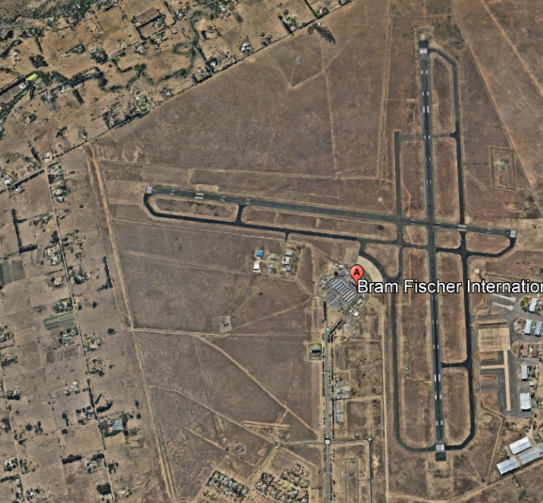

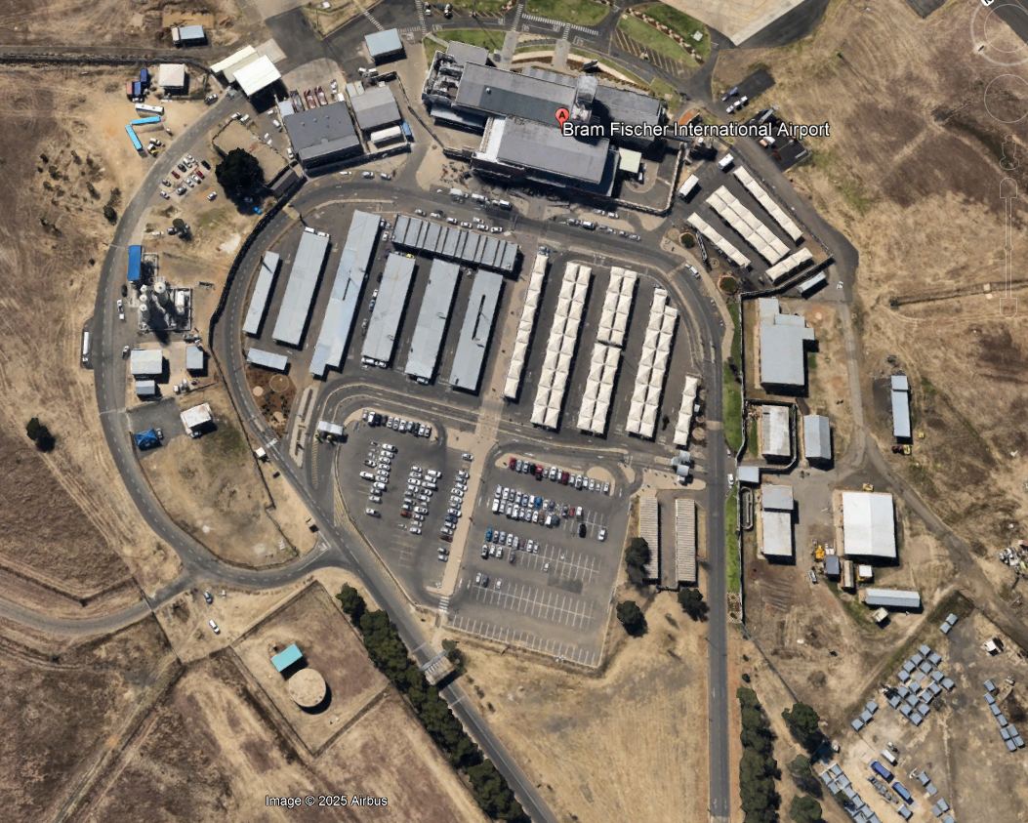

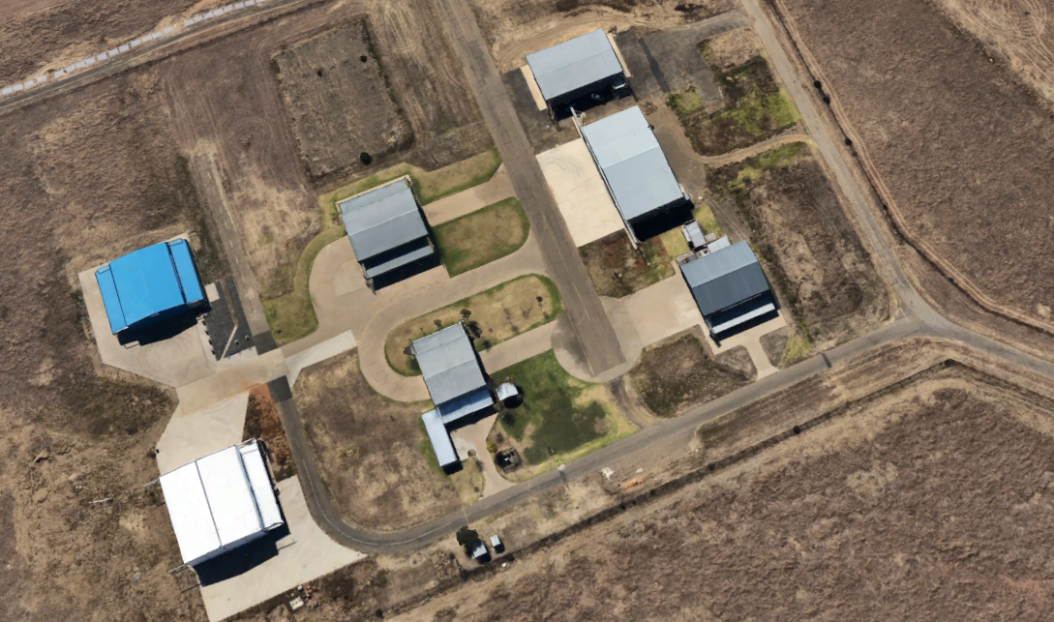

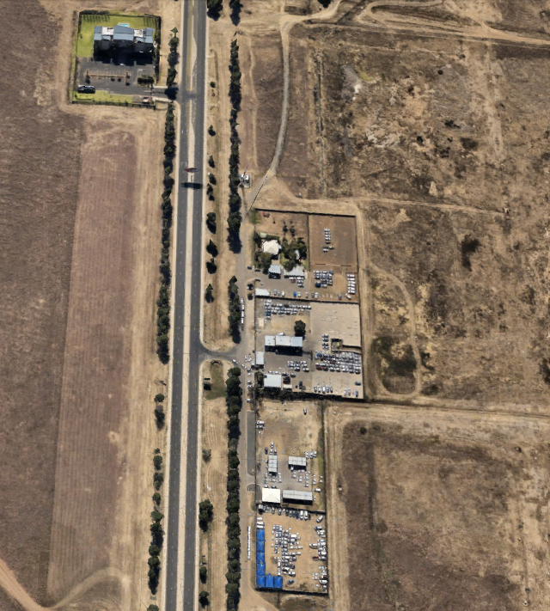

Environmental constraints and management

Service & Maintenance Contractors Environmental Terms and Conditions to Commence Work - EMS 048

The following Environmental Terms and Conditions shall be strictly adhered to by all contractors when conducting works for ACSA. ACSA shall audit contractor activities, products and services on an ad hoc basis to ensure compliance to these environmental conditions. Any pollution clean-up costs shall be borne by the contractor.

ISSUE | REQUIREMENT
Environmental Policy | ACSA’s Environmental Policy shall be communicated, comprehended and implemented by all ACSA appointed contractor staff (see attached Environmental Policy).
Stormwater, Soil and Groundwater Pollution | - No solid or liquid material may be permitted to contaminate or potentially contaminate stormwater, soil or groundwater resources.  - Any pollution that risks contamination of these resources must be cleaned up immediately. Spills must be reported to ACSA immediately. Contractors shall supply their own suitable clean-up materials where required.  - Washing, maintenance and refuelling of equipment shall only be allowed in designated service areas on ACSA property. It is the contractor’s responsibility to determine the location of these areas.  - No leaking equipment or vehicles shall be permitted on the airport.
Air Pollution | - Dust: Dust resulting from work activities that could cause a nuisance to employees or the public shall be kept to a minimum.  - Odours and emissions: All practical measures shall be taken to reduce unpleasant odours and emissions generated from work related activities.  - Fires: No open fires shall be permitted on site.
Noise Pollution | - All reasonable measures shall be taken to minimise noise generated on site as a result of work operations.  - The Contractor shall comply with the applicable regulations with regard to noise.
Waste Management | - Waste shall be separated as general or hazardous waste.  - General and hazardous waste shall be disposed of appropriately at a permitted landfill site should recycling or re-use of waste not be feasible.  - Under no circumstances shall solid or liquid waste be dumped, buried or burnt.  - Contractors shall always maintain a tidy, litter free environment in their work area.  - Contractors must keep on file:  - The name of the contracting waste company  - Waste disposal site used  - Monthly reports on quantities – separated into general, hazardous and recycled  - Maintained file of all Waste Manifest Documents and Certificates of Safe Disposal  - Copy of waste permit for disposal site  This information must be available during audits and inspections.
Handling & Storage of Hazardous Chemical Substances (HCS) | - All HCS shall be clearly labelled, stored and handled in accordance to Materials Safety Data Sheets.  - Materials Safety Data Sheets shall be stored with all HCS.  - All spillages of HCS must be cleaned-up immediately and disposed of as hazardous waste. (HCS spillages must be reported to ACSA immediately).  - All contractors shall be adequately informed with regards to the handling and storage of hazardous substances.  - Contractors shall comply with all relevant national, regional and local legislation with regard to the transport, storage, use and disposal of hazardous substances.
Water and Energy Consumption | ACSA promotes the conservation of water and energy resources. The contractor shall identify and manage those work activities that may result in water and energy wastage.
Training & Awareness | The conditions outlined in this permit shall be communicated to all contractors and their employees prior to commencing works at the airport.

Penalties
Penalties shall be imposed by ACSA on Contractors who are found to be infringing these requirements and/or legislation. The Contractor shall be advised in writing of the nature of the infringement and the amount of the penalty. The Contractor shall take the necessary steps (e.g. training/remediation) to prevent a recurrence of the infringement and shall advise ACSA accordingly.

The Contractor is also advised that the imposition of penalties does not replace any legal proceedings, the Council, authorities, land owners and/or members of the public may institute against the Contractor.

Penalties shall be between R200 and R20 000, depending upon the severity of the infringement. The decision on how much to impose will be made by ACSA’s Airport Environmental Management Representative in consultation with the Airport Manager or his/her designate, and will be final. In addition to the penalty, the Contractor shall be required to make good any damage caused as a result of the infringement at his/her own expense.

I, ________________________ (name & surname) of ________________________ (company)

agree to the above conditions and acknowledge ACSA’s right to impose penalties should I or any of my employees or sub-contractors fail to comply with these conditions.

Signed: ______________________ on this date: _______________________ (dd/mm/yyyy)

at: ___________________________________________ (airport name).

Quality assurance requirements

The Contractor shall ensure that works are carried out as per industry norms and the Airport Company South Africa procedures, OHS Act, and applicable standards. In this regard the Contractor will be expected to draft quality plans for the Service Manager from time to time.

BASELINE HIRA: ACSA GENERIC HAZARDS ASSESSMENT

Baseline Risk Assessment

Project Name: | Airport plumbing works and General Building Maintenance, for a period of Three (3) Years.
Document Number: HIRA 1 | Revision Number: 001

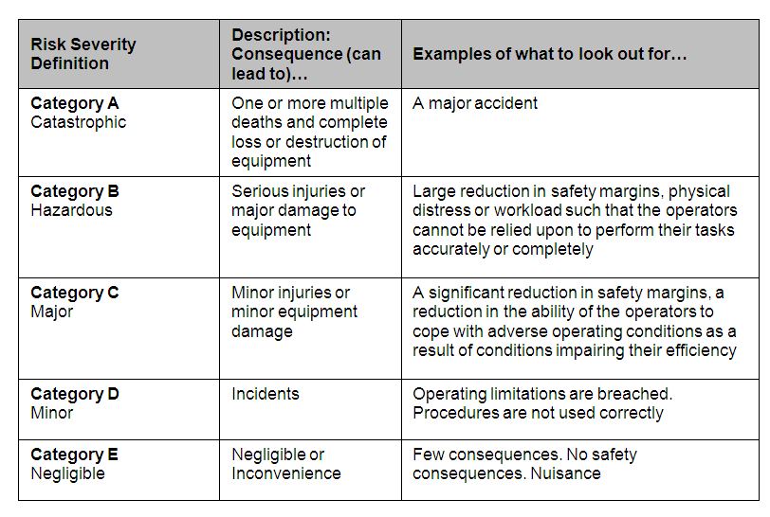

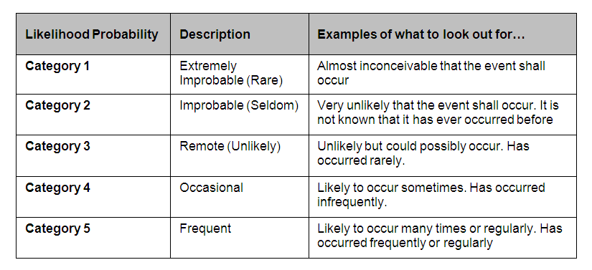

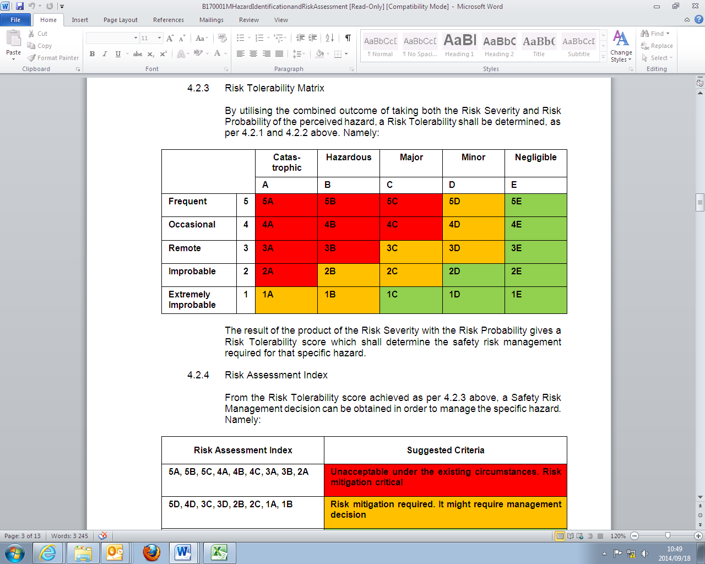

Generic Hazard | Specific component of Hazard | Hazard related consequence | Existing defenses to control risk | Safety Risk Index
Site establishment | Delivering of containers and materials; increased vehicle movements and location of services | Operational disruptions, incidents and service disruptions | Site plan location requires prior approval, services to be identified by ACSA representatives and drivers to be competent and vigilant of other road users. Vehicle inspections are to be conducted daily | 2D
Site Access | Access is to be controlled and movement of vehicles and staff are to be monitored to reduce impact on operations | Injuries to Airport users, traffic build up, operational delays, vehicle incidents | Site is to be access controlled. All visitors to site are to report to the site office. Entrance to site camp is to be kept clean, swept after truck deliveries to minimize impact to operations. | 2D
Persons on airside | Accidents and injuries | Injury to persons/Fatality | All staff wishing to work on the Airside are to go for Airside induction training. These staff members are to have valid Permits with them at all times. Personal protective equipment required for Airside includes but is not limited to high visibility jackets (as per the procedure, hearing protection, safety shoes & hard hats (if required). An airside safety plan must be submitted before commencement of work. | 3A
Vehicles on airside | Accidents and injuries | Damage to aircraft/vehicles/  property/persons | All vehicles operating on the Airside are to be fitted with a strobe light, appropriate signage in the form of a prefix, have the necessary vehicle permit in place, to be fitted with a fire extinguisher and are to be serviceable. Vehicles are to be checked by Airside Safety prior to be granted Airside access | 4A
Driving on airside | Incidents | Damage to aircraft/ vehicles/property/ persons | Airside induction is required for all persons entering the Airside. For persons wishing to drive on the Airside Service Road an AVOP 2 permit is required. Where work is to be conducted on the Airfield, then contractors are required to be under escorts or have undergone Radio License training and be in the possession of an AVOP 3 permit  The speed limit on the Apron Service Roads is 30km/h, 15km/h at the back of stand and 60km/h on the Perimeter Road. During period of Low Visibility (LVP) will be affected and no vehicular movements are allowed on the Airfield. Low visibility procedures will be in place | 4A
Driving on runways and taxiways without permission | Incursion (include definition) | Collision with aircraft/property damage or fatality/ies | Runway and taxiway markings are indicated as per ICAO Annex 14. Permission is required from Air Traffic Control when crossing runways and taxiways. Signage indicating movement areas are painted on the ground or by means of illuminated signage boxes. Only persons in possession of a valid Airside Vehicle Operators Permit with the necessary radio license (Partac training) will be permitted to drive in restricted areas. Vehicles under escort must follow at reasonable distance. | 3A
Noise | Health Risks | Noise induced hearing loss | Baseline and annual audiograms are to be conducted. Contractors are to implement a hearing conservation program and issue staff with hearing protection and provide the necessary training in this regard. Contractors to identify noisy operations in passenger areas and are to conduct noise generating operations at off peak times were possible or if unavoidable with ACSA’s Project Leaders written permission. | 3B
Jet blast | Potential injuries and property | Damage to vehicles/property/persons | Signage warning against jet blast is installed at high risk areas. Risks associated with jet blast are covered during Airside Induction Training. Caution to be taken around aircraft when the anti-collision lights are activated in the Apron bays. 75-meter clearance behind aircraft to be observed to prevent jet blast. Contractors to be aware of aircraft movements | 4C
Perimeter fence breach | Security risk | National Key Point Violation | Access and egress points are strictly enforced. Contractors are only to use the entry points as provided by the ACSA Project Leader. No materials are to be stored within 3 meter of the perimeter fence. | 3B
Crane operations | Height of crane | Flight path obstruction/collisi-on with aircraft | 30-meter height restriction procedure – refer to Airfield Operation Department for further information | 2A
Weather | Adverse weather conditions | Damage to aircraft/vehicles/equipment | Weather warnings are issued by the Airside Safety Department as and when required. All equipment on the Airside is to be secured | 4A
Construction works | Foreign Object Debris (FOD) | Ingestion into aircraft engine | Airside induction is required for all staff working on the Airside, FOD bins are to be used for any FOD found lying on the ground. All waste to be secured to prevent it from becoming airborne (refer to Environmental Terms and Conditions) | 4B
Construction works | Working at Height | Injury /fatality | Fall protection plan to be devised by the contractors in line with the Construction Regulations 2014. Rescue plans are to be included | 3A
Construction works | Storage of hazardous chemicals substances | Contamination/fire/ injury to persons/ environmental impact | ACSA’s Environmental terms and conditions are to be adhered to. All relevant legislation and bylaws are to be adhered to. All necessary permits are to be applied for by the contractor such as transport permits, possession permits and flammable certificates.  ACSA Environment and Fire and Rescue to be notified where a spill occurs. | 4B
Construction works | Waste | Attracts rodents and birds which leads to bird strikes and adds to FOD | Waste management to be implemented in line with ACSA’s Environmental Terms and Conditions | 4B
Construction works | Spillages (fuels/oils/hydraulics/chemicals/human waste) | Contamination/Pollution/injury to persons/adverse health effects | ACSA’s Environmental terms and conditions and applicable legislative controls are to be adhered to. ACSA Environment and Fire and Rescue to be notified where a spill occurs | 4B
Construction works | Dust | Damage to aircraft//injury to persons/adverse health effects/ | Dust suppression measures are to be implemented and PPE used where required | 4A
Construction works/ Trenching | Damage to underground services. Interruption of critical services | Electrocution, loss of critical services, damage to property, major injuries, aircraft diversions | Consult as-built plans. Scan area before trenching. Trenching to be done under competent supervision. | 4A
Delivery of materials | Falling materials or stones or sand | Vehicle/pedestrian accidents | Materials are to be delivered within specified time frames, flagman to be utilized during deliveries, load limitations to be observed, netting is to be used, contractors to clean road after deliveries | 4E
Lack of signage – warning signs | Injuries and accidents | Injuries and accidents | Contractors to install sufficient demarcations around construction sites along with the necessary warning signs and beacon lights (refer to Construction Regulations and Traffic Act) No signs are to be removed without prior permission and notification. Temporary way finding signage is required if signage has been disturbed | 2D
Waste management | Environmental impact | Illegal dumping | Temporary laydown areas to be identified and no illegal dumping is permitted. | 3C
Trolleys | Damaging trolleys through misuse | Injuries and property damage | Contractors to provide their own trolleys. ACSA’s trolleys are for passenger use only | 5D
Golf carts | Misuse of golf carts | Injuries and property damage | Contractor staff to be aware of golf cart movements on the Landside. Golf cart use for airport users only and not for contractor use for transporting materials. Golf carts operate in predetermined routes – contractors to be aware thereof | 3D
Fire equipment | Use and abuse of fire equipment | Injuries and property damage | Fire equipment is only to be used during emergencies. Contractors to provide their own fire equipment. No materials to be stored in ACSA fire cabinets. Emergency exits are to be kept clear at all times | 2B
Unattended bags | Security risk | Injuries/fatality to Airport users/stakeholders/ACSA employees. Bomb threat-damage to property, vehicle and or Operational disruptions | Contractors are not permitted to leave bags unattended as they will be removed and will be handed to SAPS | 5C
Speed limits | Car accidents | Injuries and vehicle damage | Speed limits are shown on signage in various areas. | 3C
Deliveries | Basement | Disrupt traffic flow and passenger movements | Delivery notes are required, and delivery times are to be specified. | 2C
Overhead works | Falling items | Injuries, vehicles, property damage | Fall protection plan required as per the Construction Regulations 2014. | 5C
General housekeeping | Damage to infrastructure | Injuries, property damages | Site and task specific risk assessments to carried out by the contractor | 4C

