
HSRC SCM Specifications to Request Quotes for CeSTII 20 Years Exhibition Materials

Background Project Description:

- The HSRC-CeSTII team is developing an exhibition recognising 20 years of science, technology and innovation measurement at the HSRC.
- The exhibition will be launched at the HSRC Research Conference “Next Generation Insights on Intractable National and Global Challenges” 18-20 September 2023, as well as during the launch of the HSRC’s Cape Town office.
- The exhibition will permanently be housed in the CeSTII space of the HSRC's Cape Town office, locating as necessary to other sites/venues as the opportunities arise.
- Under the title, 20 years of measuring South African science, technology and innovation indicators, the exhibition will consist of stations focussing on team objectives, thought leader quotes, team building and a timeline.
- The exhibition will consist of seven components to be procured, some of which will also include installation by the service provider, such as:
- Washing-line-and-peg Hung Printed A5 Photographs
- Exhibition Leaflet
- Detailed specifications for each component, with illustrative reference images, is provided in the table overleaf for SCM.
- The contact for this project in CeSTII is Gerard Ralphs gralph@hsrc.ac.za.

SCM Specifications:
Element | Type of service provider | What CeSTII will do | What we want service provider to do | Unit | Units to be quoted for | Detailed Specifications | Reference example
20 Years Exhibition Leaflet | Printer | - Provide a printable design of the leaflet | - Print the leaflet and deliver to CT office by 13 September | - 1 leaflet | - 500 | - 20 pages fold out and retractable  - 10 pages per side  - Each page is 120mm x 120mm  - Full colour  - Matt finish  - Scored to fold  - Paper weight 150mg | Click to go to illustrative example >
CeSTII Team Photo Wall – photographs | Printer | - Provide polaroid style design of photos | - Print photos on full-colour matt finish  - Cut to size | - Photograph | - 50 | - Type of wall: Dry Wall  - Max. height of wall space available: 250cm  - Max. length of wall space available:  - Type of wall art: | Click to go to illustrative example >

Illustrative Examples:

20 Years Exhibition Leaflet | 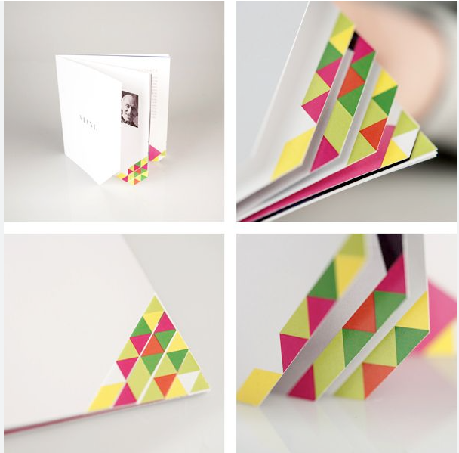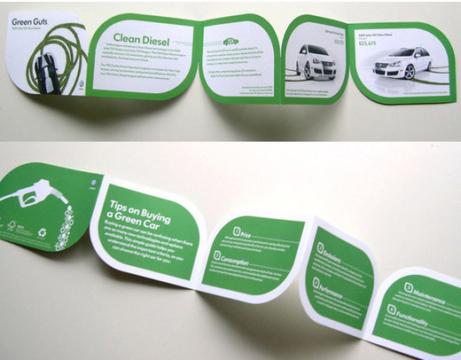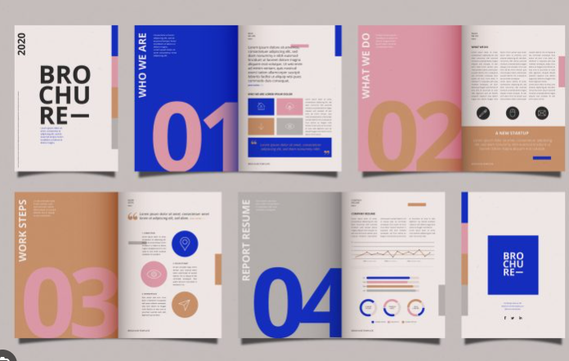
CeSTII Team Photo Wall – photographs | 