The scope of works entails the renovation of the Rietkuil Single Quarters kitchen to meet compliance requirements and attend to general maintenance issues. The required repairs include repair of damaged/leaking roofs, replacement of damaged entrance/exit doors, repairs of cold room doors, repair of ventilation/extraction unit and kitchen and relocation of gas tank with cage.
All the repair works and installations of the new components shall include all fittings and all necessary ancillary items.

Description of the works

Dining hall

Design and install/replace the new roof structure including drainage systems on the roof :

Dismantle existing roof structure by removal of the following components;

Top roof tiles - Marley Double Roman concrete type tiles– coverage 91m²

Membrane/coating waterproofing, 30m perimeter

Old fascia boards, 40m perimeter

Old Steel galvanized gutters, 30m perimeter

Old cast iron downpipe, 110mm dia, 3,5m long

Remove and terminate/reroute electrical cables inside the roof

Dismantle and remove existing temporary support scaffolding structure; 6 off frames;

3m long standards; 6 off

2m long ledgers; 9 off

1.5m short ledgers; 12 off

3m long ladder beams; 8 off

Remove standard dry walling of 6mm board that enclose the dining hall; 10m perimeter, 3m high

Install temporary covering during construction period to cover the opening

Design new roof structure

Assess the existing roof/wall layout and design a Monoplanar prefabricated timber roof structure as per SANS 1900 and SANS 2001-CT2 standard to match existing layout.

Wall layout of 15m length by 8m width

Reconstruct roof structure

Fabricate and install new roof structure including roof trusses, waterproofing, roof tiles, flashing, valleys, gutters, downpipes and fascia.

Roof tile, gutter and downpipe to match existing

New roof to cover 91m²

Reinstate water supply pipes in the roof as existing

Reinstate electrical cables in the roof as existing

Paint gutters, downpipes, fascia and make good. Match existing. With acrylic paint

Supply and install new ceiling (91m²)

Supply and install 4,6mm fibre-cement plain ceiling boards

Paint the ceiling and make good the area.

Painted with Acrylic PVA white paint

Install standard Polystyrene cornices on the ceiling edge perimeter (39m).

Upper Edge Z60 Polystyrene Cornice

Supply and install new LBP-24-S-60W-LED lights
on the dining hall ceiling (x7)

Remove old light switches and install new ones

All interior walls in the dining hall shall be painted (115m²)

Grecian white paint colour

Fill and repair all cracks on walls before painting

Floor tiling

Remove existing ceramic tiles (91m²)

Scrape residual adhesive off the floor, clean and prepare the floor for new floor tile installation

New floor tile installation (39m²)

Supply and install ceramic floor tiles

Light grey in colour, 330 mm x 330 mm

Reinstate all fixed tables and benches in the dining hall

Install new timber skirting after tiling to match existing (39m)

Replace wall mounted heaters in dining hall

Remove existing old heaters from wall. Close wall with bricks and plaster and paint. Install wall-mounted heater and provide power source if not existing already.

Dining patio

Reinstate the outdoor open roof

Dismantle existing roof structure (32m²)

Remove all roof tiles, waterproofing, flashing, fascia, gutters and downpipes of affected roof area

Make good the roof drainage

Reinstate all gutters and downpipes

Replace the missing drain cover with new square dish grid inlet of size 600x600 to fit

Kitchen area roof and ceiling

Roof leaks repairs

Identify all leaking areas

Identify all damaged gutters and downpipes and replace with galvanised steel gutters and downpipes.

Install waterproofing at identified leaking areas

Replace affected ceiling

Replace water damaged ceiling

Paint the ceiling with Acrylic PVA and make good the area.

Replace asbestos ceiling in the kitchen (131m²)

Replace with flush plaster Rhino-board ceiling and plaster with Rhino-lite plaster

Paint the ceiling and make good the area.

Painted with Acrylic PVA white paint

Supply and install new LBP-24-S-60W-LED lights on the kitchen hall ceiling (x12)

Remove old light switches and install new ones

Install standard Polystyrene cornices on the ceiling edge perimeter (66m).

Upper Edge Z60 Polystyrene Cornice

Swirl room

Re-design and install the new roof structure

Dismantle existing roof structure (28m²)

Remove all roof tiles, waterproofing, flashing, fascia, gutters and downpipes of affected roof area

Design new roof structure

Assess roof/wall layout and design appropriate roof structure as per SANS 1900 and SANS 2001-CT2 standard to match existing.

Reconstruct roof structure

Install new roof structure including roof trusses, waterproofing, roof tiles, flashing, valleys, gutters, downpipes and fascia. Match existing.

Roof tile, gutter and downpipe to match existing (galvanised)

New roof to cover 28m²

Supply and install new ceiling (28m²)

Supply and install 4,6mm fibre-cement plain ceiling boards

Paint the ceiling and make good the area.

Painted with Acrylic PVA white paint

Supply and install new LBP-24-S-60W-LED lights on the swirl room ceiling (x2)

Remove old light switches and install new ones

Install standard Polystyrene cornices on the ceiling edge perimeter (21m).

Upper Edge Z60 Polystyrene Cornice

Replace the existing gates – entrance & exit

Remove old entrance and exit gates

Single gate Clear view lockable hinged gate for entrance

Double gate Clear view lockable hinged gate for exit

Cold room freezer

House the cold room unit with brickwork structure

Repair existing foundation brickwork on the foundation

Build a double wall masonry enclosing the cold room freezer up to a height of 2.1m

Cold room freezer enclosure dimensions

Length 4.6m

Width 3.40m

Supply and install service door Clear view on the eastern side of the enclosure

New sloped IBR roof with gutters and downpipe

Design appropriate IBR roof covering for cold room as per concept sketch below

Supply and install IBR roof sheet (0.8mm)

Supply and install isotherm insulation below the IBR roof sheet

Thickness 40mm

Density 8.5kg/m³

Size 16m²

Supply and install gutters in the front of the enclosure (3.4m). Paint to match existing with acrylic paint

Supply and install 2x downpipes in the front of the enclosure, one on each corner to drain into the drain inlet. Paint to match existing with acrylic paint
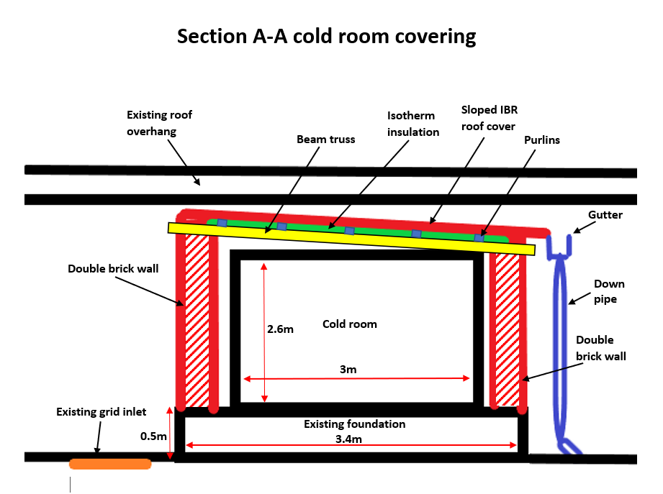

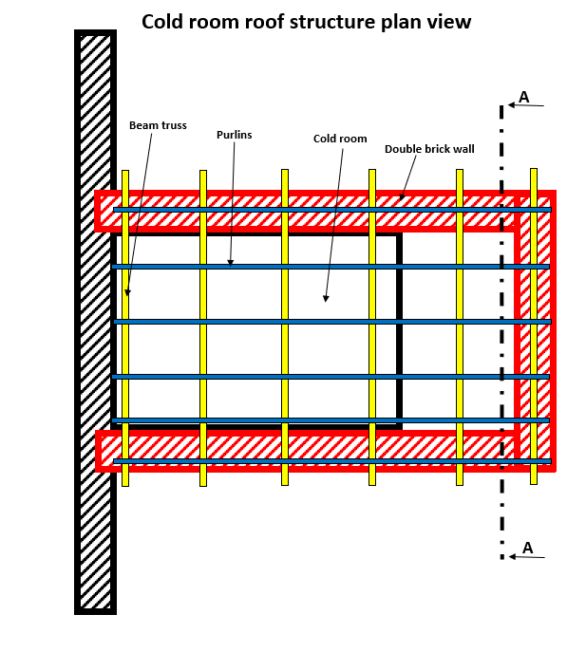

Slope direction

Install new heavy-duty door gasket (x 2, for exterior and interior doors)

Supply and install cold room large door heavy duty gasket around all sides of the door

Gasket spec: Height 25mm – Width 35mm, to suit door of 92mm thickness

Door height 2.1m; Door width 1m

Repair door hinges

Repair or replace loose cold room door hinges. If replacing, replace with matching existing spec or similar.

Vegetables cold room

Install new heavy-duty door gasket

Supply and install cold room large door heavy duty gasket around all sides of the door

Gasket spec: Height 25mm – Width 35mm, to suit door of 92mm thickness

Door height 2.1m; Door width 1m

Repair door hinges

Repair or replace loose cold room door hinges. If replacing, replace with matching existing spec or similar.

Kitchen equipment

Relocating the gas cage (as per SANS 10087-1)

Construct and install a lockable gas cylinder storage cage to house 2x 19kg gas tanks on the eastern side of the kitchen as per SANS 10087-1

Reroute gas supply pipe from gas tank on the eastern side of the kitchen. Sleeve tube in stainless steel conduit as per SANS 10087-1

Fat trap

Supply and install an underground grease trap with phase separation and a solid strainer basket.

Stainless Steel 304 material frame and lid to ensure acid and stain resistance.

Assess, size and install new fat trap for the kitchen drains. Retrofit into existing.

Replace rusted cast iron drain pipes with 60mm diameter PVC pipes

Window screen

Install adjustable magnetic mesh window fly screen on all kitchen windows sized 2mx1.2m

Kitchen floor drains

Replace rusted floor drain gratings with stainless steel drain gratings to match existing size and design

Length 9m

Width 0.25m

General maintenance

Entrance/exit door frame and doors

Replace rusted door frames and door with aluminium frame and glass doors

Double glass door with aluminium frame

Length 2.4m; Width 1.8m

Supply and install automatic door closer

Repair floor area where tiling has been repaired with plaster. Remove plaster and install floor tiling (2m²) to match existing tile

Repair shower walls by finishing off with cladding and installing wall tiles (1m²) to match existing wall tiles

