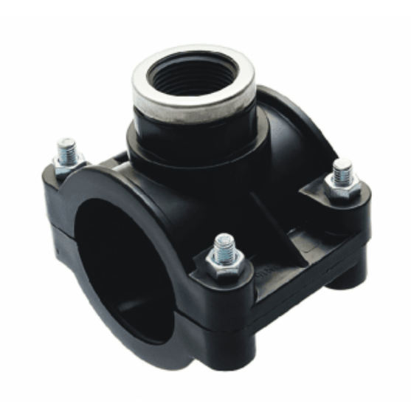
Saddle clamp, 90mmx25mm
Saddle clamp, 75mmx25mm

