ARC Infruitec-Nietvoorbij
Private Bag X5026, Stellenbosch, 7599, South Africa
Tel: (021) 809 3172
Fax: (021) 809 3400/3592
OFFICE OF SUPPLY CHAIN MANAGEMENT
- DESCRIPTION OF PURCHASE: WHITE COTTON LAB COATS + EMBROIDERY

WHITE COTTON LAB COATS + EMBROIDERY |  | Quantity | If No, Please Indicate Deviation
1. Specific Description | Compliance to Specification (Yes/No)  *Describe If Specification Differs | Quantity | If No, Please Indicate Deviation
- White cotton dust coat, long sleeves  Size 38 – Taryne  Size 38 – Alvino  Size 36 – Biosha  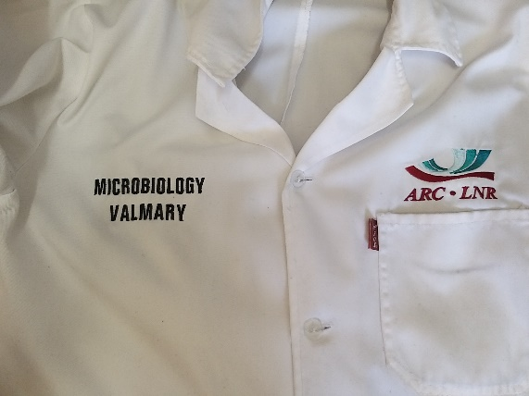 |  | 3
- ARC Logo embroidered on top of left pocket |  | 3
- Division name embroidered on right side |  | 3
- Person name embroidered on right side – below Division |  | 3
2. General

- PRICING SCHEDULE FOR DELIVERY OF WHITE COTTON LAB COATS + EMBROIDERY

Item description | Quantity | Unit price | Total Price
- White cotton dust coat, long sleeves | 3
- ARC Logo embroidered on top of left pocket | 3
- Division name embroidered on right side | 3
- Person name embroidered on right side – below Division | 3
SUBTOTAL
VAT
GRANDTOTAL

Company name:……………………………………………………………………………………………….

Contact person:………………………………………………………………………………………………..

Contact number:……………………………………………………………………………………………….

Date and signature:…………………………………………………………………………………………

Contact: Valmary van Breda – vbredav@arc.agric.za or 021 809 3039

