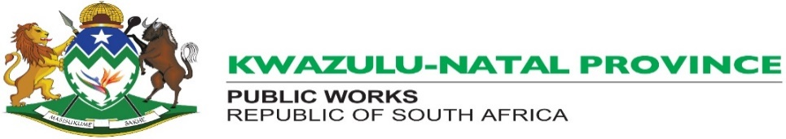

Notification of Tender
The KZN Department of Public Works: Harry Gwala District Office invites bids for the following service:

Description of Service : Kokstad Research Station: Department Of Agriculture:
Electrical Repairs To The Sub- Station
Bid Number/Quotation number : ZNQ021-2025/2026HG
CIDB Grading : 1EP OR HIGHER
Contract Period : Two (02) Calendar Months
Cost of Tender Document : R0.00
Closing Date : 24 November 2025
Time : 11:00
Documents available from : KZN Department of Public Works: Harry Gwala District Office: No.2
Margaret Street, Ixopo
: During Working Hours 09h00 to 15h00.
Enquiries relating to bid
document may be directed to : Ms. P. Khumalo - Tel: 039 8340700
All technical enquiries may be directed
to : Ms F. Buthelezi Tel: 039 8340700

TENDERERS TO NOTE:

- Requirements for sealing, addressing, delivery, opening and assessment of the tender are contained in the tender document.
2. The Department reserves the right not to award to the lowest bidder.
3. In addition, the Department may conduct a detailed risk assessment prior to the award of the bid.
4. Late submissions will not be accepted.
5. Faxed or e-mailed bids are not accepted.
6. Only Bidders registered on Central Suppliers Database and within the applicable CIDB grading of 1EP or higher
will be eligible to submit quotations.
7. The Preference points system is applicable for this bid is 80/20, where 20 points of specific goals will be
allocated as followers:
- Ownership by people who are black :10
- Exempted Micro-Enterprise (EME) :10

