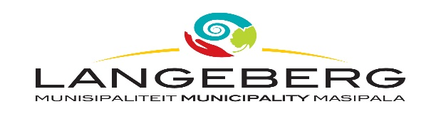

QUOTATION 57/2022: OVERHAUL GEARBOX CBR2684
Published on 09 September 2022

Tenders are hereby requested for the OVERHAUL GEARBOX CBR 2684 as specified in the bid document. Completed Bids, in sealed envelopes, clearly marked “QUOTATION 57/2022: OVERHAUL GEARBOX CBR2684” should be placed in the tender box, at the Langeberg Municipal Office, 28 Main Road, Ashton, not later than 12:00 on 23 SEPTEMBER 2022 when the Bids will be opened in public. Late, faxed or e-mailed tenders will not be considered.

PLEASE NOTE:
The official Bid document must be fully completed in black ink, all pages must be submitted and the document should preferably be bound.
Supporting documents must be submitted separately and must be stapled or bound.
Only goods and services applicable to local production and content will be considered.
The lowest, or any tender, will not necessarily be accepted and council reserves the right to accept any tender. Tenders will be evaluated according to the Council’s Supply Chain Management Policy and the 80/20 Preference Point system. The Supply Chain Management Policy can be viewed at Municipal Offices or www.langeberg.gov.za

Tender documents are available from 09 SEPTEMBER 2022, on the Langeberg Municipal website: www.langeberg.gov.za

Please refer written enquiries to MR. W. BREWIS (wbrewis@langeberg.gov.za).

MGAJO, ACTING MUNICIPAL MANAGER
Private Bag X2, Ashton, 6715

