REQUEST FOR QUOTATION OF GOODS AND SERVICES
RFQ NO: RFQ97AM (25/26)
IMPORTANT INFORMATION FOR CONSIDERATION BY SUPPLIERS
NOTE:
- Tenderers are required to use this Request for Quotation (RFQ) Form when quoting and include VAT per item (where applicable), and the quotation must be in your company’s letterhead, correct banking details should be also included on the quotation.
- Quotations received after the closing date and time, at the Quotations@dffe.gov.za will NOT be accepted for consideration.
- For quotations with a Rand value up to R50 000 000, the preference point system of 80/20 will apply, where 80 points will be for (Price) and 20 points will be for Specific Goals (more than 50% ownership by (either Black, Women or Disability) in terms of section 2(1)(d) of the Preferential Procurement Policy Framework Act, 2000, (Act No 5 of 2000),
- A trust, consortium or joint venture will qualify for Preference Points if their average combined ownership is more than 50% (fifty percent) of ownership on specific goals (e.g. two or more companies claiming preference points, Ownership/ Directorship will be combined and divided by the number of companies to ascertain the preference points),
- DFFE reserves the right to request additional information to validate any information submitted by bidders including preference points claimed,
- Unless specifically stated by DFFE in the specification, all received prices must be firm until the required goods or services are delivered to the specified location. No price adjustment will be accepted, except those that are subject to rate of exchange.

- For bidders to claim preference points, the following must be adhered to;
- Submit a complete and signed SBD 6.1 which is used for claiming specific goals.
- Submit a Medical Certificate signed by a medical practitioner with a practice number when claiming for disability.
- Submit a SANAS/ Companies and Intelectual Properthy Commission (CIPC) Accredited B-BBEE certificate or sworn affidavit indicating the level of ownership in the enterprise by persons historically disadvantaged by unfair discrimination on the basis of race; gender or
- Submit ownership Certificate issued by the Companies and Intellectual Property Commission (CIPC)
- CSD Registration Report or MAAA...number.
- Failure on the part of a tenderer to submit proof or document required in terms of this tender to claim points for specific goals with the tender, will be interpreted to mean that preference points for specific goals are not claimed.
- DFFE reserves the right to:
- Perform due diligence during evaluation of quotations on information submitted by tenderers.
- NOT to appoint any tenderer.
- Tenderers must Indicate delivery timelines and quotation expiry date (Unless otherwise stated, quotations will be deemed valid for a period of 30 days from the date RFQ closes)
- Tenderers are required to duly complete and sign the SBD 4, SBD 6.1 forms respectively,
- DFFE reserves the right to negotiate price with the preferred tenderers in line with the legislative requirements.
In a case where there are pictures and or brand names on the specification, tenderers must note that those pictures are for illustration purpose and similar or equivalent brand specifications will be accepted by the Department.
SUPPLIER DETAILS (TO BE COMPLETED BY THE USER)
SUPPLIER NAME:
TEL NO: |  |  |  | EMAIL ADDRESS:
CENTRAL SUPPLIER DATABASE (CSD) NUMBER
ATTENTION TO:
DATE REQUESTED: |  | 19 June 2025
SERVICE/GOODS LOCATION |  | Durban
SUBMIT QUOTATION TO DEPARTMENT OF ENVIRONMENT, FORESTRY AND FISHERIES
ATTENTION TO:
TEL NO: |  |  | EMAIL ADDRESS: |  | Quotations@dffe.gov.za
CC EMAIL ADD: Sithembela smthalane@dffe.gov.za

CLOSING DATE: 25 June 2025  (Quotations to be advertised for at least 5 days) |  |  | CLOSING |  | TIME |  | 1 | 1 | : | 0 | 0
MANDATORY REQUIREMENTS (YES/NO) |  |  |  | Proof Attached  (to be completed by DFFE)
Professional registration: |  |  | NO
Food Premises Certificate issued by the Municipality |  |  | NO
The above mandatory requirements will apply, and bidders’ must submit the requested requirements indicated above with the RFQ documents at the closing date and time of the RFQ. Bidders who fail to comply with any of the mandatory requirements will be disqualified and not be evaluated further.

NO | BRIEF DESCRIPTION OF ITEM(S)/ SERVICE(S) REQUIRED:  PROCUREMENT OF EXHIBITION SPACE AT THE ORGANIC AND NATURAL PRODUCTS EXPO AFRICA  18 - 20 September 2025 |  |  | UNIT OF ISSUE  (BOX/ ITEM) | QUANTITY OF ITEM(S) | NUMBER OF DAYS | UNIT AMOUNT | TOTAL AMOUNT  (to be same as the quotation attached)
PROCUREMENT OF EXHIBITION SPACE AT THE ORGANIC AND NATURAL PRODUCTS EXPO AFRICA in Sandton Convention Centre from 18 - 20 September 2025

IMPORTANT NOTES:
The Organic & Natural Products Expo Africa is a platform that aims to increase awareness, stimulate growth, and enhance interaction in the natural and organic product market. The expo is a physical industry engagement that is part of the portfolio of offerings by SA Trade Promotions, providing 365 days exposure to participants for the various SMMES in the upcoming Africa Travel Indaba. The Expo will be held in Sandton Convention Centre from 18 - 20 September 2025
SPECIFICATION:
1 | - Conference area: Size: 100m² carpeted floor space for 75 people  - 75 x Conference Chairs  - 1 x Podium |  |  | Each | 1 | 3
2 | - Walling and signage (including ABF branding) |  |  | Each | 3 | 3
3 | - Electrical DB board and plug points |  |  | Each | 3 | 3
4 | - PA System x 2 Speakers  - 2 roving mics location inside exhibition area  - Relevant cabling and set up |  |  | Set | 1 | 3
5 | Exhibition stand– For 30 SMMEs  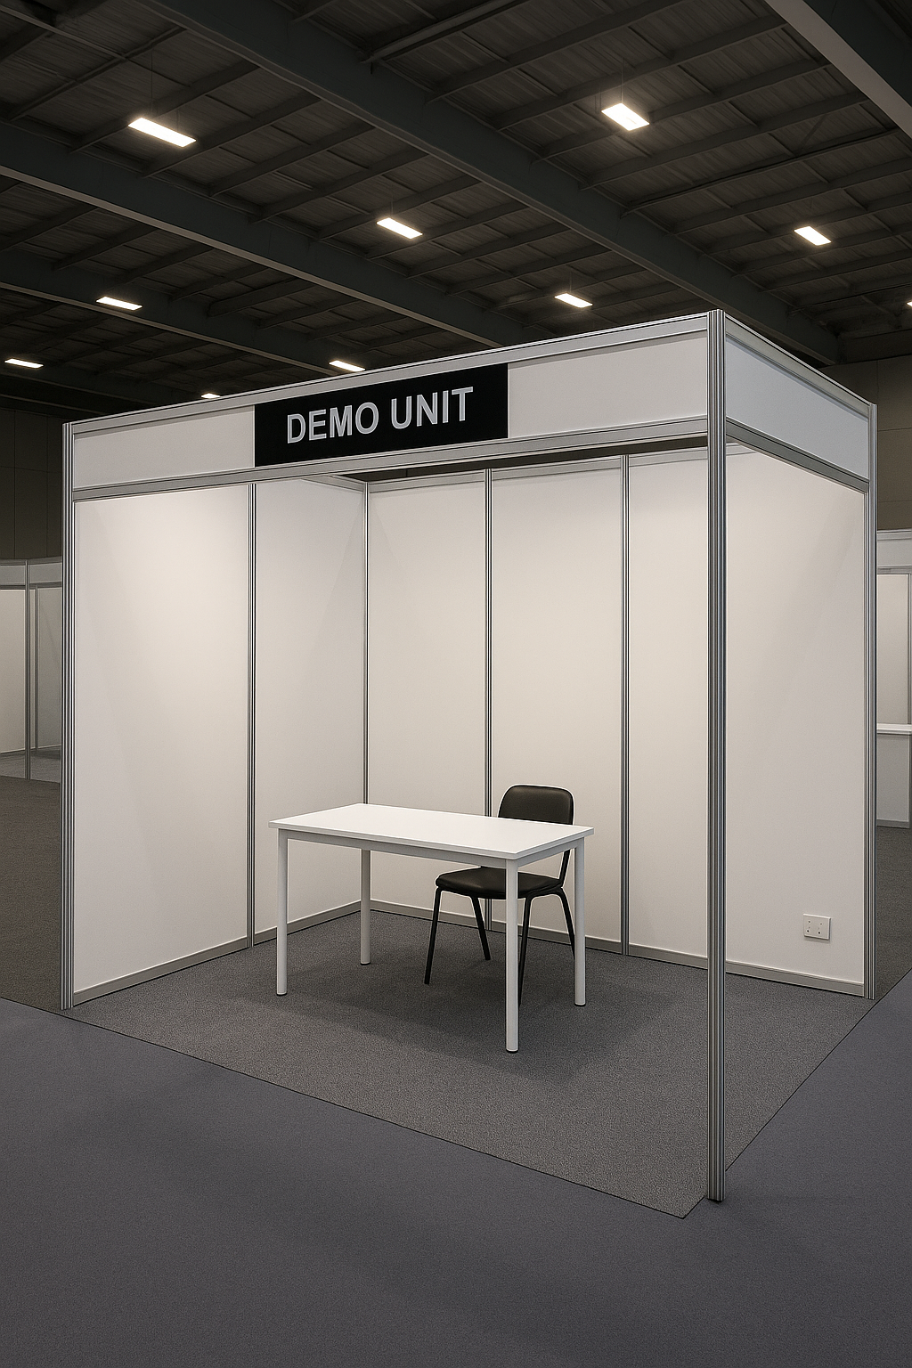  Each Unit Includes:  - Exhibition stand: 3m² carpeted exhibition space  - Shell scheme walling  - Company name fascia |  |  | Each | 30 | 3
6 | - Built-in counter |  |  | Each | 30 | 3
7 | - 2 x bar stool |  |  | Each | 60 | 3
8 | - Plug point |  |  | Each | 30 | 3
9 | - Small bins |  |  | Each | 30 | 3
Admin Office Specifications

10 | - Admin Office Specifications – Expo Setup (Size & Space: 12 m²)  - Enclosed with partition walls (2.4m high minimum) |  |  | Each | 1 | 3
11 | - Lockable door for privacy and security |  |  | Each | 1 | 3
12 | - 3 x Trestle tables (1.89 m X 76cm) with black/white tablecloths |  |  | Each | 2 | 3
13 | - 10 x plastic chairs- Heavy-duty plastic chairs with covers |  |  | Each | 5 | 3
14 | - 1 x Lockable storage cabinet or drawer unit |  |  | Each | 1 | 3
15 | - 1 x Shelving unit or literature rack |  |  | Each | 1 | 3
16 | - Waste bin |  |  | Each | 2 | 3
17 | - 1 x Plug point |  |  | Each | 1 | 3
IMPORTANT REQUIREMENTS:
- Electric certificate
- Engineer’s certificate
- Floor plan drawing/design
- build-up and break- down of the stands:
Set up date: 15 September 2025.
Break down: 21 September 2025
TOTAL VAT 15% |  |  |  |  |  |  |  | R
GRAND TOTAL AMOUNT ( Incl. 15% VAT for VAT Vendors)  Note:All delivery costs all applicable taxes, includes value- added tax, pay as you earn, income tax, unemployment insurance fund contributions and skills development levies must be included in the bid price, for delivery at the prescribed destination.  NB: the service provider must submit a valid quotation as per the above guideline on his/ her letterhead reflecting the item descriptions; validity; banking details contact details and CSD MAAA number. |  |  |  |  |  |  |  | R
NB: No goods/ services should be delivered before an official order is received from the Department of Forestry,Fisheries and the Environment.
- Failure to deliver goods within the agreed timelines might result in an order being cancelled and possible inclusion on the Database of Restricted suppliers by the National Treasury

