IPP - SCOPE OF WORK – Annexure K2
  - Functional Requirements:

Functional Area | Functional Requirement | Current Environment | Work Requirement | Screen / Wire Frame
Disaster Recovery Environment | - Set up and test disaster recovery  - Formalise pre-production environment as a “hot standby” | - Can use of Pre-production environment for disaster recovery  - Disaster recovery servers in place but not configured | - Review, assess pre-production environment for "hot standby"  - Establish process/procedures/environment for pre-production to be a “hot standby”  - Design & set up disaster recovery environment  - Compile disaster recovery documentation (as per Eskom templates)  - Test disaster recovery  - Update architecture documents and submit to governance for approval  - Update functional specification document | N/A
Environment Upgrade | - Upgrade to Microsoft .NET 6 framework | - Microsoft .NET 4.5 framework  - Windows Server 2019  - Windows SQL Server 2019  - DevExpress | - Impact assessment  - Upgrade / Migrate to .NET 6  - Modify and recompile applets  - Test applets end-to-end  - Update architecture documents and submit to governance for approval  - Update functional specification document | N/A
IPP Portal Menu / Landing Page | - Adding of additional menu items  - Enable additional dynamic public info (e.g news items - Bid Window X is open & close on dd/mm/yyyy hh:mm)  - Modify Login, Password reset and password change screens to be more user friendly with validation messages and error messages. | - Written in Visual Studio (MVC) NET 4.5 framework  - USE CASE done  - Applet in place | - Review USE CASE  - Modify applet  - Add new menu items (as per below)  - Link new menu items to relevant applets  - Update architecture documents and submit to governance for approval  - Update functional specification document | 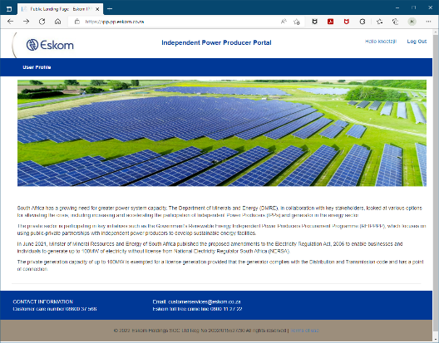
USER MANAGEMENT | - Enhance to the user management module to be more user friendly (e.g., list views, search functionality, Validation Messages, general user-friendly screen enhancements | - Written in Visual Studio (MVC) NET 4.5 framework  - USE CASE done  - Basic applet in place | - Review USE CASE  - Modify applet  - Test applet end-to-end, including current functionality  - Update architecture documents and submit to governance for approval  - Update functional specification document | 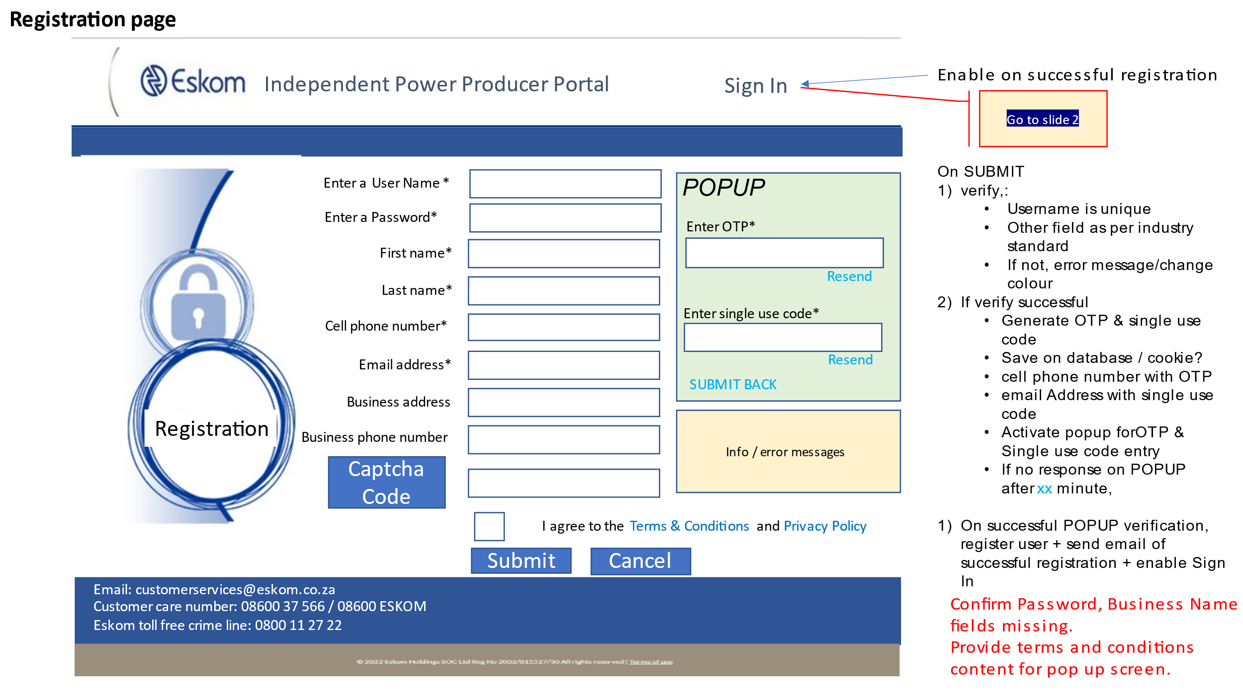
APPLETS enhancements | - Capability to record when (date & time) & duration of user access to applets  - Ability to view the information related to user access of applets.  - Handling of exceptions/error (e.g. source system unavailable)  - Updating of components newer software version (e.g. graphs, list views)  - Implement bootstrap of applets for scalability on multiple devices  - Modification of changed functionality | - Applets written in Visual Studio (Grid Control/MVC)  - Integration to relevant system (i.e., CC&I, CC&B, THEMIS) via Data Power and Oracle Fusion messages in place  - Applets in place or developed  - Some capability not in place | - Create USE CASE(s)  - Create required database tables  - Design, develop and test applet.  - Add menu item & link to applet in the menu  - Modify roles & services/applets associated with roles  - Modify applets (existing & below) to include this capability  - Test applets end-to-end  - Design, develop and test applet to view user access of applets information using Visual Studio (Web Forms or MVC)  - Update and test integration path/point.  - Document the end-to-end integration on Eskom templates and submit to governance for approval.  - Update architecture documents and submit to governance for approval  - Update functional specification document | N/A
APPLICATION FOR GRID CONNECTION | - The Operating unit, zone, Sector and Customer Network Centre fields must not be visible to external IPP users.  - Implement the rules that convert the IPP supplied information into the Operating Unit, Sector and Customer Network Centre values to be provided to the integration message | - Written in Visual Studio (MVC)  - USE CASE done  - To confirm Integration with CC&I via Oracle Fusion message in place  - Interface to SharePoint document library  - Information stored in IPP Portal database  - Links to other applets:  - LIST OF APPLICATIONS | - Determine business rules  - What information does IPP need to provide  - Conversion rules to Operating Unit, Sector and Customer Network Centre values  - Review USE CASE  - Change document library to interface to OpenText (Refer to “App4G-Docmuents” Presentation)  - Modify applet  - Add menu item & link to applet in the menu  - Update and test integration path/point.  - Document the end-to -end integration on Eskom templates and submit to governance for approval.  - Test applet end-to-end  - Update architecture documents and submit to governance for approval  - Update functional specification document | 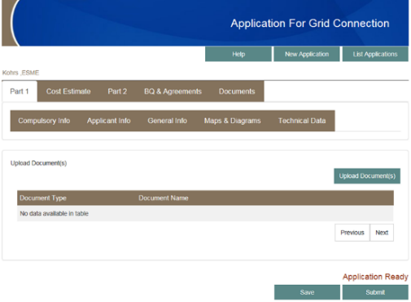
LIST OF APPLICATIONS | - Ability to download an application to an PDF file | - Written in Visual Studio (MVC)  - Using SSRS to create PDF file of Application for Grid Connection  - To confirm Integration with CC&I via Oracle Fusion message in place  - Capability was de-activate as Data Power message not in place. | - Review USE CASE  - Modify applet  - Modify applet Refer to “App4G-Docmuents” Presentation  - Test applet end-to-end  - Add menu item & link to applet in the menu  - Update architecture documents and submit to governance for approval  - Update functional specification document | 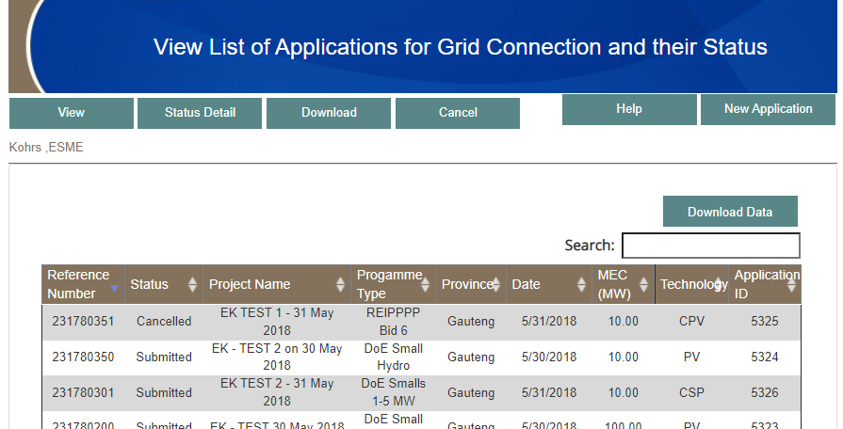
VIEW ACCOUNT BALANCE | - Modify integration messages to cater for Data Power | - Written in Visual Studio (Web Forms) NET 4.5 framework  - To confirm Integration message to CC&B via Oracle Fusion in place, however documentation is not available  - Applet de-activated due to integration message via Data Power not being available | - Review USE CASE  - Modify applet  - Reserve engineer integration message, include Data Power message  - Update and test integration path/point.  - Document the end-to -end integration on Eskom templates and submit to governance for approval.  - Test applet end-to-end  - Update architecture documents and submit to governance for approval  - Update functional specification document | 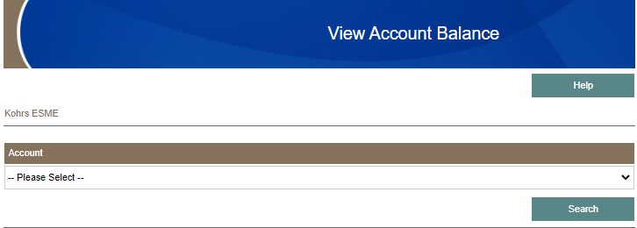
VIEW BILL HISTORY | - Modify integration messages to cater for Data Power | - Written in Visual Studio (Web Forms) NET 4.5 framework  - Applet de-activated due to integration message via Data Power not being available  - To confirm Integration message to CC&B via Oracle Fusion in place, however documentation is not available | - Review USE CASE  - Modify applet  - Reserve engineer integration message, include Data Power Message  - Update and test integration path/point.  - Document the end-to -end integration on Eskom templates and submit to governance for approval.  - Test applet end-to-end  - Update architecture documents and submit to governance for approval  - Update functional specification document | 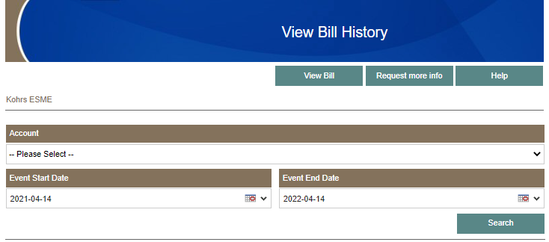
LOG A CASE | - Modify integration messages to cater for Data Power | - Written in Visual Studio (MVC) NET 4.5 framework  - Applet de-activated due to integration message via Data Power not being available  - To confirm Integration message to CC&B in place | - Review USE CASE  - Modify applet  - Add menu item & link to applet in the menu  - Update and test integration path/point.  - Document the end-to -end integration on Eskom templates and submit to governance for approval.  - Test applet end-to-end  - Update architecture documents and submit to governance for approval  - Update functional specification document | 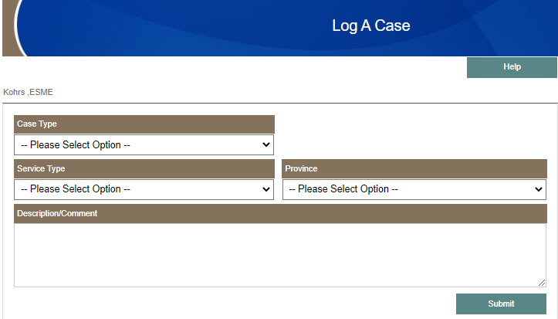
VIEW CASE LIST | - Modify integration messages to cater for Data Power | - Written in Visual Studio (MVC) NET 4.5 framework  - Applet de-activated due to integration message via Data Power not being available  - To confirm Integration message to CC&B in place | - Review USE CASE  - Modify applet  - Add menu item & link to applet in the menu  - Update and test integration path/point.  - Document the end-to -end integration on Eskom templates and submit to governance for approval.  - Test applet end-to-end  - Update architecture documents and submit to governance for approval  - Update functional specification document | 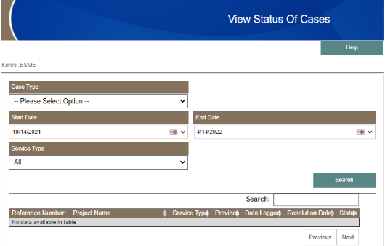
IPP DAY AHEAD FORECAST | - Ability for the IPP user to capture the IPP Day ahead forecast for up to seven days (currently the user can edit only one day forecast at a time).  - Ability for the IPP user to copy data from a previous forecast and edit it (currently the user cannot do this).  - Ability for the IPP user to edit the data of the uploaded XML file and submit the changes. (Currently the XML file can be used to populate the application/screen, but it first needs to be saved (submit) before the data can be retrieved for editing and then resubmitted.)  - Ability to (de)activate “EDIT” & “Upload XML” depending of the user role associated with IPP. | - Written in Visual Studio (Web Forms) NET 4.5 framework  - USE CASE done  - Only information for one day can be captures  - To confirm Integration with THEMIS via Oracle Fusion message in place  - IPP Portal database contain GENERATOR information | - Review USE CASE  - Modify applet  - Add menu item & link to applet in the menu  - Update and test integration path/point.  - Document the end-to -end integration on Eskom templates and submit to governance for approval.  - Test applet end-to-end  - Update architecture documents and submit to governance for approval  - Update functional specification document | 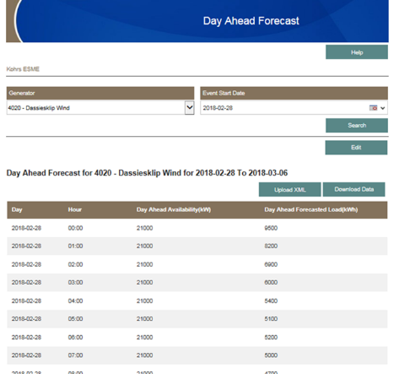
6 HOUR AHEAD FORECAST | - Ability to (de)activate “EDIT” & “Upload XML” depending of the user role associated with IPP. | - Written in Visual Studio (Web Forms) NET 4.5 framework  - USE CASE done  - Only information for one day can be captures  - To confirm Integration with THEMIS via Oracle Fusion message in place  - IPP Portal database contain GENERATOR information | - Review USE CASE  - Modify applet  - Add menu item & link to applet in the menu  - Update and test integration path/point.  - Document the end-to -end integration on Eskom templates and submit to governance for approval.  - Test applet end-to-end  - Update architecture documents and submit to governance for approval  - Update functional specification document | 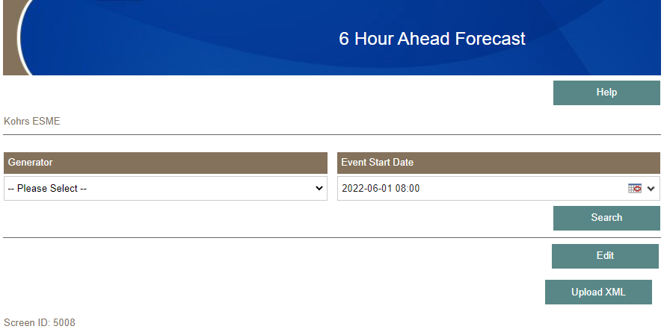
IPP OUTAGE | - Ability for Central Dispatchable Generator to capture the IPP outages and send it to Eskom (Modify existing IPP outages application to accommodate Central Dispatchable Generators)  - Ability to (de)activate “EDIT” & “Upload XML” depending of the user role associated with IPP. | - Written in Visual Studio (Web Forms) NET 4.5 framework  - USE CASE done  - To confirm Integration with THEMIS via Oracle Fusion message in place  - IPP Portal database contain GENERATOR & UNIT information  - Only one month data can be displayed | - Review USE CASE  - Modify applet  - Add menu item & link to applet in the menu  - Update and test integration path/point.  - Document the end-to -end integration on Eskom templates and submit to governance for approval.  - Test applet end-to-end  - Update architecture documents and submit to governance for approval  - Update functional specification document | 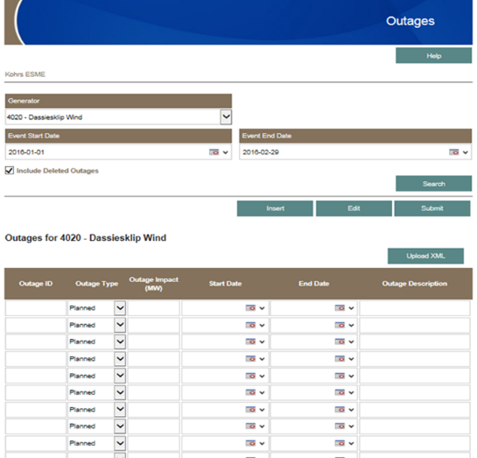
ESKOM LOAD FORECAST | - Ability to display information about Eskom’s Load Forecast (short term hourly values for 1 week) - Total, not residual value | - No Applet in place  - USE CASE done | - Review USE CASE  - Design, develop and end-to-end test applet using Visual Studio (Web Forms or MVC) + DevExpress  - Add menu item & link to applet in the menu  - Modify roles & services/applets associated with roles  - Ensure modification to Web Service on THEMIS  - Update and test integration path/point.  - Document the end-to -end integration on Eskom templates and submit to governance for approval.  - Test applet end-to-end  - Update architecture documents and submit to governance for approval  - Update functional specification document | 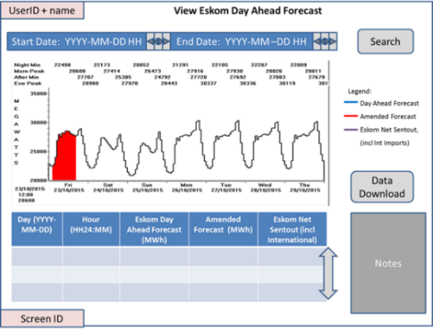
IPP DAY AHEAD AVAILABILITIES | - Ability for the IPP user to capture, edit, add and change the IPP Day Ahead Availabilities up to 7 days ahead  - Ability for the IPP user to upload the XML File containing the Day Ahead Availabilities.  - Ability for the IPP user to edit the data in the uploaded XML file.  - Ability for the IPP user to copy the data from the previous set of current availabilities data and then edit the data  - Ability to (de)activate “EDIT” & “Upload XML” depending of the user role associated with IPP. | - Written in Visual Studio (MVC) NET 4.5 framework  - USE CASE done  - To confirm Integration with THEMIS via Oracle Fusion message in place  - IPP Portal database contain GENERATOR & UNIT information  - Applet developed, not implemented. | - Review USE CASE  - Modify applet  - Add menu item and link to applet in the menu  - Update and test integration path/point.  - Document the end-to -end integration on Eskom templates and submit to governance for approval.  - Test applet end-to-end  - Update architecture documents and submit to governance for approval  - Update functional specification document | 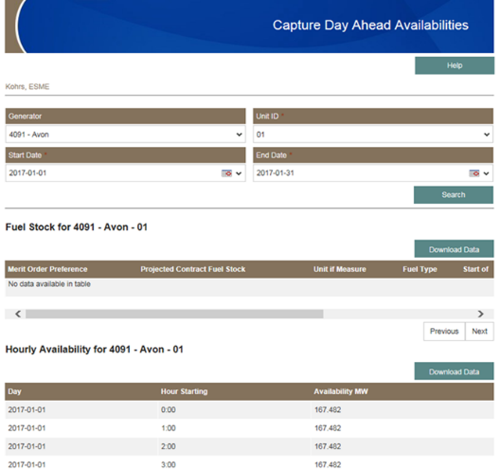
IPP AMENDED AVAILABILITIES | - Ability for the Peaker user to capture, edit, add and change the Day Ahead Availabilities data.  - Ability for the Peaker user to upload XML File containing the Day Ahead Availabilities.  - Ability for the IPP user to edit the data in the uploaded XML file.  - Ability to (de)activate “EDIT” & “Upload XML” depending of the user role associated with IPP. | - Written in Visual Studio (MVC) NET 4.5 framework  - USE CASE done  - To confirm Integration with THEMIS via Oracle Fusion message in place  - IPP Portal database contain GENERATOR & UNIT information  - Applet developed, not implemented. | - Review USE CASE  - Modify applet  - Add menu item and link to applet in the menu  - Update and test integration path/point.  - Document the end-to -end integration on Eskom templates and submit to governance for approval.  - Test applet end-to-end  - Update architecture documents and submit to governance for approval  - Update functional specification document | 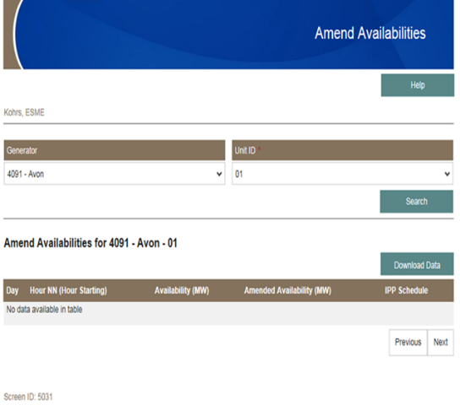
SETTLEMENT PAYMENT SUMMARY | - Enable for Central Dispatchable Generators to view their settlement payments. Currently only enabled for Self-Dispatchable Generators.  - Add Generator name to Payment Certificate  - Modify / Create new PDF report for Payment Certificate | - Written in Visual Studio (MVC) NET 4.5 framework  - USE CASE done  - To confirm Integration with THEMIS via Oracle Fusion message in place  - IPP Portal database contain GENERATOR & UNIT information  - Applet developed, not implemented. | - Review USE CASE  - Modify applet  - Add menu item and link to applet in the menu  - Update and test integration path/point.  - Document the end-to -end integration on Eskom templates and submit to governance for approval.  - Test applet end-to-end  - Update architecture documents and submit to governance for approval  - Update functional specification document | 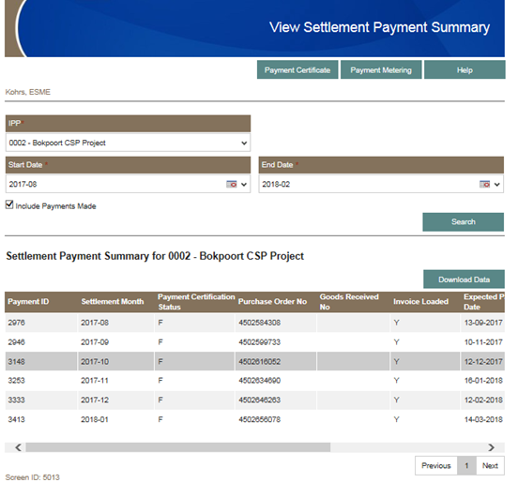
STATION DATA FOR PEAKERS (View) | - Enable Data Power on integration | - Written in Visual Studio (MVC) NET 4.5 framework  - To confirm Integration with THEMIS via Oracle Fusion message in place  - IPP Portal database contain GENERATOR information  - Only one month’s data can be displayed  - USE CASE done  - Applet developed, not implemented. | - Review USE CASE  - Modify applet  - Add menu item and link to applet in the menu  - Update and test integration path/point.  - Document the end-to -end integration on Eskom templates and submit to governance for approval.  - Test applet end-to-end  - Update architecture documents and submit to governance for approval  - Update functional specification document | 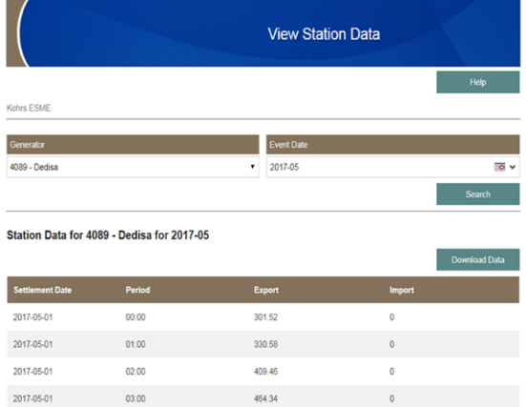
PAYMENT RESULTING DATA (View) | - Enable Data Power on integration | - Written in Visual Studio (Web Forms) NET 4.5 framework  - To confirm Integration with THEMIS via Oracle Fusion message in place  - IPP Portal database contain GENERATOR information  - Only one month’s data can be displayed  - USE CASE done  - Applet developed, not implemented. | - Review USE CASE  - Modify applet  - Add menu item and link to applet in the menu  - Update and test integration path/point.  - Document the end-to -end integration on Eskom templates and submit to governance for approval.  - Test applet end-to-end  - Update architecture documents and submit to governance for approval  - Update functional specification document | 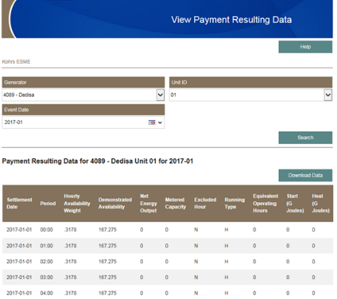
IPP DAILY STATEMENT | - Ability for the IPP user to capture, edit, add and change the IPP Daily Statement (Dispatch instruction portion should only show System Operator instructions, but IPP should be able to acknowledge)  - Ability for the IPP user to upload a file containing the Daily Statement.  - Ability for the IPP user to edit the data in the uploaded a file.  - Ability for the IPP user to copy the data from the previous set of current daily statement data and then edit the data  - Ability for the IPP to send Eskom the Fuel Report File (SFTP) | - Written in Visual Studio (MVC) NET 4.5 framework  - USE CASE done  - To confirm Integration with THEMIS via Oracle Fusion message in place  - GENERATOR & UNIT information stored in IPP Portal database  - Applet developed for view capability, not implemented | - Review USE CASE  - Modify applet  - Define “upload” file format, e.g. XML, JSON  - Ensure modification to Web Service on THEMIS  - Add menu item and link to applet in the menu  - Update and test integration path/point.  - Document the end-to -end integration on Eskom templates and submit to governance for approval.  - Test applet end-to-end  - Update architecture documents and submit to governance for approval  - Update functional specification document  - Update functional specification document | 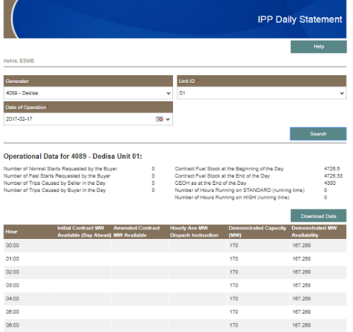
DAILY OPERATIONAL DATA (view) | - Enable Data Power on integration | - Written in Visual Studio (MVC) NET 4.5 framework  - USE CASE done  - To confirm Integration with THEMIS via Oracle Fusion message in place  - GENERATOR & UNIT information stored in IPP Portal database  - Applet developed, not implemented | - Review USE CASE  - Modify applet  - Add menu item and link to applet in the menu  - Update and test integration path/point.  - Document the end-to -end integration on Eskom templates and submit to governance for approval.  - Test applet end-to-end  - Update architecture documents and submit to governance for approval  - Update functional specification document | 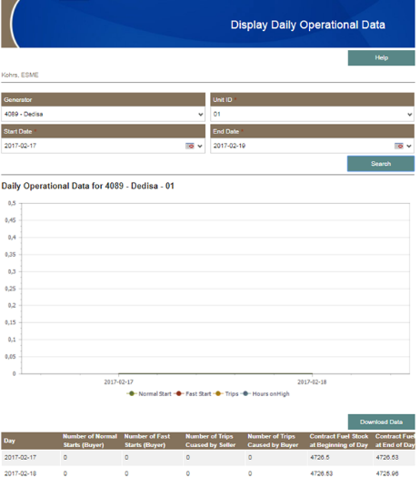
HOURLY OPERATIONAL DATA (view) | - Enable Data Power on integration | - Written in Visual Studio (MVC) NET 4.5 framework  - USE CASE done  - To confirm Integration with THEMIS via Oracle Fusion message in place  - GENERATOR & UNIT information stored in IPP Portal database  - Applet developed, not implemented | - Review USE CASE  - Modify applet  - Add menu item and link to applet in the menu  - Update and test integration path/point.  - Document the end-to -end integration on Eskom templates and submit to governance for approval.  - Test applet end-to-end  - Update architecture documents and submit to governance for approval  - Update functional specification document | 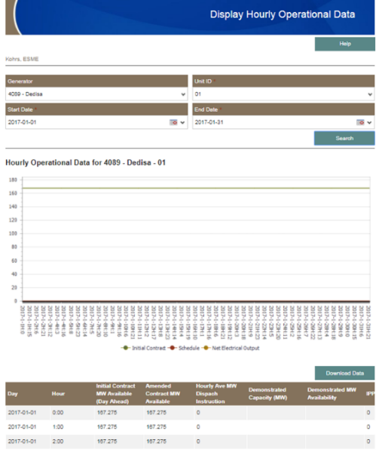
IPP SCHEDULE (view) | - Enable Data Power on integration | - Written in Visual Studio (MVC) NET 4.5 framework  - USE CASE done  - To confirm Integration with THEMIS via Oracle Fusion message in place  - GENERATOR & UNIT information stored in IPP Portal database  - Applet developed, not implemented | - Review USE CASE  - Modify applet  - Add menu item and link to applet in the menu  - Update and test integration path/point.  - Document the end-to -end integration on Eskom templates and submit to governance for approval.  - Test applet end-to-end  - Update architecture documents and submit to governance for approval  - Update functional specification document | 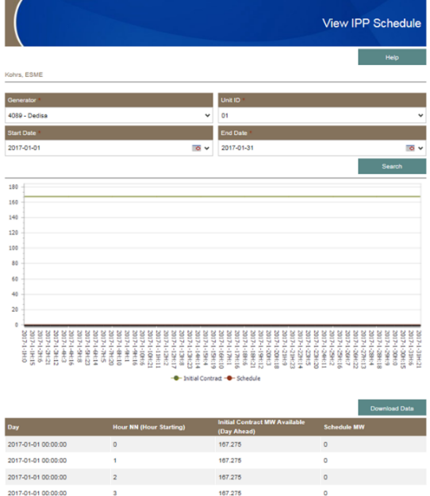
IPP DISPATCH INSTRUCTION (view) | - Enable Data Power on integration | - Written in Visual Studio (MVC) NET 4.5 framework  - USE CASE done  - To confirm Integration with THEMIS via Oracle Fusion message in place  - GENERATOR & UNIT information stored in IPP Portal database  - Applet developed, not implemented | - Review USE CASE, with business  - Modify applet  - Add menu item and link to applet in the menu  - Update and test integration path/point.  - Document the end-to -end integration on Eskom templates and submit to governance for approval.  - Test applet end-to-end  - Update architecture documents and submit to governance for approval  - Update functional specification document | 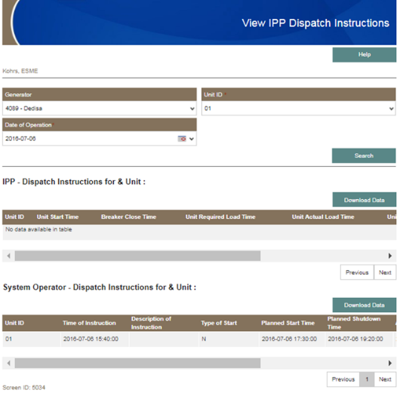
IPP FUEL REPORT | - Ability for the IPP user to capture, edit, add and change the IPP Fuel report  - Ability for the IPP user to upload a file containing the fuel data.  - Ability for the IPP user to edit the data in the uploaded a file.  - Ability for the IPP user to copy the data from the previous set of current fuel data and then edit the data  - Ability for the IPP to send Eskom the Fuel Report XML File (SFTP) | - Written in Visual Studio (MVC) NET 4.5 framework  - USE CASE done  - To confirm Integration with THEMIS via Oracle Fusion message in place  - GENERATOR & UNIT information stored in IPP Portal database  - Applet developed to view information, not implemented | - Review USE CASE  - Modify applet  - Define “upload” file format, e.g. XML, JSON  - Add menu item and link to applet in the menu  - Ensure modification to Web Service on THEMIS  - Update and test integration path/point.  - Document the end-to -end integration on Eskom templates and submit to governance for approval.  - Test applet end-to-end  - Update architecture documents and submit to governance for approval  - Update functional specification document | 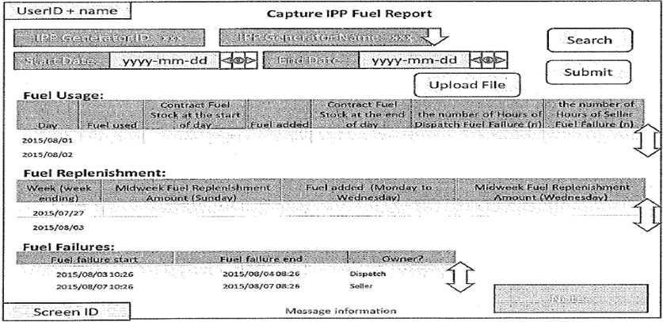
DATA POWER | - Ability to capture a message on the IPP Portal database of (un)successful files submitted via SFTP  - Ability to send an email to the IPP user if error occurred with transfer or upload of an XML data file | - Not in place | - Create USE CASE  - Design, develop and test capability  - Create database tables  - Modify roles & services/applets associated with roles  - Update and test integration path/point.  - Document the end-to -end integration on Eskom templates and submit to governance for approval.  - Test applet end-to-end  - Update architecture documents and submit to governance for approval  - Update functional specification document | N/A
View SFTP file upload messages | - Ability to view on IPP Portal Web application whether files uploaded via SFTP was successful of not | - Not in place | - Create USE CASE  - Design, develop and test applet  - Add menu item & link to applet in the menu  - Modify roles & services/applets associated with roles  - Update and test integration path/point.  - Document the end-to -end integration on Eskom templates and submit to governance for approval.  - Test applet end-to-end  - Update architecture documents and submit to governance for approval  - Update functional specification document | N/A
ADMIN of lookup lists & other “static” data (e.g. account number, IPP generator, services & roles) | - Ability to manage lookup lists and “static” data via an applet | - Not in place  - Management of lookup list and static data done via the database | - Create USE CASE(s)  - Design, develop and test applet(s) using Visual Studio (Web Forms or MVC)  - Add menu item(s) & link to applet(s) in the menu  - Modify roles & services/applets associated with roles  - Update architecture documents and submit to governance for approval  - Update functional specification document | N/A

  - Project Requirements:

IMPORTANT:
Project must be completed as an agile solution within eight months and two months stabilisation post final deployment in month eight. Total project timeline therefore is 10 months.
This includes.
- Agile Development as per functional requirements section
  - Iterative deployments, and stabilisation
  - Analysis, design and build of functional changes
  - Analysis, design and build of integration changes
- Testing
  - Analyse and update existing test cases
  - Analyse and create new test cases where applicable
  - Full functional and performance testing – end to end of entire solution
- Training
  - Support staff handover and upskill on entire solution
  - Develop training manuals and User Guides (Noddy Guides for Support Staff and for Help Desk Staff) on entire solution
  - No end user training required
- Support
  - Support required during the development phase for deployed functionality including two months post final deployment stabilisation

Initiation/Planning
Vendor must provide project management and project administrative services in line with the Eskom Project Office guidelines. Refer to 240-85200946 Group IT Project Assurance Report for all relevant Project Documentation required by the project.

- Vendor must maintain the IPP Portal Project Teams site for document records keeping and collaboration
- Vendor must create and maintain the detailed project schedule in Microsoft Project.
- The vendor must coordinate and control all activities on the project schedule with assistance from the Eskom project manager.

The Project Manager/Scrum Master must throughout the life of the project:
- Plan, execute and manage the solution realisation process and deliverables
- Report the project finances as per billing milestones contracted
- Produce all project management documents as agreed with PMO
- Ensure that the project complies to all the PMBOK Knowledge Areas and Controlling Processes or Agile project methodologies
- Provide operational and technical leadership on the project execution
- Establish, manage, and conduct interactions between project and the Eskom Business where applicable
- Communication and Operational Change Management

Analysis and Design (Hardware and System Platform)

IMPORTANT: The vendor must perform a full technical assessment on the entire IPP Portal landscape (including integration points) and confirm design of the solution. The vendor must provide Eskom with the detail report within one month of project commencement highlighting problem areas and proposed changes. This will allow the project to plan the necessary changes timeously.

A detailed functional and technical analysis must be done on the application and captured in the use cases and functional specification documents.
Required environments must be confirmed with Enterprise Architecture, IPP Portal and various integrating systems support teams.
These environments include but are not limited to:
- Production environments
- Pre-production environments
- System Integrated Testing / Quality Assurance environment
- Development environment

Software (Application)

IMPORTANT: Vendor will update the detailed software design to ensure the solution meets the requirements and fits into the current environment. Eskom Architecture approval is required prior to implementation of changes.

Vendor must provide web UX/UI graphic design, Front end development, and Back-end development capabilities to:
- Analyse, design, develop, test, and deploy integrated solutions based on the logical design. External interfaces to integrate using Oracle Fusion 12c and IBM WebSphere (Data Power), thus the vendor should be well skilled to work with the mentioned technologies.
- Vendor must facilitate JAD sessions between all participating streams to ensure proper alignment and design.
  - Physical Design Documents
  - Detail Functional Specs
  - SOA governance documents
  - Use Cases
  - Testing Artifacts
- All development will happen to Eskom standards and agreed Corporate Identity guidelines provided by Eskom.
- All development must happen on only approved software with no Third Part tools that might require updates or changes later in the product life cycle.
- All changes must be documented in a detail design specification document and taken through the necessary governance and approval processes.

Architecture
Vendor must provide a Solution and Integration application architecture specialised capability that will compile the physical architecture design for the entire system landscape. The Architectural Governance processes must be followed for all approvals prior to execution and deployment.

The solution architect to:
- Document the physical architecture design of the solution within the architecture project.
- Engage relevant architects (especially security) regarding architecture patterns and standards to be included in the design with assistance of the assigned Eskom lead architect
- Engage with relevant support functions regarding the various aspects to be included in the design with assistance of the assigned Eskom lead architect or Eskom project manager
- Present the physical architecture design and pre-transfer at relevant architecture governance committees as communicated by Eskom lead architect
- Ensure that the implementation of the solution adheres to the approved physical design

The solution architect must have;
- Working knowledge and experience of TOGAF framework, TOGAF9 certification will serve as an advantage.
- Working knowledge and experience of UML.

Integration
Vendor must provide Solution and Integration application architecture specialised and Integration Analysis, Design and Development capabilities.

The Integration into the Eskom applications will be done within a phased approach.

Integration scope and deliverables is listed below:
- The solution should be able to integrate to THEMIS, CC&I, XRM, ACNAC and any other systems that Eskom may need to integrate to. Refer to the logical design for systems that must integrate to the solution.
- Analyse, design, develop, test, and deploy integrated solutions based on the logical design. External interfaces to integrate using Oracle Fusion 12c and IBM WebSphere (Data Power), thus the vendor should be well skilled to work with the mentioned technologies.
- The Integration Centre of Excellence (ICOE) governance process must be followed for all approvals. Kindly reference “SOA Workgroup artefacts”. All diagrams and processes are to be captured in the Eskom Enterprise Architect (EA).
- All CIM message artefacts (including Mapping Document) to be placed in the Eskom defined CIM SVN. All code to be placed in Eskom defined Code SVN repository All artefacts to be placed in the Eskom share point.
- The following are the integration and Testing activities and artefacts to be produced and presented at the committee for approval and sign off:
- Business Test case.
- Integration specification document and Mapping Document.
- CIM message artefacts including WSDL’s and XSD’s.
- Code and unit testing review and Deployment Guide.
  - (A submission to the sub-committee to take place before SOA Governance submission)
- SIT testing review of results in ALM.
  - (A Submission to the Testing Sub-committee to take place before SOA Governance submission)
- SIT test case sign-off.
- Performance testing review of results in ALM (if performance testing is required).
- Performance testing sign-off.
- Pre-transfer documents for go-live approval (All above listed artefacts to be signed off for Pre-transfer to take place).
- Test requirements in ALM. Test cases and results in ALM. Defects managed in ALM. Test plan Document. Non-functional Test plan document. Test closure reports documents. Performance test scripts and results.
- Provide a message modeller to complete the following:
- Analysis of message requirements
- Model or update integration message which follow a Common information model
- Create payloads and envelopes
- Generate XSD, message model and model dictionary
- A signed off test closure report is required before a test milestone is completed. Refer to Testing section.
  - All testing requirements must cover all identified interfaces that have been identified. The testing team must adhere to the TCoE Turnkey Project Requirements Guideline provided as part of the RFP document.

Data Migration
- Vendor must Review, Analyse and Document the current IPP Portal System’s data.
- Vendor must in advance notify Eskom of any data that requires clean-up with a strategy to guide business with the clean-up.
- Vendor will be responsible for the entire data migration and ensure backups are in place.
- Vendor must present a Zero Data loss strategy to Eskom.
- Vendor must align and implement archiving according to Eskom’s archiving strategy.

Testing

IMPORTANT: All test cases must be captured and tracked in HP ALM. This includes all unit test cases created and tested by the vendor to setup IPP Portal System.

The vendor must provide the following testing capabilities:
- Testing management capability
- Test analysis and testing execution capability
- Testing performance scripter and testing execution capability

The vendor must plan, guide, and coordinate the entire testing effort based on Eskom’s testing guidelines and standards. The vendor must provide Eskom with a minimum of two weeks lead time to arrange business resources to assist with functional and user acceptance testing.

Minimum Required Test types:
- Unit Testing – test results from the Vendor’s team.
- System Integrated Testing
- Functionality testing (in QA – end to end functional testing and integration testing. That means testing with other systems and ensuring that all requirements have been successfully configured).
- Functional and Integrated Testing
- Non-Functional Testing (performance testing and disaster recovery testing).
- User Acceptance Testing
- Performance Testing
- ALL TESTING, must be driven & executed by the Vendor but must include Eskom staff for completeness & authenticity

All test cycles must be managed using HP ALM. All defects must be recorded and tracked using HP ALM. Testing progress reports and sign-off will be done via HP ALM. All testing shall be in accordance and approved by the Eskom’s testing standards, processes and procedures.

The testing team must adhere to the TCoE Turnkey Project Requirements Guideline provided as part of the RFP document.

Vendor must provide testing resources as per functional areas below:
IPP Portal Interfaces

All integration points must be documented as end-to-end use cases from source to destination system and loaded in HP ALM to ensure thorough end to end testing.
The Integration Centre of Excellence (ICoE) governance process must be followed for all approvals.
Test Analyst/Test Manager must ensure alignment between source, integration, and destination resources as resources could be over utilised and require advance notice to test.

IPP Portal Test Cases

Test Analysts must verify the current list of IPP Portal functional requirements (refer to section 3.1 Functional Requirements) with IPP Portal functional leads and Eskom’s Testing Centre of Excellence. Test Analysts to update the list if required based on the additional system functional requirements.

Test Analysts must Review, Analyse and Document the verified list of IPP Portal Test Cases in HP ALM, according to the Eskom HP ALM Standard for capturing test cases (Refer to Eskom TCOE standards). Vendor must setup the different test cycles with relevant test cases in HP ALM.

IPP Portal Automated Test Cases (if applicable)

Vendor must use the automated testing platform during the project and in future projects. The technology used must be in line with the Eskom approved standards.
Automated testing tool to be used is: Unified Functional Tester (UFT) formerly known as Quick Test Professional (QTP).
Automated testing framework: Business Process Testing.
Vendor must identify all test cases that qualify for automated testing and create these test cases to speed up the testing effort.

Deployment/Cutover

Vendor must plan the development sprints with governance approvals:
- Vendor with input from Eskom project manager must integrate Eskom governance gates into the project schedule to ensure deployment dates are complied with and closely track all required approvals with the relevant Eskom leads to ensure there are no delays. Committees sit from weekly to Bi-Monthly thus timing is important.
- Vendor must ensure the cutover change is logged with all the supporting governance and test results.
- All Integration points must be tested post go-live to ensure connectivity and throughput.
- Test critical list of test cases to ensure application is functioning correctly.
- Develop deployment documentation.
- Develop support handover documentation.

Vendor must arrange all approvals in line with Eskom process and be aware of lead-times for the various committees.

Training / Knowledge Transfer

IMPORTANT: Vendor must ensure continuous knowledge transfer to Eskom resources.

Vendor must produce comprehensive training guides on the full system functionality.
- Vendor must ensure training of Eskom 1st line support staff.
- Training and skill transfer is required for the Eskom resources;
  - Development (2 resources)
  - Database (2 resource)
  - Application Technical Support (1 x Technical, 1 x Lead)
  - Support teams (2 x THEMIS, CC&I, XRM and ACNAC)
  - Integration (2 x resources)
- Develop training material and support material. Train Eskom development, Database, Application Technical Support and Support teams and ensure sufficient knowledge transfer
- Skill and knowledge transfer will be included as part of deliverable sign-off. The requirement for training will be at all 3 Eskom levels of functional application support, 1st line support, 2nd line, and 3rd line of support, including the Application Technical Support and Database Support.
  - Post go-live support
- Maintenance and support, including stabilisation, for a period of 2 months.
- Maintenance and support must include the IPP Portal front-end, back-end, integration, and database
- Maintenance and support include but not limited to queries, errors, trouble shooting, investigations, configurations, enhancements, and user support
- The vendor must ensure compliance to all Eskom’s required changes impacting the solution. Example of such changes but not limited to application, integration, security, or configuration changes
- Dedicated resource/s on site, dependent on Eskom and COVID requirements.
  - Minimum qualifying capabilities
This section provides the minimum required capabilities, but not limited, to successfully deliver the project:
1 x Web UX/UI graphic design capability
2 x Front end development capability, Back-end development capability
1 x Business/System Analyst capability
1 x Solution and Integration application architecture specialised capability
2 x Integration Analysis, Design and Development capability
1 x Testing management capability
2 x Test analysis and testing execution capability
1 x Testing performance scripter and testing execution capability
1 x Training facilitator and Training material creation capability
1 x Project Management, Scrum Master, or Agile Project Management capability

