CLARIFICATION QUESTIONS FROM TENDERERS:
SCOPE: THE SUPPLY AND DELIVERY OF PERSONAL PROTECTIVE EQUIPMENT FOR KOEBERG OPERATING UNIT
REF: WCKBG2445CS
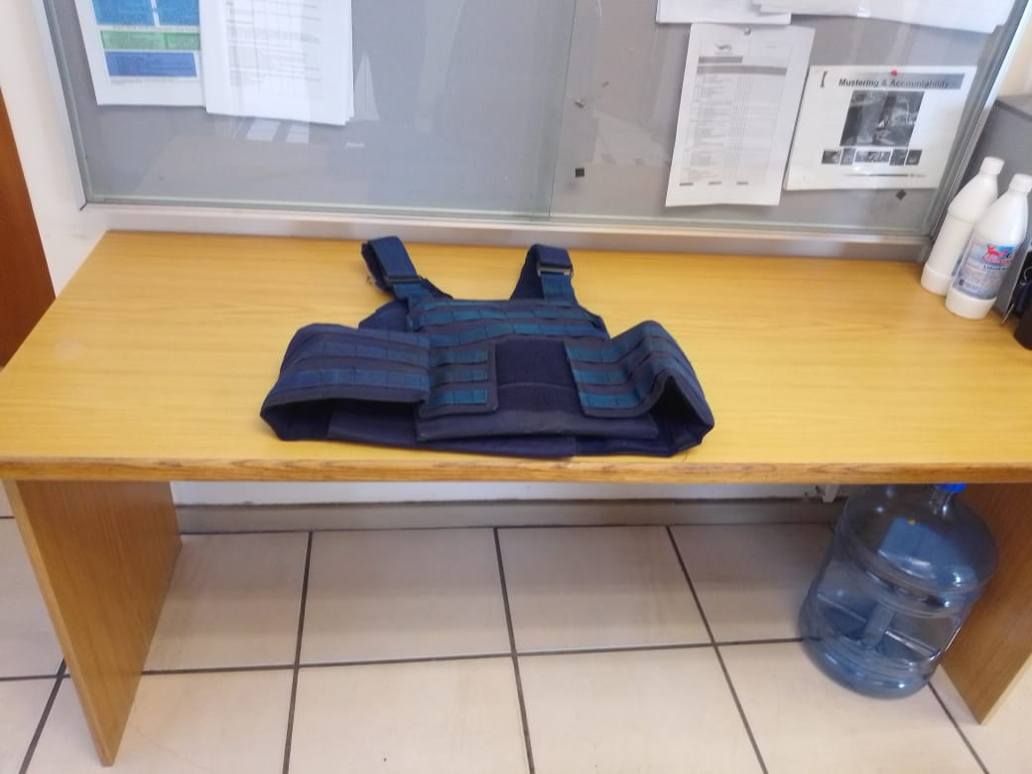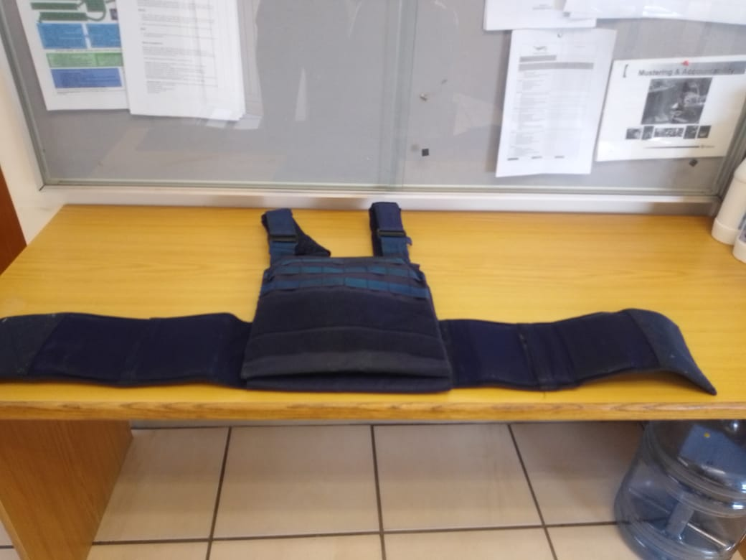
No. | QUESTIONS ASKED BY THE TENDERERS | ESKOM’S RESPONSE
1. | Kindly provide me with pictures of the following items:  - SHIRT GOLF: WITH ESKOM LOGO (IN WHITE)  - SUIT: JUMPSUIT; ESKOM LOGO; COTTON  - BOOTS: BRONX SHOES; BRONX; BLACK; LEATHER  - VEST: BULLETPROOF COMBAT; VEST; NAVY  - ESKOM NAME; PLANT; NAME TAG  - JACKET: COMBAT PARKA JACKET WITH LOGO | Requested photos attached.  Golf shirt and name plate still to be published.
2. | Kindly clarify “Submit technical delivery scheduled” under technical requirements deliverables on WCKBG2445CS_Annexure K. | Submit a detailed list of each item quoted and delivery timeframe/availability of each item

