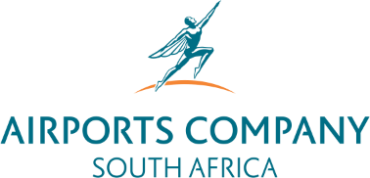

Request for Proposals for the Service Provider to Provide the Solution To Extract Water From The Nearby Stream, Treat, Distribute, And The Drilling Of Boreholes Within The Vicinity Of The Airport At King Shaka International Airport for a once-off period

Microsoft Teams meeting
Join on your computer or mobile app
Click here to join the meeting
Meeting ID: 319 724 726 819
Passcode: mMHbTA
Download Teams | Join on the web
Or call in (audio only)
+27 21 834 0841,,350685368# South Africa, Cape Town
Phone Conference ID: 350 685 368#
Find a local number | Reset PIN

