NATIONAL KEY POINT BOARD
- PURPOSE
To request for the supply and installation of the National Key Point Information boards for Onderstepoort Veterinary Research, and Transboundary Animal Disease displaying unauthorized items not allowed on site and that you are entering a National Key Point site OHS and other security information boards as stated in the attached board example.
To request for Kaalplaas information boards informing trespassers that the farm is a private property, no trespassing is allowed and that violators will be prosecuted.

- BACKGROUND

The ARC has administrative offices, farms and other critical infrastructure and facilities. Considering the above, ARC requires service providers who are certified in terms providing security information boards to the ARC Sites.

- DETAILS OF REQUIREMENTS

  - SPECIFICATION
- Supply and installation of a free-standing steel structure information board on the right side at the main entrance gate on the right at OVR and on the left entrance side at TAD. The main boards must be supported with 4 steel poles each and must be secured to the ground with concrete.
- The size of the board to be 3m horizontal and 2m vertical (to be verified on the site visit). SABS approved sizes for safety signs as per the board size.
- The board must display the prohibited/warning signs and wording in the attached examples.
- Loose signages that the facility is under 24hr protection and no camera signages must be mounted onto the respective walls of the buildings and the sizes should be 2.4 x 2.4 for TAD and OVR
- Supply and install GA26 - Emergency Assembly Point Signage a free-standing steel galvanized structure. The signs must be fitted to a metal post 2000 mm above ground.
- The board must display the prohibited/warning signs and wording in the attached examples.
- Supply and installation of free-standing steel galvanized structures information boards around the Kaalplaas farm.
- The board must display Private Property, No Trespassing, Violators will be prosecuted words and the ARC logo to be printed on top, The size of the board to be 900 x 600 (to be verified on the site visit). SABS approved sizes as per the board size. The Trespass Act 6 of 1959 must be printed on the board.
- Installation of Condition of entry boards and condition of parking board to be mounted at OVR and TAD
- All printing must be for all outdoor conditions, 100% weatherproof with waterproof printing and not laminated.
- The printing on all the boards must be printed, this includes the signages on the boards (engraved and not pasted) and all information boards must have the ARC logo on them.
- The Prohibition/Warning Signs must be SABS Approved safety signs that indicates that certain behavior is prohibited.
- These symbolic safety signs display a black pictogram on a white circular shaped sign with a red border and red diametral line at an angle of 45°, depicting actions that are prohibited.
- The height, width, or diameter of the pictogram on these signs occupy between 75 % and 90 % of the corresponding dimensions of the backing sheet, Chromadek Steel.
- The draft signage shall be sent to the ARC for proof reading before they can be supplied and installed.
- All sizes to be confirmed during the briefing.

- COSTING BREAKDOWN
Item description | Location | Quantity | Price per unit ( incl VAT ) | Total price all inclusive
The NKP Board and printing on the board | OVR and TAD entrance | 02
Printing of the wording and the 06 signages on each the board | OVR and TAD entrance gate (NKP Board) | 12 signages
Loose signages that the facility is under 24hr protection | Around OVR and TAD premises | 30 signages
Loose signages that taking of pictures is not allowed | Around OVR and TAD | 10 signages
Free standing and printing of Information boards displaying Private property, trespassers will be prosecuted and printing of the ACT with the ARC logo | Kaalplaas | 20 signages
Assembly Points signages and printing | OVR and TAD | 15 boards
Condition of entry board | OVR and TAD | 2 X boards
Condition of parking board | OVR and TAD | 2 X boards
Labour (installation) and Transport | Please provide detailed breakdown
GRAND TOTAL ALL INCLUDED |  |  | R | R
NB: ALL SERVICE PROVIDER ARE REQUESTED TO QUOTE AS PER THE ABOVE ITEM DESCRIPTIONS AND ATTACH A DETAILED BILL OF QUANTITIES PER ITEM.

- GUARANTEES

- ARC requires guarantees for all printing and installation for 12 months.
- The supplier shall observe all relevant ISO and SABS standards or any applicable related regulations or standards.
- The supplier shall in detail document what is covered by of the guarantee as well as the terms and conditions.
The following documents are required:
Document that must be submitted | Non-submission may result in disqualification.
Three reference letters on similar projects | Yes / No | Bidders must submit three reference letters of successfully completed related or similar projects.
Tax Compliance Status  Tax Clearance Certificate | Yes / No | Bidders must ensure compliance with TAX obligations.  Bidders required to submit a printed Tax Compliance Status or Tax clearance certificate

- INSPECTION OF SITE AND EQUIPMENT

Before tendering, tenderers shall visit the site to make themselves conversant with the equipment to be installed and integrated and submit a quotation thereof.

All invited suppliers are kindly requested to attend a compulsory briefing session at Kaalplaas OVR and TAD, 100 Soutpan Road, Onderstepoort on.

ANNEXURE 1: EXAMPLE OF INFORMATION TO BE DISPLAYED ON THE NKP BOARD: OVR


AGRICULTURAL RESEARCH COUNCIL
ONDERSTEPOORT VETERINARY RESEARCH

ACCESS AND EGRESS TO THESE PREMISES ARE CONTROLLED IN TERMS OF THE NATIONAL KEY POINT ACT 102 OF 1980 AND ACCESS TO PUBLIC PREMISES AND VEHICLES ACT 53 OF 1985
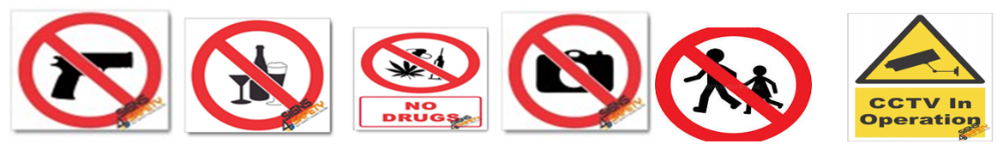
Declare and register all personal items.
Access cards/permits must be always worn.
All persons and vehicles entering and leaving the premises shall be searched and personal belongings will be inspected in the presence of the owner.
The ARC management reserves the right to allow and/or deny access to the premises, subject to compliance to security policies and procedures.

ANNEXURE 2: EXAMPLE OF INFORMATION TO BE DISPLAYED ON THE NKP BOARD: TAD



AGRICULTURAL RESEARCH COUNCIL
TRANSBOUNDARY ANIMAL DISEASES
ACCESS AND EGRESS TO THESE PREMISES IS CONTROLLED IN TERMS OF THE NATIONAL KEY POINT ACT 102 OF 1980 AND ACCESS TO PUBLIC PREMISES AND VEHICLES ACT 53 OF 1985
Declare and register all personal items.
Access cards/permits must be always worn.
All persons and vehicles entering and leaving the premises shall be searched and personal belongings will be inspected in the presence of the owner.
The ARC management reserves the right to allow and/or deny access to the premises, subject to compliance to security policies and procedures.

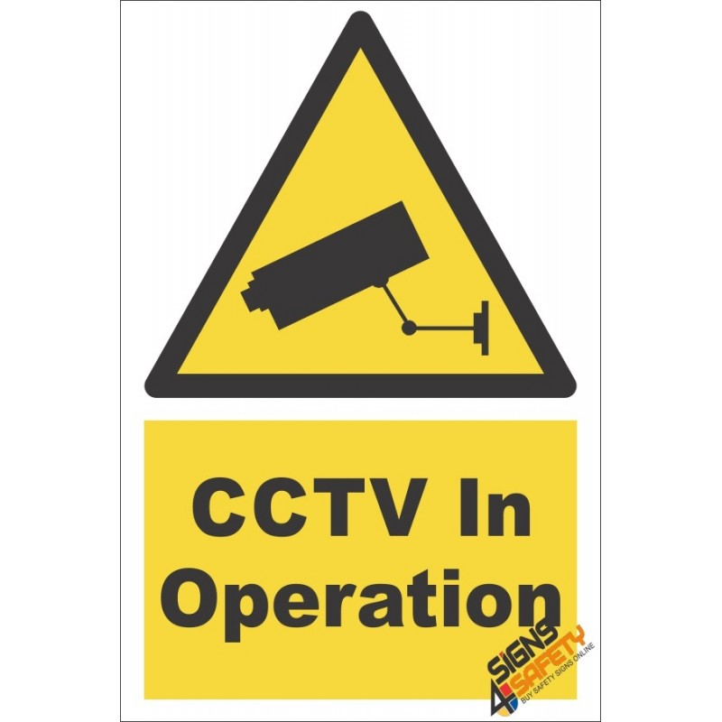

ANNEXURE 3: KAALPLAAS BOARDS

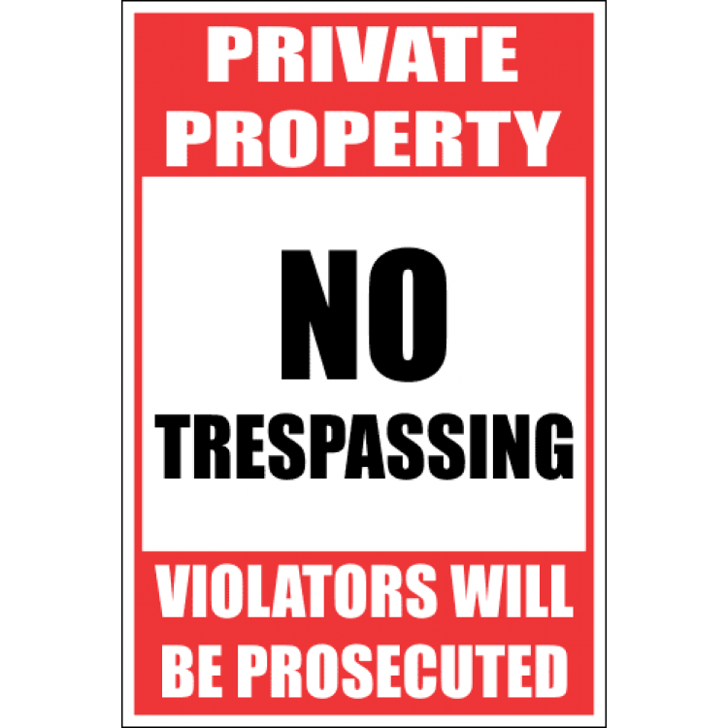

ANNEXURE 4: ASSEMBLY POINTS

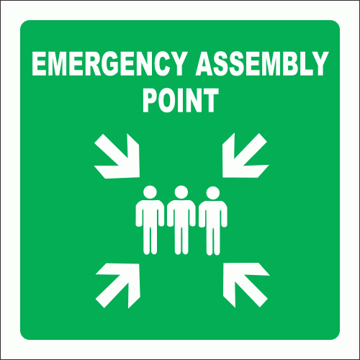
Annexure 5: CONDITIONS OF ENTRY AND PARKING BOARDS
