AIR TRAFFIC AND NAVIGATION SERVICES CO. LTD
REPUBLIC OF SOUTH AFRICA


REQUEST FOR TENDER:
ATNS/XXX/XXX/XXX
TOWER AND APPROACH CONSOLES REPLACEMENT AT FAPM, FAVG, FALE and FARB
The replacement of Tower Consoles at FAPM, FAVG and FARB and Approach Consoles at FALE
[Project Reference: Dis_2020_315]
VOLUME 2
Version 1.2
TECHNICAL SPECIFICATIONS
February 2024

The information contained within this document is confidential to ATNS in all respects and it is hereby acknowledged that the information as provided shall only be used for the preparation of a response to this document. The information furnished will not be used for any other purpose than stated and that the information will not directly or indirectly, by agent, employee or representative, be disclosed either in whole or in part, to any other third party without the express written consent by the Company or its representative.

REVISION INDEX SHEET

Version | Revision | Date | Reason for Change | Pages Affected
1 | 0 | 02/10/2023 | Initial Document | All
1 | 1 | 09/01/2024 | Minor Updates | All
1 | 2 | 27/02/2024 | Minor Updates | All

TABLE OF CONTENTS

ABBREVIATIONS 6
1 GENERAL INSTRUCTIONS TO TENDERERS 7
2 SCOPE OF WORK 8
3 PRELIMINARY 8
4 SYSTEM DESCRIPTION 9
5 EXISTING CONSOLE LAYOUTS 13
5.1 FALE Approach Hall, Playback Room and Equipment Room 13
5.1.1 FALE Approach Hall, Playback Room and Equipment Room Consoles Layout 13
5.1.2 FALE Approach Hall, Playback Room and Equipment Room Equipment 15
5.2 Tower Consoles Layouts 16
5.2.1 FAPM Tower 17
5.2.2 FAVG Tower 18
5.2.3 FARB Tower 19
CHAPTER 1: GENERAL TECHNICAL SPECIFICATIONS 22
6 GENERAL REQUIREMENTS 23
6.1 Supply, Delivery and Installation 23
6.2 Design Life 23
6.3 Material 24
6.4 Modularity 28
6.5 Ergonomics 29
6.6 Electrical 33
6.7 Disposal 33
CHAPTER 2: FALE APPROACH CONSOLES TECHNICAL SPECIFICATIONS 35
7 APPROACH CONSOLE REQUIREMENTS 36
7.1 Console Layout 36
7.2 Design 36
7.3 Flight Strip Board 39
7.4 Equipment Storage Section 41
7.5 Power Distribution 44
7.6 Distribution Board (DB Board) 45
7.7 Rotary Isolator Switch 47
7.8 Static Switch 47
7.9 Headset connecting ports module 48
7.10 Cable Management 50
7.10.1 Cable Routes 50
7.10.2 Cable Separation 52
7.10.3 Cable Routing Mechanism/s 52
7.11 Display/Monitor Mounting Arm (TNAC Consoles) 52
7.12 VCCS Mounting Bracket 55
7.13 Map Display (TNAC Consoles) 56
7.14 Faceplate 58
7.15 Biometric Fingerprint Readers 61
7.16 Very High Frequency (VHF) Radio Module 62
8 UPS CABINET INSTALLATION 63
9 APPROACH HALL REQUIREMENTS 65
CHAPTER 3: FALE MAINTENANCE CONSOLES TECHNICAL SPECIFICATIONS 66
10 MAINTENANCE CONSOLES REQUIREMENTS 67
10.1 Design 67
10.2 Equipment Storage Section 69
10.3 Power Distribution 73
10.4 Distribution Board (DB Board) 74
10.5 Rotary Isolator Switch 76
10.6 Static Switch 77
10.7 Cable Management 77
10.7.1 Cable Routes 77
10.7.2 Cable Separation 79
10.7.3 Cable Routing Mechanism/s 79
10.8 Display/Monitor Mounting Arm 80
CHAPTER 4: FAPM, FAVG, FARB TOWER CONSOLES TECHNICAL SPECIFICATIONS 83
11 TOWER CONSOLE REQUIREMENTS 84
11.1 Design 84
11.2 Adjacent Consoles 87
11.3 Flight Strip Board 88
11.4 Freestanding General Use Cabinet 90
11.5 Reading light 92
11.6 Auxiliary or Special Modules 92
11.6.1 VHF Radio Module 93
11.6.2 Crash Alam Module 94
11.7 Cable Management 95
11.7.1 Cable Routes 95
11.7.2 Cable Separation 96
11.7.3 Cable Routing Mechanism/s 96
11.7.4 Cable Replacement 97
12 TOWER CAB SPECIFICATIONS 97
12.1 Tower Cab Consoles and Equipment Fitting Requirements 97
13 SITE SPECIFIC REQUIREMENTS 98
13.1 FAPM 98
13.1.1 Acrylic Sheet for Map 98
13.1.2 Mounting Solution for Digital Clock 99
13.1.3 Roster Stand Cabinet 100
13.1.4 Equipment Cabinet 101
13.2 FAVG 105
13.2.1 Filing Cabinet 105
13.2.2 Fridge 107
13.2.3 Sink 108
13.2.4 Dish Cabinet 110
13.2.5 6-way Multi Plug 111
13.2.6 Emergency Exit Access 112
13.3 FARB 113
13.3.1 Acrylic Sheet for Map 113
13.3.2 Equipment Cabinets 114
13.3.3 6-way Multi Plug 118
13.3.4 Sink 119
13.3.5 Built-in Cupboard 120
13.3.6 Freestanding Cupboard 122
13.3.7 Cable Trunking 123
CHAPTER 5: GENERAL PROJECT SPECIFICATIONS 124
14 GENERAL SPECIFICATIONS 125
14.1 Project Execution and Compliance 125
14.2 Console Mock Setup 126
APPENDIX A: DRAWINGS 127
1 TNAC DRAWINGS 128
2 ADMIN CONSOLE 135

ABBREVIATIONS

ADMIN Administration
ATC Air Traffic Controller
ATNS Air Traffic and Navigation Services SOC Ltd
ATSO Air Traffic Services Officer
DAID Digital Airfield Information Display
DB Distribution Board
ECC Electrical Compliance Certificate
EIA Electronic Industries Association
FALE King Shaka International Airport
FAT Factory Acceptance Test
FAT Factory Acceptance Test
IEC International Electrotechnical Commission
IEEE Institute of Electrical and Electronics Engineers
ISO International Organization for Standardization
KVM Keyboard, Video and Mouse Switch
LED Light Emitting Diode
PDU Power Distribution Unit
PMP Project Management Plan
PVC Polyvinyl chloride
SAT Site Acceptance Test
STD Standard
UPS Uninterrupted Power Supply
VCCS Voice Communication and Control System
VESA Video Electronics Standards Association
VSR Voice and Surveillance Recorder
WBS Work Breakdown Structure

GENERAL INSTRUCTIONS TO TENDERERS
The Tenderer shall submit all responses, diagrams, project management documentation and drawings according to the GENERAL INFORMATION AND INSTRUCTIONS TO TENDERERS document and in the English language.
To assist Tenderers only, each paragraph or article has been appended throughout with the letters “(M)”, “(D)”, “(O)” or “(I)”, to indicate whether the requirement is Mandatory, Desirable, Optional or for Information only.
ALL RESPONSES TO THE REQUIREMENTS IN THIS DOCUMENT SHALL BE PROVIDED AS FOLLOWS:
TENDERERS SHALL RESPOND IN FULL TO EACH ITEM IN THE FORMAT PROVIDED AND REFERENCES (CHAPTER, SECTION, PAGE NUMBER, PARAGRAPH NUMBER) TO DOCUMENTS AND RELEVANT INFORMATION SUPPORTING THE RESPONSES SHALL BE INDICATED IN THE SPACE PROVIDED. THIS INFORMATION WILL BE THE ONLY RESPONSE USED FOR THE EVALUATION AND ASSESSMENT.
Responses, provided in the space allowed, that are not clear or inadequate or the lack thereof shall be interpreted as “Not Compliant” even though the compliance column is declared as “Comply” and/or the Tenderer’s offer meets the requirement. Tenderers shall ensure that each response correctly addresses the requirement stated. Responses not addressing the requirement of the specific paragraph shall be interpreted as “Not Compliant”.
Tenderers shall declare compliance to each and every paragraph of this document in the column labelled “Compliance” as follows:
C: fully compliant = 2 points:
PC: partly compliant = 1 point;
NC: not compliant = 0 points.
Noted: Noted and accepted (applicable to paragraphs marked as “I”, not containing requirements)

Tenderers shall, for paragraphs declared “PC” or “NC”, include a statement as to the nature of the variation and may additionally supply supporting information in the space provided to demonstrate how the proposal meets the needs of ATNS.
Paragraphs marked “(M)”, indicates that the requirement is mandatory and proposals not compliant with the requirement shall be disqualified for further evaluation.
Paragraphs marked “(D)”, indicates that the requirement is desirable, and the tenderer is expected to declare their level of compliance, formal response and reference supporting documents.
Paragraphs marked “(I)”, indicates that the requirement is for information, however the tenderer is still expected to respond and provide information if requested. Any information gathered herein may form part of the contractual terms.
Paragraphs marked “(O)”, indicates that the requirement is optional, and the tenderer may decide how to respond.

SCOPE OF WORK
The scope of this project includes the decommissioning and uninstalling of the old technical consoles; and the design, manufacture, delivery, installation, and commissioning of new technical consoles at the airports listed below. The Tower and Approach Consoles Project includes Air Traffic Control Tower consoles at Pietermaritzburg Airport (FAPM), Virginia Airport (FAVG), Richards Bay Airport (FARB); Approach Hall consoles at King Shaka International Airport (FALE) Radar Hall, and consoles for the FALE playback room and equipment room. The project also includes equipment cabinets, storage cabinets and auxiliary modules. Other activities included in the scope of work includes electrical work, cabling and transitional activities. These deliverables shall be environmentally friendly, durable with a design life of at least 10 years and functionally compliant to the specifications detailed herein.
The consoles shall be installed at the stations as follows:
Airport | Console Type | Location | ICAO Airport Code | Number of Positions | Positions
King Shaka International Airport | Approach | Approach Hall | FALE | 6 | - Administrator (ADMIN) x2  - Approach Controller (APP) x2  - Air Traffic Service Officer (ATSO) x2
King Shaka International Airport | Approach | Playback Room | FALE | 2 | - Playback x2
King Shaka International Airport | Maintenance | Equipment Room | FALE | 3 | - Maintenance x3
Pietermaritzburg Airport | Tower | Control Tower Cab | FAPM | 1 | - Tower Controller (TWR)
Virginia Airport | Tower | Control Tower Cab | FAVG | 1 | - Tower Controller (TWR)
Richards Bay Airport | Tower | Control Tower  Cab | FARB | 1 | - Tower Controller (TWR)

PRELIMINARY
- The specification describes the requirement to design, manufacture, supply, deliver and install technical consoles at the airports listed above. The Tower and Approach Consoles Replacement project includes consoles for the respective airports, equipment cabinets, auxiliary modules, and minor refurbishments.
- The specifications herein describe structural and functional characteristics of the required consoles and auxiliary modules.
- Within this document:
- A console is defined as a technical workstation, designated for Air Traffic Controllers, that assists in Air Traffic Management efficiency and productivity improvements.
- An auxiliary module is defined as a structure or enclosure that accommodates, protects and provides mounting for equipment.
- Modularity is defined as the ability of a structure (e.g. consoles, console cabinet) to be dismantled or disassembled into smaller unit components or building blocks, i.e. legs, doors, surfaces etc.
- All technical drawings or diagrams provided within this document are for illustration or clarification of stated requirements and should not be interpreted otherwise.

SYSTEM DESCRIPTION
Consoles are used for organising the equipment and display screens used by Air Traffic Controllers. ATC consoles have the benefit of ensuring comfort and ergonomics for the ATCs in the operating position. The consoles replacement project accounts for the replacement of auxiliary items including equipment cabinet and auxiliary consoles modules.
Figure 1 [a] and [b], illustrates, for clarification purposes, the two types of consoles at the identified stations namely, Approach and Tower consoles. Various sections of the consoles are indicated as well e.g., the “working surface” and “support base” of the console. The Support base supports ATC equipment such as Personal Computers (PCs) and the Voice Communication System (VCS). The Work Surface is used for resting arms, writing, and accommodating reference manuals and other books used in operations. Currently the section of the tower consoles where ATCs sit and operate only consists of a countertop that is used as the equipment support base and working surface. Tower consoles do not have front, back, side or face plates. The tower console countertops are supported against the tower cab wall using brackets.
The future proposed console design of the new consoles may differ from the designs below.
- Figure 1 illustrates, for clarification purposes, the concept of the Approach console.
- Figure 2 illustrates, for clarification purposes, the concept of the Tower console.
- Figure 3 illustrates, for clarification purposes, the concept of the Maintenance console.

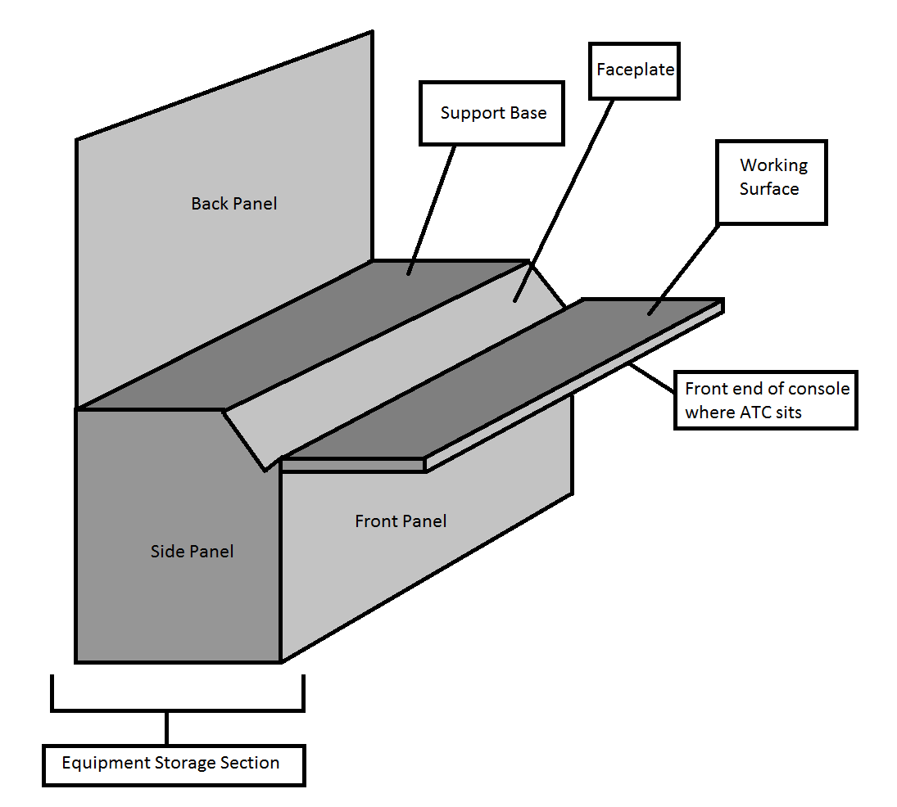
Figure 1: Approach console terms of reference.
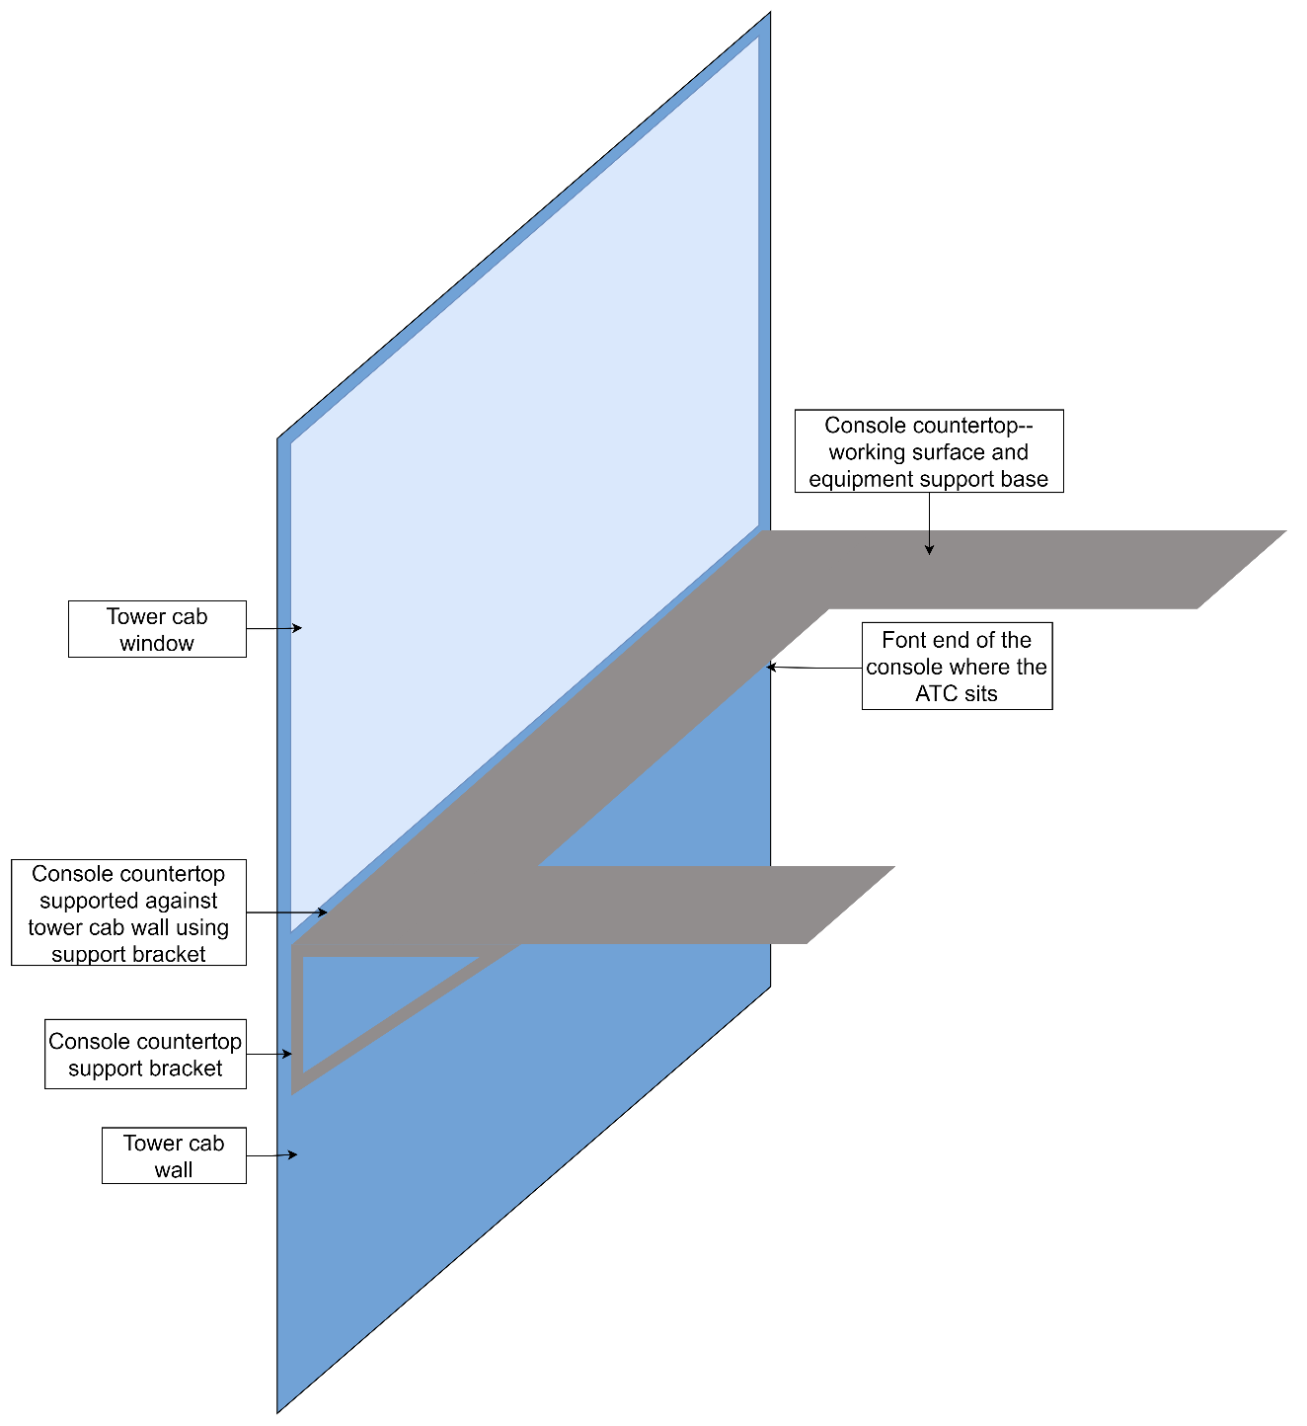
Figure 2. Tower console terms of reference
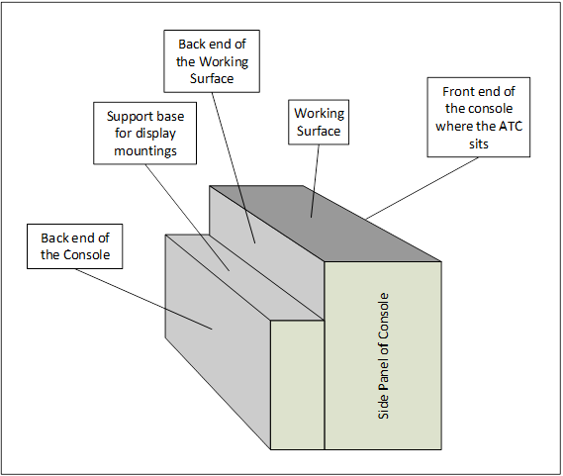
Figure 3. Maintenance console terms of reference

EXISTING CONSOLE LAYOUTS

FALE Approach Hall, Playback Room and Equipment Room

FALE Approach Hall, Playback Room and Equipment Room Consoles Layout
FALE approach hall consoles cater for two (2) Administration, two (2) Approach Control and two (2) Air Traffic Service Officer (ATSO) positions. The project also caters for the replacement of FALE’s two (2) playback room consoles and three (3) maintenance consoles located in the equipment room. The layout of the existing approach hall consoles, playback room, and equipment room are presented in Figure 4, Figure 5 and Figure 6 respectively. The height of the Approach, ATSO and Administration consoles is 830 mm.
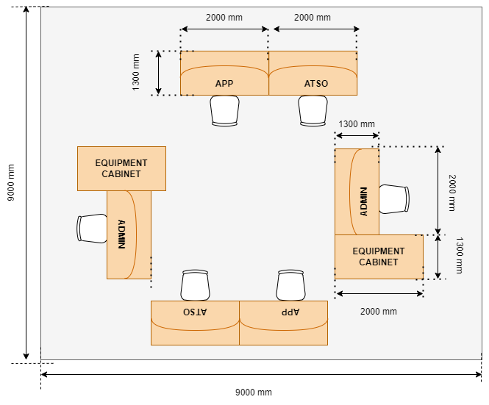
Figure 4. FALE Approach Hall Consoles layout

The height of Playback Position 1 console is 730mm, and the height of Playback Position 2 and Administration consoles is 830 mm. Although the playback consoles are currently two different heights, the project will standardize the playback consoles such that they are the same height and specification as the approach consoles.
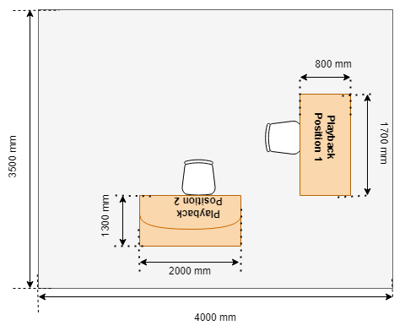
Figure 5. FALE Playback Room Consoles Layout

The height of all the maintenance consoles is currently 700mm.
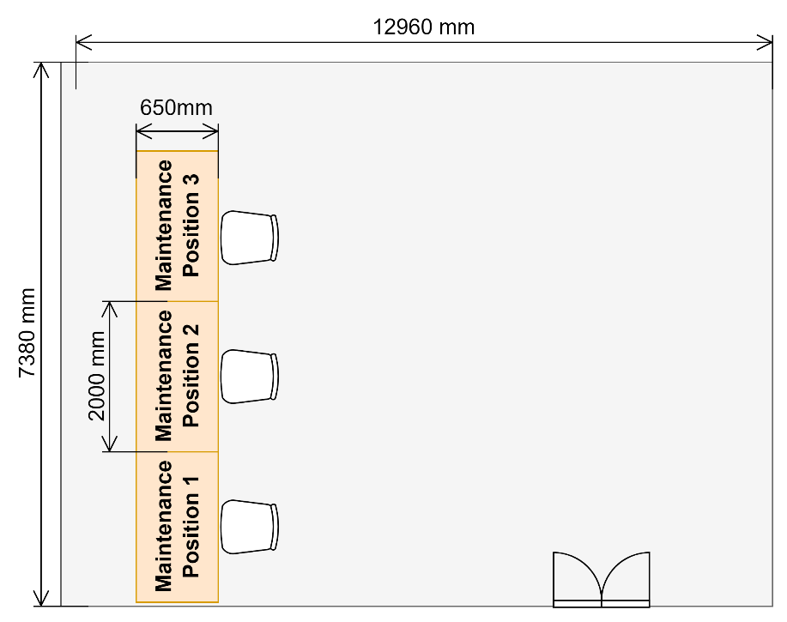
Figure 6. FALE Maintenance Consoles Layout in Equipment Room

FALE Approach Hall, Playback Room and Equipment Room Equipment
The following equipment is currently catered for on the existing consoles and will have to be incorporated on the new consoles.

Table 1. Existing equipment installed per position at FALE Approach Hall and Playback Room.
 | Controller Positions
 | FALE Approach Hall |  |  | Playback Room
Approach Control (APP) Position (x2) | Air Traffic Service Officer (ATSO) Position 1 | Air Traffic Service Officer (ATSO) Position 1 | Administrator Position (x2) | Playback Position (x2)
Voice Communication and Control System (VCCS) (15-inch display) | VCCS (15-inch display) | VCCS (15-inch display) | VCCS (15-inch display) | Topsky displays  - 1 x 28-inch monitor  - 1 x 24-inch monitor
Topsky displays  - 1 x 28-inch monitor  - 1 x 24-inch monitor | Topsky displays  - 1 x 28-inch monitor  - 1 x 24-inch monitor | Topsky displays  - 2 x 24-inch monitor | Keyboard | Keyboards (x3)
Keyboard | Keyboard | Keyboard | Mouse | Mouse (x3)
Mouse | Mouse | Mouse | Desktop computer (Administration PC) (24 inch) | Topsky Clock
Topsky Clock | Topsky Clock | Topsky Clock | Freestanding Printer | Voice and Surveillance Recorder (VSR) monitor (25 inch)
Standby radio | Standby radio | Standby radio | UPS and battery pack (inside equipment cabinet) | Air Traffic Service (ATS) resource tool  (21-inch monitor)
DAID (Digital Airfield Information Display) (25 inch monitor) | UPS and battery pack (inside equipment cabinet) | UPS and battery pack (inside equipment cabinet) |  | Speakers (x4)
Flight strip board |  |  |  | UPS and battery pack (inside equipment cabinet)
Polycom (telephone) (PABX/PCUG failover)
Reading Lamp
Biometric fingerprint reader (1X ATC and 1X ATSO) (to be moved to the Admin position with this project)
UPS and battery pack (inside equipment cabinet)

Table 2. Existing Equipment Installed- FALE Equipment Room consoles
Maintenance Position 1 | Maintenance Position 2 | Maintenance Position 3
Topsky 4k x 4k Display (28-inch monitor) | MCS 1 (25-inch monitor) | Schmidt VCS (21-inch)
Topsky 1k Display (24-inch monitor) | MCS 2 (24-inch monitor) | VCS Maintenance Position (15-inch)
Topsky CMS (24-inch monitor) | Marc/ Eventide (21-inch monitor) | Radar RCMS (26-inch monitor)
Topsky HCT (24-inch monitor) | Sitti VCS (24-inch) | OTN (21-inch monitor)
TMCS/ VCS (17,32-inch) | 4 x Mouse | 4 x Mouse
5 x Mouse | 4 x Keyboard | 4 x Keyboard
5 x Keyboard | UPS and Battery Pack | UPS and Battery Pack
UPS and Battery Pack
Static Switch

Tower Consoles Layouts
Figure 7 contains the equipment icons legend for Figure 8, Figure 9 and Figure 10.
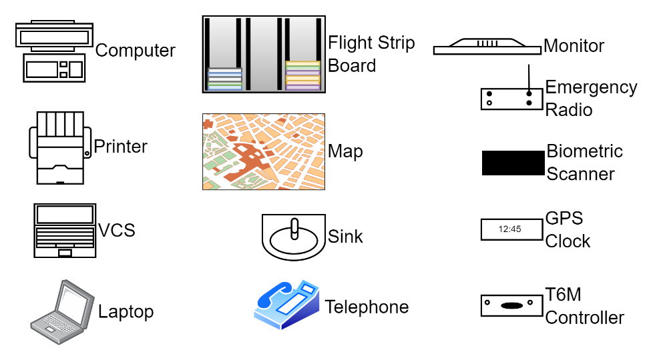
Figure 7. Equipment Icons Legend for Tower consoles Layout diagrams

FAPM Tower

FAPM Tower Console Layout
FAPM tower console caters for one Tower Controller position. The layout of the FAPM tower console is presented in Figure 8 The current console height is 700mm. The new height of the FAPM console shall allow 740mm legroom as required in the ATNS ergonomics manual.
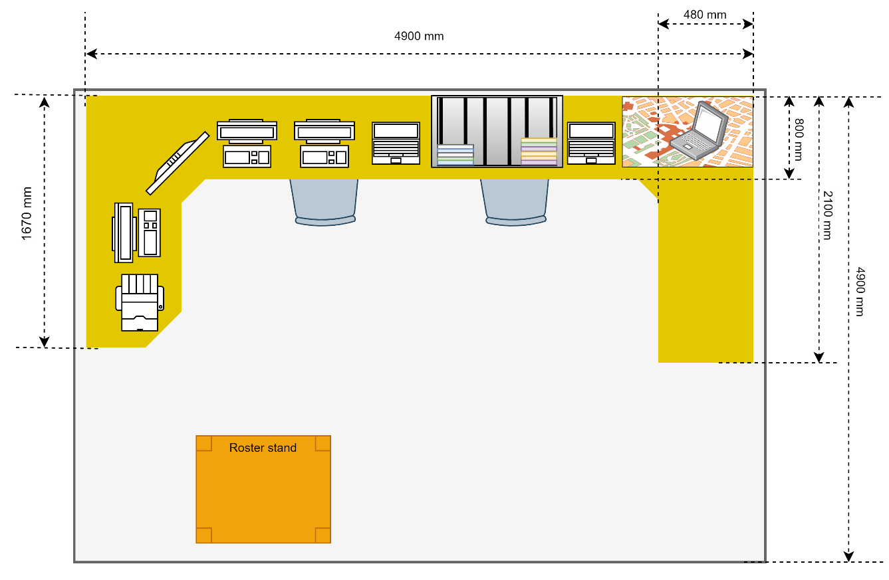
Figure 8. FAPM Tower Consoles Layout

FAPM Tower Equipment
The FAPM Tower has the following equipment which is accommodated on the console:
Tower Controller Position | Other
Voice Communication Systems (VCSs) (x2) | Officer In Charge (OIC) workstation
AMATIS/ ANAIS (Aeronautical Automated Information Systems) Personal Computer (PC), Keyboard and Mouse | Map
Weather Monitor (22 inch) | Roster Stand
Very High Frequency Direction Finder (VDF) Display
Admin PC (Tower PC)
Flight Strip Board
Digital Light Emitting Diode (LED) Display Clock (GPS Clock)
Standby VHF radio (Dittel)

FAVG Tower

FAVG Tower Console Layout
FAVG tower console caters for a Tower Controller position. The layout of the FAVG tower console is presented in Figure 9. The current console height is 770 mm.
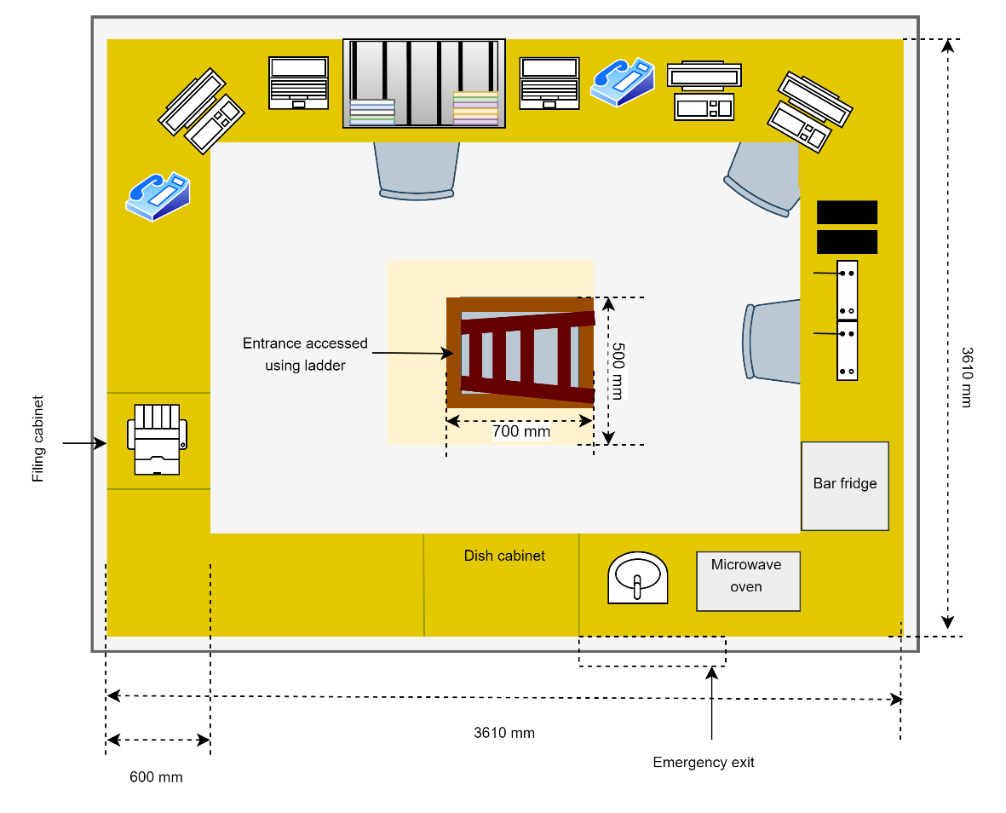
Figure 9. FAVG Tower Console Layout

FAVG Tower Equipment
The FAVG Tower has the following equipment which is accommodated on the console:
Tower Controller Position | Other
Telephone | Printer
SAWS Weather PC, tower, keyboard and mouse | Filing Cabinet
VCS (x2) | Plastic Buddy Drawers
Flight Strip Board | Kitchen Sink
PCUG Telephone | Bar Fridge
Ambient microphone (above PCUG telephone) | Microwave Oven
AMATIS/ ANAIS PC, keyboard and mouse | Staff Files (next to microwave)
Office/ Admin PC, keyboard and mouse | Dish Cabinet
Biometric fingerprint reader (x2)
Emergency portable VHF radios (Dittel) (x2)
Intercom System

FARB Tower

FARB Tower Console Layout
FARB tower console caters for one Tower Controller position. The layout of the FARB tower console is presented in Figure 10. The current console height is 775mm.
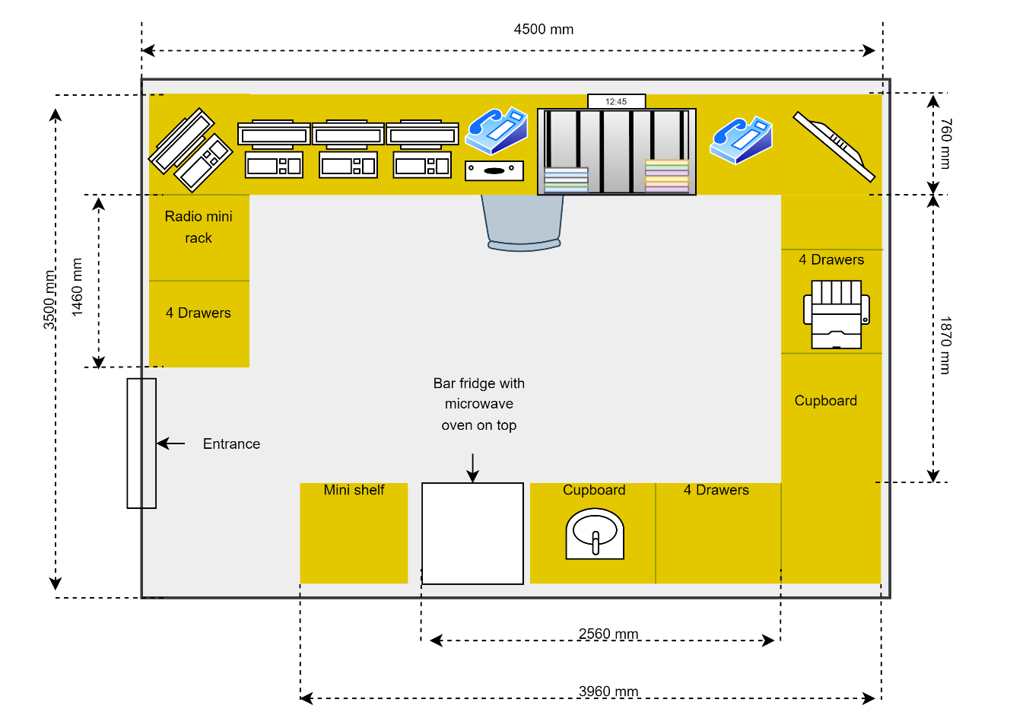
Figure 10. FARB Tower Console Layout

FARB Tower Equipment
The FARB Tower has the following equipment which is accommodated on the console:
Tower Controller Position | Other
Emergency portable VHF radios (Dittel) (x2) | Tabletop Printer
Radio (underneath the console) | Filing Cabinet
Recorder Screen, keyboard, and mouse | Kitchen Sink
AWOS PC, keyboard and mouse | Bar fridge
Admin PC, wireless keyboard and mouse | Microwave oven
AMATIS/ ANAIS PC, wireless keyboard and mouse
T6M Controller Radio
Telephone (x2)
Cellphone (x1)
6-way Multiplug
GPS Clock
Flight Strip Board
Runway/ Taxiway lighting controller
Binoculars (x2)
Provision for VCS operator positions (x2) to be made.

Other equipment includes the following:
- UPS placed under the console on the floor in the corner to the left of the controller position.
- AWOS CPU placed on top of the UPS.
- MTN network box and switch belonging to ATNS IT placed under the console in the corner to the right of the controller position.

GENERAL TECHNICAL SPECIFICATIONS

GENERAL REQUIREMENTS
The specifications contained under this section apply to all consoles, cabinets and auxiliary components being supplied to all sites i.e. FAPM, FAVG and FARB towers; and FALE approach hall, playback room and equipment room.

Supply, Delivery and Installation
- The Contractor shall supply, deliver, and install the consoles and associated components as defined herein at the FALE Radar Hall, Equipment Room and Playback Room; and the FAPM, FARB and FAVG Control Towers. (D)
COMPLIANCE (C/PC/NC/Noted)
[INSERT FULL RESPONSE FOR EVALUATION HERE]

[INSERT REFERENCE TO ADDITIONAL INFORMATION HERE]

Design Life
- The console and all auxiliary modules, components and equipment cabinets shall have a design life of at least 10 years. The Tenderer shall provide supporting documentation, on all products or materials used, to support this statement. (D)
COMPLIANCE (C/PC/NC/Noted)
[INSERT FULL RESPONSE FOR EVALUATION HERE]

[INSERT REFERENCE TO ADDITIONAL INFORMATION HERE]

- The console shall not incorporate any cut-outs or slots that will weaken its durability and longevity. The Tenderer shall demonstrate on design documents that no cut-outs or slots are used. (D)
COMPLIANCE (C/PC/NC/Noted)
[INSERT FULL RESPONSE FOR EVALUATION HERE]

[INSERT REFERENCE TO ADDITIONAL INFORMATION HERE]

- The console shall not be drilled to accommodate the installation of any components. The Tenderer shall provide full details on how the installation of components will be achieved. (D)
COMPLIANCE (C/PC/NC/Noted)
[INSERT FULL RESPONSE FOR EVALUATION HERE]

[INSERT REFERENCE TO ADDITIONAL INFORMATION HERE]

- The consoles shall minimize the potential for damage of consoles including the chipping and structural stability of the consoles over the lifespan of the console. The Tenderer shall provide full details on how structural stability of the consoles is achieved by the proposed design.(D)
COMPLIANCE (C/PC/NC/Noted)
[INSERT FULL RESPONSE FOR EVALUATION HERE]

[INSERT REFERENCE TO ADDITIONAL INFORMATION HERE]

Material
- The consoles and auxiliary components shall be made of a material that is fire resistant, heat resistant, moisture proof, durable, scratch resistant and hard wearing with the required design life of at least 10 years. The Tender shall provide full details on the material/s; and supporting information to show that the material/s adheres to these requirements. (D)
COMPLIANCE (C/PC/NC/Noted)
[INSERT FULL RESPONSE FOR EVALUATION HERE]

[INSERT REFERENCE TO ADDITIONAL INFORMATION HERE]

- The FALE consoles shall be water-resistant to withstand damage from spilt liquids. (D)
COMPLIANCE (C/PC/NC/Noted)
[INSERT FULL RESPONSE FOR EVALUATION HERE]

[INSERT REFERENCE TO ADDITIONAL INFORMATION HERE]

- The Tower consoles at FAPM, FAVG and FARB shall be waterproof. The Tender shall provide full details on the material/s; and supporting information to show that the material/s adheres to these requirements. (D)
COMPLIANCE (C/PC/NC/Noted)
[INSERT FULL RESPONSE FOR EVALUATION HERE]

[INSERT REFERENCE TO ADDITIONAL INFORMATION HERE]

- The material shall be, as far as possible, environmentally responsible and sustainable. The proposed material shall adhere to the following requirements:
  - Should the proposed consoles or auxiliary components be produced from wood, the Tenderer shall provide a certificate from the Forest Stewardship Council (FSC) to show that the wood has been sourced from sustainable forest plantations. (D)
COMPLIANCE (C/PC/NC/Noted)
[INSERT FULL RESPONSE FOR EVALUATION HERE]

[INSERT REFERENCE TO ADDITIONAL INFORMATION HERE]

  - For any non-renewable material used, Tenderers shall provide details of the suppliers’ practices showing how their resource extraction and manufacturing processes have reduction measures in place to address environmental impacts. (D)
COMPLIANCE (C/PC/NC/Noted)
[INSERT FULL RESPONSE FOR EVALUATION HERE]

[INSERT REFERENCE TO ADDITIONAL INFORMATION HERE]

  - At least 50% of the consoles and auxiliary components shall be made from recycled content. Tenderers shall provide supporting information indicating what percentage of the proposed consoles and auxiliary components will be manufactured from recycled materials i.e. wood, fabrics, metal and plastic, as well as organic wool and cotton that has been recycled. (D)
COMPLIANCE (C/PC/NC/Noted)
[INSERT FULL RESPONSE FOR EVALUATION HERE]

[INSERT REFERENCE TO ADDITIONAL INFORMATION HERE]

  - At least 50% of the consoles and auxiliary components shall be recyclable. Tenderers shall provide supporting information indicating what percentage of the proposed consoles and auxiliary components will be recyclable. (D)
COMPLIANCE (C/PC/NC/Noted)
[INSERT FULL RESPONSE FOR EVALUATION HERE]

[INSERT REFERENCE TO ADDITIONAL INFORMATION HERE]

  - There shall be no toxic substances in the materials used (i.e. adhesives, paints with high volatile organic compound content, PVC, lead, etc.). The Tenderer shall indicate compliance to this requirement. (D)
COMPLIANCE (C/PC/NC/Noted)
[INSERT FULL RESPONSE FOR EVALUATION HERE]

[INSERT REFERENCE TO ADDITIONAL INFORMATION HERE]

  - Flame retardant and solvent free materials shall be used. The Tenderer shall indicate compliance to this requirement. (D)
COMPLIANCE (C/PC/NC/Noted)
[INSERT FULL RESPONSE FOR EVALUATION HERE]

[INSERT REFERENCE TO ADDITIONAL INFORMATION HERE]

  - Products that may result in indoor air pollution through chemicals that are emitted by processed materials and finishes shall not be used. The Tenderer shall indicate compliance to this requirement. (D)
COMPLIANCE (C/PC/NC/Noted)
[INSERT FULL RESPONSE FOR EVALUATION HERE]

[INSERT REFERENCE TO ADDITIONAL INFORMATION HERE]

- The Tenderer shall provide supporting information showing that the console and all its supporting equipment and auxiliaries shall withstand and operate within specifications under the environmental conditions as stated below: (D)
Table 3: Environmental Conditions.
Meteorological Variable | Specifications
Ambient Temperature | +5 °C to +35 °C (indoor)  -10 °C to +50 °C (outdoor)
Relative humidity | ≤ 95% for temperatures ≤ +35 °C (indoor)  ≤ 60% for temperatures $>$ + 35 °C (indoor)  1% to 100% (outdoor)

COMPLIANCE (C/PC/NC/Noted)
[INSERT FULL RESPONSE FOR EVALUATION HERE]

[INSERT REFERENCE TO ADDITIONAL INFORMATION HERE]

- The console and all its supporting equipment and auxiliaries shall be resistant to rust considering that FALE, FAVG and FARB are situated in coastal regions. The Tenderer shall indicate compliance to this requirement. (D)
COMPLIANCE (C/PC/NC/Noted)
[INSERT FULL RESPONSE FOR EVALUATION HERE]

[INSERT REFERENCE TO ADDITIONAL INFORMATION HERE]

- The Tenderer shall provide supporting information indicating how the console shall minimise natural light and room light reflections taking into consideration the following: (D)
- The tower cabs experience 10 to 15 hours of sunlight through large glass windowpanes daily.
- The rooms in which the consoles are installed are well illuminated by electrical lighting.
- The light emitted from multiple monitors simultaneously.
COMPLIANCE (C/PC/NC/Noted)
[INSERT FULL RESPONSE FOR EVALUATION HERE]

[INSERT REFERENCE TO ADDITIONAL INFORMATION HERE]

- The Tenderer shall provide supporting information indicating how the working surface material shall support the operation of an optical mouse. (D)
COMPLIANCE (C/PC/NC/Noted)
[INSERT FULL RESPONSE FOR EVALUATION HERE]

[INSERT REFERENCE TO ADDITIONAL INFORMATION HERE]

- The Tenderer shall provide supporting information indicating how the console and auxiliary equipment shall contribute minimal noise in the control tower cab to accommodate clear communication and support acceptable noise levels for operations given that the threshold of unimpaired human hearing is 0dBA and typical sound level of normal conversation is 60dBA. (D)
COMPLIANCE (C/PC/NC/Noted)
[INSERT FULL RESPONSE FOR EVALUATION HERE]

[INSERT REFERENCE TO ADDITIONAL INFORMATION HERE]

Modularity
- A complete consoles design shall be modular to support installation and maintenance activities, and for ease of moving the console through passages and around corners. The Tenderer shall provide modular technical designs for each station, and indicate how the following limitations of the access routes in the respective areas, are considered in their designs: (D)
- FALE Approach Hall, Playback Room and Equipment Room: The smallest access point is 800 mm in width, 1800 mm in height and 90-degree corners shall be assumed.
- FAPM an FARB Tower Cab: The smallest access point is 800 mm in width, 1800 mm in height and 90-degree corner shall be assumed. The control towers can only be access using a staircase where 90-degree corners need to be navigated.
- FAVG Tower Cab: Entrance to the tower cab is via a ladder through a trapdoor in the tower cab floor. The trapdoor entrance measures 700 mm x 500mm. Staircases and 90-degree corners need to be navigated before climbing the ladder.
COMPLIANCE (C/PC/NC/Noted)
[INSERT FULL RESPONSE FOR EVALUATION HERE]

[INSERT REFERENCE TO ADDITIONAL INFORMATION HERE]

- The Tenderer shall indicate the separate parts that make up the consoles in technical drawings for each station. This drawing shall highlight how these parts combine to form the complete console structure. (D)
COMPLIANCE (C/PC/NC/Noted)
[INSERT FULL RESPONSE FOR EVALUATION HERE]

[INSERT REFERENCE TO ADDITIONAL INFORMATION HERE]

Ergonomics
The following illustration is taken from the ATNS Ergonomic Specifications Manual.
Figure 11. Seated workspace dimensions and illustrations

- Prior to the console being manufactured, the Contractor shall submit the final console design to ATNS for approval from the ATNS Human Factors department. The ATNS Ergonomic Specification Manual has been attached for console design reference. (I)
COMPLIANCE (C/PC/NC/Noted)
[INSERT FULL RESPONSE FOR EVALUATION HERE]

[INSERT REFERENCE TO ADDITIONAL INFORMATION HERE]

- The Contractor shall ensure that the surfaces and edges of the consoles are smooth. The Tenderer shall provide information indicating how this will be achieved. (D)
COMPLIANCE (C/PC/NC/Noted)
[INSERT FULL RESPONSE FOR EVALUATION HERE]

[INSERT REFERENCE TO ADDITIONAL INFORMATION HERE]

- The console shall have sufficient space available for leg room and essential equipment beneath the working surface on the console design. The minimum leg room dimensions are 460 x 510 x 740 mm (depth x width x height). The Tenderer shall indicate the space available for leg room and essential equipment beneath the working surface on the console design. (D)
COMPLIANCE (C/PC/NC/Noted)
[INSERT FULL RESPONSE FOR EVALUATION HERE]

[INSERT REFERENCE TO ADDITIONAL INFORMATION HERE]

- The final design review of the Tower consoles for FAPM, FAVG and FARB shall include a line-of-sight review to ensure that a seated TWR Controller has unobstructed visibility of the manoeuvring area and apron as well as the circuit and final approach/take off sectors. Tower consoles should be designed such that equipment will be placed on the working surface in a manner which will promote unobstructed visibility of the manoeuvring area before equipment will be placed , taking into consideration the window beams that may obstruct runways/taxiway intersections and aerodrome hotspots. The Tenderer shall indicate compliance to this requirement. (I)
COMPLIANCE (C/PC/NC/Noted)
[INSERT FULL RESPONSE FOR EVALUATION HERE]

[INSERT REFERENCE TO ADDITIONAL INFORMATION HERE]

- The recommended layout for the Tower consoles is as follows:
  - Primary equipment within 35-degree angle of controller position centreline
    - Flight Strip Board
    - Weather Display
    - Crash Alarm
    - Telephones, VCS, Emergency Radios, Intercom (Fire)
    - Clock
    - Binoculars
  - Secondary equipment that are applied less frequently and placed within a 45-degree centreline of the seated controller position:
    - Storage bay for flight plan strips.
    - Speakers
    - Entrance control
The Tenderer shall provide the proposed equipment layout for their Tower console designs. (D)
COMPLIANCE (C/PC/NC/Noted)
[INSERT FULL RESPONSE FOR EVALUATION HERE]

[INSERT REFERENCE TO ADDITIONAL INFORMATION HERE]

- The recommended layout for the Approach consoles is as follows:
  - Primary equipment within 35-degree angle of controller position centreline:
    - Radar display
    - AWOS display
    - Keyboard
    - Flight Strip Board
    - Electronic Flight Plan Strip Display
    - VCCS
    - Clock
    - Computer mouse/ mice
  - Secondary equipment that are applied less frequently and placed within a 45-degree centreline of the seated controller position:
    - Embedded headset sockets
    - Speakers
    - Storage bay for flight plan strips
The Tenderer shall provide the proposed equipment layout for their Approach console designs. (D)
COMPLIANCE (C/PC/NC/Noted)
[INSERT FULL RESPONSE FOR EVALUATION HERE]

[INSERT REFERENCE TO ADDITIONAL INFORMATION HERE]

Electrical
- The project shall include the issuing of the Certificate of Compliance (CoC) for FALE Approach Hall and FAPM, FAVG and FARB Towers. The Tenderer shall indicate compliance to this requirement. (D)
COMPLIANCE (C/PC/NC/Noted)
[INSERT FULL RESPONSE FOR EVALUATION HERE]

[INSERT REFERENCE TO ADDITIONAL INFORMATION HERE]

- The console shall incorporate materials that are good insulators to minimize the occurrence of electrical shock. The Tenderer shall provide details on the insulated materials that are used in their design. (D)
COMPLIANCE (C/PC/NC/Noted)
[INSERT FULL RESPONSE FOR EVALUATION HERE]

[INSERT REFERENCE TO ADDITIONAL INFORMATION HERE]

Disposal
- The existing consoles shall be uninstalled, disassembled, and disposed of in an environmentally friendly manner and in line with current environmental laws. Waste must be managed according to the ATNS waste management policies and there shall be adherence to the requirements of the National Waste Management Act (No.59 of 2008). The Tenderer shall make provision for these activities in the project costing. (D)
COMPLIANCE (C/PC/NC/Noted)
[INSERT FULL RESPONSE FOR EVALUATION HERE]

[INSERT REFERENCE TO ADDITIONAL INFORMATION HERE]

FALE APPROACH CONSOLES TECHNICAL SPECIFICATIONS

APPROACH CONSOLE REQUIREMENTS

Console Layout
- ATNS’s preference is to keep the existing layout in the Radar Hall. The Tenderer shall propose a layout for the Radar Hall and the Playback Room. The dimensions of the Radar Hall are 9000 x 9000 mm and the dimensions of the Playback Room are 4000 x 3500 mm. Existing console layouts can be found in Figure 4 and Figure 5. (D)
COMPLIANCE (C/PC/NC/Noted)
[INSERT FULL RESPONSE FOR EVALUATION HERE]

[INSERT REFERENCE TO ADDITIONAL INFORMATION HERE]

Design
- There are two types of consoles required, namely, “TNAC” and “Admin” consoles. TNAC consoles refers to the type of consoles that will be used for the Approach and ATSO positions. Admin consoles refers to the type of consoles that will be used for the Administrator positions and the playback room positions. The technical drawings for these two preferred consoles are provided in Appendix A. The consoles shall be the same as, or similar, to these consoles. There shall be four TNAC consoles and two Admin consoles installed in the Radar Hall. In addition, there shall be two Admin consoles installed in the Playback room. The Tenderer shall provide a conceptual design of the consoles in the form of technical drawings to demonstrate understanding of the requirements. The drawings shall highlight the shape/form of the console and include the dimensions of the console. (D)
COMPLIANCE (C/PC/NC/Noted)
[INSERT FULL RESPONSE FOR EVALUATION HERE]

[INSERT REFERENCE TO ADDITIONAL INFORMATION HERE]

- The consoles shall not incorporate devices that generate noise such as cooling fans. The Tenderer shall explain how equipment cooling is achieved in their console design. (D)
COMPLIANCE (C/PC/NC/Noted)
[INSERT FULL RESPONSE FOR EVALUATION HERE]

[INSERT REFERENCE TO ADDITIONAL INFORMATION HERE]

- In addition to the drawings supplied, the Contractor shall ensure that the eye level of a person seated at the Admin position shall be just above the midway of the display/monitor. (D)
COMPLIANCE (C/PC/NC/Noted)
[INSERT FULL RESPONSE FOR EVALUATION HERE]

[INSERT REFERENCE TO ADDITIONAL INFORMATION HERE]

- The back end of the console and the front panel under the working surface (refer to Figure 1) shall be closed with lockable panels that can be removed and placed back into position quickly and easily to allow for maintenance personnel to access the equipment and cables. An example of the panels at the back are shown in Figure 12. Padlocks will not be accepted. The Tenderer shall indicate in their proposal how this will be achieved. (D)
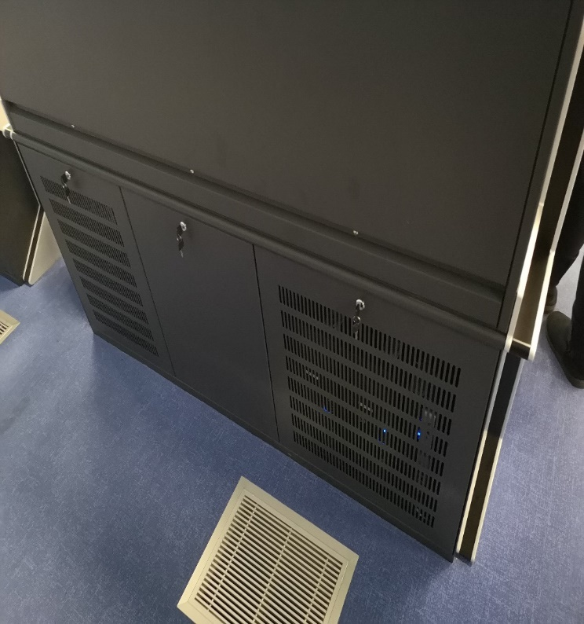
Figure 12: Example of the back of the console.
COMPLIANCE (C/PC/NC/Noted)
[INSERT FULL RESPONSE FOR EVALUATION HERE]

[INSERT REFERENCE TO ADDITIONAL INFORMATION HERE]

- The console shall be stable after it has been assembled and all equipment has been installed on it. The console shall also provide stability for the displays and all other equipment such that it shall not shake if the console is pushed or pulled. Tenderers shall provide details of how this will be achieved. (D)
COMPLIANCE (C/PC/NC/Noted)
[INSERT FULL RESPONSE FOR EVALUATION HERE]

[INSERT REFERENCE TO ADDITIONAL INFORMATION HERE]

- The Tenderer shall indicate the point loads for the console that will be in contact with the floor on the technical drawings. (D)
COMPLIANCE (C/PC/NC/Noted)
[INSERT FULL RESPONSE FOR EVALUATION HERE]

[INSERT REFERENCE TO ADDITIONAL INFORMATION HERE]

- The consoles shall be fitted with two Power Distribution Units (PDU) as per the drawings in Appendix A. Each PDU shall have at least six International Electrotechnical Commission (IEC) C13 sockets. There shall be three PDU’s supplied per position. Two PDU’s shall be mounted inside the console and one PDU shall be delivered as a spare. The PDU’s shall not obstruct access to equipment. The PDU’s shall be connected to the Distribution Board installed inside the console. An example of a PDU with C13 sockets is shown in Figure 13. Tenderers shall provide details of the PDU to be used. The Contractor shall supply an Electrical Compliance Certificate for the installation of the PDUs. (D)
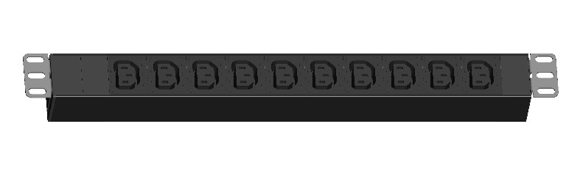
Figure 13: Example of an IEC power distribution unit with C13 sockets.

COMPLIANCE (C/PC/NC/Noted)
[INSERT FULL RESPONSE FOR EVALUATION HERE]

[INSERT REFERENCE TO ADDITIONAL INFORMATION HERE]

- There shall be one hundred and twenty (120) 2m long, C13 to C14 cables supplied. The Tenderer shall make provision for this in the costing. (D)
COMPLIANCE (C/PC/NC/Noted)
[INSERT FULL RESPONSE FOR EVALUATION HERE]

[INSERT REFERENCE TO ADDITIONAL INFORMATION HERE]

Flight Strip Board
A flight strip board serves as a placement for flight strip holders. The flight strip board comprises of 4 columns. Each column consists of two 10mm cylindrical rods placed 82 mm apart. The flight strip board columns are carefully separated to allow a perfect fit of flight strip holders. The height of the flight strip board is very shallow approximately 25 mm. A side view and a bottom view of a flight strip holder is presented in Figure 14. Figure 15 provides a picture of a typical operations flight strip board/s.
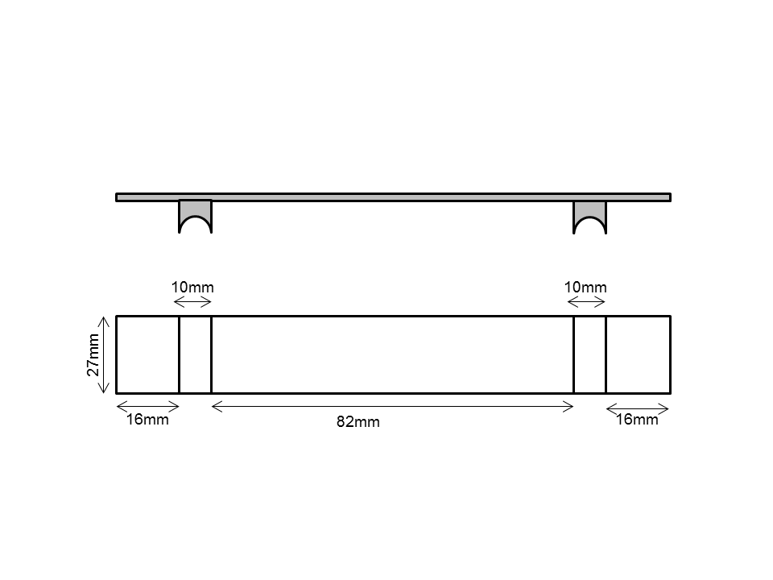
Figure 14: Flight strip dimensions for flight strip board Type A.

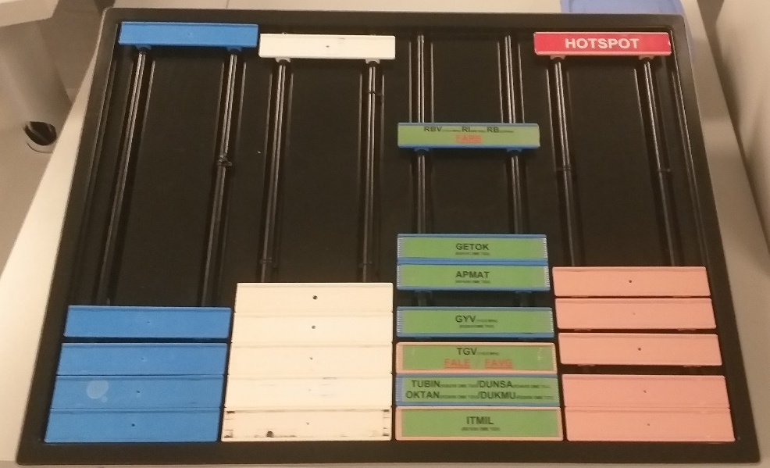
Figure 15: Typical operations flight strip board/s

- Each console shall be provided with a flight strip board, and one spare flight strip board shall be provided. The flight strip board shall have a length to fit at least 14 flight strips in a column and a width that allows four flight strips to fit side by side with a 10mm gap between each strip. The minimum length and width shall be 378mm and 566mm respectively. The Tenderer shall provide a conceptual design of flight strip board indicating these dimensions. (D)
COMPLIANCE (C/PC/NC/Noted)
[INSERT FULL RESPONSE FOR EVALUATION HERE]

[INSERT REFERENCE TO ADDITIONAL INFORMATION HERE]

- The angle of the top surface of the flight strip board shall be adjustable within a range of 0 to 45 degrees. The flight strip board shall have a locking mechanism to keep the flight strip board at the desired angle. The Tenderer shall provide supporting information to show how this will be achieved. (D)
COMPLIANCE (C/PC/NC/Noted)
[INSERT FULL RESPONSE FOR EVALUATION HERE]

[INSERT REFERENCE TO ADDITIONAL INFORMATION HERE]

- The flight strip board shall be freestanding and mobile, with a means to prevent it from unintentionally movement on the console such as rubber backing. Tenderers shall provide details of how this will be achieved. (D)
COMPLIANCE (C/PC/NC/Noted)
[INSERT FULL RESPONSE FOR EVALUATION HERE]

[INSERT REFERENCE TO ADDITIONAL INFORMATION HERE]

Equipment Storage Section
- The back section of the console under the support base and faceplate shall form the equipment storage section. The Tenderer shall indicate this on the Technical drawings. (D)
COMPLIANCE (C/PC/NC/Noted)
[INSERT FULL RESPONSE FOR EVALUATION HERE]

[INSERT REFERENCE TO ADDITIONAL INFORMATION HERE]

- The equipment storage section shall have three sections as per the drawings in Appendix A. The Tenderer shall indicate this on the Technical drawings. (D)
COMPLIANCE (C/PC/NC/Noted)
[INSERT FULL RESPONSE FOR EVALUATION HERE]

[INSERT REFERENCE TO ADDITIONAL INFORMATION HERE]

- Each section of the equipment storage section shall be easily accessible from the front and the back of the console. The Tenderer shall provide details on how this will be achieved. (D)
COMPLIANCE (C/PC/NC/Noted)
[INSERT FULL RESPONSE FOR EVALUATION HERE]

[INSERT REFERENCE TO ADDITIONAL INFORMATION HERE]

- A maintenance light shall be installed in the middle section of the equipment storage section. The maintenance light shall be in the form of a low power LED tube. The fitting and cabling for the LED tube shall be provided and installed as per the drawings in Appendix A. The fitting shall have an on/off switch. The Tenderer shall indicate this on the Technical drawings and provide details of the maintenance light. (D)
COMPLIANCE (C/PC/NC/Noted)
[INSERT FULL RESPONSE FOR EVALUATION HERE]

[INSERT REFERENCE TO ADDITIONAL INFORMATION HERE]

- Each section of the equipment storage section shall have a minimum width of 19 inch to accommodate a 19-inch server. The Tenderer shall indicate this on the Technical drawings. (D)
COMPLIANCE (C/PC/NC/Noted)
[INSERT FULL RESPONSE FOR EVALUATION HERE]

[INSERT REFERENCE TO ADDITIONAL INFORMATION HERE]

- One of the three sections shall cater for 19-inch rack mountable equipment by complying with the Electronic Industries Association (EIA) standard EIA-310 for a standard rack. The Tenderer shall indicate this on the Technical drawings. (D)
COMPLIANCE (C/PC/NC/Noted)
[INSERT FULL RESPONSE FOR EVALUATION HERE]

[INSERT REFERENCE TO ADDITIONAL INFORMATION HERE]

- The equipment storage section shall incorporate two heavy-duty 19-inch rack mountable sliding mechanisms that will allow technicians to slide/draw out equipment from the console beyond the edge of the console for maintenance activities. The Tenderer shall provide details of the rack mountable sliding mechanisms. (D)
COMPLIANCE (C/PC/NC/Noted)
[INSERT FULL RESPONSE FOR EVALUATION HERE]

[INSERT REFERENCE TO ADDITIONAL INFORMATION HERE]

- There shall be four 19-inch rack mountable shelves supplied with the console. The Tenderer shall provide details of the rack mountable shelves. (D)
COMPLIANCE (C/PC/NC/Noted)
[INSERT FULL RESPONSE FOR EVALUATION HERE]

[INSERT REFERENCE TO ADDITIONAL INFORMATION HERE]

- The panels at the back of the console shall be perforated to permit sufficient air flow in and out of the equipment storage section. There shall be no vents in the front where the ATC sits. The Tenderer shall indicate this on the Technical drawings. (D)
COMPLIANCE (C/PC/NC/Noted)
[INSERT FULL RESPONSE FOR EVALUATION HERE]

[INSERT REFERENCE TO ADDITIONAL INFORMATION HERE]

- The panels used to close off the console on the front and the back shall be lockable. The lock shall cater for a master key. Padlock locking mechanisms are not acceptable. The Tenderer shall provide details of the lock mechanism. (D)
COMPLIANCE (C/PC/NC/Noted)
[INSERT FULL RESPONSE FOR EVALUATION HERE]

[INSERT REFERENCE TO ADDITIONAL INFORMATION HERE]

- The equipment storage section shall cater for air forced cooling from the floor. The Tenderer shall indicate this on the Technical drawings. (D)
COMPLIANCE (C/PC/NC/Noted)
[INSERT FULL RESPONSE FOR EVALUATION HERE]

[INSERT REFERENCE TO ADDITIONAL INFORMATION HERE]

- The equipment storage section design shall cater for natural heat dissipation through venting to prevent heat build-up within the cabinet, while minimising the ingress of dust. There shall be no vents in the front where the ATC sits. The Tenderer shall provide details on how this will be achieved. (D)
COMPLIANCE (C/PC/NC/Noted)
[INSERT FULL RESPONSE FOR EVALUATION HERE]

[INSERT REFERENCE TO ADDITIONAL INFORMATION HERE]

- The equipment storage section design shall cater for noise suppression. The cooling of equipment shall also be done silently without introducing any additional noise in the equipment cabinets. The Tenderer shall provide details on how this will be achieved. (D)
COMPLIANCE (C/PC/NC/Noted)
[INSERT FULL RESPONSE FOR EVALUATION HERE]

[INSERT REFERENCE TO ADDITIONAL INFORMATION HERE]

- The equipment storage section shall have a cable management system. The cable management system shall take into consideration the cable route as defined herein and the sliding in and out of equipment from the console. The Tenderer shall provide details on how this will be achieved. (D)
COMPLIANCE (C/PC/NC/Noted)
[INSERT FULL RESPONSE FOR EVALUATION HERE]

[INSERT REFERENCE TO ADDITIONAL INFORMATION HERE]

Power Distribution
- Figure 16 below shows how the power shall be distributed within the console. The Tenderer shall provide a detailed diagram of the power distribution layout within the console. (D)

Figure 16: Power Distribution.
COMPLIANCE (C/PC/NC/Noted)
[INSERT FULL RESPONSE FOR EVALUATION HERE]

[INSERT REFERENCE TO ADDITIONAL INFORMATION HERE]

Distribution Board (DB Board)
- Each console shall have a 12-way distribution board installed in the equipment storage section. The Tenderer shall provide details of the distribution board to be installed within the console. (D)
COMPLIANCE (C/PC/NC/Noted)
[INSERT FULL RESPONSE FOR EVALUATION HERE]

[INSERT REFERENCE TO ADDITIONAL INFORMATION HERE]

- The DB Board shall have one mains switch. The main switch shall be a 2 pole, D Curve miniature circuit breaker with a rating of 16A. The main switch shall be clearly labelled on the DB Board. The Tenderer shall provide supporting information showing compliance to this requirement. (D)
COMPLIANCE (C/PC/NC/Noted)
[INSERT FULL RESPONSE FOR EVALUATION HERE]

[INSERT REFERENCE TO ADDITIONAL INFORMATION HERE]

- The DB Board shall have eight single pole, D Curve miniature circuit breakers with a rating of 6A. Each breaker shall be numbered 1 to 8 and clearly labelled as shown below in Figure 17. The Tenderer shall provide supporting information showing compliance to this requirement. (D)
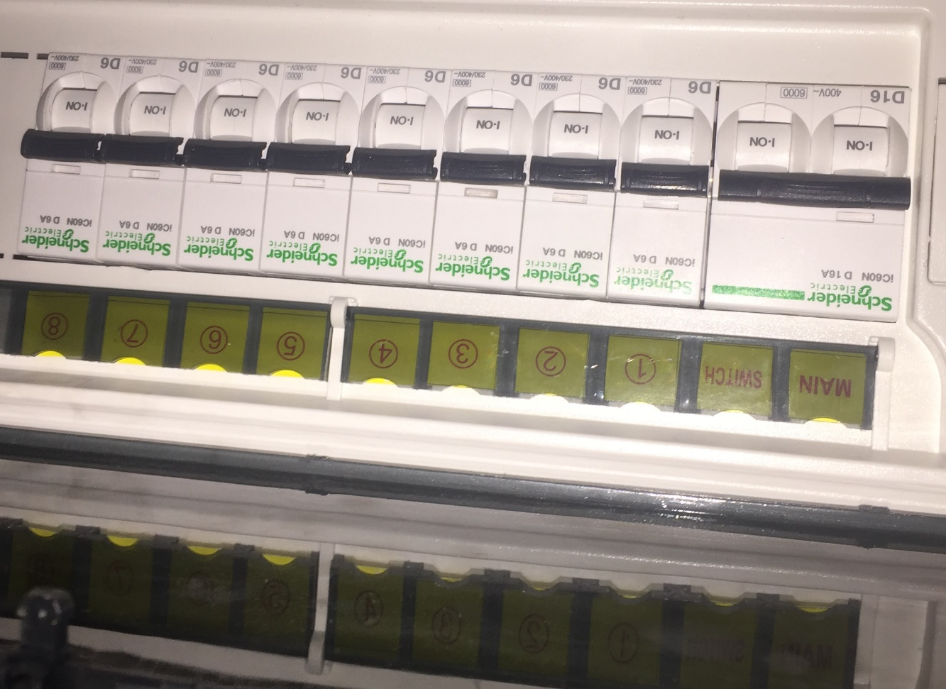
Figure 17: Example of the DB Board.
COMPLIANCE (C/PC/NC/Noted)
[INSERT FULL RESPONSE FOR EVALUATION HERE]

[INSERT REFERENCE TO ADDITIONAL INFORMATION HERE]

- An Electrical Compliance Certificate (ECC) shall be provided for the installation of the DB Board and all electrical work done on the console. The Tenderer shall indicate compliance to this requirement. (D)
COMPLIANCE (C/PC/NC/Noted)
[INSERT FULL RESPONSE FOR EVALUATION HERE]

[INSERT REFERENCE TO ADDITIONAL INFORMATION HERE]

Rotary Isolator Switch
- Each console shall have two rotary isolators installed. The Tenderer shall provide full details on the proposed rotary isolator and indicate the rotary isolators on the technical design. (D)

COMPLIANCE (C/PC/NC/Noted)
[INSERT FULL RESPONSE FOR EVALUATION HERE]

[INSERT REFERENCE TO ADDITIONAL INFORMATION HERE]

- The rotary isolators shall have 2 poles with a rating of 32 Amps, 400V. The Tenderer shall provide supporting information showing compliance to this requirement. (D)
COMPLIANCE (C/PC/NC/Noted)
[INSERT FULL RESPONSE FOR EVALUATION HERE]

[INSERT REFERENCE TO ADDITIONAL INFORMATION HERE]

- The rotatory isolator shall have an ingress protection rating of IP65. The Tenderer shall provide supporting information showing compliance to this requirement. (D)
COMPLIANCE (C/PC/NC/Noted)
[INSERT FULL RESPONSE FOR EVALUATION HERE]

[INSERT REFERENCE TO ADDITIONAL INFORMATION HERE]

Static Switch
- Each console shall have a single phase 3 kVA, 16 Amp static switch. The Tenderer shall provide supporting information proving compliance to this requirement; and indicate the static switch on the technical design. (D)
COMPLIANCE (C/PC/NC/Noted)
[INSERT FULL RESPONSE FOR EVALUATION HERE]

[INSERT REFERENCE TO ADDITIONAL INFORMATION HERE]

- The static switch shall have a height of 1U and be rack mountable in a 19-inch rack. The depth of the static switch and associated connectors shall be less than 500mm. The Tenderer shall provide supporting information showing compliance to this requirement. (D)
COMPLIANCE (C/PC/NC/Noted)
[INSERT FULL RESPONSE FOR EVALUATION HERE]

[INSERT REFERENCE TO ADDITIONAL INFORMATION HERE]

- The static switch shall have an efficiency of 99.9%. The Tenderer shall provide supporting information showing compliance to this requirement. (D)
COMPLIANCE (C/PC/NC/Noted)
[INSERT FULL RESPONSE FOR EVALUATION HERE]

[INSERT REFERENCE TO ADDITIONAL INFORMATION HERE]

Headset connecting ports module
- The headset connecting ports module shall cater for three headset connecting ports. The three ports are for the ATC on position, a supervisor and an observer or student. The cut-out for a single headset connecting port shall be as illustrated in Figure 18. The Tenderer shall provide the conceptual design of the headset connecting ports module demonstrating their understanding of the explanation provided. (D)
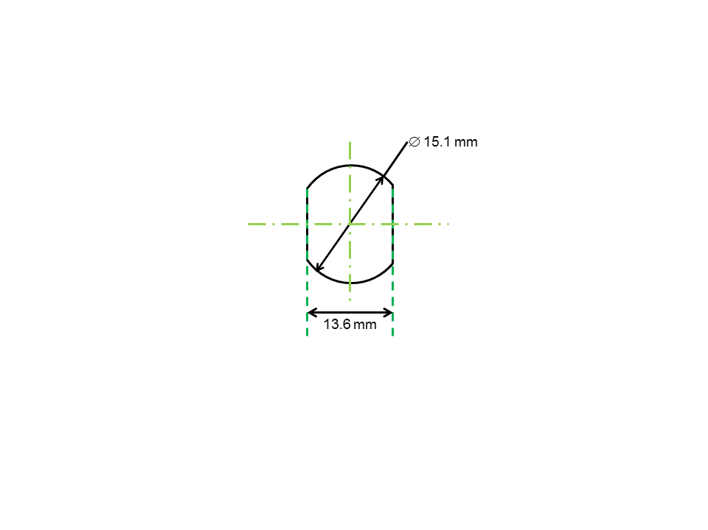
Figure 18: Audio connection cable cut-out dimensions.
COMPLIANCE (C/PC/NC/Noted)
[INSERT FULL RESPONSE FOR EVALUATION HERE]

[INSERT REFERENCE TO ADDITIONAL INFORMATION HERE]

- Each console shall be installed with two headset connecting ports modules. The headset connecting ports modules will be positioned on the left-hand side and the right-hand side in relation to the centre. These stated positions shall be optimized in consideration of the mobility of the controller. Figure 19 below shows the location of the headset connecting ports. The Tenderer shall indicate the position of the headset connecting ports on the technical drawings. (D)
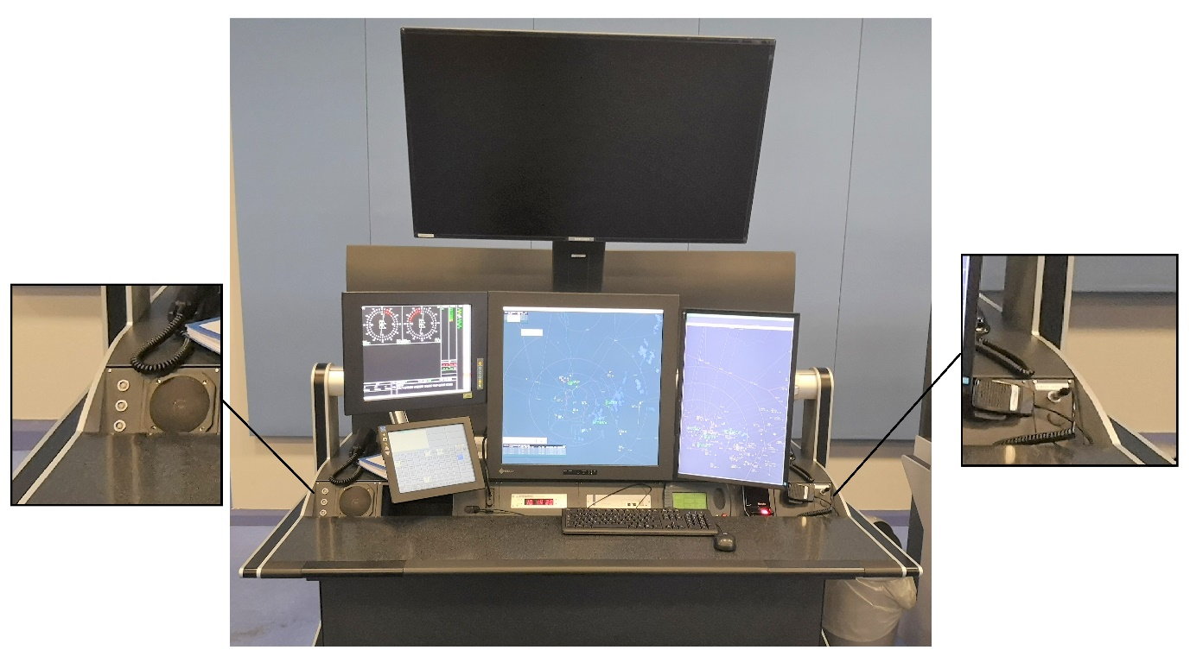
Figure 19: Headset Connecting Ports.
COMPLIANCE (C/PC/NC/Noted)
[INSERT FULL RESPONSE FOR EVALUATION HERE]

[INSERT REFERENCE TO ADDITIONAL INFORMATION HERE]

- The headset connecting port modules shall be installed onto the console while taking the following factors into consideration:
  - The cable management system of the console.
  - The modules shall remain fixed in position until the end of life of the console;
  - Drilling into the console on-site will not be acceptable; and
  - Alignment dots of the port to be facing upward for ease of headset connection.
The Tenderer shall indicate compliance to this requirement. (D)
COMPLIANCE (C/PC/NC/Noted)
[INSERT FULL RESPONSE FOR EVALUATION HERE]

[INSERT REFERENCE TO ADDITIONAL INFORMATION HERE]

Cable Management

Cable Routes
Cabling for equipment will be routed through the radar hall floor. There are feeder holes running through the floor at various positions for connections to the equipment room. The cabling will then be routed to the console’s working surface (to modules, mice and keyboards) or the console’s support base (to display/monitor mounting arms and monitors/displays) or the equipment storage section (to desktop computer towers). In principle, cables shall be routed to any of the following termination points, through any of the following passage/midway points and from any of the following entry points:
- Console working surface,
- Console support base,
- Monitor/display mounting arm/s,
- Equipment storage section,
- The radar hall floor.

- The cable management system of the consoles shall account for the cable route defined above. The Tenderer shall define and provide the design of the cable management system for the consoles and associated modules as required. (D)
COMPLIANCE (C/PC/NC/Noted)
[INSERT FULL RESPONSE FOR EVALUATION HERE]

[INSERT REFERENCE TO ADDITIONAL INFORMATION HERE]

- The heavy-duty sliding trays and mechanism in the equipment cabinets; and the sliding movement of equipment shall be accommodated by the cable management system. The Tenderer shall provide a demonstration of compliance to stated requirement. (D)
COMPLIANCE (C/PC/NC/Noted)
[INSERT FULL RESPONSE FOR EVALUATION HERE]

[INSERT REFERENCE TO ADDITIONAL INFORMATION HERE]

- The cable management system shall ensure that cables are directed through the necessary channels or routing mechanisms, in an organised manner, without congesting the route. The cable routes of the cable management system should allow for flexible routing. The Tenderer shall indicate the flexibility in routing of the cable management system. (D)
COMPLIANCE (C/PC/NC/Noted)
[INSERT FULL RESPONSE FOR EVALUATION HERE]

[INSERT REFERENCE TO ADDITIONAL INFORMATION HERE]

- ATNS’s preference is for brush panels or similar instead of open cable entry/exit points. The Tenderer shall provide a design for cable entry/exit points and indicate how it will decrease the ingress of dust within the console. (D)
COMPLIANCE (C/PC/NC/Noted)
[INSERT FULL RESPONSE FOR EVALUATION HERE]

[INSERT REFERENCE TO ADDITIONAL INFORMATION HERE]

Cable Separation
- The incorporated cable management system shall separate power cables and communication cables. The Tenderer shall highlight how the cable management system will ensure separation of power cables from communication cables. (D)
COMPLIANCE (C/PC/NC/Noted)
[INSERT FULL RESPONSE FOR EVALUATION HERE]

[INSERT REFERENCE TO ADDITIONAL INFORMATION HERE]

Cable Routing Mechanism/s
- There shall be a cable routing mechanism/s for the cable management system that allows for easy access to routed cables and for installation of new cables. The Tenderer shall provide details of the cable routing mechanism/s. (D)
COMPLIANCE (C/PC/NC/Noted)
[INSERT FULL RESPONSE FOR EVALUATION HERE]

[INSERT REFERENCE TO ADDITIONAL INFORMATION HERE]

- The capacity of the cable routing mechanism/s shall take into consideration the quantity of equipment (current and anticipated) per controller position. It can be assumed that each equipment will have at minimum two cables (one for power and one for communication) connecting to it. The Tenderer shall provide the maximum number of cables a particular cable routing mechanism can handle. (D)
COMPLIANCE (C/PC/NC/Noted)
[INSERT FULL RESPONSE FOR EVALUATION HERE]

[INSERT REFERENCE TO ADDITIONAL INFORMATION HERE]

Display/Monitor Mounting Arm (TNAC Consoles)
- The Contractor shall provide mounting arms and mounting adapters/ plates to mount each display. The display/monitor mounting arm shall be able to carry a 28-inch display and support a weight of at least 19 kilograms for the full life span of the console. The Tenderer shall provide supporting information showing compliance to this requirement. (D)
COMPLIANCE (C/PC/NC/Noted)
[INSERT FULL RESPONSE FOR EVALUATION HERE]

[INSERT REFERENCE TO ADDITIONAL INFORMATION HERE]

- The display/monitor mounting arm shall allow for horizontal, vertical and tilt adjustments. The tilt adjustment shall allow for a 30 degrees tilt in all directions with regards to its central point. The tilting adjustment shall be designed such that the displays/monitors do not tilt unless intentional force is applied. The Tenderer shall provide supporting information showing compliance to this requirement. (D)
COMPLIANCE (C/PC/NC/Noted)
[INSERT FULL RESPONSE FOR EVALUATION HERE]

[INSERT REFERENCE TO ADDITIONAL INFORMATION HERE]

- The vertical and horizontal adjustments of the display/monitor mounting arm parts as defined above shall be lockable. This means that the display/monitor mounting arm shall allow for locking of its positions after an adjustment (horizontal or vertical) is completed. The Tenderer shall provide supporting information showing compliance to this requirement. (D)
COMPLIANCE (C/PC/NC/Noted)
[INSERT FULL RESPONSE FOR EVALUATION HERE]

[INSERT REFERENCE TO ADDITIONAL INFORMATION HERE]

- The display/monitor mounting arm shall incorporate a cable management system that will allow for routing of cables. This cable management system shall take into account the accessibility and manageability of different cables (e.g. power and communications cables). The Tenderer shall provide supporting information showing compliance to this requirement. (D)
COMPLIANCE (C/PC/NC/Noted)
[INSERT FULL RESPONSE FOR EVALUATION HERE]

[INSERT REFERENCE TO ADDITIONAL INFORMATION HERE]

- The mounting adapter for the display/monitor mounting arm shall be the same as the mounting adapter for the current display/monitor mounting arm. The existing mounting adapter used are a Video Electronics Standards Association (VESA) mount plate as shown in Figure 20. The mounting adapter for the display/monitor mounting arm shall be replaceable. The Tenderer shall provide supporting information showing compliance to this requirement. (D)
COMPLIANCE (C/PC/NC/Noted)
[INSERT FULL RESPONSE FOR EVALUATION HERE]

[INSERT REFERENCE TO ADDITIONAL INFORMATION HERE]

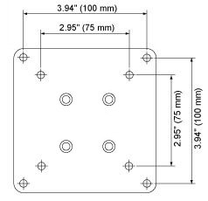
Figure 20: Two types of the current display/monitor mounting adapter or plate (VESA mounts).

- The display/monitor mounting arm shall be installed in a manner that allows for additional display/mounting arms to be installed in the future. Provision shall be made for at least two additional mounting arms for future expansion. The Tenderer shall provide supporting information showing compliance to this requirement. (D)
COMPLIANCE (C/PC/NC/Noted)
[INSERT FULL RESPONSE FOR EVALUATION HERE]

[INSERT REFERENCE TO ADDITIONAL INFORMATION HERE]

- The setup of the mounted displays on the console shall be similar to the drawing of Appendix A. The Tenderer shall indicate compliance to this requirement and make provision for it in the costing. (D)
COMPLIANCE (C/PC/NC/Noted)
[INSERT FULL RESPONSE FOR EVALUATION HERE]

[INSERT REFERENCE TO ADDITIONAL INFORMATION HERE]

VCCS Mounting Bracket
- The Contractor shall provide mounting arms and mounting adapters/ plates to mount each VCCS. The VCCS at FALE is different from the one depicted in the drawings in Appendix A. The VCCS used at FALE is shown in Figure 21. The setup that is required in shown in Figure 22. The VCCS display/ touchscreen shall be accommodated on a mounting bracket at the Approach control, ATSO and Admin positions. The Tenderer shall provide a conceptual design for the proposed VCCS mounting solution. (D)
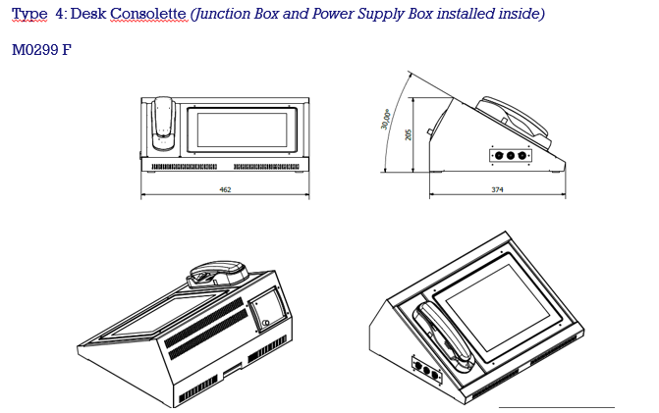
Figure 21. Current VCCS setup at FALE
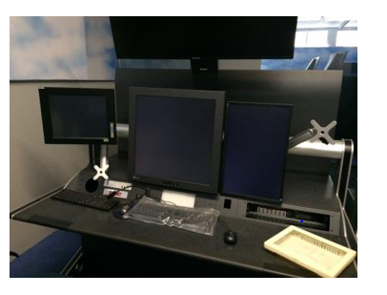
Figure 22. Desired VCCS display/ touchscreen mounting solution

COMPLIANCE (C/PC/NC/Noted)
[INSERT FULL RESPONSE FOR EVALUATION HERE]

[INSERT REFERENCE TO ADDITIONAL INFORMATION HERE]

- The VCCS mounting bracket shall perform the following adjustments to allow for flexible positioning of the VCCS display:
[a] Upward and downward adjustment.
[b] Forward and backward adjustment; and
[c] A 45 degrees tight tilt in all directions.
The Tenderer shall explain how this is achieved by the proposed VCCS mounting bracket. (D)
COMPLIANCE (C/PC/NC/Noted)
[INSERT FULL RESPONSE FOR EVALUATION HERE]

[INSERT REFERENCE TO ADDITIONAL INFORMATION HERE]

- The VCCS shall be installed within arms reach of the seated controller position in accordance with the required ergonomics specification contained in Section 6.5. The Tenderer shall indicate the placement of the VCCS on the technical drawings. (D)
COMPLIANCE (C/PC/NC/Noted)
[INSERT FULL RESPONSE FOR EVALUATION HERE]

[INSERT REFERENCE TO ADDITIONAL INFORMATION HERE]

Map Display (TNAC Consoles)
- The console shall allow for a map display to be mounted as shown below in Figure 23. The Tenderer shall indicate the mounting for the map display on the technical drawings. (D)
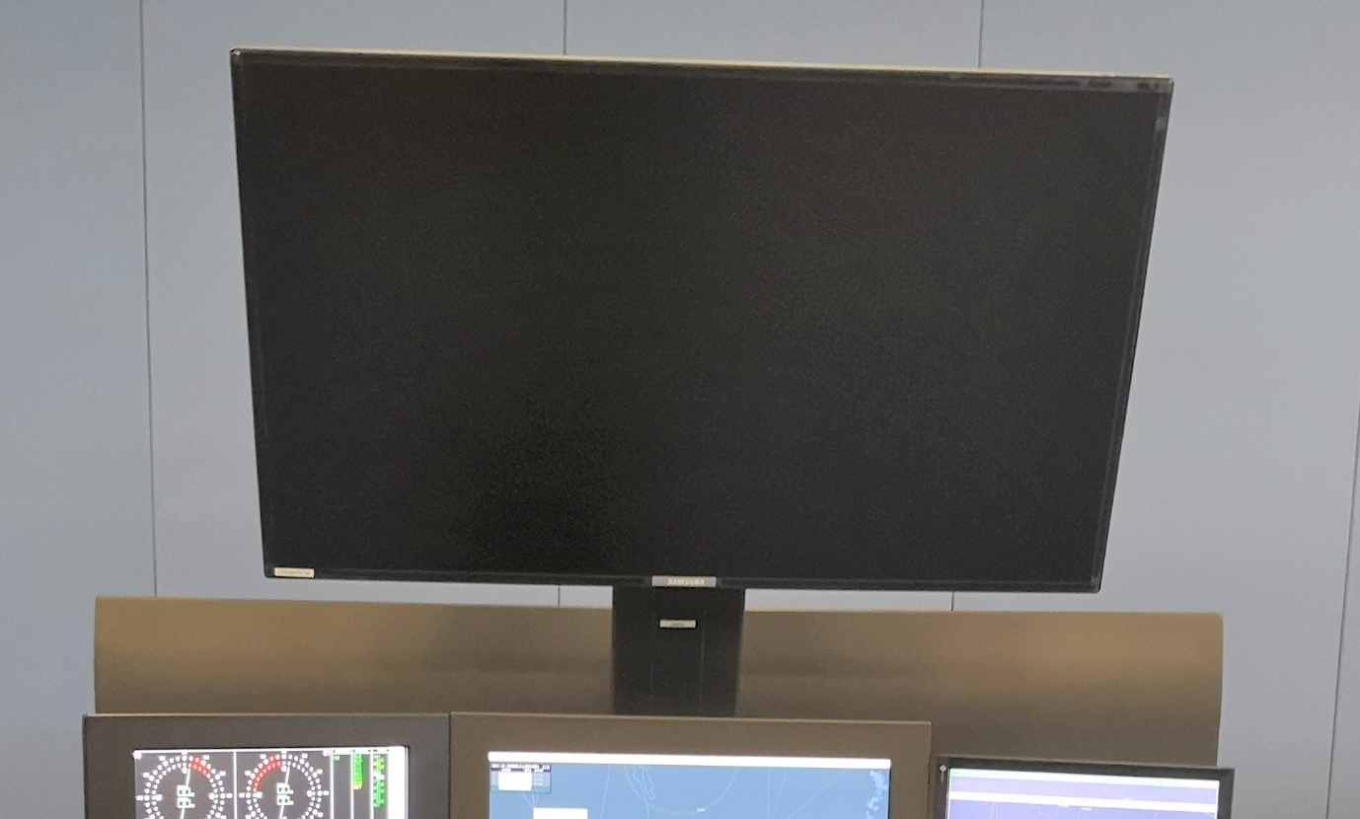
Figure 23: Map Display.

COMPLIANCE (C/PC/NC/Noted)
[INSERT FULL RESPONSE FOR EVALUATION HERE]

[INSERT REFERENCE TO ADDITIONAL INFORMATION HERE]

- The map display shall be a 46-inch ultra-high-definition LED screen. The Tenderer shall provide supporting information showing compliance to this requirement. (D)
COMPLIANCE (C/PC/NC/Noted)
[INSERT FULL RESPONSE FOR EVALUATION HERE]

[INSERT REFERENCE TO ADDITIONAL INFORMATION HERE]

- The mounting for the display shall have a VESA mount. The Tenderer shall provide supporting information showing compliance to this requirement. (D)
COMPLIANCE (C/PC/NC/Noted)
[INSERT FULL RESPONSE FOR EVALUATION HERE]

[INSERT REFERENCE TO ADDITIONAL INFORMATION HERE]

- The mounting for the display shall hold the display firmly in position for the entire life span of the console. The Tenderer shall provide supporting information showing compliance to this requirement. (D)
COMPLIANCE (C/PC/NC/Noted)
[INSERT FULL RESPONSE FOR EVALUATION HERE]

[INSERT REFERENCE TO ADDITIONAL INFORMATION HERE]

- The mounting for the display shall incorporate a cable management system that will allow for routing of cables. This cable management system shall take into account the accessibility and manageability of different cables (e.g. power and communications cables). The Tenderer shall provide supporting information showing compliance to this requirement. (D)
COMPLIANCE (C/PC/NC/Noted)
[INSERT FULL RESPONSE FOR EVALUATION HERE]

[INSERT REFERENCE TO ADDITIONAL INFORMATION HERE]

Faceplate
The following items shall be installed on the faceplate of the console. Figure 24 shows some of items to be installed on the faceplate.
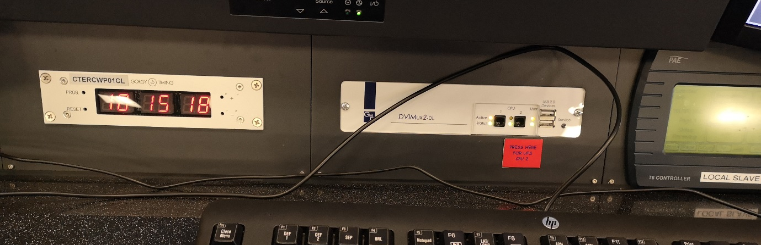
Figure 24: Gorgy clock and KVM switch on the Faceplate.

- The faceplate shall allow for the mounting of a Gorgy clock. The Tenderer shall indicate this on the Technical Drawings. (D)
COMPLIANCE (C/PC/NC/Noted)
[INSERT FULL RESPONSE FOR EVALUATION HERE]

[INSERT REFERENCE TO ADDITIONAL INFORMATION HERE]

- The faceplate shall allow for the mounting of the interface of a KVM switch. The Tenderer shall indicate this on the Technical Drawings. (D)
COMPLIANCE (C/PC/NC/Noted)
[INSERT FULL RESPONSE FOR EVALUATION HERE]

[INSERT REFERENCE TO ADDITIONAL INFORMATION HERE]

- The faceplate shall allow for the mounting of a Park Air Electronics T6 controller. The T6 Controller at FALE is different to the one shown in Figure 24 and in the drawings in Appendix A. The T6 Controller at FALE is shown below in Figure 25. The Tenderer shall indicate the T6 Controller on the Technical Drawings. (D)
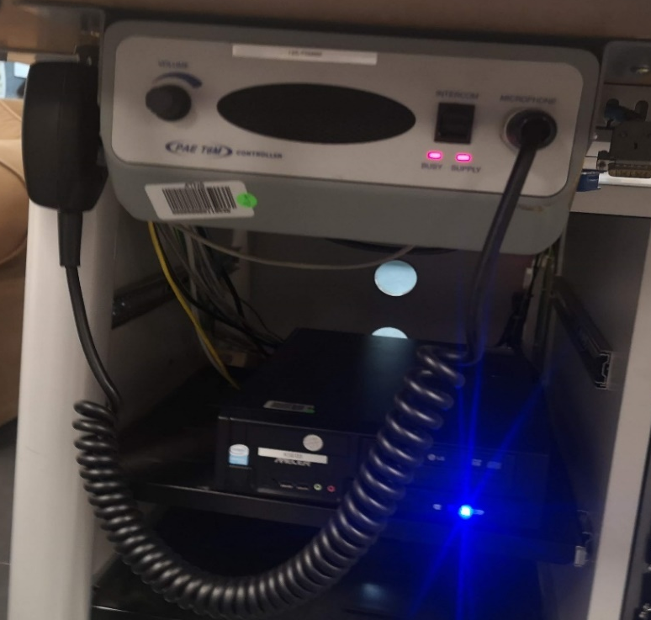
Figure 25: T6 Controller used at FALE.

COMPLIANCE (C/PC/NC/Noted)
[INSERT FULL RESPONSE FOR EVALUATION HERE]

[INSERT REFERENCE TO ADDITIONAL INFORMATION HERE]

- The faceplate shall have a task light and switch installed on it. The cable for the reading light shall run through flexible gooseneck tubing as shown in Figure 26. The Tenderer shall provide details of the task light to be installed and indicate it on the Technical Drawings. (D)
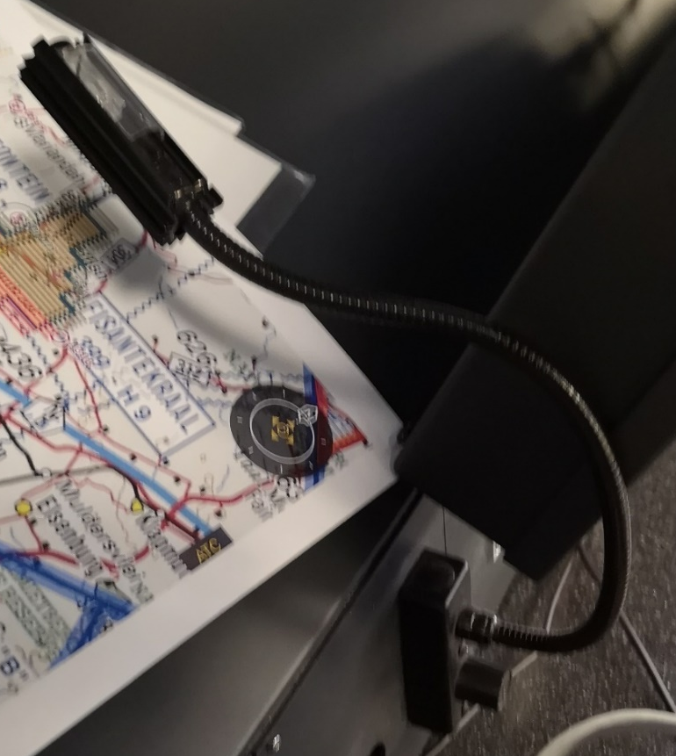
Figure 26: Reading light connected through flexible gooseneck tubing.
COMPLIANCE (C/PC/NC/Noted)
[INSERT FULL RESPONSE FOR EVALUATION HERE]

[INSERT REFERENCE TO ADDITIONAL INFORMATION HERE]

- The faceplate shall have a blank plate fitted in place of the biometric fingerprint reader. The biometric fingerprint reader shall be installed on the Admin consoles. The Tenderer shall indicate this on the Technical Drawings. (D)
COMPLIANCE (C/PC/NC/Noted)
[INSERT FULL RESPONSE FOR EVALUATION HERE]

[INSERT REFERENCE TO ADDITIONAL INFORMATION HERE]

- The faceplate shall have a speaker grill. The speaker for the VCCS shall be installed under this grill. The Tenderer shall indicate this on the Technical Drawings. (D)
COMPLIANCE (C/PC/NC/Noted)
[INSERT FULL RESPONSE FOR EVALUATION HERE]

[INSERT REFERENCE TO ADDITIONAL INFORMATION HERE]

Biometric Fingerprint Readers
- Modules for accommodating the biometric fingerprint readers on the Admin consoles shall be provided. The dimensions of the biometric fingerprint reader are as follows:
  - Height: 150 mm
  - Width: 90 mm
  - Depth: 90 mm
The Tenderer shall provide the conceptual design for the proposed biometric fingerprint reader module. (D)
COMPLIANCE (C/PC/NC/Noted)
[INSERT FULL RESPONSE FOR EVALUATION HERE]

[INSERT REFERENCE TO ADDITIONAL INFORMATION HERE]

- The modules shall be installed on the Admin console worksurface, at the Admin position closest to the Approach Hall entrance door. The location for the modules is indicated by the red dots in Figure 27 below. The Tenderer shall indicate the position of the modules on their proposed console layout. (D)
COMPLIANCE (C/PC/NC/Noted)
[INSERT FULL RESPONSE FOR EVALUATION HERE]

[INSERT REFERENCE TO ADDITIONAL INFORMATION HERE]

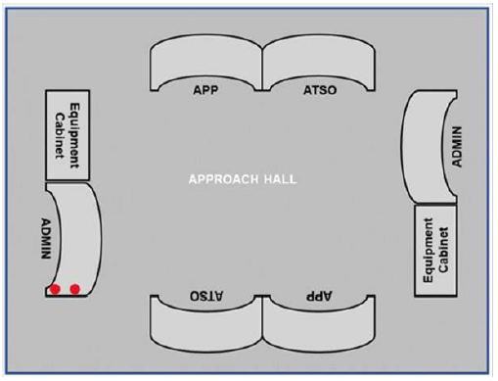
Figure 27. Approach Hall consoles with indication of biometric fingerprint readers location

Very High Frequency (VHF) Radio Module
- There shall be four (4) VHF radio modules provided for FALE. The VHF radio module shall accommodate a backup portable VHF radio with dimensions 270mm x 80mm x 280mm (width x depth x height). The VHF radio is shown in Figure 28Figure 41. The Tenderer shall provide a conceptual design for the proposed VHF radio module. (D)
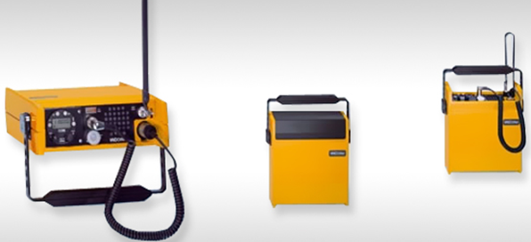
Figure 28: VHF Radio.
COMPLIANCE (C/PC/NC/Noted)
[INSERT FULL RESPONSE FOR EVALUATION HERE]

[INSERT REFERENCE TO ADDITIONAL INFORMATION HERE]

- The VHF radio module shall allow for the ease of removal and placement of the VHF radio within the module for evacuation purposes. The Tenderer shall explain how this achieved by the proposed VHF radio module. (D)
COMPLIANCE (C/PC/NC/Noted)
[INSERT FULL RESPONSE FOR EVALUATION HERE]

[INSERT REFERENCE TO ADDITIONAL INFORMATION HERE]

- The VHF radio module shall be close to the controller position such that the VHF radio may be used by the seated controller as a backup radio. The Tenderer shall indicate the position of the modules on their proposed console layout. (D)
COMPLIANCE (C/PC/NC/Noted)
[INSERT FULL RESPONSE FOR EVALUATION HERE]

[INSERT REFERENCE TO ADDITIONAL INFORMATION HERE]

- The areas of contact for the VHF radio module shall be protected from wear and tear. The Tenderer shall explain how this achieved by the proposed VHF radio module. (D)
COMPLIANCE (C/PC/NC/Noted)
[INSERT FULL RESPONSE FOR EVALUATION HERE]

[INSERT REFERENCE TO ADDITIONAL INFORMATION HERE]

UPS CABINET INSTALLATION
- There shall be two 19 inch, 43U server cabinets supplied and installed in the radar hall. These will be used to house UPSs and battery packs. The cabinets shall have a depth of 1m. The Tenderer shall provide supporting information on the server cabinet showing compliance to this requirement. (D)
COMPLIANCE (C/PC/NC/Noted)
[INSERT FULL RESPONSE FOR EVALUATION HERE]

[INSERT REFERENCE TO ADDITIONAL INFORMATION HERE]

- The server cabinet shall permit sufficient airflow in and out of the cabinet. The Tenderer shall provide supporting information on the server cabinet showing compliance to this requirement. (D)
COMPLIANCE (C/PC/NC/Noted)
[INSERT FULL RESPONSE FOR EVALUATION HERE]

[INSERT REFERENCE TO ADDITIONAL INFORMATION HERE]

- The UPS’s in the existing consoles shall be uninstalled from the consoles and installed in the new server cabinets. The Tenderer shall indicate compliance to this requirement. (D)
COMPLIANCE (C/PC/NC/Noted)
[INSERT FULL RESPONSE FOR EVALUATION HERE]

[INSERT REFERENCE TO ADDITIONAL INFORMATION HERE]

- All cabling required for moving the UPS’s to the server cabinets shall be provided for. The cabinets will be located within 10m of the consoles. The Tenderer shall indicate compliance to this requirement. (D)
COMPLIANCE (C/PC/NC/Noted)
[INSERT FULL RESPONSE FOR EVALUATION HERE]

[INSERT REFERENCE TO ADDITIONAL INFORMATION HERE]

- An ECC shall be provided for the installation of the UPS’s. The Tenderer shall indicate compliance to this requirement. (D)
COMPLIANCE (C/PC/NC/Noted)
[INSERT FULL RESPONSE FOR EVALUATION HERE]

[INSERT REFERENCE TO ADDITIONAL INFORMATION HERE]

- The look and feel of the UPS cabinets shall match the aesthetic of the approach consoles. (D)
COMPLIANCE (C/PC/NC/Noted)
[INSERT FULL RESPONSE FOR EVALUATION HERE]

[INSERT REFERENCE TO ADDITIONAL INFORMATION HERE]

APPROACH HALL REQUIREMENTS
- FALE Approach Hall makes use of a raised floor which is tiled. A picture of the tiles which are used is given in Figure 29. The tiles are MONOINTEC (041 09 07 F6B) which are 500mm x 500mm in size (Figure 30). A total of ten (10) metres squared of spare tiles shall be supplied and delivered to FALE. The Tenderer shall provide full details on the proposed tile and make provision for the tiles in the costing. (D)

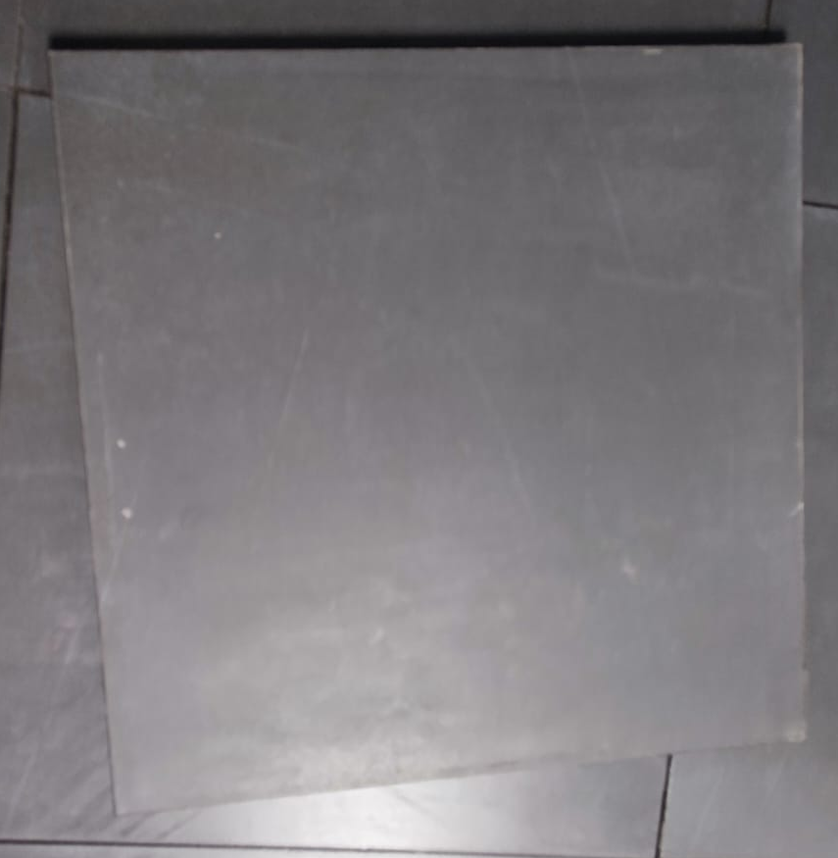  Figure 29. FALE Raised Floor Tile | 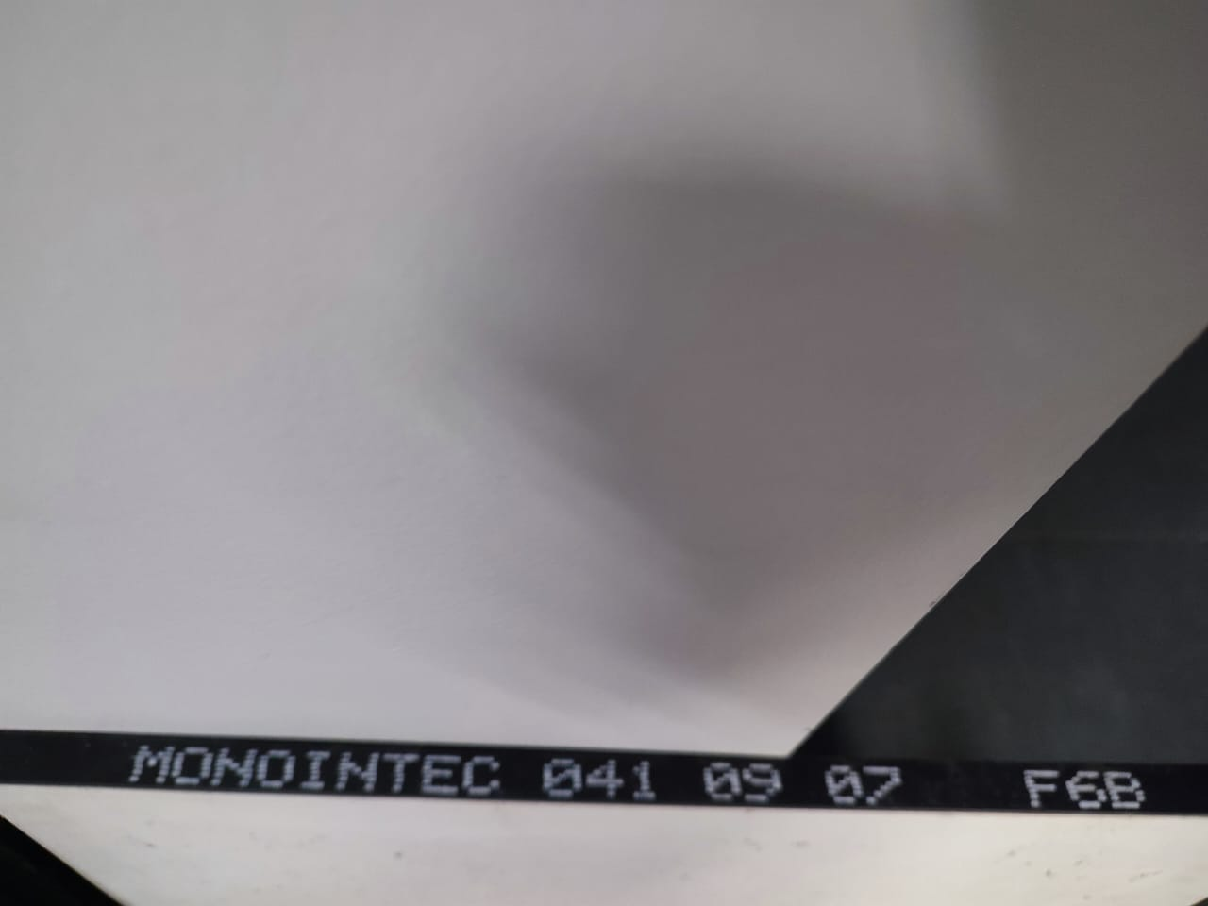  Figure 30. FALE Raised Floor Tile Code
COMPLIANCE (C/PC/NC/Noted)
[INSERT FULL RESPONSE FOR EVALUATION HERE]

[INSERT REFERENCE TO ADDITIONAL INFORMATION HERE]

FALE MAINTENANCE CONSOLES TECHNICAL SPECIFICATIONS

MAINTENANCE CONSOLES REQUIREMENTS

Design
- The preferred type of design for these consoles is a step-down design with a storage compartment for equipment underneath. A concept for this design can be found in Figure 31. There shall be three maintenance consoles provided and installed in the FALE equipment room.
The total dimensions of the console shall be 2000mm x 1300mm x 800mm (length x depth x height). The working surface of the console shall extend over the full length of the console and be 600mm in depth. The support base for display mountings (refer to Figure 3) shall be stepped down for the mounting of displays. The Tenderer shall provide a conceptual design of the consoles in the form of technical drawings to demonstrate understanding of the requirements. The drawings shall highlight the shape/form of the console and include the dimensions of the console. (D)
COMPLIANCE (C/PC/NC/Noted)
[INSERT FULL RESPONSE FOR EVALUATION HERE]

[INSERT REFERENCE TO ADDITIONAL INFORMATION HERE]

- An equipment storage section shall be incorporated in the form of an equipment cabinet underneath the support base for display mountings. The depth of the support base and the equipment cabinet section shall be 850mm and the height shall be 700mm. The Tenderer shall indicate the equipment storage section in the technical drawings. (D)
COMPLIANCE (C/PC/NC/Noted)
[INSERT FULL RESPONSE FOR EVALUATION HERE]

[INSERT REFERENCE TO ADDITIONAL INFORMATION HERE]

- The working surface may overlap over the support base, maintaining legroom of 460mm. The space between the support base and the working surface shall be used as a cable entry point from the working surface and the equipment cabinet. The Tenderer shall indicate on the technical drawings how this requirement is met by their proposed design. (D)
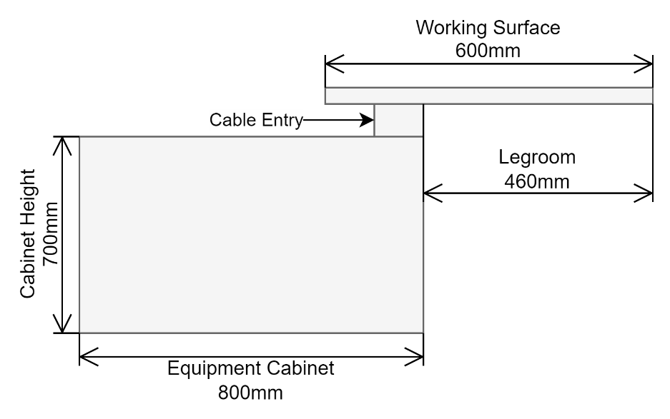
Figure 31. Maintenance Consoles step down design

COMPLIANCE (C/PC/NC/Noted)
[INSERT FULL RESPONSE FOR EVALUATION HERE]

[INSERT REFERENCE TO ADDITIONAL INFORMATION HERE]

- The consoles shall not incorporate devices that generate noise such as cooling fans. The Tenderer shall explain how equipment cooling is achieved in their console design. (D)
COMPLIANCE (C/PC/NC/Noted)
[INSERT FULL RESPONSE FOR EVALUATION HERE]

[INSERT REFERENCE TO ADDITIONAL INFORMATION HERE]

- The console shall be stable after it has been assembled and all equipment has been installed on it. The console shall also provide stability for the displays and all other equipment such that it shall not shake if the console is pushed or pulled. Tenderers shall provide details of how this will be achieved. (D)
COMPLIANCE (C/PC/NC/Noted)
[INSERT FULL RESPONSE FOR EVALUATION HERE]

[INSERT REFERENCE TO ADDITIONAL INFORMATION HERE]

- The Tenderer shall indicate the point loads for the console that will be in contact with the floor on the technical drawings. (D)
COMPLIANCE (C/PC/NC/Noted)
[INSERT FULL RESPONSE FOR EVALUATION HERE]

[INSERT REFERENCE TO ADDITIONAL INFORMATION HERE]

Equipment Storage Section
- The back section of the console under the support base shall form the equipment storage section. The equipment storage section shall be divided into three equal sized equipment compartments. The Tenderer shall indicate this on the Technical drawings. (D)
COMPLIANCE (C/PC/NC/Noted)
[INSERT FULL RESPONSE FOR EVALUATION HERE]

[INSERT REFERENCE TO ADDITIONAL INFORMATION HERE]

- Each section of the equipment storage section shall be easily accessible from the front and the back of the console. The Tenderer shall provide details on how this will be achieved. (D)
COMPLIANCE (C/PC/NC/Noted)
[INSERT FULL RESPONSE FOR EVALUATION HERE]

[INSERT REFERENCE TO ADDITIONAL INFORMATION HERE]

- The back end of the console (equipment storage section) and the front panel under the working surface (refer to Figure 3) shall be closed with lockable panels that can be removed and placed back into position quickly and easily to allow for maintenance personnel to access the equipment and cables. An example of the panels at the back are shown in Figure 32. Padlocks will not be accepted. The Tenderer shall provide details of the lock mechanism. (D)
Figure 32. Example of panels on the back of the console.

COMPLIANCE (C/PC/NC/Noted)
[INSERT FULL RESPONSE FOR EVALUATION HERE]

[INSERT REFERENCE TO ADDITIONAL INFORMATION HERE]

- There shall be four (4) PDU’s supplied per console. Each console shall be fitted with three Power Distribution Units (PDUs), and one shall be provided as a spare. Each PDU shall have at least six International Electrotechnical Commission (IEC) C13 sockets. One PDU shall be mounted in the each of the equipment storage sections. The PDU’s shall not obstruct access to equipment. The PDU’s shall be connected to the Distribution Board installed inside the console (refer to Section 7.5). An example of a PDU with C13 sockets is shown in Figure 33. Tenderers shall provide details of the PDU to be used. The Contractor shall supply an Electrical Compliance Certificate for the installation of the PDUs. (D)
Figure 33: Example of an IEC power distribution unit with C13 sockets.

COMPLIANCE (C/PC/NC/Noted)
[INSERT FULL RESPONSE FOR EVALUATION HERE]

[INSERT REFERENCE TO ADDITIONAL INFORMATION HERE]

- There shall be ninety (90) 2m long, C13 to C14 cables supplied. The Tenderer shall make provision for this in the costing. (D)
COMPLIANCE (C/PC/NC/Noted)
[INSERT FULL RESPONSE FOR EVALUATION HERE]

[INSERT REFERENCE TO ADDITIONAL INFORMATION HERE]

- A maintenance light shall be installed in the middle section of the equipment storage section. The maintenance light shall be in the form of a low power LED tube. The fitting and cabling for the LED tube shall be provided and installed. The fitting shall have an on/off switch. The Tenderer shall indicate this on the Technical drawings and provide details of the maintenance light. (D)
COMPLIANCE (C/PC/NC/Noted)
[INSERT FULL RESPONSE FOR EVALUATION HERE]

[INSERT REFERENCE TO ADDITIONAL INFORMATION HERE]

- Each section of the equipment storage section shall have a minimum width of 19 inch to accommodate a 19-inch server; and shall accommodate at least 14U vertically. The Tenderer shall indicate this on the Technical drawings. (D)
COMPLIANCE (C/PC/NC/Noted)
[INSERT FULL RESPONSE FOR EVALUATION HERE]

[INSERT REFERENCE TO ADDITIONAL INFORMATION HERE]

- One of the three sections shall cater for 19-inch rack mountable equipment by complying with the Electronic Industries Association (EIA) standard EIA-310 for a standard rack. The Tenderer shall indicate this on the Technical drawings. (D)
COMPLIANCE (C/PC/NC/Noted)
[INSERT FULL RESPONSE FOR EVALUATION HERE]

[INSERT REFERENCE TO ADDITIONAL INFORMATION HERE]

- The equipment storage section shall incorporate three (3) heavy-duty 19-inch rack mountable sliding mechanisms that will allow technicians to slide/draw out equipment from the console beyond the edge of the console for maintenance activities. These mechanisms shall be able to withstand a weight of at least 65 kilograms. The Tenderer shall provide details of the rack mountable sliding mechanisms. (D)
COMPLIANCE (C/PC/NC/Noted)
[INSERT FULL RESPONSE FOR EVALUATION HERE]

[INSERT REFERENCE TO ADDITIONAL INFORMATION HERE]

- There shall be four (4) removable heavy duty 19-inch rack mountable shelves supplied with the console. The shelves shall be able to withstand a weight of at least 65 kilograms. The Tenderer shall provide details of the rack mountable shelves. (D)
COMPLIANCE (C/PC/NC/Noted)
[INSERT FULL RESPONSE FOR EVALUATION HERE]

[INSERT REFERENCE TO ADDITIONAL INFORMATION HERE]

- The panels at the back of the console shall be perforated to permit sufficient air flow in and out of the equipment storage section. There shall be no vents in the front where the technician sits. The Tenderer shall indicate this on the Technical drawings. (D)
COMPLIANCE (C/PC/NC/Noted)
[INSERT FULL RESPONSE FOR EVALUATION HERE]

[INSERT REFERENCE TO ADDITIONAL INFORMATION HERE]

- The equipment storage section shall cater for air forced cooling from the floor. The Tenderer shall indicate this on the Technical drawings. (D)
COMPLIANCE (C/PC/NC/Noted)
[INSERT FULL RESPONSE FOR EVALUATION HERE]

[INSERT REFERENCE TO ADDITIONAL INFORMATION HERE]

- The equipment storage section design shall cater for natural heat dissipation through venting to prevent heat build-up within the cabinet, while minimising the ingress of dust. The Tenderer shall provide details on how this will be achieved. (D)
COMPLIANCE (C/PC/NC/Noted)
[INSERT FULL RESPONSE FOR EVALUATION HERE]

[INSERT REFERENCE TO ADDITIONAL INFORMATION HERE]

- The equipment storage section design shall cater for noise suppression. The Tenderer shall provide details on how this will be achieved. (D)
COMPLIANCE (C/PC/NC/Noted)
[INSERT FULL RESPONSE FOR EVALUATION HERE]

[INSERT REFERENCE TO ADDITIONAL INFORMATION HERE]

- The equipment storage section shall have a cable management system. The cable management system shall take into consideration the cable route as defined herein and the sliding in and out of equipment from the console. The Tenderer shall provide details on how this will be achieved. (D)
COMPLIANCE (C/PC/NC/Noted)
[INSERT FULL RESPONSE FOR EVALUATION HERE]

[INSERT REFERENCE TO ADDITIONAL INFORMATION HERE]

Power Distribution
- Figure 34 below shows how the power shall be distributed within the console. The Tenderer shall provide a detailed diagram of the power distribution layout within the console. (D)

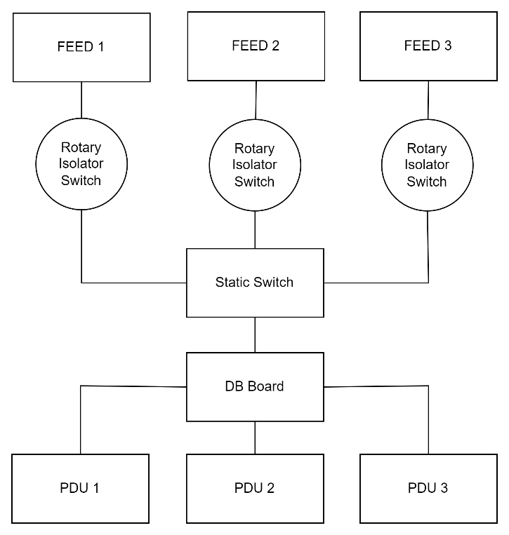
Figure 34: Power Distribution.

COMPLIANCE (C/PC/NC/Noted)
[INSERT FULL RESPONSE FOR EVALUATION HERE]

[INSERT REFERENCE TO ADDITIONAL INFORMATION HERE]

Distribution Board (DB Board)
- Each console shall have a 12-way distribution board installed in the equipment storage section. The Tenderer shall provide details of the distribution board to be installed within the console. (D)
COMPLIANCE (C/PC/NC/Noted)
[INSERT FULL RESPONSE FOR EVALUATION HERE]

[INSERT REFERENCE TO ADDITIONAL INFORMATION HERE]

- The DB Board shall have one mains switch. The main switch shall be a 2 pole, D Curve miniature circuit breaker with a rating of 16A. The main switch shall be clearly labelled on the DB Board. The Tenderer shall provide supporting information showing compliance to this requirement. (D)
COMPLIANCE (C/PC/NC/Noted)
[INSERT FULL RESPONSE FOR EVALUATION HERE]

[INSERT REFERENCE TO ADDITIONAL INFORMATION HERE]

- The DB Board shall have eight single pole, D Curve miniature circuit breakers with a rating of 6A. Each breaker shall be numbered 1 to 8 and clearly labelled as shown below in Figure 35. The Tenderer shall provide supporting information showing compliance to this requirement. (D)
Figure 35: Example of the DB Board.

COMPLIANCE (C/PC/NC/Noted)
[INSERT FULL RESPONSE FOR EVALUATION HERE]

[INSERT REFERENCE TO ADDITIONAL INFORMATION HERE]

- An Electrical Compliance Certificate (ECC) shall be provided for the installation of the DB Board and all electrical work done on the console. The Tenderer shall indicate compliance to this requirement. (D)
COMPLIANCE (C/PC/NC/Noted)
[INSERT FULL RESPONSE FOR EVALUATION HERE]

[INSERT REFERENCE TO ADDITIONAL INFORMATION HERE]

Rotary Isolator Switch
- Each console shall have three rotary isolators installed. The Tenderer shall provide full details on the proposed rotary isolator and indicate the rotary isolators on the technical design. (D)
COMPLIANCE (C/PC/NC/Noted)
[INSERT FULL RESPONSE FOR EVALUATION HERE]

[INSERT REFERENCE TO ADDITIONAL INFORMATION HERE]

- The rotary isolators shall have 2 poles with a rating of 32 Amps, 400V. The Tenderer shall provide supporting information showing compliance to this requirement. (D)
COMPLIANCE (C/PC/NC/Noted)
[INSERT FULL RESPONSE FOR EVALUATION HERE]

[INSERT REFERENCE TO ADDITIONAL INFORMATION HERE]

- The rotatory isolator shall have an ingress protection rating of IP65. The Tenderer shall provide supporting information showing compliance to this requirement. (D)
COMPLIANCE (C/PC/NC/Noted)
[INSERT FULL RESPONSE FOR EVALUATION HERE]

[INSERT REFERENCE TO ADDITIONAL INFORMATION HERE]

Static Switch
- Each console shall have a single phase 3 kVA, 16 Amp static switch. The Tenderer shall provide supporting information proving compliance to this requirement; and indicate the static switch on the technical design.(D)
COMPLIANCE (C/PC/NC/Noted)
[INSERT FULL RESPONSE FOR EVALUATION HERE]

[INSERT REFERENCE TO ADDITIONAL INFORMATION HERE]

- The static switch shall have a height of 1U and be rack mountable in a 19-inch rack. The depth of the static switch and associated connectors shall be less than 500mm. The Tenderer shall provide supporting information showing compliance to this requirement. (D)
COMPLIANCE (C/PC/NC/Noted)
[INSERT FULL RESPONSE FOR EVALUATION HERE]

[INSERT REFERENCE TO ADDITIONAL INFORMATION HERE]

- The static switch shall have an efficiency of 99.9%. The Tenderer shall provide supporting information showing compliance to this requirement. (D)
COMPLIANCE (C/PC/NC/Noted)
[INSERT FULL RESPONSE FOR EVALUATION HERE]

[INSERT REFERENCE TO ADDITIONAL INFORMATION HERE]

Cable Management

Cable Routes
Cabling for equipment will be routed through the equipment room floor. There are feeder holes running through the floor at various positions. The cabling will then be routed to the console’s working surface (to modules, mice and keyboards) or the console’s support base (to display/monitor mounting arms and monitors/displays) or the equipment storage section (to desktop computer towers). In principle, cables shall be routed to any of the following termination points, through any of the following passage/midway points and from any of the following entry points:
- Console working surface,
- Console support base,
- Monitor/display mounting arm/s,
- Equipment storage section,
- The equipment room floor.

- The cable management system of the consoles shall account for the cable route defined above.
The Tenderer shall define and provide the design of the cable management system for the consoles and associated modules as required. (D)
COMPLIANCE (C/PC/NC/Noted)
[INSERT FULL RESPONSE FOR EVALUATION HERE]

[INSERT REFERENCE TO ADDITIONAL INFORMATION HERE]

- The heavy-duty sliding trays and mechanism in the equipment cabinets; and the sliding movement of equipment shall be accommodated by the cable management system. The Tenderer shall provide a demonstration of compliance to stated requirement. (D)
COMPLIANCE (C/PC/NC/Noted)
[INSERT FULL RESPONSE FOR EVALUATION HERE]

[INSERT REFERENCE TO ADDITIONAL INFORMATION HERE]

- The cable management system shall ensure that cables are directed through the necessary channels or routing mechanisms, in an organised manner, without congesting the route. The cable routes of the cable management system should allow for flexible routing. The Tenderer shall indicate the flexibility in routing of the cable management system. (D)
COMPLIANCE (C/PC/NC/Noted)
[INSERT FULL RESPONSE FOR EVALUATION HERE]

[INSERT REFERENCE TO ADDITIONAL INFORMATION HERE]

- ATNS’s preference is for brush panels or similar instead of open cable entry/exit points. The Tenderer shall provide a design for cable entry/exit points and indicate how it will decrease the ingress of dust within the console. (D)
COMPLIANCE (C/PC/NC/Noted)
[INSERT FULL RESPONSE FOR EVALUATION HERE]

[INSERT REFERENCE TO ADDITIONAL INFORMATION HERE]

Cable Separation
- The incorporated cable management system shall separate power cables and communication cables. The Tenderer shall highlight how the cable management system will ensure separation of power cables from communication cables. (D)
COMPLIANCE (C/PC/NC/Noted)
[INSERT FULL RESPONSE FOR EVALUATION HERE]

[INSERT REFERENCE TO ADDITIONAL INFORMATION HERE]

Cable Routing Mechanism/s
- There shall be a cable routing mechanism/s for the cable management system that allows for easy access to routed cables and for installation of new cables. The Tenderer shall provide details of the cable routing mechanism/s. (D)
COMPLIANCE (C/PC/NC/Noted)
[INSERT FULL RESPONSE FOR EVALUATION HERE]

[INSERT REFERENCE TO ADDITIONAL INFORMATION HERE]

- The capacity of the cable routing mechanism/s shall take into consideration the quantity of equipment (current and anticipated) per maintenance position. It can be assumed that each piece of equipment will have at minimum two cables (one for power and one for communication) connecting to it. The Tenderer shall provide the maximum number of cables a particular cable routing mechanism can handle. (D)
COMPLIANCE (C/PC/NC/Noted)
[INSERT FULL RESPONSE FOR EVALUATION HERE]

[INSERT REFERENCE TO ADDITIONAL INFORMATION HERE]

Display/Monitor Mounting Arm
- The displays on the console shall be arranged in an array similar to Figure 36 below. The array shall cater for at least 6 screens per position, configured in two rows of three. Display/ monitor mounting arms which enable the below setup and arrangement of displays shall be provided. The Tenderer shall provide full details on the proposed display/ monitor mounting arm to prove compliance to this requirement. (D)

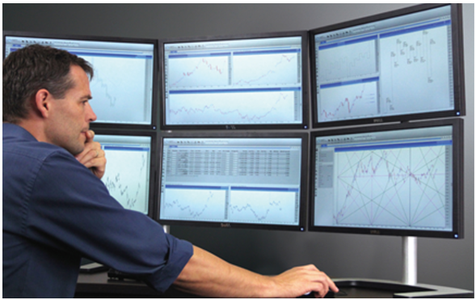
Figure 36. Concept of display array.

COMPLIANCE (C/PC/NC/Noted)
[INSERT FULL RESPONSE FOR EVALUATION HERE]

[INSERT REFERENCE TO ADDITIONAL INFORMATION HERE]

- The display/monitor mounting arm shall be able to carry a 28-inch display and support a weight of at least 19 kilograms for the full life span of the console. If a single mounting arm is used to mount multiple screens, then the mounting arm shall be able to support the weight of the number screens being supported multiplied by 19 kilograms. The Tenderer shall provide supporting information showing compliance to this requirement. (D)
COMPLIANCE (C/PC/NC/Noted)
[INSERT FULL RESPONSE FOR EVALUATION HERE]

[INSERT REFERENCE TO ADDITIONAL INFORMATION HERE]

- The display/monitor mounting arm shall allow for horizontal, vertical and tilt adjustments. The tilt adjustment shall allow for a 30 degrees tilt in all directions with regards to its central point. The tilting adjustment shall be designed such that the displays/monitors do not tilt unless intentional force is applied. The Tenderer shall provide supporting information showing compliance to this requirement. (D)
COMPLIANCE (C/PC/NC/Noted)
[INSERT FULL RESPONSE FOR EVALUATION HERE]

[INSERT REFERENCE TO ADDITIONAL INFORMATION HERE]

- The vertical and horizontal adjustments of the display/monitor mounting arm parts as defined above shall be lockable. This means that the display/monitor mounting arm shall allow for locking of its positions after an adjustment (horizontal or vertical) is completed. The Tenderer shall provide supporting information showing compliance to this requirement. (D)
COMPLIANCE (C/PC/NC/Noted)
[INSERT FULL RESPONSE FOR EVALUATION HERE]

[INSERT REFERENCE TO ADDITIONAL INFORMATION HERE]

- The display/monitor mounting arm shall incorporate a cable management system that will allow for routing of cables. This cable management system shall consider the accessibility and manageability of different cables (e.g., power and communications cables). The Tenderer shall provide supporting information showing compliance to this requirement. (D)
COMPLIANCE (C/PC/NC/Noted)
[INSERT FULL RESPONSE FOR EVALUATION HERE]

[INSERT REFERENCE TO ADDITIONAL INFORMATION HERE]

- The mounting adapter/s for the display/monitor mounting arm shall be the same as the mounting adapter for the current display/monitor mounting arm. The existing mounting adapter used are a Video Electronics Standards Association (VESA) mount plate as shown in Figure 37. The mounting adapter for the display/monitor mounting arm shall be replaceable. The Tenderer shall provide supporting information showing compliance to this requirement. (D)

Figure 37: Two types of the current display/monitor mounting adapter or plate (VESA mounts).

COMPLIANCE (C/PC/NC/Noted)
[INSERT FULL RESPONSE FOR EVALUATION HERE]

[INSERT REFERENCE TO ADDITIONAL INFORMATION HERE]

- The display/monitor mounting arm shall be installed in a manner that allows for additional display/mounting arms to be installed in the future. Provision shall be made for at least two additional mounting arms for future expansion. The Tenderer shall indicate compliance to this requirement and make provision for it in the costing. (D)

COMPLIANCE (C/PC/NC/Noted)
[INSERT FULL RESPONSE FOR EVALUATION HERE]

[INSERT REFERENCE TO ADDITIONAL INFORMATION HERE]

FAPM, FAVG, FARB TOWER CONSOLES TECHNICAL SPECIFICATIONS

TOWER CONSOLE REQUIREMENTS

Design
- The Contractor shall provide, install and commission Tower consoles for FAPM, FAVG and FARB Control Towers respectively. The Tenderer shall provide conceptual designs of the Tower consoles in the form of technical drawings. The drawings shall highlight the shape/form of the console and include the dimensions of the console. The Tenderer shall submit separate designs for each Tower. (D)
COMPLIANCE (C/PC/NC/Noted)
[INSERT FULL RESPONSE FOR EVALUATION HERE]

[INSERT REFERENCE TO ADDITIONAL INFORMATION HERE]

- The consoles shall not incorporate devices that generate noise such as cooling fans. The Tenderer shall explain how equipment cooling is achieved in their console design. (D)
COMPLIANCE (C/PC/NC/Noted)
[INSERT FULL RESPONSE FOR EVALUATION HERE]

[INSERT REFERENCE TO ADDITIONAL INFORMATION HERE]

- The console shall be a single-level countertop style design as depicted in Figure 2, mounted against the walls of the Tower cabs using mounting brackets. There shall be no gaps between the console and the walls. The Tenderer shall indicate how this requirement is met by their proposed design. (D)
COMPLIANCE (C/PC/NC/Noted)
[INSERT FULL RESPONSE FOR EVALUATION HERE]

[INSERT REFERENCE TO ADDITIONAL INFORMATION HERE]

- The mounting brackets shall be designed and placed such that they do not hinder the movement of a seated TWR Controller’s legs passing underneath the working surface. The Tenderer shall indicate the proposed placement of mounting brackets in the technical drawings. (D)
COMPLIANCE (C/PC/NC/Noted)
[INSERT FULL RESPONSE FOR EVALUATION HERE]

[INSERT REFERENCE TO ADDITIONAL INFORMATION HERE]

- The mounting brackets shall support the full weight of the countertop, all the equipment and at least two average weight (75kg) people leaning on the console, for the entire duration of the lifespan without causing sagging, warping or breaking in the countertop. The Tenderer shall provide the weight bearing capacity of the proposed design. (D)
COMPLIANCE (C/PC/NC/Noted)
[INSERT FULL RESPONSE FOR EVALUATION HERE]

[INSERT REFERENCE TO ADDITIONAL INFORMATION HERE]

- The console shall allow for displays/monitors to be placed on the working surface such that a seated TWR Controller, of average height, can comfortably view the full display/monitor and have unobstructed visibility of the runway and manoeuvring areas. The Tenderer shall provide drawings to show how low the displays/monitors can be placed. The drawings shall be accompanied with calculations to support the measurements on the drawing. (D)
COMPLIANCE (C/PC/NC/Noted)
[INSERT FULL RESPONSE FOR EVALUATION HERE]

[INSERT REFERENCE TO ADDITIONAL INFORMATION HERE]

- There shall be cable entry points to the rear of the countertop where it would not obstruct the operation of the TWR Controller. The cable entry points shall have brush panels or similar and must be supplied with caps/ covers to close the cable entry point should it not be in use. The cable entry points shall be installed such that the entry point cap/ cover sits flush with the edge of the working surface of the console. The Tenderer shall indicate the cable entry points on the technical designs and provide full details on how the requirement is met by their design. (D)
COMPLIANCE (C/PC/NC/Noted)
[INSERT FULL RESPONSE FOR EVALUATION HERE]

[INSERT REFERENCE TO ADDITIONAL INFORMATION HERE]

- The console shall be stable after it has been assembled and all equipment has been installed on it. The console shall also provide stability for the displays and all other equipment such that it shall not shake if the console is pushed or pulled. Tenderers shall provide details of how this will be achieved. (D)
COMPLIANCE (C/PC/NC/Noted)
[INSERT FULL RESPONSE FOR EVALUATION HERE]

[INSERT REFERENCE TO ADDITIONAL INFORMATION HERE]

- The Tenderer shall indicate the point loads for the console that will be in contact with the control tower cab floor on the technical drawings. (D)
COMPLIANCE (C/PC/NC/Noted)
[INSERT FULL RESPONSE FOR EVALUATION HERE]

[INSERT REFERENCE TO ADDITIONAL INFORMATION HERE]

- The consoles shall be fitted with Power Distribution Units (PDU) to the rear underside of the console working surface as follows. Each PDU shall have at least ten International Electrotechnical Commission (IEC) C13 sockets and at least two IEC Type C (Europlug/Two pin plug) sockets. There shall be three PDU’s supplied per position. The PDU’s shall not obstruct access to equipment. The PDU’s shall be connected to the mains supply at each of the tower cabs. An example of the PDU with C13 sockets is shown in Figure 38. Tenderers shall provide details of the PDU to be used. An Electrical Compliance Certificate for the wiring of the PDUs to the mains supply shall be provided for the installation. (D)
Figure 38: Example of an IEC power distribution unit with C13 sockets.

COMPLIANCE (C/PC/NC/Noted)
[INSERT FULL RESPONSE FOR EVALUATION HERE]

[INSERT REFERENCE TO ADDITIONAL INFORMATION HERE]

- There shall be sixty (60) 2m long, C13 to C14 cables supplied per tower. The Tenderer shall make provision for this in the costing. (D)
COMPLIANCE (C/PC/NC/Noted)
[INSERT FULL RESPONSE FOR EVALUATION HERE]

[INSERT REFERENCE TO ADDITIONAL INFORMATION HERE]

Adjacent Consoles
- There shall be no gaps between the working surface of adjacent consoles. The Tenderer shall include a proposal on how to close the gaps (gap filler surface) between two adjacent consoles. The gap filler surfaces shall connect only the working surface portions of the adjacent consoles. (D)
COMPLIANCE (C/PC/NC/Noted)
[INSERT FULL RESPONSE FOR EVALUATION HERE]

[INSERT REFERENCE TO ADDITIONAL INFORMATION HERE]

- The gap filler surface between adjacent consoles shall be designed such that the space beneath it is completely unobstructed for the seated controller. The Tenderer shall indicate the gap filler surface in the technical drawings for the proposed consoles. (D)
COMPLIANCE (C/PC/NC/Noted)
[INSERT FULL RESPONSE FOR EVALUATION HERE]

[INSERT REFERENCE TO ADDITIONAL INFORMATION HERE]

Flight Strip Board
A flight strip board serves as a placement for flight strip holders. The flight strip board comprises of 3 columns. Each column consists of two 9mm cylindrical rods placed 83 mm apart. The flight strip board columns are carefully separated to allow a perfect fit of flight strip holders. The height of the flight strip board is very shallow approximately 25 mm. A side view and a bottom view of a flight strip holder is presented in Figure 39, and Figure 40 provides a picture of a typical operations flight strip board/s.
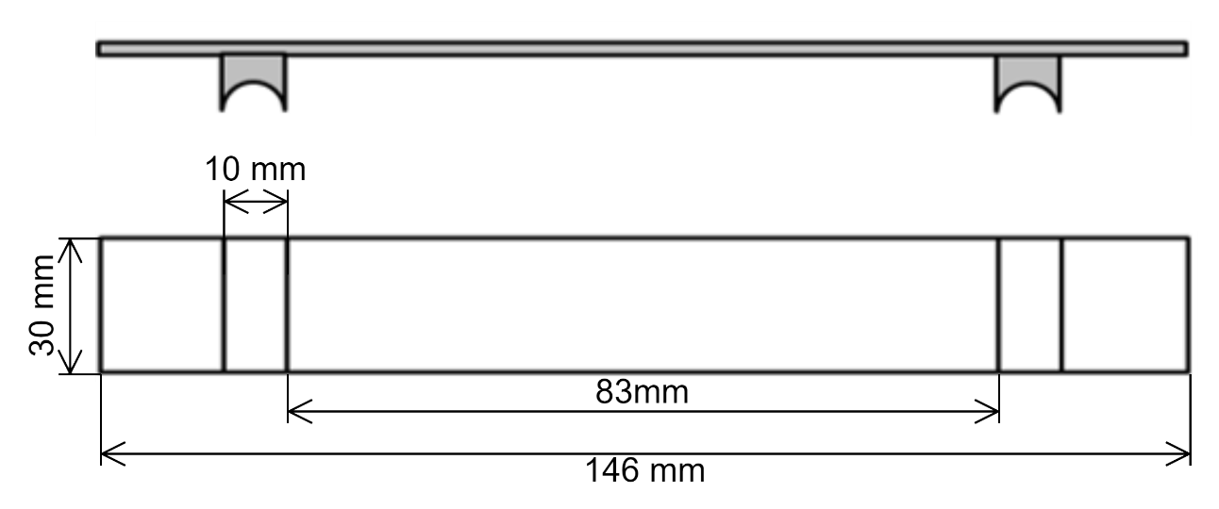
Figure 39: Flight strip dimensions for flight strip board.

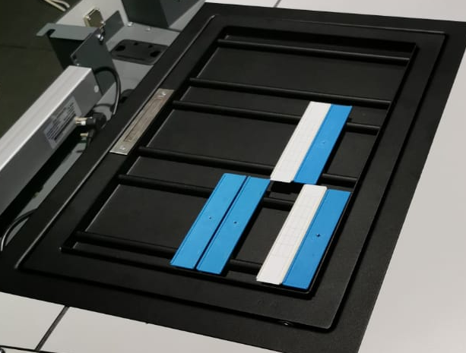 | 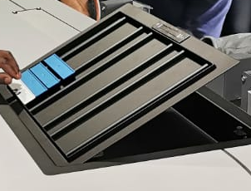
Figure 40: Typical operations flight strip board/s

- The Contractor shall provide flight strip boards for FAPM and FARB. FAPM and FARB Flight strip boards shall have a length to fit at least 14 flight strips in a column and a width that allows three flight strips to fit side by side with a 10mm gap between each strip. The minimum length (left to right) shall be 540 mm, and minimum width (top to bottom) shall be 480 mm. The Tenderer shall provide a conceptual design of a flight strip board for FAPM and FARB indicating these dimensions. (D)
COMPLIANCE (C/PC/NC/Noted)
[INSERT FULL RESPONSE FOR EVALUATION HERE]

[INSERT REFERENCE TO ADDITIONAL INFORMATION HERE]

- The Contractor shall provide flight strip boards for FAVG. FAVG Flight strip board shall have a length to fit at least 15 flight strips in a column and a width that allows three flight strips to fit side by side with a 10mm gap between each strip. The minimum length (left to right) shall be 540 mm, and minimum width (top to bottom) shall be 510 mm. The Tenderer shall provide a conceptual design of a flight strip board for FAVG indicating these dimensions. (D)
COMPLIANCE (C/PC/NC/Noted)
[INSERT FULL RESPONSE FOR EVALUATION HERE]

[INSERT REFERENCE TO ADDITIONAL INFORMATION HERE]

- The flight strip boards shall be movable and not fixed to the consoles. The flight strip boards shall however have some means to prevent the board from sliding or moving around on the table when in use. The Tenderer shall explain how this requirement is met by their design. (D)
COMPLIANCE (C/PC/NC/Noted)
[INSERT FULL RESPONSE FOR EVALUATION HERE]

[INSERT REFERENCE TO ADDITIONAL INFORMATION HERE]

- The angle of the top surface of the flight strip board shall be adjustable within a range of 0 to 45 degrees. The flight strip board shall have a locking mechanism to keep the flight strip board at the desired angle. The Tenderer shall provide supporting information to show how this will be achieved. (D)
COMPLIANCE (C/PC/NC/Noted)
[INSERT FULL RESPONSE FOR EVALUATION HERE]

[INSERT REFERENCE TO ADDITIONAL INFORMATION HERE]

- There shall be no gap between the bottom edge of the flight strip board and the console to ensure that the controller can easily write on the flight strip located at the bottom of the board. The Tenderer shall indicate no gap in the console technical drawings. (D)
COMPLIANCE (C/PC/NC/Noted)
[INSERT FULL RESPONSE FOR EVALUATION HERE]

[INSERT REFERENCE TO ADDITIONAL INFORMATION HERE]

- The flight strip board shall be placed at the tower controller position. The exact position of the flight strip board on the console will be determined during the final design as it needs to be ergonomically placed. The Tenderer shall indicate the proposed position of the flight strip board on the console technical drawings. (D)
COMPLIANCE (C/PC/NC/Noted)
[INSERT FULL RESPONSE FOR EVALUATION HERE]

[INSERT REFERENCE TO ADDITIONAL INFORMATION HERE]

Freestanding General Use Cabinet
- There shall be one (1) freestanding general use cabinet provided for each Tower for storage of stationery, documents, and other office items. The height of each cabinet shall be such that the cabinet fits snug under the working surface of the console at the respective tower.
The height of the consoles at each Tower is given as follows: (D)
Table 4. Console height at each Tower
 | FAPM | FAVG | FARB
Console Height | 740 mm | 770 mm | 775 mm

The Tenderer shall provide a conceptual design for the freestanding general use cabinets. (D)
COMPLIANCE (C/PC/NC/Noted)
[INSERT FULL RESPONSE FOR EVALUATION HERE]

[INSERT REFERENCE TO ADDITIONAL INFORMATION HERE]

- The width of the cabinet shall be at least 420 mm. The height and depth dimensions of the cabinet will vary depending on the height and depth of the console at each Tower. The depth of each storage cabinet shall be such that the cabinet sits flush with the edge of the console working surface at the respective tower. The Tenderer shall provide full details on the dimensions of the freestanding general use cabinets in the conceptual design. (D)
COMPLIANCE (C/PC/NC/Noted)
[INSERT FULL RESPONSE FOR EVALUATION HERE]

[INSERT REFERENCE TO ADDITIONAL INFORMATION HERE]

- The cabinet shall have the same lifespan as the consoles. The Tenderer shall indicate compliance to this requirement. (D)
COMPLIANCE (C/PC/NC/Noted)
[INSERT FULL RESPONSE FOR EVALUATION HERE]

[INSERT REFERENCE TO ADDITIONAL INFORMATION HERE]

- The cabinet shall comprise of four (4) equal sized pull-out drawers that are on heavy duty ball bearing sliders. The Tenderer shall indicate the pull-out drawers in the conceptual design for the cabinet and provide full details on the proposed sliders. (D)
COMPLIANCE (C/PC/NC/Noted)
[INSERT FULL RESPONSE FOR EVALUATION HERE]

[INSERT REFERENCE TO ADDITIONAL INFORMATION HERE]

- The cabinet shall rest on four (4) 360-degree swivel wheels/ castors which are lockable to prevent them from being moved unintentionally. The Tenderer shall provide full details on the proposed swivel wheels. (D).
COMPLIANCE (C/PC/NC/Noted)
[INSERT FULL RESPONSE FOR EVALUATION HERE]

[INSERT REFERENCE TO ADDITIONAL INFORMATION HERE]

Reading light
- An LED reading light shall be provided for the Tower Controller position. The reading light shall be dimmable and have a switch installed on it. The Tenderer shall provide full details on the proposed LED reading light; and supporting information to prove compliance to this requirement. (D)
COMPLIANCE (C/PC/NC/Noted)
[INSERT FULL RESPONSE FOR EVALUATION HERE]

[INSERT REFERENCE TO ADDITIONAL INFORMATION HERE]

- The cable for the reading light shall run through flexible gooseneck tubing. The Tenderer shall provide supporting information to prove compliance to this requirement. (D)
COMPLIANCE (C/PC/NC/Noted)
[INSERT FULL RESPONSE FOR EVALUATION HERE]

[INSERT REFERENCE TO ADDITIONAL INFORMATION HERE]

- The reading light shall be powered from AC mains. The Tenderer shall provide supporting information to prove compliance to this requirement. (D)
COMPLIANCE (C/PC/NC/Noted)
[INSERT FULL RESPONSE FOR EVALUATION HERE]

[INSERT REFERENCE TO ADDITIONAL INFORMATION HERE]

Auxiliary or Special Modules
Table 5 below tabulates all the modules to be supplied along with the consoles and their features.
Table 5: Consoles associated modules and their features.
Module | Feature
Very High Frequency (VHF) Radio module (11.6.1) | Accommodates the VHF radio used for operations support and/or emergency cases.
Crash Alarm module (Crash Alam Module (11.6.2) | Accommodates the crash alarm used in emergencies.

VHF Radio Module
- There shall be two (2) VHF radio modules provided for each station. The VHF radio module shall accommodate a VHF radio with dimensions 270mm x 80mm x 280mm (width x depth x height). The VHF radio is shown in Figure 41. Tenderer shall provide a conceptual design of the VHF radio module to show compliance with this requirement. (D)
Figure 41: VHF Radio.

COMPLIANCE (C/PC/NC/Noted)
[INSERT FULL RESPONSE FOR EVALUATION HERE]

[INSERT REFERENCE TO ADDITIONAL INFORMATION HERE]

- The preferred location for the VHF radio module is behind the working surface area (the portion of area separating the support base and the working surface) on the right-hand side of the console relative to the controller position or on the side (left end or right end) of the console. However, if the VHF module is placed at the former location, the distance of a mounted display/monitor relative to the module’s position should be considered. The VHF radio module must be within an arm’s reach of the controller, and located in such a way that the controller can switch it on, use the microphone and adjust the frequency without removing the radio from the module/ bracket. The VHF radio module shall allow for the ease of removal and placement of the VHF radio within the module for evacuation purposes. The areas of contact for the VHF radio module shall be protected from wear and tear. The Tenderer shall explain how the proposed module complies with the stated requirement. (D)
COMPLIANCE (C/PC/NC/Noted)
[INSERT FULL RESPONSE FOR EVALUATION HERE]

[INSERT REFERENCE TO ADDITIONAL INFORMATION HERE]

Crash Alam Module
- A crash alarm module which houses the crash alarm buttons for FAPM and FARB respectively, shall be supplied and installed at each station. The crash alarm modules shall enclose a 30mm diameter button for FAPM, and a 40mm diameter button for FARB such that accidental activation of the button is prevented. These modules shall not be larger than 100 mm x 100 mm in size. The Tenderer shall provide conceptual designs for the FAPM and FARB crash alarm modules. (D)
COMPLIANCE (C/PC/NC/Noted)
[INSERT FULL RESPONSE FOR EVALUATION HERE]

[INSERT REFERENCE TO ADDITIONAL INFORMATION HERE]

- A crash alarm module which houses the crash alarm remote for FAVG shall be supplied and installed. The crash alarm module shall enclose the 30mm x 70mm crash alarm remote such that accidental activation of the alarm is prevented. The Tenderer shall provide a conceptual design for the FAVG crash alarm module. (D)
COMPLIANCE (C/PC/NC/Noted)
[INSERT FULL RESPONSE FOR EVALUATION HERE]

[INSERT REFERENCE TO ADDITIONAL INFORMATION HERE]

- The crash alarm modules shall be mounted within an arm’s length from the seated controller’s position. The Tenderer shall provide full details on how the crash alarm modules will be mounted on the consoles. (D)
COMPLIANCE (C/PC/NC/Noted)
[INSERT FULL RESPONSE FOR EVALUATION HERE]

[INSERT REFERENCE TO ADDITIONAL INFORMATION HERE]

- The crash alarm module shall cater for the wiring of the crash alarm button where applicable. The Tenderer shall indicate how this requirement is met in the conceptual design for the crash alarm module. (D)
COMPLIANCE (C/PC/NC/Noted)
[INSERT FULL RESPONSE FOR EVALUATION HERE]

[INSERT REFERENCE TO ADDITIONAL INFORMATION HERE]

Cable Management

Cable Routes
Cabling for equipment will be routed along the tower cab walls below the console. The cabling will then be routed to the console’s working surface (to modules, mice and keyboards, monitors/displays) or the equipment which may be stored underneath the console. In principle cables shall be routed to any of the following termination points, through any of the following passage/midway points and from any of the following entry points:
- Console working surface,
- Monitor/display mounting arm/s (where applicable)
- Equipment cabinets,
- Auxiliary modules,
- The control tower cab walls and
- The control tower cab floor.

- The cable management system of the consoles, equipment cabinets and auxiliary modules shall account for the cable route defined above. The Tenderer shall define and provide the design of the cable management system for the consoles and associated modules as required. (D)
COMPLIANCE (C/PC/NC/Noted)
[INSERT FULL RESPONSE FOR EVALUATION HERE]

[INSERT REFERENCE TO ADDITIONAL INFORMATION HERE]

- The cable management system shall ensure that cables are directed through the necessary channels or routing mechanisms, in an organised manner, without congesting the route. The cable routes of the cable management system should allow for flexible routing. The Tenderer shall indicate the flexibility in routing of the cable management system. (D)
COMPLIANCE (C/PC/NC/Noted)
[INSERT FULL RESPONSE FOR EVALUATION HERE]

[INSERT REFERENCE TO ADDITIONAL INFORMATION HERE]

Cable Separation
- The incorporated cable management system shall separate power cables and communication cables. The Tenderer shall highlight how the cable management system will ensure separation of power cables from communication cables. (D)
COMPLIANCE (C/PC/NC/Noted)
[INSERT FULL RESPONSE FOR EVALUATION HERE]

[INSERT REFERENCE TO ADDITIONAL INFORMATION HERE]

Cable Routing Mechanism/s
- There shall be a cable routing mechanism/s for the cable management system that allows for easy access to routed cables and for installation of new cables. The Tenderer shall provide full technical details of the proposed cable routing mechanism/s. (D)
COMPLIANCE (C/PC/NC/Noted)
[INSERT FULL RESPONSE FOR EVALUATION HERE]

[INSERT REFERENCE TO ADDITIONAL INFORMATION HERE]

- The capacity of the cable routing mechanism/s shall take into consideration the quantity of equipment (current and anticipated) per controller position. It can be assumed that each equipment will have at minimum two cables (one for power and one for communication) connecting to it. The Tenderer shall provide the maximum number of cables a particular cable routing mechanism can handle. (D)
COMPLIANCE (C/PC/NC/Noted)
[INSERT FULL RESPONSE FOR EVALUATION HERE]

[INSERT REFERENCE TO ADDITIONAL INFORMATION HERE]

Cable Replacement
- The current cable layout of the equipment on the console may change with the design of the new consoles. Subsequently, some of the existing cables may be too short for the new cable layout and will need to be replaced. The Contractor shall supply the cables and interfaces listed below to be delivered to FALE. Tenderers shall make provision for these cables and interfaces in the costing. Labelling of the cables shall also be accounted for. (D)
  - 1250m of UTP CAT 6 cable.
  - Two Hundred and Fifty (250) RJ45 plugs.
  - 750m of surfix 2 core and earth power cable (16A).
COMPLIANCE (C/PC/NC/Noted)
[INSERT FULL RESPONSE FOR EVALUATION HERE]

[INSERT REFERENCE TO ADDITIONAL INFORMATION HERE]

TOWER CAB SPECIFICATIONS

Tower Cab Consoles and Equipment Fitting Requirements
- The Contractor shall be responsible for the removal and re-installation of all CNS equipment and all associated wiring and cabling work. This will be under the supervision of the ATNS technical team. The Tenderer shall indicate compliance with this requirement. (I)
COMPLIANCE (C/PC/NC/Noted)
[INSERT FULL RESPONSE FOR EVALUATION HERE]

[INSERT REFERENCE TO ADDITIONAL INFORMATION HERE]

SITE SPECIFIC REQUIREMENTS
Table 6. Site Specific Requirements
FAPM | FAVG | FARB
Acrylic Sheet for Map | Filing Cabinet | Acrylic Sheet for Map
Mounting Solution for Digital Clock | Fridge | Equipment Cabinets
Roster stand Cabinet | Sink | 6-way Multi Plug
Equipment Cabinet | Dish Cabinet | Sink
 | 6-way Multi Plug | Built-in Cupboard
 | Emergency Exit Access | Radio Mini Rack
 |  | Freestanding Cupboard
 |  | Cable Trunking

FAPM

Acrylic Sheet for Map
- A clear 3mm acrylic sheet shall be provided for the FAPM tower. This sheet will be used to protect the map which is displayed on the console worksurface. The acrylic sheet shall be 730mm x 760mm. The Tenderer shall provide full details on the proposed acrylic sheet and make provision for it in the costing. (D)
COMPLIANCE (C/PC/NC/Noted)
[INSERT FULL RESPONSE FOR EVALUATION HERE]

[INSERT REFERENCE TO ADDITIONAL INFORMATION HERE]

- The edges of the acrylic sheet shall not be sharp or pose an OHS hazard. The Tenderer shall indicate compliance to this requirement. (D)
COMPLIANCE (C/PC/NC/Noted)
[INSERT FULL RESPONSE FOR EVALUATION HERE]

[INSERT REFERENCE TO ADDITIONAL INFORMATION HERE]

Mounting Solution for Digital Clock
- A mounting solution shall be provided for the digital display LED clock. The dimensions of the clock are 380mm x 50mm x 90mm (length x width x height). The clock is currently mounted as shown in Figure 42 and Figure 43. The Tenderer shall provide full details on the proposed mounting solution for the digital clock. (D)

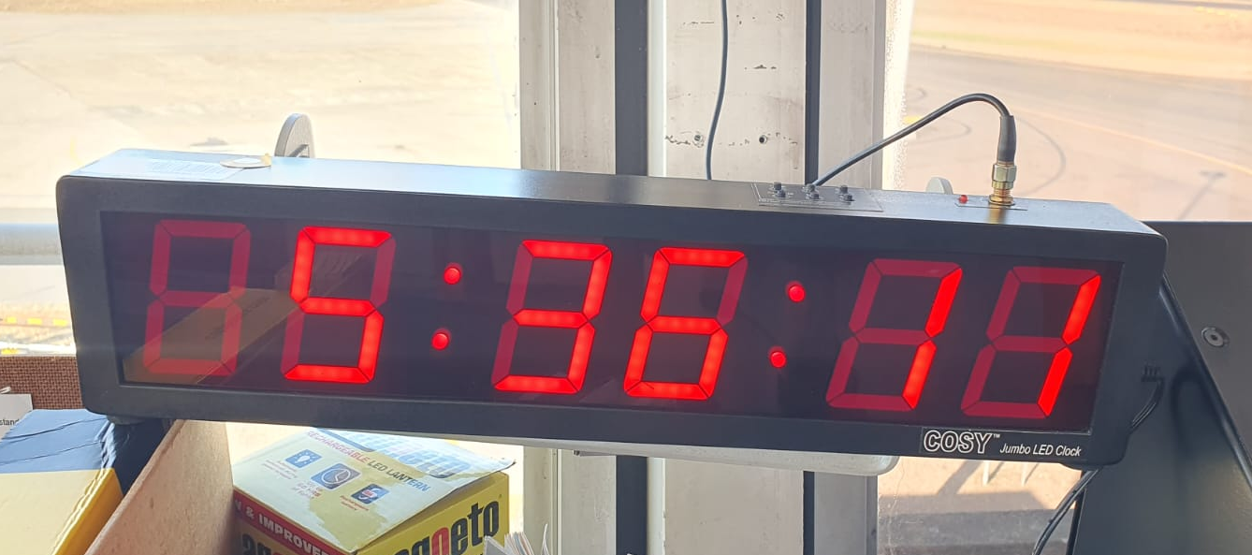
Figure 42. Mounted digital clock

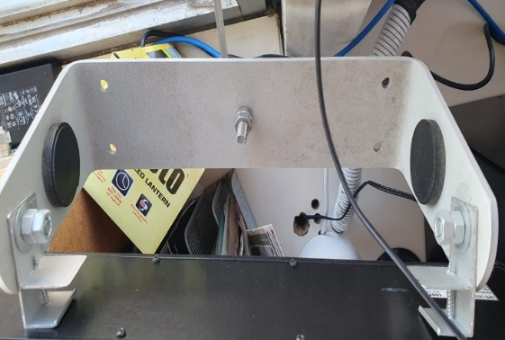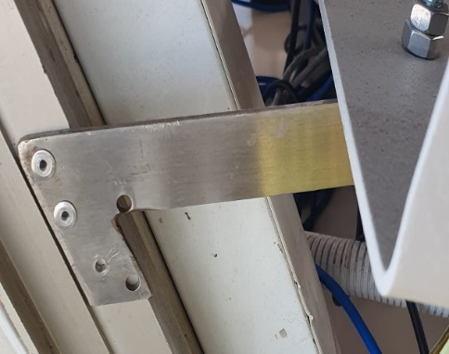
Figure 43. Digital clock mounting bracket

COMPLIANCE (C/PC/NC/Noted)
[INSERT FULL RESPONSE FOR EVALUATION HERE]

[INSERT REFERENCE TO ADDITIONAL INFORMATION HERE]

Roster Stand Cabinet
- A cabinet shall be provided to fit under the existing roster stand depicted in Figure 44. The space underneath the roster stand is 468mm x 534mm x 1184mm (width x depth x height). The Tenderer shall provide a conceptual design of the proposed roster stand cabinet. (D)
COMPLIANCE (C/PC/NC/Noted)
[INSERT FULL RESPONSE FOR EVALUATION HERE]

[INSERT REFERENCE TO ADDITIONAL INFORMATION HERE]

- The cabinet shall be divided into 6 equal sized drawers on sliders with stoppers. The drawers shall have integrated handles that do not protrude or create a snag hazard. The Tenderer shall indicate how this requirement is met in the conceptual design. (D)
COMPLIANCE (C/PC/NC/Noted)
[INSERT FULL RESPONSE FOR EVALUATION HERE]

[INSERT REFERENCE TO ADDITIONAL INFORMATION HERE]

- Each drawer shall be lockable with a key. A master key for the drawers shall be provided. The Tenderer shall provide full details on the locking mechanism. (D)
COMPLIANCE (C/PC/NC/Noted)
[INSERT FULL RESPONSE FOR EVALUATION HERE]

[INSERT REFERENCE TO ADDITIONAL INFORMATION HERE]

- The cabinet shall fit snug under the roster stand and shall be flush with the edge of the roster stand work surface. There shall be no gap between the cabinet and the tower cab floor. The Tenderer shall explain how this requirement is met by their proposed design. (D)

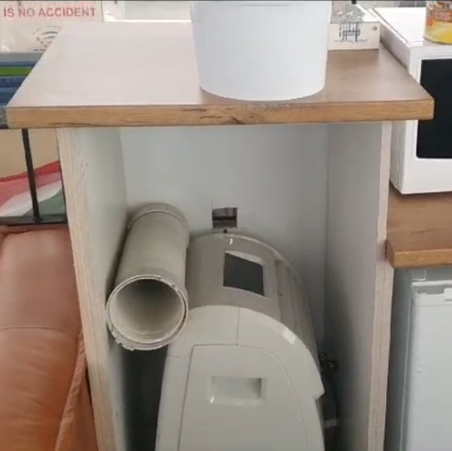
Figure 44. FAPM Roster stand
COMPLIANCE (C/PC/NC/Noted)
[INSERT FULL RESPONSE FOR EVALUATION HERE]

[INSERT REFERENCE TO ADDITIONAL INFORMATION HERE]

- The look and feel of the cabinet shall match the aesthetic of the consoles and any other cabinets/ cupboards in the tower. The Tenderer shall explain how this requirement is met by their proposed design. (D)
COMPLIANCE (C/PC/NC/Noted)
[INSERT FULL RESPONSE FOR EVALUATION HERE]

[INSERT REFERENCE TO ADDITIONAL INFORMATION HERE]

Equipment Cabinet
- There shall be one equipment cabinet placed under the working surface of the console at FAPM. This cabinet will be used to house rack mountable server equipment. The equipment cabinet shall have the same lifespan as the consoles. The basic design of the equipment cabinet is depicted in Figure 45. The dimensions on the diagram should not be assumed to be accurate. The Tenderer shall provide a conceptual design for the equipment cabinet. (D)
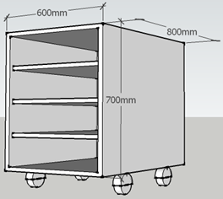
Figure 45: Basic conceptual design of a typical equipment cabinet.
COMPLIANCE (C/PC/NC/Noted)
[INSERT FULL RESPONSE FOR EVALUATION HERE]

[INSERT REFERENCE TO ADDITIONAL INFORMATION HERE]

- The existing cabinet is approximately 567mm x 402mm x 443mm (length x width x height) and can only fit three 19” 2U servers. The height of the new cabinet shall be determined by the height of the console as the cabinet shall fit comfortably underneath the worksurface while offering maximum storage capacity for equipment. The Tenderer shall indicate the dimensions of the cabinet on the conceptual design. (D)
COMPLIANCE (C/PC/NC/Noted)
[INSERT FULL RESPONSE FOR EVALUATION HERE]

[INSERT REFERENCE TO ADDITIONAL INFORMATION HERE]

- The equipment cabinet shall have a minimum width of 19 inch to accommodate a 19-inch server. The Tenderer shall indicate the dimensions of the cabinet on the conceptual design. (D)
COMPLIANCE (C/PC/NC/Noted)
[INSERT FULL RESPONSE FOR EVALUATION HERE]

[INSERT REFERENCE TO ADDITIONAL INFORMATION HERE]

- The equipment cabinet shall cater for rack mountable equipment by complying with the Electronic Industries Association (EIA) standard EIA-310 for a standard rack. The Tenderer shall indicate compliance to this requirement. (D)
COMPLIANCE (C/PC/NC/Noted)
[INSERT FULL RESPONSE FOR EVALUATION HERE]

[INSERT REFERENCE TO ADDITIONAL INFORMATION HERE]

- The equipment within the cabinets shall be easily accessible from the front and back of the cabinet for maintenance activities. The cabinet doors shall be easily removable to accommodate the maintenance activities from either end. The Tenderer shall explain how this requirement is met by the proposed design. (D)
COMPLIANCE (C/PC/NC/Noted)
[INSERT FULL RESPONSE FOR EVALUATION HERE]

[INSERT REFERENCE TO ADDITIONAL INFORMATION HERE]

- The equipment cabinets doors shall be perforated to permit sufficient air flow in and out of the equipment cabinets. The Tenderer shall explain how this requirement is met by the proposed design. (D)
COMPLIANCE (C/PC/NC/Noted)
[INSERT FULL RESPONSE FOR EVALUATION HERE]

[INSERT REFERENCE TO ADDITIONAL INFORMATION HERE]

- The equipment cabinet shall have wheels/ castors which are lockable to prevent them from being moved unintentionally. The Tenderer shall provide full details on the proposed wheels/ castors. (D)
COMPLIANCE (C/PC/NC/Noted)
[INSERT FULL RESPONSE FOR EVALUATION HERE]

[INSERT REFERENCE TO ADDITIONAL INFORMATION HERE]

- The equipment cabinets front, and back doors shall be lockable. The lock shall cater for a master key. Padlock locking mechanisms are not acceptable. The Tenderer shall provide full details on the locking mechanism. (D)
COMPLIANCE (C/PC/NC/Noted)
[INSERT FULL RESPONSE FOR EVALUATION HERE]

[INSERT REFERENCE TO ADDITIONAL INFORMATION HERE]

- The equipment cabinet shall incorporate heavy-duty sliding mechanisms and drawers that will allow technicians to slide/draw out equipment from the equipment cabinets beyond the edge of the equipment cabinets for maintenance activities. The Tenderer shall provide full details on the heavy-duty sliding mechanisms and drawers. (D)
COMPLIANCE (C/PC/NC/Noted)
[INSERT FULL RESPONSE FOR EVALUATION HERE]

[INSERT REFERENCE TO ADDITIONAL INFORMATION HERE]

- The equipment cabinet design shall cater for natural heat dissipation to prevent heat build-up within the cabinet. The Tenderer shall provide details on how this will be achieved. (D)
COMPLIANCE (C/PC/NC/Noted)
[INSERT FULL RESPONSE FOR EVALUATION HERE]

[INSERT REFERENCE TO ADDITIONAL INFORMATION HERE]

- The equipment cabinet design shall cater for noise suppression. The Tenderer shall provide details on how this will be achieved. (D)
COMPLIANCE (C/PC/NC/Noted)
[INSERT FULL RESPONSE FOR EVALUATION HERE]

[INSERT REFERENCE TO ADDITIONAL INFORMATION HERE]

- The equipment cabinet shall have a cable management system. The cable management system shall take into consideration the cable route as defined herein and the sliding in and out of equipment from the equipment cabinets. The Tenderer shall provide details on how this will be achieved. (D)
COMPLIANCE (C/PC/NC/Noted)
[INSERT FULL RESPONSE FOR EVALUATION HERE]

[INSERT REFERENCE TO ADDITIONAL INFORMATION HERE]

- The equipment cabinet shall be flush with the edge of the console working surface. The Tenderer shall explain how this requirement is met by their proposed design. (D)
COMPLIANCE (C/PC/NC/Noted)
[INSERT FULL RESPONSE FOR EVALUATION HERE]

[INSERT REFERENCE TO ADDITIONAL INFORMATION HERE]

- The look of the cabinet shall match the aesthetic of the consoles and any other cabinets/ cupboards in the tower. The Tenderer shall explain how this requirement is met by their proposed design. (D)
COMPLIANCE (C/PC/NC/Noted)
[INSERT FULL RESPONSE FOR EVALUATION HERE]

[INSERT REFERENCE TO ADDITIONAL INFORMATION HERE]

FAVG

Filing Cabinet
- A filing cabinet shall be provided for the FAVG tower. The filing cabinet shall sit snug underneath the work surface of the console in the position indicated in Figure 9. The edge of the filing cabinet shall be flush with the edge of the work surface of the console. The filing cabinet shall be 3.5m long. The Tenderer shall provide a conceptual design of the proposed filing cabinet. (D)
COMPLIANCE (C/PC/NC/Noted)
[INSERT FULL RESPONSE FOR EVALUATION HERE]

[INSERT REFERENCE TO ADDITIONAL INFORMATION HERE]

- The filing cabinet shall have two sections as depicted in Figure 46. The grey section shall accommodate a set of plastic buddy drawers comfortably. The Tenderer shall indicate how this requirement is met in the conceptual design. (D)
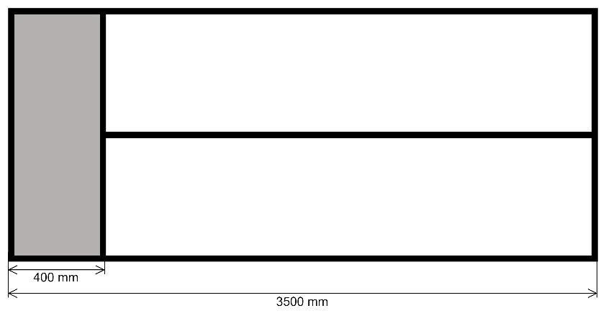
Figure 46. Concept for FAVG Filing Cabinet
COMPLIANCE (C/PC/NC/Noted)
[INSERT FULL RESPONSE FOR EVALUATION HERE]

[INSERT REFERENCE TO ADDITIONAL INFORMATION HERE]

- The white section indicated in Figure 46 shall be closed with hinged cupboard doors. The doors shall have integrated door handles which do not protrude and cause a snag hazard. The grey section shall not be closed by a door. The Tenderer shall explain how this requirement is met by their proposed design. (D)
COMPLIANCE (C/PC/NC/Noted)
[INSERT FULL RESPONSE FOR EVALUATION HERE]

[INSERT REFERENCE TO ADDITIONAL INFORMATION HERE]

- There shall be no gaps between the base of the filing cabinet and the floor of the Tower cab. The Tenderer shall explain how this requirement is met by their proposed design. (D)
COMPLIANCE (C/PC/NC/Noted)
[INSERT FULL RESPONSE FOR EVALUATION HERE]

[INSERT REFERENCE TO ADDITIONAL INFORMATION HERE]

- The look and feel of the cabinet shall match the aesthetic of the consoles and any other cabinets/ cupboards in the tower. The Tenderer shall explain how this requirement is met by their proposed design. (D)
COMPLIANCE (C/PC/NC/Noted)
[INSERT FULL RESPONSE FOR EVALUATION HERE]

[INSERT REFERENCE TO ADDITIONAL INFORMATION HERE]

Fridge
- The tower is currently equipped with a bar fridge which is placed on top of the console countertop as indicated in Figure 9. The fridge shall be replaced with a new bar fridge to fit underneath the console worksurface. The fridge shall have the following specifications at minimum:
  - 93 litre capacity
  - Metallic finish
  - Frost free
  - Low noise during operation
  - Minimum A Energy rating
  - Reversible door with integrated handle
  - Separate freezer compartment
  - Minimum 2-year guarantee
The Tenderer shall provide full details on the proposed fridge. (D)
COMPLIANCE (C/PC/NC/Noted)
[INSERT FULL RESPONSE FOR EVALUATION HERE]

[INSERT REFERENCE TO ADDITIONAL INFORMATION HERE]

- The bar fridge shall be installed in the corner of the tower as indicated in Figure 9. The new installation shall be on the floor and not on top of the console. The console shall not be cutout to accommodate the installation of the fridge. A step-up design may be used to accommodate the height of the fridge in the corner in which it is installed. The worksurface of the console shall continuous such that there are no gaps between the stepped surfaces. The Tenderer shall provide full details on the installation of the fridge and how it will be accommodated by the console design. (D)
COMPLIANCE (C/PC/NC/Noted)
[INSERT FULL RESPONSE FOR EVALUATION HERE]

[INSERT REFERENCE TO ADDITIONAL INFORMATION HERE]

- Cooling and ventilation of the fridge shall be considered during installation. There shall be at least 50 mm clearance around the fridge to assist cooling and ventilation. The Tenderer shall explain how this requirement is met by their proposed solution. (D)
COMPLIANCE (C/PC/NC/Noted)
[INSERT FULL RESPONSE FOR EVALUATION HERE]

[INSERT REFERENCE TO ADDITIONAL INFORMATION HERE]

- The fridge door shall be protected from being dented by being opened against any part of the adjacent console. The Tenderer shall explain how this requirement is met by their proposed solution. (D)
COMPLIANCE (C/PC/NC/Noted)
[INSERT FULL RESPONSE FOR EVALUATION HERE]

[INSERT REFERENCE TO ADDITIONAL INFORMATION HERE]

- A drip tray shall be installed underneath the fridge to collect any water should the fridge defrost during power outages. The drip tray shall not present any tripping hazard and shall not hinder the function of the fridge door. The Tenderer shall provide full details on the proposed drip tray. (D)
COMPLIANCE (C/PC/NC/Noted)
[INSERT FULL RESPONSE FOR EVALUATION HERE]

[INSERT REFERENCE TO ADDITIONAL INFORMATION HERE]

Sink
- The tower cab is equipped with a sink and a tap (Figure 47) with plumbing (Figure 48).
 | 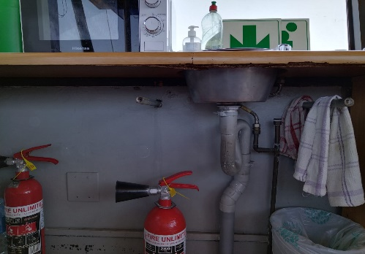
Figure 47. FAVG Sink and tap. | Figure 48. FAVG sink and tap plumbing
The sink and tap installation shall be moved such that the tower fire escape above the sink is completely unobscured. This will require the installation including plumbing to be moved approximately 65cm to the left, or 50cm to the right by the Contractor. The sink shall be replaced with a stainless-steel drop-in prep bowl which is at least 340mm diameter, and at least 150mm deep. The Tenderer shall provide full details on the proposed sink and associated plumbing; and make provision for it in the costing. (D)
COMPLIANCE (C/PC/NC/Noted)
[INSERT FULL RESPONSE FOR EVALUATION HERE]

[INSERT REFERENCE TO ADDITIONAL INFORMATION HERE]

- The plumbing hoses and seals shall be replaced. The Tenderer shall provide full details on the hoses and seals; and make provision for it in the costing. (D)
COMPLIANCE (C/PC/NC/Noted)
[INSERT FULL RESPONSE FOR EVALUATION HERE]

[INSERT REFERENCE TO ADDITIONAL INFORMATION HERE]

- A basket strainer waste plug shall be provided for the sink. The Tenderer shall provide full details on the proposed basket strainer waste plug. (D)
COMPLIANCE (C/PC/NC/Noted)
[INSERT FULL RESPONSE FOR EVALUATION HERE]

[INSERT REFERENCE TO ADDITIONAL INFORMATION HERE]

- A new chrome tap shall be installed with a guarantee of at least 10 years. The tap shall be high enough to comfortably fit and fill a 2L kettle underneath it. The Tenderer shall provide full details on the proposed chrome tap. (D)
COMPLIANCE (C/PC/NC/Noted)
[INSERT FULL RESPONSE FOR EVALUATION HERE]

[INSERT REFERENCE TO ADDITIONAL INFORMATION HERE]

Dish Cabinet
- The tower is equipped with a dish cabinet with approximate dimensions 710mm x 310mm x 770mm (length x width x height). The dish cabinet shall be replaced with a new cabinet that includes drawers for storage of cutlery and dishcloths, and two shelves for storage of crockery (Figure 49). The Tenderer shall provide a conceptual design of the proposed dish cabinet. (D)
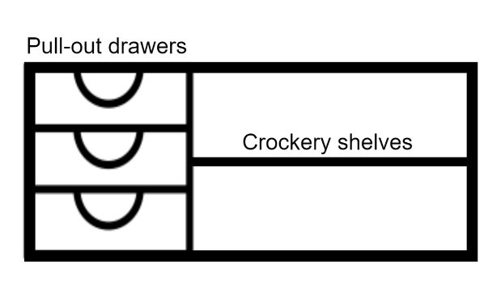
Figure 49. Dish cabinet conceptual design
COMPLIANCE (C/PC/NC/Noted)
[INSERT FULL RESPONSE FOR EVALUATION HERE]

[INSERT REFERENCE TO ADDITIONAL INFORMATION HERE]

- The cabinet shall have 3 equally spaced drawers on sliders with stoppers. The drawers shall have integrated handles that do not protrude or create a snag hazard. The Tenderer shall indicate how this requirement is met in the conceptual design. (D)
COMPLIANCE (C/PC/NC/Noted)
[INSERT FULL RESPONSE FOR EVALUATION HERE]

[INSERT REFERENCE TO ADDITIONAL INFORMATION HERE]

- The cabinet shall fit snug under the console worksurface and shall be flush with the edge of the console working surface. There shall be no gap between the cabinet and the tower cab floor. The Tenderer shall explain how this requirement is met by their proposed design. (D)
COMPLIANCE (C/PC/NC/Noted)
[INSERT FULL RESPONSE FOR EVALUATION HERE]

[INSERT REFERENCE TO ADDITIONAL INFORMATION HERE]

- The look and feel of the cabinet shall match the aesthetic of the consoles and any other cabinets/ cupboards in the tower. The Tenderer shall explain how this requirement is met by their proposed design. (D)
COMPLIANCE (C/PC/NC/Noted)
[INSERT FULL RESPONSE FOR EVALUATION HERE]

[INSERT REFERENCE TO ADDITIONAL INFORMATION HERE]

6-way Multi Plug
- There shall be one 6-way surge protected multi plug installed underneath the console in the position marked with “X” in the figure below. The multi plug shall accommodate 6 x 16A SA plugs, 5 x Euro plugs, and 1x Schucko plug. The Tenderer shall provide full details on the proposed multi plug. (D)
COMPLIANCE (C/PC/NC/Noted)
[INSERT FULL RESPONSE FOR EVALUATION HERE]

[INSERT REFERENCE TO ADDITIONAL INFORMATION HERE]

- A cable entry point shall be installed in the console at the position marked with “Y” in the figure below. The cable entry point shall have an opening large enough to pass a standard South African 3 pin plug through. The entry point hole shall have a cover with a grommet to hold the cables in place. The Tenderer shall provide full details on the cable entry point; and indicate the cable entry point on the console technical drawings. (D)
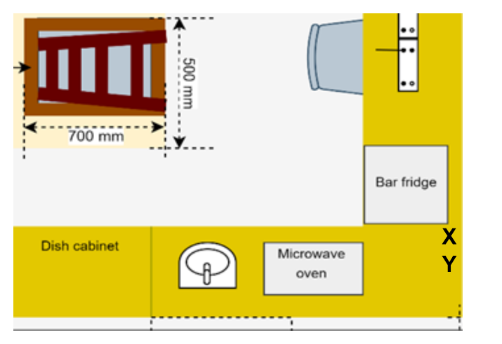
Figure 50. Location for multi plug and cable entry point.

COMPLIANCE (C/PC/NC/Noted)
[INSERT FULL RESPONSE FOR EVALUATION HERE]

[INSERT REFERENCE TO ADDITIONAL INFORMATION HERE]

Emergency Exit Access
- At the FAVG Tower, a window situated above the kitchen consoles serves as the emergency exit. To access the emergency exit, the controllers currently need to climb onto the console and climb through the window. In the new console installation, there shall be no console below the emergency exit window, ie. The console shall terminate on either side of the window. The Tenderer shall indicate this in the proposed design for FAVG TWR consoles. (D)
COMPLIANCE (C/PC/NC/Noted)
[INSERT FULL RESPONSE FOR EVALUATION HERE]

[INSERT REFERENCE TO ADDITIONAL INFORMATION HERE]

- A set of stairs/ steps shall be installed directly below the window which will be used to access the emergency exit. These stairs/ steps shall be a permanent fixture and shall not protrude past the front edge of the consoles. The stairs/ steps shall be sturdy and rigid and must have a lifespan of at least 10 years. The Tenderer shall provide a proposed design for the stairs/ steps, full details on the materials, and proposed method of installation. (D)
COMPLIANCE (C/PC/NC/Noted)
[INSERT FULL RESPONSE FOR EVALUATION HERE]

[INSERT REFERENCE TO ADDITIONAL INFORMATION HERE]

- The steps shall be wide enough for the controller to place both feet next to each other on the step simultaneously. The Tenderer shall indicate the dimensions of the steps in technical drawings. (D)
COMPLIANCE (C/PC/NC/Noted)
[INSERT FULL RESPONSE FOR EVALUATION HERE]

[INSERT REFERENCE TO ADDITIONAL INFORMATION HERE]

- The steps shall not pose an OHS hazard in the Tower. The Tenderer shall explain how the proposed design complies with this requirement. (D)
COMPLIANCE (C/PC/NC/Noted)
[INSERT FULL RESPONSE FOR EVALUATION HERE]

[INSERT REFERENCE TO ADDITIONAL INFORMATION HERE]

- The steps shall be able to withstand at least 120kg weight. The Tenderer shall provide supporting information to prove compliance with the requirement. (D)
COMPLIANCE (C/PC/NC/Noted)
[INSERT FULL RESPONSE FOR EVALUATION HERE]

[INSERT REFERENCE TO ADDITIONAL INFORMATION HERE]

FARB

Acrylic Sheet for Map
- A clear 3mm acrylic sheet shall be provided for the FAPM tower. This sheet will be used to protect the map which is displayed on the console worksurface. The acrylic sheet shall be 730mm x 760mm. The Tenderer shall provide full details on the proposed acrylic sheet and make provision for it in the costing. (D)
COMPLIANCE (C/PC/NC/Noted)
[INSERT FULL RESPONSE FOR EVALUATION HERE]

[INSERT REFERENCE TO ADDITIONAL INFORMATION HERE]

- The edges of the acrylic sheet shall not be sharp or pose an OHS hazard. The Tenderer shall indicate compliance to this requirement. (D)
COMPLIANCE (C/PC/NC/Noted)
[INSERT FULL RESPONSE FOR EVALUATION HERE]

[INSERT REFERENCE TO ADDITIONAL INFORMATION HERE]

Equipment Cabinets
- There shall be two movable equipment cabinets placed under the working surface of the console at FARB. These cabinets will be placed under the two corners of the TWR Controller position. The equipment cabinet shall have the same lifespan as the consoles. The basic design of the equipment cabinet is depicted in Figure 51. The dimensions on the diagram should not be assumed to be accurate. The Tenderer shall provide a conceptual design for the equipment cabinet. (D)

Figure 51: Basic conceptual design of a typical equipment cabinet.

COMPLIANCE (C/PC/NC/Noted)
[INSERT FULL RESPONSE FOR EVALUATION HERE]

[INSERT REFERENCE TO ADDITIONAL INFORMATION HERE]

- The equipment cabinets shall accommodate a minimum of 3 desktop computer towers. The dimensions of a typical desktop computer tower can be assumed to be 750 mm x 150 mm x 550 mm (depth x width x height). The desktop computer towers shall be placed horizontally within the equipment cabinets. The Tenderer shall indicate the dimensions of the cabinet on the conceptual design. (D)
COMPLIANCE (C/PC/NC/Noted)
[INSERT FULL RESPONSE FOR EVALUATION HERE]

[INSERT REFERENCE TO ADDITIONAL INFORMATION HERE]

- The equipment cabinet shall have a minimum width of 19 inch to accommodate a 19-inch server. The Tenderer shall indicate the dimensions of the cabinet on the conceptual design. (D)
COMPLIANCE (C/PC/NC/Noted)
[INSERT FULL RESPONSE FOR EVALUATION HERE]

[INSERT REFERENCE TO ADDITIONAL INFORMATION HERE]

- The equipment cabinet shall cater for rack mountable equipment by complying with the Electronic Industries Association (EIA) standard EIA-310 for a standard rack. The Tenderer shall indicate compliance to this requirement. (D)
COMPLIANCE (C/PC/NC/Noted)
[INSERT FULL RESPONSE FOR EVALUATION HERE]

[INSERT REFERENCE TO ADDITIONAL INFORMATION HERE]

- The equipment within the cabinets shall be easily accessible from the front and back of the cabinet for maintenance activities. The cabinet doors shall be easily removable to accommodate the maintenance activities from either end. The Tenderer shall explain how this requirement is met by the proposed design. (D)
COMPLIANCE (C/PC/NC/Noted)
[INSERT FULL RESPONSE FOR EVALUATION HERE]

[INSERT REFERENCE TO ADDITIONAL INFORMATION HERE]

- The equipment cabinets’ doors shall be perforated to permit sufficient air flow in and out of the equipment cabinets. The Tenderer shall explain how this requirement is met by the proposed design. (D)
COMPLIANCE (C/PC/NC/Noted)
[INSERT FULL RESPONSE FOR EVALUATION HERE]

[INSERT REFERENCE TO ADDITIONAL INFORMATION HERE]

- The equipment cabinet shall have wheels/ castors which are lockable to prevent them from being moved unintentionally. The Tenderer shall provide full details on the proposed wheels/ castors. (D)
COMPLIANCE (C/PC/NC/Noted)
[INSERT FULL RESPONSE FOR EVALUATION HERE]

[INSERT REFERENCE TO ADDITIONAL INFORMATION HERE]

- The equipment cabinets front, and back doors shall be lockable. The lock shall cater for a master key. Padlock locking mechanisms are not acceptable. The Tenderer shall provide full details on the locking mechanism. (D)
COMPLIANCE (C/PC/NC/Noted)
[INSERT FULL RESPONSE FOR EVALUATION HERE]

[INSERT REFERENCE TO ADDITIONAL INFORMATION HERE]

- The equipment cabinet shall incorporate heavy-duty sliding mechanisms and drawers that will allow technicians to slide/draw out equipment from the equipment cabinets beyond the edge of the equipment cabinets for maintenance activities. The Tenderer shall provide full details on the heavy-duty sliding mechanisms and drawers. (D)
COMPLIANCE (C/PC/NC/Noted)
[INSERT FULL RESPONSE FOR EVALUATION HERE]

[INSERT REFERENCE TO ADDITIONAL INFORMATION HERE]

- The equipment cabinet design shall cater for natural heat dissipation to prevent heat build-up within the cabinet. The Tenderer shall provide details on how this will be achieved. (D)
COMPLIANCE (C/PC/NC/Noted)
[INSERT FULL RESPONSE FOR EVALUATION HERE]

[INSERT REFERENCE TO ADDITIONAL INFORMATION HERE]

- The equipment cabinet design shall cater for noise suppression. The Tenderer shall provide details on how this will be achieved. (D)
COMPLIANCE (C/PC/NC/Noted)
[INSERT FULL RESPONSE FOR EVALUATION HERE]

[INSERT REFERENCE TO ADDITIONAL INFORMATION HERE]

- The equipment cabinet shall have a cable management system. The cable management system shall take into consideration the cable route as defined herein and the sliding in and out of equipment from the equipment cabinets. The Tenderer shall provide details on how this will be achieved. (D)
COMPLIANCE (C/PC/NC/Noted)
[INSERT FULL RESPONSE FOR EVALUATION HERE]

[INSERT REFERENCE TO ADDITIONAL INFORMATION HERE]

- The equipment cabinet shall be flush with the edge of the console working surface. The Tenderer shall explain how this requirement is met by their proposed design. (D)
COMPLIANCE (C/PC/NC/Noted)
[INSERT FULL RESPONSE FOR EVALUATION HERE]

[INSERT REFERENCE TO ADDITIONAL INFORMATION HERE]

- The look of the cabinet shall match the aesthetic of the consoles and any other cabinets/ cupboards in the tower. The Tenderer shall explain how this requirement is met by their proposed design. (D)
COMPLIANCE (C/PC/NC/Noted)
[INSERT FULL RESPONSE FOR EVALUATION HERE]

[INSERT REFERENCE TO ADDITIONAL INFORMATION HERE]

6-way Multi Plug
- There shall be one 6-way surge protected multi plug installed to the rear of the TWR console at the in the position marked with “X” in the figure below. The multi plug shall accommodate 6 x 16A SA plugs, 5 x Euro plugs, and 1x Schucko plug. The Tenderer shall provide full details on the proposed multi plug. (D)

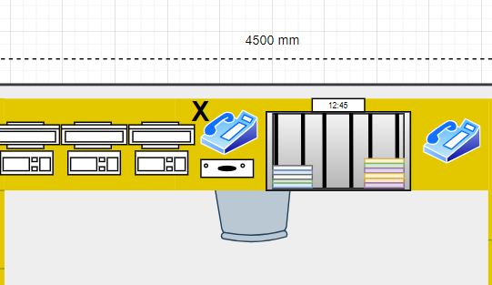
Figure 52. 6-Way multiplug installation position

COMPLIANCE (C/PC/NC/Noted)
[INSERT FULL RESPONSE FOR EVALUATION HERE]

[INSERT REFERENCE TO ADDITIONAL INFORMATION HERE]

Sink
- The tower cab is equipped with a sink and a tap (Figure 53) with plumbing (Figure 54). The sink shall be replaced with a similar ceramic drop-in basin which is at least 190mm deep. The Tenderer shall provide full details on the proposed sink and associated plumbing; and make provision for it in the costing. (D)
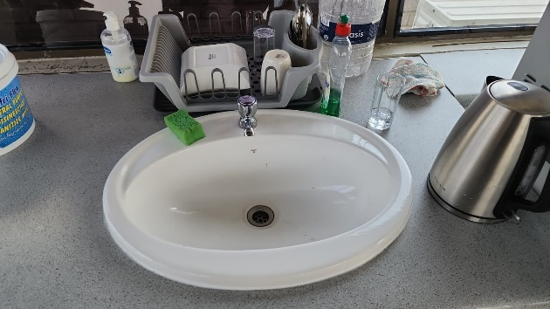 | 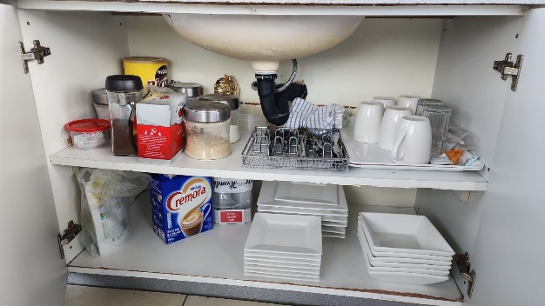
Figure 53. FARB Sink and tap. | Figure 54. FARB sink and tap plumbing
COMPLIANCE (C/PC/NC/Noted)
[INSERT FULL RESPONSE FOR EVALUATION HERE]

[INSERT REFERENCE TO ADDITIONAL INFORMATION HERE]

- The plumbing hoses and seals shall be replaced. The Tenderer shall provide full details on the hoses and seals; and make provision for it in the costing. (D)
COMPLIANCE (C/PC/NC/Noted)
[INSERT FULL RESPONSE FOR EVALUATION HERE]

[INSERT REFERENCE TO ADDITIONAL INFORMATION HERE]

- A basket strainer waste plug shall be provided for the sink. The Tenderer shall provide full details on the proposed basket strainer waste plug. (D)
COMPLIANCE (C/PC/NC/Noted)
[INSERT FULL RESPONSE FOR EVALUATION HERE]

[INSERT REFERENCE TO ADDITIONAL INFORMATION HERE]

- A new chrome tap shall be installed with a guarantee of at least 10 years. The tap shall be high enough to comfortably fit and fill a 2L kettle underneath it. The Tenderer shall provide full details on the proposed chrome tap. (D)
COMPLIANCE (C/PC/NC/Noted)
[INSERT FULL RESPONSE FOR EVALUATION HERE]

[INSERT REFERENCE TO ADDITIONAL INFORMATION HERE]

Built-in Cupboard
- The tower is equipped with cupboard space and drawers built in underneath the consoles, in the section outlined in red in Figure 55. These cupboards and drawers are shown in Figure 56. The built-in cupboards and drawers shall be replaced with built-in cupboards only (no drawers) in the area outlined in red. The cupboards shall be divided into 3 equal sized compartments by 2 horizontal shelves. The Tenderer shall provide a conceptual design of the proposed built-in cupboard. (D)
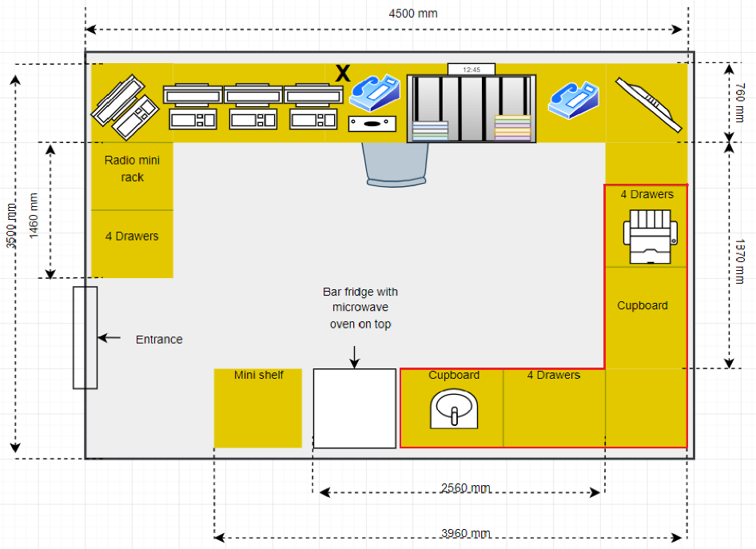
Figure 55. Built-in cupboards outlined in red.

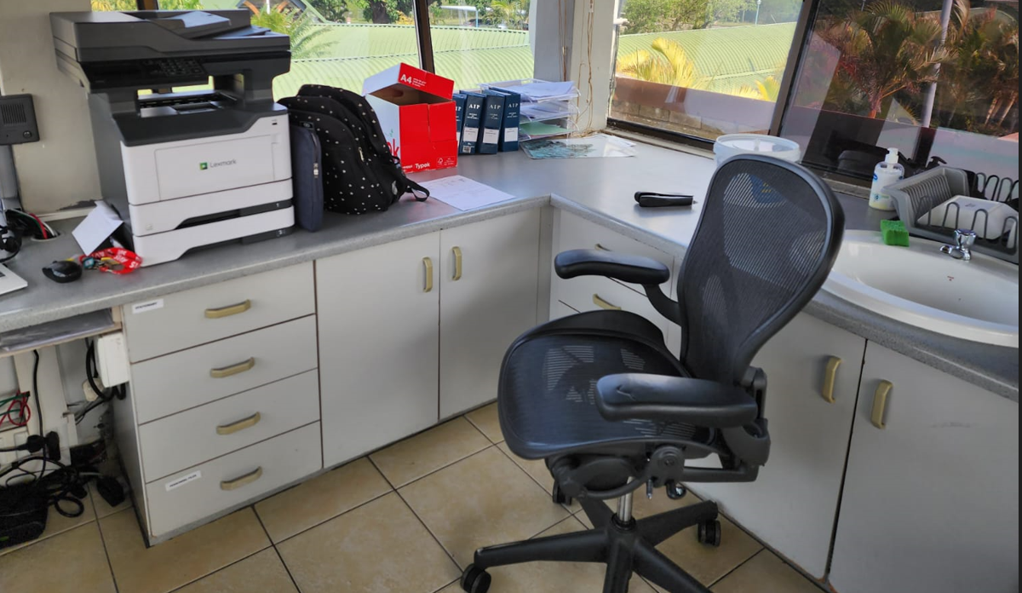
Figure 56. Built-in Cupboards

COMPLIANCE (C/PC/NC/Noted)
[INSERT FULL RESPONSE FOR EVALUATION HERE]

[INSERT REFERENCE TO ADDITIONAL INFORMATION HERE]

- The cupboards shall be closed with hinged cupboard doors. The doors shall have integrated door handles which do not protrude and cause a snag hazard. The Tenderer shall explain how this requirement is met by their proposed design. (D)
COMPLIANCE (C/PC/NC/Noted)
[INSERT FULL RESPONSE FOR EVALUATION HERE]

[INSERT REFERENCE TO ADDITIONAL INFORMATION HERE]

- There shall be no gaps between the base of the cupboards and the Tower cab floor. The Tenderer shall explain how this requirement is met by their proposed design. (D)
COMPLIANCE (C/PC/NC/Noted)
[INSERT FULL RESPONSE FOR EVALUATION HERE]

[INSERT REFERENCE TO ADDITIONAL INFORMATION HERE]

- The look and feel of the cupboard shall match the aesthetic of the consoles and any other cabinets/ cupboards in the tower. The Tenderer shall explain how this requirement is met by their proposed design. (D)
COMPLIANCE (C/PC/NC/Noted)
[INSERT FULL RESPONSE FOR EVALUATION HERE]

[INSERT REFERENCE TO ADDITIONAL INFORMATION HERE]

Freestanding Cupboard
- A freestanding cupboard shall be provided to replace the mini shelf depicted in Figure 10. The freestanding cupboard shall be 505mm x 530mm x 775mm (width x depth x height). The edge of the freestanding cupboard shall be flush with the edge of the work surface of the console. The Tenderer shall provide a conceptual design of the proposed freestanding cupboard. (D)
COMPLIANCE (C/PC/NC/Noted)
[INSERT FULL RESPONSE FOR EVALUATION HERE]

[INSERT REFERENCE TO ADDITIONAL INFORMATION HERE]

- The cupboard shall be divided into two equal sized sections by one horizontal shelf. The Tenderer shall indicate how this requirement is met in the conceptual design. (D)
COMPLIANCE (C/PC/NC/Noted)
[INSERT FULL RESPONSE FOR EVALUATION HERE]

[INSERT REFERENCE TO ADDITIONAL INFORMATION HERE]

- The cupboard shall be closed with hinged cupboard doors. The doors shall have integrated door handles which do not protrude and cause a snag hazard. The Tenderer shall explain how this requirement is met by their proposed design. (D)
COMPLIANCE (C/PC/NC/Noted)
[INSERT FULL RESPONSE FOR EVALUATION HERE]

[INSERT REFERENCE TO ADDITIONAL INFORMATION HERE]

- There shall be no gaps between the base of the cabinet and the Tower cab floor. The Tenderer shall explain how this requirement is met by their proposed design. (D)
COMPLIANCE (C/PC/NC/Noted)
[INSERT FULL RESPONSE FOR EVALUATION HERE]

[INSERT REFERENCE TO ADDITIONAL INFORMATION HERE]

- The look and feel of the cupboard shall match the aesthetic of the consoles and any other cabinets/ cupboards in the tower. The Tenderer shall explain how this requirement is met by their proposed design. (D)
COMPLIANCE (C/PC/NC/Noted)
[INSERT FULL RESPONSE FOR EVALUATION HERE]

[INSERT REFERENCE TO ADDITIONAL INFORMATION HERE]

Cable Trunking
- The power and communication cables in the tower are kept separate in cable trunking which is installed along the four walls of the tower cab. There shall be eight (8) lengths of aluminium cable trunking provided with the following dimensions:
  - Length: 4410mm
  - Width: 84mm
  - Depth: 55mm
The Tenderer shall provide full details on the proposed trunking and make provision for it in the costing. (D)
COMPLIANCE (C/PC/NC/Noted)
[INSERT FULL RESPONSE FOR EVALUATION HERE]

[INSERT REFERENCE TO ADDITIONAL INFORMATION HERE]

GENERAL PROJECT SPECIFICATIONS

GENERAL SPECIFICATIONS

Project Execution and Compliance
- The Contractor shall repair to its original condition or replace, at their own cost, any component damaged during the execution of this project. (I)
COMPLIANCE (C/PC/NC/Noted)
[INSERT FULL RESPONSE FOR EVALUATION HERE]

[INSERT REFERENCE TO ADDITIONAL INFORMATION HERE]

- The Contractor shall not sub-contract any portion of the scope of work detailed herein or support contract without prior approval by ATNS. (I)
COMPLIANCE (C/PC/NC/Noted)
[INSERT FULL RESPONSE FOR EVALUATION HERE]

[INSERT REFERENCE TO ADDITIONAL INFORMATION HERE]

- ATNS may request a demonstration of compliance on any of the components of the consoles and associated components provided. (I)
COMPLIANCE (C/PC/NC/Noted)
[INSERT FULL RESPONSE FOR EVALUATION HERE]

[INSERT REFERENCE TO ADDITIONAL INFORMATION HERE]

- The Tenderer shall provide a list of all standards and/or regulations that the consoles and/or its components or associated components as specified herein adhere to or comply with. (D)
COMPLIANCE (C/PC/NC/Noted)
[INSERT FULL RESPONSE FOR EVALUATION HERE]

[INSERT REFERENCE TO ADDITIONAL INFORMATION HERE]

- The Contractor shall ensure that the consoles, equipment cabinets, auxiliary modules and associated components are designed to the same look (colour) and feel (texture). (I)
COMPLIANCE (C/PC/NC/Noted)
[INSERT FULL RESPONSE FOR EVALUATION HERE]

[INSERT REFERENCE TO ADDITIONAL INFORMATION HERE]

Console Mock Setup
- A mock setup of the consoles shall be set up for each type of console (Approach, Maintenance and Tower) to allow the users to test the ergonomics of the console before the final design is approved for production. Changes to the design to enhance ergonomics may occur after the mock-up. The mock set-up can be made of cheaper materials. Tenderers shall ensure that provision is made for the mock setup in their offer. (D)
COMPLIANCE (C/PC/NC/Noted)
[INSERT FULL RESPONSE FOR EVALUATION HERE]

[INSERT REFERENCE TO ADDITIONAL INFORMATION HERE]

APPENDIX A: DRAWINGS

TNAC DRAWINGS
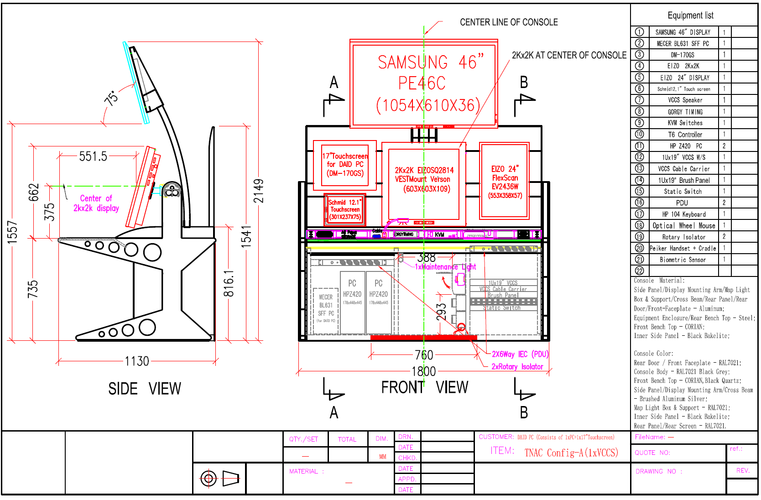
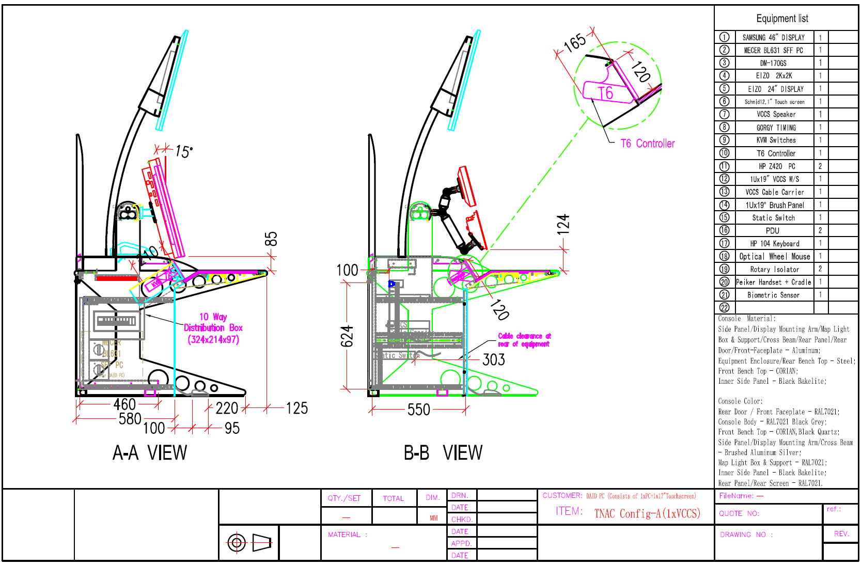
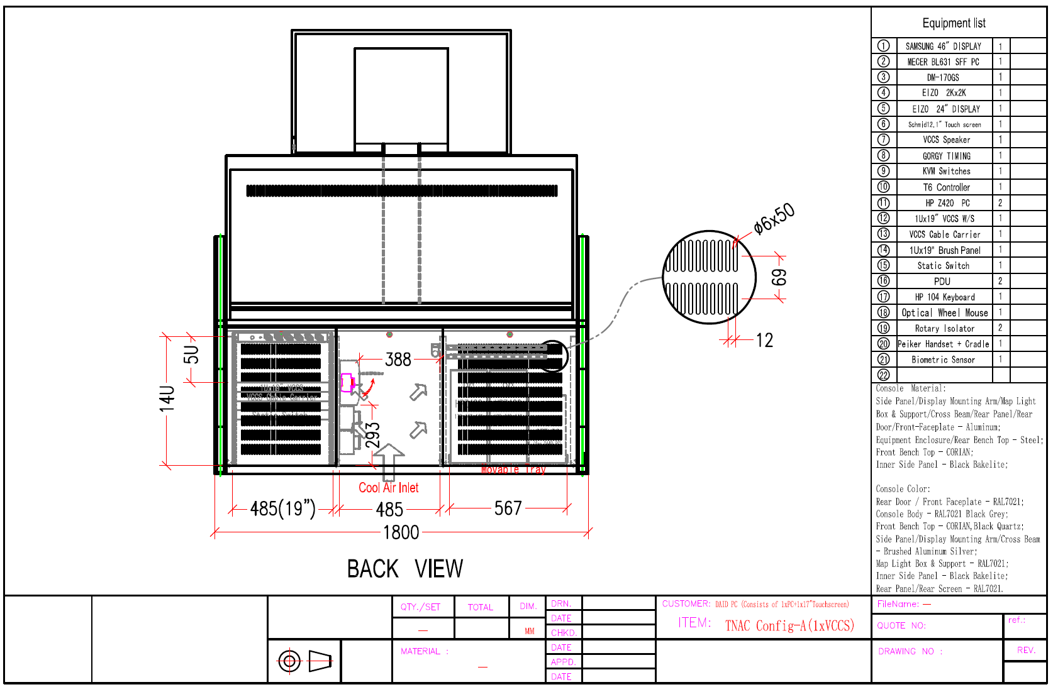
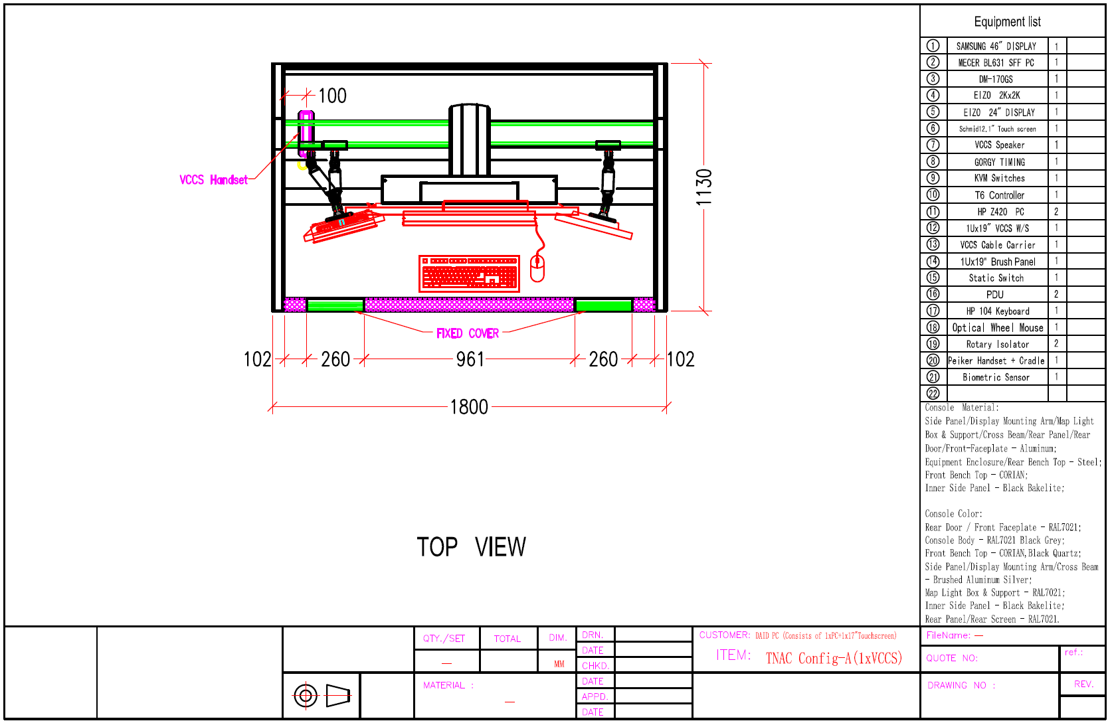
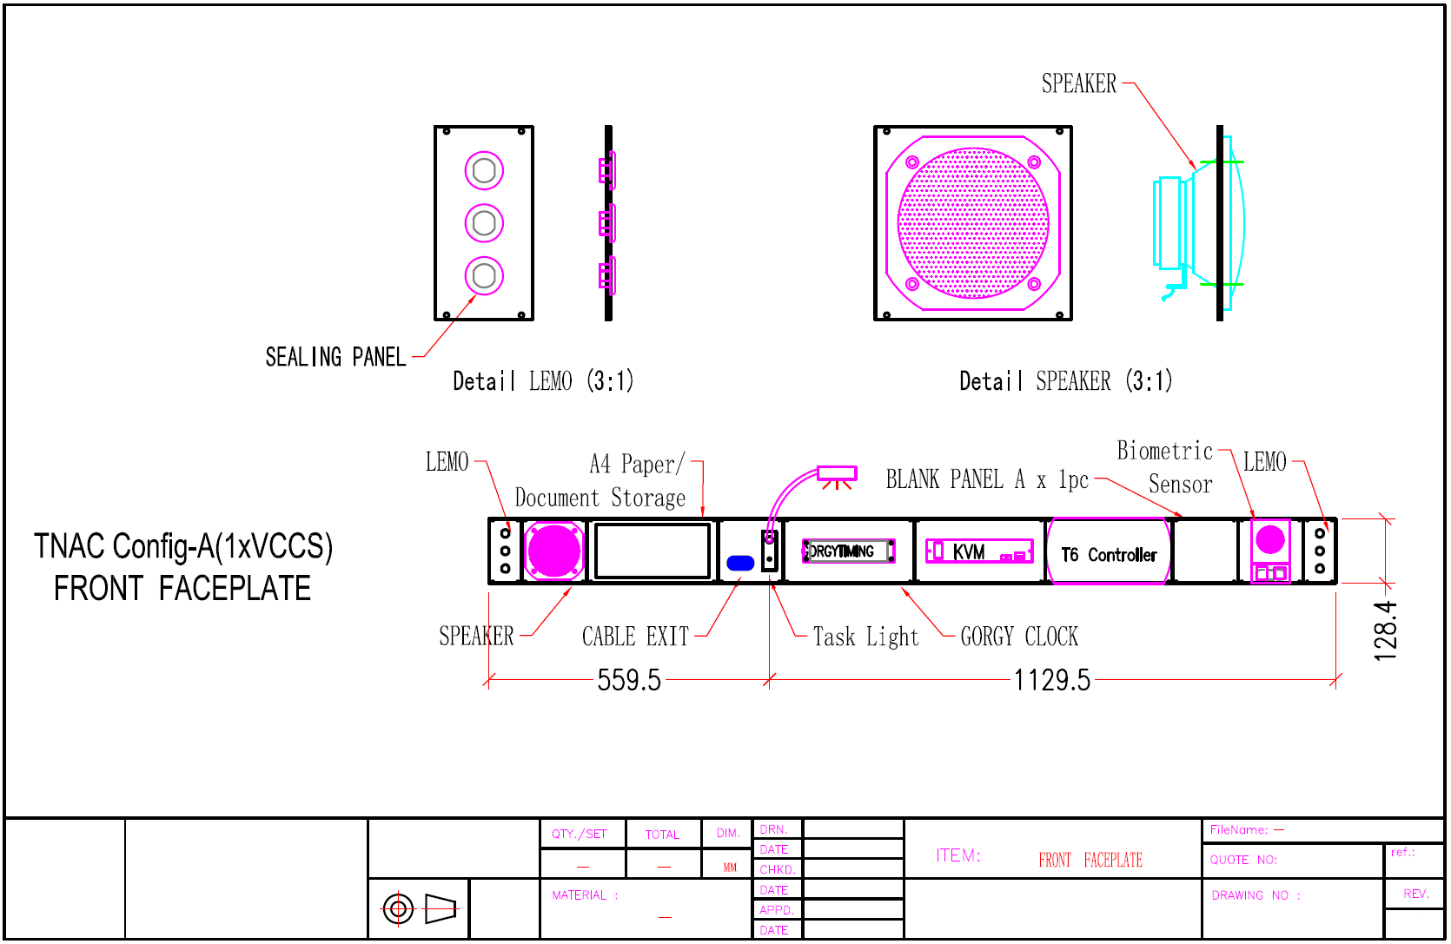
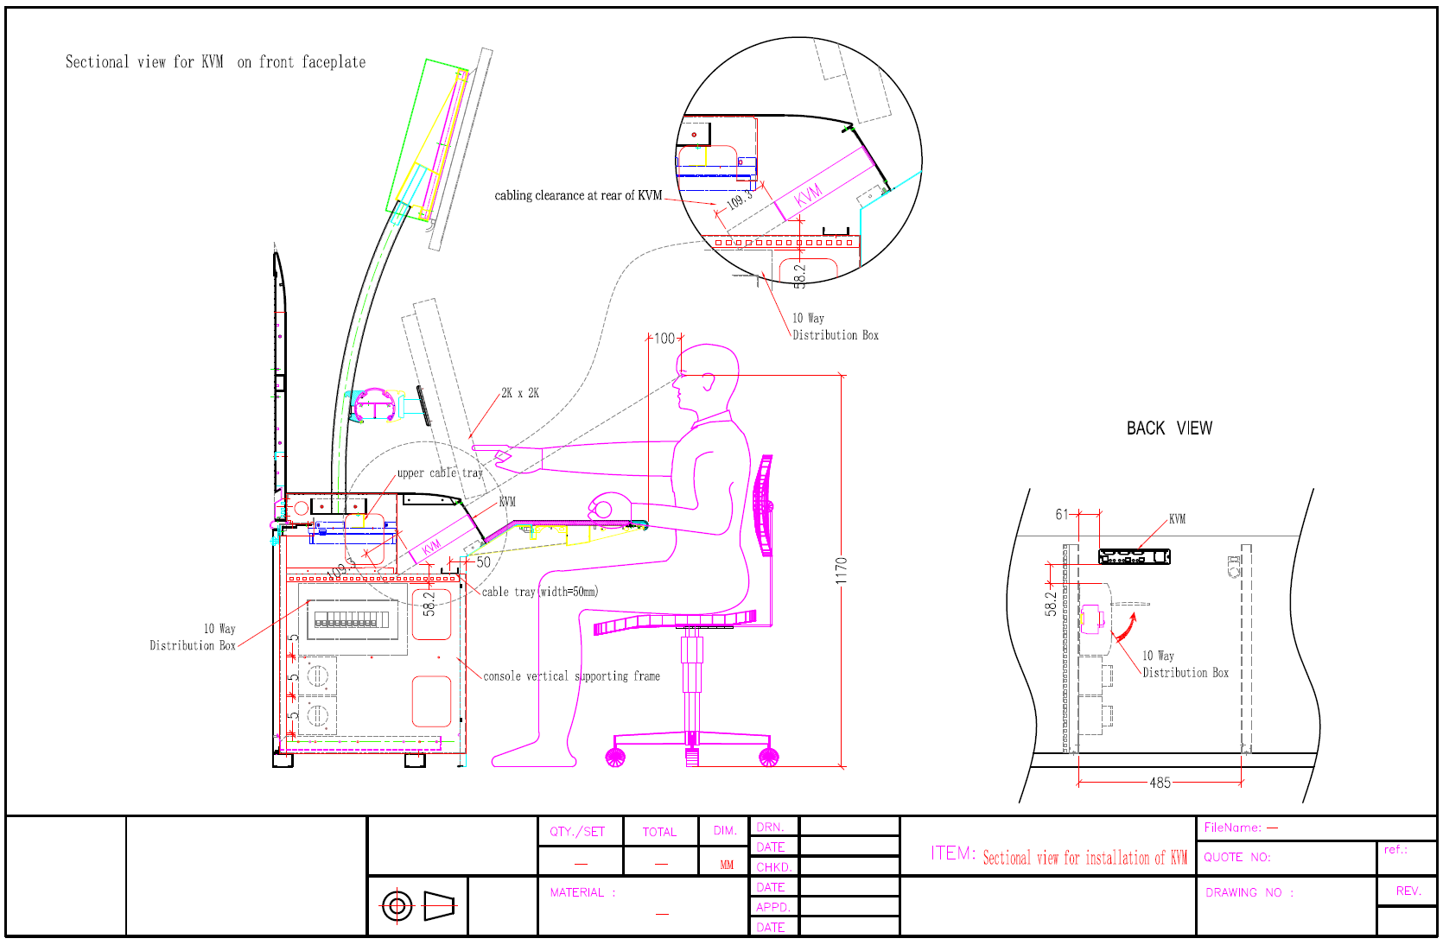
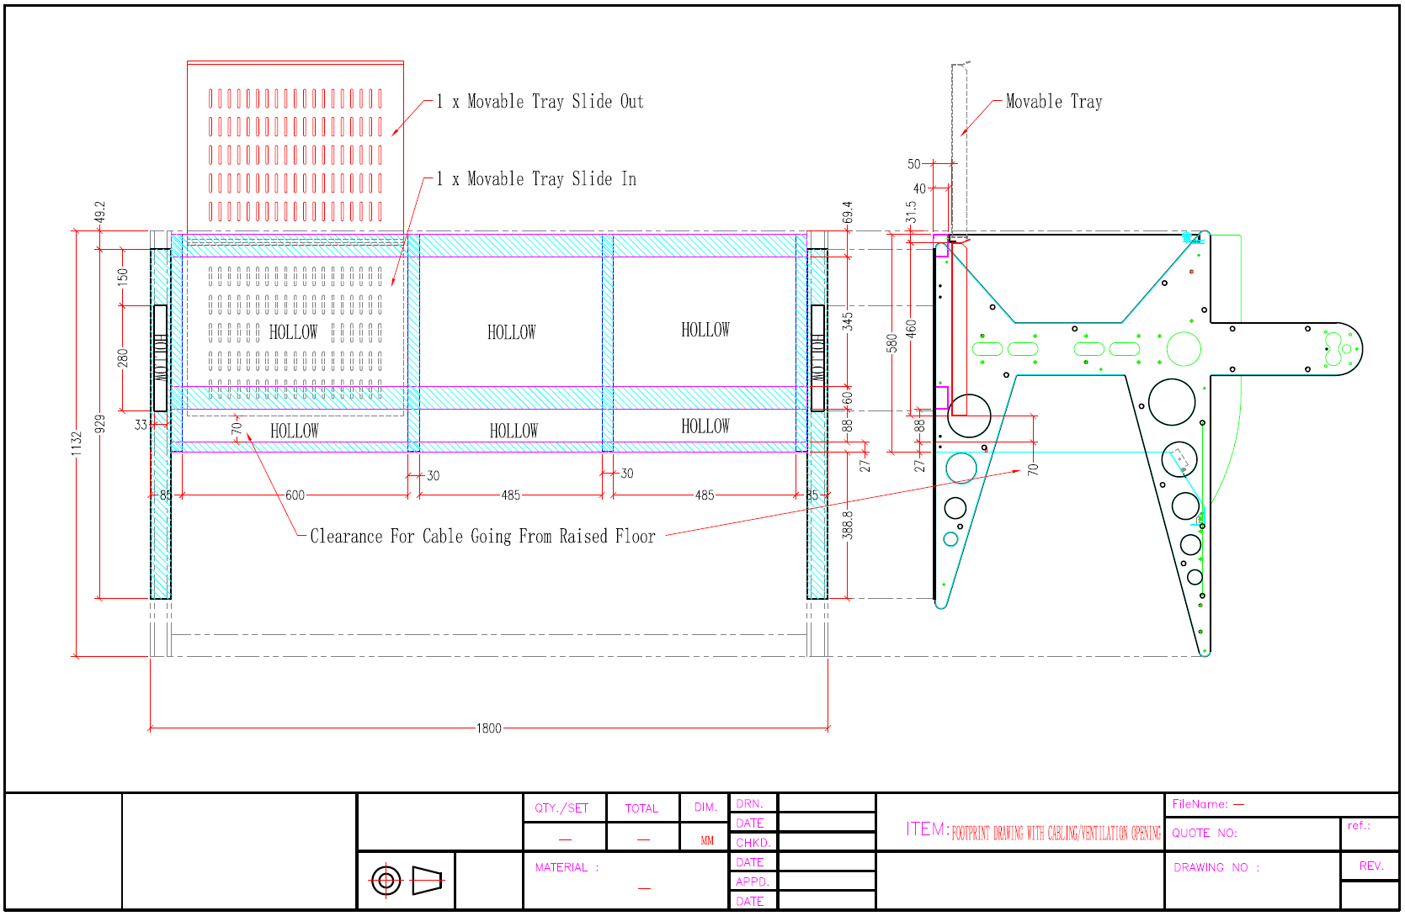

ADMIN CONSOLE
