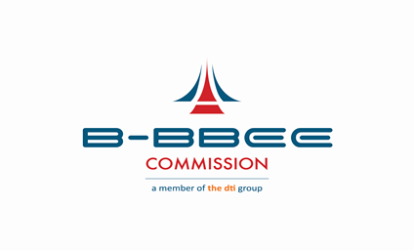 | Broad-Based Black Economic Empowerment Commission  Compliance Report by Companies Listed on the  Johannesburg Stock Exchange (JSE)  (in terms of Section 13G (2) of the Act)
 | Case Number |  | FORM BBBEE 1
SECTION A: DETAILS OF ENTITY

Name of Entity / Organisation
Registration Number
Physical Address
Telephone Number
Email Address
Indicate Type of Entity / Organisation
Industry / Sector
Relevant Code of Good Practice
Name of Verification Agency
Name of Technical Signatory

SECTION B: INFORMATION AS VERIFIED BY THE BROAD-BASED BLACK ECONOMIC EMPOWERMENT VERIFICATION PROFESSIONAL AS PER SCORECARDS

B-BBEE Elements | Target Score Including | Bonus Points | Actual Score Achieved
Ownership | e.g. 25 points
Management Control | e.g. 19 points
Skills Development | e.g. 20 points
Enterprise and Supplier Development | e.g. 40 points
Socio-Economic Development | e.g. 5 points
Total Score | e.g. 109 points
Priority Elements Achieved | YES / NO and specify them
Empowering Supplier Status | YES / NO and specify them
Final B-BBEE Status Level
*indicate how each element contributes to the outcome of the scorecard

SECTION C: FINANCIAL REPORT

- BASIC ACCOUNTING DETAILS:
- Accounting Officer’s Name:
- Address:
- Accounting Policy: (Your accounts are done?) | Weekly | Monthly | Other (specify)
- Has the attached Financial Statements and Annual Report been approved by the entity?
- PLEASE ATTACH THE FOLLOWING:
    - Copy of Annual Financial Statement including Balance Sheet and Income and Expenditure Report.
    - Annual Report

R
- Entity Annual Turnover:

- Sign-off and Date

_____________________________ ________________________
Signature Date

