


State Information Technology Agency (SOC) LTD
Registration number 1999/001899/07
Request for information
RFI Ref. No: | 2506/2021
DESCRIPTION | Request for Information for the Development of a Broadband Strategy for OTP (Northern Cape)
Publication Date: | 30 November 2021
Vendor Briefing Session | NON-COMPULSORY BRIEFING SESSION:  DATE: 08 December 2021  TIME: 11:h00  Online briefing session:  Click here to join the meeting
Closing Date for questions / queries | 17 November 2021
RFB Closing Details | Date: 14 January 2022  Time: 11:00 (South African Time)  SITA SOC LTD HEAD OFFICE  PONGOLA - APOLLO  459 TSITSA STREET,  ERASMUSKLOOF  PRETORIA  0181
Public Opening of RFB Responses | N/A
RFB Validity Period | 120 Days from the Closing Date

PROSPECTIVE BIDDERS MUST REGISTER ON NATIONAL TREASURY’S CENTRAL SUPPLIER DATABASE PRIOR TO SUBMITTING BIDS.

CONTENTS
1 Introduction 3
1.1 Purpose 3
1.2 Background 4
2 Business objective and portfolio 4
3 Project scope 4
4 Value proposition 5
5 Technical and functional requirements 5
5
6 Proposed service delivery or contracting model 6
7 6

Introduction

Purpose
The purpose of the request for information (RFI) is to invite Telecommunication Service Providers to give input on information in accordance with the provision of a telecommunications network, known as the "Provincial-Wide Area Network" or PWAN, to provide connectivity to various buildings and other facilities across the province of the Northern Cape
This telecommunications network must be capable of carrying data and voice communications and provide public internet access together with private corporate government network access (for multiple government clients) on the same infrastructure.

Background
SITA values the opportunity to provide the Northern Cape Office of the Premier with the Broadband Strategy that is aligned to the Client’s requirements.
SITA trusts that the information contained in this document will provide sufficient information to make the necessary decisions with regard to the future direction of the Northern Cape ICT environment.
The NC Province is committed to reducing the cost of communication, increasing the broadband penetration and reducing the digital divide in both urban and rural contexts.
There is growing evidence that the diffusion of ICT is an accelerator of economic growth in a country (studies by the OECD, World Bank, Economic Commission for Africa, etc.). Broadband is being identified as a key contributor to economic growth and offering “opportunities for employment generation, creation of new sources of innovation and enhancement of industrial competitiveness”.
Many global indices indicate that South Africa is rapidly falling behind other developed and developing countries, including some on the African continent, when it comes to broadband and telecommunications connectivity. Moreover, the leading countries are accelerating in their capabilities, further widening the gap between South Africa and the more advanced nations.
The NC economy is moving from one based principally around the production and distribution of physical goods to one driven primarily by the production and application of knowledge. As such, the Province is home to many initiatives in the ICT/ Knowledge economy space. Most of these initiatives requires the presence of a well-functioning, robust and accessible telecommunications infrastructure.
In response, the NC Province has prioritised Broadband as a strategic enabler for economic development

Business objective and portfolio
To strategy’s on how to connect all Northern Cape corporate sites, schools, healthcare institutions (clinics, day hospitals, emergency medical services, forensic pathology services and hospitals), libraries (provincial as well as municipal libraries in rural areas) as well as satellite administrative offices and depots. Catalyst in developing the telecommunications infrastructure for a connected and smart province is having these important centre’s connected. The strategy will allow for a structural development of regional and local backbone networks, as well as some of the subscriber access infrastructure. This future infrastructure could be extended to be utilised for national departments, municipalities, and other public entities and thereby not only achieve better economies of scale, but also potentially serve to eradicate the duplication of network infrastructure. This would also dramatically improve the speed of service delivery for all government entities where broadband network access services are required in future.

Project scope
The information should cover amongst others:
  - Current Network coverage per District within the NC. (Metro/Urban/Rural)
  - Different modes of Broadband distribution with speed for existing network coverage per District
  - Provincial Government’s current spending on broadband
  - Spatial analysis classification as per Business/Household usages per District. (Home/Office/Mobile Devices/Internet café’s/Educational facilities)
  - Problem framing by geography and broadband connection speeds
  - Future broadband infrastructure projects with a summary of total budget required.

Value proposition
SITA reason for requesting this information from Telco’s is to formulate a Broadband Strategy for the NCPG (and supporting GIS Analysis and Model) that should provide detailed analysis of the existing supply of broadband (network coverage maps) and the demand for broadband within the borders of the Northern Cape. Supply and demand should clearly be identified and mapped using GIS tools, where after a Business and Technology gap analysis will be done to determine the current Broadband tools and technology against the desired state, with a plan on how NCPG will bridge the gap.

Technical and functional requirements
The Information required should cover the full NC Spectrum as detailed below:
- https://www.statssa.gov.za/census/census_2011/census_products/Census_2011_Census_in_brief.pdf

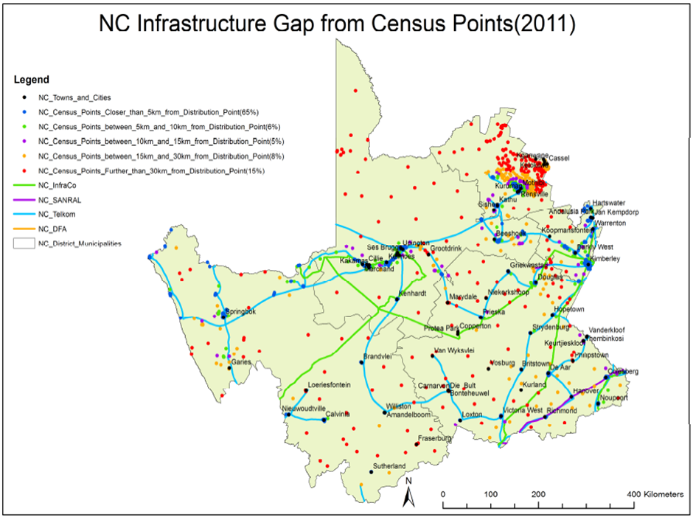

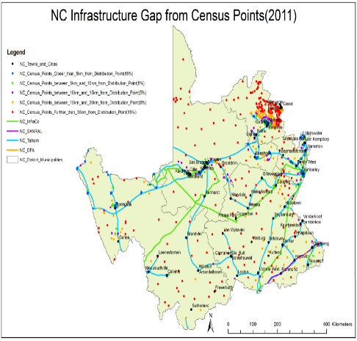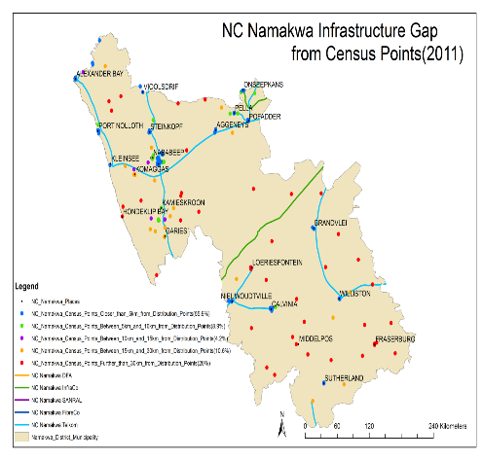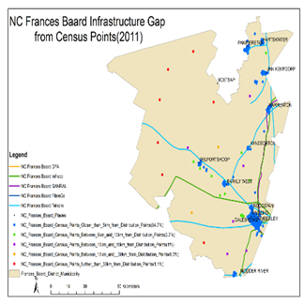
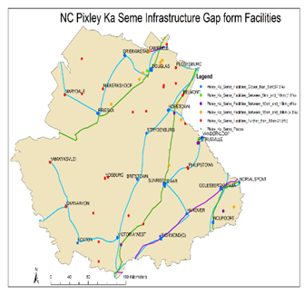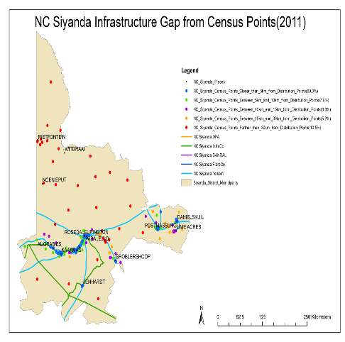

Proposed service delivery or contracting model
SITA Northern Cape to utilise SCM office, to source from all Telecommunication suppliers that covers the Broadband Spectrum as set out in technical and functional requirements.
  - The bidder will comply with all networking standards; codes and recommendations during design; manufacture fabrication; installation; testing; certification and administration of this project. Work shall be performed in accordance of the International Standards; local codes and authorities having jurisdiction.
  - All South African National Standards (SANS) specification and regulations; civil engineering electrical and construction standards as per the original 1611/2017 bid will be adhere to and stay applicable for this purpose of this RFQ.
NOTE: the service provider has the responsibility to determine and comply with the most recent release of the above listed codes and documents.

Name and Surname: | Audrey Matlapeng
Telephone number: | 012 482 2339
e-Mail: | audrey.matlapeng@sita.co.za

