eSubmission testing 20 Dec 2022

- Error when adding tender document and editing dates. But changes appear after the error. Resolved Working on Prod 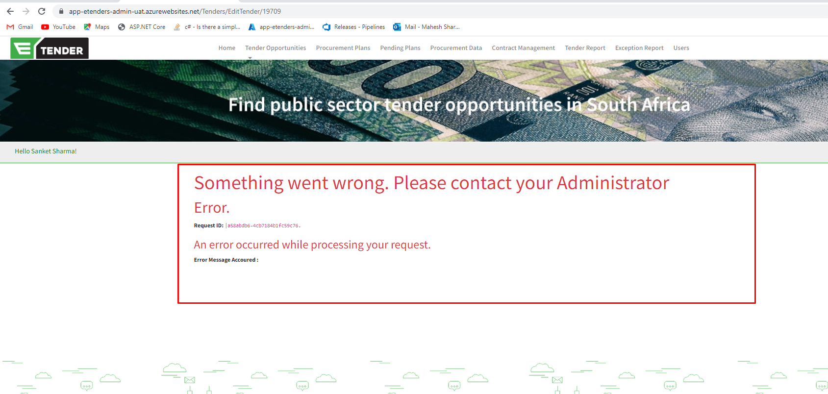
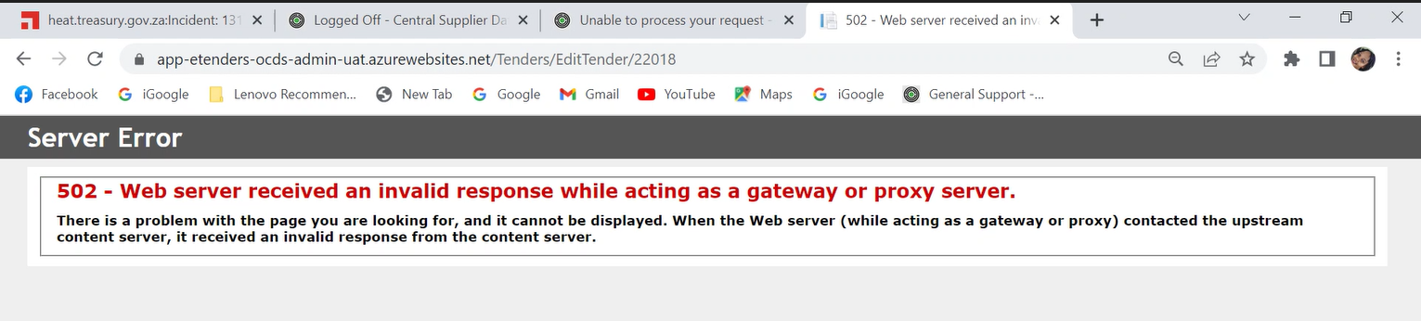

- Error message when re-assigning the tender Resolved
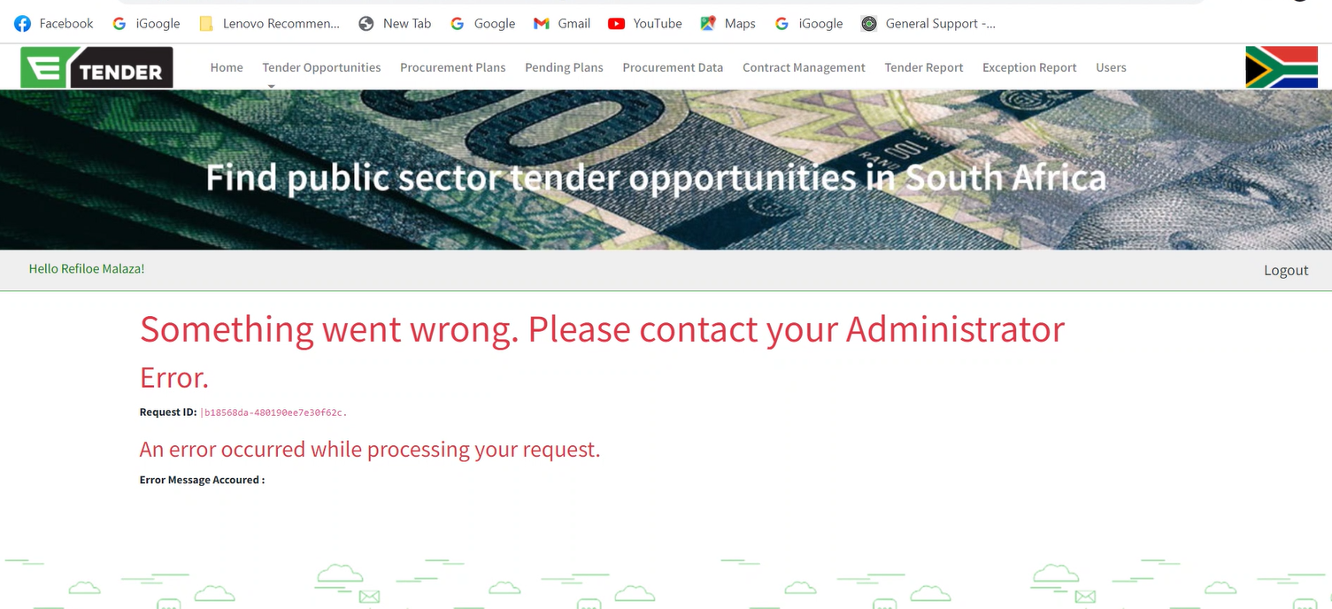

- After reassigning the tender, the name does not change to the new owner. However, the notification goes though
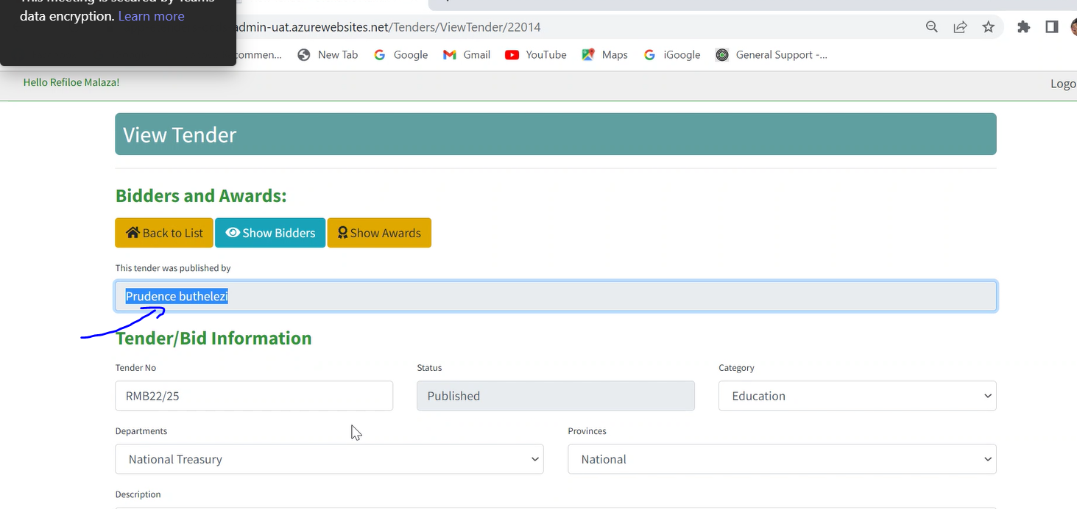
21-Dec-2022 (fixing on above) :-
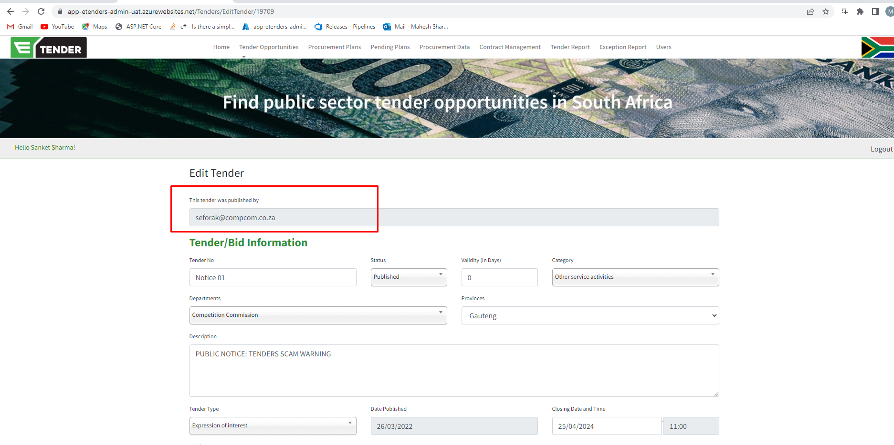

- Procurement plan - Menu option on the public view is black.

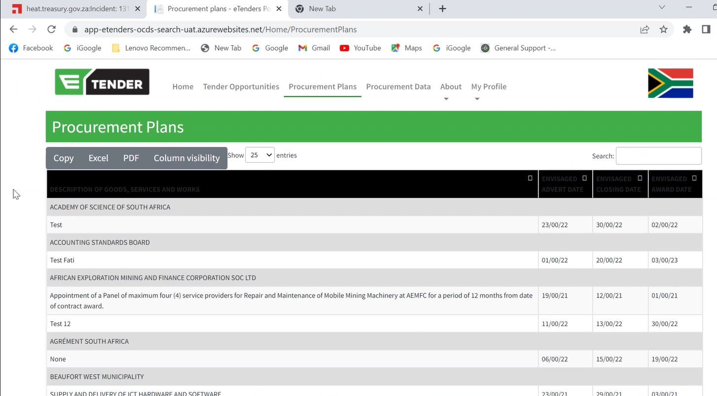
I will check it showing the below error:-
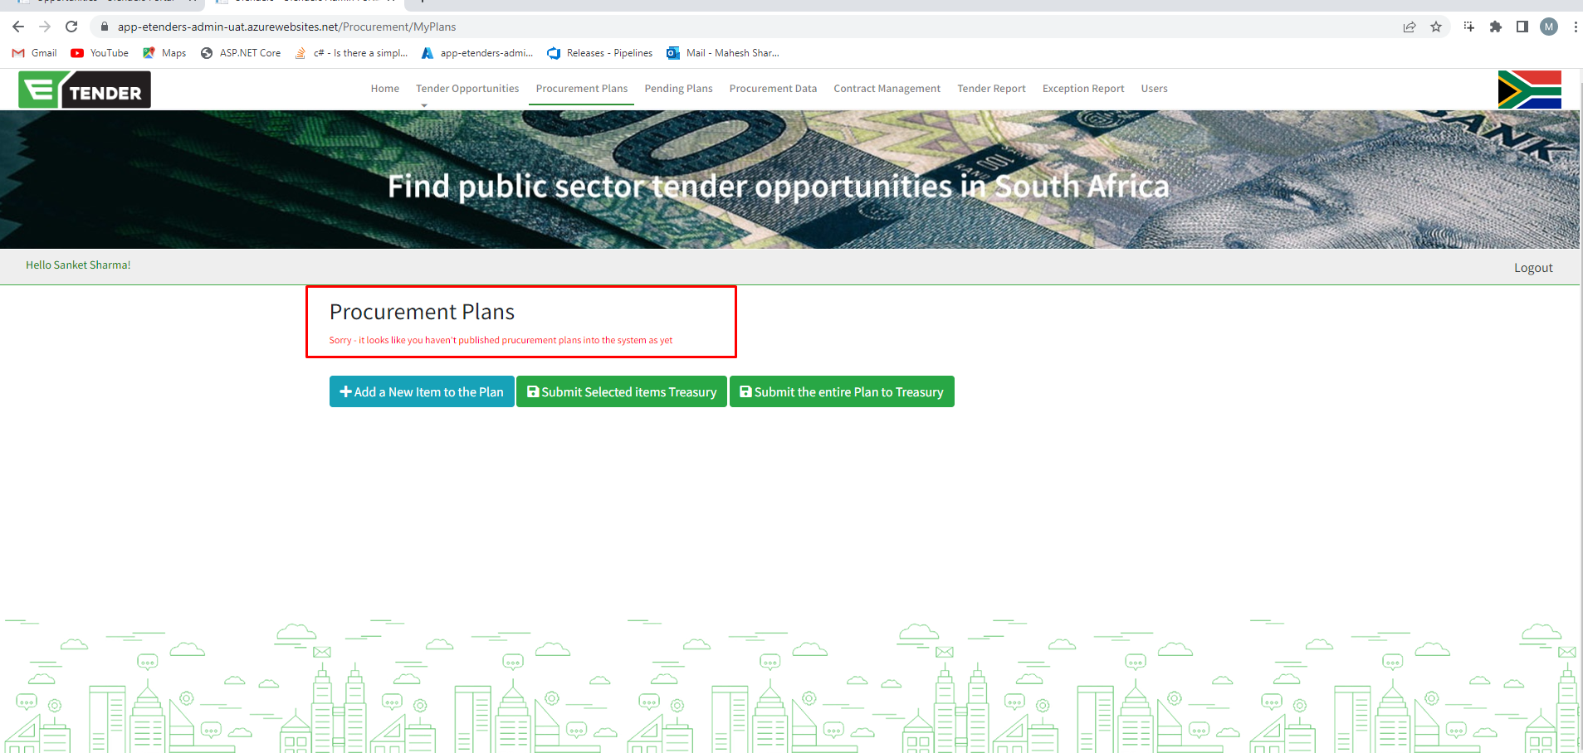
- The system is still showing 2 menu options. resolved

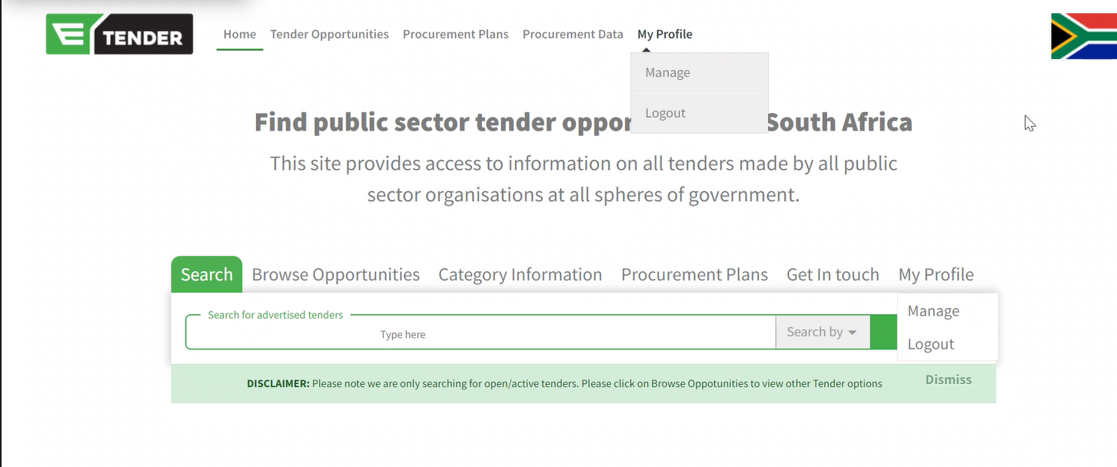

- Deactivate icon not visible under users resolved
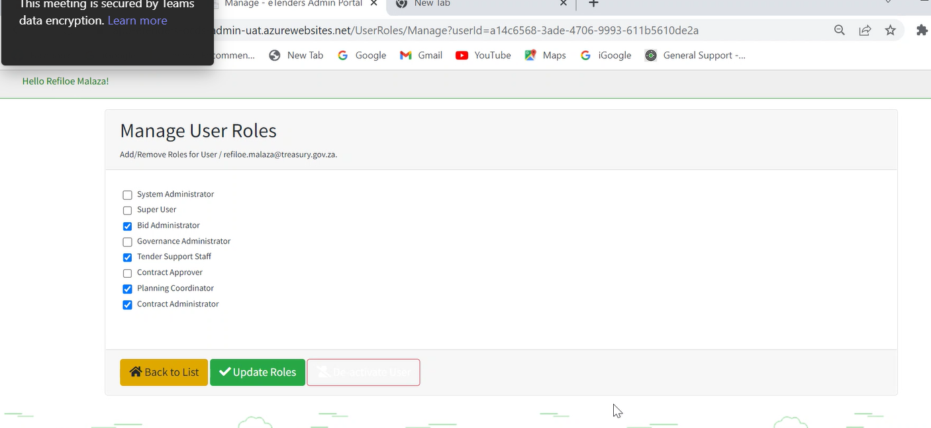

- Officials not getting the report, only system admin and super users can get it. Below is the error message.

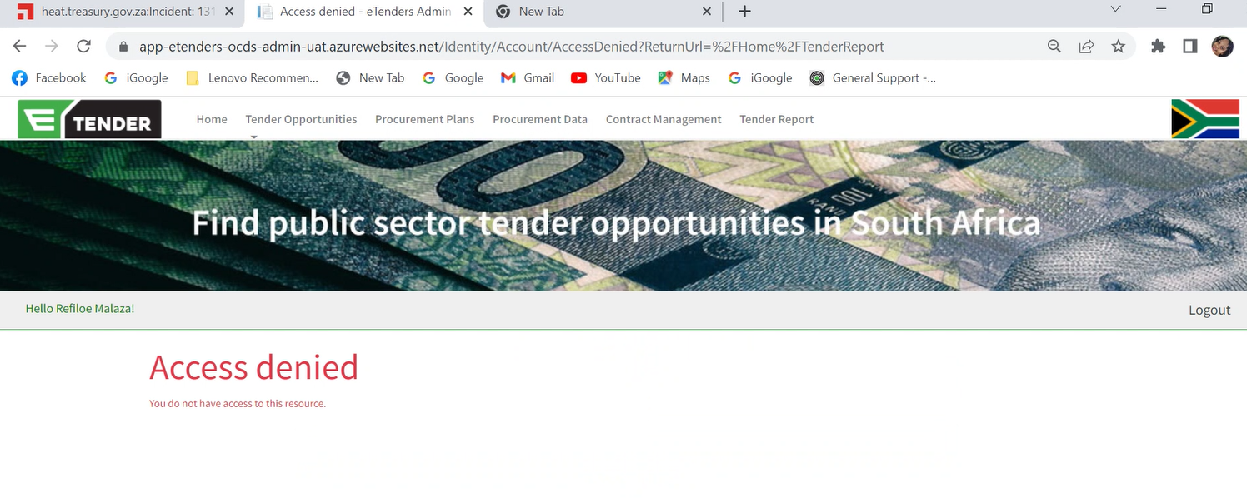
I am able to see below is the screen shot:-
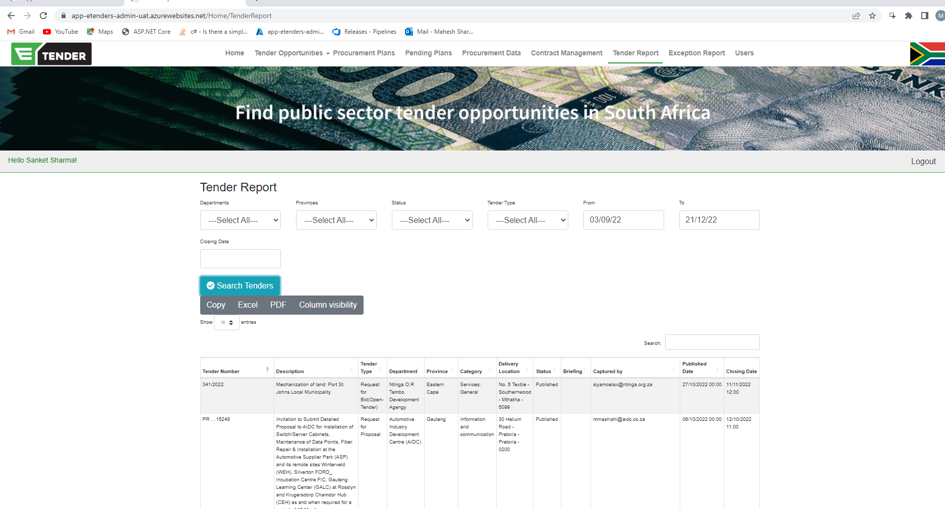

- The suppliers cannot respond to the tender with their supplier numbers: resolved to a point
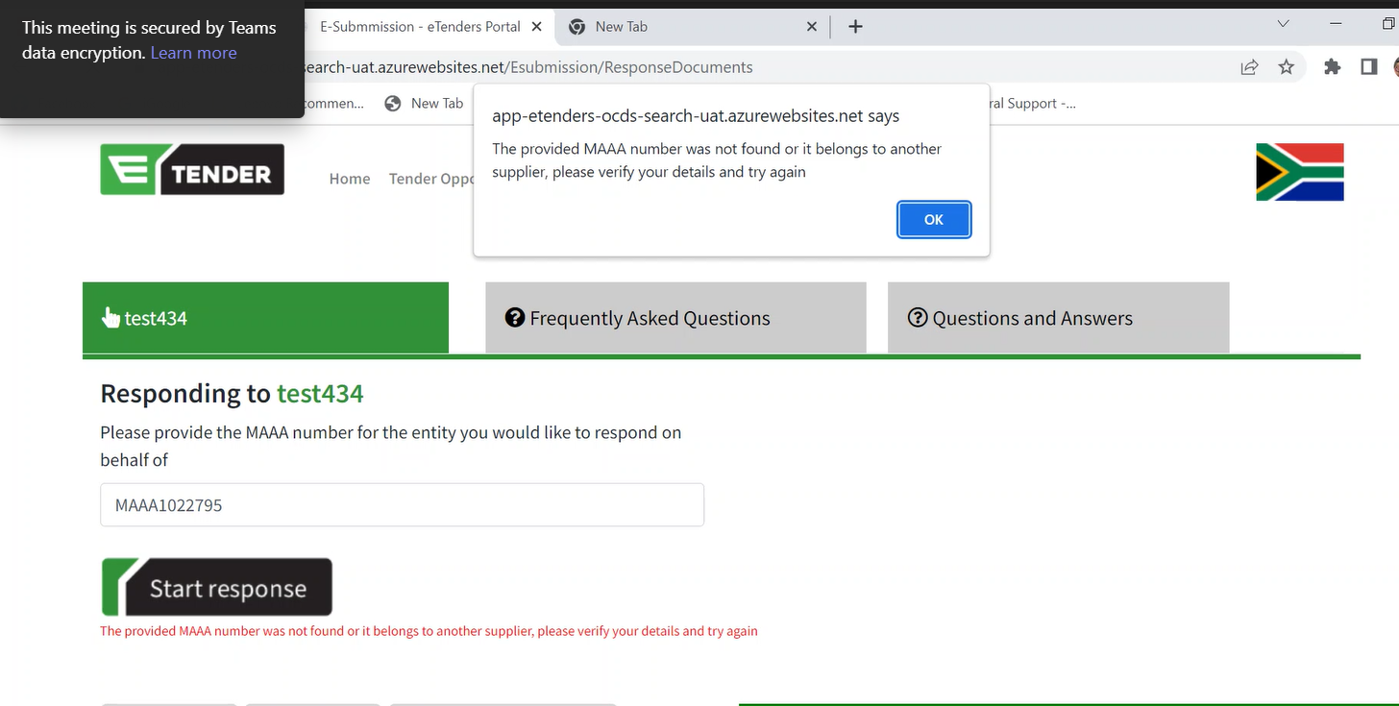

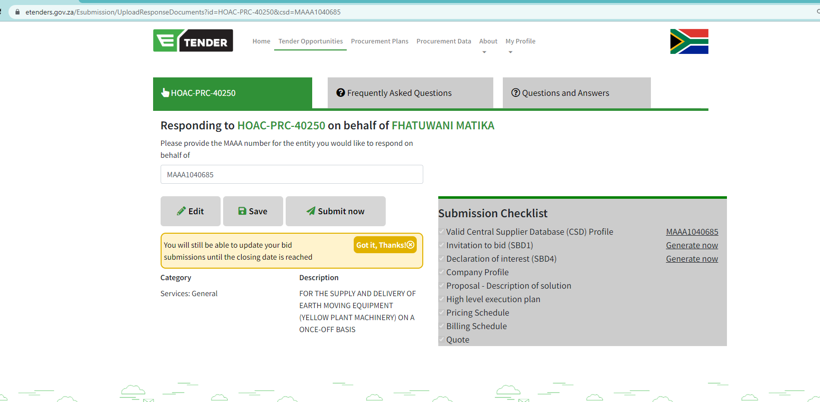

- Unable to view documents when quick searching-resolved
