Hearing aid – Quantity 1

Oticon Ruby 2 Mini RITE Hearing Aid, Rechargeable Digital Programmable Mini RIC. digital behind-the-ear or receiver-in-canal hearing aid with noise reduction and speech enhancement features.

Bose Noise Cancelling Earbuds/Headphones: Noise cancellation Type: Active Noise Cancellation or Type Voyager 5200 Office and UC Series

The recommended item is a digital behind-the-ear or receiver-in-canal hearing aid with noise reduction and speech enhancement features. This aligns with the intern’s functional needs by improving sound clarity, supporting directional hearing, and enhancing hearing performance in various work settings. The device will enable the intern to participate equally in verbal communication, training activities, and collaborative tasks.
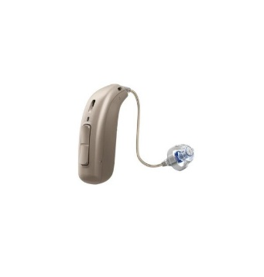
Mandatory requirement
The supplier must be accredited with South African Health Products Regulatory Authority (SAHPRA)- please provide proof.

