ARC Infruitec-Nietvoorbij
Private Bag X5026, Stellenbosch, 7599, South Africa
Tel: (021) 809 3172
Fax: (021) 809 3400/3592
OFFICE OF SUPPLY CHAIN MANAGEMENT
- DESCRIPTION OF SERVICE: SUPPLY & DELIVER FOLDING LADDER 24 STEPS

FOLDING LADDER 24 STEPS |  | Quantity | If No, Please Indicate Deviation
1. Specific Description | Compliance to Specification (Yes/No)  *Describe If Specification Differs | Quantity | If No, Please Indicate Deviation
- Multi-purpose folding ladder 24 steps (4-section 6 rung construction) (See Picture) |  | 2
- Must be aluminium

- Use as a double sided 12 step A-frame

- 12 step extended length

- Must be rust proof with electro-plated steel hinges

- Must have a max weight capacity of at least 150kg

- Complies with: EN 131:2010+A1:2012, SANS 1304-2:2009 and BS 2037: 1994

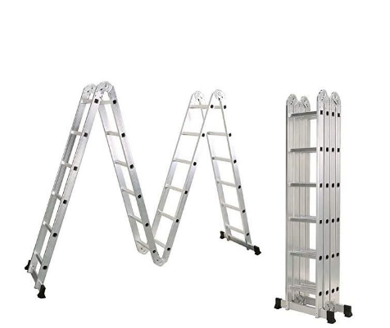

Contact: Janéne Strydom - StrydomJ@arc.agric.za 021 8093040 for any enquiries.

