REQUEST FOR QUOTATION FORM FOR GOODS
AND SERVICES

AGRICULTURAL RESEARCH COUNCIL (ARC)

1. You are kindly requested to submit a written quotation RFQ-012882 to Agricultural
Research Council as per below specifications.

Specification for Garden Machinery or equivalent to:

Item Specification Quantity

1. Chain Saw STIHL MS 250 petrol saw medium1.0 x 1
STIHL 35cm 325X1.6mm guide bar 1.0
STIHL 325X1.6 cut chain 56DL 1.0
46CC Petrol two stroke motor
2.3KW output power
4.6Kg dry weight
Light weight powerful petrol wood saw able to
Tackle a multitude of tasks from cutting fire wood
/pruning/ even manufacturing furniture

2. Blower Machine STIHL BG 56 Petrol Blower medium x 1
27cc Petrol two stroke Motor
0.7KW output Power
4.1KG dry Weight
730 Cubic Meter an hour air through Put
Ideal for keeping things tidy on drive ways, Gardens, Paths etc

3. Similar to Prof HI-VAC Hoffmann 6.5HP 196cc four stroke petrol Hoffman motor x 2
Over Head valves for easy staring and better fuel economy
13 Height setting with single leaver adjuster
50L NON spill grass catcher

5. Prof PRO420 Petrol Bush Cutter 40cc Petrol two stroke Bush Cutter x 1
1.5KW Output Power
7.3KG Dry Weight
Unique Low Maintenance Float and Bowl Carburettor
Comes with Carry Harness
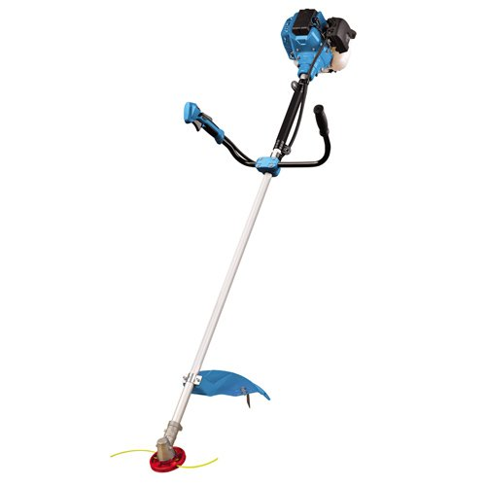

6. MTD 38” Cut Ride-On lawn tractor mower with MTD x 1
Thorx engine 420cc 14hp 10.5kw transmatic drive 96cm deck

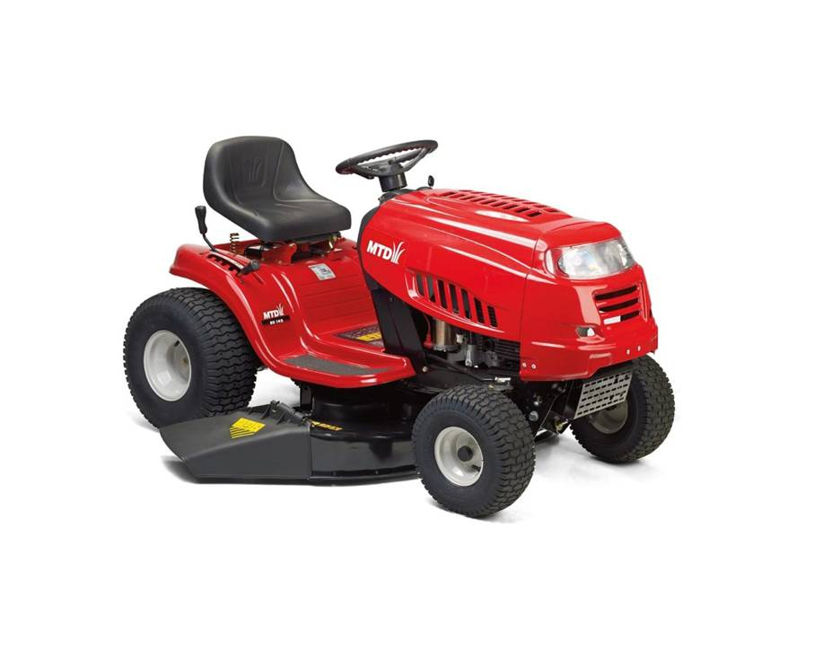
2. The above specified goods/services should be delivered/rendered to:
Name of Institute : ARC-IAE
Address : 141 Creswell Road
: Weavind Park
: Pretoria

3. The particulars of the guarantee that will apply to the goods quoted for,
with particular regard to the period and extent of the warranty must be
clearly stated. Where services are required, service providers must submit
documentation pertaining the relevant experience.

4. Your written quotation should be sent to:
Lungile Kubheka
Tel: 012 842 4078

Fax: 012 8040863
E Mail: KubhekaL@arc.agric.za

5. All price quotations that have a rand value of R30,000-00 to R50 000 000.00
including VAT, will be evaluated by applying the 80/20 principle as
prescribed by the Preferential Procurement Policy Framework Act 5 of
2000 and its Regulations. The lowest acceptable price will score
80 points, the 20 BBBEE points will be allocated as follows:

B-BBEE Status  Level of  Contributor | 80/20
1 | 20
2 | 18
3 | 14
4 | 12
5 | 8
6 | 6
7 | 4
8 | 2
Non-compliant  Contributor | 0

6. Standard conditions:

6.1 The validity of the quotations must be indicated.

6.2 Prices quoted should be in South African Rand and inclusive of VAT costs
such as delivery, insurance, taxes, etc.

6.3 No price adjustments or amendment of the delivery particulars contained
in paragraph 2 will be considered by the ARC.

6.4 The supplier accepts full responsibility for the proper execution and
fulfilment of the goods/services quoted for.

6.5 ARC reserves the right to accept or reject any special terms and
conditions that may qualify the goods/services to be provided.

6.6 Quotes should be submitted on an official letterhead and duly signed

6.7 Goods and services should be supplied/rendered upon receipt of a
purchase order from the ARC

6.8 The General Conditions of Contract issued by National Treasury are
applicable.

6.9 The ARC supply chain management code of conduct is applicable.

6.10 SBD Forms must be signed and returned together with the quotation if
your price is above R10 000.00, failure to comply will result to
disqualification of your quotation.

6.11 Your quotation must indicate the delivery date.

6.12 The ARC reserve the right to do due diligence on the quotations.

6.13 The ARC reserve the right to benchmark prices quoted.

Compulsory requirements

- Valid tax PIN number from SARS.
- Central Supplier Database report (Current and updated CSD report) showing a tax compliant status for the duration of the bidding process.
- Complete and sign the Standard Bidding Documents (SBD forms)

Thank you in anticipation

Supply Chain Management: ARC

