To whom it may concern | Date | 22 JUNE 2026
To whom it may concern | Enquiries | Rosherville Site Clarification Meeting
To whom it may concern | E-mail address | makumej@eskom.co.za
Dear Sir/Madam
Request for Enquiry Number | MWP1256CXMWPR
Description / Project Title | TO ENGINEER, PROCURE AND CONSTRUCT A WATER ELECTROLYSIS HYDROGEN GENERATION PLANT, WHICH MUST BE INTEGRATED WITH THE EXISTING RENEWABLE POWER PLANT FOR “GREEN H2 PRODUCTION” AT ERIC ROSHERVILLE FOR A PERIOD OF THREE (3) YEARS.
Tender Questions Closing Date | 10 July 2025

Item | Reference: | Questions | Answers | Clarity Published Dates
 |  | What is the capacity of the electrolyser | Maximum power 50 - 65kW  Hydrogen Production: 24 kg / day  Hydrogen Purity: 99.9% purity  System Pressure: 27 Bar  Maximum Storage 80m³ | 22 June 2026
 |  | This is a re-issue. Why did the first process fail? | Conditions for cancelled tenders as stated in Eskom Policy 32-1034.  An Enquiry may be cancelled in the following circumstances:  ➢ Due to changed business circumstances, there is no longer a need for the goods, works or services as described in the Enquiry;  ➢ The Enquiry contains improper or unrealistic specifications or functionality criteria;  ➢ Funds are no longer available to cover the entire envisaged expenditure for the goods, works or services;  ➢ No acceptable tenders (as the term is defined in the PPFA) were received;  ➢ Material irregularities such as non-compliance with legislation or where fairness, equitability, transparency, competitiveness or cost-effectiveness has been breached); or  ➢ A market-related price has not been agreed after negotiations with the three highest- ranked tenderers  Eskom’s procurement process has a number of evaluation stages, and a tender could fall out at any one of these stages. Pay attention to commercial documents required (i.e. mandatory on submission) and technical evaluation criteria.
 |  | Is the Kusile site visit compulsory? | No
 |  | Can the power consumption be higher than the specification? | The power limit is set based on the available solar power and BESS system. An electrolyser with a higher power consumption will not be automatically disqualified. It will be evaluated in terms of the whole offer to see if the system meets the requirements of the project.
 |  | Portable impedance measurement | This will be used by the operator to take measurements on the plant and manually record them. (This will not be for online monitoring)
 |  | Would it be possible to share the pump curves for the fire system. | Pump curves are not available, but here are the Fire pump nameplates – this should give all the required details:  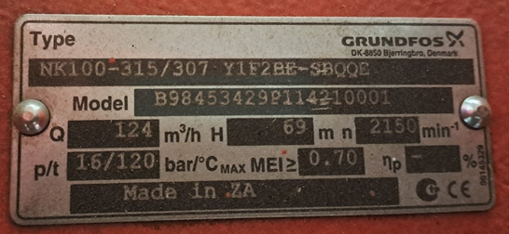  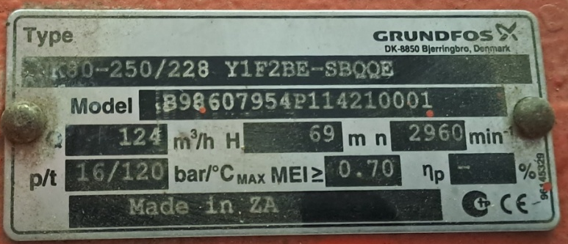
 |  | According to what code was the fire system designed | ASIB Design
 |  | If 2 cell stacks are provided is the cell stack monitoring required on both or just the one. | Individual cell stack monitoring is required on each of the cell stacks provided. The data generated will be used to analyze cell stack degradation.
 |  | What is the capacity of construction power? | Bulk supply of 63A
 |  | Is there existing storm water infrastructure? | The RHF site location has no existing storm water infrastructure and is naturally drained.
 |  | Will there be a laydown area for construction? | The laydown area will be allocated to the contractor prior to construction. It will not necessarily be in the footprint allocated for the plant.

