Scope of work

The facility will comprise of two 12-meter refurbished shipping containers with isolated walls and an isolated ceiling. The undercover shelter will be between the two containers on an existing slab (size of slab 16.5m x 10.5m).
The complex will be used for Seed sorting and storage as well as processing of other agricultural produce.

The refurbishment of all the containers was specified as follows:
  - Container 1
    - 2 toilets and a wash basin (2.5 m)
    - Kitchen (2.5 m) with wash basin, cabinet and top space to place kettle and microwave and space for a small refrigerator, 1 plug point
    - Office (4.5m), 1 plug point
    - Germination Laboratory (2.5m), small narrow window for minimum light; 1 plug point
  - Container 2
    - Processing facility to place seed processing machine, big enough windows to allow light – 10m long. 2-3 plug points
    - Storeroom with high narrow window – 2 m long
The two containers must be insulated and painted and linked to water reticulation, sewer and connections. Electrical wiring should be to include household plugs and lights.

Site location

The Ncera farm is situated 25 km South of East London at 33° 7.384'S 27° 36.890'E

Existing structure
A concrete slab has been laid as a foundation for the seed sorting facility., made of containers. The facility will be erected over the concrete slab, see picture below.

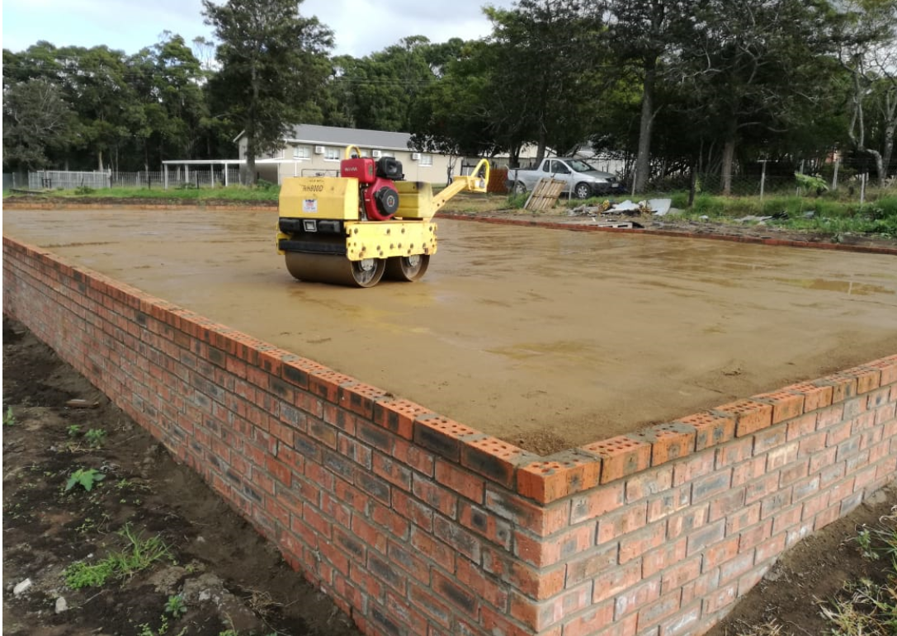
Figure 1: Photos of the site
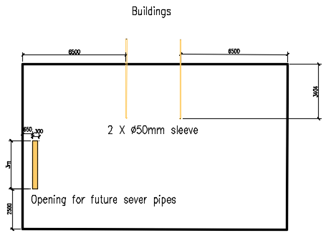
Figure 2: Drawing of the existing concrete slab

Design of facilities

The general layout of the facility

Figure 3: Outlay of the containers (NB: A visible drawing is as per attached pdf document and should be printed on A3 for sharing with potential contractors0

Table 1: Bill of Quantities
Item No. | Item Description | Units | Quantity
1 | 12-meter shipping container | No. | 2
2 | C4 Windows | No. | 7
3 | E1 Windows | No. | 3
4 | E4 Windows | No. | 2
5 | Standard doors | No. | 7
6 | Double delivery doors (1359 x 2032) | No. | 1
7 | Standard toilet | No. | 2
8 | Standard wash basin | No. | 2
9 | Double kitchen sink (standard) | No. | 1
10 | Office Cabinet (standard) | No. | 1

.

Ramp and steps
- Ramps at the back of the building and in front must be constructed or installed for trollies to access the building space between the two containers
- Steps next to the ramp on the front of the building must be installed

