Johannesburg Water (SOC) Ltd

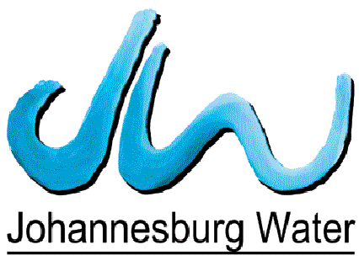

CONTRACT NO. JW14402

TURFFONTEIN CORRIDORS OF FREEDOM –
WATER UPGRADE (FOREST HILL TOWER AND PUMP STATION)

JOHANNESBURG SOUTH

VOLUME 3

HEALTH, SAFETY & ENVIRONMENTAL
SPECIFICATIONS

