 | FBC  Free State OU and Northern Cape OU  INVESTIGATION REPORT | Template Identifier | 240-43921804 | Rev | 6
 |  | Document Identifier | 240-136349448 | Rev | 2
 |  | Review Date | 10 April 2018
 |  | Effective Date | 01 March 2022

INFORMATION SUPPLIED BY THE CUSTOMER AND POPULATED BY INSURANCE DEPARTMENT
Incident location (Town) | Dewetsdorp | Sector | Bloemfontein Sector
Date of incident | 19 Junie 2021 | Time of Incident | 22h47
Date reported (fault) | 20 Junie 2021 | Reference number | Not stated
Date reported (claim) | 01 November 2023 | Reference number | Summons Received
Pole No. | DDW 331A-56-62 | Works order No.
Name of claimant | AJ Kingsley  C Van Gend Jacobs  Van Aswegen Trust | Contact number | 082 567 0523 – Kingsley  051-505 6600 – Leon Strating - Attorney
Stand Number/Address | Farm Oorlogspruit,  Farm Willowvale,  Farm Blydschap,  Dewetsdorp | Claim No. | 438204
Summary of incident
AJ Kingsley – Natural Pasture - R314 834.85
Lick Supplement - R90 634.27
Fence – R45 363.29 TOTAL R 450 832.41
C van Gend Jacobs - Natural Pasture – R83 199.60
Lick Supplement – R23 951.40
Fence – R22 965.18 TOTAL R 130 116.18
G Van Aswegen(TRUST) - Natural Pasture – R96 435.90
Lick Supplement – R27 761.85
Fence – R16 101.30 TOTAL R140 299.05
Insurance remarks
Date to PCC | 14.02.2024,21.02.2024

INVESTIGATION MAINTENANCE AND OPERATIONS DEPARTMENT
Complied by | Jaco Weldhagen | Designation | Sector Engineer
Authorised by | Korone Moea | Designation | Sector Manager
Claimant’s allegations for claim:

Date and Time of Incident | 19/06/2021 22:47 | Date and Time supply Restored | 20/06/2021 14:23
Time Dispatched | 09:01 | Work Order Number | 501- 27091662
Number of Interruptions | 1 | Duration of Interruptions | 14 Hrs
Network or Customers Affected | Both | Planned Outage? (Yes/No) | No
Approximate MVA hours lost | NA | Network or Customers still at risk (Yes/No) | Yes
Weather Conditions | Windy | Protection Details
Proposed Contingency Plans | Install vibration dampers  Page 15 of 28  Table B.2: To determine the number of dampers required  Arrangement of dampers per  conductor  115m to 250m Number of dampers per span per conductor = 2 & 1 damper at each end
Root Cause of the Incident | Vibration. Line on uphill, severe wind cause vibration.
Summary of the Incident | At DDW 331A/56/62,Fox armrodding and conductor strands broke on red phase at suspension clamp, which caused steel wire to burn off and conductor fell to ground, load side, and caused veld fire on 19/06/2021. On 20/06/2021 10:12 Brkr at DDW 331A/1 was opened via Telecontrol.  At DDW 331A/56/74 conductor broke and caused a veld fire on 01/11/2022.
Summary of Switching and Actions taken after the Incident | An employee was dispatched to a fault at Dridorp Dewetsdorp 22KV line (DDW331A/56/169/8 (WO 501-27091662 and the Ref Num: 35945) On arrival on site the employee discovered that the Red phase conductor was broken and lying on the ground which cause a veld fire. The operator took instruction to open isolate and earth and repair the fault and restore the supply to the customers affected.
Voltage Regulation within NRS048 | NA
Findings | Note 3: Ensure that only one joint is made in a span and no joints are made within a distance of 20 metres (240-75883906) from either side of the structure. Page 10 TM  Conductor was repaired with splice at structure.  No other joints between /61 & /62 and /62 & /63. Joints on all phases between /63 & /64 – Red phase repair sleeve/splice, White phase crimped sleeve , Blue phase Quick joint. Splice on White phase between /68 & /69.  Wind blew from N -S. Span length between /62 & /63 = 124m.  Poles 65,66,67,69 was replaced previously. Pole nameplate year 2013.
Line Maintenance / Pole Inspection Reports attached (In case of veld fires)
Proposed Recommendations to prevent recurrence | Install vibration dampers
I hereby Acknowledge that the Above Information provided by me is correct and to the Best of my Ability | Jaco Weldhagen

Approval of Investigation by Sector Manager | Comments and Action by Sector manager:  Vibration dampers to be installed.  Name: Korone Moea  Date: 05/02/2024  Signature: ……………………………………..

PHOTOS AND ANY OTHER SUBSTANTIATED DOCUMENTATION
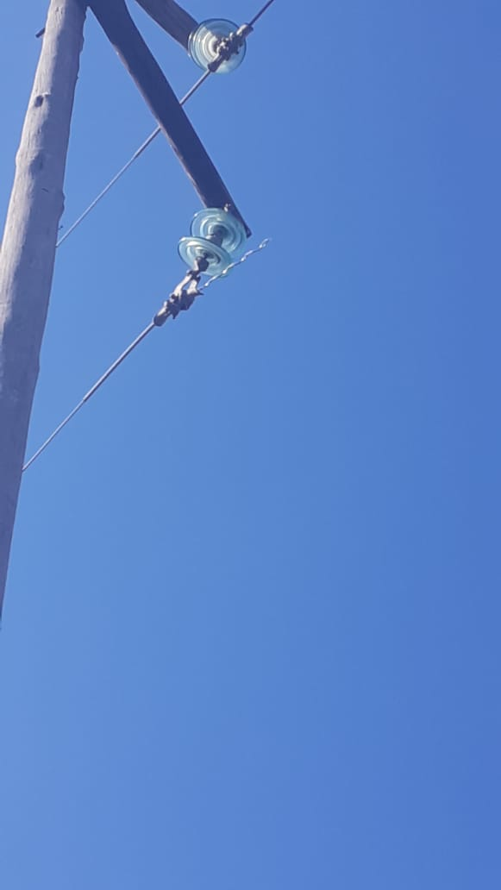
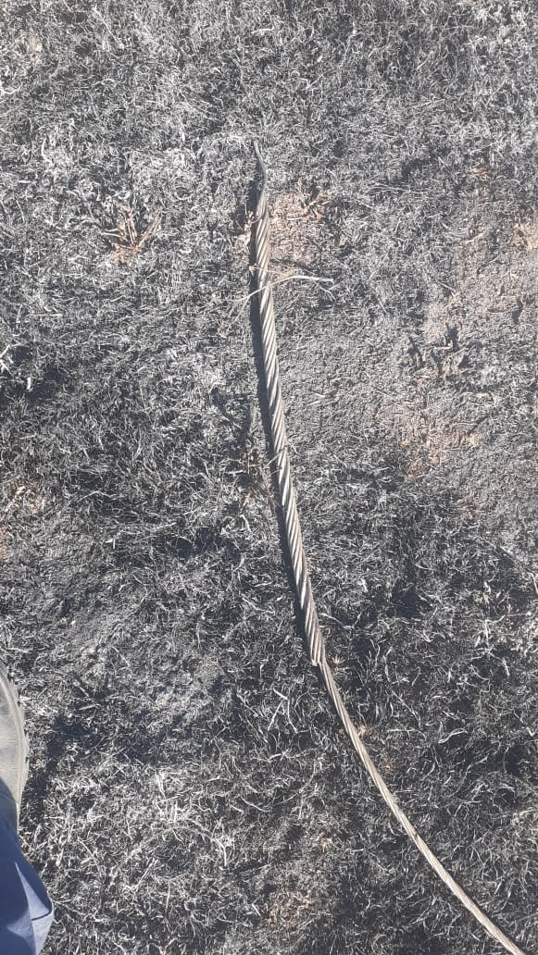
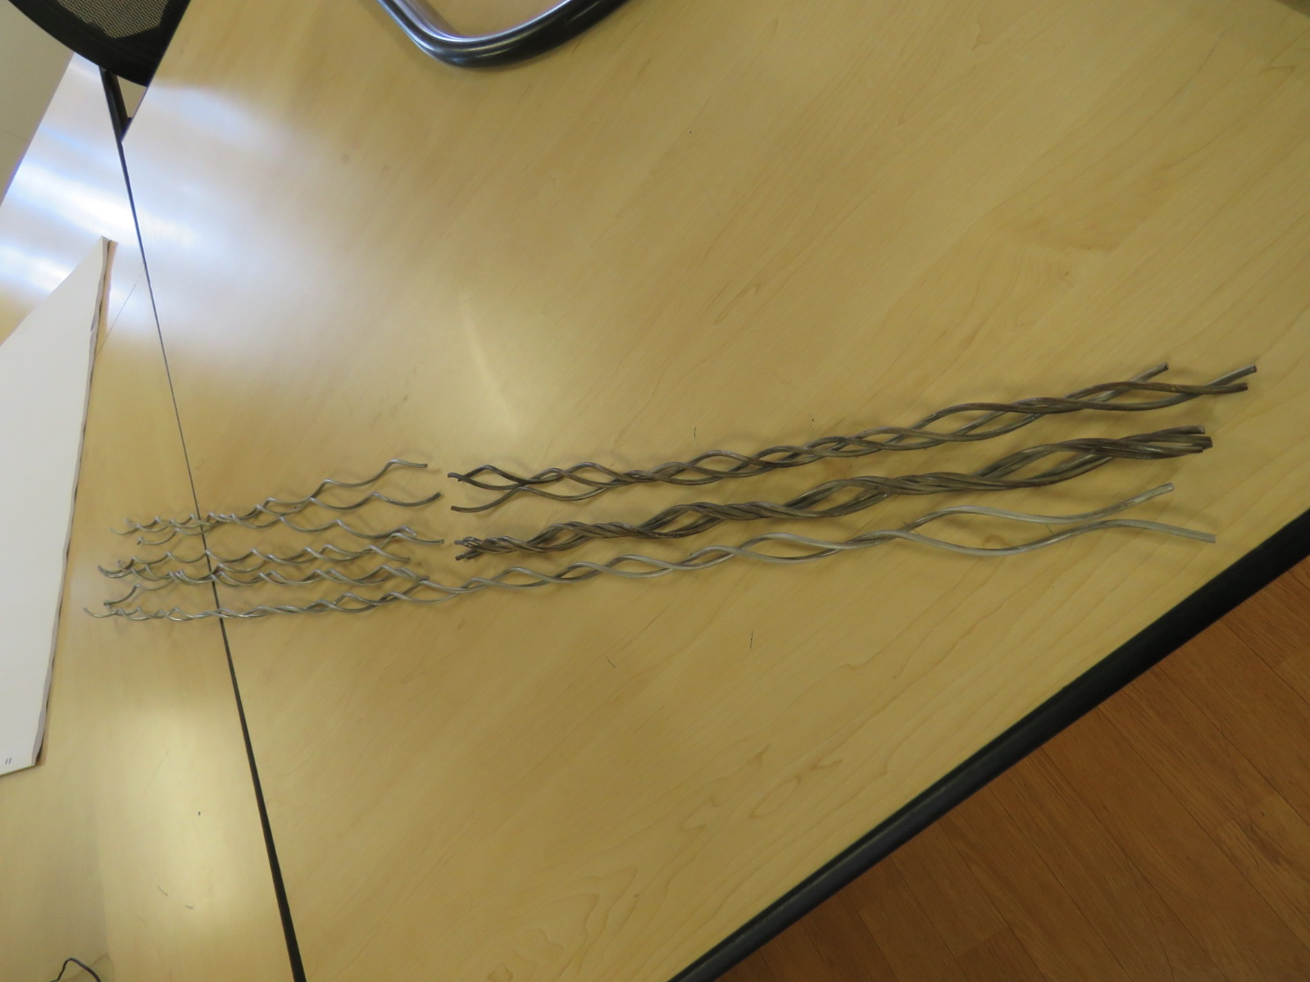
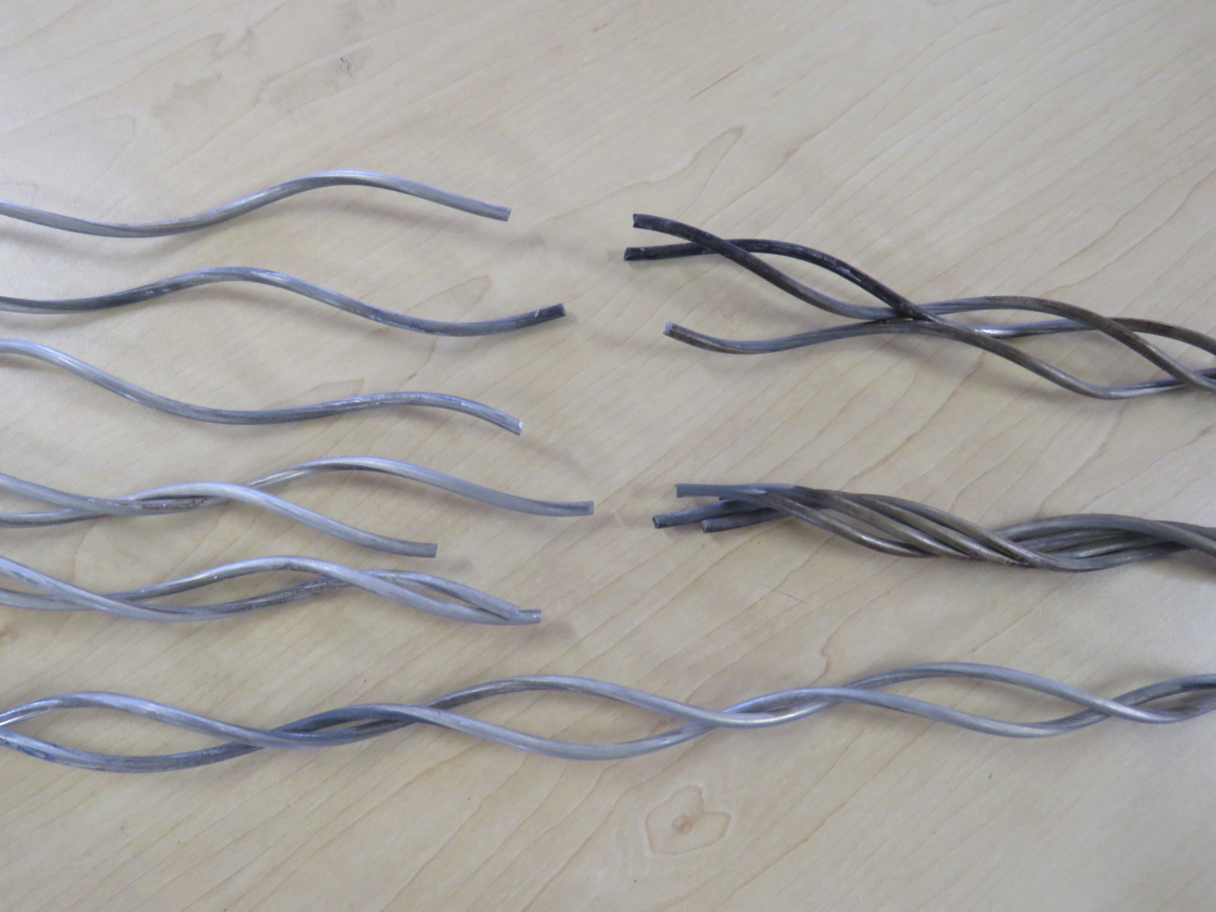
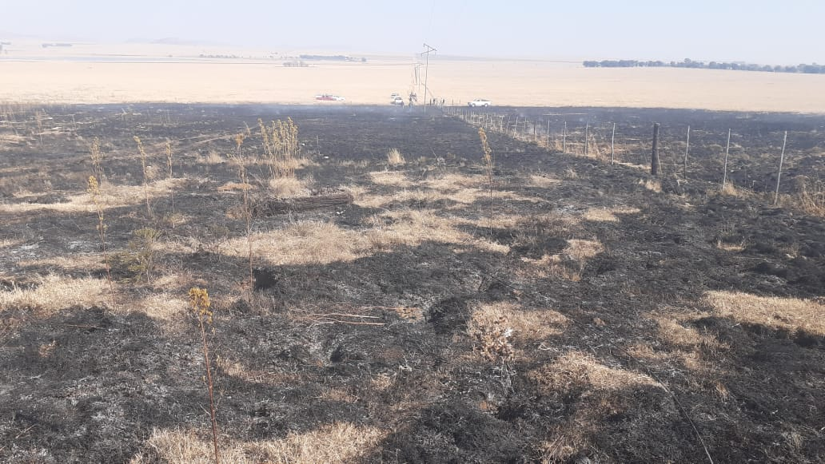
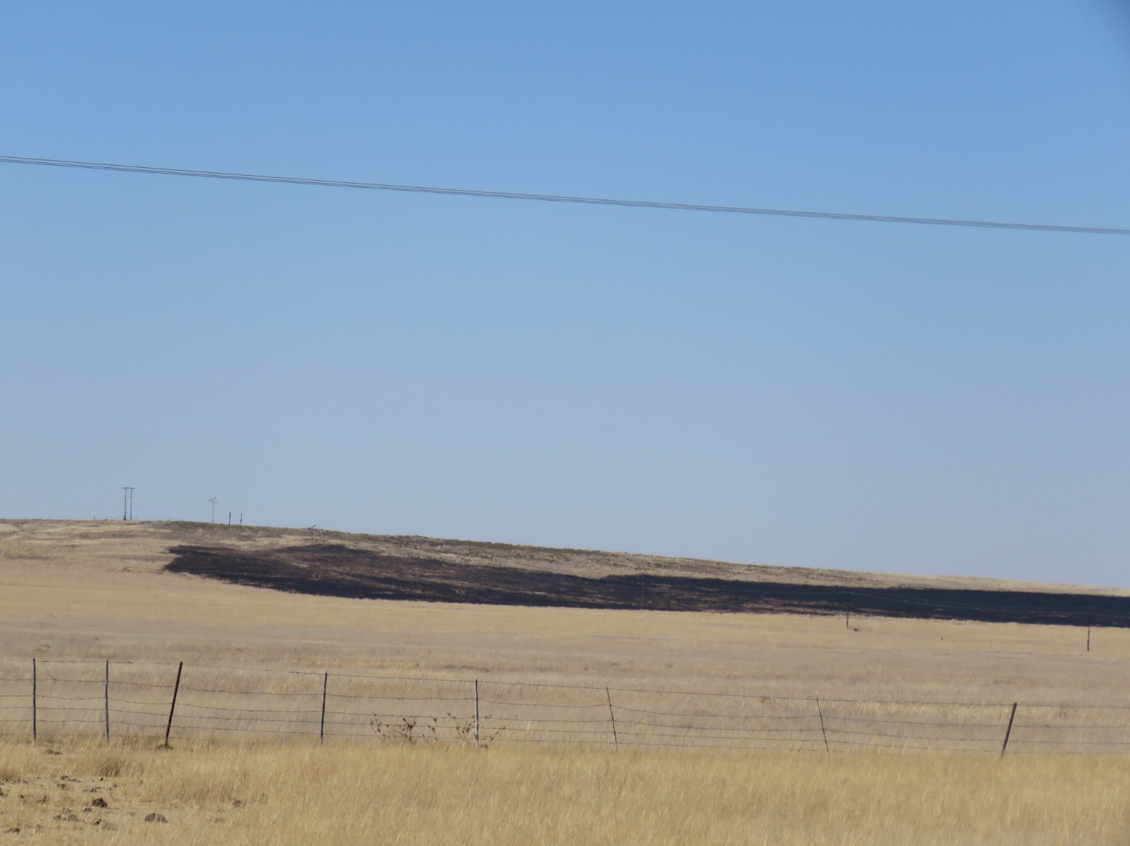
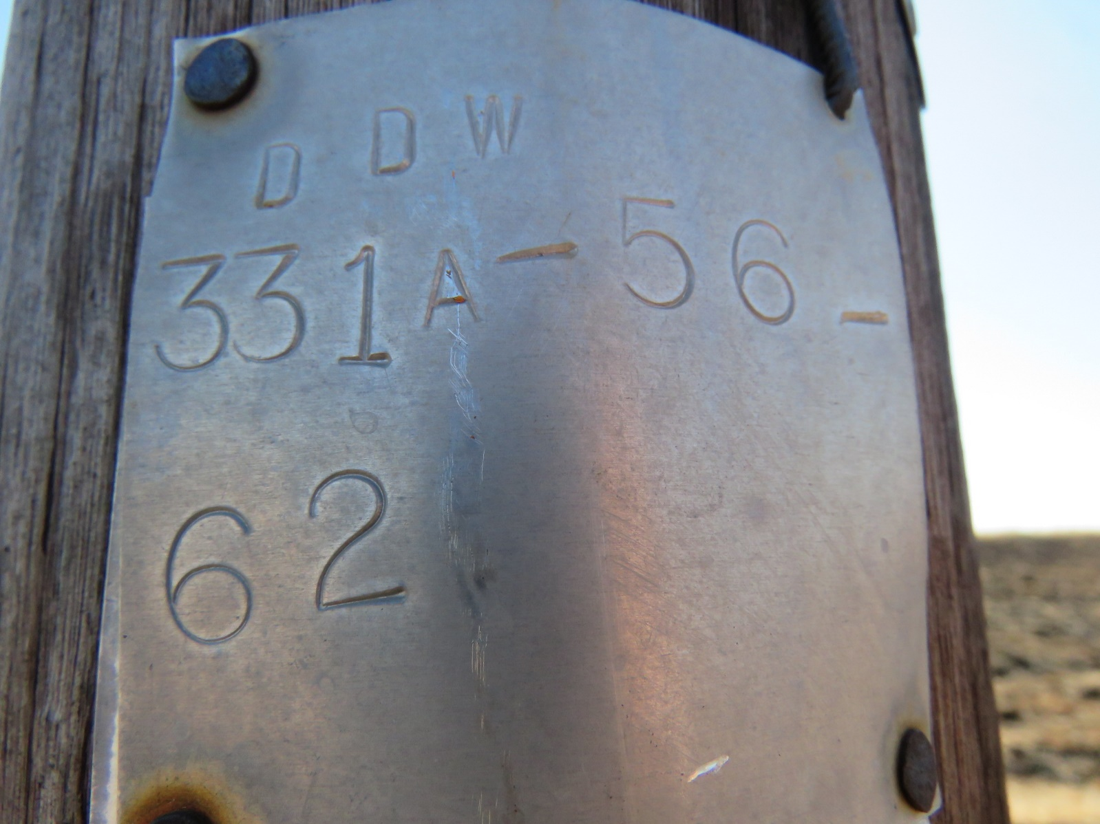
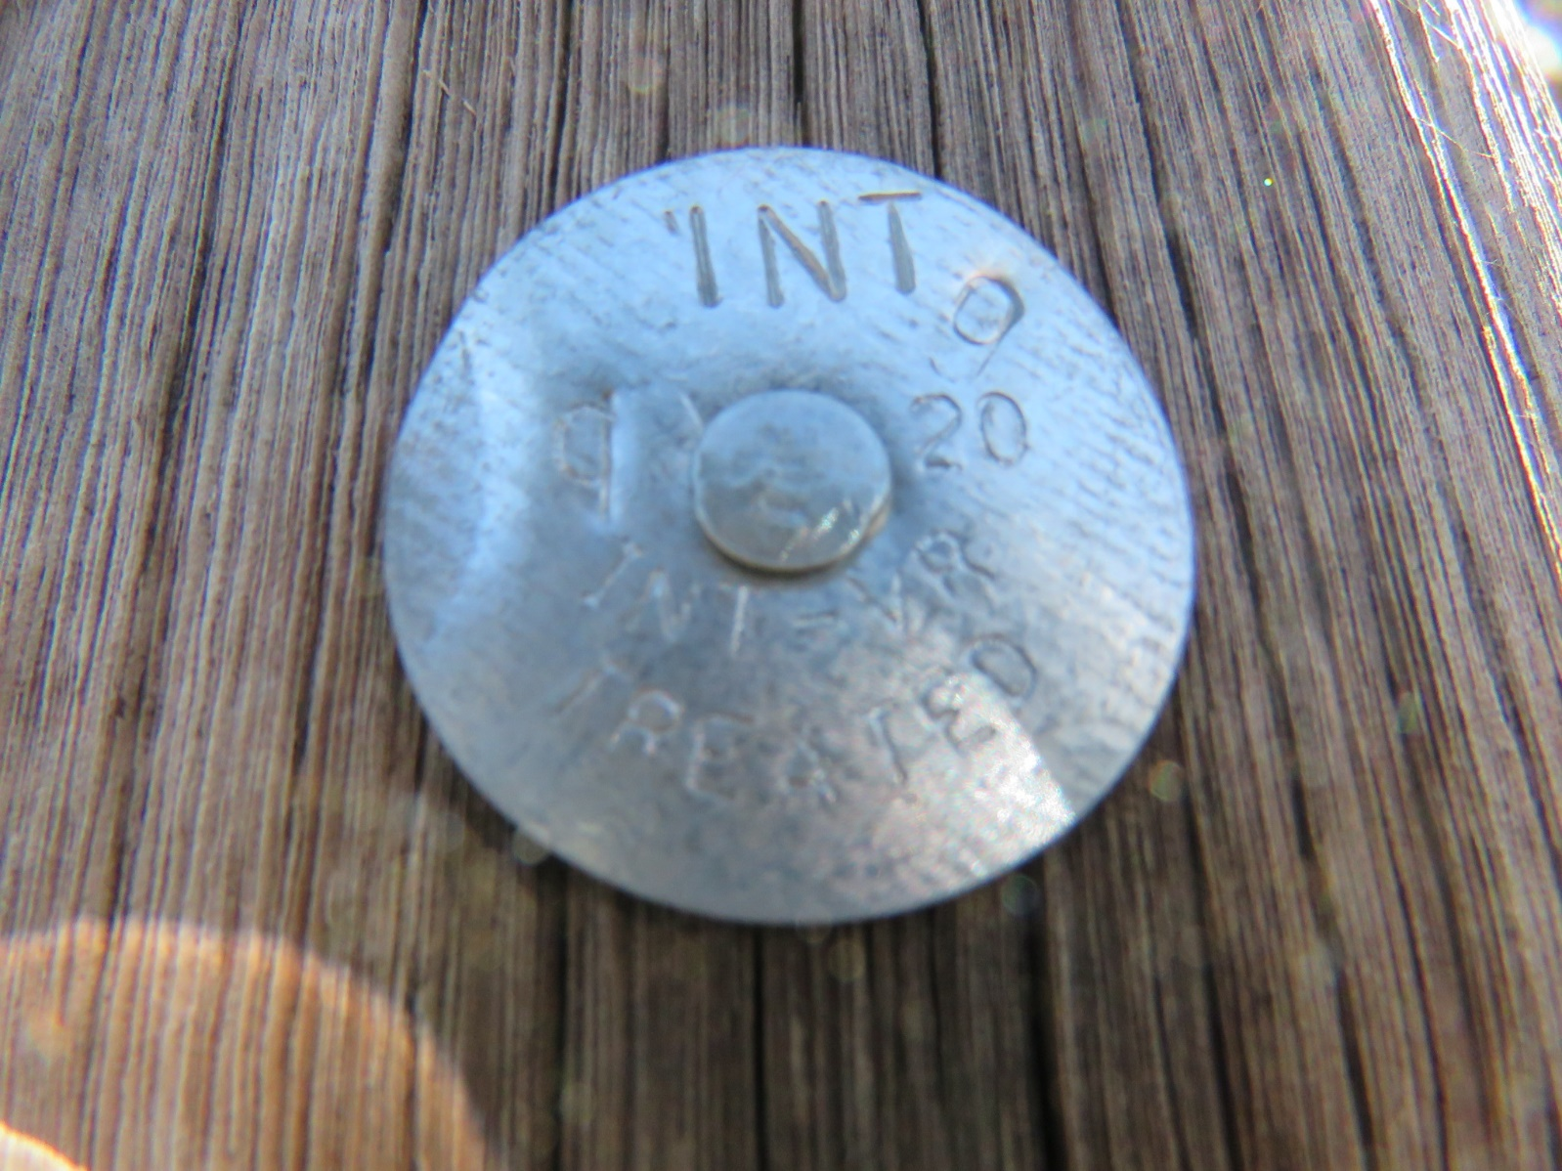
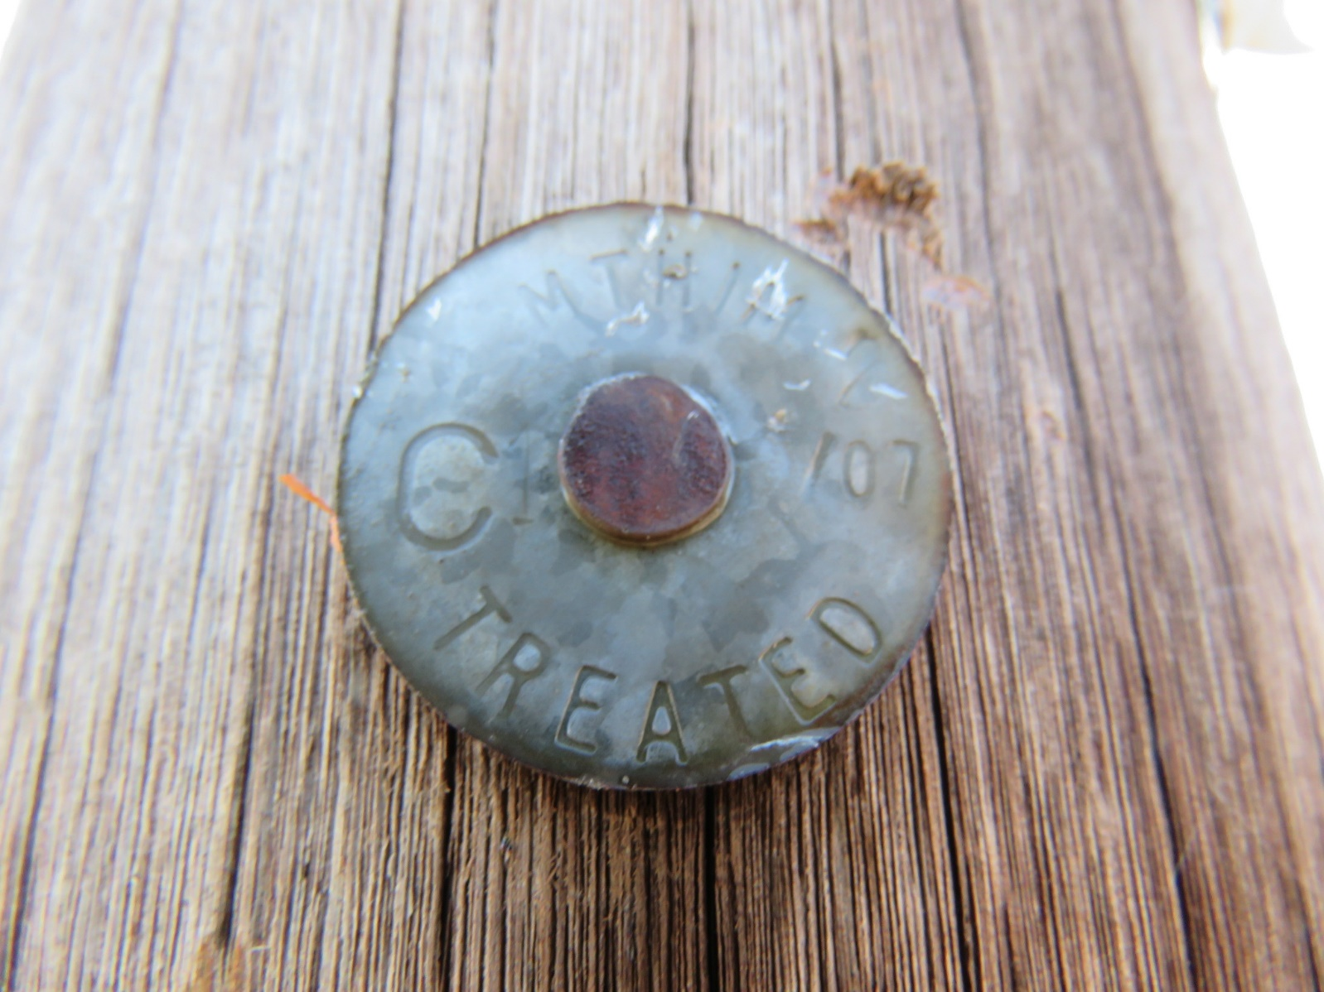
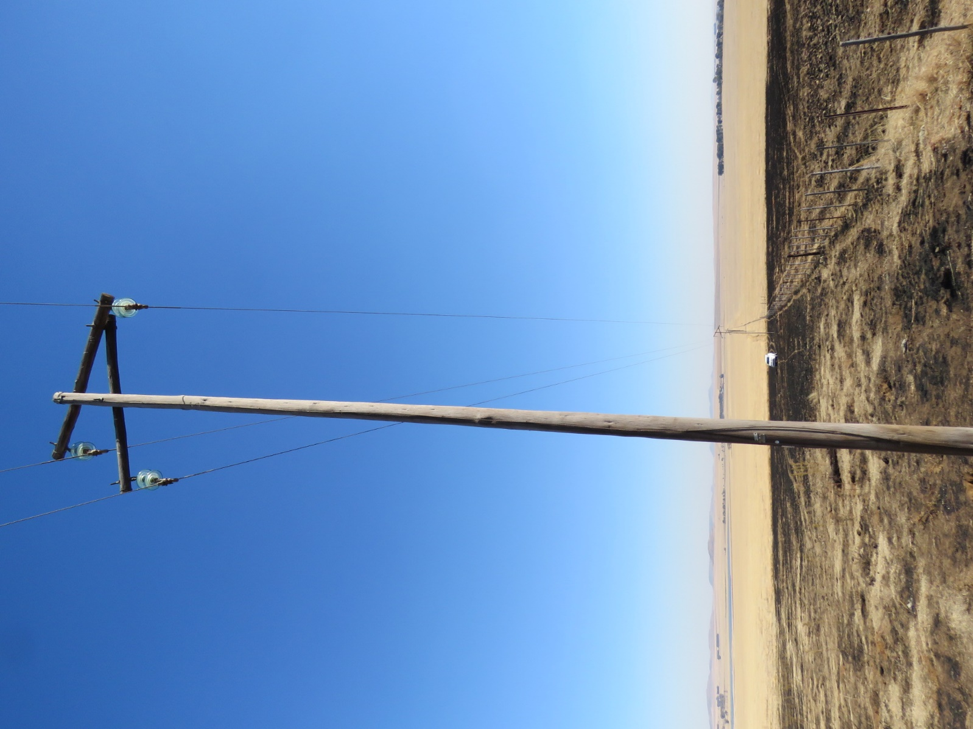
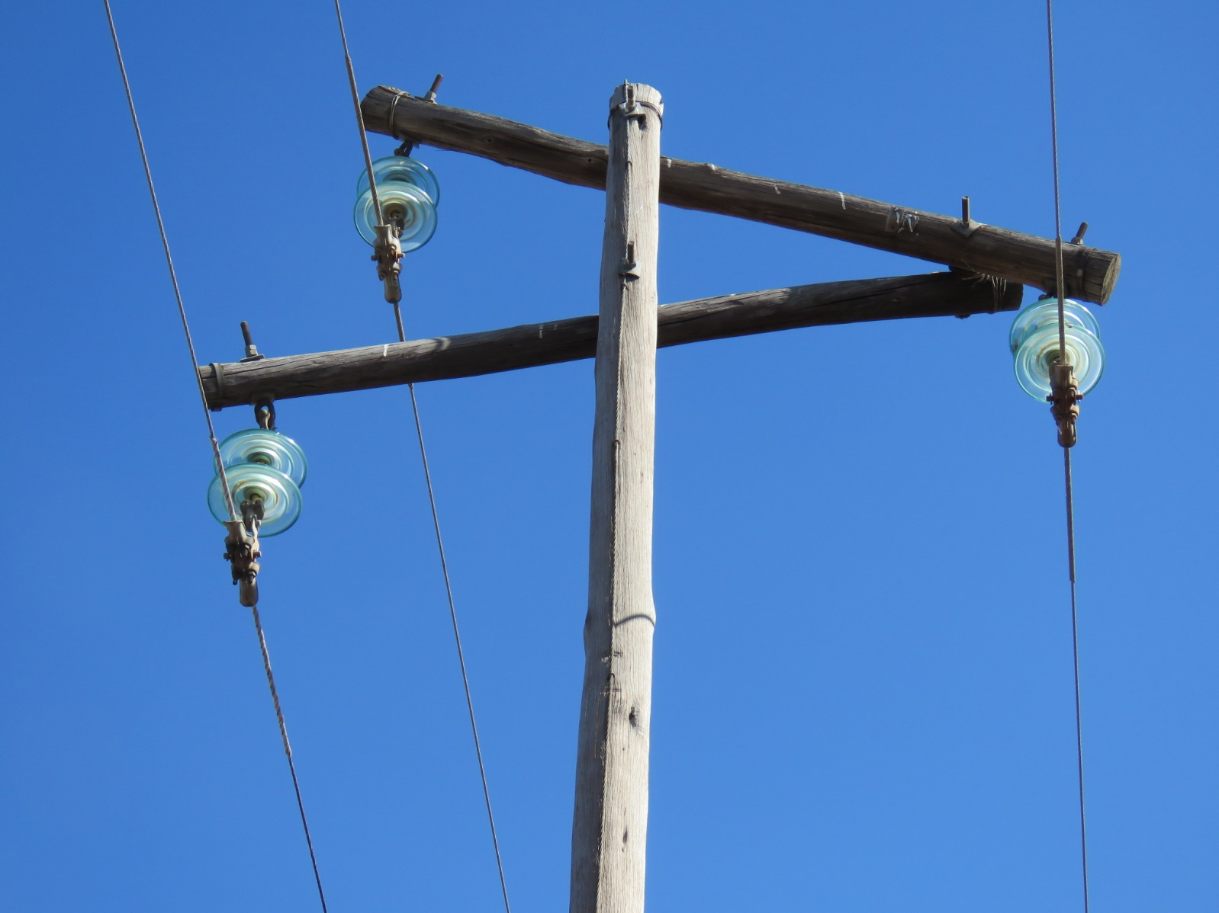
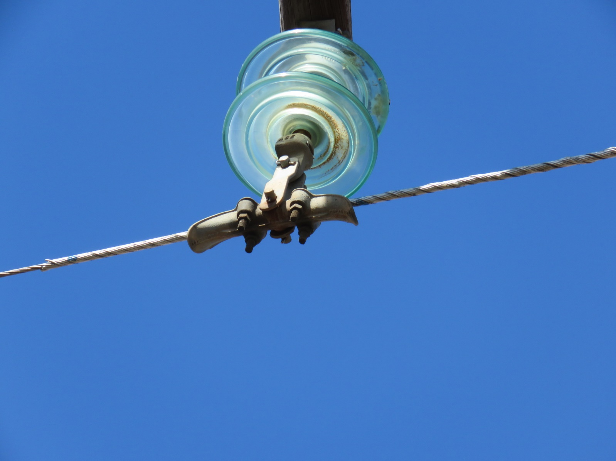
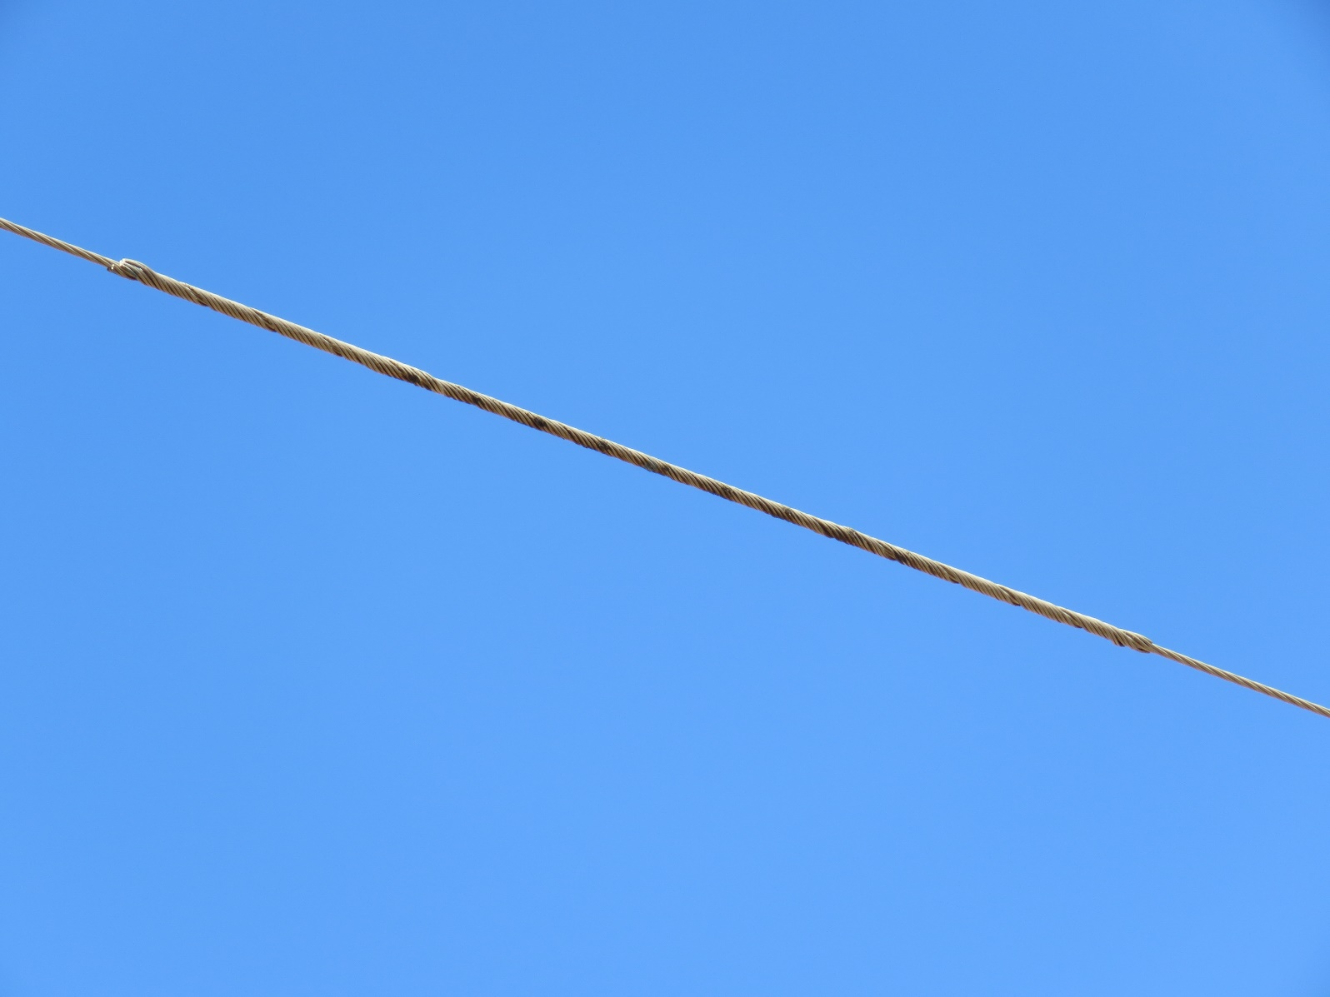
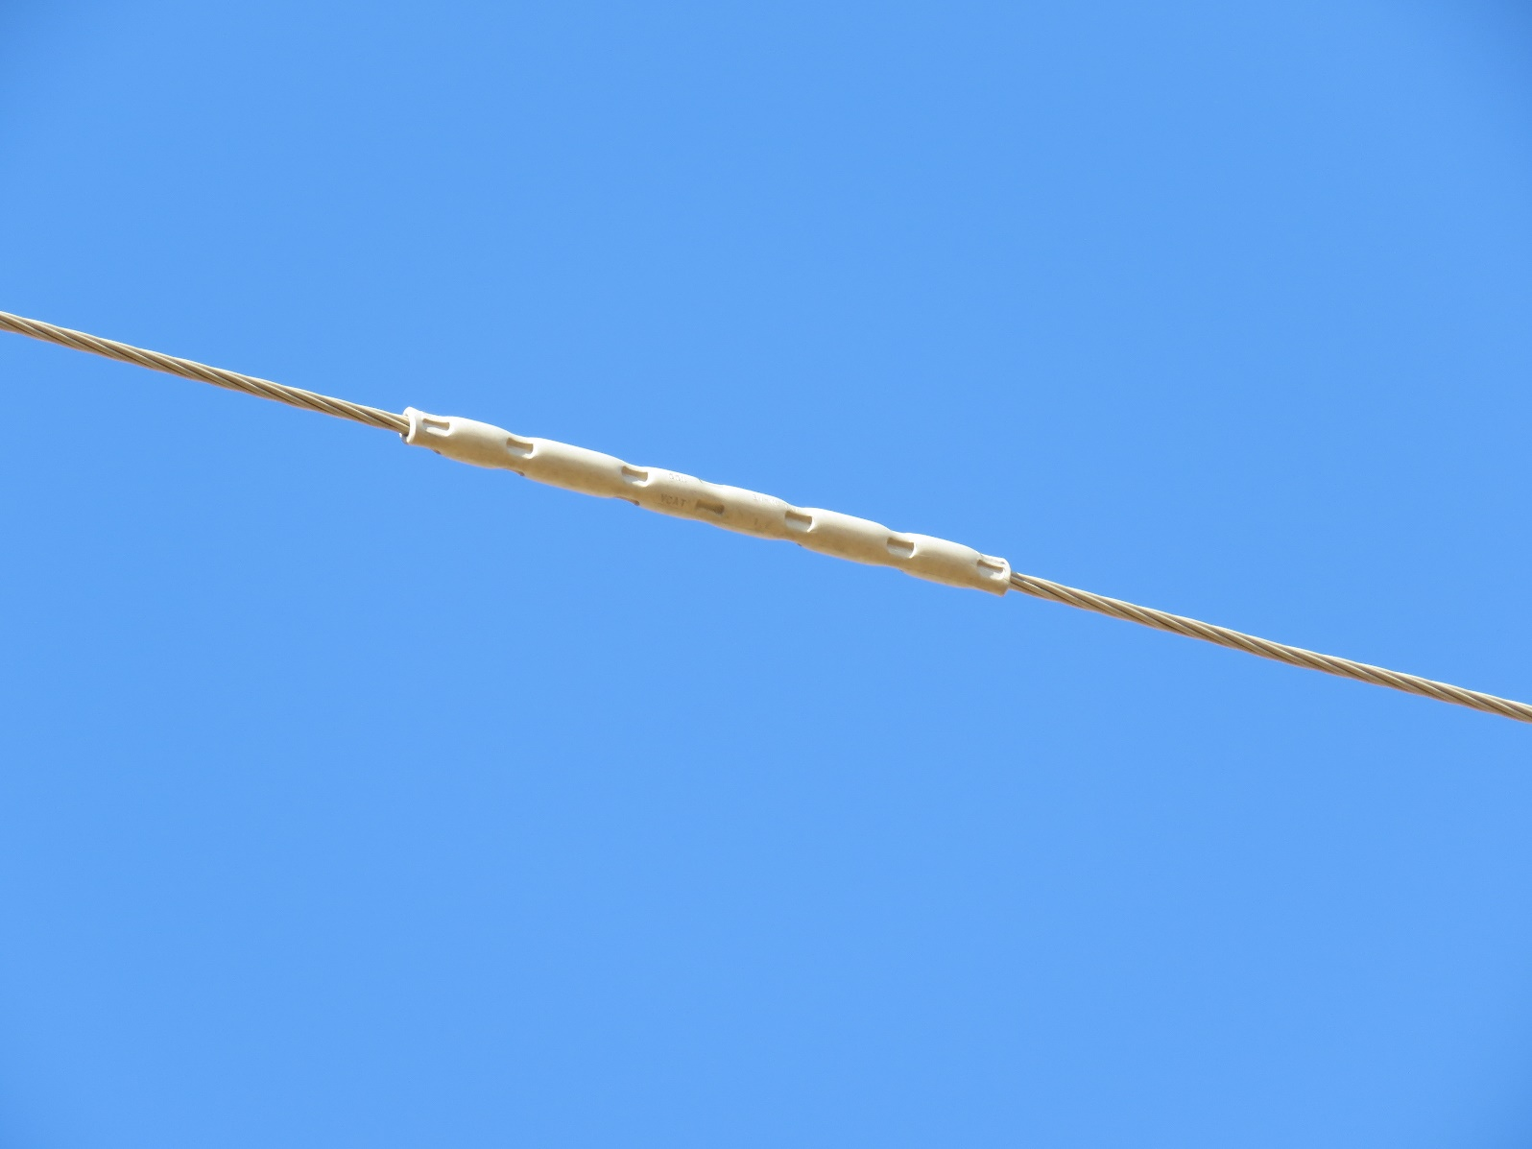
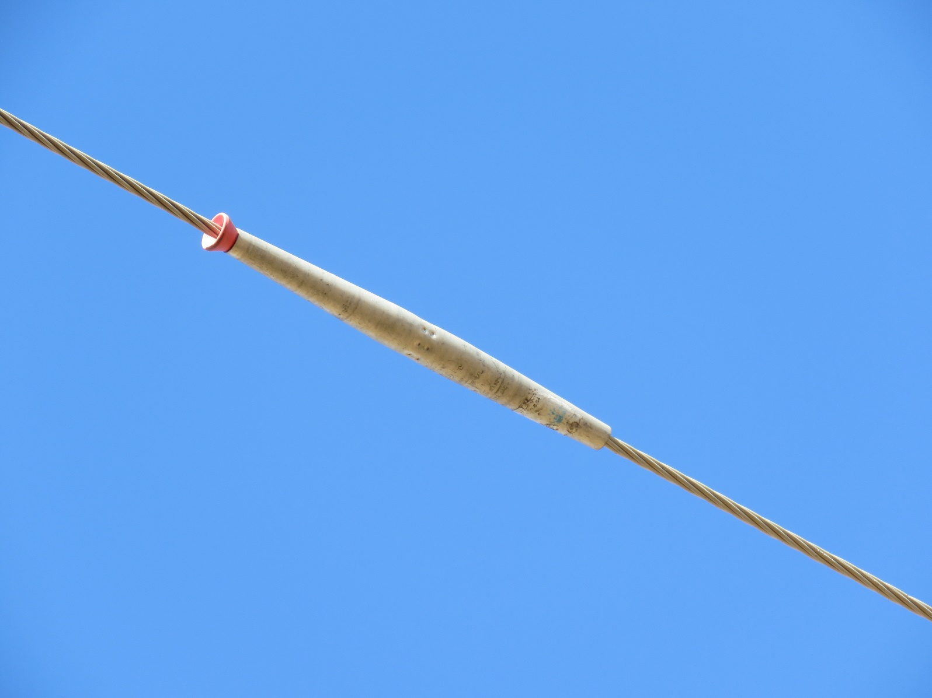
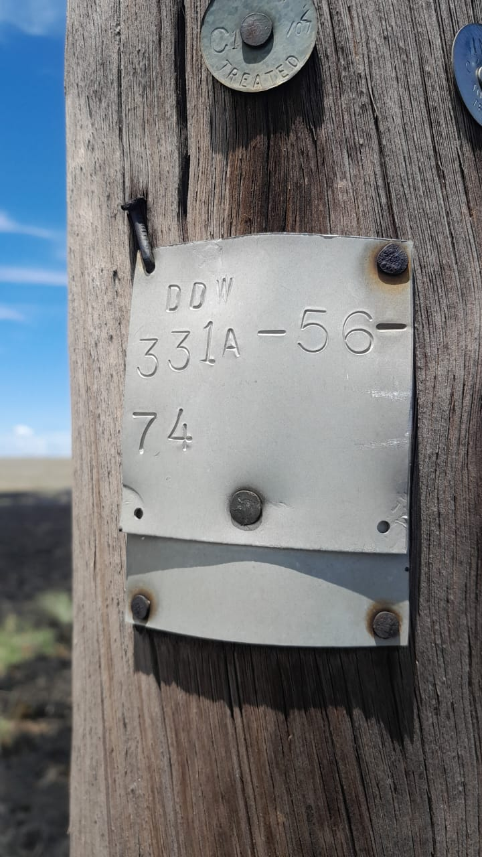
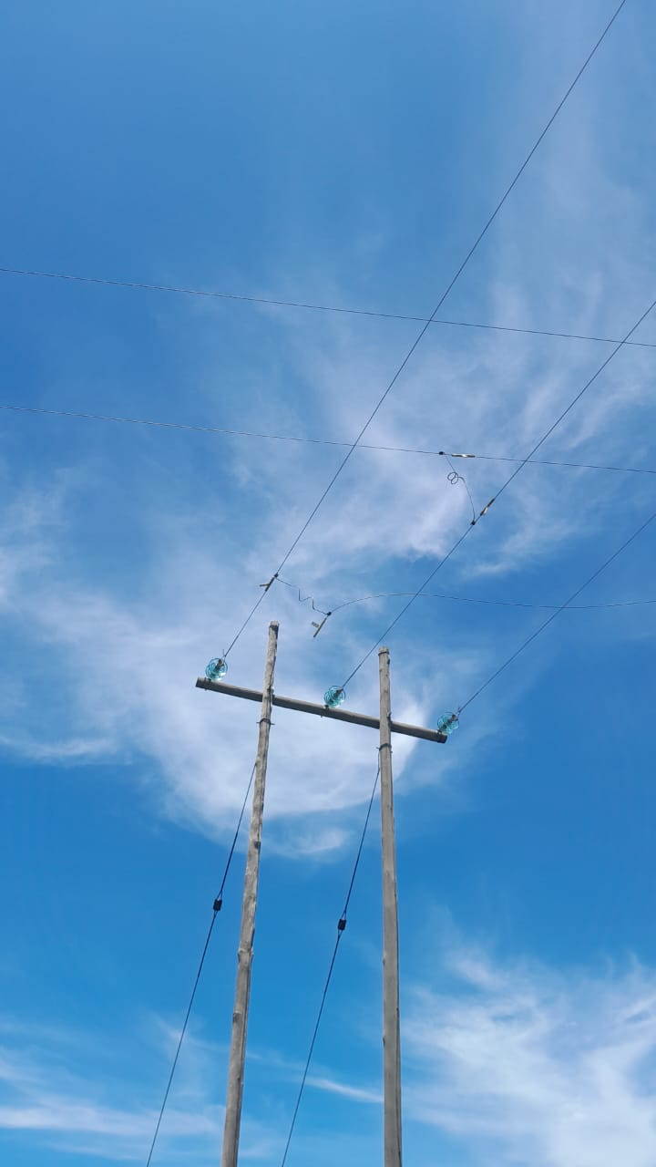
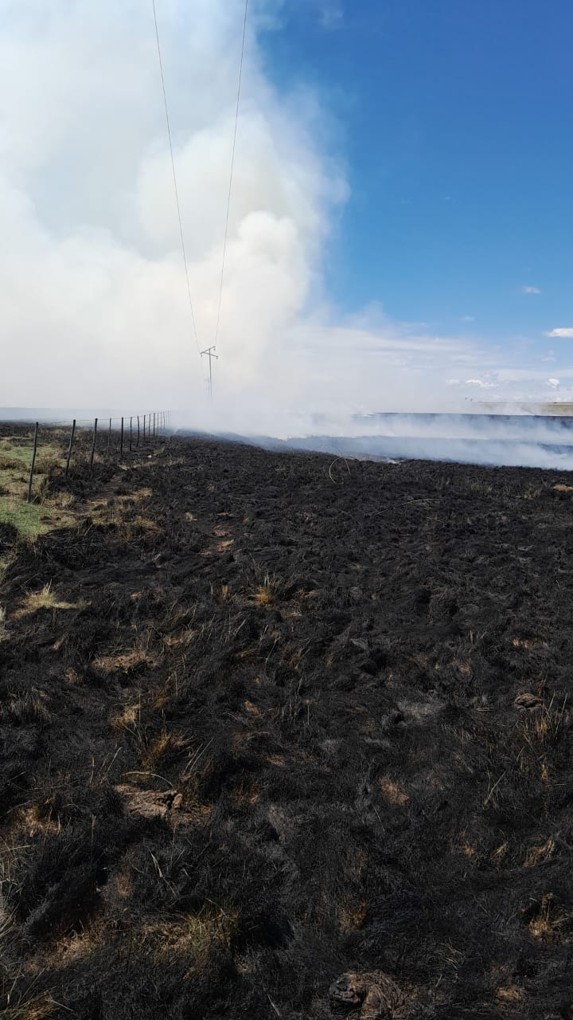
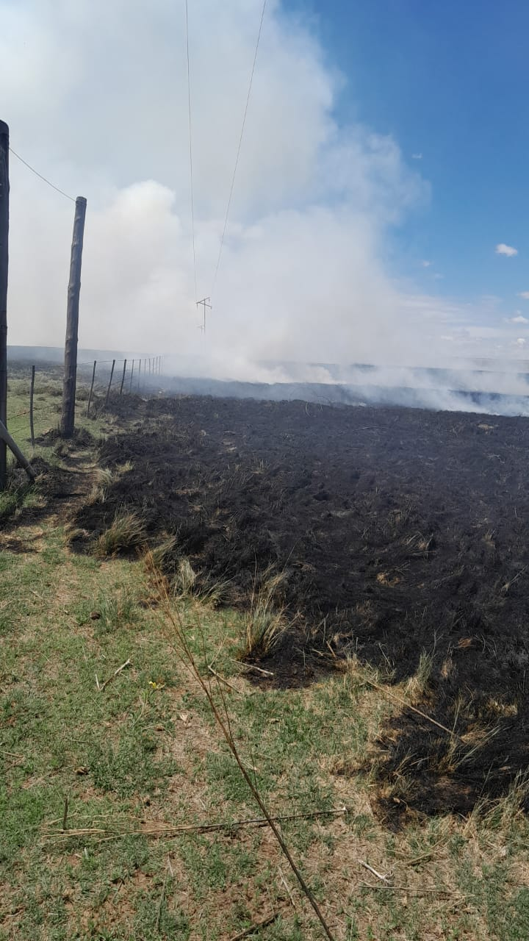
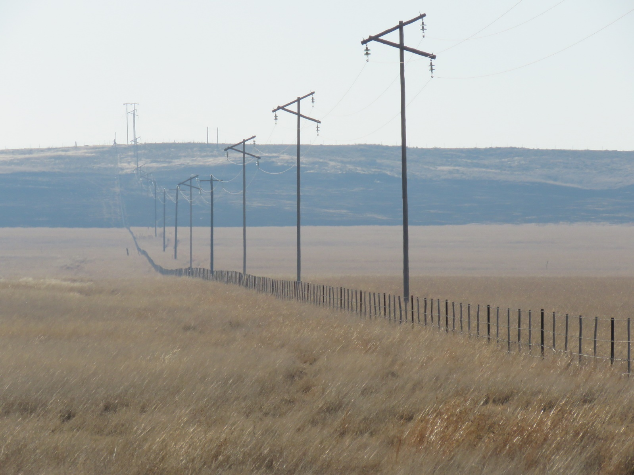

PROVINCIAL CLAIMS COMMITTEE USE ONLY
Notes for consistency:
- A note log to be kept of discussions regarding steps to be taken to prevent future incidents.
- Eskom only responsible up to meter point, therefore the Customer is responsible for his own installation beyond this meter point.
- Claims caused by stormy weather arising in December must be paid due to inconvenience caused to customers.
- Ex Gratia payment: a minimum of 50% direct damage will be considered and based on the circumstances an amount higher than 50% will be considered based on consensus reached by the committee.
- Veld Fire claims: Direct losses will be paid as per advice from the Agricultural extension officer of the Area.
- Airdac in townships should be at a height of 4.7 meter as per EMR 15.
- Staff needs to be sensitized as to the wording for root causes for normal deterioration.
- Position where the LV neutral is broken will determine whether Eskom is liable.
- Guiding principles for negligence:
a) Deviation from the procedures, standards and legal requirements
b) Reasonable steps not taken where it was required (Excluding major works & failure of major equipment)
c) Omission or failure to act.
- Damage due to strong winds causing poles to break (veldt set alight) will not be considered as a claim.-
QUESTIONS  - Is Eskom liable?  - Was fault attended to in a reasonable time? | Yes  Yes | REMARKS:  Equipment failure

PROVINCIAL CLAIMS COMMITTEE DECISION
PCC Decision:14.02.2024 Claim supported by PCC.
PCC Decision 21.02.2024
The claim to be referred to legal for them to decide on behalf of the OU
REASON:
POLICY | REASONS FOR REJECTION
There must be damage to Eskom property | No conclusive evidence could be detected on Eskom network linking the damage to an Eskom event.
Must be one sudden, unforeseen, specific or identifiable event | - Incident could not have caused the damage  - Eskom not responsible for the cause of the fire
Proximate cause should not be due to parties external to Eskom | - Proximate cause due to persons external to Eskom
Power fluctuations/power failures are specifically excluded unless Eskom contributed to the fault. | - Phases incorrectly connected  - Neutral burnt  - Refer clause 6. 3  - Lack of maintenance  - Fault repaired within a reasonable time.  - Voltage Regulation was within the NRS048
Act of God | - Eskom could not have foreseen  - Customer could not have taken reasonable standard
Must be direct damage | - Consequential loss  - Incorrectly disconnected  - Cable damaged due to excavation activities in the area by non-Eskom contractor and highly unlikely that damaged cable could have caused damage to Customers equipment.  - Fault on customer side

6.3 Customers are cautioned that they should ascertain from ESKOM the nature of the protection provided on the supply and should provide adequate means for the protection of their own equipment. Inter alia,
6.3.1 It is not practicable for ESKOM to install protective equipment on its system which will ensure in all cases that motors and/or other equipment on the CUSTOMER's side will be protected in the event of low voltage or over voltage or single-phasing. It is therefore necessary for the CUSTOMER to take adequate measures to protect his motors and/or equipment against damage that may arise under low voltage or over voltage conditions or from single-phasing;
6.3.2 Where a voluntary or involuntary outage of supply may cause damage to the CUSTOMER's plant or business, he should take measures to protect himself against such possible damage. (i.e. standby generator & personal Insurance (Especially a sensitive business) Should the CUSTOMER have, or decide to install, his own standby generating plant for use during such outages, the equipment for connecting such plant to his electrical installation shall be subject to ESKOM's approval. Such standby plant shall be operated only during such outages and furthermore the use and operation thereof by the CUSTOMER shall be subject to such terms and conditions as ESKOM may lay down to ensure the safety and protection of its personnel and equipment.

20. CONTINUITY, REDUCTION OR VARIATION OF SUPPLY
20.1 ESKOM shall take all reasonable precautions to procure and maintain suitable plant for the generation and distribution of electricity calculated to secure to its consumers a constant supply of electricity and shall procure efficient technical staff to control such plant, but ESKOM does not guarantee that the same will always be maintained, and ESKOM shall not be liable for damages, expenses or costs caused to the CUSTOMER from any interruption in the supply, variation of voltage, variation of frequency, any failure to supply a balanced three-phase current or failure to supply electricity unless the said interruption or failure is due to the negligence of ESKOM in failing to carry out its obligations aforesaid. In the event that ESKOM should be liable for damage caused to the CUSTOMER as a result of any such reduction in load or any interruption in the supply, or any variation of voltage or frequency or any failure to supply electricity, such liability shall be limited to direct damage only.
20.2 For purposes of the efficient operation and extension of ESKOM's distribution system, or if ESKOM should experience any shortage of generating capacity, ESKOM shall have the right to interrupt the supply to the CUSTOMER

