

Agricultural Research Council
Plant Health and Protection
P/Bag X134, Queenswood, Pretoria 0121

SUPPLY, INSTALLATION AND COMMISSIONING OF SOIL PASTEURISATION EQUIPMENT

BID SPECIFICATION CRITERIA

- PROJECT LOCATIONS

- Agricultural Research Council - Plant Health and Protection
Vredenburg Research Farm (Western Cape)
Winery Way
Stellenbosch, 7600
33°56’55.2”S 18°50’10.9”E

- Agricultural Research Council - Plant Health and Protection
Cedara Research Farm (KwaZulu-Natal)
Cedara Road, Hilton
Pietermaritzburg, 3201
29°32’28.9”S 30°16’05.5”E

- ARC-PHP SUPPLY CHAIN MANAGEMENT REPRESENTATIVE

Name: Ms. Pontsho Mahloko
Office: 012 808 8179
Email: MahlokoP@arc.agric.za

BID SPECIFICATION CRITERIA: SUPPLY, INSTALLATION AND COMMISSIONING OF SOIL PASTEURISATION EQUIPMENT

BACKGROUND

This specification document covers work to be undertaken for the installation of new pasteurisation equipment at two separate ARC - Plant Health and Protection research campuses. These campuses are located in Stellenbosch in the Western Cape (Vredenburg Research Farm) and just outside Pietermaritzburg in KwaZulu-Natal (Cedara Research Farm). The equipment will primarily be used for the pasteurisation of bulk soil, but also pots, tools and other smaller horticultural equipment, in support of experimental glasshouse trials. Sterilisation cycles will be required to eliminate a variety of plant pathogens and other microorganisms, as well as unwanted seeds that might be present in the soil. The supplied equipment must therefore be robust, accurate, and of a high standard to ensure reliability and long service. Specifications for the equipment required at each research farm are detailed below:

1. TECHNICAL SPECIFICATIONS: VREDENBURG RESEARCH FARM (WESTERN CAPE)

1.1. BACKGROUND AND REQUIREMENTS FOR THE SYSTEM

A new pasteuriser is required at ARC-PHP Vredenburg campus in Stellenbosch. This pasteuriser will be used mainly to pasteurise soil and pots for the purpose of glasshouse trials. The purpose of pasteurisation is to eliminate plant pathogens, other microorganisms and weeds that can interfere with trial results. For the most part, soil will be pasteurised in 13 cm diameter plastic pots that each contain ~800 g of soil, but in some cases larger pots will be used, or buckets containing up to ~20 L of soil. The pasteuriser must be able to accommodate a maximum capacity of at least 720 x 13 cm diameter pots filled with soil per batch. On average, the pasteuriser will be used twice every 1–2 weeks.

These requirements are based on our current system which is depicted in Figures 1–3.
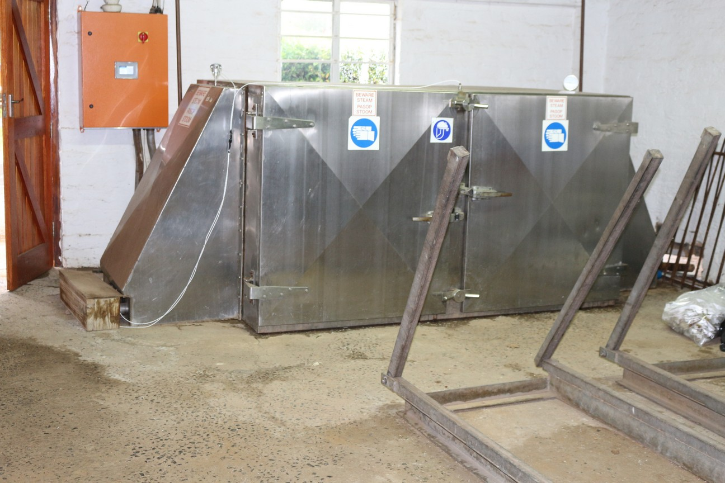
Figure 1. Closed pasteuriser with trolley tracks raised.

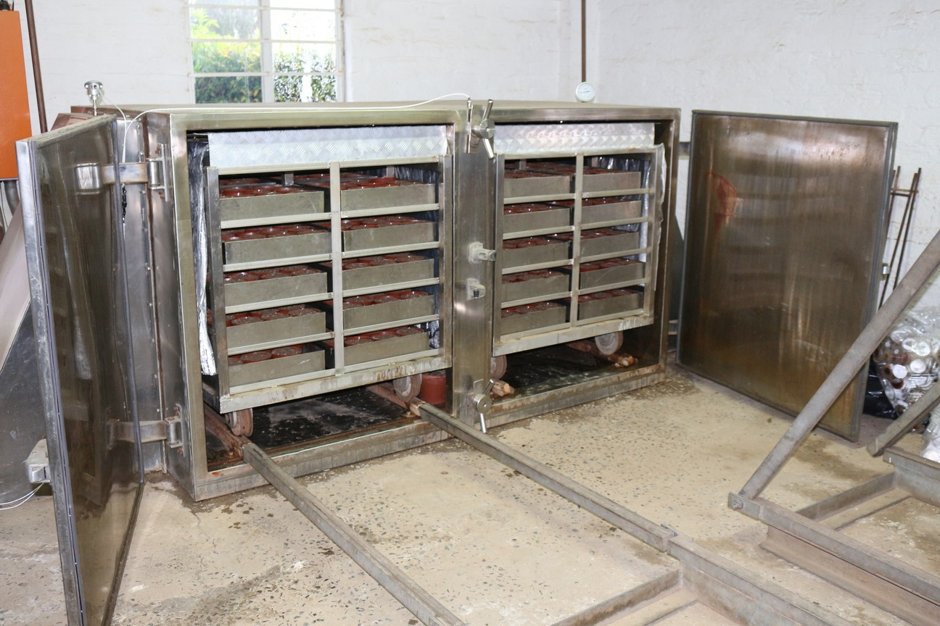
Figure 2. Open, loaded pasteuriser with one set of trolley tracks lowered.

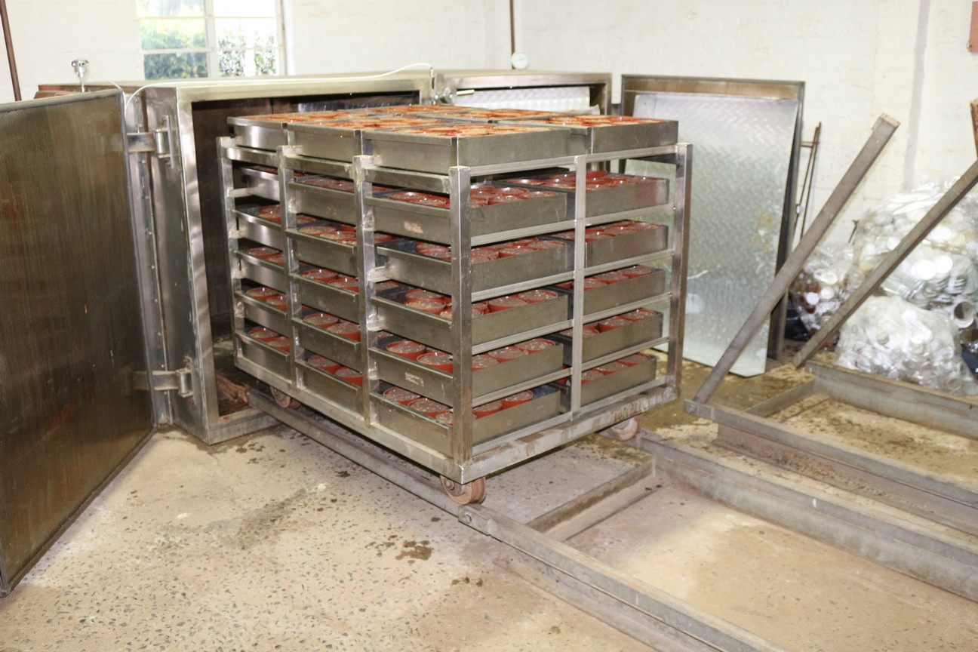
Figure 3. Open pasteuriser with one trolley pulled out onto the tracks. The trolley is loaded with steel trays containing 13 mm diam. pots with soil.

1.2. TECHNICAL SPECIFICATIONS

Please Note:
Quantities and pricing should be added to the following template so as to enable fair comparison between bids. Any modifications or changes to the proposed specifications listed should be clearly indicated, together with a brief motivation, in a different coloured font under each point or where applicable.

NO. | TECHNICAL SPECIFICATION: [VREDENBURG] | QTY. | UNIT PRICE | TOTAL COST
1 | SCHEMATIC DRAWINGS AND RECORDS UPON COMPLETION
1.1 | A detailed layout/schematic drawings of the instrument needs to be supplied upon completion of the project. This is to allow easier maintenance of the system by any qualified supplier that were not involved in the construction or design of the system.  This layout should further indicate the:  - Electrical and water connections to the machine  - Interior parts and connections  - Mechanical operation during working
1.2 | Certification of key features on completion:  Bidders are also to demonstrate key features, supply appropriate certification documentation and/or evidence that the required specifications herein have been met. These must include:  - Temperature distribution test and report.
1.3 | Manuals, training and guarantees:  Upon completion of work, all instruction manuals (electronic copies), software keys, passwords, written guarantees and warranties of newly installed equipment and materials must be provided. Training of ARC-PHP staff (5 people) in operation and basic maintenance of the machine must also be undertaken.
1.4 | A maintenance and service plan needs to be included detailing the following:  - Expected lifetimes of key parts  - Schedule for cleaning or maintenance of specific parts  - Servicing intervals
2. | PASTEURISATION BOX
2.1 | - The pasteurisation box and doors should be constructed of durable stainless steel that is strong enough to maintain structural integrity of the pasteurisation box, does not corrode, and does not warp, despite frequent exposure to steam and water.  - Maximum capacity of at least 720 x 13 cm diam. pots while allowing for adequate steam penetration of soil in each pot.  - Doors that lock securely during operation.  - Doors must seal during operation without allowing steam to escape. Any rubbers or other materials used as seals should be resistant to frequent exposure to steam, moisture and high temperatures.  - If doors are hinged, durable hinges should be used that can carry the weight of doors without warping over time.  - Doors and walls of the pasteurisation box should be insulated to prevent heat loss and improve energy efficiency.  - The box should be fitted with the necessary drainage and steam outlets.
2.2 | A two-trolley system should be used for the easy loading and off-loading of the pasteurisation box, unless a more efficient system is proposed.  - Two trolleys with racks to carry removable trays. Each trolley should be able to accommodate 36 stainless steel trays.  - 72 stainless steel trays, each tray with a capacity of 10 x 13 cm pots.  - Trays and trolleys should be constructed in such a manner as to allow adequate steam penetration into soil of all pots even when fully loaded.  - Trolleys, trays, and/or the pasteurisation box should be constructed in such a manner that water condensing against any surfaces in the pasteuriser does not drip or flow into any of the pots or trays, which can cause some pots to be wetter than others.  - Tracks should be included to allow for the movement of trolleys in and out of the pasteurisation box.  - The trolleys, tracks and trays should be constructed of durable stainless steel that can withstand frequent exposure to steam and water, as well as carry the necessary weight without warping or compromising the integrity of any part of the machine.  - When fully loaded, trolleys should still be able to be moved in and out of the pasteurisation box by a maximum of two people.  - Trolleys and tracks should be constructed in such a manner as to prevent trolleys from falling off tracks.  - Trolley wheels should be strong enough to carry the weight of the trolley as well as trays and filled pots.  - Trolley tracks should not interfere with opening and closing of pasteurisation box doors.
3 | TEMPERATURE RANGE AND RETENTION TIME CONTROL
3.1 | - A controller should be included through which the temperature and soak times for each pasteurisation cycle can be set easily.  - During operation the controller should display the cycle progress at least in terms of duration and current temperature.  - The controller should be password protected to prevent unauthorised changes to settings.  - Temperature and duration data for completed cycles should be stored and downloadable in an easily readable format (e.g. Microsoft Office .xlsx or .csv).  - The controller should be able to resume incomplete cycles in case of interruptions of 5 minutes or less.  - The controller should be connected to the local network to access data of current and completed cycles, but a network connection should not be required for operation of the pasteuriser.  - The controller must be located in the same room as the pasteuriser and must be able to withstand exposure to high humidity  - The controller should display at least the following error messages when necessary:  - Interrupted cycle  - Incomplete cycle  - Failure to reach set temperature  - Inadequate water supply
3.2 | The pasteuriser should be able to maintain set temperatures ranging from 50–100 °C for periods of up to 1 h with variation of 2 °C above or below the set temperature for the duration of the retention time.  - Temperature range: 50–100 °C  - Retention times: up to 1h for the entire temperature range  - The heat should be evenly distributed across the pasteurisation space – there should be no cold spots.
3.3 | Steam and heat generation should be done in an energy-efficient manner.  - Steam supply system must comply with safety regulations.  - If applicable to heating system, incorporate return air cowling to recycle hot air back through heating element/boiler.  - If applicable to heating system, use fan forced circulation of air/steam mixture to accelerate heat up time.  - If applicable, steam supply system has to be insulated to prevent heat loss.  - Any ducting should be insulated to prevent heat loss during transfer of steam to pasteurisation box.
3.4 | Probes should be installed to monitor soil temperatures in the middle of the pots or buckets, regardless of the pot or bucket size.  - Probes should be firmly secured in pots, but easily transferable to other pots of different sizes when needed.  - The number of probes needed might depend on the pasteurisation system used.
4 | GENERAL REQUIREMENTS
4.1 | - Connection to the existing electrical supply need to be included.  - A Certificate of Compliance (COC) needs to be supplied for electrical connections.
4.2 | - Connection to the existing water supply and drainage need to be included.  - Should the system require filtering or softening of water supply, this should be included.
4.3 | The space allocated for the entire system (pasteuriser, steam supply system and trolley tracks) is inside an enclosed room. The entire system needs to fit in this allocated space. Depending on the system provided, some modifications will be considered for approval.  - The available space currently measures: 4.5 x 3 x 3 m (L x W x H)  - If necessary, additional floor space of up to 4.5 x 0.7 m can be freed up through the removal of concrete benches currently built into the wall and floor (to be included in quotation).  - Should this modification be required, all rubble should be removed and walls replastered and repainted.  - Any structural changes to the current space need to be included in the quotation.  - Construction and installation should be done without structural changes to the entrances of the room.
4.4 | The machine should be fully functional once delivered and installed.
5 | MAINTENANCE, SERVICE AND REPAIR
5.1 | All parts required for maintenance, service and repair must be available locally.

- ARC-PHP VREDENBURG CAMPUS REPRESENTATIVE

Name: Chris Spies
Mobile: 076 838 0088
E-mail: spiesc@arc.agric.za

2. TECHNICAL SPECIFICATIONS: CEDARA RESEARCH FARM (KWAZULU-NATAL)

2.1. BACKGROUND AND REQUIREMENTS FOR THE SYSTEM

ARC-PHP Cedara (Weeds Division – biological control) continuously grows plants in pots for rearing candidate and approved biological control agents to feed on – these include stock plants (target weed) for both quarantine research and mass-rearing for release; and test plants for quarantine research. A large volume of potting medium is used and recycled. Before re-use, it needs to be treated in order to kill:
- Biocontrol agents (insects) that may be present on or in the potting medium once the plant has been cut back. Some of these agents pupate in the medium. This is achieved largely through freezing of the potting medium, but an extra precaution would be heat treatment.
- Pathogens that may be in the medium (both phyto- and entomopathogens) which may infect plants and insects on re-use. Heat treatment is needed to kill these.
- Weed seeds which otherwise germinate and compete with the plants, and harbour pests, on re-use. Heat treatment is needed to kill these.

Current system
A large autoclave is used (Fig. 4). The volume of soil in a ‘standard pot’ is around 1.85 dm³. The diameter of most of these pots is 175 x 140mm (diameter x height). However, we currently empty the medium out of the pots into a stainless steel tray (140 x 330 x 530mm – height x width x length) before placing it in the autoclave (shallower block of medium than in pot, therefore less distance for steam and heat to penetrate). We put 6-7 standard pots' worth of potting medium (equivalent to 12.03 dm³) into each tray (otherwise too heavy to lift) (Fig. 5).

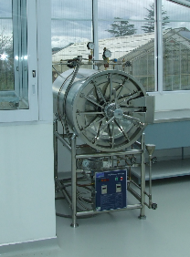
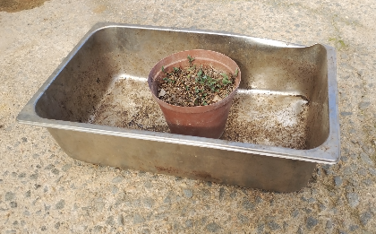

Figure 5. Steel tray and plant pot.

Figure 4. Current autoclave.

Six trays (72.15 dm³) are placed in the autoclave per cycle - run on a programme lasting 1 hour, reaching a temperature of 120 °C. In order to process sufficient potting medium, we need to run 3 cycles per day (216.45 dm³), 5 days per week (1082.25 dm³ or 1.08 m³). The maximum we will need is up to 2 m³ per week.

Disadvantages of current setup
- Very labour-intensive
- Medium needs to be moved into quarantine
- Probably very energy intensive
- Medium may be treated at too high a temperature (sterilized vs pasteurized)
- Loadshedding causes problems – oftentimes insufficient potting medium is available

2.2. TECHNICAL SPECIFICATIONS

Please Note:
Quantities and pricing should be added to the following template so as to enable fair comparison between bids. Any modifications or changes to the proposed specifications listed should be clearly indicated, together with a brief motivation, in a different coloured font under each point or where applicable.

NO. | TECHNICAL SPECIFICATION: [CEDARA] | QTY. | UNIT PRICE | TOTAL COST
1 | SCHEMATIC DRAWINGS AND RECORDS UPON COMPLETION
1.1 | A detailed layout/schematic drawings of the instrument needs to be supplied upon completion of the project. This is to allow easier maintenance of the system by any qualified supplier that was not involved in the construction or design of the system.  This layout should further indicate the:  - Electrical and water connections to the machine  - Interior parts and connections  - Mechanical operation during working
1.2 | Certification of key features on completion:  Bidders are also to demonstrate key features, supply appropriate certification documentation and/or evidence that the required specifications herein have been met. These must include:  - Temperature distribution test and report.
1.3 | Manuals, training and guarantees:  Upon completion of work, all instruction manuals (electronic copies), software keys, passwords, written guarantees and warranties of newly installed equipment and materials must be provided. Training of ARC-PHP staff (4 people) in operation and basic maintenance of the machine must also be undertaken.
1.4 | A maintenance and service plan, and a detailed list of parts available, needs to be included detailing the following:  - Expected lifetimes of key parts  - Schedule for cleaning or maintenance of specific parts  - Servicing intervals
2. | PASTEURISATION BOX
2.1 | - The pasteurisation box and doors should be constructed of durable stainless steel that is strong enough to maintain structural integrity of the pasteurisation box, does not corrode, and does not warp, despite frequent exposure to steam and water.  - Maximum capacity of at least 144 x 16 cm diameter pots which can fit into 36 stainless steel trays while allowing for adequate steam penetration of soil in each pot.  - Doors that lock securely during operation.  - Doors must seal during operation without allowing steam to escape. Any rubbers or other materials used as seals should be resistant to frequent exposure to steam, moisture and high temperatures.  - If doors are hinged, durable hinges should be used that can carry the weight of doors without warping over time.  - Doors and walls of the pasteurisation box should be insulated to prevent heat loss and improve energy efficiency.  - The box should be fitted with the necessary drainage and steam outlets.
2.2 | A one-trolley system should be used for the easy loading and off-loading of the pasteurisation box, unless a more efficient system is proposed.  - One trolley with racks to carry removable trays. This trolley should be able to accommodate 36 stainless steel trays.  - 36 stainless steel trays, each tray with dimensions 430 x 380 x 75mm.  - Trays and trolleys should be constructed in such a manner as to allow adequate steam penetration into soil of all pots/trays even when fully loaded.  - Trolleys, trays, and/or the pasteurisation box should be constructed in such a manner that water condensing against any surfaces in the pasteuriser does not drip or flow into any of the pots or trays, which can cause some pots to be wetter than others.  - Tracks should be included to allow for the movement of trolleys in and out of the pasteurisation box.  - The trolleys, tracks and trays should be constructed of durable stainless steel that can withstand frequent exposure to steam and water, as well as carry the necessary weight without warping or compromising the integrity of any part of the machine.  - When fully loaded, trolleys should still be able to be moved in and out of the pasteurisation box by a maximum of two people.  - Trolleys and tracks should be constructed in such a manner as to prevent trolleys from falling off tracks.  - Trolley wheels should be strong enough to carry the weight of the trolley as well as trays and filled pots.  - Trolley tracks should not interfere with opening and closing of pasteurisation box doors.
3 | TEMPERATURE RANGE AND RETENTION TIME CONTROL
3.1 | - A controller should be included through which the temperature and soak times for each pasteurisation cycle can be set easily.  - During operation the controller should display the cycle progress at least in terms of duration and current temperature.  - The controller should be password protected to prevent unauthorised changes to settings.  - Temperature and duration data for completed cycles should be stored and downloadable in an easily readable format (e.g. Microsoft Office .xlsx or .csv).  - The controller should be able to resume incomplete cycles in case of interruptions of 5 minutes or less.  - As an option, the controller could be connected to the local network to access data of current and completed cycles, but a network connection should not be required for operation of the pasteuriser. In this case, software should be updateable as needed.  - The controller must be located in the same room as the pasteuriser and must be able to withstand exposure to high humidity  - The controller should display at least the following error messages when necessary:  - Interrupted cycle  - Incomplete cycle  - Failure to reach set temperature  - Inadequate water supply
3.2 | The pasteuriser should be able to maintain set temperatures ranging from 90–100 °C for periods of up to 1 h with variation of 2 °C above or below the set temperature for the duration of the retention time.  - Desired temperature range: 90–100 °C  - Retention times: up to 1h for the entire temperature range  - The heat should be evenly distributed across the pasteurisation space – there should be no cold spots.
3.3 | Steam and heat generation should be done in an energy-efficient manner.  - Steam supply system must comply with safety regulations.  - If applicable to heating system, incorporate return air cowling to recycle hot air back through heating element/boiler.  - If applicable to heating system, use fan forced circulation of air/steam mixture to accelerate heat up time.  - If applicable, steam supply system has to be insulated to prevent heat loss.  - Any ducting should be insulated to prevent heat loss during transfer of steam to pasteurisation box.
3.4 | Probes should be installed should be installed to monitor soil temperatures in the middle of the pots or buckets, regardless of the pot or bucket size.  - Probes should be firmly secured in pots, but easily transferable to other pots of different sizes when needed.  - The number of probes needed might depend on the pasteurisation system used.
4 | GENERAL REQUIREMENTS
4.1 | - Connection to the existing electrical supply need to be included. This entails providing and installing an electrical 3-phase cable from the mini-substation for about 37m to the machine that will deliver sufficient power (e.g. 30kW) to the machine to run it, and a DB board as necessary. All electrical connections to be made by supplier.  - A Certificate of Compliance (COC) needs to be supplied for electrical connections.
4.2 | - Connection to the existing water supply and drainage need to be included.  - Should the system require filtering or softening of water supply, that should be included.
4.3 | The space allocated for the entire system (pasteuriser, steam supply system and trolley tracks) is inside a PX container. The entire system needs to fit in this allocated space.  - The PX container, to be provided and installed by the supplier, should be in good condition, with no rust, with internal dimensions of 5.71 m x 2.34 m x 2.27 m (L x W x H), and a double door at each end of the container (see example illustration below.  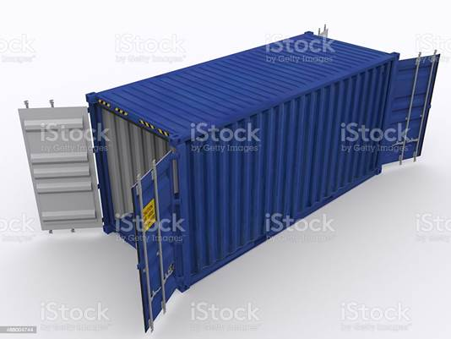  - Concrete footings for the PX container should be provided and installed by the supplier in order to stabilise it.  - Two ‘whirlybirds’ should be installed in the roof of the container to allow the escape of heat and moisture.  - Sufficient artificial lighting within the PX container (≥ 500 LUX).  - Aluminium(3 mm) tread plate on the base of the flooring of the shipping container to cover the whole floor area. Bidder to list the grade and thickness of the aluminium tread plate and how many squares it will cover.  - The interior walls and ceiling of the shipping container should be painted with either an epoxy-based waterproof paint or a steam and moisture resistant paint. Bidder to list the make of the paint and the expected area that the paint will cover.
4.4 | The machine should be fully functional once delivered and installed.
5 | MAINTENANCE, SERVICE AND REPAIR
5.1 | All parts required for maintenance, service and repair must be available locally.

- ARC-PHP CEDARA CAMPUS REPRESENTATIVE

Name: Connel Adey
Mobile: 082 773 9648
E-mail: AdeyC@arc.agric.za

3. BIDDING CRITERIA

3.1 GENERAL

- Bidders must provide a detailed quote and costing describing the type of steam generating system proposed (incl. kW), components to be used (i.e., control system, number of probes, materials, etc.) and design features incorporated (e.g. trolley system, safety features and failsafe’s, etc.), as well as purchase and fabrication lead times and installation timelines.
- It is desired that bidders provide a detailed written proposal or pre-recorded presentation (e.g. MS PowerPoint) outlining their proposed system and how it will address the needs as stated in the initial background paragraphs. The presentation should address aspects of operation, serviceability, energy efficiency, running cost per cycle and life expectancy of components.
- A CIDB grading of 3ME or above is compulsory.
- Sub-contracting will be permitted. Full details of proposed sub-contractors to be provided with the bid so far as possible. The appointed contractor will remain responsible for ensuring all work carried out by sub-contractors is to a standard in accordance with the specifications/requirements described herein. Selection and appointment of sub-contractors to be done by the appointed contractor, the ARC-PHP will not appoint sub-contractors.
- Bidders are expected to attend a compulsory site visit at each location at a specified date to be communicated.
- The bidder must give a detailed price breakdown on the template provided for each location with changes and additions clearly marked with a brief motivation.
- A two envelope tendering system will be followed. The bidding price must be in a separate envelope.
- The bidder shall guarantee the installation, workmanship, materials and mechanical equipment used under this project for a period of twelve months.
- Bidders to clearly indicate any improvements to the proposed specifications, where those changes will increase the overall functionality, safety, efficiency and usability of the system, and/or a cost saving.
- The ARC has the right to choose or omit certain aspects of the quotation.
- The specifications of listed herein may contain errors or omissions. Tenderers should familiarise themselves with the requirements of the system and scope of work required prior to submitting their bids.
- A contingency amount equivalent to 10% of the total project value should be clearly included in the bid pricing. The ARC reserves the right to not spend this contingency, or only part of it. Variation orders to be drawn from this contingency must be pre-approved by the ARC project manager/representative prior to being actioned.

3.2. TECHNICAL EVALUATION

All tenderers and proposals will be evaluated according to compliance with the listed specifications, Functionality Criteria of the potential tenderer (as per table below), specific goals and price. Points will be allocated and weighed on the following criteria and procedure:

NO | FUNCTIONALITY CRITERIA / EVALUATION QUESTIONNAIRE | POINTS ALLOCATED | WEIGHT
1. | Project team experience:  (Technical capability of the team)  Company’s general experience, level of education and training and positions held in each discipline of the team. The bidder shall include resumes of the project personnel and sub-contractors that will be assigned to this work.  - The foreman must have at least a Higher Certificate (NQF Level 5) in Mechanical Engineering or related field recognised by the South African Qualifications Authority (SAQA) with 3 years relevant experience.  - Qualified electrician that will issue the Electrical Certificate of Compliance with 3 years’ experience.  - Technician(s) with at least 3 years relevant experience. Minimum NQF level 3. |  | 30%
1. | Foreman (6 years’ experience) + 2 of the listed key personnel | 5
1. | Foreman (3 years’ experience) + 2 of the listed key personnel | 4
1. | Foreman (3 years’ experience) + 1 of the listed key personnel | 3
1. | Any 2 of the listed key personnel | 2
1. | Any 1 of the listed key personnel | 1
2. | Company experience and past performance:  Bidders must list, and support with original reference letters or Completion Certificates issued by past clients, projects involving the installation and/or fabrication of pasteurisation and/or sterilisation equipment. This should include projects that were executed from a minimum value of R400 000, and which are not older than ten years. The ARC evaluation committee has the right to contact these companies. Letters/completion certificates should be on the clients company letterhead and must include the following information:  - Name of the business (client’s company)  - Location of the project, your company's role in the project.  - The project/contract value.  - Elaborate on the project - industry served, purpose of installation.  - Contact person, contact numbers, and email address. |  | 40%
2. | Completion of 4 projects involving design, component fabrication and installation of pasteurisation equipment to a value in excess of R800 000 each, that are not older than 10 years. | 5
2. | Completion of 4 projects involving design, component fabrication and installation of pasteurisation equipment to a value of between R400 000 and R800 000 each, that are not older than 10 years. | 4
2. | Completion of 3 projects involving design, component fabrication and installation of pasteurisation equipment to a value of at least R400 000 each, that are not older than 10 years. | 3
2. | Completion of 3 projects involving only installation of pasteurisation and/or sterilisation equipment to a value of at least R400 000 each, that are not older than 10 years. | 2
2. | Completion of 2 projects involving only installation of pasteurisation and/or sterilisation equipment to a value of at least R400 000 each, that are not older than 10 years. | 1
3. | Technical approach, methodology and work plan:  This should include:  - A work plan to complete the project within 3 calendar months.  - Work breakdown with logical sequence of activities, including timelines.  - Manufacturing capacity and resources to be used.  - Quality management (i.e., milestones, inspections, etc.).  - Risk mitigation (i.e., identification of possible delays or problems and proposed solutions). |  | 30%
3. | Provision for all 5 aspects (work breakdown, timeline, resources, quality management, risk mitigation) clearly explained and demonstrated with detailed GANTT chart. | 5
3. | Provision for 4 aspects (work breakdown, timeline, resources, quality management, risk mitigation) clearly explained and demonstrated with detailed GANTT chart. | 4
3. | Provision for 3 aspects (work breakdown, timeline, resources, quality management, risk mitigation) explained and demonstrated with detailed GANTT chart or activity table. | 3
3. | Provision for 2 aspects (work breakdown, timeline, resources, quality management, risk mitigation) demonstrated with GANTT chart or activity table. | 2
3. | Provision for 1 aspects (work breakdown, timeline, resources, quality management, risk mitigation) demonstrated with GANTT chart or activity table. | 1

3.3. TOTAL SCORE FOR FUNCTIONALITY

Bids that do not obtain a minimum score of 60% for functionality will be disqualified and will not be evaluated further on price and specific goals.

