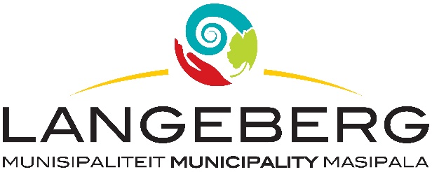

QUOTATION 22/2023

Tenders are hereby requested for the SUPPLY, REPLACEMENT AND NEW INSTALLATION OF SWIMMING POOL PIPE SYSTEM as specified in the bid document. Completed Bids, in sealed envelopes, clearly marked
“QUOTATION 22/2023: SUPPLY, REPLACEMENT AND NEW INSTALLATION OF SWIMMING POOL PIPE SYSTEM” should be placed in the tender box, at the Langeberg Municipal Office, 28 Main Road, Ashton, not later than 12:00 on 01 DECEMBER 2023 when the Bids will be opened in public. Late, faxed or e-mailed tenders will not be considered.

Tenderers must be registered with the CIDB in a class of construction works and have a grading designation equal to or higher than that determined in accordance with the sum tendered or a value determined in accordance with regulation 25 (7A) of the Construction Industry Development Regulations, 2004. It is estimated that tenderers will need a grading designation of CIDB – ME1 OR HIGHER.

COMPULSORY CLARIFICATION MEETING
A COMPULSORY CLARIFICATION MEETING WILL BE HELD ON THE 22 NOVEMBER 2023 AT 10H00, AT 52 CHURCH, TOWN HALL, ROBERTSON MUNICIPAL OFFICES,

PLEASE NOTE:

The official Bid document must be fully completed in black ink, all pages must be submitted and the document should preferably be bound.
Supporting documents must be submitted separately and must be stapled or bound.
The lowest, or any tender, will not necessarily be accepted and council reserves the right to accept any tender. Tenders will be evaluated according to the Council’s Supply Chain Management Policy and the 80/20 Preference Point system. The Supply Chain Management Policy can be viewed at Municipal Offices or www.langeberg.gov.za

Tender documents are available from 17 NOVEMBER 2023, on the Langeberg Municipal website: www.langeberg.gov.za

Please refer written enquiries to MS L APRIL (lapril@langeberg.gov.za).

DP LUBBE
MUNICIPAL MANAGER
Private Bag X2 Ashton, 6715

